Module G1


Electric Power Generation and Machine Controls

Primary Author: James D. McCalley, Iowa State University
Email Address: jdm@iastate.edu
Co-author: None
Last Update: 7/30/99
Prerequisite Competencies: 1. Steady-state analysis of circuits using phasors, typically covered in an introductory circuit course
2. Three-phase circuit analysis and three-phase power relationships, found in module B3
3. Conversion between three-phase analysis and per-unit analysis, found in module B2
Module Objectives: 1. Identify the physical structure and essential components of a synchronous generator.
2. Perform analysis of a three-phase synchronous generator using the Equivalent Circuit Model.
3. Describe reactive operation of a synchronous generator in terms of reactive power generation, excitation voltage magnitude, power angle, leading generator operation versus lagging generator operation, capacitive load versus inductive lad, and current angle.
4. Express terminal voltage, excitation voltage, real and reactive power, and armature current using phasor diagrams.

G1.0 Introduction
Generation of electrical power is a process whereby energy is transformed into an electrical form. There are several different transformation processes, among which are chemical, photo-voltaic, and electromechanical. Electromechanical energy conversion is used in converting energy from coal, petroleum, natural gas, uranium, water flow, and wind into electrical energy. Of these, all except the wind energy conversion process take advantage of the synchronous AC generator coupled to a steam, gas, or hydro turbine such that the turbine converts steam, gas, or water flow into rotational energy, and the synchronous generator then converts the rotational energy of the turbine into electrical energy. It is the turbine-generator conversion process that is by far most economical and consequently most common in the industry today. In this chapter, we will study this conversion process with particular emphasis on the synchronous machine and the controls that are used to govern its behavior.

All materials are under copyright of PowerLearn project
copyright © 2000, all rights reserved

G1.1 Generator Operation
A turbine-generator is illustrated in its basic form in Figure G1.1.

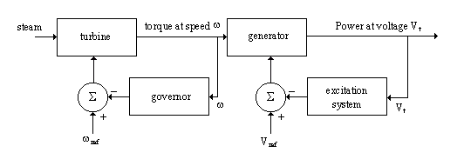

Figure G1.1 Block Diagram for Turbine-Generator System

The governor and excitation systems are known as feedback control systems because it is the feedback loops which provide for good control of certain parameters. The governor and excitation systems are typical feedback controllers in that the quantities to be controlled (speed and voltage, respectively) are also providing the feedback signal. We will study these controllers more closely. However, we must first take a closer look at the operation of the generator itself.

The generator is classified as a synchronous machine because it is only at synchronous speed that it can develop electromagnetic torque. If the nominal system frequency is 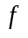(60 Hz in North America), synchronous speed is computed as
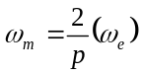 (G1.1)

where 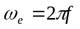is the frequency in rad/sec and is the number of poles on the rotor of the machine. The machine speed in RPM can be computed as 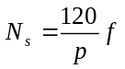.

The synchronous generator has two iron structures. The rotor is the revolving part of the machine, and is located inside the stator, which is the stationary part of the machine. Hydroelectric generators have their rotors built with saliency; the rotor poles protrude from the central axis. Because hydro-turbines are relatively slow (600 to 1800 RPM hydro-turbine generators are typical ), the number of poles must be high in order to produce 60 Hz voltages (see eqn. G1.1). Salient pole construction is simpler and more economical when a large number of poles are required.

Steam plants, on the other hand, have very high speeds (1800 and 3600 RPM steam-turbine-generators are typical), and saliency would create significant mechanical stress at these speeds. Therefore, smooth or round rotor construction is employed for these generators. The two types of rotor construction are illustrated in Figure G1.2.

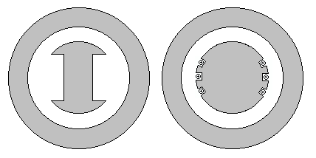

Figure G1.2 Salient Pole (left) and Smooth (right) Rotor Construction

A magnetic field is provided by the DC-current carrying field winding, which induces the desired AC voltage in the armature winding. For synchronous generators, field winding voltages are typically much lower in magnitude than armature winding voltages; in addition, armature voltages must be available external to the machine. It is therefore simpler to locate the armature winding on the stator where there is no rotation. The field winding is always located on the rotor where it is connected to an external DC source via slip rings and brushes or to a revolving DC source via a special brushless configuration. The armature consists of three windings, all of which are wound on the stator, physically displaced from each other by 120 degrees. It is through these windings that the electrical energy is produced and distributed. A typical layout for a 2 pole, smooth rotor machine would appear as in Figure G1.3.

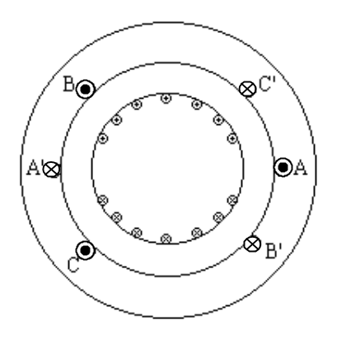

Figure G1.3 Winding Layout for Two-Pole Smooth Rotor Synchronous Machine

A complete theoretical analysis of synchronous machine operation is beyond the scope of this course, but there are many good texts on the subject; a representative sample of these is [2,3,4]. It will suffice here to discuss the basics of steady-state, balanced operation only.

G1.2.1 The Revolving Magnetic Field
The DC current in the revolving field windings on the rotor produces a revolving magnetic field. We denote the flux associated with this field that links the armature windings as 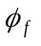 (the subscript “f” indicates field windings). By Faraday’s Law of Induction, this rotating magnetic field will induce voltages in the three armature windings. Because these three windings are physically displaced by 120 degrees (for a two-pole machine), the induced voltages will be phase displaced in time by 120 degrees.

If each of the three armature windings is connected across equal impedances, balanced three phase currents will flow in them. These currents will in turn produce their own magnetic fields. We denote the flux associated with each field as 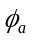, 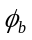, and 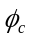. The resultant field with associated flux obtained as the sum of the three component fluxes, , and is the field of armature reaction. We designate the associated flux as 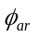. Using electromagnetic field theory and a trigonometric identity, one can show that revolves at the same velocity as the rotor. Therefore the two fields represented by 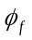 and are stationary with respect to each other. The armature field is effectively “locked in” with the rotor field and the two fields are said to be rotating in synchronism. The total resultant field is the sum of the field from the rotor windings and that associated with armature reaction: 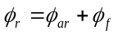.

G1.2.2 The Phasor Diagram
From Faraday’s Law of Induction, a voltage is induced in each of the three armature windings according to 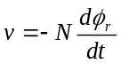 where Ν is the number of winding turns. Because 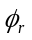 is a sinusoidal function of time, the negative sign captures the fact that the induced voltage will lag the flux by 90 degrees. Letting 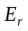, 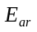, and 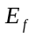 be the voltages induced in winding a by the fluxes , , and , respectively, we can represent the relationships in time between the various quantities using the phasor diagram, illustrated in Figure G1.4.
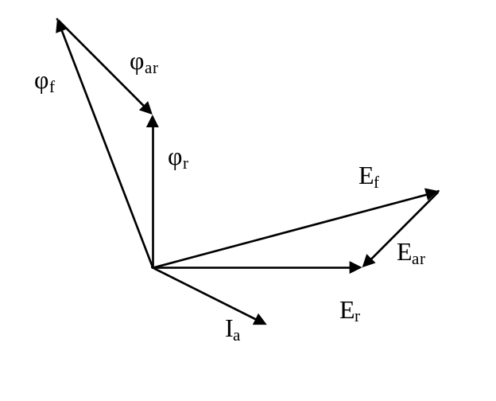

Figure G1.4 Phasor Diagram for Synchronous Machine

Regarding Figure G1.4, take note that
- All voltages lag their corresponding fluxes by 90 degrees.
- The current in winding a, denoted by 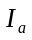, is in phase with the flux it produces
- If 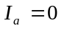 (no load conditions), then 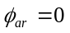, and in this case, 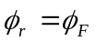, and 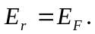
- All resistances have been neglected.

G1.2.3 The Equivalent Circuit Model
We develop the equivalent circuit model for winding a only; the same model applies to windings b and c with appropriate 120 degree phase shifts in all currents and voltages, assuming balanced operation such that the loading on each winding is the same.

From Figure G1.4, the component voltages are related via
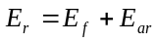 (G1.2)
However, because

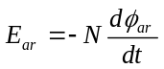

and is directly proportional to (assuming constant permeability), we can write that

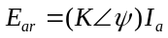.

Assuming is sinusoidal, the angle must be -90 degrees; therefore the constant of proportionality must be a reactance, which we will denote as 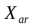. These changes result in

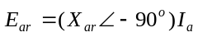 or 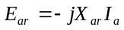

Substitution into eqs.(G1.2) yields

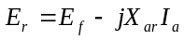

We obtain the terminal voltage by subtracting from 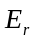, a voltage drop caused by to account for the leakage flux. This refinement results in

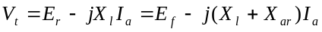

Defining 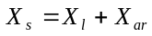 as the synchronous reactance, we have that

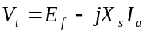

The circuit model corresponding to this equation is illustrated in Figure G1.5.

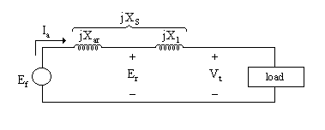

Figure G1.5 Equivalent Circuit Model of Synchronous Machine

The phasor diagram corresponding to the equivalent circuit, when the load is inductive, is shown in Figure G1.6.

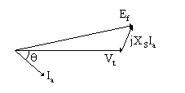

Figure G1.6 Phasor Diagram for Equivalent Circuit – Inductive Load

The phasor diagram corresponding to the equivalent circuit, when the load is capacitive, is shown in Figure G1.7.

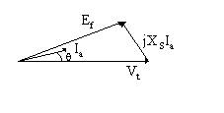

Figure G1.7 Phasor Diagram for Equivalent Circuit – Capacitive Load

When the load is inductive, the current 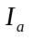 lags the voltage ; the generator is said to be operating “lagging.” When the load is capacitive, the current leads the voltage 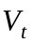; the generator is said to be operating “leading.” The angle between and is _{i}, i.e., 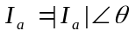_{i} if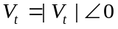. This implies that
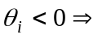lagging, 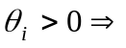leading

Example G 1.1

A 10 MVA, 3 phase, Y-connected, two pole, 60 Hz, 13.8 kV (line to line) generator has a synchronous reactance of 20 ohms per phase. Find the excitation voltage 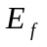 if the generator is operating at rated terminal voltage and supplying (a) 300 Amperes at 30 degrees lagging, (b) 300 Amperes at 30 degrees leading.

Solution
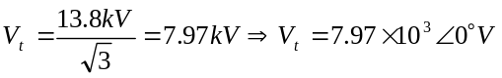
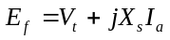
(a)
(b)

Note that the excitation voltage magnitude 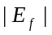 is much higher in the lagging case. We sometimes refer to the lagging case as overexcited operation; here we have that 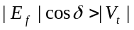, where δ is the angle between and . The leading case results in under-excited operation; in this case we have 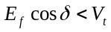.

G1.2.4 Power Relationships
From our equivalent circuit in Figure G1.5, we write that . Solving for yields

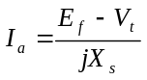

Define the power angle, , where 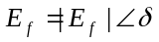, 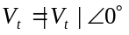so that is the angle at which the excitation voltage leads the terminal voltage. Therefore,

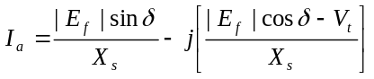 (G1. 3)

But

. (G1.4)

since 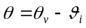 and 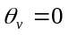 because is the reference phasor.

Equating real and imaginary parts of eqns. G1.3 and G1.4, we have 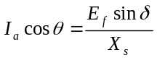 and 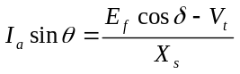. Multiplying both sides of the previous equations by 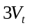 yields

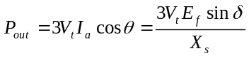 (G1.5)

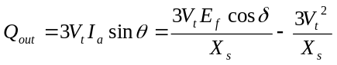 (G1.6)

In eqn. G1. 6, reactive power out of the machine is positive when the machine is operated overexcited, i.e., when it is lagging implying 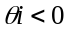.It is important to realize that eqns. G1.5 and G1.6 are based on the assumption that stator winding resistance is zero.

Example G 1.2

Find 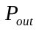 and 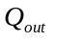 for the conditions (a) and (b) described in the previous example.

Solution

(a)

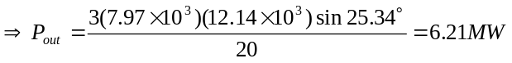

(b)

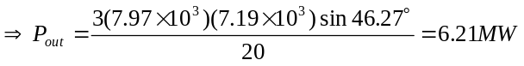

The student should consider the following questions regarding this example:
- Why is real power the same under the two conditions?
- When the generator is operating lagging, is it absorbing VAR from or supplying VAR to the network? What about when the generator is operating leading?
- For a particular angle , are the terms “lagging” and “leading” meaningful with respect to real power? With respect to reactive power?

G1.2.5 Generator Pull-Out Power
From eqs.(G1.5), the electrical power output 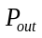 can be plotted against the power angle , resulting in sinusoidal variation as shown in Figure G1.8.

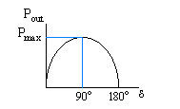

Figure G1.8 Power Angle Curve

For simplicity, and without loss of generality, we neglect all real power losses associated with windage and heat loss in the turbine and friction in turbine and generator bearings. Continuing with the assumption that stator winding resistances are zero, in steady-state operation, the mechanical power input to the machine is equal to the electrical power: 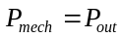. (In reality, 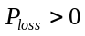 in steady-state operation so that 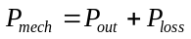.) Consider what happens to this lossless machine operating at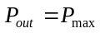 (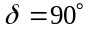) when the steam valve opening is increased so that 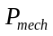 becomes slightly larger. In this case, the power angle increases beyond 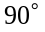, and the electrical power begins to decrease. However, the mechanical power is only dependent on the steam valve opening, i.e., it is unaffected by the decrease in 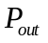. This can only mean that 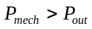. The difference 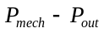 causes the machine to accelerate beyond its synchronous speed. When this happens, we say that the machine has “pulled out,” “gone out of step,” or “lost synchronism.” The generation level at which this happens is called the pull out power. It is given by
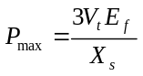

This limit is lower when the generator is under-excited (leading current) because is lower.

Example G 1.3

Compute the pull-out power for the two conditions described in Example G1.1.

Solution

(a) Overexcited case (lagging):
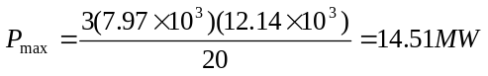
(b) Under-excited case (leading):
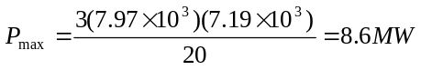

G1.3 Excitation Control
In examples G1.1 and G1.2, we saw two different conditions, summarized as follows:

a. 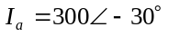 (lagging), (supplying)
b. 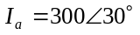 (leading), (absorbing)

We recall that in both conditions, the terminal voltage was constant at 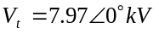. One observes that although terminal voltage is constant, and 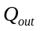 are not. These effects are achieved via control of the generator field current, which produces the field flux 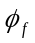. Field current control can be done manually, but it is also done automatically via the excitation control system.

The excitation control system is an automatic feedback control having the primary function of maintaining a predetermined terminal voltage by modifying the field current of the synchronous generator based on changes in the terminal voltage. Without excitation control, terminal voltage would fluctuate as a result of changes in or external network conditions. The control is referred to as “negative feedback” because when terminal voltage increases, field current is decreased, and when terminal voltage decreases, field current is increased. A simplified block diagram of an excitation control system is shown in Figure G1.9.

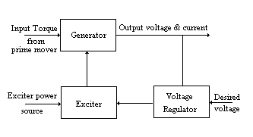

Figure G1.9 Block Diagram of Excitation Control System

There are three fundamental components to any excitation system. The main exciter, or more simply, the exciter, is the device that provides the field current for the synchronous generator. The automatic voltage regulator (AVR) couples the terminal voltage to the input of the main exciter. The amplifier increases the power of the regulating signal to that required by the exciter. If the amplifier is electromechanical, it is called the pilot exciter or the rotating amplifier. If the amplifier is solid state, it is usually considered as part of the AVR.

There are three basic types of excitation systems. These are:
- rotating DC commutator
- rotating AC alternator
- static

These are illustrated in Figures G1.10, G1.11, and G1.12.

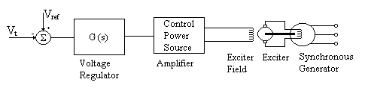

Figure G1.10 Rotating DC Commutator Type Excitation System

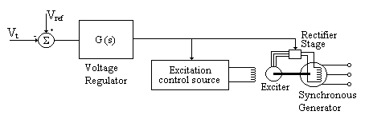

Figure G1.11 Rotating AC Alternator Type Excitation System

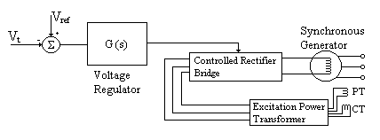

Figure G1.12 Static Type Excitation System

The DC commutator excitation system utilizes a DC generator mounted on the shaft of the synchronous generator to supply the field current. This type of system is no longer used in new facilities because it is slow in response, and because it requires high maintenance slip rings and brushes to couple the exciter output to the field windings.

The AC alternator excitation system uses an AC alternator with AC to DC rectification to supply the field winding of the synchronous generator. An important advantage over DC commutator systems is that AC alternator systems may be brushless, i.e., they do not use slip rings to couple the exciter to the rotor-mounted field winding. For example, the General Electric Althyrex© uses an “inverted” alternator to supply the field voltage through a rectifier. The alternator is inverted in that, unlike the power generator, the field winding is on the stator and the armature windings are on the rotor. Therefore the alternator field can be fed directly without the need for slip rings and brushes. Rectification to DC, required by the synchronous generator field, takes place by feeding the alternator three-phase output to a thyristor controlled bridge. The thyristor or silicon controlled rectifier (SCR) is similar to a diode, except that it remains “off” until a control signal is applied to the gate. The device will then conduct until current drops below a certain value or until the voltage across it reverses. This device will be further discussed in Chapter 7.

The third type of excitation system is called a static system because it is composed entirely of solid state circuitry, i.e., it contains no rotating device. The power source for this type of system is a potential and/or a current transformer supplied by the synchronous generator terminals. Three-phase power is fed to a rectifier, and the rectified DC output is applied to the synchronous generator field via slip rings and brushes. Static excitation systems are usually less expensive than AC alternator types, and the additional maintenance required by the slip rings and brushes is outweighed by the fact that static excitation systems have no rotating device.

G1.4 Turbine Speed Control
We have already seen that the mechanical speed of a synchronous generator 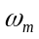 (rad/sec) is related to the electrical frequency through 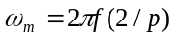 where is the number of poles. This implies that control of speed also means control of frequency. But what causes frequency to deviate from its nominal value of 60 Hz?

If you consider your own daily use of electricity, you will realize that the load level seen by supplying generators is constantly changing, and at least one generator must compensate for these changes. In discussion of pullout power, we saw that when , the generator accelerated. In the same way, if is greater than the load, 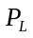, the generator will also accelerate, resulting in a frequency increase; if is less than , the generator will decelerate, resulting in a frequency decrease.

The effect of a generation-load imbalance on frequency, and the relation between generator speed and frequency, offers an elegant way to maintain a generation-load balance: use deviation from rated turbine speed (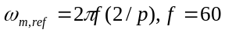) as a control signal to cause appropriate action regarding adjustment of the energy supply valve. If 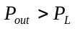, causing 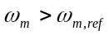, the difference signal 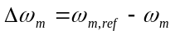 is fed back to an actuator, which adjusts the energy supply valve so as to reduce the energy supply and thus reduce . Likewise, if 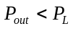, causing 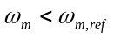, the difference signal 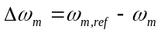 is fed back to an actuator, which adjusts the energy supply valve so as to increase the fuel intake and thus increase . The actuator, which accomplishes these actions, is called the speed governor. A simplified block diagram of the complete speed governing control system is shown in Figure G1.13.

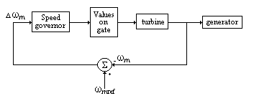

Figure G1.13 Block Diagram of Speed Governing Control System

The purpose of frequency control is not only to maintain power balance, but also to protect frequency-sensitive loads from experiencing large frequency excursions. Some types of loads are designed to operate best at nominal frequency, and the performance of these loads may degrade substantially when frequency deviates from its nominal value. Frequency sensitive loads include some types of motor drives, electronic loads (including computers), and clocks. In North America, frequency is normally regulated to remain within 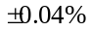 (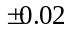 Hz), but this is considered “tight;” many power systems in other regions of the world are operated under “looser” regulation. Indeed, there is ongoing debate in the U.S. today regarding loosening the frequency control criterion.

Because speed-governors act to maintain load balance and frequency constancy, the overall control system of which they are a part is often referred to as load-frequency control. The speed-governor constitutes what is known as the primary control; the higher level aspects of load frequency control are known as secondary control and constitute automatic generation control (AGC). We will not discuss AGC here.

Speed governing equipment for steam and hydro turbines are conceptually similar. Most speed governing systems are one of two types; mechanical-hydraulic or Electro-hydraulic. Electro-hydraulic governing equipment use electrical sensing instead of mechanical, and various other functions are implemented using electronic circuitry. Some Electro-hydraulic governing systems also incorporate digital (computer software) control to achieve necessary transient and steady state control requirements. The mechanical-hydraulic design, illustrated in Figure G1.14, is used with older generator units.

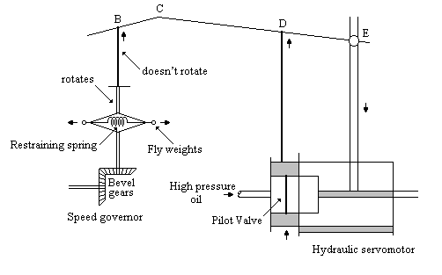

Figure G1.14 Mechanical-Hydraulic Governor Design

Basic operation of this feedback control system for turbine under-speed is indicted by movement of each component as indicated by the arrows. As decreases, the bevel gears decrease their rotational speed, and the rotating flyweights pull together due to decreased centrifugal force. This causes point B and therefore point C to raise. Assuming, initially, that point E is fixed, point D also raises causing high pressure oil to flow into the cylinder through the upper port. The oil causes the main piston to lower, which opens the steam valve (or water gate in the case of a hydro machine), increasing the energy supply to the machine in order to increase the speed.

If rod CDE was not connected at point E, the previous actions would provide constant frequency, as long as no more than one machine in the system was regulating. However, if two or more machines were regulating, each machine would continuously “correct” frequency changes made by the others, i.e. they would “fight” each other. The connection at point E solves this problem. This connection forces point D to move down slightly as point E moves down. This action provides for a nonzero steady state frequency deviation according to 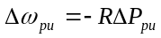 where is called the steady state droop or regulation constant, and 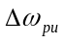 and 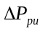 are the per unit steady state deviations in frequency and power, respectively. The so-called steady state droop characteristic is illustrated in Figure G1.15.

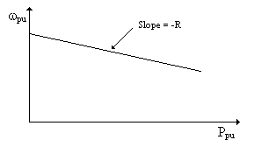

Figure G1.15 Steady-State Droop Characteristic

Example G 1.4

Two machines on speed-governor control are interconnected and supplying the same load when the load suddenly increases such that the steady state frequency deviation is 0.01 Hz. If both machines have a droop of 5% (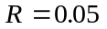), machine A is rated at 100 MW and machine B is rated at 200 MW, compute the steady state deviation in power for each machine.

Solution

A sudden increase in load will decelerate the machine and therefore frequency must decrease.
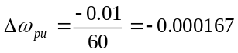
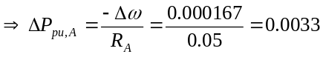
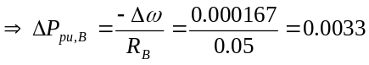
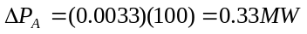
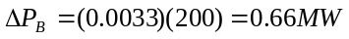

The student should answer the following questions:

- Why is steady state frequency deviation the same for both machines?
- Why is the steady state change in per unit power the same for both machines?
- Basic intuition might suggest that, for a given load change, we would like all machines to respond, but “bigger machines should respond more than smaller machines.” By studying the above example, you should be able to state a simple requirement regarding coordination of governing systems that would provide for this.

A key point is that the droop characteristic does result in nonzero steady state frequency deviation. This frequency deviation must be corrected so that the system frequency returns to 60 Hz. This is the function of the secondary load-frequency control loop, to be discussed in Chapter 5.

G1.5 Summary

The operating costs of generating electrical energy is determined by the fuel cost and the efficiency of the power plant. The efficiency depends on generation level and can be obtained from the heat rate curve. We may also obtain the incremental cost curve from the heat rate curve. In Module E3 it is illustrated how this very important generator characteristic is used to find optimal (least cost) allocation of demand among all of the interconnected generators. The AC synchronous machine is the most common technology for generating electrical energy. It is called synchronous because the composite magnetic field produced by the three stator windings rotate at the same speed as the magnetic field produced by the field winding on the rotor. We use a simplified circuit model to analyze steady-state operating conditions for a synchronous machine. The phasor diagram is an effective tool for visualizing the relationships between internal voltage, armature current, and terminal voltage. The excitation control system is used on synchronous machines to regulate terminal voltage, and the turbine-governor system is used to regulate the speed of the machine.

References

A. Bergen, Power Systems Analysis, Prentice-Hall, New Jersey, 1986.

V. Del Toro, Electric Power Systems, Prentice-Hall New Jersey, 1992.

P. Kundur, Power System Stability and Control, McGraw-Hill, New York, 1994.

W. Stevenson, Elements of Power System Analysis, 4th edition, McGraw-Hill, New York, 1982.

D. Fink and H. Beaty, editors, Standard Handbook for Electrical Engineers, 13th edition, 1993, Graw-Hill, Inc., New York.

L. Matsch, Electromagnetic and Electromechanical Machines, 2nd edition, Ahrper and Row, new York, 1977.

A. Fitzgerald, C. Kingsley, and A. Kusko, Electric Machinery, 3rd edition, McGraw-Hill, New York, 1971.

V. Mablekos, Electric Machine Theory for Power Engineers, Harper and Row, Cambridge, 1980.

S. Dewan and A. Straughen, Power Semiconductor Circuits, John Wiley and Sons, New York, 1975.

P. Anderson and A. Fouad, Power System Control and Stability, The Iowa State University Press, 1977.

E. Kimbark, Power System Stability, Synchronous Machines, Dover Publications, 1956.

P R O B L E M S

Problem 1
A three-phase, 60 Hz generator has a synchronous reactance of 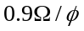 and negligible resistance. The generator is delivering 50MW at 0.8 power factor lagging. The terminal voltage remains constant at 30kV line to line throughout this problem.

- Determine the excitation voltage per phase (angle and magnitude ) and the reactive power out of the machine.
- With the field current held constant at the level of part (a), the mechanical power into the machine is reduced to 25MW. Determine the reactive power out of the machine.
- With the machine initially generating 50MW at 0.8 power factor lagging, as in part (a), a change is made so that the excitation voltage is reduced to 79.2% of its value. Determine the reactive power out of the machine.

Problem 2
A three-phase, 6-pole, 60 Hz, Y-connected synchronous generator has a synchronous reactance of 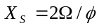. It is operating so that the terminal voltage is constant at 13.8kV line-to-line. The three-phase real power output of the machine is 6MW. Assume the line-to-neutral terminal voltage is the reference (angle = 0 degree) for all calculation below.

- What is the synchronous speed of this generator in RPM?
- The excitation voltage magnitude is 19kV line-to-line. What is the power angle delta (the angle between the excitation voltage and the terminal voltage) ? Based on this answer, indicate whether the generator is operating leading or lagging and how you can tell.
- What is the magnitude and angle of the current ? Based on this answer, indicate whether the generator is operating leading or lagging and how you can tell.
- Compute the three phase reactive power out of the machine. Based on this answer, indicate whether the generator is operating leading or lagging and how you can tell.

Problem 3
In each of the following questions circle the answer that is most likely to be correct based only on the information for that question and the following two sentences. In all cases a single generator is directly connected to a single load. All voltages are line to neutral.

i) A generator is supplying 20 MVAR to a load. The angle 'theta' of the load impedance is ____.
a) negative b) zero c) positive d) not enough information

ii) The terminal voltage of a generator is kV. The excitation voltage is 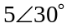 kV. This generator is operating with a power factor that is ______.
a) leading b) unity c) lagging d) not enough information

iii) A generator has an armature current of 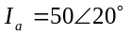A when the terminal voltage is 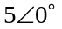kV. The generator is _______.
a) overexcited b) under-excited c) neither d)not enough information

iv) The excitation voltage of a generator is very large in magnitude. The load is _______.
a) resistive b) inductive c) capacitive d) not enough information

v) The real power output of a generator is positive. The current is ________ the terminal voltage.
a) leading b) in phase with c) lagging d) not enough information

vi) The load is inductive. The angle of the terminal voltage is 0 degrees. The angle of the current is _______.
a) positive b) negative c) zero d) not enough information

vii) The DC current to the field winding is very small. The generator is ________ reactive power.
a) supplying b) absorbing c) neither d) not enough information

viii) The angles of the excitation voltage and the terminal voltage are both 0 degrees. The real power of the machine is ________.
a) positive b) negative c) zero d) not enough information

ix) The real power consumed by the load suddenly increases. The system frequency will ___.
a) increase b) decrease c) stay the same d) not enough information

x) The system frequency increases. The speed of the machine must have ________.
a) increased b) decreased c) stayed the same d) not enough information

Problem 4
Draw a rough sketch of a three-phase two-pole smooth-rotor synchronous generator. Label the stator, rotor, field winding, and armature winding.

Problem 5
Why are the armature windings in a three-phase two-pole synchronous generator spaced 120 degrees apart?

Problem 6
In Germany normal appliances use 50 Hz AC power. What is the ideal speed (in RPM) of the rotor in a three-phase four-pole synchronous generator supplying this power?

Problem 7
Why is it necessary to control the speed of the turbine? What would the problem be (for power consumers) if the turbine speed were not controlled? In a broad sense, how is control of turbine speed accomplished?

Problem 8
A three-phase synchronous generator is operating with terminal voltage (line-to-neutral) of 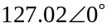V. Its per-phase internal excitation voltage is 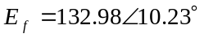V. The synchronous reactance is 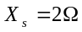.
a) Compute the three phase real power out of the generator.
b) Compute the three phase reactive power out of the generator.
c) Compute the total current supplied by the generator.
d) Draw the phasor diagram for this operating situation. Show terminal voltage, internal voltage, and current.
e) Indicate whether this operating condition is leading or lagging.
f) Compute the angle of 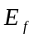(denoted as delta) required if the operating condition were changed so that the magnitude of remains unchanged, but the reactive power being produced by the generator is zero (i.e. unity power factor).

Problem 9
A three-phase synchronous generator, having rated terminal voltage (line-to-line) of 220 volts, is operating so that its per-phase internal (excitation) voltage is V. Assume constant terminal voltage at rated voltage. The synchronous reactance is 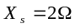.
- Compute the reactive power out of the generator.
- The field current is now changed so that the reactive power supplied by the machine is 600 VAR. The real power out of the machine is 3kW. Find the excitation voltage 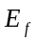(magnitude and angle).

Problem 10
A three-phase synchronous generator is supplying a load over a transformer connected to a transmission line. The circuit is illustrated below.

Impedance data (in per-unit) are:
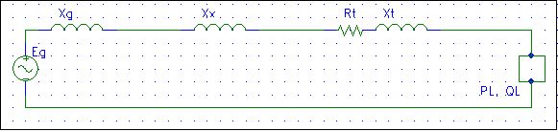
+
V₁
-
+
V_{L}
-
+
V₃
-

= V_{t}

Operating information:
Base Voltages: 13.8kV, 230kV
Base Power: 100MVA

a) Draw the vector diagram, showing 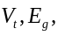and for this operating condition. Also, redraw the phasor diagram for the case when 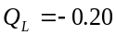per-unit. It is unnecessary to do calculations, but the length and angles of the three vectors relative to each other should be approximately correct. Identify each phasor diagram as either leading, lagging, or neither.
b) Compute the real and reactive power supplied at the generator terminals (at bus 1), in MW and MVAR.
c) Compute the real and reactive power flowing into the transmission line from bus 3, in MW and MVAR.
d) Are the answers to (b) and (c) different? Why or why not?

Problem 11
A Y-connected three-phase synchronous generator has a synchronous reactance of 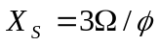. The terminal voltage of the generator is 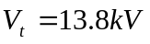 (line-to-line) and the armature current is 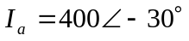 (referenced to line-to-neutral terminal voltage). (a) Compute the internal voltage phasor of the machine, E_{f} (line-to-neutral). (b) Determine the magnitude of this phasor, |E_{f} | necessary to provide 0 vars reactive power out of the machine terminals, assuming that the angle of this phasor, ∠E_{f} , is held constant at the value obtained in your calculation of part (a).

Problem 12
A synchronous generator having synchronous reactance of X_{S}=2 ohms is operating with an 18.0 line-to-line terminal voltage. The power out of the machine terminals is P_{out}=140 MW, Q_{out}=0.

  - Compute the magnitude |E_{f}| and angle ∠δ of the internal (excitation) voltage.
  - A large reactor (e.g., inductive element) is suddenly connected in parallel with the load R_{L}, and the field current is adjusted. Indicate what would happen to each of the below by checking the appropriate space:
  - Field current increase______ decrease_____
  - Reactive power out of the generator increase______ decrease_____ no change_____
  - Current lead_________ lag_________ neither________

Per unit frequency deviation is given by 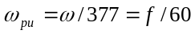 when 60 Hz is the nominal frequency.

