Notes 2: Loads and Load Duration

2.0 Introduction

Unlike transmission systems, distribution systems are directly connected to loads. As a result, the nature of the load often has a large influence on operational and planning decisions concerning the distribution system.

We characterize loads in two different ways:
- Devices:
        - Lighting
        - Motor
        - Heating
        - Electronic
- End user classes:
        - Residential
        - Commercial
        - Agricultural (rural commercial)
        - Industrial

Device characterization of loads is important when assessing load behavior under abnormal voltage conditions, either transient or steady-state, because the various devices behave differently under such conditions.

End-user class (also called customer class) characterization is more appropriate when assessing usage behavior. Such behavior is normally assessed at the feeder, substation, region, or system level, and at this level, end-users of a given class tend to use electrical energy in much the same manner. This is the orientation we will take in this module.

2.1 Load curves

Note: Reference [1] has a good picture (Fig. 7-7, page 147) and explanation regarding load curve variation. Should include this in this section.

The load curve is a plot of load (or load per end-user) variation as a function of time for a defined group of end-users.

The end-user grouping may be by electrical proximity, e.g., by feeder, substation, region, or system level. Alternatively, it may be by end-user class.

Daily, weekly, monthly, and yearly load curves are commonly developed and used in order to gain insight into the usage behavior of a group of end-users.

Fig. 1 shows a daily load curve for a single residential end-user. The multiplicity of high peaks is due to the intermittent operation of large appliances such as refrigerators, air conditioners, and stoves, where the highest peaks are a result of simultaneous operation of such devices.
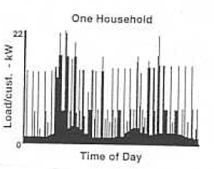

Fig. 1: Daily load curve for single residential end-user [1]

Fig. 1 is not very useful for understanding the usage behavior of residential end-users as a class. To do this, we develop a load curve for multiple residential end-users. To provide a basis for comparison, we plot the load per end-user rather than the total load. Fig. 2 illustrates daily load curves for 2, 5, 20, and 100 end-users, respectively.

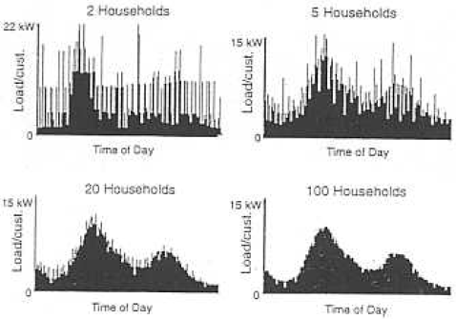
Fig. 2: Daily load curves for groups of end-users [1]

We observe the smoothing effect on the curves. We also observe the peak load per end-user decreases as the number of end-users in the group increases. This is because at any given moment, some end-users will incur a peak while others do not, so that the average load at any given moment will always be less than the highest individual peaks for that moment.
This aggregation of load curves across multiple end-users is done for each of the different end-user classes, except the load curves are given in terms of percent of peak rather than load per end-user.

Fig. 3 illustrates such load curves for the various end-user classes, including a “miscellaneous” class (mainly sales to other utilities) and also the aggregation of these class-specific load curves into a system load curve.
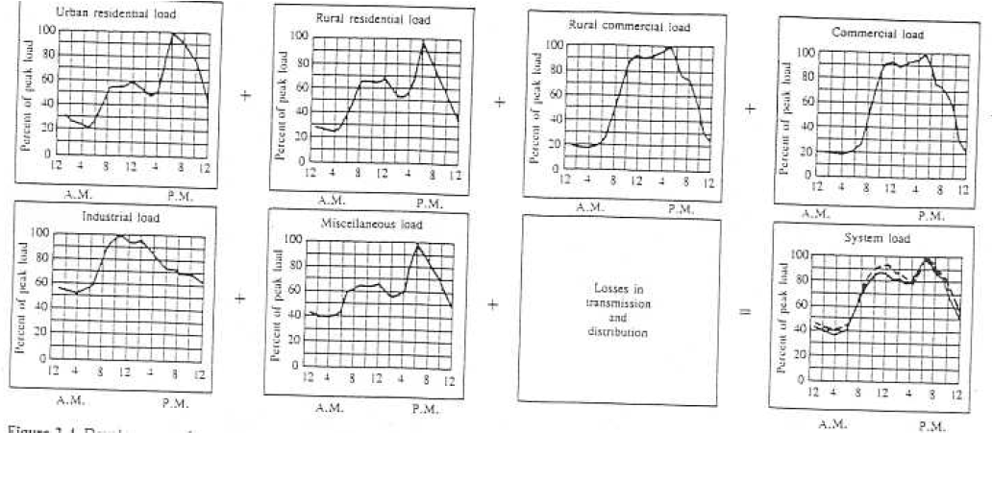
Fig. 3: Class-specific load curves and system load curve

Some observations from Fig. 3 follow:
- Urban and rural residential loads
- Have three peaks: once at 8 am, once at noon, and once at 6 pm,
- Have two valleys, once at 5 am and once at 3 pm,
- Differ in that the urban load does not fall off so steeply after 7 pm.
- Commercial loads (rural and urban) peak at about 11 am, dip slightly at noon, and then are rise slightly until about 5 pm after which they drop sharply.
- The industrial load curves are similar to the commercial except that the valley’s only dip to about 50% of peak rather than 20% in the case of commercial. This is the case since many industrial end-users operate 24 hours a day.
The final aggregate curve (solid line) has the same form as the residential curves but the peaks and valleys are less pronounced due to the smoothing effect of the other load class curves.

Definition: A conforming load, relative to a group of loads, has a load curve that looks similar to the group’s load curve. A non-conforming curve does not.

Residential loads are typically conforming relative to the system load, as we saw in the above.

City street light load is non-conforming relative to the system load as these loads tend to peak at the system off-peak times. Steel mills with their electric arc furnaces that generate intermittent and sharp load use spikes are also non-conforming.

2.2 Load duration curves

It is often of interest to know the percent of time that the load in a system, flowing through a substation, or flowing on a feeder exceeds some particular level.

For example, we might determine that at 90% of peak, the losses are unacceptably large for the existing amount of voltage switched capacitors. Purchasing and installing more voltage switched capacitors would solve the problem. This may be a good investment if the load exceeds 90% of peak for more than 5% of the time. Otherwise, it is not a good investment. So how do we tell the % of time the load exceeds a particular value?

One tool for doing this is the so-called load duration curve, which is formed as follows.

Consider that we have obtained, either through historical data or through forecasting, a plot of the load vs. time for a period T, as shown in Fig. 4 below.
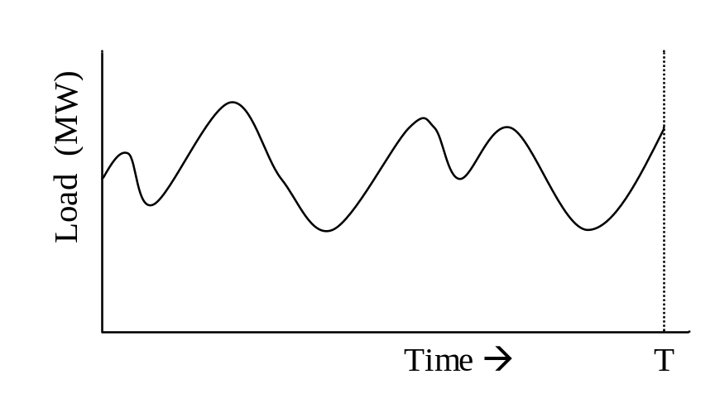
Fig. 4: Load curve (load vs. time)

Of course, the data characterizing Fig. 4 will be discrete, as illustrated in Fig. 5.
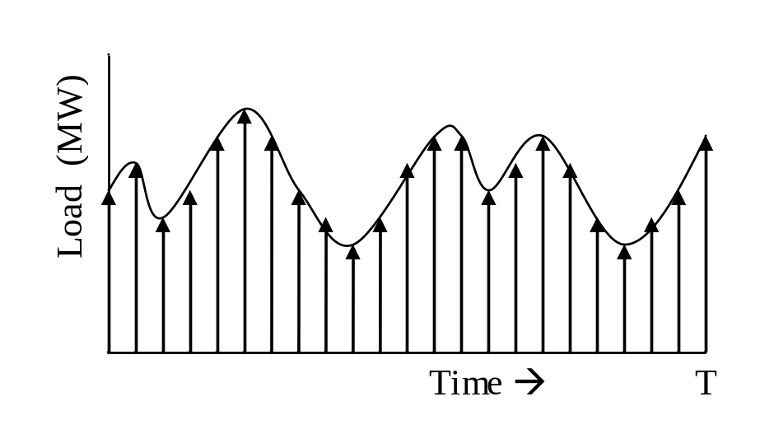
Fig. 5: Discretized Load Curve

We now divide the load range into intervals, as shown in Fig. 6.
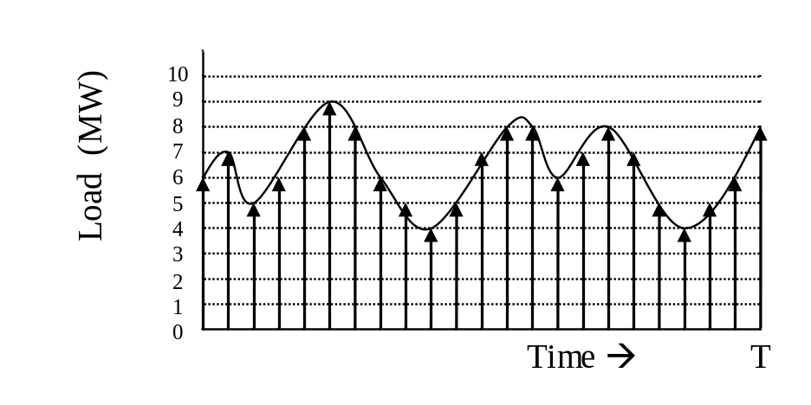
Fig. 6: Load range divided into intervals

This provides the ability to form a histogram by counting the number of time intervals contained in each load range. In this example, we assume that loads in Fig. 6 at the lower end of the range are “in” the range. The histogram for Fig. 6 is shown in Fig. 7.
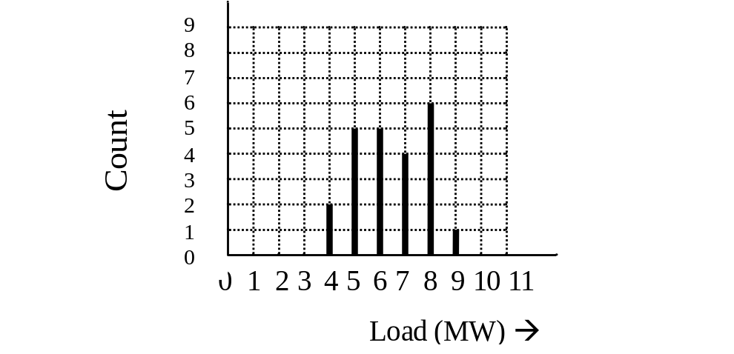
Fig. 7: Histogram

Figure 7 may be converted to a probability mass function, pmf, (which is the discrete version of the probability density function, pdf) by dividing each count by the total number of time intervals, which is 23. The resulting plot is shown in Fig. 8.
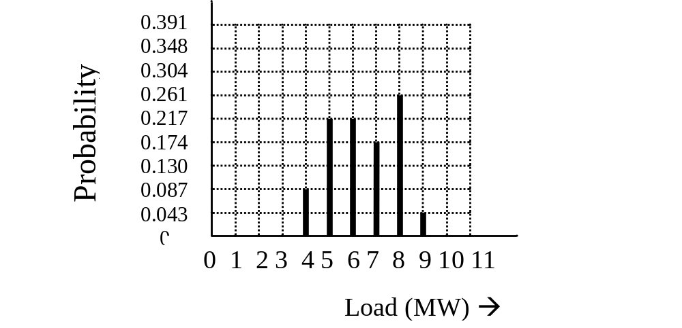
Fig. 8: Probability mass function

Like any valid pmf, the summation of all probability values should be 1, which we see by the following sum: 0.087+0.217+0.217+0.174+0.261+0.043=0.999 (it is not exactly 1.0 because there is some rounding error). The probability mass function provides us with the ability to compute the probability of the load being within a range according to:
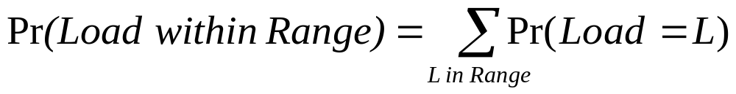
We may use the probability mass function to obtain the cumulative distribution function (CDF) according to:
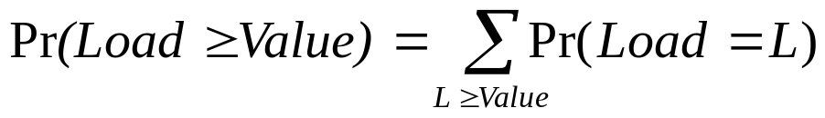
From Fig. 8, we obtain:
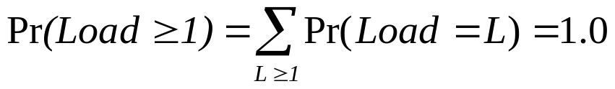
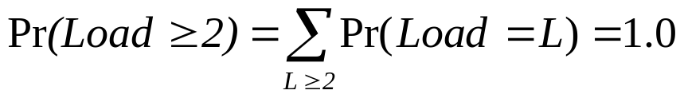
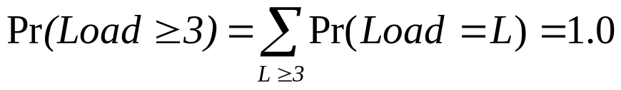
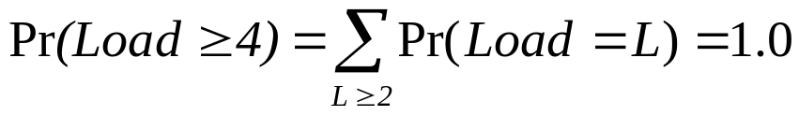
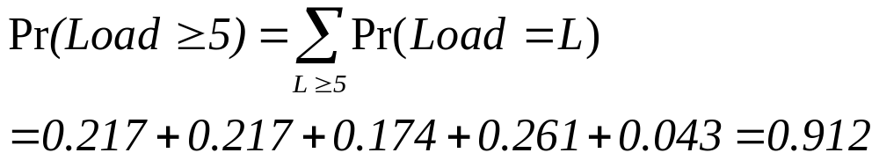

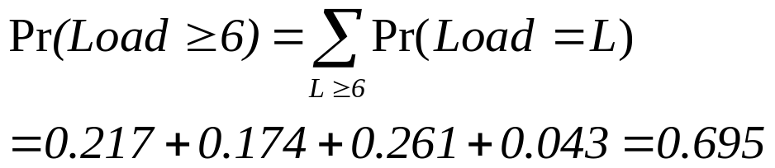
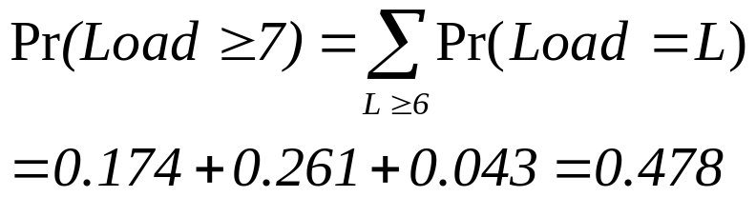

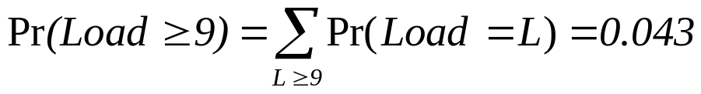
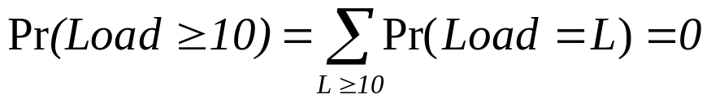
Plotting these values vs. the load results in the CDF of Fig. 9.
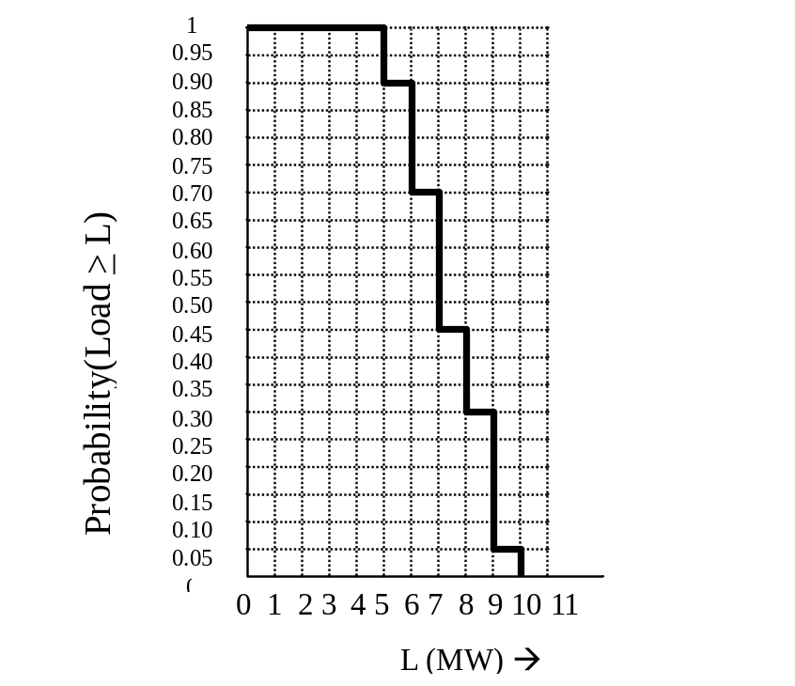
Fig. 9: Cumulative distribution function
The plot of Fig. 9 is often shown with the load on the vertical axis, as given in Fig. 10.
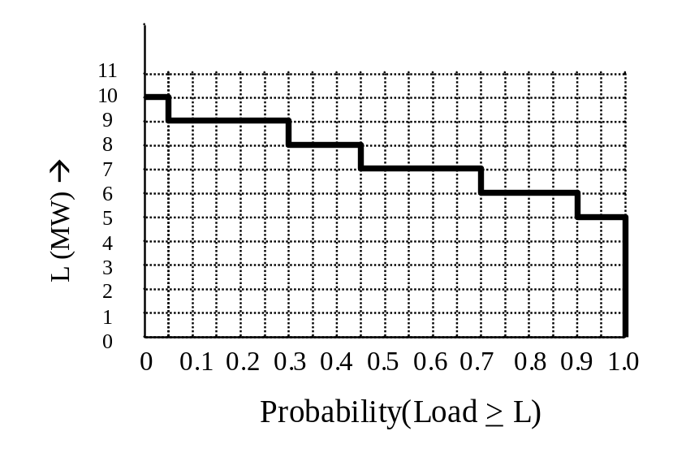
Fig. 10: CDF with axes switched

If the horizontal axis of Fig. 10 is scaled by the time duration of the interval over which the original load data was taken, T, we obtain the load duration curve.

This curve provides the number of time intervals that the load equals, or exceeds, a given load level. For example, if the original load data had been taken over a day, then the load duration curve would show the number of hours out of that day for which the load could be expected to equal or exceed a given load level, as shown in Fig. 8.
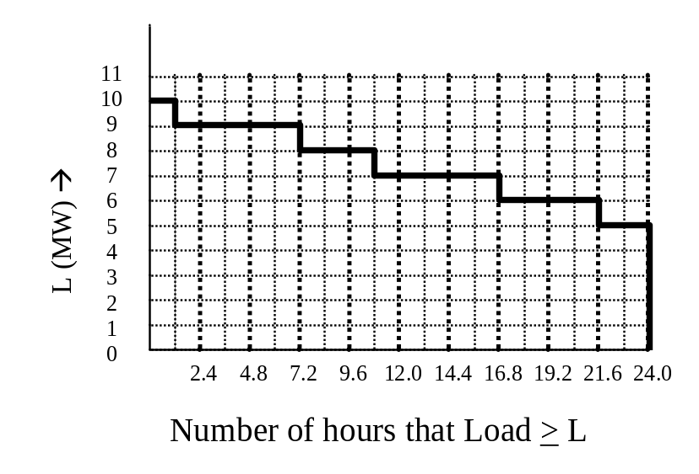
Fig. 11: Load duration curve

Load duration curves are useful in that they provide guidance for judging different alternatives. In our example of unacceptable losses at loads exceeding 90%, we see from Fig. 11 that this situation occurs for 1.2 hours/day (or 5% of the time).

References:
[1] T. Gonen, Electric Power Distribution System Engineering, McGraw-Hill, 1986.

