CE 524: Air Pollution
A2 Noise Pollution Homework
Problems: 15-2, 15-4, 15-8, 15-15, and 15-17

15-2: A building located near a road is 6.92m high. How high is the building in terms of wavelength of a 500-Hz sound if the temperature is 25°C? Speed of sound is 346.12 m/s.

λ=c/f where: λ=wavelength, c=speed of sound (346.12 m/s), f=frequency (500-Hz)

λ=346.12/500 → λ=.692 m

The building height is 10 wavelengths

15-4: A motorcyclist is warming up his racing cycle at a racetrack approximately 200m from a sound level meter. The meter reading is 56 dBA. What meter reading would you expect if 15 of the motorcycle’s friends join her with motorcycles having exactly the same sound emission characteristics? You may assume that the sources may be treated as ideal point sources located at the same points .
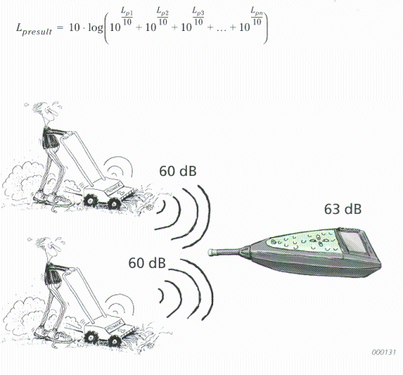
Note: A quick approach could be to observe doubling sources adds 3dBA. Doubling that to four, adds another 3dBA. Doubling that again and again gets us to 16 motorcycles and 68 dBA.

L_{presult} = 10 x log[16 x 10^(56/10)] → Lp = 68 dBA

15-8: Using the typical noise spectrum from automobiles traveling at 50-60km/h (see Figure 15-25), determine the equivalent A-weighted level using the following octave band geometric mean center frequencies (all hertz): 63, 125, 250, 500, 1000, 2000, 4000, and 8000.

Octave Frequency Range (Hz)* | Band Center Frequency (Hz) | Band Level (dB) | A Factor (dB) | Equivalent A Scale Value (dBA) | 10^(A Scale Value/10)
44-88 | 63 | 65 | -27 | 38 | 6309.6
88-175 | 125 | 63 | -18 | 45 | 31622.8
175-350 | 250 | 58 | -12 | 46 | 39810.7
350-700 | 500 | 59 | -4 | 55 | 316227.8
700-1400 | 1000 | 58 | 0 | 58 | 630957.3
1400-2800 | 2000 | 55 | 1 | 56 | 398107.2
2800-5600 | 4000 | 50 | 1 | 51 | 125892.5
5600-11200 | 8000 | 45 | -1 | 44 | 25118.9
 |  |  |  | Total | 1574046.8
 |  |  |  | 10*log(1574046)= | 62.0
*From Table 15-2
This could also have been calculated by using Figure 15-4
Lp=62.0 dBA
15-15: Consider an ideal single lane of road that carries 1200 vph uniformly spaced along the road and determine the following:
- The average center-to-center spacing of the vehicles for an average traffic speed of 40 km/h
- The number of vehicles in a 1km length of the lane when the average speed is 40 km/h
- The sound level (dBA) 60m from a 1km length of this roadway with automobiles emitting 71 dBA at the edge of an 8m wide roadway. Assume that the autos travel at a speed of 40 km/hr, that the sound radiates ideally from a hemisphere, and that contributions of less than 0.3 dBA may be ignored.

- 1 km = 1,000 m
(40,000 m/hr) / (1200 veh/hr) = 33.3 m per vehicle
Average center-to-center spacing = 33.3 m
Or: 1200 veh/h = 30 veh/km
40 km/h
- 1 km = 1,000 m
(1,000 m) / (33.3 m/veh) = 30 vehicles
30 vehicles in a kilometer length

- Sound level at edge of 8m wide, i.e. 4m to centerline

L_{p2} = 71 -20 log 60/4 = 71 – 23.5 = 47 dBA

15-17: In preparation for a public hearing on a proposed interstate bypass at Nontroppo, Michigan, the county road commission has requested that you prepare an estimate of the potential for violation of residential FHA noise standards 75m from the centerline of the interstate. The edge of the pavement is 28.65 m from the centerline.
Estimated Traffic Data for I-481 at Pianissimo Avenue
Automobiles: 7800 per hour at 88.5 km/hr
Heavy Trucks: 650 per hour at 88.5 km/hr
Compute the unattenuated Leq, at the receiver for autos only.

L_{eq} = 42.3 + 10.2log(Vc+6Vt) – 13.9logD + 0.13S (Equation 15-25)

L_{eq} = energy equivalent sound level during 1 h (dBA) = ?
V_{c} = volume of automobiles (vph) = 7800 vph
V_{t} = volume of trucks (vph) = 650 vph
D = distance from edge of pavement to receiver (m) = 75 m
S = average speed of traffic flow during 1 hr(km/h) = 88.5 km/h

Leq = 42.3 + 10.2log(7800+6*650) – 13.9log(75) + 0.13(88.5)

Leq = 70 dbA

