MODULE 9

NOISE POLLUTION

Noise is defined as unwanted sound. It is considered an environmental pollutant because, if it is present at sufficient intensity, undesired physiological and psychological effects are produced. Unlike chemical pollution, noise pollution can be immediately removed from the environment. Moreover, noise pulses have much shorter decay times than hazardous chemical shocks. However, once the disturbance begins, a reduction in the severity of its effect may be very difficult in contrast to a chemical plant upset. Simple action by stopping a leak, diverting a hazardous liquid flow, or shutting down equipment may prevent further environmental damage in that case, while noise amelioration may require redesign or a whole enclosure.

High intensity noise causes temporary or permanent hearing loss, interference with speech communication, sleep, and relaxation, and an impaired ability to carry out basic tasks. Prolonged exposure to noise may result in a slow loss of hearing over many years. The affected individual may be unaware that he or she is being injured by the noise until the hearing impairment becomes known. Because of the long apparent latency period, it becomes difficult to determine how long injury has taken place and to define the time-intensity noise profile causing the injury.

With the growth of modern society, noise levels have steadily risen, creating various adverse effects on our quality of life. Laws regarding noise control have been developed, requiring that noise be controlled in cities near airports, railway stations, freeways, and in other public areas. Air traffic routes and freeway sound barriers are designed to minimize disturbances to homeowners. Industrial operations must also comply with noise regulation. Areas within factories or chemical plants where noise levels are high have warning signs indicating the need for noise protection (ear plugs). Noise surveys are routinely done to protect workers and to satisfy occupational health and safety requirements.

This chapter presents the basic fundamentals of noise pollution and control. There are a growing number of environmental engineering books covering noise pollution. It is likely that, as new noise control technologies are developed and the regulations become more stringent, this area will gain additional importance to the environmental engineering profession.

PROPERTIES OF NOISE

Sound waves create sinusoidal changes in air pressure. The surrounding air undergoes an alternating compression and expansion causing a cyclic increase and decrease in air pressure and density. The time between the highs and lows in air pressure is known as the period. The frequency is the inverse of the period:

f = 1/P

and is measured in the units of Hertz (Hz). Sound waves are characterised by wavelength, or distance between the peaks or troughs and amplitude, the height of the peaks and troughs relative to a zero pressure line. Sound measurements are expressed in terms of root mean square air pressure:

$P_{\text{rms}}=\sqrt{\overline{P^{2}}}=\sqrt{\frac{1}{T}\int_{0}^{T}{P^{2}(t)\text{dt}}}$

where P is the air pressure and T is the time. The bar indicates that the pressure is a time weighted mean quantity. Use of an average pressure for sound measurement would not be possible because it averages to zero. Squaring also leads to adding, not subtracting negative values.

The time weighted average pressure force exerted by sound over the distance of propagation of the sound waves is work. The rate at which the work is done is the sound power (W). Sound intensity is the sound power per unit area normal to the direction of propagation.

Sound power is related to sound pressure:

I = (P_{rms})2/ρc

where I = sound intensity, W/m2
P_{rms} = Root means square pressure
ρ = density of air
c = speed of sound

At 1 atmosphere:

$$c=\text{20}\text{.}\text{05}\sqrt{T}$$

where T is in degrees K and c is in m/s.

SOUND LEVELS

The faintest sound detectable by the human ear in terms of air pressure is 0.00002 Pa (20 μPa) and that caused by a Saturn rocket is 200 Pa. Because of this enormous range, a scale based on logarithm of ratios of measured quantities is used. The units are referred to as Bels;

L' = log Q/Qo

where L' = level, Bels
Q = measured quantity
Qo = reference quantity
Log = logarithm in base 10
The Bel is normally subdivided into decibels (dB):

L = 10 log Q/Qo

For sound the measured quantity, Q, may be sound power, sound intensity, and sound pressure. The reference levels, Qo, for sound power and sound intensity are 10⁻¹² W and 10⁻¹² W/m², respectively. The sound pressure level is computed as:

L_{p} = 10 log(P_{rms})²/(P_{rms})o²

or equivalently;

L_{p} = 20 log P_{rms}/(P_{rms})o

The reference level is 20 μPa. The relative scale of sound pressure levels is shown in Figure 1.

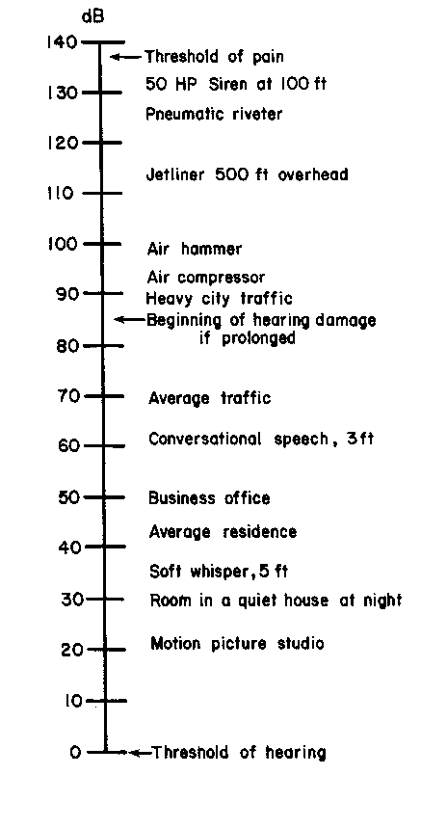
Figure 1 Environmental Noise
From Vesilind, P.A., Peirce, J.J., and Weiner, R.F. 1990. Environmental Pollution and Control. Butterworth-Heinemann, Figure 22-4 p 333

The addition of sound in decibels is illustrated in the following example.

Example 1

Determine the noise level corresponding to the addition of two noise levels of 60 dB.

The ratio of root mean square pressures for 60 dB is:

(P_{rms})²/(P_{rms})o² = 10^{60/10}
The sum of root mean square pressures for two sources is

P²_{rms1+2} = P²_{rms1} + P²_{rms2}

Therefore:

60 dB + 60 dB = 10 log (10 ^{60/10} + 10 ^{60/10}) = 63 dB

The sound pressure level is reported as 63 dB re: 20 μPa

Note that the doubling of sound level causes a 3dB gain. This is often the limit of what is admissible for new activities.

Adding more sound sources, e.g. 68, 75 and 79 dB, would just be 10 log (10^{68/10} + 10^{75/10} + 10 ^{79/10}) = 80.7dB

The human sensitivity to sound depends not only on sound pressure but also on sound frequency. The frequency range of sound can be estimated using a sound level meter, which contains electronic filtering circuits, which approximate the human response to sound at various frequencies. The weighting characteristics of a sound level meter are A, B, and C. Low sound frequencies are filtered substantially by the A network, moderately by the B network, and hardly at all by the C network. The response characteristics of the three weighting networks are shown in Figure 2. The filters subtract or add dB at the various frequencies as illustrated in Table 1. The readings (dB) for each of the three networks over the sound level frequency range are then added by logarithmic addition (as in the previous example) and reported as sound levels.

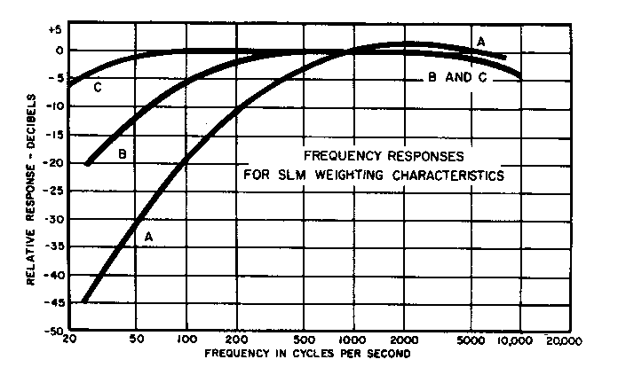

Figure 2 The A, B, and C Filtering Curves for a Sound Level Meter
From Vesilind, P.A., Peirce, J.J., and Weiner, R.F. 1990. Environmental Pollution and Control. Butterworth-Heinemann.Figure 23-3 p 341

Example 2

A Type 2 sound level meter is to be tested with two pure tone sources that emit 90 dB. The tones are 1000 and 125 Hz. Estimate the expected readings on the A, B and C weighting system.

In the low frequencies (200 to 1000 Hz) the filters subtract much more from the A network than the B and C networks. At 1000 Hz, there is a zero correction, so the reading for all three should be 90 dB. At 125 Hz, the values will be 90 –16.1 = 74 dBA, 86 dBB and 90 dBC.

Table 1 Network Weighting Values for Sound Level Meter

From: Davis, M.L., and D.A. Cornwell. 1991. Introduction to Environmental Engineering. McGraw-Hill, Inc.
Table 7-1 p 511.

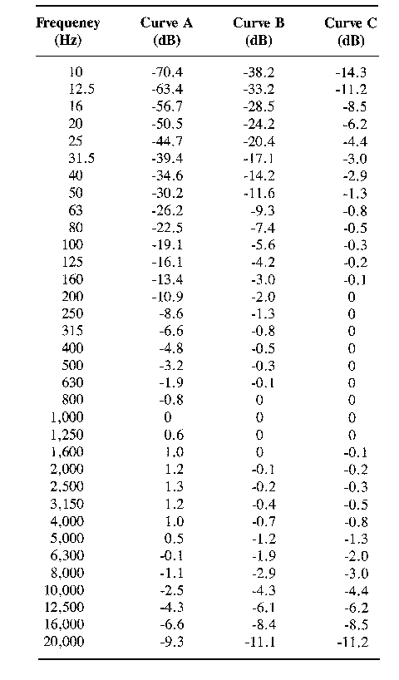

Octave band analysis is frequently done for community noise control. The noise is broken down into 8 to 11 frequency intervals (octaves) with the highest frequency of the interval being twice the lowest frequency. (An octave jump in music also signifies a doubling or halving in frequency.) The analysis is done with a sound level meter (combination precision) and an octave filtering set.

Another unit of importance is the phon, which is a measure of loudness, the brain's perception of the magnitude of sound levels. The phon is the loudness of a tone that is numerically equal to the corresponding sound pressure level when heard at 1000 Hz. A sound pressure level of 40 dB when heard at 1000-Hz is 40 phons.

Averaging sound pressure levels

Average sound pressure level, L_{p} = 20 log 1/N Σ 10^{Lj/20}
Where L_{j} is the jth sound pressure level, dB re: 20μPa

Example 3: Compute the mean sound level from the following sounds: 40, 52, 68 and 78 dBA.

Σ = 10^{40/20} + 10 ^{52/20} + 10 ^{68/20} + 10 ^{78/20} = 1.1 x 10⁴
L_{p} = 20 log (1/4 x 1.1 x 10⁴) = 69dBA

EFFECTS OF NOISE

The human ear is extremely sensitive to sound. The lowest perceptible sound pressure in the frequency range of speech (500 to 2000 Hz) is 20 μPa. This may be compared with the 1 μPa sound pressure corresponding to the thermal motion of air molecules. Our perception of sound is controlled by the human auditory system consisting of the outer, middle, and inner ear. Noise-related injury may result in damage to the eardrum but more often damage occurs to the tiny hair cells in the inner ear. The former is the result of very loud, sudden noises and the latter the result of chronic exposure to noise. A loss of hearing is quantified as a threshold shift, which may be either temporary or permanent.

Rock band members are sometimes victims of a temporary threshold shift (TTS). In one study members of a band suffered a 15 dB TTS after a concert. Permanent threshold shift (PTS) has been reported for workers in a textile mill where noise levels were highest (4000 Hz). Figures 3 and 4 illustrates that the severity of a temporary or permanent injury depends on the frequency of the noise at which it is assessed.

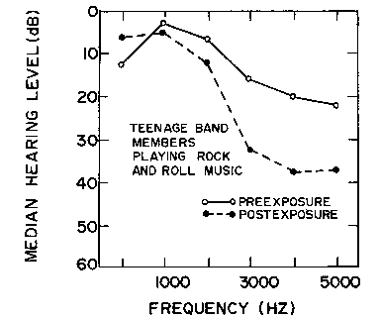

Figure 3 Temporary Threshold Shift for Rock Band Performers
From Vesilind, P.A., Peirce, J.J., and Weiner, R.F. 1990. Environmental Pollution and Control.
Butterworth-Heinemann.Figure 22-7 p 336

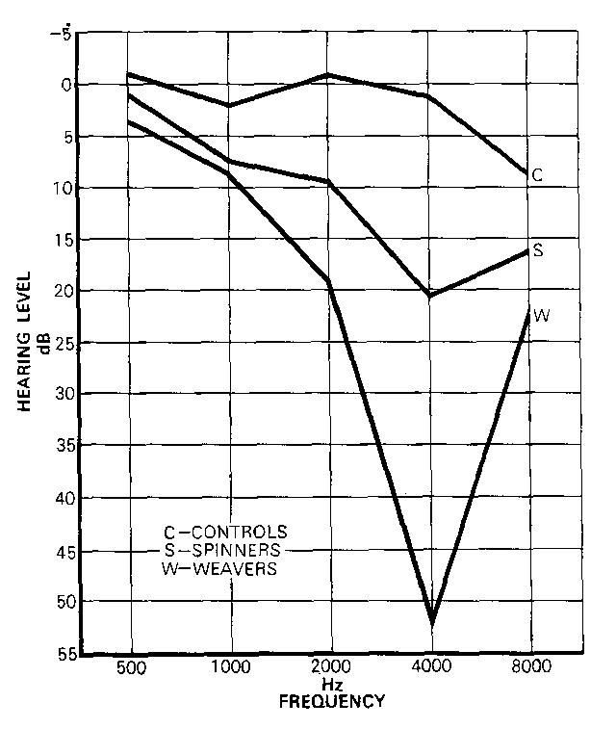
Figure 4 Permanent Threshold Shift for Textile Workers.
From Vesilind, P.A., Peirce, J.J., and Weiner, R.F. 1990. Environmental Pollution and Control. Butterworth-Heinemann.Figure 22-8 p 337

NOISE RATING SYSTEM

A rating system is developed to assess the daily impact of noise on the surroundings. The impact of noise is related not only to sound pressure but also to frequency, and whether the noise is continuous, intermittent, or impulsive. Two systems commonly used in rating noise are referred to as the LN and the Leq concepts. The LN concept is a statistical measure of how frequently a particular sound level is exceeded. For instance, L40 = 72 dB(A) implies that 72 dB(A) was exceeded 40% of the measuring time. A plot of LN against N has the appearance of a cumulative distribution curve (Figure 5).

The equivalent continuous equal energy level, Leq, is calculated as
L_{eq} = 10 log 1/t $\int_{0}^{t}{}$10 ^{L(t)/10} dt
where t = the time over which L_{eq} is determined and L(t) = the time varying noise
level in dBA.

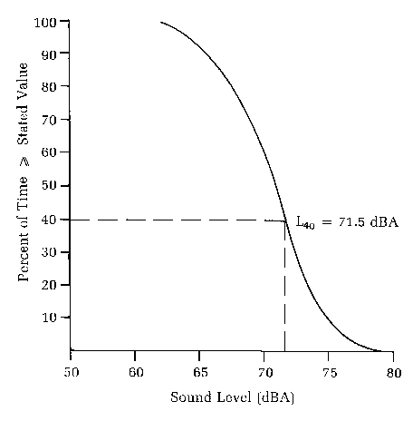

Figure 5 Cumulative Distribution Curve
From: Davis, M.L., and D.A. Cornwell. 1991. Introduction to Environmental Engineering. McGraw-Hill, Inc.
Figure 7-23 p 532.

The working version of the equation, for discrete samples, is

L_{eq} = 10 log $\sum_{i=1}^{i=n}{}$10 ^{Li/10ti}

where n = total number of samples taken
L_{i} = noise level in dBA of the ith sample
ti = fraction of total sample time

Example 3

Calculate the L_{eq} corresponding to a 90 dBA noise for 5 minutes followed by a 60 dBA noise for 50 minutes. Assume a sampling interval of 5 minutes.

The tis for the 5 minute and 50 minute samples are 1/11 (0.091) and 10/11 (0.91). The sum is:

(10 ^{90/10})(0.091) + (10 ^{60/10})(0.91) = 9.19 x 10⁷

Therefore: Leq = 10 log(9.19 x 10⁷) = 80 dBA

NOISE SOURCES AND CONTROL

The following are common noise sources, which may represent an annoyance to members of a community.

- aircraft
- rail traffic
- highway vehicles
- internal combustion engines
- industrial activities
- stadiums
- construction activities

The U.S. Federal Highway Administration (FHA) has developed noise standards for various land use categories. For areas where serenity and quiet are necessary such as amphitheatres, parks, or open spaces the Leq and L10 values averaged over 1 hour are 57 and 60, respectively. Residences, motels, schools, churches, and recreational areas should have Leq and L10 not exceeding 67 and 70, respectively.

The quantification of the noise level in a community causing annoyance is difficult. Aircraft noise associated with overflying aircraft can represent a significant disturbance to a residential neighbourhood, particularly if landing and takeoff patterns are over residential areas. Internal combustion (IC) engines used around the home such as lawn mowers, chain saws, and model aircraft cause sporadic annoyance but are, in general, not considered to be significant contributors to community noise. The dBA range at 15.2 m for residential IC engines is 70-84. Noise associated with single house construction in a suburban community will generate sporadic complaints if the 8 hour Leq exceeds 70 dBA. Threats of legal action are common for major construction activities in suburban communities with an 8-hour Leq greater than 85 dBA.

Control of noise requires some understanding of three basic elements 1) the nature of the source, 2) the path over which the noise travels, and 3) the receiver or listener. Solution to the problem may require examining how each might be altered to reduce noise. Three possibilities for alleviation of the problem are

1. Reduction of the noise output of the source
2. Change the transmission path of the noise to reduce the noise level
3. Provide the listener with protective equipment.

Noise at the source (equipment) is decreased by reduction of impact forces, frictional resistance, speeds and pressures, noise radiating area, and noise leakage. Mufflers or silencers also reduce noise.

If noise reduction is not possible at the source, the use of devices to block or reduce the sound along its transmission path may reduce the effect of the noise. Three ways of accomplishing this are 1) absorption of the sound along its path, 2) deflection of the sound, and 3) contain the source in a sound-insulating enclosure. The atmosphere has absorption capacity for sound. Doubling the distance from a point source reduces its sound pressure level by 6 dB. For a line source such as a train the sound reduction with doubling of distance is 3 dB. Sound absorbing materials including drapes, acoustical tiles and carpets have the potential to reduce the sound pressure level in a room by 5-10 dB for high frequency sounds and 2-3 dB for low frequency sounds. Lining the inside surfaces of ducts, pipe chases, or electrical channels with sound-absorbing materials reduces noise. A reduction of 10 dB/m of high-frequency noise in a duct installation with an acoustical lining of 2.5 cm thick is not uncommon. However, reduction of low frequency noise requires thicker and longer acoustical lining.

Barriers, screens, and deflectors are effective in reducing noise transmission. The size of the barrier and frequency of noise are important parameters influencing the efficiency of noise reduction. High frequency noise is attenuated to a greater extent than low frequency noise. Noise passing well over the top of a barrier to receptors, who can see the source is unattenuated. However, noise just passing over the top of barrier is diffracted downward to the other side at an angle inversely proportional to the sound energy passing over the barrier. Noise will also be transmitted directly through the barrier. Finally, the noise may be reflected to the opposite side of the source. The diffracted noise is considered to be the most important for design of barriers.

When considering the design of barriers, it is useful to relate the reduction in dB to energy and loudness reduction. This is illustrated for a line source in Table 2.

Table 2 Noise Reduction with Barriers

Reduction in A-level dB % Reduction in energy % Loudness reduction
3 50 17
6 75 33
10 90 50
30 99.9 88
40 99.99 93.8

It is apparent that a reduction in noise of 10 dB(A) provides substantial reduction in loudness but requires that the sound energy be reduced by 90% which would require a very long and high barrier. The complexity of barrier design varies from simple for a 10 dB reduction to nearly impossible for a 20 dB reduction. The noise reduction for various highway configurations is shown in Table 3. Increasing the number of trucks on the highway decreases the noise reduction. Noise reduction is less at 152 m because of limited "shadow" of the barrier.

When the noise level cannot be reduced, protection to the receiver is possible by providing

1. limited exposure to the disturbing noise source
2. curtailed noisy operations at night and early morning to avoid disturbance of sleep
3. ear protection

Ear protection devices such as moulded and pliable earplugs, cup-type protectors, and helmets provide noise reduction ranging from 15 to 35 dB. However, they do have disadvantages which include the interference with speech communication and the hearing of warning calls. Therefore, it is recommended that they be used if the other control measures such as source and transmission reduction are not possible.

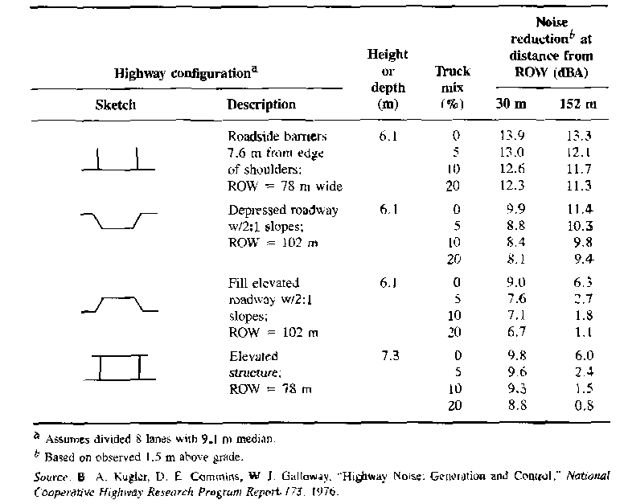

Table 3 Noise Reductions for Various Highway Configurations
From: Davis, M.L., and D.A. Cornwell. 1991. Introduction to Environmental Engineering. McGraw-Hill, Inc.Table 7-10

PROBLEMS

1. The figure below represents a typical noise spectrum for automobiles travelling
at 50 to 60 km/h. Determine the equivalent A-weighted level using the following
geometric mean frequencies for octave bands of 63, 125, 250, 500, 1,000,
2,000, 4,000, and 8,000. Estimate the dB readings corresponding to each of the
frequencies.

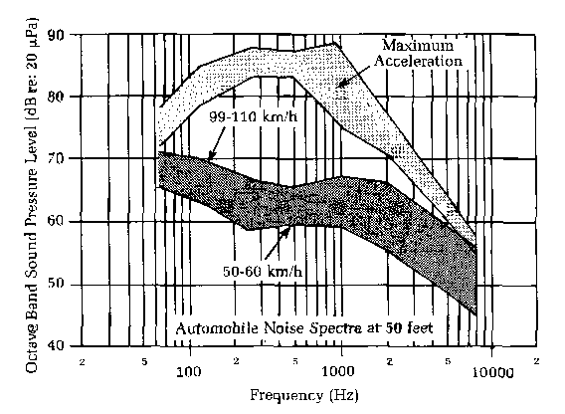
From: Davis, M.L., and D.A. Cornwell. 1991. Introduction to Environmental Engineering. McGraw-Hill, Inc.
Figure 7-27 p 536.

2. A motorcyclist is warming up her racing cycle at a racetrack approximately 200m from a sound level meter. The meter reading is 56 dBA. What meter reading would you expect if 15 other motorcyclists join her with motorcycles having exactly the same sound emission characteristics? Assume that all of the motorcycles are located at the same point.

3. You are working in a production plant and are required to conduct a noise survey.
You will also make recommendations regarding how plant operations/equipment
might be modified to improve the current situation. Discuss how you would
conduct the survey and, based on the results, what improvements you would
recommend. Consider hypothetical noise conditions as examples on which to
base your recommendations.

REFERENCES

Davis, M.L., and D.A. Cornwell. 1998. Introduction to Environmental Engineering, 2nd Edition, McGraw-Hill, Inc.

Sincero, A.P. and Sincero, G.A. 1996. Environmental Engineering: A Design Approach. Prentice-Hall.

Vesilind, P.A., Peirce, J.J., and Weiner, R.F. 1990. Environmental Pollution and Control. Butterworth-Heinemann.

