MODULE 8
SLUDGE PROCESSING AND DISPOSAL

The main objective of wastewater treatment is to reduce the pollution load on receiving waters. The treatment processes concentrate some of the impurities in a sludge along with the microbial excess biomass. Water treatment also produces a sludge from the chemical coagulation and separation of impurities. The treatment and disposal of these sludges should be considered as an integral part of the treatment process. The treatment processes should be regarded therefore as a low-solids stream (effluent or drinking water) and a high-solids stream (sludge).

It should be appreciated that the sludges consist mainly of water and that dewatering is the first and most important requirement in sludge processing. The cost of treating the sludges, particularly for wastewaters, is a major component of the total cost of treatment, and the effects of the final disposal methods and return flows from sludge treatment can have significant implications for the preceding processes.

CHARACTERIZATION AND SOURCES OF SLUDGES FROM WASTEWATER TREATMENT

Humans deposit about 70 g per capita per day of solids into wastewater. With 'garbage grinders', this can reach 100g per day. The impurities present in the wastewater must either be transformed into innocuous end-products or be effectively separated from the effluent stream. Impurities which are removed are drawn off as side-streams to the main flow and partially converted into gaseous products. Treatment and disposal of side-streams is an essential part of the overall treatment process, and frequently they contribute significantly to the total cost of treatment.

In conventional wastewater treatment works, the main sidestream products, apart from screenings and grit, are the various forms of sludge, comprising the underflow from sedimentation tanks which effect separation of the greater proportion of the removed impurities. Treatment and disposal of these sludges is dependent on the volume and characteristics of the sludges produced, which in turn are related to the type of treatment giving rise to the sludge.

The simplest classification of wastewater sludges is based on the process from which they are produced.

Raw or primary sludge This is drawn from the primary sedimentation tanks. It contains all the readily settleable matter from the wastewater; plus another 1% collected as scum; it has a high organic content - mainly faecal matter and food scraps - and is thus highly putrescible. In its fresh state, raw sludge is grey in colour with a heavy faecal odour. Both colour and odour intensify on prolonged storage under anoxic conditions, leading rapidly to onset of putrefaction and extremely unpleasant odours. This is often evident in small works when sludge is drawn from the sedimentation tanks into open pits for transfer to the digestion tanks.

Primary sludge accounts for 50-60% of the suspended solids applied. Primary precipitates can be dewatered readily after chemical conditioning because of their fibrous and coarse nature. Typical solids concentrations in raw primary sludge from settling municipal wastewater are 6%-8%. The portion of volatile solids varies from 60% to 80%.

Trickling-filter humus from secondary clarification is dark brown in colour, flocculent, and relatively inoffensive when fresh. The suspended particles are of biological growth sloughed from the filter media. Although they exhibit good settleability, the precipitate does not compact to a high density. For this reason and because sloughing is irregular, underflow from the final clarifier containing filter humus is returned to the wet well for mixing with the inflowing raw wastewater. Thus humus is settled with raw organics in the primary clarifier. The combined sludge had a solids content of 4% to 6%, which is slightly thinner than primary residue with raw organics only.

Waste-activated sludge is a dark-brown, flocculent suspension of active microbial masses inoffensive when fresh, but it turns septic rapidly because of biological activity. Mixed - liquor solids settle slowly, forming a rather bulky sludge of high water content. The thickness of return activated sludge is 0.4% - 1.5% suspended solids with a volatile fraction of 0.7 - 0.8. Excess activated sludge in most processes is wasted from the return sludge line. A high water content, resistance to gravity thickening, and the presence of active microbial floc make this residue difficult to handle. Routing of waste activated to the wet well for settling with raw wastewater is not recommended. Carbon dioxide, hydrogen sulphide, and odourous organic compounds are liberated from the settlings in the primary basin as a result of anaerobic decompostion, and the solids concentration is rarely greater than 4%. Waste-activated sludge can be thickened effectively by flotation or centrifugation; however, chemical additions may be needed to ensure high solids capture in the concentrating process.

Anaerobically digested sludge is a thick slurry of dark - coloured particles and entrained gases, principally carbon dioxide and methane. When well digested, it dewaters rapidly on sand - drying beds, releasing an offensive odour resembling that of garden loam. Substantial additions of chemicals are needed to coagulate a digested sludge to mechanical dewatering, owing to the finely divided nature of the solids. They dry residue is 30% - 60% volatile, and the solids content of digested liquid sludge ranges from 6% to 12%, depending on the mode of digester operation.

Aerobically digested sludge is a dark - brown, flocculent, relatively inert waster produced by long - term aeration of sludge. The suspension is bulky and difficult to thicken, thus creating problems of ultimate disposal. Since decanting clear supernatant can be difficult, the primary functions of an aerobic digester are stabilisation of organics and temporary storage of waste sludge. The solids concentration in thickened, aerobically digested sludge is generally in the range 1.0% - 2.0% as determined by digester design and operation. The thickness of aerobically digested sludge can be less than that of the influent, since approximately 50% of the volatile solids are converted to gaseous end products. Stabilised sludge, expensive to dewater, is often disposed of by spreading on land for its fertiliser value. For these reasons, aerobic digestion is generally limited to treatment of waste activated from aeration plants without primary clarifiers.

Mechanically dewatered sludges vary in characteristics based on the type of sludge, chemical conditioning, and unit process employed. The density of dewatered cakes ranges from 15% to 40%. The thinner cake is similar to a wet mud, while the latter is a chunky solid. The method of ultimate disposal and economics dictate the degree of moisture reduction necessary.

Waste solids production in primary and secondary processing can be estimated using the calculation bleow.

W_{s} = W_{sp} + W_{ss} (1)

where W_{s} = total dry solids, kg/day

W_{sp} = raw primary solids, kg/day
= f x SS x Q

where f = fraction of suspended solids removed in primary settling
SS = suspended solids in unsettled wastewater, mg/L
Q = daily wastewater flow, ML/d

W_{ss} = secondary biological solids, kg/day
= (k x BOD + 0.27SS)Q

where k = fraction of applied BOD that appears as excess biological growth in waste - activated sludge or filter humus, assuming about 30 mg/L of BOD and suspended solids remaining in the secondary effluent
BOD = concentration in applied wastewater, mg/L
Q = daily wastewater flow, ML/d

The coefficent k is a function of process food/microorganism ratio and biodegradable (volatile) fraction of the matter in suspension. For trickling - filter humus, k is assumed to be in the range 0.3 - 0.5, with the lower value for light BOD loadings and the larger number applicable to high -rate filters and rotating biological contractors. The k for secondary activated sludge processes canbe estimated using Figure 1 by entering the diagram along the ordinate witha known food/microorganism ratio.

Excess solids production for activated - sludge processes treating unsettled wastewater can be estimated without considering suspended solids input, by increasing the calculated quantity by 100%. The k factor is the value determined from Figure 1 multiplied by 2.0.

The design of a sludge - handling system is based on the volume of wet sludge as well as dry solids content. Once the dry weight of residue has been estimated, the volume of sludge can be calculated as shown in Equation 1.

The foregoing formulations are reasonable for sludge quantities from processing domestic wastewater at average daily design flow.

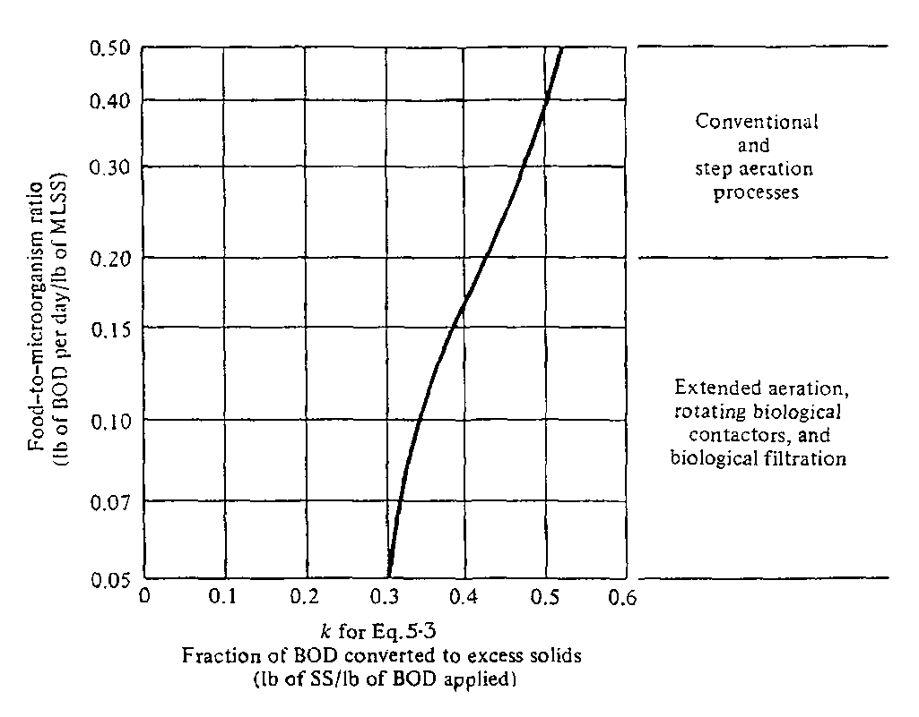

Figure 1 Hypothetical relationship between the food - to - microorganism ratio and the coefficient k in Equation 1.

CHARACTERIZATION OF WATER TREATMENT SLUDGES

Water treatment plant wastes are suited to pressure filtration since they are often difficult to dewater, particularly alum sludges and softening precipitates containing magnesium hydroxide. Gravity-thickened alum wastes are conditioned by the addition of lime slurry. A precoat of diatomaceous earth or fly ash is applied prior to each cycle, and conditioned sludge is then fed continuously to the pressure filter until filtrate ceases and the cake is consolidated under high pressure. A power pack holds the chambers as the equalisation tank provides uniform pressure across the filter chambers as the cycle begins. Prior to cake discharge, excess sludge in the inlet ports of the filter is removed by air pressure to a core separation tank. Filtrate is measured through a weir tank and recycled to the inlet of the water treatment plant. Cake is transported by truck to a disposal site.

Alum sludges are conditioned using lime and/or fly ash. Lime dosage is in the range 10%-15% of the sludge solids. Ash from an incinerator, or fly ash from a power plant, is applied at a much higher dosage, approximately 100% of dry sludge solids. Polyelectrolytes may also be added to aid coagulation. Fly ash and diatomaceous earth are used for precoating; the latter requires about 50.2 kg/m2 of filter area. Under normal operation, cake density is 40%-50% solids and has a dense, dry, textured appearance.

Alum sludge from surface-water treatment is amenable to centrifuge dewatering. Performance must be verified by testing at each location, since sludge characteristics vary considerably. In general, aluminum hydroxide slurries from coagulation settlings and gravity-thickened backwash waters can be concentrated to a truckable pasty sludge of about 20% solids. The removal efficency in a scroll centrifuge ranges from 50% to 95% based on operating conditions and polymer dosage, and the centrate is correspondingly turbid or clear. A basket centrifuge thickening the same waste can provide higher solids capture and a clearer overflow even without polymer addition, but the cake is often less dense and cycle time longer than that of a scroll machine.

Lime softening precipitates compact more readily than alum floc in a scroll centrifuge. A settled sludge imput with 15% - 25% solids can be dewatered to a solidified cake of 65%. Suspended-solids recovery is often 85%-90% with polyelectrolyte flocculation.

The performance of thickeners handling water treatment plant wastes varies with the character of the water being treated and the chemicals applied. Alum sludges from surface-water coagulation settle to a density in the range of 2%-6% solids. Coagulation-softening mixtures from the treatment of turbid river waters gravity thicken approximately as follows: alum-lime sludge, 4%-10%; iron-lime settlings 10%-20%; alum-lime wash water, about 4%; and iron-lime backwash up to 8%. The density achieved in gravity thickening relates to 8%. The density achieved in gravity thickening relates to the calcium-magnesium in the solids, quantity of alum, nature of impurities removed from the raw water, and other factors.

Calcium carbonate residue from groundwater softening consolidates to 15-25% solids. In most cases, special studies have to be conducted at a particular waterworks to determine settleability of solids in waste sludges and wash water. Flocculation aids are used to improve clarification in most cases.

Mass and Volume Relationships

The concentration of suspended solids in a liquid sludge is determined by straining a measured sample through a glass - fibre filter. Nonfilterable residue, expressed in milligrams per litre, is the solids content. Since the filterable portion of a sludge is very small, sludge solids are often determined by total residue on evaporation (ie. the total deposit remaining in a dish after evaporation of water from the sample and subsequent drying in an oven at 103ºC).

Total solids residue (TSR) is the usual method of measuring the gross solids content. It is determined by evaporating to constant mass a measured amount of sludge, weighing the residue and expressing this as a percentage of the original wet sludge mass.

Sludge moisture content (P_{M}), equal to (100 - TSR) per cent, is an alternative parameter, commonly quoted as a measure of gross sludge composition.

Volatile solids content (VS), measured as the mass loss on ignition of the dried sludge solids from the TSR test at a standard temperature (usually 550 - 600ºC), is a measure of the organic content of the sludge. It is thus related to the possible reduction in the sludge mass by incineration. Volatile solids content is usually quoted as a percentage of the total solids residue.

Solids content remaining after ignition (ash) is termed the fixed residue (FR) and defines the mass of inorganic matter in the sludge and thus the mass of solids which would remain for ultimate disposal after incineration.

Volume of sludge

Since sludges commonly contain only between 1 and 10 per cent solids by mass, their major component is water. Filter backwash water contains even much lower solid fractions. Furthermore, since sludge solids are of similar density to water, the water content accounts for most of the volume of wet sludges. Sludge moisture content is therefore the single parameter which has the greatest effect on the volume of sludge to be processed at a given plant. It is therefore useful to examine sludge moisture - mass - volume relationships.

For a sludge which contains 1 per cent dry solids (moisture content, P_{M} = 99 per cent), 10 kg of dry solids is associated with 990 kg of water. The average density of water sludge solids is 1400 kg/m³ and the density of water is 1000 kg/m³. Therefore 10/1.4 = 7L of dry solids are associated with 990L of water; or, for 10 kg of dry solids in a 1 per cent content sludge, the total volume occupied is 997 L. Similarly, for a 2 per cent solids, the volume occupied, with 20 kg of dry solids, is 994 L. In both cases the amount of dry solids has only a small influence upon the total volume of the sludge. If the total volume is assumed to be 1000 L (or one cubic metre), the error is less than 1 per cent for sludge concentrations up to 3%.

For any sludge, the volume, V, is given by

V = Mass
Density

If the sludge has a dry solids content less than 20 per cent (that is P_{M} > 80 per cent), then

Density of wet sludge $@$ Density of WATER = 1000 kg/m³

Sludge volume, V (m³)
= Total mass of wet sludge $´$ Mass of dry solids
Mass of dry solids 1000

= 100 $´$ Mass of dry solids (kg)
100 - P_{M} 1000 (2)

For example, for a sludge of 2 per cent solids content, 10 kg of dry solids would be contained in wet sludge with a volume given by

V = 100 $´$ 10 = 0.5 m³
100 - 98 1000

If a sludge is concentrated so that the mass of dry solids, Ss, remains constant, but the moisture content is decreased from P_{M1} to P_{M2}, the ratio between the initial volume, V₁, and the final volume, V₂, is given by

V₁ = 100 $´$ S_{s} $´$ 100 - P_{M2} $´$ 1000
V₂ 100 - P_{M1} 1000 100 S_{s}

= 100 - P_{M2}
100 - P_{M1} (3)

Thus, removing water from a sludge of low solids content affords a dramatic reduction in volume. Doubling the solids content from 1 to 2 per cent halves the volume of wet sludge. In Table 9.1 the density of dry solids has been assumed to be 1400 kg/m³ for sludges of greater than 10 per cent solids content and the liquid is assumed to be water (density 1000 kg/m³).

Sludge solids content  % | kg sludge per  kg dry solids | m³ sludge per  tonne dry solids
1 | 100 | 100
2 | 50 | 50
5 | 20 | 20
10 | 10 | 9.7
15 | 6.7 | 6.4
20 | 5.0 | 4.7
30 | 3.3 | 3.0
40 | 2.5 | 2.2
Table 1 Density and volume of sludges

TESTS FOR DEWATERABILITY OF SLUDGES

Wherever sludges have to be disposed of in restricted land areas or transported over long distances for ultimate disposal, some form of volume reduction is usually necessary. From the above discussion, it is apparent that sludge dewatering is an effective method of volume reduction in such cases. It is also an essential pretreatment where incineration is required. Dewatering processes in common use, such as pressure filters, vacuum filters and centrifuges, require for their design some measure of the sludge dewatering characteristics. Two alternative methods are used to measure the ease of dewatering - specific resistance and capillary suction time.
Specific resistance to filtration, r, is the most commonly used measure of sludge dewatering characteristics. It is determined by means of a laboratory apparatus for filtering a sample of sludge under an applied vacuum (Fig 2). During the test, the volume, V, of filtrate is noted at regular time intervals. These data are then plotted in the form t/ V against V. The slope of the straight line of best fit to the data is then used to calculate the value of specific resistance to filtration, as described in the following development.

Fig 2 Apparatus for the determination of specific resistance to filtration

Sludge filtration rate has been described by the following relationship

dV = PA² .
dt μ(rCV + R_{M}A) (4)

where V is the volume of filtrate (m³); t is the time (s); P is the vacuum (Pa); A is the filtration area (m²); μ is the filtrate viscosity (Pa.s); r is the specific resistance to filtration (m/kg); C is the suspended solids concentration (kg/m³); and R_{M} is the initial resistance of filter medium.

Integration of Eq. 4 and rearrangement gives

t = μrC V + μR_{M}
V 2PA² PA (5)

Hence, from a plot t/V against V, the slope, b, of the line of best fit is given by

b = μrC
2PA² (6)

and hence
r = 2PA²b
μC (7)

which can be calculated from the measured applied vacuum (49 kPa is recommended), the filter area, filtrate viscosity and the suspended solids concentration of the sludge. The value of r obtained by using sludge suspended solids is sometimes referred to as the apparent specific resistance, r, rather than true specific resistance calculated from the suspended solids in the filter cake.

A sludge of high specific resistance is more difficult to dewater than one of low specific resistance. Sludges with a specific resistance of > 10¹⁴ m/kg are difficult to dewater. Conventional dewatering by methods such as filter pressing is feasible for r ~ 2 x 10¹² m/kg. It should be noted, however, that the value of r depends so closely on the nature of the sludge solids and the mechanism by which water is retained within the solids matrix that, for designing dewatering facilities, it is necessary to determine the value of r for the particular sludge concerned.

Capillary suction time (cst)

Sludge filterability can be determined by timing the movement of water from a sludge sample longitudinally through filter paper. The apparatus is shown schematically in Fig 9.2. Sludge is placed in the sludge well and the water moves radically outwards from the sludge. The rate of advance of the solvent front is timed manually or electronically as it moves between two pre-set points on the filter paper. This method provides a simple technique for estimating dewaterability and, on a comparative basis, can be very useful. The method relies upon the varying pressure applied by the movement of water through filter paper, so that a theoretically complete mathematical treatment of cst is not possible.

The cst values usually correlate well with r determinations. However, it is best if such correlation is confirmed experimentally. The cst values do not allow for the solids content and therefore it is necessary to specify the solids content of the sludge. It is possible for a sludge with a low cst value and a high solids content to be easily dewatered.

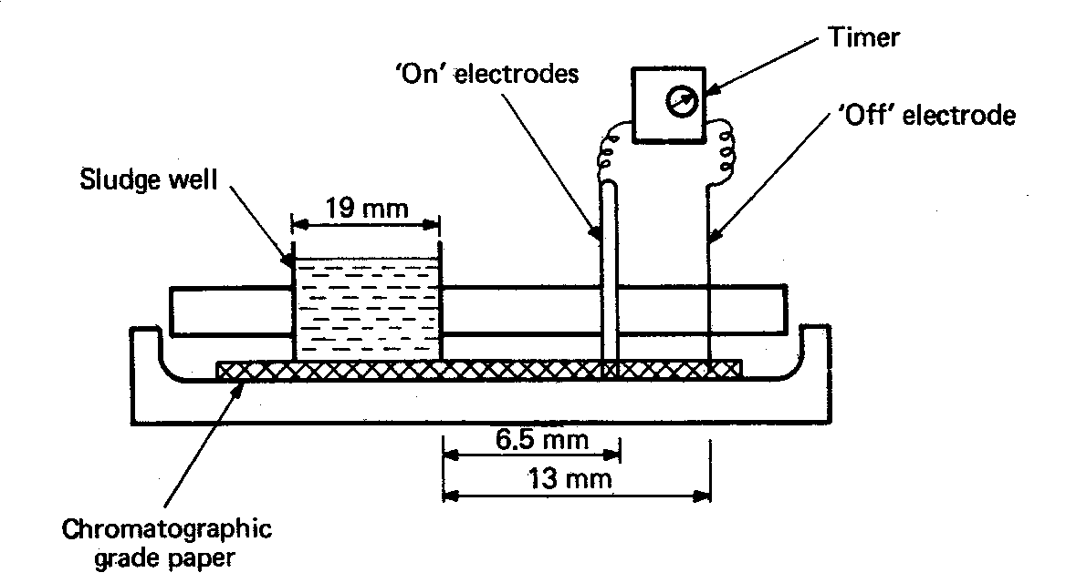

Fig 3 Apparatus for the determination of capillary suction time.

OBJECTIVES AND METHODOLOGY IN SLUDGE
TREATMENT AND DISPOSAL

Objectives

The main objectives of sludge treatment are

a. Reduction in the volume of sludge for disposal by removing some of the
water.

b. Collection of by-products which may be used or sold to off-set some of
the costs of sludge treatment. Unfortunately, this is an ideal rarely
achieved in practice except in the case of methane gas, which is produced
in anaerobic digestion. The methane is often collected and used as a fuel
to provide heat for controlling the temperature of the digesting sludge
and, occasionally, for driving dual fuel engines which may be used to
generate power for the treatment plant. The production of a compost and
the use of sludges for agricultural purposes can be viewed as a use.

c. Disposal of the sludge in a safe and aesthetically acceptable manner.

d. Destruction of pathogenic organisms.

e. Stabilisation of the organic matter contained in the sludge.
.

Methods

Sludge treatment and disposal at any particular location may comprise any or all of the steps as outlined below.

a. Concentration - reduction in the volume of sludge to be treated by
encouraging the sludge to compact to a higher solids content.
b. Treatment - to stabilise organic matter, destroy pathogens and/or yield
by-products.
c. Dewatering and drying - removal of water, thus reducing sludge volume.
Sludges with less than 80 per cent moisture content are usually
spadeable.
d. Disposal - the only places where sludge can be disposed of are into the
air, onto land or water. Whether or not the impact on the receiving
environment is legally, aesthetically and ecologically acceptable depends
on both the degree of treatment provided and the method of dispersing
the sludge into the environment.

In comparing the various alternative methods of sludge treatment and disposal, it is important to consider all steps necessary for the final disposal of the treated sludge.

A scheme which includes the majority of available processes for wastewater and mainly applicable to water treatment sludges is given in Table 2. Not all these methods would be practised at any one site and not all of the methods are necessarily compatible. For each site, the range of options requires consideration.

Thickening | Stabilization | Dewatering | Partial  disposal | Ultimate disposal
Gravity | Anaerobic digestion | Drying beds | Incineration | Sanitary landfill
Flotation | Aerobic  digestion | Filter press | Pyrolysis | Crop land
Centrifuge | Lagooning | Centrifuge | Wet air  oxidation | Ocean
Elutriation | Heat treatment | Vacuum filter  Belt press  Lagooning | Composting
Table 2 Treatment and disposal options for wastewater sludges

Mechanical dewatering reduces sludge volumes and is a necessity for incineration. Ultimate disposal of any residue or sludge is to land or sea. If non-digested sludges are being handled, particular attention has to be paid to odour, insect and rodent infestation and hygiene. Subsequent sections deal in greater detail with particular processes.

GRAVITY THICKENING

Gravity thickening is the simplest and least expensive process for consolidating waste sludges. Thickeners in wastewaster treatment are employed most successfully in consolidating primary sludge separately or in combination with trickling-filter humus. Occasionally, raw primary and waste-activated sludges are blended and concentrated, but results are often marginal because of poor solids capture.

Description of gravity thickeners

A typical waste sludge thickener is illustrated in Figure 4. The tank resembles a circular clarifier except that the depth/diameter ratio is greater and the hoppered bottom has a steeper slope. A bridge fastened to the tank walls supports a truss-type scraper arm mounted on a central shaft. Sludge enters at the centre behind a circular baffle that directs it downward, and supernatant overflows a peripheral weir. Settled solids are gently agitated by slow rotation of the scraper to dislodge gas bubbles, prevent bridging of the solids, and move slurry toward a central well for withdrawal. Feed is provided continuously while the underflow may be extracted intermittently for further processing.

Three settling zones in a thickener are the clear supernatant on top, feed zone characterised by hindered settling, and compression near the bottom where consolidation occurs. Settling data may be collected from batch-type laboratory tests conducted in small cylinders. These are influenced by such factors as cylinder diameter, initial height, temperature, effect of stirring, and so on. Vesilind suggests that batch thickening tests use an 20 cm diameter cylinder, initial height of at least 1 m, filling the cylinder from the bottom, and slow stirring of the sample throughout the test. Continuous-flow bench-scale experiments can also be conducted, but they are difficult and often yield questionable results. Because of the problems in scale-up from laboratory units to real systems, designers rely extensively on experience acquired from studies at full-size installations.

Evaluating the performance of a thickener often involves mass balance calculations. Overflow plus underflow solids equals influent solids. Also, the sum of overflow and underflow volumes is equal to the quantity of applied sludge and supplementary dilution water.

Figure 4 Cross sectional view of a gravity sludge thickener.

Example 1
A waste activated sludge with 0.4% solids content is gravity thickened to 2.0 % with a removal efficiency of 95%. Calculate the quantity of underflow per 1.0m³ of slurry applied and the concentration of solids in the overflow. Assume a specific gravity of 1.05 for the dry solids.

Solution
solids applied = 1.0m3 x 1000 kg/m3 x 0.004 = 4.0 kg
underflow solids = 0.95 x 4 = 3.8 kg

relative density, ρu, of underflow is
= 98 + 2 = 1.001
____________________________________________
(98/1.0)+(2/1.05)

volume of underflow (eqn 2) = mass of dry solids (kg)
(100-P_{M})/100xdensity of water(kg/m³)xρ_{u}

= 3.8 = 0.0039 m3
___________________________________________
0.98 x 1000 x 1.001

volume of overflow = 1.0 -0.0039 = 0.9961 m3

The concentration of solids in the overflow is

0.05 x 4 x 100 = 0.02% = 200 mg/L
____________________________________________
0.9961 x 1000 x 1.0

Design of wastewater treatment sludge thickeners

The principal design criterion is solids loading expressed in units of kilograms of solids applied per square meter of bottom area per day (kg/m².d). Typical loading values and thickened sludge concentrations based on operational experience are listed in Table 3. These data assume good operation and chemical additions, such as chlorine, if necessary to inhibit biological activity. Solids recovery in a properly functioning unit is 90-95%, with perhaps the exception of a unit handling primary plus waste activated where it is difficult to achieve this degree of solids capture. Most continuous flow thickeners are designed with a side water depth of approximately 3.5 m to provide an adequate clear-water zone, sludge blanket depth, and space for temporary storage of consolidated waste sludge. Sludge blanket depths (feed plus compaction zones) should be 1 m or greater to ensure maximum compaction, using a suggested solids retention time of 24 hrs. This is estimated by dividing the volume of the sludge blanket by the daily sludge withdrawal; values vary from 0.5 to 2 days, depending on operation. Overflow rates should be 16-37 m³/m².d and are defined by the quantity of sludge plus supplementary dilution water applied.

Type of Sludge | Average solids loading (kg/m².d) | Underflow Concentration (%solids)
Primary | 97.6 | 8-10
Primary plus filter humus | 48.8 | 6-9
Primary plus activated sludge | 39 | 4-6
Table 3 Gravity thickener design loadings and underflow concentrations for wastewater sludges

Gravity thickeners are normally sized to handle the maximum seasonal or monthly sludge yield anticipated. Peak daily sludge production often requires storage in the thickener or other sludge processing units. Low liquid overflow rates result in maladours from septicity of the thickener contents. A common remedy is to feed dilution water to the thickener along with the sludge to increase hydraulic loading. An alternative is to apply chlorine to reduce bacterial activity. The design of pumps and piping should be sufficiently flexible to allow regulation of the quantity of dilution water and have the capacity to transport viscous, thickened sludges.

Example 2
The daily quantity of primary sludge from a water treatment plant contains 500 kg of solids at a concentration of 4.5%. Size a gravity thickener based on a solids loading of 50 kg/m²/d. Calculate the daily volumes of applied and thickened sludges, assuming an underflow of 8.0% and 95% solids capture. If the blanket of consolidation sludge in the tank has a depth of 1m, estimate the solids retention time.

Solution

tank area required = 500 kg/d = 10m2
50 kg/m²/d

diameter = (10 x 4) 0.5 = 3.5 m
π

Use a depth of 3m
volume of applied sludge = 500 = 11m3/day
0.45 x 1000

overflow rate of applied sludge = 11 m³/d = 0.5 m3m-1d-1
3.5 x 2π

volume of thickened sludge = 500 x 0.95 = 5.94 m3/d
(8.0/100)1000

solids retention time = 1 x 10 x 24 = 40 hours
5.94

FLOTATION THICKENING

Air flotation is most applicable in concentration waste-activated sludges and pretreatment of industrial wastes to separate grease or fine particulate matter. Fine bubbles to buoy up particles may be generated by air dispersed through a porous medium, by air drawn from the liquid under vacuum, gases released by electrolysis, or by air forced into solution under elevated pressure followed by pressure release. The latter, called dissolved-air flotation, is the process employed most frequently in thickening sludges because of its reliable performance.

Description of dissolved-air flotation

The major components of a typical flotation system are sludge pumps, chemical feed equipment to apply polymers, an air compressor, a control panel, and a flotation unit. Figure 5 is a schematic diagram of a dissolved-air system. Influent enters near the tank bottom and exits from the base at the opposite end. Float is continuously swept from the liquid surface and discharged over the end wall of the tank. Effluent is recycled at a rate of 30-150% of the influent flow through an air dissolution tank to the feed inlet. In this manner, compressed air at 700-1000 kPa is dissolved in the return flow. After pressure release, minute bubbles with a diameter about 80μm form and attach to solid particles and become enmeshed in sludge flocs, floating them to the surface. The sludge blanket, varying from 200-600mm thick, is skimmed from the surface. Flotation aids are introduced in a mixing chamber at the tank inlet.

The operating variables for flotation thickening are air pressure, recycle ratio, detention time, air/solids ratio, solids and hydraulic loading rates, and application of chemical aids. The operating air pressure in the dissolution tank influences the size of bubbles released. If too large, they do not attach readily to sludge particles, while too fine a dispersion breaks up fragile floc. Generally, a bubble size less than 100 μm is best; however, the only practical way to establish the proper rise rate is by conducting experiments at various air pressures.

Recycle ratio is interrelated with feed solids concentration, detention time, and air/solids ratio. Detention time in the flotation zone is not critical, providing that particles rise rapidly enough and the horizontal velocity does not scour the bottom of the sludge blanket. An air/solids ratio of 0.011-0.03 kg of air/kg of solids is sufficient to achieve acceptable thickening of most sludges. Optimum recycle ratio must be determined by one-site studies.

Figure 5 Schematic diagram of a dissolved-air flotation system.

Operating data from plant-scale units indicate solids loadings of 10-20 kgm⁻² h⁻¹ with hydraulic loadings of about 2.4 m³ m⁻² h⁻¹, can produce floats of 4%-8% solids. Without polyelectrolyte addition, solids capture is 70-90%. However, removal efficiency increases to a mean of 97%, with a polymer dosage of approximately 4.5 kg/t of dry suspended solids. This is the reason most wastewater instillations use flotation aids.

Design of dissolved-air flotation units

Wherever possible, laboratory and pilot-scale tests are recommended to help determine specific design criteria for a given waste. Notwithstanding, the suggested design criteria for flotation thickening of typical waste-activated sludges are listed in Table 9.3. A conservative solids design loading is 10 kgm⁻² h⁻¹ with the use of flotation aids. From actual operating data, at least 15 kgm⁻² h⁻¹ can be expected, and most thickeners have a built-in capacity for 20-25 kg/m².h⁻¹ as specified for design purposes, and 5%-6% solids can normally be expected. Flotation without polymers generally results in a concentration that is about one percentage point less than with chemical aids. Removal efficiency varies from 90-98% with polyelectrolyte addition. The maximum hydraulic loading for design is set at 2m³ m⁻² h⁻¹; this is equivalent to applying a waste with a solids concentration of 5000 mg/L at a loading of 10 kgm⁻² h⁻¹. Lesser solids levels or higher loadings result in lower removal efficiencies and/or densities.

The typical design values recommended in Table 4 apply to anticipated average sludge production. This procedure provides a significant safety factor and permits flexibility in operations. Peak solids loads at municipal treatment plants can usually be accommodated, since these conservative design criteria allow a maximum loading of nearly 100% greater than the average without a serious drop in performance. Perhaps the most critical condition is during a period of sludge bulking when the waste mixed liquor is more difficult to thicken and maximum hydraulic loading is applied to the flotation unit.

Table 4 Design parameters for dissolved-air flotation of waste-activated sludge with addition of polyelectrolyte flotation aids
Parameter | Typical Design Value | Anticipated Results
Solids loading (kgm-2h-1) | 10 | 15-25
Float concentration (%) | 4 | 5-6
Removal efficiency | 90-95 | 97
Polyelectrolyte addition  (kg/tonne of dry solids) | 4 | 2-4
Air/solids ratio  (kg of air/kg of solids) | 0.02
Effluent recycle ratio  (% of influent) | 40-70
Hydraulic loading  m3m-2h-1 | 2 (max)

Sizing of flotation units for an existing plant can be calculated from available data on sludge quantities, characteristics, and solids concentrations. For new plant design, raw waste is often assumed to contain 0.1 kg of dry solids/capita/day. A proportion of the solids is removed in primary settling, and a conservative estimate for secondary activated-sludge production is 0.05 kg/capita/day. The actual amount is more likely to be closer to one-half of this value, because of biological decomposition. Solids yield in an activated-sludge process without primary settling may be safely assumed to be 0.1kg/capita/day for domestic wastewater. If the waste sludge from such a system is aerobically digested, the concentration of solids is reduced by about 35%.

Operating hours of a flotation unit depend on size of plant and the working schedule. Although a unit does not require continuous operator attention, periodic checks of a system are scheduled. Generally, a 48 hour/week is adequate for plants with capacities of less than 7.5 mgd. For systems of 7.5-19 Ml/d, two shifts 5 days per week establishes an operating periods of 80 h/week. Treatment plants handling more than 80ML/d have operators on duty continuously, and thickening units are run on a schedule appropriate for sludge dewatering and disposal.

Example 3

A dissolved-air flotation thickener is being sized to process waste-activated sludge based on the design criteria given in Table 4. The average sludge flow is 125 m3/d at 15 000 mg/L (1.5%) suspended solids, and the maximum daily quantity contains 50% more solids at a reduced concentration of 10 000 mg/L. What is the peak daily hydraulic loading that can be processed? Base all computations on a 14h/day operating schedule.

Solution

The flotation tank surface area required for the average daily flow at a design loading of 10 kgm-2h-1 for a 14 hr/day schedule is
= 125 x 0.015 x 1000 = 1875 = 13.4 m2
10 x 14 140

Check the solids loading and overflow rate at maximum daily sludge production:
maximum solids loading = 1.5 x 1875 = 15 m-2h-1
13.4 x 14
maximum sludge volume = 1.5 x 1875 = 281 m3
0.01 x 1000

maximum hydraulic loading = 281 = 1.5 m3m-2h-1
13.4 x 14

peak hydraulic loading based on 2.1 m3m-1h-1 = 2.1 x 13.4 x 14
= 394 m3/d

VACUUM FILTRATION

Rotary vacuum filters are rarely used for dewatering sludges from plants with design flows greater than 20 ML/d. Adoption in handling water treatment plant wastes is limited to thickening lime-softening precipitates. Alum coagulation sludge, being more gelatinous, does not dewater readily by suction; thus; pressure filtration is more successful.

Description of Rotary Vacuum Filtration

The principal components of a vacuum filter system are illustrated in Fig. 6. Positive-displacement pumps draw sludge from clarifiers of holding tanks and discharge it into a conditioning tank. Here the waste is mixed with chemical coagulants metered by solution feeders and is then applied through a feed chute to a vat under the filter. The cylindrical drum, covered with a porous medium, is partially submerged in the liquid sludge. As is slowly rotates, vacuum applied immediately under the filter medium draws solids to form a cake on the surface. Suction continues to dewater the solids adhering to the belt as it rotates out of the liquid; then vacuum is stopped while the belt rides over a small-diameter roller for removal of the cake, and the medium is washed by water sprays before re-entering the vat. Collecting channels behind the belt in the drum surface are connected by pipes to a combination vacuum receiver and filtrate pump. The principal purpose of the receiver is air-liquid separation. Air taken from the top is discharged through a wet-type vacuum pump, while water from the bottom is removed by a filtrate pump.

Three categories of rotary vacuum filters are defined by the type of medium used and mechanism for cake discharge. A belt-type unit (Fig 6) can be fitted with a variety of synthetic and natural-fibre filter cloths of differing porosities, such as wool, nylon, Orlon, or Dacron.

Figure 6 Rotary vacuum-filter system. (Courtesy of Eimco Process Equipment Co.)
A coil filter has a medium consisting of two layers of stainless-steel helically coiled springs about 0.4 in. in diameter. They are placed around the filter drum in corduroy fashion with the upper layer resting on the bottom springs, which are held in place by grooved division strips attached to the drum surface.

A drum filter differs from the previous two types described in that the cloth covering does not leave the drum for solids discharge or washing. Cake is scraped from the fabric on the cylinder surface after being loosened by compressed air blown through the medium from the inside. In handling waste sludges, dewatering may have to be stopped periodically to wash the drum cloth to prevent blinding. For this reason, belt and coil filters are preferred.

The objectives of vacuum filtration are to obtain an acceptable filter yield, relatively clear filtrate, and high solids concentration in the cake and to minimise operational costs. Filter yield, expressed in kg of dry sludge solids discharged per m2 of filter area per hour, varies from 10 -75 kg m-2 h-1. Output increases with rising dosage of coagulants; for a given chemical conditioning, yield increases with solids concentration in the feed sludge. Solids capture varies from 85% to 95%, depending on the type of filter covering, the character and density of the applied sludge, and chemical conditioning. The cake solids content is affected by the same factors, as well as by the machine variables of vacuum pressure, drum submergence, and speed of rotation. Optimum suction relates to cake compressibility - a relatively incompressible solids layer dewaters better under high vacuum, while compressing an organic cake may decrease its porosity and filterability. Higher chemical consumption can increase yield and reduce operating time, thus raising chemical costs while decreasing labour and power. Disposal costs may be directly related to cake density. For example, the expense of hauling a relatively wet sludge to a distant landfill may be more costly than operating the filter to produce a drier cake.

Theory of Vacuum Filtration

The theoretical equation is

dV = PA2 (8) (as in the theory of specific
dt μ(rCV + RfA) resistance to filtration)

where V = volume of filtrate, m3 (ml)
t = time, s (s)
P = pressure difference, N/m2 (dyn/cm2)
A = filter area, m2 (cm2)
μ= viscosity of filtrate, N⋅s/m2 (P)
r = specific resistance of sludge cake, m/kg (s2/g)
C= mass of dry solids per unit volume of filtrate, kg/m3 (g/cm3 )
Rf = resistance of filter medium (s2/cm2)

This basic formula assumes laminar flow, uniform solids deposition during filtration, and a increases in filtrate flow resistance as the cake increases in thickness. For constant pressure throughout filtration, integration of Eq. 8 yields (as shown in the theory of specific resistance to filtration).

t = μrC V + μRf
V 2PA2 PA (9)

and the use proceeds further as shown in section on the theory of specific resistance to filtration.

The specific resistance varies with the filter area, solids concentration, liquid viscosity, and pressure. For compressible sludge solids, r has been found empirically to vary as

r = r0 ( P )s
(P0) (10)

where r = specific resistance at pressure P
r0 = specific resistance at pressure P0
s = coefficient of cake compressibility

The coefficient of compressibility is determined by conducting a series of filtration tests at various pressures. The value of s equals the slope of the line through r versus P data plotted on log-log paper.

Laboratory Buchner funnel filtration analyses and resulting specific resistance data are used to measure differences in sludge filterability. The best chemical conditioning for specified conditions can be determined by a series of tests conducted on sludge portions flocculated with increasing chemical additions. A plot of specific resistance versus chemical dosage yields a dipping curve. Optimum dosage is at the point of least resistance, while smaller or greater conditioning decreases filterability. Although filter yield data can be derived from these tests, they are not recommended for design purposes.

Example 4

A waste sludge was tested for filterability using a Buchner funnel apparatus with a filter diameter of 7.5 cm and a 10-psi vacuum drawn on the sample. For 50 ml of filtrate, the dried cake solids collected on the filter were 3.15g. The slope of the t/V versus V data plotted on graph paper was 0.72 s/ml2, and the filtrate temperature was 10°C. Calculate the specific resistance.

Solution

P = 10 psi = 703 dyn/cm2 = 6.90 x 104 N/m2
A = π(3.75)2 = 44.2 cm2 = 0.00442 m2
b = 0.72 s/ml2 (100 cm/m)6 = 72 x 1010 s/m6

The value of μ at 10°C equals 0.0013 Nsm-2

C= 3.15 g = 0.063 g/ml = 63 kg/m3
50mL

Substituting into Eq. 6, one finds
r = 2 x 6.90 x 104 x (0.00442)2 x 72 x 1010 = 2.4 x 1013 m/kg
0.0013 x 63

Sizing Vacuum Filters

Vacuum-filter installations may be designed based on experience, pilot-plant tests, filter-leaf testing, or a combination of these. In sizing equipment for dewatering wastewater sludges, experience indicates that filter yield will be about 5kgm-2⋅h-1 for each percentage of solids in the feed sludge. Consequently, common design yields are 5kgm-2⋅h-1 29 - 39 kg/m2⋅h for raw sludge drawn from primary clarifiers and 5kgm-2⋅h-1 24 - 34 kg/m2⋅h for anaerobically digested waste. Thin sludges containing less than 4% solids should be concentrated for economical filter operation.

Equipment manufacturers lease portable pilot-plant vacuum filters. These scaled-down units, with a drum area of about 1m2, can be operated on site for sludge-dewatering evaluations. Pilot-plant studies are superior to laboratory analyses since both machine and operational variables are considered.

A leaf-filter apparatus for laboratory evaluation of sludge filterability is shown in Fig. 7. The filter holder is a circular device with a drainage grid to firmly support a fitted cloth medium with an effective area of 0.01 m2 having characteristics similar to a full-scale filter medium. After the application of suction, the unit is immersed upside down in the sludge sample to simulate cake formation for 0.5 - 1.5 min. It is then carefully withdrawn and held upright for dewatering for the same length of time. Form and drying times relate to the speed of drum rotation and submergence of full-scale unit. Immediately after dewatering, the cake is removed from the face of the filter, and both cake and filtrate can be tested for solids content.

Figure 7 Filter-leaf apparatus for laboratory evaluation of sludge filterability.

The filter yield is computed using the following relationship:

yield kgm-2 h-1 = dry sludge solids (kg) x cycles per hour (11)
filter-leaf area m2

Filter-leaf analysis are conducted at varying chemical dosages and selected operating conditions, sludge solids concentration, vacuum pressure, and cycle time. For a given set of conditions, values of filter yield, sludge solids content, and suspended solids in the filtrate are plotted versus chemical dosage for graphical presentation. The air flow used in dewatering the cake per cycle can be calculated if the air flow through the filter leaf is measured.

Example 5

A wastewater sludge was tested for filterability at various polymer dosages using a leaf-filter apparatus (Fig 7). Laboratory analyses included cake solids concentration, filtrate suspended solids, and total solids accumulation on the filter leaf. Equation 11 was used to calculate the yield for each test. The results follow:

Polymer Filter Cake Filtrate
Dosage Yield Solids SS
(%) kgm-2 h-1 (%) (mg/L)

0 2.8 20 2000
0.2 4.0 26 1000
0.4 5.8 28 600
0.6 7.0 29 500
0.8 7.8 28 400

Plot the test data. Select the polymer dosage and cake density for a yield of 6.0 kgm⁻²h⁻¹ Calculate the chemical consumption per ton of dry solids. For this yield, also calculate the weight of cake produced and volume of filtrate per m³ of 0.8% sludge applied.

Solution.

From the graphs plotted in Figure 8, the polymer dosage required for a 6.0 kgm⁻²h⁻¹ yield is 0.43%, and the cake density is 28% solids.

polymer dosage = 0.0043 x 1000 = 4.3 kg/tonne of dry solids

dry solids /m³ = .008 x 1000 = 8 kg
Wet mass of cake produced/m³ sludge feed = $\frac{8}{0\text{.}\text{28}}$ = 28.6 kg
volume of cake = $\frac{\text{28}\text{.}6}{1\text{.}\text{05}x\text{1000}}$ = 0.027m³

volume of filtrate/m³ = 1 - 0.027 = 0.97 m³

Figure 8 Plot of filter-leaf data for Example 5.

Vacuum Filtration of Wastewater Sludges

Efficient dewatering requires a minimum sludge concentration of about 4% solids for acceptable yield and reasonable chemical conditioning. Many trickling-filter plants pump settled sludge directly from primary clarifiers to vacuum filtration. Gravity thickening, although not common on small plants, may be used in large installations to increase the performance of vacuum filters. Unthickened waste-activated sludge is not dewatered separately because of its low solids concentration and high percentage of fine particles. It may be vacuum filtered after mixing with raw primary, but the blended sludges should preferably be thickened for economical operation. One successful scheme for pretreatment of wastes from an aeration plant is separate flotation thickening of the waste-activated sludge followed by blending with primary wastes in a mixed holding tank.

Vacuum filters are manufactured with surface areas ranging from 10 to more than 30 m2. Based on typical design criteria, the smallest unit can dewater sludge from 4ML/d of domestic wastewater in an operating period of 6-8 hr/day. Sizing of filters is based on an anticipated yield, which is related to sludge characteristics and number of hours of operation. Thirty hours per week are commonly assumed for small plants, while a larger ones operations may extend for two shifts plus cleanup, for a total of 20 hr/day. For new installations, it is popular to assume a conservative design loading such as 0.1 kg/d of dry solids per population equivalent design load on the treatment plant.

Chemical conditioning of wet sludge is necessary to achieve satisfactory yield and a clear supernatant. Fine particles in untreated sludge tend to blind the medium by plugging the pores. Coagulation agglomerates the very fine particles thus reducing filter resistance and clarifying the filtrate. Minimum chemical conditioning requires greater than 90% solids capture in dewatering. Recycling of matter in the filtrate can lead to excessive solids circulating within the treatment plant, so their continuous and adequate removal is essential to efficient operation.

Common chemicals in conditioning are polyelectrolytes. All are mixed with water and applied by solution feeders.

Chemical dosages are expressed as percentages of the dry solids filtered; for example, 2% conditioner means 2kg of coagulant per 100 kg of dry solids in the filter cake. The tabulated values illustrate the relative chemical conditioning for various residues and are not intended to be used for design or operation.

The choice of polymers is based on economics, the desired operating conditions, and the method of ultimate cake disposal. A new design should have the flexibility to apply different forms of polyelectrolytes. A minimum cake density of 20 - 25% solids is generally satisfactory for hauling to landfill. Nevertheless, if long- distance trucking is involved, a lower moisture content reduces the total weight of cake transported. Incineration requires a low moisture content for burning with a minimum of auxiliary fuel.

Laboratory Buchner funnel and filter-leaf analyses are advantageous in determining suitable chemical dosages. Special full-scale studies may be conducted periodically to ensure economical performance and selection of the best coagulant, particularly if various brands of polyelectrolytes are being compared for possible adoption.

Example 6

A water treatment plant produces 2000 m³ /d of sludge containing 5.5% solids. What size vacuum filters are required, assuming a yield of 5.0 kgm⁻²h⁻¹ and 12 hr of operation per day? Chemical conditioning is with 1% polyelectrolyte .
Calculate the chemical dosages per ton of dry solids and mass of filter cake produced per day.

Solution
dry sludge solids = 2000 x 1000 x 0.055 = 110,000 kg/d

filter area required = $\frac{\text{110000}}{5x\text{24}}$ = 917 m²

Polyelectrolyte dosage = 0.01 x 110 000 kg/d = 1100 kg/d

Wet mass of filter cake = $\frac{\text{110000}+\text{1100}}{0\text{.}\text{23}}$ = 483 tonne. (The 0.23 value from Figure 8).

PRESSURE FILTRATION

Sludges can be dewatered by pressure filtration using either a belt filter press or a plate-and-frame filter press. The belt filter press consists of two continuous porous belts that pass over a series of rollers to squeeze water out of the sludge layer compressed between the belts. In comparison to vacuum filters, belt presses have the advantage of producing a drier cake with much less energy consumption. A filter press consists of a series of recessed plates with cloth filters and intervening frames held together to form enclosed filter chambers. Sludge pumped under high pressure into these chambers forces water out through the cloth filters, filling the chamber with dewatered cake. At the end of the feed and pressure cycles, the plates are separated to remove the sludge cake. This type of pressure filter is noted for producing a dry cake.

Description of Belt Filter Press Dewatering

A belt filter press compresses the sludge between two endless porous belts tensioned over a series of rollers to squeeze out the water. The basic operational steps of the process are illustrated in Fig. 9. Before wet sludge is distributed on the top of the upper belt, it is conditioned with polymer to aggregate the solids. Initial dewatering takes place in the gravity drainage zone, where the belt is supported horizontally on an open framework or grid that allows separated water to drain freely through the belt into a collection pan. Most machines use adjustable plastic vanes supported just above the belt surface in the upper drainage zone to open channels in the sludge, aiding the release of free water. Rather than an open framework, dome manufacturers use closely spaced, small-diameter rollers to support the belt in the drainage zone. Approximately one-half of the water is removed in the gravity zone; thus; the solids content is doubled and the sludge volume halved. After dropping onto the lower belt, the sludge is gradually compressed between the two belts as they come together in the low-pressure, cake-forming zone. This wedge zone terminates with the two belts wrapping over the first of a series of rollers. Some machines have uniform diameter rollers, while on others the subsequent rollers decrease in diameter to gradually increase pressure on the cake. As the belts pass over these rollers, the confined sludge layer is subjected to both compression and shearing action caused by the outer belt being a greater distance from the centre of the roller than the inner belt. Depending on the manufacturer the rollers may be perforated stainless steel cylinders or plain carbon steel with a coating for protection against corrosion. The belt tension, alignment, and drive rollers have a rubber coating to increase frictional resistance and prevent slippage. The cake is scraped from the belts by doctor blades held against the belts.

Belts are made from several fabrics of synthetic fibres. Monofilament polyester woven fabrics with visible clear openings are used in dewatering wastewater sludges. As a result, solids pressed tightly on the surface can penetrate the pores of the fabric and belts require washing with a high-pressure water spray.

Figure 9 Schematic diagram of a belt filter press.
(Courtesy of Ashbrook-Simon Hartley).

Application of Belt Filter Dewatering

The most significant variables that affect dewatering performance of a belt filter press are the sludge sludge characteristics, polymer conditioning, sludge feed rare, belt tension, and belt speed. The characteristics of greatest importance in wastewater sludges are the solids concentration, the nature if the solids, and prior biological or chemical conditioning. A press is limited to a hydraulic capacity essentially independent of solids concentration less than about 4%. Most manufacturers suggest a maximum hydraulic loading of 11.4 m3/h per meter of belt width. At solids contents greater than about 6%, the capacity of a press is restricted by solids loading. The nature of the solids influence both polymer flocculation and mechanical dewatering. Fibrous solids, commonly associated with primary clarifier settlings, are much easier to dewater than the fine, bulky biological solids wasted from secondary activated-sludge processing.

The main performance parameters of a belt filter press are the hydraulic and solids loading rates, polymer dosage, solids recovery, cake dryness, wash-water consumption, and wastewater discharge. Hydraulic loading is expressed in cubic metres sludge feed per metre per hour. Solids loading is expressed as the pounds of total dry solids feed per metre per hour (kilograms per metre per hour). The polymer dosage is calculated as kilograms per tonne of total dry solids in the feed. Although the fraction of solids recovery is the quantity of dry solids in the cake divided by the dry solids in the feed sludge it is often calculated based on the suspended solids in the wastewater (filtrate plus wash water) as follows:

( total solids ) - (suspended solids)
solids recovery = (in feed sludge) ( in wastewater )

total solids in feed sludge

Cake dryness is expressed as the percentage of dry solids by weight in the cake. For easy comparison with hydraulic sludge loading, washwater consumption and wastewater discharge are usually expressed in units of cubic metre per hour per metre of belt width. The example illustrates the calculation of these parameters.

Example 7

A belt filter press with an effective belt width of 2.0 m is used to dewater a waterworks sludge. The machine settings during operation are a sludge feed rate of 18.2 m3/h, polymer dosage of 1.8 m3/h containing 0.20% powered polymer by weight, belt speed of 6.1 m/min, belt tension of 4.7 kN/m of roller, and wash-water application of 15.4 m3/h at 550 kN/m2. Based on laboratory analyses, total solids in the feed sludge equal 3.5%, total solids in the cake are 32%, wastewater from belt washing contains 2600 mg/L suspended solids, and filtrate production measures 17.7 m3/h with a suspended solids concentration of 500 mg/L. From these data calculate the hydraulic loading rate, solids loading rate, polymer dosage, and solids recovery. Comment on the production water usage and wastewater generated relative to the hydraulic sludge feed.

Solution

hydraulic loading rate = 18.2 = 9.1 m3/m⋅h
2

solids loading rate = 18.2 m3/h x 1000 kg/m3 x 0.035
2 m

= 320 kg/m⋅h

polymer dosage = 0.5 x 1.8 m3/h x 1000 kg/m3 x 0.002
(320 kg/m⋅h)/(1000 kg/t)

= 5.7 kg/t

wastewater suspended solids = wash-water solids + filtrate solids

= (15.4 m3/h x 2600 g/m3 + 17.7 m3/h x 500 g/m3) = 24kg/m⋅h
2 m x 1000 g/kg

(note that approximately 80% of the waste solids are in the wash water).

solids recovery = (320 - 24) 100 = 93%
(320)

Wash-water consumption equals 7.7 m3/m⋅h and the polymer feed is 0.9 m3/m⋅h for a total of 8.6 m3/m⋅h, and hence the process water added very nearly equals the 9.1m3/m⋅h sludge feed. Wastewater production is 16.5 m3/m⋅h, composed of 7.7 m3/m⋅h wash water and 8.8 m3/m⋅h filtrate from the sludge and polymer solution water. This equals 1.8 times the sludge feed rate of 9.1 m3/m⋅h.

Sizing of Belt Filter Presses

Belt widths of presses range from 0.5 to 3 m, with the most common sizes between 1.0 and 2.5m. Some manufacturers supply only 1.0 and 2.0 m machines while others build 1.5 and 2.5 m units. The selection during design of a sludge dewatering facility depends on such factors as the size of the plant, the desired flexibility of operations, anticipated conditions of dewatering, and economics. Typical results from filter pressing of wastewater sludges are listed in Table 5. The solids loading rates depend upon the feed solids concentration and hydraulic loading. Also, the cake solids percentage decreases and the polymer dosage increases with greater dilution of the sludges. Since performance of filter pressing depends on the character of the sludge, sizing of presses for new treatment plants without an existing sludge to test must be based on operating experience at other installations. New installations should be conservatively sized to account for the probable inaccuracy in projecting performance.

Design of a belt filter press installation at an existing facility can be reliably done by conducting field testing using a narrow-belt machine enclosed in a mobile trailer. Most manufacturers use a full scale 0.5 or 1.0 m press that is representative of their larger machines. During the preliminary design phase, a rented trailer unit can be used to determine the dewaterability of the sludge and to establish testing criteria for the performance specifications. After sizing and design of the press facility, selection of the press manufacturer can be based on both competitive bidding and qualification testing using trailer units, either individually, with the lower bidder's press first, or as a group of several proprietary machines operating in parallel. This procedure reduces the risk in design by demonstrating that the selected manufacturer's press can achieve the results required by the performance specifications. This testing does not replace acceptance testing after construction, when the installed presses are evaluated to ensure compliance with the specifications.

Table 5 Typical results from belt filter press dewatering of polymer flocculated wastewater sludges

Type Feed Hydraulic Solids Cake Polymer
of Sludge Solids Loading Loading Solids Dosage
(%) (gpm/m) (lb/m/hr) (%) (Ib/ton)

Anaerobically digested
primary only 4 - 8 40-50 1000-1600 25-35 3-6
Anaerobically digested
primary plus waste
activated 2 - 5 40-50 500-1000 15-26 6-12
Aerobically digested
without primary 1 - 3 30-45 200-500 11-22 8-14
Raw primary and
waste activated 3 - 6 40-50 800-1200 16-25 4-10
Thickened waste
activated 3 - 5 40-50 800-1000 14-20 6-8
Extended aeration
waste activated 1 - 3 30-45 200-500 11-22 8-14
Heat treated primary
plus waste activated 1-4 35-50 1000-1800 30-40 1-2

Description of Filter Press Dewatering

The two types of plate-and-frame filter presses are the fixed volume press and the variable-volume diaphragm press. Removal of dewatered cake from a fixed-volume press is done by manually separating the press frames and loosening the layers of cake from the recessed plates with a wooden paddle if they do not drop by force of gravity. The diaphragm press is designed for automatic operation. After opening, the cakes are forcefully discharged and the filter cloths automatically washed before the press closes for another cycle. Although the manual labour in operation is reduced, this modification increases the mechanical complexity.

Compared to vacuum filters and belt presses, filter presses are more expensive, have higher operating costs, and are substantially larger machines for the same sludge processing capacity. Dewatering of wastewater sludge requires lime and ferric chloride conditioning; polymer flocculation is not suitable. High cake dryness is the principal advantage of pressure filtration with cake solids content greater than 35% and up to 40%-50% possible.

Chemical conditioning improves sludge filterability by flocculating fine particles so that the cake remains reasonably porous, allowing passage of water under high pressure. Dosages for conditioning wastewater sludges, expressed as percentages of dry solids in the feed sludge, are commonly 10 - 20% CaO and 5 - 8% FeCI3. Precoating the media with diatomaceous earth or fly ash helps to protect against blinding and ensures easy separation of the cake for discharge. Filter aid for the precoat is placed by feeding a water suspension through the filter before applying sludge. In some cases the aid may be added to the conditioned sludge mixture to improve porosity of the solids as they collect.

Solids capture in pressure filtration is very high, commonly measuring 98-99%. The organic sludge solids content in a typical cake is 35%. If the application of conditioning chemical were 20%, the cake would have a total solids concentration including chemicals of 40%.

Application of Pressure Filtration

Water treatment plant wastes are suited to pressure filtration since they are often difficult to dewater, particularly alum sludges and softening precipitates containing magnesium hydroxide. Gravity-thickened alum wastes are conditioned by the addition of lime slurry. A precoat of diatomaceous earth or fly ash is applied prior to each cycle, and conditioned sludge is then fed continuously to the pressure filter until filtrate ceases and the cake is consolidated under high pressure. A power pack holds the chambers as the equalisation tank provides uniform pressure across the filter chambers as the cycle begins. Prior to cake discharge, excess sludge in the inlet ports of the filter is removed by air pressure to a core separation tank. Filtrate is measured through a weir tank and recycled to the inlet of the water treatment plant. Cake is transported by truck to a disposal site.

Alum sludges are conditioned using lime and/or fly ash. Lime dosage is in the range 10%-15% of the sludge solids. Ash from an incinerator, or fly ash from a power plant, is applied at a much higher dosage, approximately 100% of dry sludge solids. Polyelectrolytes may also be added to aid coagulation. Fly ash and diatomaceous earth are used for precoating; the latter requires about 50.2 kg/m2 of filter area. Under normal operation, cake density is 40%-50% solids and has a dense, dry, textured appearance.

Wastewater sludges are amenable to dewatering by pressure filtration.

CENTRIFUGATION

Centrifuges are employed for both dewatering sludges and thickening waste slurries for further processing. Applications include sludges difficult to dewater by gravity separation, such as alum coagulation residues and waste-activated sludge and lime-softening precipitates prior to recalcining.

Description of Centrifugation

All centrifuges have the same basic operating principle. Solids are removed from the waste stream flowing through the machine under the influence of a centrifugal field of 100-600 times the force of gravity. Particles are deposited against the spinning solid bowl while the overflow is a clear liquid supernatant. The fundamental difference in centrifuges is the manner of solids collection and discharge - the method of discharge determines the size and nature of the particles removed by a particular unit. Material encountered in wastes includes a broad range of granular, fibrous, flocculent, and gelatinous solids that differ in settling and compaction characteristics. Therefore, the type of centrifuge adopted is determined by the particular waste as well as discharge requirements of supernatant clarity and cake dryness. The two most popular types for handling sanitary wastes are the scroll or conveyor centrifuge and the imperforate basket.

Scroll centrifuges can handle large quantities of fairly coarse solids (Fig. 10). Two principal elements are a rotating solid bowl in the shape of a cylinder with a cone section on one end and an interior rotating-screw conveyor. Feed slurry enters at the centre and is spun against the bowl wall.

Fig. 10 Solid bowl, scroll centrifuge
(Courtesy of Sharples-Stokes Division Penwalt Corporation)

Settled solids are moved by the conveyor to one end of the bowl and out of the liquid for drainage before discharge while clarified effluent discharges at the other end over a dam plate. This system is best suited for separating solids that compact to a firm cake and can be conveyed easily out of the water pool. If solids compact poorly moving a soft cake causes redispersion, resulting in poor clarification and a wet concentrate. Flocculent solids can generally be made scrollable by chemical conditioning of the sludge, and the redispersing action that occurs in a scroll machine is advantageous in classification of particles by centrifugation.

A major advantage of scroll dewatering is operational flexibility. Machine variables include pool volume, bowl speed, and conveyor speed. The depth of liquid in the bowl and the pool volume can be controlled by an adjustable plate dam.

Pool volume adjustment varies the liquid retention time and changes the drainage deck surface area in the solids-discharge section. The bowl speed affects gravimetric forces on the settling particles, and conveyor rotation controls the solids retention time. The driest cake results when the bowl speed is increased, the pool depth is the minimum allowed, and the differential speed between the bowl and conveyor is the maximum possible. Flexibility of operation allows a range of densities in the solids discharge varying from a dry cake to a thickened liquid slurry. Feed rates, solids content, and prior chemical conditioning can also be varied to influence performance. Solids removal and cake consolidation can both be enhances by adding polyelectrolytes or other coagulants with the feed sludge.

The performance of centifugal dewatering for given feed and machine operating conditions depends on the dosage of chemical coagulants. Suspended solids removal and usually cake dryness increase with greater chemical additions, while carry-over of solids in the centrate decreases. There is, however, a saturation point at which flocculent dosage does not significantly improve centrate clarity. Optimum chemical conditioning without overdosing can be determined most reliably by full-sclae or pilot-plant tests. For some wastes, centrate recycling can improve overall suspended-solids removal, but for others it may cause upset, owing to an accumulation of fine particles.

Applications of Centrifugation

Alum sludge from surface-water treatment is amenable to centrifuge dewatering. Performance must be verified by testing at each location, since sludge characteristics vary considerably. In general, aluminium hydroxide slurries from coagulation settlings and gravity-thickened backwash waters can be concentrated to a truckable pasty sludge of about 20% solids. The removal efficiency in a scroll centrifuge ranges from 50% to 95% based on operating conditions and polymer dosage, and the centrate is correspondingly turbid or clear. A basket centrifuge thickening the same waste can provide higher solids capture and a clearer overflow even without polymer addition, but the cake is often less dense and cycle time longer than that of a scroll machine.

Lime softening precipitates compact more readily than alum floc in a scroll centrifuge. A settled sludge input with 15% - 25% solids can be dewatered to a solidified cake of 65%. Suspended-solids recovery is often 85%-90% with polyelectrolyte flocculation.

Scroll centrifuges are employed for dewatering wastewater sludges, although they are not as popular as filters. Anaerobically digested solids separate effectively because of their particulate nature. A moist cake of 20%-30% solids can be produced with 80%-95% recovery and a reasonable level of chemical conditioning. Raw primary sludge is more difficult to dewater efficiently, since it contains organics that are difficult to clarify and scroll. For an average cake density of 30%, solids recovery is 50%-70% without chemical addition but increases to the 70%-90% range with proper chemical coagulation. The choice between centrifugation and mechanical filtration is based on both performance and economics.

Basket centrifuges may be competitive with dissolved-air flotation for thickening waste biological sludge since they can be operated with high efficiency. Solids capture in excess of 90% is possible without chemical addition while producing a concentrated slurry up to 10% solids. However, waste-activated sludge thickening by scroll centrifugation is generally considered unfeasible, owing to complications in producing a clear centrate.

Suspended-Solids-Removal Efficiency

Centrate from dewatering sludge is returned to the head of a treatment plant contributing suspended solids to the raw water influent. In addition to centrate from centrifuges, other recycled flows from sludge processes are, overflow from gravity thickeners and filtrate from belt, pressure, and vacuum filters. Consequently, poor solids capture in sludge thickening and dewatering contribute to the load on the plant and cycling of solids around and within the system. Being colloidal in nature, many of the finer solids pass through primary sedimentation for capture in biological aeration and return in the waste secondary sludge for thickening and dewatering again. Cycling solids can lead to overloading and upset of all treatment processes.

A relatively easy method of estimating solids capture by a sludge-thickening or dewatering unit is to measure solids concentrations in the process flows. The relationship is developed as follows. The solids mass balance is given in Eq. 9.12 and 9.13:

MS = MR + MC (12)
QS = QR + QC (13)

where MS, QS = mass of solids and quantity of flow of feed sludge
MR ,QR = mass of solids and quantity of return flow
MC,QC = mass of solids and quantity of flow of thickened sludge or cake

Without introducing significant error, the specific gravity of all flows can be assumed to be 1.0. Hence, the mass of solids M in a process flow stream is the rate of flow Q times the solids concentration S.

M = Q x S (14)

Combining these equations results in the following relationships:

$\frac{M_{C}}{M_{S}}=\frac{S_{C}\left(S_{S}−S_{R}\right)}{S_{S}\left(S_{C}−S_{R}\right)}$ (15)

where MC/MS = fraction of solids removal (solids capture)
SC = solids concentration in thickened sludge or cake
SS = solids concentration in feed sludge
SR = solids concentration in return flow

$\frac{Q_{R}}{Q_{S}}=\frac{S_{C}−S_{S}}{S_{C}−S_{R}}$ (16)

where QR/QS = fraction of feed sludge appearing as return flow

The solids concentrations, S, can be within total solids (residue upon evaporation) or suspended solids (nonfilterable residue). Testing for suspended solids by the standard laboratory technique of filtration through a glass filter is feasible for dilute suspensions where dissolved solids are a major portion of the total solids. In contrast, wastes with high solids contents are difficult to test accurately by laboratory filtration.
Therefore, suspended solids analysis of a sludge sample is performed by a total-solids test that is corrected by subtracting an estimated dissolved-solids concentration. The procedure does not create significant error since the filterable solid content usually amounts to less than 5% of the total solids in the sludge samples.

Example 8

A scroll centrifuge dewaters an alum-lime sludge containing 8.0% solids at a feed rate of 5m³/m. The cake produced has a solids concentration of 53% and the centrate contains 9000 mg/L. Calculate the solids-removal efficiency and the centrate flow.

Solution From Eq. 15,

solids removal = MC = 53(8.0 - 0.9) = 0.87 = 87%
MS 8.0(55 - 0.9)

Substituting into Eq. 16 yields

QR = 5m³ x $\frac{\text{55}−8\text{.}0}{\text{55}−0\text{.}9}$ = 4.34m³/h

Example 9

The operation of a vacuum filter dewatering wastewater sludge was analysed by sampling and testing the feed sludge and cake for total-solids content and the filtrate for both total-solids and suspended-solids concentrations. The presence of conditioning chemicals was ignored since the polyelectrolyte addition amounted to only 3% of the solids content in the sludge.Based on the following laboratory results estimate the suspended-solids capture and the fraction of flow of feed sludge appearing as filtrate.

Total Solids Suspended Solids
(mg/L) (mg/L)

Sludge 36,600
Cake 158,000
Filtrate 10,800 8700

Calculate the dissolved solids in the filtrate;

DS = TS - SS = 10800 - 8700 = 2100 mg/l

Applying this value to the sludge and cake, one sees that suspended solids concentrations for all three flows are -

S_{c} = 158000 - 2100 = 156000 mg/l
S_{s} = 36600 - 2100 = 34500 mg/l
S_{R} = 8700 mg/l

Substituting into eqns 15 and 16 yields;

solids removal = M_{c} = 156000 x (34500 - 8700) = 0.79 (79%)
M_{s} 34500 x (156000 - 8700)

Filtrate flow = Q_{r} = 156000 - 34500 = 0.82 (82%)
sludge feed Q_{s} 156000 - 8700

The final step of removing undesirable suspended matter is accomplished by either gravity clarification or filtration. Recovered alum solution is held in tanks and metered to points of application in the treatment plant. Waste residue from processing is treated with lime, dewatered, and disposed of by land burial.

The most critical problem in alum regeneration is the elimination of impurities that cannot be separated by gravity. Recovered alum solution may carry over resolubilised iron and manganese, inert solids such as clay, carbon added for odour control, and colloidal organics charred by the sulfuric acid. One proposed scheme is pressure filtration of the reclaimed alum solution using fly ash as a filter aid. Near the end of each filter cycle, lime is applied to neutralise the cake. Gravity clarification recovers only about 70% of the original alum fed, while pressure filtration allows nearly 100% recovery. Treatment plants should be equipped to supply new alum in case of failure in the alum recovery process.For example, high turbidity in the raw water during spring runoff may result in contaminated sludge that cannot be processed to recover the alum.

BIOLOGICAL SLUDGE DIGESTION

Biological digestion of sludge from wastewater treatment is widely practised to stabilise the organic matter prior to ultimate disposal. Anaerobic digestion is used in plants employing primary clarification followed by either trickling filter or activated sludge secondary treatment. Aerobic digestion stabilises waste activated sludge from aeration plants without primary settling tanks. The end product of aerobic digestion is cellular protoplasm, and growth is limited by depletion of the available carbon source. The end products of anaerobic metabolism are methane, unused organic substances, and relatively small amounts of cellular protoplasm. Growth is limited by a lack of hydrogen acceptors. Anaerobic digestion is basically a destructive process, although complete degradation of the organic matter under anaerobic conditions is not possible.

Anaerobic sludge digestion

Anaerobic digestion consists of 2 distinct stages that occur simultaneously in digesting sludge. The first consists of hydrolysis of the high molecular mass organic compounds and conversion to organic acids by acid forming bacteria. The second stage is gasification of the organic acids to methane and carbon dioxide by the acid splitting methane forming bacteria.

Methane bacteria are strict anaerobes and very sensitive to conditions in their environment. The optimum temperature and pH for maximum growth are limited. Methane bacteria can be adversely affected by excess concentrations of oxidised compounds, volatile acids, soluble salts, and metal cations and also show a rather extreme substrate specifity. Each species is restricted to the use of only a few compounds, mainly alcohols and organic acids, whereas the normal energy sources, such as carbohydrates and amino acids, are not attacked. An enrichment culture developed on a feed of acetic or butyric acid cannot decompose propionic acid.

The sensitivity exhibited by methane bacteria in the second stage of anaerobic digestion, coupled with the rugged nature of the acid forming bacteria in the first stage, creates a biological system where the population dynamics are easily upset. Any shift in environment adverse to the population of methane bacteria causes a buildup of organic acids, which in turn further reduces the metabolism of acid splitting methane formers. Pending failure of the anaerobic digestion process is evidenced by a decrease in gas production, a lowering in the percentage of methane gas produced, an increase in the volitile acids concetration, and eventually a drop in pH when the accumulated volatile acids exceed the buffering capacity created by the ammonium bicarbonate in solution. Digester failure may be caused by any of the following: a significant increase in organic loading, a sharp decrease in digesting sludge volume (ie when digesting sludge is withdrawn), a sudden increase in operating temperature, or the accumulation of a toxic or inhibiting substance.

Single - Stage Floating - Cover Digesters

The cross section of a typical floating-cover digestion tank is shown in Fig 11. Raw sludge is pumped into the digester through pipes terminating either near the centre of the tank or in the gas dome. Pumping sludge into the dome helps to break up the scum layer that forms on its surface.

Digested sludge is withdrawn from the tank bottom. The contents are heated in the zone of digesting sludge by pumping them through an external heater and returning the slurry through the inlet lines. The tank contents stratify with the scum layer on top and digested, thickened sludge on the bottom. The middle zones consist of a layer of supernatant (water of separation) underlain by the zone of actively digested sludge. Supernatant is drawn from the digester through any one of a series of pipes extending out of the tank wall. Digestion gas from the gas dome is burned as fuel in the external heater or wasted to a gas burner.

The weight of the cover is supported by sludge, and the liquid forced up between the tank wall and the side of the cover provides a gas seal. Gas rises out of the digesting sludge, moves along the ceiling of the cover, and collects in the gas dome. The cover can float on the surface of the sludge between the landing brackets and the height of the overflow pipe. Rollers around the circumference of the cover keep it from binding against the tank wall..

Table 6 General Conditions For Sludge Digestion.

Temperature
Optimum 35ºC
General range of operation 29ºC
pH
Optimum 7.0 - 7.1
General limits 6.7 - 7.4

Gas Production
Per kg of volatile solids added 0.5 -0.8 m³
Per kg of volatile solids destroyed 1 - 1.1 m³

Gas Composition
Methane 65% - 69%
Carbon Dioxide 31% - 35%
Hydrogen sulfide Trace

Volatile acids concentration as acetic acid
Normal operation 200 - 800 mg/L
Maximum Approx. 2000 mg/L

Alkalinity concentrations as CaCO₃
Normal operation 2000 - 3500 mg/L

Three functions of a single-stage floating-cover digester are (1) anaerobic digestion of the volatile solids, (2) gravity thickening, and (3) storage of the digested sludge. A floating-cover feature of the tank provides for a storage volume equal to approximately one-third that of the tank. The unmixed operation of the tank permits gravity thickening of sludge solids and withdrawal of the separated supernatant. Anaerobic digestion of the sludge solids is promoted by maintaining near optimum temperature and stirring the digesting sludge through the recirculation of heated sludge. However, the rate of biological activity is inhibited by the lack of mixing; on the other hand, good mixing would prevent supernatant formation. Therefore, in single-tank operation, the biological process is compromised to allow both digestion and thickening to occur in the same tank. Sludge and supernatant are withdrawn intermittently, usually on a daily basis. The latter is returned to the waste water intake.

Digested sludge is stored in the tank and withdrawn periodically for disposal. Spreading of liquid sludge on grassland or cropland is common practice in agricultural regions. In some plants, it is dried on sand beds or in lagoons and hauled to land burial. In either case, weather often dictates the schedule for digested sludge disposal. In northern climates, the cover is lowered as close as possible to the corbels (landing brackets) in the fall of the year to maximum volume for winter sludge storage.

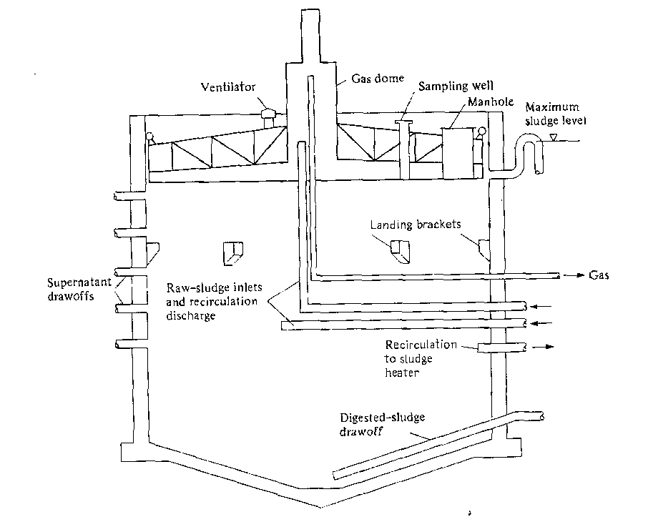

Figure 11 Cross-section of a typical floating-cover digester

High-Rate (Completely Mixed) Digesters

The biological process of anaerobic digestion is significantly improved by complete mixing of the digesting sludge either mechanically or by use of compressed digestion gases. Mechanical mixing is normally accomplished by an impeller suspended from the cover of the digester (Fig. 12a). Three common methods of gas mixing are the injection of compressed gas through a series of small-diameter pipes hanging from the cover into the digesting sludge (Fig. 12b); the use of a draft tube in the center of the tank, with compressed gas injected into the tube to lift recirculating sludge from the bottom and spill it out on top (Fig. 12c); and supplying compressed gas to a number of diffusers mounted in the center at the bottom of the tank (Fig. 12d).

A completely mixed digester may have either a fixed- or floating-cover tank. Digesting sludge is displaced when raw sludge is pumped into a fixed-cover tank. Digesting sludge is displaced when raw sludge is pumped into a fixed-cover digester. By use of a floating cover, tank volume is available for the storage of digesting sludge, and withdrawals do not have to coincide with the introduction of raw sludge.

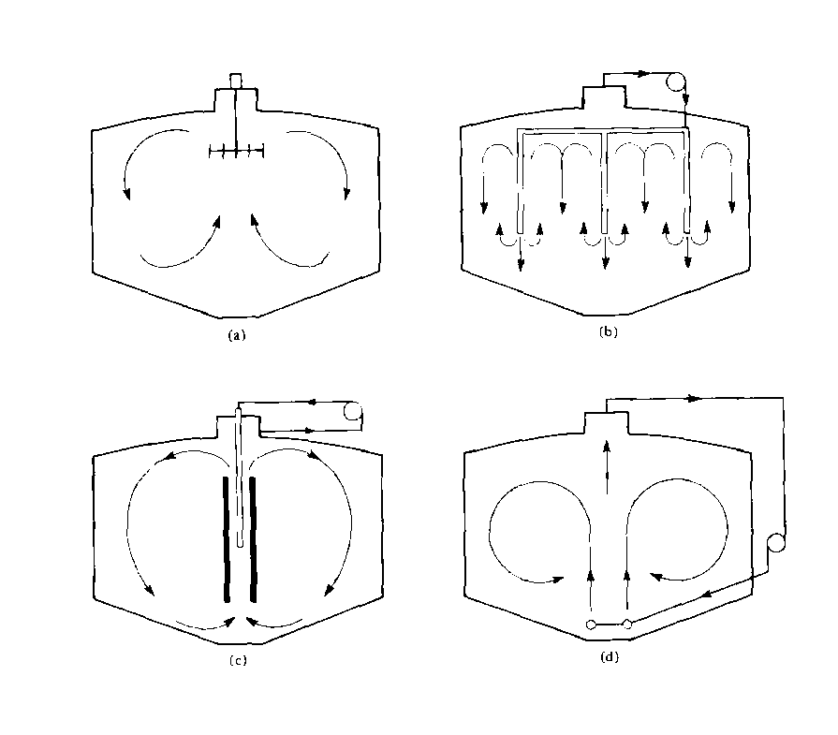Figure 12 High-rate digester-mixing systems. (a) Mechanical mixing. (b) Gas mixing using a series of gas discharge pipes. (c) Gas mixing using a central draft tube. (d) Gas mixing using diffusers mounted on the tank bottom.

Mixing prevents separation therefore, thickening cannot be performed in a completely mixed digester. High-rate digestion systems normally consist of two tanks operated in series (Fig. 13). The first stage is a completely mixed, heated, floating, or fixed-cover digester fed as continuously as possible, whose function is anaerobic digestion of the volatile solids. The second stage may be heated or unheated, and it accomplishes gravity thickening and storage of the digested sludge. Two-stage systems may consist of two similar floating-cover tanks with provisions for mixing in one tank.

Volatile Solids Loadings and Detention Times

Typical ranges of ladings and detention times employed in the design and operation of heated anaerobic digestion tanks treating domestic waste sludge are listed in Table 7. Values given for volatile solids loading and digester capacity for conventional, single-stage digesters are based on the total sludge volume available in the tank (ie., the volume with the floating cover fully raised). Figures given for high-rate digestion apply only to the volume needed for the first stage tank. There are no established design standards for the tank capacity required in second-stage thickening and supernatant separation.

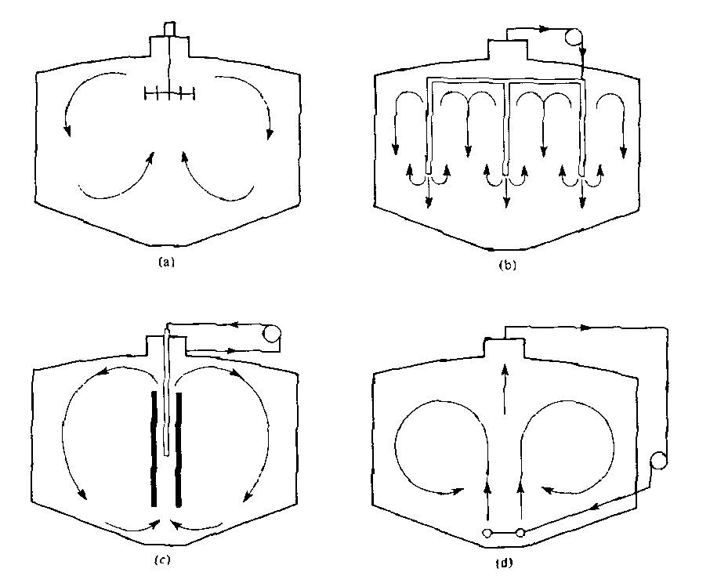

Figure 13 Two-stage digester system, showing piping in control room and external sludge heater.

Table 7 Loadings and detention times for heated anaerobic digesters.
Conventional First-Stage
Single-Stage High-Rate
(Unmixed) (Completely Mixed)
Loading (kg m-3d-1 of VS) 0.3 - 0.8 1.5 - 3
Detection time (days) 30 - 90 10 - 15
Capacity of digester
(m3 / population / equivalent)
Primary only 0.03 - 0.06 0.011 - 0.015
Primary and Secondary 0.12 - 0.18 0.02 - 0.04
Volatile solids reduction (%) 50 - 70 50

Anaerobic Digester Capacity

A maximum of 0.6 kg m-3d-1 ( 1.3 kg m-3 d-1) volatile solids for high rate digestion and a maximum of VS loading for single stage operation is recommended. These loadings assume that the raw sludge is derived from domestic waste water, the digestion temperature is in the range of 29°C - 30°C, volatile solids reduction is 40% - 50%, and the digested sludge is removed frequently from the digester.

Anaerobic digesters are much more difficult to start operating than are aerobic systems. This is because of the slow growth rate and sensitivity of methane-forming bacteria. If a substantial amount of digesting sludge from an operating digester is used as seed, a new digester can be in operation within a few weeks. However, if only raw sludge is available, startup may take months. Normal procedure for startup of a digester is to fill the tank with wastewater and apply a one-tenth sludge feed rate. Lime may be added with the raw sludge to maintain the pH near 7.0. After the digestion process has been established the feed rate is gradually increased by small increments to full loading.

The operation of a digester can be monitored by any of the following methods: plotting the daily gas production per unit raw sludge fed, the percentage of carbon dioxide in the digestion gases, or the concentration of volatile acids in the digesting sludge. A reduction in gas production, an increase in carbon dioxide percentage, and a rise in volatile acids concentration all indicate reduced activity of the acid-splitting methane-forming bacteria.

Aerobic Sludge Digestion

The function of aerobic digestion os to stabilise waste sludge solids by long-term aeration, thereby reducing the BOD and destroying volatile solids. The most common application of aerobic digestion is in handling waste-activated sludge. Customary methods for disposal of the digested sludge are spreading on farmland, lagooning, and drying on sand beds.

Aerobic digestion is accomplished in one or more tanks mixed by diffused aeration. Since dilute solids suspensions have a low rate of oxygen demand, the need for effective mixing rather than microbial metabolism usually governs the air supply required. The volume of air supplied for aerobic digestion is normally in the range of 0.9 - 1.8 m³/m³ of digester.

Design criteria vary with the type of activated-sludge system, BOD loading and the means provided for ultimate disposal of the digested sludge. Small activated-sludge plants without primary sedimentation are generally provided with 57-85 L of aerobic digester volume per design population equivalent of the plant. For stabilising waste-activated sludge with a suspended solids concentration of 1.0% or less, the volatile solids loading should be limited to 0.64 kg/m3.d, and the aeration period 200-300 degree-days computed by multiplying the digesting temperature in degrees Celsius times the sludge age. This equates to a minimum aeration period of 10 days at 20°C or 20 days at 10°C. Volatile solids and BOD reductions at these loadings are in the range of 30% - 50%, and the digested sludge can be disposed of without causing odours or other nuisance conditions.

Long term aeration of waste-activated sludge creates a bulking material that resists gravity thickening. The solids concentration of aerobically digested sludge is usually in the range of 1.0% - 2.0%. The maximum concentration in a well-operated system is not likely to exceed 2.5%. This poor settleability frequently creates problems in disposing of the large volume of sludge produced. Thickening by flotation, pressure filtration, or other mechanical methods is too expensive for incorporation in small treatment plants. Therefore, plant design should take care of storage and elimination of the relatively large volume of aerobically digested sludge.

An aerobic digester is operated as a semibatch process with continuous feed and intermittent supernatant and digested sludge withdrawals. The contents of the digester are continuously aerated during filling and for a specified period after the tank is full. Aeration is then discontinued, allowing the stabilised solids to settle. Supernatant is decanted and returned to the head of the plant, and a portion of the gravity-thickened sludge removed for disposal. In practice, aeration and settlement may be a daily cycle with feed applied early in the day and clarified water decanted later in the day. Digested solids are withdrawn when the sludge in the tank does not gravity thicken to provide a supernatant with adequate clarity.

Example 10
Mambaville is a town of 2000 with an aerobic digester of 150m3 and BOD load on plant = 182 kg/d. Calculate the cubic meters of aerobic digester volume provided per design population equilavent, and estimate the volatile solids loading on the aerobic digester.

Solution
Volume provided = 150 x 1000 = 75 litres of digester volume
2000 design population equivalent

Assuming a BOD loading of 0.20 g of BOD/g of MLSS applied to the aeration tank, the estimated excess sludge produced per day from Fig. 5.1 is 0.42 g of SS/g of BOD load. For the digester volume of 150m3 and assuming 70% of the SS as volatile, the estimated volatile solids loading applied to the aerobic digester is
2.0 (182 x 0.70 x 0.42)/150 = 0/71 kg/m3 .d.

Open-Air Drying Beds

Historically, small communities have dewatered digested sludge on open beds because of their simplicity, rather than operating more complex mechanical systems. Their disadvantages include poor drying during inclement weather, manual labour required for cleaning, potential odour problems, and the relatively large land area required. A typical sand bed consists of 150 - 225 mm. of coarse sand supported on a graded gravel bed that incorporates tile or perforated pipe underdrains. These are spaces 6m apart and return seepage tot he treatment plant influent. Individual sections, nominally 8 x 30m, are contained by watertight walls extending 450mm above the surface; concrete tracks are constructed in the bed to support a vehicle used to haul away the dried cake. A pipe heater with a gated opening to each cell is used to apply liquid slurry in depths of 200 - 250mm.

Rational design for sludge beds is difficult, owing to the multitude of variables that affect the drying rate. These include climate and atmospheric conditions, such as temperature, rainfall, humidity, and wind velocity; sludge characteristics, including degree of stabilisation, grease content, and solids concentration; depth and frequency of sludge application and condition of the sand stratum and drainage piping. The bed are furnished for desiccating anaerobically digested sludge is from .1 - .2 m2 / BOD design population equivalent of the treatment plant. Solids loadings average about 200kg m-2 y-1 in warm climates, while unit loading may be as high as 100kg m-2 y-1 in cooler climates. Drying time ranges from several days to weeks, depending on drainability of the sludge and suitable weather conditions for evaporation. Dewatering may be improved and exposure time shortened by chemical conditioning, such as addition of a polyelectrolyte. Traditionally, dried cake has been removed manually using a shovel-like fork. Attempts to employ mechanical equipment often lead to disturbance of the bed and excessive loss of sand.

Paved drying areas with limited drainage systems cab be constructed to permit mechanical cleaning. But climatic conditions must be favourable, since the major water loss is through evaporation. Wedge-wire beds have been used in England to increase the rate of sludge dewatering and for ease of cleaning. During sludge application, the underdrain is filled with water and the wedge-wire bottom is submerged 2.5mm to serve as a cushion, permitting the sludge to float into position without contacting the surface of the wedge wire. Later, the water is drained and the sludge dries by seepage and evaporation.

Air drying of digested sludge may be practiced in shallow lagoons where permitted by soil and weather conditions. Water removal is by evaporation, and the groundwater table must remain below the bottom of the lagoon to prevent contamination by seepage. Sludge is normally applied to a depth of about .6m and residue removed by a front-end loader after an extended period of consolidation. Because of long holing times, odour problems are more likely to occur. Design data and operational techniques are defined by local experience.

Composting

The objectives of sludge composting are to biologically stabilise putrescrible organics, destroy pathogenic organisms, and reduce the volume of waste. The optimum moisture content for a compost mixture is 50% - 60%; less than 40% may limit the rate of decomposition, while over 60% is too wet to stack in piles. Volatile solids reduction during composting is similar to biological digestion averaging about 50%. The compost product is a moist, friable humus with a water content less then 40%. For most efficient stabilisation and pasteurisation, the temperature in the compost piles should rise to (55° - 65°C) but not above 80°C. Moisture content, aeration rates, size and shape of pile, and climatic conditions affect composting temperature. The finished compost, although too low in nutrients to be classified a fertiliser, is an excellent soil conditioner. When mixed with soil, one advantage of the added humus content is increased capacity for retention of water.

The main products of biological metabolism in aerobic composting are carbon dioxide, water, and heat. Anaerobic composting produces intermediate organics, such as organic acids, and gases including carbon dioxide and methane. Since anaerobic decomposition has a higher odour potential and releases less heat, most systems are designed for aerobic composting. Nevertheless, all forms of composting have the potential of nuisance problems such as odours and dust.

Dewatered sludge cake, usually with a moisture content in the range if 70% - 85%, is too wet to maintain adequate porosity for aeration. If it is not mixed with another substance, a pile of sludge cake tends to slump and compact to a dense mass with a wet, anaerobic interior and a dried exterior crust. Figure 14 is a generalised diagram for composting organic sludges. Dewatered cake is mixed with either an organic amendment (e.g., dried manure, straw, or sawdust) or a recoverable bulking agent (e.g., wood chips) to reduce the unit weight and increase air voids. Finished compost may also by recycled and added to the wet cake. Although composting can be performed in an enclosed reactor, the common processes used outdoor piles wither exposed or sheltered under a roofed structure. Compost may be placed in either windrows agitated by periodic turning or remixing and aeration or static piles with forced aeration. The choice between these two processes is based on several factors, including climate, environmental considerations, the availability of a bulking agent, and economics.

In the windrow system, mixed compost material is arranged in long parallel rows. These windrows are turned at regular intervals by mobile equipment to restructure the compost. The piles may be triangular or trapezoidal in shape and may vary in height and width, as determined by the equipment used for turning and the characteristics of the composting material. The height of windrows is usually 1.2 - 2.4m and the width 2.5 - 4m.

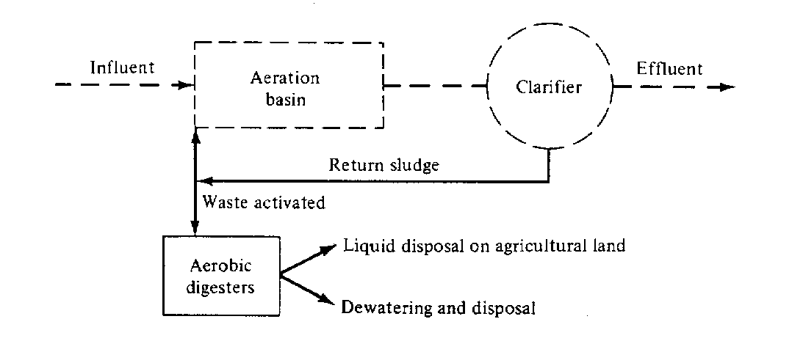
Figure 14 Generalised diagram for composting dewatered wastewater sludges.

Windrow composting is used in agricultural regions where manure from confined feeding of cattle is available for an amendment. The manure is aged and dried by stacking in the feedlot. The wastewater sludge is unstable (raw) filter cake collected immediately after mechanical dewatering with polymer conditioning. Combined in approximately equal portions, the wet cake and dried manure are mixed using a modified manure spreader with the back beaters reversed so that the compost is deposited on the ground in a row rather than being thrown upward by the back beaters for widespread distribution. A large machine straddling the rows, equipped with an auger type agitator between the outboard wheels, forms the shaped windrows; periodic turning is performed by the same machine. With weekly turning, stabilisation requires 4-6 weeks in good weather. In northern climates, the windrows may freeze on the outside and be covered with snow for several weeks, preventing turning and slowing the rate of decomposition. The finished compost is stored and applied times on grassland and cropland.

In the aerated static-pile process, oxygen is supplied by mechanically drawing air through the pile. Porosity is maintained by wood chips or similar recyclable bulking agent, which also reduces the initial water content by absorption. The ratio of sludge to wood chips on a volumetric basis is in the range of 1:2 to 1:3. After preparing a base of wood chips over perforated aeration piping, the mixture is placed on a pile 8-10ft. This is layered with finished compost to form a cover. Air is then drawn through the pile of finished compost to form a cover. Air is then drawn through the pile for a period of about 3 weeks by a blower operating intermittently to prevent excessive cooling. Exhaust air is vented and deodorised through a pile of finished compost. After stabilisation, the mixture is cured and dried for several weeks either in the original pile or moving to a stockpile. The wood chips are separated from the compost by vibrating screens for reuse.

ULTIMATE DISPOSAL OF SLUDGES

Most wastewater sludges are disposed of on land, with approximately three-quarters being used as soil conditioner and the remainder buried in landfill. Other principal methods of disposal are incineration and discharging in the ocean. Land application is increasing because of the rising cost of energy required to burn sludge and the regulatory restrictions on ocean disposal.

Land Application of Sludge

Most of the sludge spread on agricultural land is stabilised by anaerobic or aerobic digestion. The haul distance climate, and availability of liquid sludge storage are key factors in considering application of liquid-digested sludges. At small plants, tank trucks or tractor-drawn wagons are often adequate for transportation and the storage capacity in digesters or holding tanks is sufficient to hold sludge during equipment breakdown and bad weather. Favoured at large plants, mechanical filtration is used to dewater the sludge to reduce the mass and cost of hauling. Also, digested sludge cake can be stored in piles on an open site and placed on cropland at appropriate times. Other kinds of sludge solids suitable for surface spreading on farmland are dried cake from drying beds and lagoons, compost, limed raw sludge, and thermally conditioned solids. Environmental regulations in nearly all regions require burial of raw sludges and wastes containing excess heavy metals or organic toxins.

Liquid sludge may be applied by a vehicle equipped with a rear splash plate for surface spreading or by chisel ploughs for subsurface incorporation. The flexibility of vehicular hauling allows application at a variety of locations, often privately owned farmlands. Spraying from fixed or portable irrigation nozzles can be practiced where odour and insects are not problems. Subsurface injection is the most environmentally acceptable method since the sludge is incorporated directly with the soil, eliminating exposure to the atmosphere.

Environmental concerns regarding land disposal are surface-water and groundwater pollution, contamination of the soil and crops with toxic substances, and transmission of human and animal diseases. Laboratory analyses of a sludge normally consist of the solids concentration; nitrate, ammonium and organic nitrogen; soluble and organic phosphate; potassium; heavy metals of cadmium, copper nickel, lead and zinc; and selected organic compounds such as polychlorinated biphenyls (PCB). To eliminate the possibility of transmitting contaminants to humans, the preferred vegetation is non-food-chain crops like cotton. Grass is considered acceptable, provided cattle are restricted from grazing for a specified period after sludge application. Also, feed grains for animal consumption are commonly fertilised by tiling sludge solids into the soil before planting of crops. At a prepared sludge disposal site, sludge, soil, groundwater, and any surface water runoff are monitored on a regular basis for faecal coliforms, nutrients, and contaminants.

Cadmium is the heavy metal of greatest concern to human health when applying municipal wastewater sludges to land, since it can be taken up by plants to enter the human food chain. The movement of cadmium to groundwater is very unlikely to occur at the pH values of greater than 6.0 commonly associated with agricultural soils. The primary chronic health effect of excessive dietary intake is damage to the kidney.
The cadmium content of agricultural soils ranges from near zero to several hundred milligrams per kilogram, of soil contaminated by industrial wastes. In addition to sludge, many phosphate fertilisers contain substantial concentrations of cadmium. Predicting plant uptake from soils with accumulated cadmium is difficult because of interactive controlling condition. Soil pH is an important chemical factor, but the kind of plant species is just as important. Within plants, the highest amounts of cadmium occur in the fibrous roots followed by the leaves, and the lowest concentrations are in fruits, seeds, and storage organs. Potential high-risk plants for humans are leafy vegetables (e.g., lettuce and spinach). Fodder crops and cereal grains appear to present the least risk. David and Coker have written a comprehensive literature review and discussion of the distribution of cadmium, plant uptake, and hazards associated with sludge used in agriculture.

Guidelines for the addition of cadmium in sludge to agricultural land suggest a wide range of allowable application rates. The maximum permissible level recommended by the US Environmental Protection Agency is 2.0 kg/ha⋅y on agricultural land, with 500 g/ha⋅y suggested for accumulator crops. Regulations may also limit the concentration in the sludge applied to land (often less than 20 mg/kg of dry solids) and the maximum allowable accumulation based on characteristics of the soil (10-50 mg/kg of dry soil). The concentrations of cadmium relative to dry solids in municipal sludges are usually 20 mg/kg or less, although uncontrolled discharge of industrial wastewaters to the treatment plant can dramatically increase this amount.

Nitrogen is another important factor in determining the allowable rate of applying sludge to land. The concern is pollution of groundwater with nitrate. On porous solids, the recommended rate of nitrogen application is an amount equivalent to the nutrient need of the vegetation.

The variety and numbers of bacteria, viruses, and parasitic organisms pathogenic to humans and animals found in wastewater relate to the state of health of the contributing community. Although treatment processes reduce their numbers, often considerably, the effluent and sludge still contain the species present in raw sludge is the reason for spreading only stabilised sludges on agricultural land. The effectiveness of rescuing pathogenic populations during sludge stabilisation is a subject of considerable controversy. In general, anaerobic or aerobic digestion of sludge is effective in reducing the number of viruses and bacteria, nut not in reducing roundworm and tapeworm ova or other resistant parasites. Being the most fragile micro organisms, bacteria are inactivated by sunlight, drying, and competition in the soil environment. In contrast, viruses and parasitic ova are more resistant and may persist in soils or on vegetation for several weeks or months. Even though the risk of infecting livestock is not great, farmers are usually advised to allow 6 weeks or more after sludge application before grazing animals or harvesting a fodder crop. Regarding human health, despite the possibility of communicable disease transmission, the lack of epidemiological evidence suggests that the current practice of sludge disposal to the land is safe.

Example 11

A municipal wastewater contains 200 mg/L of BOD, 220 mg/L of suspended solids, 35 mg/L of nitrogen, and 0/16 mg/L of cadmium. Wastewater processing is primary sedimentation and secondary activated sludge with the waste sludge anaerobically digested prior to spreading on agricultural land. The plant effluent is discharged to a river. Based on operational data, 25% of the influent cadmium appears in the 100 mg of digested sludge solids produced per litre of wastewater processed. The fertiliser value of the dried sludge solids is 4.0% available nitrogen.

a. Calculate the concentration of cadmium in the plant effluent in milligrams per litre. If the concentration limit of cadmium in the river waste is 0.0013 mg/L to protect aquatic life, what dilution ration of plant effluent to cadmium free river water is needed?

b. Calculate the concentration of cadmium in the dried sludge solids in units of kilograms per tonne. The digested sludge is being applied to land cultivated for growing soybeans. The recommended annual nitrogen application is 200 kg/ha, and the maximum allowable cadmium loading is 0.5 kg/ha⋅y. Based on these criteria, compute the maximum sludge application in units of tonnes of dry solids per hectare.

c. Ferric chloride (waste prickle liquor), added to the wastewater for increasing phosphorus removal, also increases the cadmium removal to 70%. Calculate the data requested in question 1 through 4 for this degree of cadmium removal.

Solution

a. The cadmium in effluent amounts to 0.75 x 0.16 = 0.012 mg/l. Assume the dilution ratio is X (i.e., when the effluent flow is 1, the river flow is X). Then

X x 0 + 1 x 0.012 = (1 + X) x 0.0013

X = flow of river/flow of wastewater discharge = 8.2

b. The concentration of cadmium in sludge solids equals

0.25 x 0.016 mg/L x 1000 kg/t = 0.036 kg/t
110 mg/L

The nitrogen content of the sludge solids equals

110 mg/l x 0.04 x 1000 kg/t = 40 kg/t
100 mg/l

The maximum allowable sludge application rate is

based on cadmium = 0.5 = 14 t/ha
0.036
based on nitrogen = 220 = 5.5 t/ha (Use this loading)
40

c. The cadmium in effluent is 0.03 x 0.16 = 0.0048 mg/l

Dilution ratio required = 2.7
Concentration of cadmium in sludge = 0.10 kg/t

The maximum allowable sludge application rate is

based on nitrogen = 5.5 t/ha

based on cadmium = 0.5 = 5.0 t/ha (Use).
0.10

These computations illustrate that treatment for removal of phosphate by chemical precipitation also increases the removal of cadmium. While the effluent quality then improves, the contamination of the sludge increases.

Land Burial of Dewatered Sludge

Raw or digested wastewater sludges and chemical residues from water treatment may be buried if a suitable site is available. Except in highly urbanised area, land and transportation costs are less expensive than incineration or chemical recovery. Sludges are often buried at municipal sanitary landfills along with other solid wastes, requiring systematically depositing, compacting, and covering the wastes. Usually of earth are placed over each 150 - 300 mm of compacted fill. The top earth cover should have a mimimum depth of 600 mm (2x) and be grassed to prevent erosion.

Site selection considers soil conditions, groundwater levels, location relative to populated areas, and future land-use planning. Conditions must be such that gas leachate, water seepage, and runoff do not cause pollution, nuisance, or health hazards. A monitoring program should be established to ensure that an adequate environment is maintained at the site. Projected land use may be a park with recreational facilities that are not affected by gradual subsidence of the ground surface.

Combustion of Organic Sludges

Incineration involves drying sludge cake to evaporate the water, followed by burning for complete oxidation of the volatile matter. Drying occurs at a temperature of approximately 350°C, and burning is sustained at 700° - 800°C. A minimum temperature of 730°C is needed to deodorise exhaust gases. Excess air is required to ensure complete combustion of organics and minimise the escape of odour producing compounds in stack gases. The amount need is 25%-100% over the stoichiometric air requirement and varies with the nature of the sludge and type of incineration equipment. Supplying excess air has the adverse effects of reducing the burning temperature and increasing heat losses from the furnace. Heat emitted from burning volatile solids minus losses, is available for drying the incoming sludge and heating the air supply. Self-sustaining combustion of dewatered raw sludge, after the incinerator temperature has been raised to the ignition point by burning an auxiliary fuel, is possible if the organic solids content is greater than approximately 35%. The exact solids content necessary for autogenous burning depends on several factors related to the characteristics of the sludge and the design and operation of the furnace (e.g., preheating of incoming air and cooling exhaust gases).

Heat yield from sludge combustion is related directly to moisture content and volatile solids concentration. Several theoretical can be performed for calculating calorific values based on elemental composition, principally the carbon, hydrogen oxygen and sulfur contents. However, experience has shown that calculated results often are inaccurate. A laboratory calorimeter test is the only reliable method of determining the heat value of a waste. (See Environmental Technology ENVE 5/333.)

Sludge Incinerators

Two major incineration systems employed are the multiple-hearth furnace and the fluidise-bed reactor. The multiple-hearth unit has received widest adoption because of its simplicity and operational flexibility. Its furnace consists of a lined circular shell containing several hearths arranged in a vertical stack and a central rotating shaft with rabble arms. Its operating capacity is related to the total hearth area (diameter and number of stages) and varies from 100 to 400 kg/h of dry sludge. Sludge cake is fed onto the top hearth and is raked slowly in a spiral path to the centre. Here, it falls to the second level, is pushed to the periphery, and drops in turn to the third hearth, where it is again raked to the centre. The upper levels allow for evaporation of water, the middle hearths burn the solids, and the bottom zone cools the ash prior to discharge (see Figure 15).

The hollow central shaft is cooled by forced air vented out the top. A portion of this preheated air from the shafts is piped to the lowest hearth and is further heated by the hot ash and combustion as it passes up through the furnace. The gases are then cooled as heat is absorbed by the incoming sludge. The countercurrent flow pattern of air and sludge solids reduces heat losses and increases incineration efficiency. Stack gases are discharged through a wet scrubber to remove fly ash and other air pollutants. Emission control requirements specify that the exhaust cannot contain particulate matter in excess of 70 mg/m3 or exhibit 10% or greater opacity (shadiness), except for 2 min in any 1h period. The presence of uncombined water is the only reason for failure to meet the latter requirement.

Multiple-hearth furnaces can also be designed to dry organic sludge or recalcine calcium carbonate precipitate, The solids and air-flow system for calcination is similar to the pattern used for sludge drying, hot gases from an external furnace flow concurrent with the sludge down through the multiple hearths in order to dry the organics without scorching.

Sludge can also be dried in a flash-dryer system. First, wet sludge cake is mixed with recycled dried solids and pulverised in a cage mill. Hot gases from a separate incinerating furnace suspend the dispersed sludge particles up into a pipe duct, where they are dried, and a cyclone separator removes the dried solids from the moisture laden hot gas. Part of the dried sludge returns to the mixer for blending with incoming wet cake, while the remainder is wither withdrawn for a soil conditioner or burned in the furnace for fuel.

A fluidised-bed incinerator uses a sand bed as a heat reservoir to promote uniform combustion of sludge solids. the bed is expanded by upflow of air through the sand. Dewatered sludge is injected into the fluidised sand above the grid. Violent mixing of the solids and gases in the hot sand promotes rapid drying and burning at a temperature of 750°-800°C. the quantity of excess air needed is about 25%. The sand bed acts as a heat reservoir, enabling reduced startup time when the unit is operated only 4-8 h/day. When necessary, the be is preheated by using an auxiliary fuel. Water vapour and ash are carried out of the bed by combustion gases.
A cyclonic wet scrubber removes ash from the exhaust and finally separates it from the scrubber water in a cyclone separator.

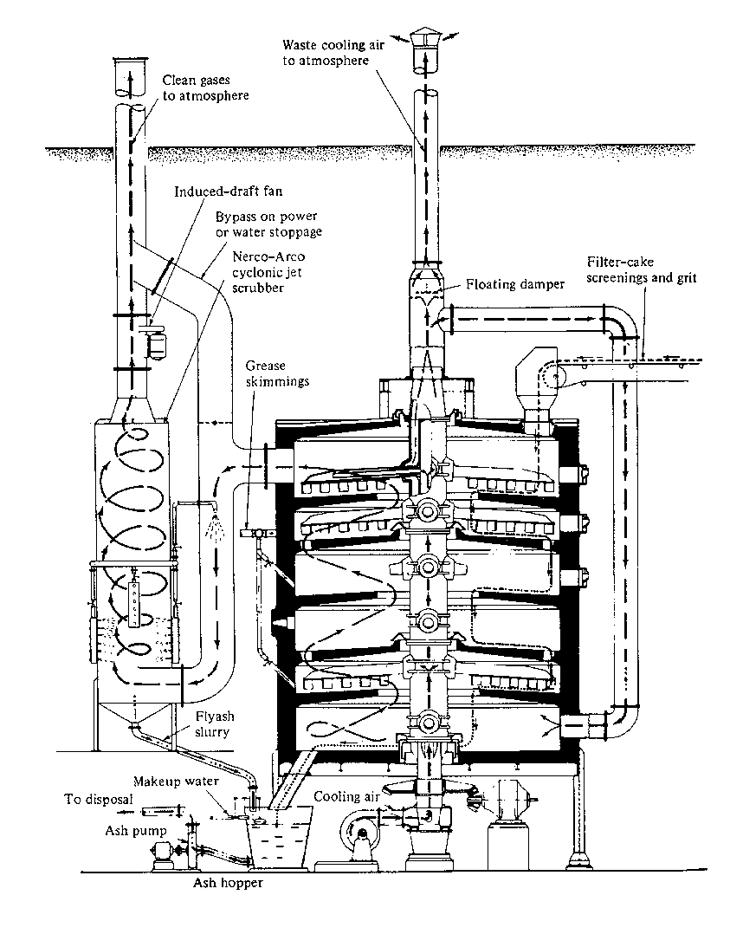
Figure 15 Multiple-hearth sludge furnace (Courtesy of Nichols Engineering and Research Corp., a Wheelabrator-Frye Co.)

Ocean disposal of sludges

Coastal cities have discharged digested sludge into the ocean for half a century. Just like crayfish have got used to be dumped into boiling water through the centuries, the oceans may have adapted to this sludge dumping. Dewatered wastes may be transported to offshore sites in barges and dumped, or sludge slurry may be dumped to deep water through a submarine outfall. In recent years, this practice has been questioned by regulatory agencies. The principal environmental concerns are degradation of recreational waters, build-up of solids on the sea bottom, and toxicity to marine life. The contaminants involved are the same as those related to disposal of land - heavy metals, pathogens, and organic pollutants.

Ocean disposal sites should have adequate current velocities for initial dilution and waste dispersion to prevent concentration of pollutants. Some waste slurries have a lower specific gravity than seawater and rise to the surface, while the solids of others accumulate on the bottom creating sludge deposits that decompose. The content of heavy metals in municipal sludges can be limited by instituting and enforcing a sewer ordinance to control industrial wastewater quality. As with land disposal, the sludge should be biologically stabilised to reduce pathogens.

A dumpsite in the Atlantic Ocean used by the city of Philadelphia to discharge digested sludge has been monitored for several years with little or no evidence of harmful effects found in the marine ecosystem. For example, faecal coliform levels were considered safe for shellfish harvesting and metal accumulations in the sediments did not show an obvious pattern. Another extensive study was conducted in coastal waters off southern California where several cities discharge wastewaters and the Hyperion plant discharges digested sludge through a submarine outfall. Except for localized areas near the ends of the outfall pipes, environmental conditions were not measurably influenced, and within these areas the major evidence of pollution was an increase in the organic matter on the bottom. The investigation was extensive, incorporating the sources and distribution of pollutants. For coastal cities, this method of ultimate disposal should be considered as one option along with incineration, land application, and permanent storage in landfill.

Proper site selection for dilution and dispersion in combination with good quality control over the sludge could make ocean disposal an environmentally safe option. Sensitive coastal ecosystems should be considered, however, as the release of nutrients could upset delicate balances. Sludge disposal within the Great Barrier Reef area or in Tampa Bay would probably be highly irresponsible.

Reuse of water treatment sludges

Sludges and silts produced by waterworks, even after extensive dewatering, often create ultimate problems. Finding a use for such materials could eliminate or reduce thee disposal problems, eliminate the spoiling of land or fouling of waterways, reduce disposal costs and create possibilities of financial return from the sale of products produced.
Work at MATTEK, the Materials Technology Division of the S.African C.S.I.R. has identified waterworks sludge as a source of raw material for the production of bricks and tiles. The building elements developed either meet or are well below usual production costs. Extensions of this work to other waterworks sludges show possibilities. A feasibility study was carried out, based on an independent market analysis, for the manufacture of bricks, blocks and tiles. This study proved such manufacture to be a viable proposition.
Severe difficulties were experienced in all critical areas of ceramic processing, i.e. forming, drying and firing. Fortunately most of these difficulties have been overcome to a greater of lesser extent and valuable experience has been gained in processing waterworks sludge in general.
Whilst the pressing of tiles worked well, the pressing of bricks proved to be the greatest area of difficulty of the whole investigation. The major effort of the investigation was focussed on overcoming this difficulty. The bricks pressed well in the die, but after being removed from the die for several house they were prone to cracking. This difficulty has been largely overcome by optimisation studies.
The drying of the pressed tiles and bricks was originally thought to present no difficulties, but eventually it was found that this was the cause of the cracking of the unfired bricks. This was unexpected and very unusual because the drying shrinkage of the bricks was very low and in the case of extruded bricks this would normally never cause such a problem. This difficulty was overcome by perforating the bricks.
In the case of fining it was found that if the bricks or tiles were fired in the normal manner up to maximum temperature, usually in the range of 900° to 1000°C, they would crack or warp badly. This difficulty was overcome by introducing a calcination step at 600°C, to burn off the flocculants and organic matter. The firing cycle finally adopted was: one day to reach 600°C from room temperature, left for one day at 600°, followed by an 80°C rise per hour to reach the required maximum temperature. This solved the problem of the cracking and warping for the tiles and the rings, but not for the solid bricks. It was found that noxious gases were evolved in the temperature range of 250°C to 550°C. Venting or scrubbing of the gases could overcome this.

Reference:
Boucher, P S and van Eeden, J J. Investigation of inorganic materials derived from water purification processes for ceramic applications, Water Research Commission Report No 538/1/95, WRC ISBN 1 86845 161 5 Pretoria, South Africa.

