SETTLING

Some basic definitions will aid in understanding the basic concept and aim of sedimentation.

Sedimentation , also known as settling, may be defined as the removal of solid particles from a suspension by settling under gravity.

Clarification is a similar term that usually refers specifically to the function of a sedimentation tank in removing suspended matter from the water to give a clarified effluent. In a broader sense, clarification could include flotation and filtration.

Thickening in sedimentation tanks is the process whereby the settled impurities are concentrated and compacted on the floor of the tank and in the sludge-collecting hoppers.

Concentrated impurities withdrawn from the bottom of sedimentation tanks are called sludge, while material that floats to the top of the tank is called scum.

Application of sedimentation processes

In water treatment, sedimentation is commonly used to remove impurities that have been rendered settleable by coagulation and flocculation, as when removing turbidity and color. Precipitates formed in processes such as water softening by chemical precipitation are also removed by sedimentation.

In municipal wastewater treatment, sedimentation is the main process in primary treatment, where it is responsible for removing 50 to 70% of the suspended solids (containing 25-40 per cent of the BOD) from the wastewater. After biological treatment, sedimentation is used to remove the biological floc produced by microorganisms in these processes, so that effluent quality will approach a standard suitable for discharge into inland waterways. The removal of grit in the preliminary stage of treatment is commonly carried out by means of a differential sedimentation process in which heavy grit is permitted to settle while lighter organic matter is retained in suspension. Further sedimentation after coagulation may be used in tertiary treatment.

Sedimentation is also required where phosphorus removal is effected by chemical precipitation separately from primary or secondary treatment. Other less obvious applications of sedimentation are in the separation of digested sludge from supernatant liquor within secondary (unstirred) sludge digesters, and also in sludge lagoons.

An understanding of the principles governing the various forms of sedimentation behavior is essential to the effective design and operation of sedimentation tanks.

Classification of settling behavior

Several cases of settling behavior may be distinguished on the basis of the nature of the particles to be removed and their concentration. Thus, individual particles may be discrete (sand grains) or flocculent (most organic materials and biological solids). Particle concentrations may vary from very low through to high in which case adjacent particles are actually in contact. Common classifications of settling behavior are:

Class I - Unlimited settling of discrete particles
Class II - Settling of dilute suspensions of flocculent particles
Class III - Hindered settling and zone settling
Class IV - Compression settling (compaction).

Sedimentation Class I - Unlimited settling of discrete particles.

The simplest form of sedimentation is that involving discrete particles in such low concentration that each particle settles freely without interference from adjacent particles (that is, unhindered settling).

When a particle settles in a fluid it accelerates until the drag force due to its motion is equal to the submerged weight of the particle. At this point, the particle will have reached its terminal velocity, V_{p}.

A diagram for settling of an idealized spherical particle is shown below (Figure 2.4). V_{p} is the particle settling velocity (m/s); D is the drag force; W is the submerged weight of the particle; d is the diameter of the particle (m); A_{p} is the projected area of the particle normal to the direction of motion (m²); ∀_{p} is the volume of the particle (m³); ρ is the density of the particle (kg/m³); ρ_{p} is the fluid density (kg/m³); μ is the dynamic viscosity of the fluid (N.s/m²); and C_{D} is the drag coefficient.
Figure 2.4 Definition diagram for particle terminal settling velocity

An expression for V_{p} may be derived from the submerged weight of the settling particle, W, and the fluid drag force, D.

The drag force on a particle is given by

D = C_{D}ρA_{p} $\frac{V_{p^{2}}}{2}$ [2.1]

The submerged weight of the particle can be expressed as

W = (ρ - ρ_{l})g ∀_{p} [2.2]

Since D = W, the above, after substituting A_{p} and ∀_{p} for functions in terms of particle diameter d and rearranging, results in the following expression for ∀_{p}

V_{p} = $\sqrt{\frac{4}{3}\frac{(ρ−ρ_{l})}{ρ_{l}}\frac{\text{gd}}{C_{D}}}$ [2.3]

In practice, it is found that C_{D} is a function of the Reynolds Number, R_{e}, and, for spherical particles, it can be represented by the following expressions

R_{e} < 1, C_{D} = $\frac{\text{24}}{R_{e}}$

1 < R_{e} < 10⁴, C_{D} = $\frac{\text{24}}{R_{e}}$ + $\frac{3}{(R_{e})^{12}}$ + 0.34

10³ < R_{e} < 10⁵, C_{D} ≈ 0.4

Substituting the above expression for R_{e} < 1 (laminar flow) in Equation 2.3 and noting that
R_{e} = ρ_{l}V_{p}d/μ, results in the following equation, known as Stokes’s Law:

$V_{P}=\frac{g}{\text{18}}\frac{\left(ρ−ρ_{l}\right)}{m}d^{2}$ [2.4]

At high values of R_{e}, where C_{D} ≈ 0.4, the equivalent expression is

V_{p} = $\sqrt{3\text{.}\text{33}\frac{(ρ−ρ_{l})}{ρ_{l}}\text{gd}}$ [2.5]

The general conclusion that V_{p} depends on a particular diameter, particle density and, under some conditions, also on fluid viscosity and hence on temperature, is important in understanding sedimentation behavior. Furthermore, in practical sedimentation tanks, the terminal settling velocity is quickly reached, so, for non-flocculent particles and uniform fluid flow the settling velocity is constant throughout the settling time. This fact can be usefully applied to a study of settling in an ideal sedimentation tank to provide an important design principle for sedimentation processes.

Idealized representations of three common types of sedimentation tanks are shown in Fig 2.5: (a) rectangular horizontal flow, (b) circular radial flow and (c) upflow tanks.

The ideal rectangular horizontal flow sedimentation tank is considered to be divided into four zones (Fig 2.5a)

a Inlet zone - in which momentum is dissipated and flow is established in a uniform forward direction

b Settling zone - where quiescent settling is assumed to occur as the water flows towards the outlet

c Outlet zone - in which the flow converges upwards to the decanting weirs or launders

d Sludge zone - where settled material collects and is moved towards sludge hoppers for withdrawal. It is assumed that once a particle reaches the sludge zone it is effectively removed from the flow.

The critical particle in the settling zone of an ideal rectangular sedimentation tank, for design purposes, will be one that enters at the top of the settling zone, at point A, and settles with a velocity just sufficient to reach the sludge zone at the outlet end of the tank, at point B. The velocity components of such a particle are V_{h} in the horizontal direction and V_{p}, the terminal settling velocity, in the vertical direction.

From the geometry of the tank it is apparent that the time required for the particle to settle, t_{o}, is given by

t_{o} = $\frac{H}{V_{p}}$ = $\frac{L}{V_{h}}$

but, since V_{h} = Q/WH, then V_{p} = Q/WL, where Q is the rate of flow, and L, W and H are the length, width and depth of the tank, respectively. Since the surface area of the tank, A, is WL, then

V_{p} = Q/A

According to this relationship, the slowest-settling particles that could be expected to be completely removed in an ideal sedimentation tank would have a settling velocity of Q/A. Hence this parameter, which is called the surface loading rate or overflow rate, is a fundamental parameter governing sedimentation tank performance.

This relationship also implies that sedimentation efficiency is independent of tank depth - a condition that holds true only if the forward velocity is low enough to ensure that the settled material is not scoured and re-suspended from the tank floor.

A similar analysis of an ideal circular radial flow sedimentation tank is summarized in Fig 2.5b from which it is seen that the same relationship, V_{p} = Q/A, is obtained.

In an ideal upflow sedimentation tank (Fig 2.5c) it is apparent that a particle will be removed only if its settling velocity exceeds the water upflow velocity. In this case the minimum upflow velocity is given by the flow rate divided by the surface area of the tank (Q/A), so once again the minimum settling velocity for a particle to be removed is V_{p} = Q/A.

In an ideal sedimentation tank with a horizontal or radial flow pattern, particles with settling velocities < V_{p} can still be removed partially, but not in an ideal upflow tank.

Sedimentation Class II - settlement of flocculent particles in dilute suspension

It should be recognized that particles do collide and that this benefits flocculation and hence sedimentation. In a horizontal sedimentation tank, this implies that some particles may move on a curved path while settling faster as they grow rather than following the diagonal line in Figure 2.5a. This favors a greater depth as the longer retention time allows more time for particle growth and development of a higher ultimate settling velocity. However, if the same retention time were spread over a longer, shallower tank, the opportunity for collision would become even greater because the horizontal flow rate would become more active in promoting collisions. In practice, tanks need to have a certain depth to avoid hydraulic short-circuiting and are made 3-6 m deep with retention times of a few hours.

The advantage of low depths is exploited in some settling tanks by introducing baffles or tubes. These are installed at an angle that permits the settled sludge to slide down to the bottom of the settler, even though any angle effectively increases the vertical displacement between two plates.

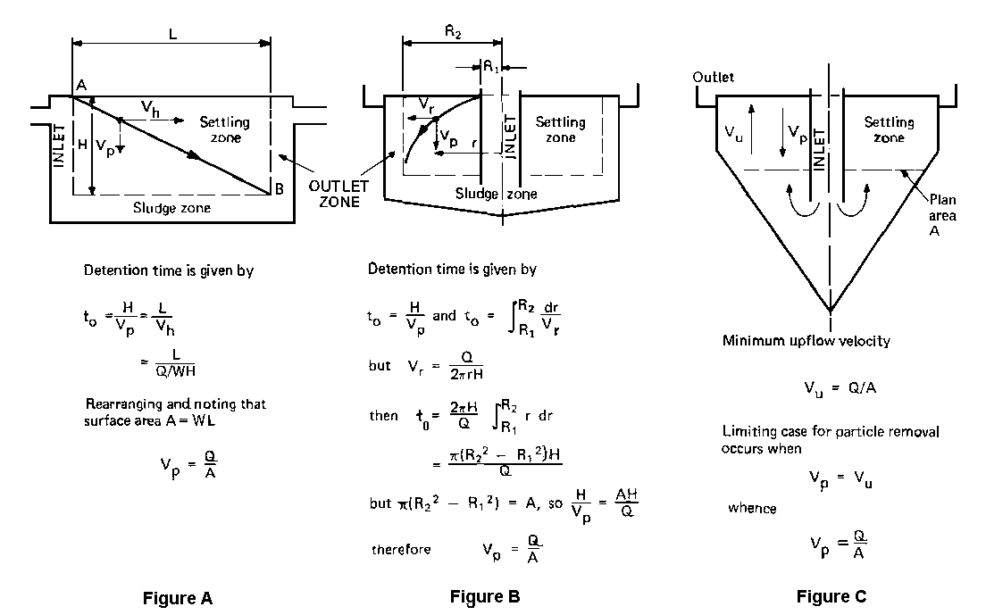

Figure 2.5 Definition for ideal settling in sedimentation tanks
(a) rectangular horizontal flow tank,
(b) circular radial flow tank,
(c) upflow tank
Sedimentation Class III - hindered settling and zone settling and sludge blanket clarifiers

As the concentration of particles in a suspension is increased, a point is reached where particles are so close together that they no longer settle independently of one another and the velocity fields of the fluid displaced by adjacent particles, overlap. There is also a net upward flow of liquid displaced by the settling particles. This results in a reduced particle-settling velocity and the effect is known as hindered settling.

The most commonly encountered form of hindered settling occurs in the extreme case where particle concentration is so high that the whole suspension tends to settle as a ‘blanket’. This is termed zone settling, because it is possible to distinguish several distinct zones, separated by concentration discontinuities. Fig 2.6 represents a typical batch-settling column test on a suspension exhibiting zone-settling characteristics. Soon after leaving such a suspension to stand in a settling column, there forms near the top of the column a clear interface separating the settling sludge mass from the clarified supernatant. This interface moves downwards as the suspension settles. Similarly, there is an interface near the bottom between that portion of the suspension that has settled and the suspended blanket. This interface moves upwards until it meets the upper interface, at which point settling of the suspensions is complete.

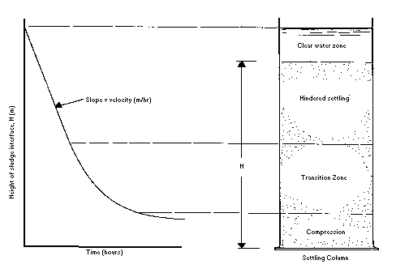
Figure 2.6 Settling column test for a suspension exhibiting zone-settling behavior

It is apparent that the slope of the settling curve at any point represents the settling velocity of the interface between the suspension and the clarified supernatant. This once again leads to the conclusion that in designing clarifiers for treating concentrated suspensions (Class III), the surface loading rate is a major constraint to be considered; unless the surface loading rate adopted is less than the zone-settling velocity (V_{sz}) of the influent suspension, solids will be carried over in the effluent.

An important application of zone settling is the final design of sedimentation tanks of activated sludge processes.

Hindered settling is also important in upflow clarifiers in water treatment. These units often operate with a high concentration of solids (consisting of chemically-formed floc and impurities) in suspension. By simple comparison with the ideal upflow sedimentation tank in Fig 2.5c, it may be seen that a suspension will be retained in an upflow clarifier only if the settling velocity of the suspension interface, V_{s}, is equal to the upflow velocity of the water, V_{u}. This is important because many practical clarifiers are designed to maintain a high concentration of solids in suspension in order to take advantage of the increased opportunity for particles to collide and agglomerate. This assists in removing many of the very fine particles that might otherwise be carried over in the effluent.

In both these cases involving hindered settling of concentrated suspensions, the settling velocity of the suspension, V_{s} (or V_{sz}) is dependent on its concentration; as concentration increases, V_{s}, (or V_{sz}) decreases.

The relationship between the velocity of settling (hereafter called simply V_{s}) and the volumetric concentration of the particles in the suspension has not yet been determined analytically for hindered settling situations. It is therefore necessary to use empirical equations to define an approximate relationship.

Many equations for this relationship have been proposed. The combined advantages of mathematical simplicity and reasonable accuracy over a wide range of concentrations are features of the empirical equation proposed by Richardson:

V_{s} = V_{p}ε^{n} [2.6]

where ε = (1 - c), the porosity of the suspension; c is the proportion of the total suspension volume occupied by particles; and n is an index depending on the Reynolds number and the size and shape of the particles.

For smooth spheres, the value of n varies from 4.65, for fully laminar flow conditions, to about 2.5 for turbulent flow conditions around the particles. For irregular particles, it is impracticable to determine volumetric concentration. The relationship may be modified to

V_{s} = V_{p} (1 - kc’) [2.7]

where c’ is the concentration in mass units; k and n are parameters so chosen that the resulting formula closely approximates the performance of the particular suspension.

Suitable values of k and n may be selected by plotting experimental values of log V_{s} against values of log (1 - kc’) for different selected values of k until a value is found to give approximation to a straight line over an appropriate range. The corresponding value of n may be calculated from the slope of the line. The value of V_{p} is given by the extrapolated value of V when c = 0. Computer techniques can be useful in selecting (or fitting) appropriate values of k and n to give a least squares best fit.

Sedimentation Class IV - compression settling (compaction)

Very high particle concentrations can arise as the settling particles approach the floor of the sedimentation tanks and adjacent particles are actually in contact. Further settling can occur only by adjustments within the matrix, and so it takes place at a reducing rate. This is known as compression settling or consolidation and is illustrated by the lower region of the zone-settling diagram (Fig. 2.6). Compression settling occurs as the settled solids are compressed under the weight of overlying solids, the void spaces are gradually diminished and water is squeezed out of the matrix.

Compression settling is important in gravity thickening processes. It is also particularly important in activated-sludge final settling tanks, where the activated sludge must be thickened for recycling to the aeration tanks and for disposal of a fraction of the sludge.

Design of sedimentation tanks

Sedimentation theory, predicts that, in the case of ideal settling, the main design parameter to be considered is surface loading rate, Q/A, because it represents the critical particle settling velocity for complete removal. Practical Class II settling likewise requires that adequate depth, H, or detention time, t, be provided in order to allow flocculation to take place. Uniform flow distribution cannot always be assumed in practice owing to density currents, inadequate dissipation of momentum at the tank inlet and draw down effects at the effluent weirs. As a result of all these effects, surface loadings and detention times derived from theory should be multiplied by a suitable safety factor, typically 1.7 to 2.5, for practical design.

These considerations apply to all three types of tank commonly used for Class II sedimentation, namely rectangular horizontal flow tanks, circular radial flow tanks and square upflow tanks.

In the case of Class III sedimentation, it was also shown that the surface-loading rate is the major parameter to be considered in design. Most of the following development of theory therefore applies to the design of both Class II and Class III sedimentation tanks.

The design of sedimentation tanks for a given flow rate Q, involves the selection of the surface loading rate, Q/A, from which the required tank surface area may be calculated, and either tank depth, H, or detention time, t. The relationships between the various parameters concerned can be expressed as shown below.

For Q in m³/h and A in m², the particle settling velocity, V_{p} (m/h) is given by

V_{p} = Q/A [2.8]

Detention time (hours) is

$\frac{\text{AH}}{Q}$ , where H is depth (m) [2.9]

The task of proportioning the tank, once values of the major parameters are chosen, can be simplified by using a simple design chart (Fig 2.7) based on the above equations. Alternative designs may be quickly compared using this diagram, and effects of flow variations on critical loading parameters be determined.

The forward velocity must also be considered in rectangular tanks, as excessive velocity may result in the scouring and re-suspension of settled sludge. This requirement influences the choice of length-to-width ratio for such tanks.

Forward velocity, V_{h} (m/h), is given by

V_{h} = $\frac{Q}{\text{WH}}$ , where W is width of tank (m)
or,
V_{h} = $\frac{L}{t}$, where L is length of tank [2.10]

Where L = length of tank (m)
t = detention time (hours)

This expression is represented in the upper left-hand quadrant of Fig 2.7 and, when read in conjunction with the lower left-hand quadrant, gives the relationship between V_{h} and L:W ratio for rectangular tanks. Values of L/W in practice range from 3 to 6, with a value of 4 being common. For conversion, m/h x $\frac{\text{1000}}{\text{3600}}$ = mm/s.

Weir loading rate, Q/L_{w}, is important in rectangular tanks. A single weir across the end of these tanks is considered too short to prevent the influence of the approach current generated by the weir from extending upstream into the settling zone, with possible disruption of the flow pattern through the tank. Placing a collection trough in the tank at the surface just before the end of the tank so that the water can flow into the trough from both sides can double the length of the weir. If this is still insufficient for larger tanks, providing multiple suspended weir troughs can increase the weir length, designed to limit the maximum weir-loading rate to about 12 m³/m.h (4 - 8 more typical). The troughs usually take the shape of square fingers, projecting into the tank for a short distance in the direction facing the oncoming water flow. Water can then flow into the troughs from all perimeters and the length of the trough is greatly extended by these so-called "fingers". The fingers all connect to an end trough or the final end weir, from where the water flows to the sand filters..

In circular radial flow tanks, the weir loading rate on a single perimeter weir, is usually within the normal range of values, so that suspended weirs are not necessary for small circular tanks. The water then runs over the weir into a collection trough all along the whole perimeter of the tank. From there, it would run into one or more pipes or channels to take the water to the sand filters. In larger radial tanks, the trough is placed within the tank, a little distance from the outer edge. It is placed at such a depth as to then make both sides of the trough overflow weirs into the trough. This almost doubles the length of the weir compared with a single, peripheral weir. Precautions must be taken with outlet weirs in large tanks because the very small depth of the of flow over the weir under low flow conditions may be completely biased towards one end of the settling tank due to slight construction inaccuracies (1mm can be significant) or even wind pressures. These problems can be counteracted by having a saw tooth pattern on the weir to increase local depth, without affecting overall weir loading rates and possible scouring of sediments.

Inlets should be designed to dissipate the momentum and accurately distribute the incoming flow in such a way as to establish the required flow pattern in the tank.

The diverging flow which occurs in circular outward flow tanks is inherently less stable than the uniform forward flow in rectangular tanks, so that the design of the inlet stilling box is important in circular tanks. Excessive turbulence must be avoided in the inlet region, since the sludge-collecting hopper in most types of tank is located immediately beneath the inlet.

Sludge scrapers must be provided in modern rectangular and large circular sedimentation tanks, since it is not practicable to slope the floor sufficiently for gravitational self-cleaning.

One of the distinctive features of square hopper-bottomed tanks is that their sides are steeply sloped so that they are self-cleaning. Sludge moves down the walls by gravity to collect at the bottom of the hopper, from where it can be drawn off under hydrostatic head. The operating simplicity and lack of mechanical parts, which are features of these tanks, have led to their widespread use in small treatment plants. They are not generally economical for larger plants, however, because of the rapid increase in hopper depth and the corresponding cost increases which large tanks entail.
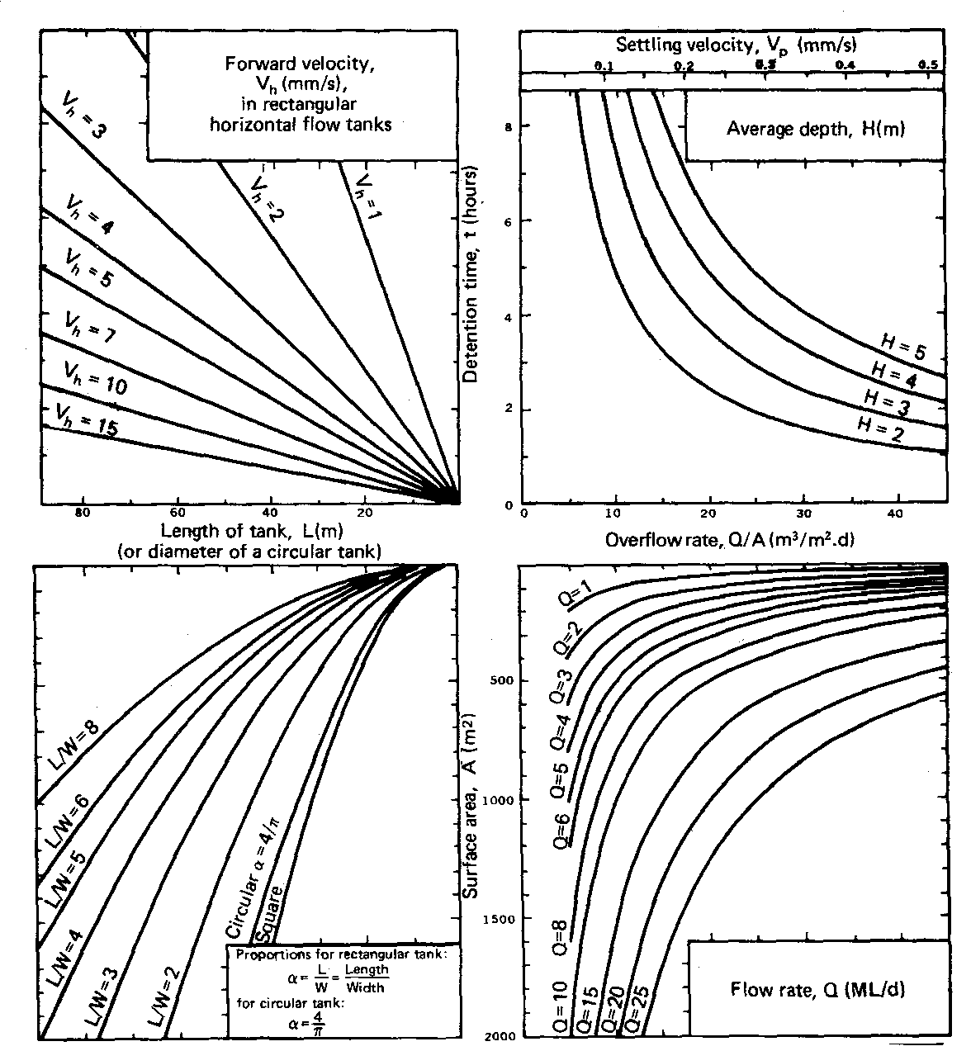
Figure 2.7 Design chart for sedimentation tanks

Shallow depth sedimentation

Particles will be completely removed from a rectangular sedimentation tank if their settling velocity, V_{p}, is equal to, or greater than, the surface loading rate on the tank, Q/A, independently of the depth of the tank (provided that the forward velocity is not so high that settled material is scoured from the sludge zone). Any particles having a lower settling velocity than V_{p}¹/V_{p}. For example, if a particle follows the settling path AB₁ in Figure 2.8 corresponding to a settling velocity of V_{p}¹ = V_{p}/n, the proportion of such particles removed will be 1/n. If, however, a tray were inserted in the settling zone at B₁, B₂ and B₃, that is, at depth intervals of H_{o}/n, all such particles will be removed and hence the efficiency of the sedimentation tank will be greatly increased.

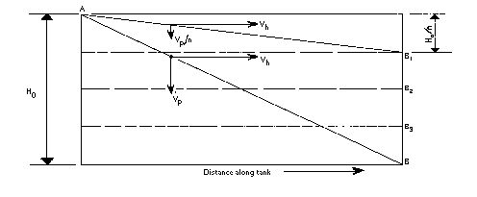

Figure 2.8 Path of a settling particle in horizontal flow tank.

Alternatively, if only particles having a settling velocity of V_{p} were required to be removed, the forward velocity, and hence the flow rate through the tank, could be increased by the factor n. This is the principle of shallow depth sedimentation, which was recognized as early as 1904, but not applied because was it was difficult to implement.

Many of the practical problems of shallow depth sedimentation have now been overcome by placing the plates at about 60⁰ to the horizontal in upflow units. At this slope, the flow pattern between the plates resembles that of an upflow settler rather than that of a horizontal flow system. These units are self-cleaning - sludge which settles on the upper face of the plates slides down them; particles collide and tend to stick together, with the result that sludge particles leaving the bottom of the plates are large enough to settle against the velocity of the inflowing water.

A similar principle to that of the inclined plate settler, which has been independently developed, is the tube settler, made by dividing the spaces between the plates by vertical baffles to form tubes of square cross-section.

From geometrical considerations, it can be proven that

V_{u} = V_{p}(n + 1) [2.11]

According to Equation 2.11, the equivalent upflow rate, V_{u}, in an inclined plate settler can be up to (n + 1) times the critical particle settling velocity V_{p} or, since V_{u} = V_{p} = Q/A, the surface loading rate can be multiplied by the factor (n + 1). The practical flow variations over the area of a clarifier, however, are such that, although using shallow depth sedimentation can attain substantial increases in upflow rate, it is not practicable to achieve the full estimated theoretical increases.

Most practical inclined tube or plate settlers have only quite small spacing between the inclined surfaces - about 50 mm is common. At these spacing, the Reynolds number is usually less than 500, so that flow is laminar. Shallow depth sedimentation has found its most frequent applications in water treatment. There are four types of shallow depth sedimentation applications as shown overleaf.
1. Class-1 clarification: Settling of dilute suspensions that have little or no tendency to flocculate.

2. Class-2 clarification: Settling of dilute suspensions with flocculation taking place during the settling process.

3. Zone settling: Particles settle as a mass and not as discrete particles. Interparticle forces hold the particles (which are sufficiently close) in a fixed position, so that the settlement takes place in a zone.

4. Compression settling: Settlement takes place over the resistance provided by the compacting mass resulting from particles that are in contact with each other

Horizontal flow sedimentation tanks

Some practical design data are provided for based on practical experiences. Various features must be incorporated into the design to obtain an efficient sedimentation process. The inlet to the tank must provide uniform distribution of flow across the tank. If more than one tank exists, the inlet must provide equal flow to each tank. Baffle walls are often placed at the inlet to distribute even flow, by use of 100-200 mm diameter holes evenly spaced across the width of the wall. Table 2.1 lists typical values.

Parameter Design value

Surface loading rate (m³/m².d) 20-60
Mean horizontal velocity (m/min) 0.15-0.90
Water depth (m) 3-5
Detention time (min) 120-240
Weir loading rate (m³/m-d) 100-200

Table 2.1 Horizontal flow sedimentation tanks

Sludge blanket clarifiers

The SBC is quite flexible and can be adopted for use in almost all site conditions. Figure 2.9 shows an interesting SBC system with plate settler arrangement. Here the usual clariflocculator is also equipped with plate settler, thereby facilitating the solid removal. The plate settler sits on top of the clariflocculator. Therefore, in most situations, this unit does not need a subsequent filter unit.

There are theoretical formulations available for the design of SBCs. Miller and West (1966a-c) give the following basic considerations for the design:

1. Stable blankets are maintained in the column at upflow velocities of up to 5.0 m/h.
2. Increase in blanket depth significantly decreases the floc carry-over. Blanket depth is generally kept between 0.9-2.7 m
3. Entry velocity of the order of 1.5-1.6 m/h was found to improve the performance of the clarifier.
4. Supernatant depth has no effect on floc entrainment when flow conditions above the blanket are uniform.

It is possible to design SBCs with the above concepts alone. However, pilot-scale studies together with jar tests are recommended. Figure 2.9 shows a form of the SBC.

Figure 2.9 Sludge blanket clarifiers

There are other forms of the SBC such as a combined slurry recirculation type with paddle flocculator or a SBC with plate settlers. SBCs with flocculator are also sometimes called “clariflocculator” or other brand names. Another variation is where pulsed flow is used to induce the required velocity gradients in the clarifier to aid flocculation and such clarifiers are then called “pulsator” or “superpulsator” clarifiers.

Table 2.2 lists some relative merits of the SBC.

Table 2.2 Advantages and Disadvantages of the Sludge Blanket Clarifier

Advantages Disadvantages

Working of the unit is very simple. Floc blanket formation after standing up takes time.
Better economy because of the combination Proper upflow velocity must be provided to prevent
of clarification and flocculation and at times sludge settling. Possible clogging of inlet.
filtration as well.
Suitable for small community water supplies Low turbidity waters require addition of artificial
due to ease of maintenance and operation. turbidity at start-up for rapid blanket formation.
Can be applied to varying initial turbidities, Hydraulic overloading or turbidity spikes may lead
particularly for high turbidities. to floc carryover and plugging of the filters.
Head loss is low compared to the other conventional SBC may require a skilled operator, particularly
techniques. when the raw water quality and the flow rates are highly variable.

The clariflocculator seems to have some clear advantages, even though it looks slightly sophisticated. It is the complicated theory that is sophisticated, but not the reactor itself. Some established detail designs of the SBC are available and could easily be incorporated into any new designs. There are modified versions incorporating a plate settler and filter to achieve entire solid-liquid separation in the same unit itself. Most of these modifications are made to suit the need of developing nations. Its use is highly recommended in developing countries - especially in small community water supply schemes - because of its flexibility in capacity and its ability to take up widely varying turbidity loads. It is highly suitable for package treatment plants, which are useful in remote areas as well as in congested urban areas.
Example 2.4

Design a sedimentation tank for a flow (Q) of 1000 m³/d. Determine the dimensions of the tank and the outflow weir length. Assume suitable design criteria.

Solution

Assume an overflow rate (OFR) of 20 m³/m².d as a typical value.

Area = $\frac{Q}{\text{OFR}}$ = $\frac{\text{1000}}{\text{20}}$ = 50 m²

Assuming a detention time (DT) of 2 h,

Volume = Q x DT = 1000 x $\frac{2}{\text{24}}$ = 83.3 m³

Depth = $\frac{V}{A}$ = $\frac{\text{83}\text{.}3}{\text{50}}$ = 1.7 m

If width (W) to length (L) ratio is 1:3, then
A = 3W² = 50
W = 4.1 m
L = 3W = 12.3 m

Assuming a weir loading rate (WLR) of 160 m³/m.d,

Minimum weir length = $\frac{Q}{\text{WLR}}$ = $\frac{\text{1000}}{\text{160}}$ = 6.3 m

In order to accommodate this required weir length, a double trough at the end of the tank would suffice, having a length of 8m.

Example 2.5

Design a rectangular sedimentation tank for a flow rate (Q) of 25,000 m³/d with the following data:
- Detention time (DT) = 3 h
- Length (L) to width (W) ratio = 4:1
- Surface loading rate = 20 m³/m².d
- Bottom slope = 1:100
- Weir loading rate = 0.1 m³/m/min
- The overflow weir to be designed will have the geometry shown in Figure 2.10

Solution

Required volume of tank, V = DT x Q = 3 x $\frac{\text{25},\text{000}{m^{3}}/d}{\text{24}}$ = 3125 m³

surface loading rate = 20 m³/m².d = $\frac{Q}{WxL}$ = $\frac{\text{25},\text{000}}{4W^{2}}$ (∴ L = 4W)
W = $\sqrt{\frac{\text{25},\text{000}{m^{3}}/d}{4x\text{20}{m^{3}}/{m^{2}}d}}$ = 17.70 m

Figure 2.10 Geometry of overflow weir in Example 2.5

L = 4 x W = 4 x 17.7 = 70.8 m ≈ 71 m
V = L x W x H = 3125 m³

∴ H = $\frac{\text{3125}}{\text{17}\text{.}7x\text{71}}$ = 2.50 m
Adopted dimensions of sedimentation tank are

L = 71 m
W = 17.70 m
H = 2.50 m + 0.5 m freeboard

Weir design
Total weir length needed = $\frac{\text{25},\text{000}{m^{3}}/d}{\frac{\text{24}x\text{60}\text{min}}{0\text{.}1{m^{3}}/m\text{.}\text{min}}}$ = 173.6 m
Available width = 17.70 m
Further weir length needed = 173.6 - 17.7 = 155.9 m
Required number of finger weirs of length 3.9 m each = 155.9/(3.9 x 2)
= 19.98
= 20

Example 2.6

Design a coagulation-settling tank with a continuous flow for treating water for a population of 45,000 persons with an average daily consumption of 135 L/person. Assume a surface loading rate of 0.9 m³m⁻²h⁻¹ and that the weir loading rate is within acceptable limits.

Solution

Average consumption = 135 x 45,000 = 6,075,000 L/d.
Allow 1.8 times for maximum daily consumption:
maximum daily consumption = 1.8 x 6,075,000 = 10,935m³/d.
Therefore, required surface area of the tank = (10,935/24)/0.9 = 506 m².

Assume minimum depth of tank = 3.5 m.
Therefore, (settling) volume of the tank = 506 x 3.5 = 1772 m³.

Assume a length to width ratio of the tank of 3.5:1. Therefore the width would be
= 506/3.5w² m = 12m

Therefore, length of tank = 3.5 x 12 = 42 m.

Assuming a bottom slope of 1 in 60.
Depth of the deep end (at the influent end) = 3.5 + (1/60) x 42 = 4.2 m.

A floc chamber should be provided, at the entry to the tank, the capacity of which is assumed to be 1/16 of the settling chamber, i.e. = 1772/16 = 110.8 m³.

If the depth of floc chamber is 2.5 m, then
the area of the floc chamber = 110.8/2.5 = 44.3 m².

The flocculation chamber also has a width equal to the sedimentation chamber, i.e. 12m. Therefore, length of floc chamber = 45.562/12 ≈ 3.8m.

It should be considered to add this length to the settling tank as it would otherwise reduce the settling volume by 3.8/42 = 9%. However, considering that we have already provided amply for maximum flow conditions, we could still fit the flocculation unit within the tank.

Question Explain the use of V-notches along the length of most settling tank weirs.

Flotation This will be done by way of classroom lecture only – take notes please

In reality, you only need to be able to do a mass balance to determine the requirements for recycling and the power required for making up enough oversaturated water for dissolve air flotation.

Oil removal/recovery technology
Oil/water separators are devices commonly used as a method to separate oils from a variety of wastewater discharges. They are typically installed in industrial and maintenance areas and receive oily wastewater generated during processes such as aircraft and vehicle maintenance and washing, seed processing, meat and fish processing, metal cutting, etc. The effluent from oil/water separators is typically discharged to either a sanitary sewer system or a storm sewer. Discharges of domestic and industrial wastewater are regulated under the Clean Water Act (CWA). Properly designed, installed, and operated, oil/water separators provide a treatment system for handling oily wastewater that prevents the entry of unacceptable levels of contamination to a storm sewer or sanitary sewer system. However, oil/water separators are generally not designed to separate solids or high concentrations of oil from water, such as might occur, for example, when a large quantity of oil or sludge is spilled or poured into a wash bay drain. Thus, it is important for all personnel who discharge wastewater into an oil/water separator to understand how they function, including their limitations, in order to prevent them from becoming sources of environmental pollution.

Oil/water separators (O/WSs) are "in-line" devices used to remove oils and greases (and sometimes solids) from industrial waste streams and storm water discharges. O/WSs operate by employing various physical or chemical separation methods, including gravity separation, filters, coagulation/ flocculation, and flotation. However, the use of any separation process depends on the properties of the oil in the oil/water mixture.
Gravity separators The type of O/WS most frequently used is the gravity separation system. The performance of gravity separation systems is a function of the relatively low water solubility of petroleum products in water and their different specific gravities. Solids, if present in the waste stream, will generally collect at the bottom of the O/WS holding tank and can be periodically removed when the tank is drained for maintenance. Figure 1 shows, in simplified form, the operation of a typical gravity O/WS system.

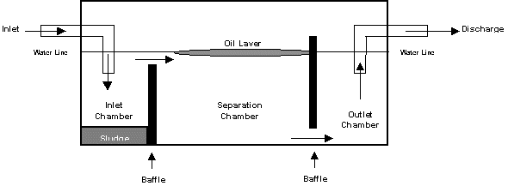

Figure 1. Conceptual Diagram of a Simple Gravity Oil/Water Separator. In a gravity operated O/WS, the oily wastewater is introduced through the system inlet. Water turbulence is calmed in the inlet chamber behind the first baffle, where solids settle out and form a sludge on the bottom of the chamber. As the wastewater flows over the first baffle to the middle, or separation, chamber, oil droplets rise to the surface and are trapped behind a second, higher baffle, which has an opening along its bottom edge. The remaining water passes under the second baffle into the outlet chamber, where it is diverted to a discharge point. Consequently, solid sludges can be collected from the bottom of the inlet chamber and oil droplets that accumulate at the water's surface in the separation chamber can be skimmed off or otherwise routed to a separate holding tank.

According to Stokes’s Law, a 100-micron diameter oil droplet will rise approximately 6 inches in water every ten minutes. A 20-micron diameter oil droplet will take over two hours to rise the same distance. Because an oil droplet must rise approximately 48 inches to reach the water surface in a typical gravity- type oil/water separator, smaller droplets may pass through uncollected. Coalescing (binding together) the smaller oil droplets makes them larger and more buoyant, causing them to rise faster. Coalescing oil/water separators may use inclined plates placed within the separation chamber, which provide only a short vertical distance (1/4") for the small droplets to travel before they encounter a fixed surface. Here they can coalesce with other droplets and continue to rise along the plates to the water's surface. Another coalescing method uses a filter made of fine oleophillic (oil "loving") fibers. The fine oil droplets attach to the fibers as the wastewater flows through. As the droplets get larger, they become buoyant enough to detach from the fibers and rise to the surface, where they can be collected.

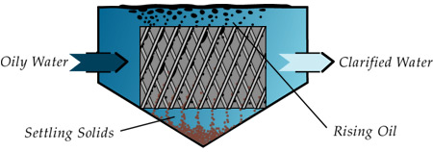

Figure 2 Conceptual Diagram of a Gravity Oil/Water Separator with inclined oil collector plates

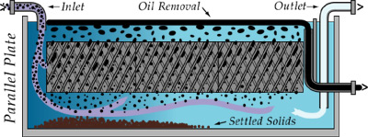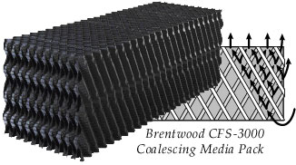

Figure 3 Conceptual diagram of a gravity oil/water separator with coalescing media

Hydrocyclones The small difference in density between oil and water, and small droplet sizes can make settling very slow. Increasing the gravitational force, according to Stokes’ Law, would have a linear effect on separation speed. A simple way to implement this is by using hydrocyclones (see Figures 4 & 5) As water contaminated with oil enters the hydrocyclone via an involuted inlet core it begins to spin. The velocity at which the water spins increases as it moves through the cone-shaped hydrocyclone. The centrifugal force generated in the cone and tail pipe cause the heavier water to move to the outside wall of the hydrocyclone leaving the lighter oil to accumulate in the centre of the spinning water core. Related pressure settings of the water inflow, clean water discharge and the oil discharge cause the separated oil to slip in the opposite direction to the clean water. Hydrocyclones could be combined with settlers and oil skimmers to reduce the bulk of the water to be processed (see Figure 4).

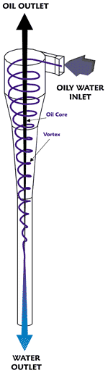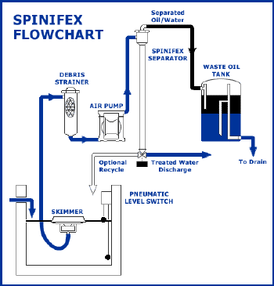

Figure 4 Conceptual diagram of a hydrocyclone and how these can be combined with other process units

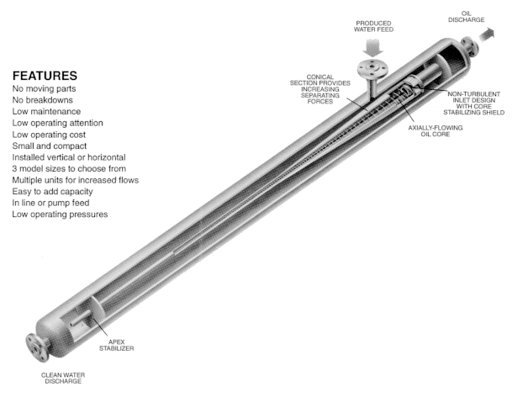

Figure 5 Details of construction of a hydrocyclone and some of its benefits

Adsorbents Different solids have an affinity for oil over water such as oleophilic (oil "loving") fibers. Polypropylene fiber is an example and there are also specially manufactured substances such as high-grade sodium bentonite that can be converted into a powerful, selective adsorbent that bonds with hydrocarbons and other contaminants upon contact, locking them inside its molecular structure (Figure 6). These can be applied as a powder, in bags, or twisted into a rope or sheet that can be continuously withdrawn and the oil squeezed out through rollers and collected (Figure 7).

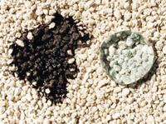
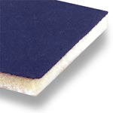

Figure 6 Polypropilene fiber (l.) and adsorbent bentonite (r.)

Information about products at http://www.waterandwastewater.com/dewatering/oilwater.htm

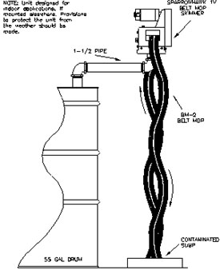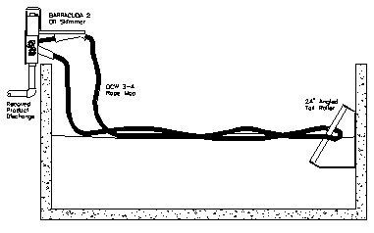

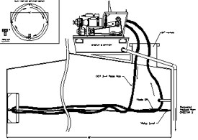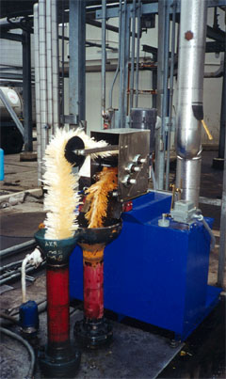

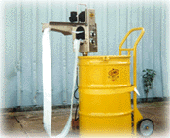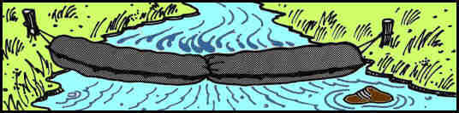

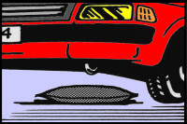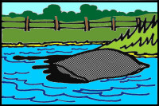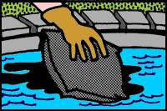

Figure 7 Various applications of fibrous and granular oil adsorbents for oil recovery and pollution control

