CE523 Assignment 6 Solutions

- Seawater is to be used as a feedstock to produce boiler water with reverse osmosis. Assuming that all of the 3.4% salt is NaCl and that there will be a 20% brine bleed-off, calculate the power requirement to produce 30m³/h of boiler feed from seawater. Assume that an additional net operating pressure drop across the membrane of 2000 kPa will be required.

Solution:
$Q_{p}=0\text{.}8×Q_{i}⇒Q_{i}=\frac{\text{30}{m^{3}}/h}{0\text{.}8}=\text{37}\text{.}5{m^{3}}/h=0\text{.}\text{0104}{m^{3}}/s$
The density of the seawater is 1023kg/m³ at 25 C., so the mass flow rate of the input water is: 10.64kg/s.
Osmotic pressure $π=\text{CRT}$
C = [NaCl] = $\frac{\text{34}g×\text{1023}g/l}{\text{58}\text{.}5g/{\text{mol}}×\text{1000}g}=0\text{.}\text{59}M$; C_{T} (Na⁺, Cl⁻) = 1.18M
During continuous operation, salt concentration will increase to 1.18/0.2 = 5.9 M
(Nobody had realized the salt concentration before the membrane is the same as the brine reject)
$π=\text{CRT}=5\text{.}9\frac{\text{mol}}{L}×0\text{.}\text{082}\frac{m^{3}⋅\text{atm}}{\text{kmol}⋅K}×\text{298}K=\text{144}\text{.}2\text{atm}=\text{14610}\text{kPa}$
So, the pressure required for the operation is:
$ΔP=\text{2000}\text{kPa}+\text{14610}\text{kPa}=\text{16610}\text{kPa}$
The equivalent head loss is:
$ρ\text{gh}=\text{16610}\text{kPa}⇒h=\frac{\text{16610}×{\text{10}}^{3}\text{Pa}}{\text{1023}{\text{kg}}/{m^{3}}×9\text{.}8m/{s^{2}}}=1,\text{657}m$ (One mile!!)
so the power requirement is(assume the efficiency is 70%):
$P=\frac{\text{mgh}}{tη}=\frac{\text{10}\text{.}\text{64}{\text{kg}}/s×9\text{.}8m/{s^{2}}×\text{1657}m}{0\text{.}7}=\text{246},\text{827}W=\text{247}\text{kW}$

- The concentrations of the major ions in a brackish ground water supply in mg/L are as follows: Na⁺, 460; Mg²⁺, 360; Ca²⁺, 400; K⁺, 39; Cl⁻, 89; HCO₃⁻, 61; NO₃⁻, 124; and SO₄²⁻, 1150. This water is to be desalinated by reverse osmosis to deliver 4000 m³/d to Pythonville. Assume a recovery fraction of 75%. Assume that an additional net operating pressure drop across the membrane of 2500 kPa will be required.

- Specify the required membrane area required for a cellulose acetate hollow fiber membrane with a mass transfer rate coefficient of 1.5 x 10⁻⁶ m/s and a flux rate coefficient of 1.6 x 10⁻⁶ s/m. Compare with typical values.

- Check if permeate will comply with a requirement of TDS < 500 mg/L.

- How much leakage could be permitted to maintain this requirement?

- Estimate the rejection rate and concentrate TDS.

- Estimate the power requirements for pumping.

Solution:
a) 4000m³/d = 0.046m³/s
Estimate the membrane area using Eq.(11-43)
$F_{w}=k_{w}({ΔP}_{a}−\text{ΔΠ})=1\text{.}6×{\text{10}}^{−6}s/m×\text{2500}×{\text{10}}^{3}\text{Pa}=4{\text{kg}}/{m^{2}}⋅s$
$Q_{p}=F_{w}×A⇒A=\frac{0\text{.}\text{046}{m^{3}}/s×{\text{10}}^{3}{\text{kg}}/{m^{3}}}{4{\text{kg}}/{m^{2}}⋅s}=\text{11}\text{.}5m^{2}$
b) Estimate permeate TDS concentration using Eq. (11-44).
$F_{i}=k_{i}{ΔC}_{i}=\frac{Q_{p}C_{p}}{A}$
$Q_{p}C_{p}=k_{i}\left(\left[\frac{C_{f}+C_{c}}{2}\right]−C_{p}\right)A$
Assume $C_{c}≈4C_{f}$and solve for Cp
$$C_{p}=\frac{\text{25}k_{i}{\text{AC}}_{f}}{Q_{p}+k_{i}A}$$
C_{f} = 460+360+400+39+89+61+124+1150 mg/L = 2.683kg/m³
$$C_{P}=\frac{\text{25}×1\text{.}5×{\text{10}}^{−6}s/m×\text{11}\text{.}\text{50}m^{2}×2\text{.}\text{683}{\text{kg}}/{m^{3}}}{0\text{.}\text{046}{m^{3}}/s+1\text{.}5×{\text{10}}^{−6}m/s×\text{11}\text{.}\text{50}m^{2}}=0\text{.}\text{025}{\text{kg}}/{m^{3}}=\text{25}{\text{mg}}/L$$
This is way below the maximum concentration and it would be possible to bypass some, (up to 1/6th) untreated water for blending.
c) Estimate the rejection rate using Eq. (11-40)
$R\text{,\%}=\frac{C_{f}−C_{p}}{C_{f}}×\text{100}=\frac{(2\text{.}\text{683}{\text{kg}}/{m^{3}}−0\text{.}\text{025}{\text{kg}}/{m^{3}})}{2\text{.}\text{683}{\text{kg}}/{m^{3}}}×\text{100}=\text{99}\text{\%}$
Estimate the concentrate stream TDS using Eq. (11-42)
$C_{c}=\frac{Q_{f}C_{f}−Q_{p}C_{p}}{Q_{c}}=\frac{1L×2\text{.}\text{683}{\text{kg}}/{m^{3}}−0\text{.}8L×0\text{.}\text{025}{\text{kg}}/{m^{3}}}{0\text{.}2L}=\text{10}\text{.}\text{66}{\text{kg}}/{m^{3}}$
d ) the head loss due the pressure drop is:
osmotic pressure $π=\text{CRT}$
Ion | Mass cone. (g L⁻¹) | Molar cone. (M)
Na⁺ | 0.46 | 0.02
Mg²⁺ | 0.36 | 0.015
Ca²⁺ | 0.4 | 0.01
K⁺ | 0.039 | 0.001
Cl⁻ | 0.089 | 0.0025
HCO₃⁻ | 0.061 | 0.001
NO₃⁻ | 0.124 | 0.002
SO₄²⁻ | 1.15 | 0.012
 |  | 0.0635

Again, the molar concentration will reach a value 4x that with a 75% recovery.
$π=\text{CRT}=4×0\text{.}\text{0635}\frac{\text{mol}}{L}×0\text{.}\text{082}\frac{m^{3}⋅\text{atm}}{\text{kmol}⋅K}×\text{298}K=6\text{.}1\text{atm}=\text{620}\text{kPa}$
So, the pressure required for the operation is:
$ΔP=\text{2500}\text{kPa}+\text{620}\text{kPa}=\text{3120}\text{kPa}$
The equivalent head loss can be calculated from
$ρ\text{gh}=\text{3120}\text{kPa}⇒h=\frac{\text{3120}×{\text{10}}^{3}\text{Pa}}{\text{1000}{\text{kg}}/{m^{3}}×9\text{.}8m/{s^{2}}}=\text{318}m$
so the power requirement is(assume the efficiency is 70%):
$P=\frac{\text{mgh}}{tη}=\frac{\left(\frac{0\text{.}\text{046}\frac{m^{3}}{s}}{0\text{.}\text{75}}\right)×\text{1000}{\text{kg}}/{m^{3}}×9\text{.}8m/{s^{2}}×\text{271}m}{0\text{.}7}=\text{273500}W=\text{274}\text{kW}$

- Chlorinated water in Pythonville has been tested for rate of passage through a 0.45 μm Millipore filter as possible pretreatment before RO. The rate of passage through a 47mm filter was studied at a pressure of 210 kPa and it was found that it took 1.5 min to pass 500 mL of water and after 20 minutes’ operation it took 11 min to pass 500 mL through the filter. Suggest suitable pretreatment and roughly estimate the size of equipment you would specify as well as required pump sizes to provide 1 mgd of filtered water.
Solution:
t_{i} = time to collect initial sample of 500mL
t_{f} = time to collect final sample of 500mL
t = total time for running the test
$\text{SDI}=\frac{\text{100}[1−({t_{i}}/{t_{f}})]}{t}=\frac{\text{100}×(1−(1\text{.}5/{\text{11}})}{\text{32}\text{.}5}=2\text{.}\text{65}$
Maximum SDI value for reverse osmosis hollow fiber is ~ 2 (according to Table 11-19), so pretreatment is required.

Pretreatment of a secondary effluent by coagulation and multimedia filtration or cartridge filtration is necessary to remove colloidal material. Cartridge filters with a pore size of 5 to 10 μm are often used.
Removal of chlorine (with sodium bisulfite or activated carbon) may be necessary.
To inhibit scale formation, the pH of the feed should be adjusted (usually with sulfuric acid) within the range from 4.0 to 7.5. Regular chemical cleaning of the membrane elements (about once a month) is necessary to restore the membrane flux.

The average flow rate through the lab filter is, assuming a linear decline:
$q_{\text{ave}}=\frac{{\text{500}}/1\text{.}5+{\text{500}}/{\text{11}}}{2}=\text{189}\text{ml}\text{/min}=\text{11}\text{.}\text{34}L/h$
The average loading rate of the filter is:
$L=\frac{V}{A}=\frac{\text{11},\text{340}{\text{cm}}^{3}}{3\text{.}\text{14}×{\left(\frac{4\text{.}7}{2}\right)}^{2}}=\text{654}{\text{cm}}/h=6\text{.}\text{54}m/h$
The head loss over the membrane: $⇒h=\frac{\text{210}×{\text{10}}^{3}\text{Pa}}{\text{1000}{\text{kg}}/{m^{3}}×9\text{.}8m/{s^{2}}}=\text{21}m$

The power requirement, assuming 70% efficiency:

$$P=\frac{\text{mgh}}{tη}=\frac{0\text{.}\text{046}{m^{3}}/s×\text{1000}{\text{kg}}/{m^{3}}×9\text{.}8m/{s^{2}}×\text{21}m}{0\text{.}7}=\text{13524}W=\text{13}\text{.}5\text{kW}$$

Note the comparatively small power requirements – this pretreatment is a good pretreatment before RO.

- As an alternative to RO, investigate the possibility of using electrodialysis for the Pythonvilleans. Assume that a double stage process will be required to obtain 75% removal of salt, with 50% removal per stage. The current efficiency is 85%, CD/N ratio is 400 mA/cm² and the resistance is 6 ohm. Determine the power requirements and the dimensions of this system.

Solution:
First stage:
Total TDS concentration: 460+360+400+39+89+61+124+1150 = 2683mg/l
The normality of solution:
Ion | Mass cone. (g L⁻¹) | Molar cone. (M) | Normality (eq/L)
Na⁺ | 0.46 | 0.02 | 0.02
Mg²⁺ | 0.36 | 0.015 | 0.03
Ca²⁺ | 0.4 | 0.01 | 0.02
K⁺ | 0.039 | 0.001 | 0.001
 |  | $$\sum{\text{cation}}$$ | 0.071
Cl⁻ | 0.089 | 0.0025 | 0.0025
HCO₃⁻ | 0.061 | 0.001 | 0.001
NO₃⁻ | 0.124 | 0.002 | 0.002
SO₄²⁻ | 1.15 | 0.012 | 0.024
 |  | $$\sum{\text{anion}}$$ | 0.0295
 |  | $$\sum{(\text{anion}+\text{cation})}$$ | 0.1005

(Note: the normality of cations and anions should balance, unless something is missing, often the difference is H⁺ or OH⁻ . In this case, I made up the numbers and did not check.)
Cation and anion concentration = 0.1 eq/L
The efficiency of salt removal = 50 percent
The current efficiency = 85 percent
The CD/N ratio = 400mA/cm²
Resistance = 6 ohm
Assume the electrodialysis unit comprises 2400 cells.
Calculate the current with Q = 4000m³/d = 46 L/s
$$I_{1}=\frac{\text{FQN}η}{{\text{nE}}_{c}}=\frac{\text{96485}{A⋅s}/{\text{geq}}×\text{46}L/s×0\text{.}1{\text{geq}}/L×0\text{.}5}{\text{2400}×0\text{.}\text{85}}=\text{108}\text{.}8A$$
- determine the current density:
CD₁ = (400)(normality) = 4000.1 = 40 mA/cm²
The required area is:
$A_{1}=\frac{\text{108}\text{.}8A×\text{1000}{\text{mA}}/A}{\text{40}{\text{mA}}/{{\text{cm}}^{2}}}=\text{2720}{\text{cm}}^{2}$
width per membrane(assuming a square configuration will be used):
= $\sqrt{\text{2720}{\text{cm}}^{2}}=\text{52}\text{cm}$
Stage 2:
After 50% removal, the anion concentration is 0.05 eq/L.
The efficiency of salt removal = 50 percent
The current efficiency = 85 percent
The CD/N ratio = 400mA/cm²
Resistance = 6 ohm
Assume the electrodialysis unit is comprised of 240 cells.
Calculate the current using Eq. (11-48)
Q = 4000m³/d = 46 L/s
$$I_{2}=\frac{\text{FQN}η}{{\text{nE}}_{c}}=\frac{\text{96485}{A⋅s}/{\text{geq}}×\text{46}L/s×0\text{.}\text{05}{\text{geq}}/L×0\text{.}5}{\text{2400}×0\text{.}\text{85}}=\text{54}\text{.}4A$$
The required surface area.
- determine the current density:
CD₂ = (400)(normality) = 4000.05 = 20mA/cm²
The required area is:
$A_{2}=\frac{\text{54}\text{.}4A×\text{1000}{\text{mA}}/A}{\text{20}{\text{mA}}/{{\text{cm}}^{2}}}=\text{2720}{\text{cm}}^{2}$
width per membrane(assuming a square configuration will be used):
width per membrane = $\sqrt{\text{2720}{\text{cm}}^{2}}=\text{52}{\text{cm}}^{2}$
The total power required is:
P = R(I₁ + I₂)² = (6$Ω$) (108.8A + 54.4A)² = 159805W or 160 kW

These power requirements are high. Literature reports energy demands of 0.1 kWh/m³. The only way to reduce current would be to have more cells. With10,000 cells, power requirements will be lowered to about 40 kW.

- Estimate the quantities and concentration of concentrates from each of the Pythonville options and pretreatment(s) used.
Solution:
1. reverse osmosis:
determine the concentrate stream flowrate:
$Q_{c}=\frac{Q_{p}(1−r)}{r}=\frac{\text{4000}{m^{3}}/d×(1−0\text{.}\text{75})}{0\text{.}\text{75}}=\text{1333}\text{.}{m^{3}}/d$
determine the total amount of water that must be processed to produce 4000m³/d of RO water. Using Eq. (11-41), the required amount of water is
$Q_{f}=Q_{p}+Q_{c}=\text{4000}{m^{3}}/d+\text{1333}{m^{3}}/d=\text{5333}{m^{3}}/d$
Determine the concentration of the permeate stream. The permeate concentration
C_{f} = 460+360+400+39+89+61+124+1150 = 2683 g/m³
$$C_{p}=C_{f}(1−R)=\text{2683}g/{m^{3}}×(1−0\text{.}\text{99})=\text{25}g/{m^{3}}$$
Determine the concentration of the concentrated waste stream. The required value is obtained by a mass balance:
$$C_{c}=\frac{Q_{f}C_{f}−Q_{p}C_{p}}{Q_{c}}=\frac{\text{5333}{\text{kg}}/{m^{3}}×2\text{.}\text{683}{\text{kg}}/{m^{3}}−\text{4000}{\text{kg}}/{m^{3}}×0\text{.}\text{025}{\text{kg}}/{m^{3}}}{\text{1333}{\text{kg}}/{m^{3}}}=\text{10}\text{.}\text{66}{\text{kg}}/{m^{3}}$$
Electrodialysis:
Q_{c} = 1333 m³/d Q_{f} = 5333 m³/d
After the second stage, 75% recovery is achieved, the concentration of permeate stream is: 0.25 2.683kg/m³ = 0.67kg/m³
Determine the concentration of the concentrated waste stream by mass balance.
$$C_{c}=\frac{Q_{f}C_{f}−Q_{p}C_{p}}{Q_{c}}=\frac{\text{5333}{\text{kg}}/{m^{3}}×2\text{.}\text{683}{\text{kg}}/{m^{3}}−\text{4000}{\text{kg}}/{m^{3}}×0\text{.}\text{67}{\text{kg}}/{m^{3}}}{\text{1333}{\text{kg}}/{m^{3}}}=8\text{.}\text{72}{\text{kg}}/{m^{3}}$$

- People get about 43 to 45 mg/L for the concentration in the system

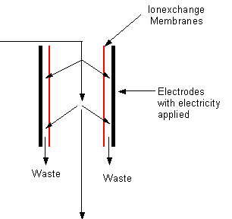

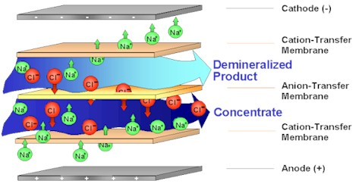

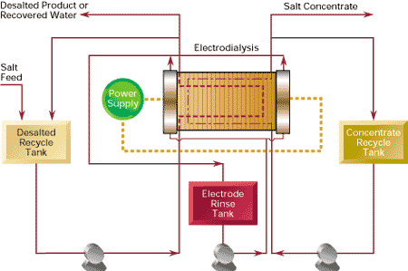

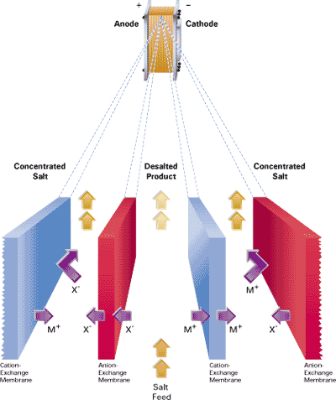

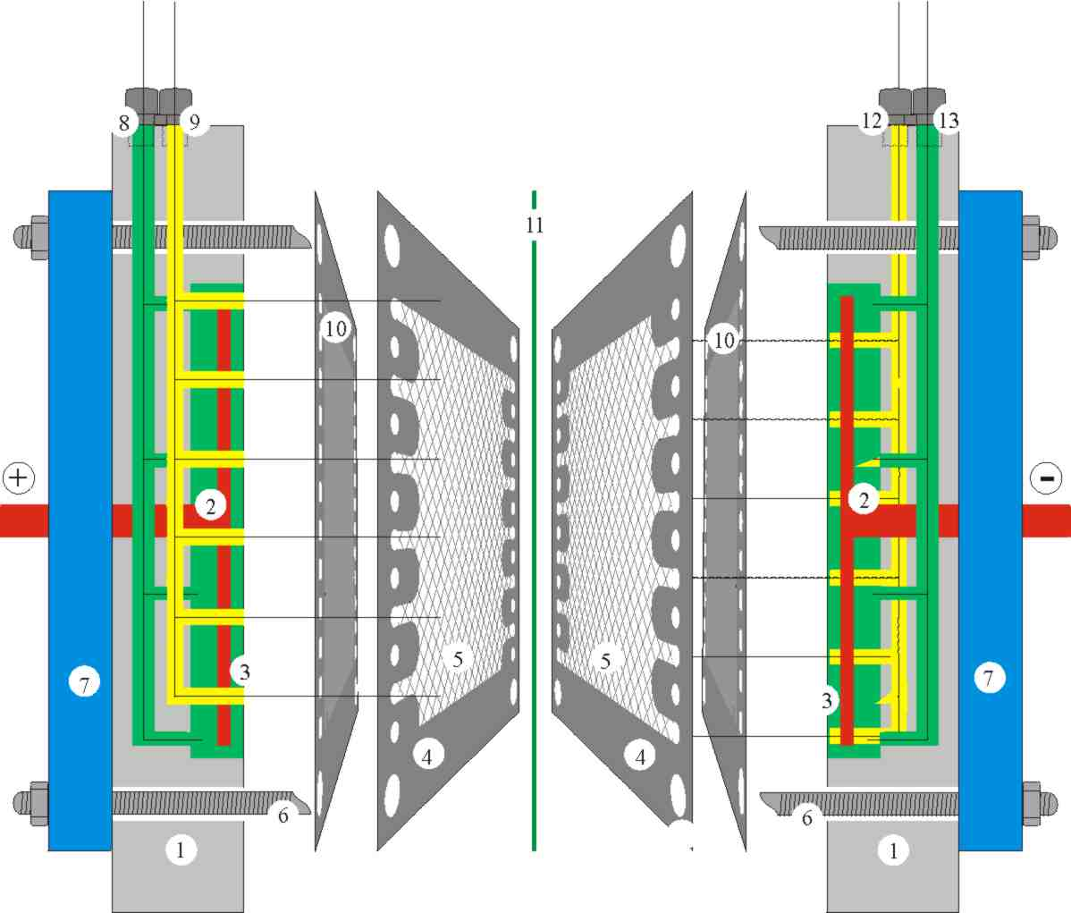
1: Polypropylene end plate | 8: Inlet anode cell
2: Electrode | 9: Inlet concentrate cell
3: Electrode chamber | 10: cation exchange membrane
4: spacer-sealing PVC | 11: AAM
5: Spacer fabric | 12: Inlet diluate cell
6: Screws | 13: Inlet cathode chamber
7: Steel frame

