Assignment 8 Adsorption Due April 8, 2011

1. An adsorption study was conducted by adding varying amounts of activated carbon to a series of seven flasks containing 500mL of feed water used in soft drink preparation having an initial TOC of 2.0mg/L. The flasks were agitated for 14h, and the residual, steady-state TOC concentrations were determined. Plot the Langmuir and Freundlich isotherms for the data presented below and determine the values of the appropriate constants. Only hand in one of the isotherms.

Flask No. Carbon Dosage (mg) Final TOC (mg/L)

1 0 2.0
2 4.4 1.7
3 9.7 1.4
4 14 1.2
5 28 1.0
6 56 0.9
7 140 0.8

(Tip: Find the non-adsorbable fraction of the TOC. As this does not participate in any way to the adsorption, its value should be disregarded, i.e. subtracted from the TOC to leave an adsorbable dissolved organic carbon, ADOC, which may then fit the adsorption models better.)

2. The Freundlich isotherm below can be accepted to represent equilibrium concentrations of phenol in the μg/L concentration range and the x/m representing μg phenol/mg C.
a) If the limiting concentration of phenol is set at 0.2μg/L and the source contains 30μg/L, calculate the required dosage of powdered activated carbon.
b) If instead of a single dosage, the carbon was dosed twice, first to achieve a concentration of 3μg/L and then in a second tank to the final requirement, how much carbon will be required?
c) How could we minimize carbon requirements over two dosages?
d) Qualitatively consider the effect of even more tanks and possibilities of reusing the carbon from tank to tank. The isotherm may be extrapolated.

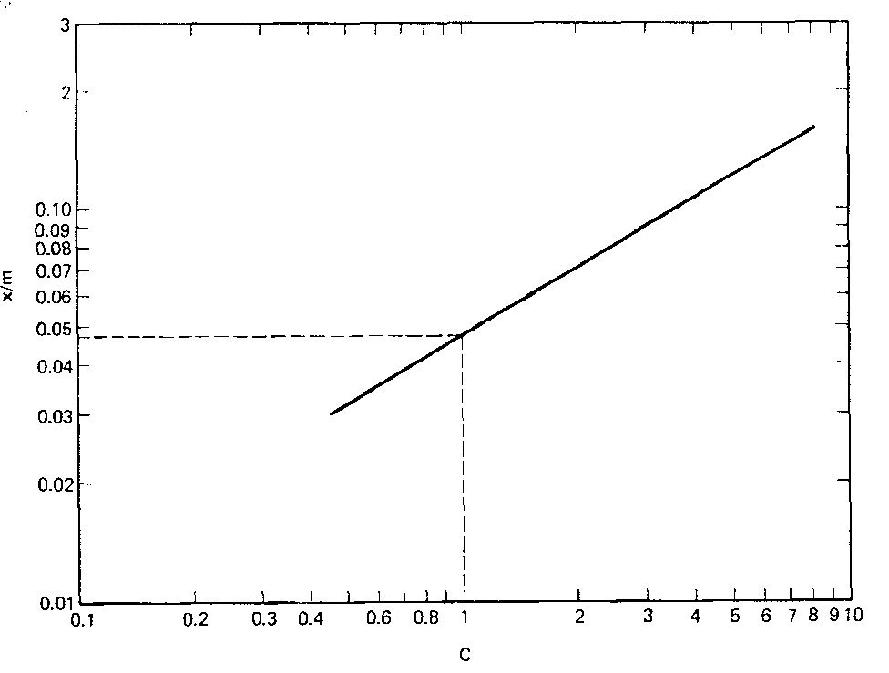

Figure: Freundlich isotherm for Problem 2

3. A laboratory column 10cm in diameter and 3m deep, is found to produce good results in COD removal when operated at a flow of 50L/h. Calculate the following:

a. The application rate in m/h.
b. The residence time, t, in the column.
c. The volumetric flow rate, Vb, in bed volumes per hour, for this residence time.
d. You need to design a GAC system consisting of two columns in series for treating the same water at a rate of 0.5 ML/d. Practical considerations limit the diameter of the columns to 3m. Calculate the required height of the columns allowing for sufficient backwash space.

4. Water, following conventional treatment and chlorination, contains 100 μg/L chloroform. This exceeds permissible levels and you need to check the implications of using GAC to keep this below 50 μg/L. Estimate the bed life and carbon usage rate. Comment on the suitability of GAC for this purpose.

5. Please review examples 14-4, 14-5 and 14-6 and make sure you could handle simple designs of this nature. Expediency, considering limited time until end of semester, difficulty to provide data for a good problem, makes it somewhat impractical to provide you with assignment questions based on these examples. Ask if any uncertainties.

