BIOLOGICAL WASTEWATER TREATMENT FOR POLLUTION CONTROL

Humans are great consumers and wasters of water. We use vast quantities to irrigate agricultural crops. Similarly large volumes are used for sanitation in First World households - toilet flushing, bathing and clothes washing. Industry has important demands for cooling, washing, steam raising, dilution and in transport of materials. All water usage pollutes and treatment is required before disposal to the environment.

Biological treatment forms the basis of many treatment processes as a first step in the recovery of water, while often presenting the possibility of recovery of other materials. It is therefore important to first address the principles of biological treatment. This module addresses very briefly some of the underlying microbiology as relevant to water and wastewater treatment before embarking on some treatment principles, growth kinetics and recovery applications.

MICROBIOLOGICAL PRINCIPLES

The science of classification, especially of living forms, is called taxonomy. The object of taxonomy is to establish the relationship between one group of organisms and another, and to be able to differentiate between them. Until the end of the nineteenth century, all organisms were divided into two kingdoms: plant and animal. Then, when microscopes were developed and biologists came to understand the structure and physiological characteristics of microorganisms, it became apparent that micro-organisms did not really belong to either the plant or animal kingdom, although many microbes have either plant or animal characteristics. In 1866, a third kingdom, the Protista, was proposed by Ernst Haeckel to include all microorganisms - bacteria, fungi, protozoans and algae. Subsequent research indicated that among the Protista, two different basic cell types could be distinguished: procaryotic and eucaryotic.

Five-kingdom system of classification

In 1969, H. R. Whittaker proposed the five-kingdom system of biological classification, which has been widely accepted. There is a basic division between organisms with procaryotic cells and those with eucaryotic cells in this system (See Figure 1). The bacteria and the cyanobacteria (formerly called blue-green algae) are the procaryotic organisms, called Monera by Whittaker and Procaryotae by others, including Bergey's Manual of Determinative Bacteriology. Procaryotes do not have a nucleus separated from the cytoplasm by a membrane. Instead, they have a nuclear region in which the genetic material is more or less localized. Fossil evidence for procaryotic organisms indicates their presence on earth since over 3.5 billion years ago.

Higher organisms, structurally much more complicated, are based on the eucaryotic cell, in which a membrane separates the nucleus from the cytoplasm. This type of cell apparently evolved more recently, a little more than a billion years ago. Simpler eucaryotic organisms, mostly unicellular, are grouped as the Protista and include fungus-like slime moulds, animal-like protozoans, and some algae. Some algae are more complex multicellular types. Algae are assigned to kingdoms based on evolutionary relationships. The more primitive algae (actually cyanobacteria) are placed in the Protista, and other algae are included with the plant kingdom.

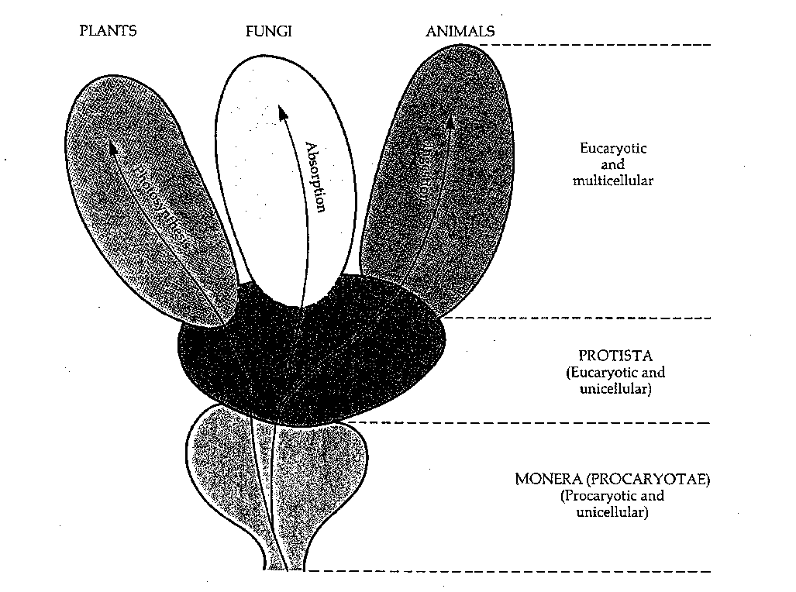

Figure 1 Five kingdom system of classification

Plants, animals, and fungi comprise three kingdoms of more complex eucaryotic organisms, most of which are multicellular. The main distinguishing factor among these three kingdoms is the nutritional mode; another important difference is cellular differentiation.

Fungi are eucaryotic organisms that include the unicellular yeasts, multi-cellular moulds, and macroscopic varieties such as mushrooms. To obtain raw materials for vital functions, a fungus absorbs dissolved organic matter through the membranes of cells in rootlike structures called hyphae.

Plantae are multi-cellular eucaryotes, and they include some algae and all mosses, ferns, conifers and flowering plants. To obtain energy, a plant photosynthesizes, a process involving the conversion of carbon dioxide from the air to organic molecules for use by the cell.

Animalia are multi-cellular animals with eucaryotic cells. These include sponges, various worms, insects, and animals with backbones (vertebrates). Animals obtain carbon and energy by ingesting organic matter through a mouth of some kind.

In 1978, Whittaker and Margulis proposed a revised classification scheme, organizing the five kingdoms according to procaryote or eucaryote as overleaf.

Superkingdom Procaryotae Superkingdom Eucaryotae

Kingdom Monera Kingdom Protista

Branch Protophyta, plantlike protists

Branch Protomycota, funguslike protists
Branch Protozoa, animallike protists

Kingdom Fungi
Kingdom Plantae
Kingdom Animalia

The division of all living organisms into procaryote and eucaryote has been challenged recently by a number of biologists who claim that there is a third basic category. The organisms belonging to this new category are bacteria, that is, procaryotes. Now it is becoming clear that these bacteria are no more closely related to other bacteria (called eubacteria or true bacteria by these biologists) than they are to eucaryotic organisms such as animals and plants.

The bacteria belonging to this new category look like typical bacteria and lack a nucleus and other membrane-bounded organelles. For years, however, it has been known that they are unusual in a number of ways. For example, their cell walls never contain peptidoglycan, they live in extreme conditions and their metabolism is unusual. Their genetic make-up is complete different from that of eubacteria. A classification allowing the archeabacteria is shown in Figure 2.

The dotted arrows also explains another long held view that chloroplasts really originate from cyanobacteria, except that they are not free-living but really almost live independently, producing photosynthetic products for its host. Similarly, mitochondria are really bacteria-like separate entities within the eucariotic cell.

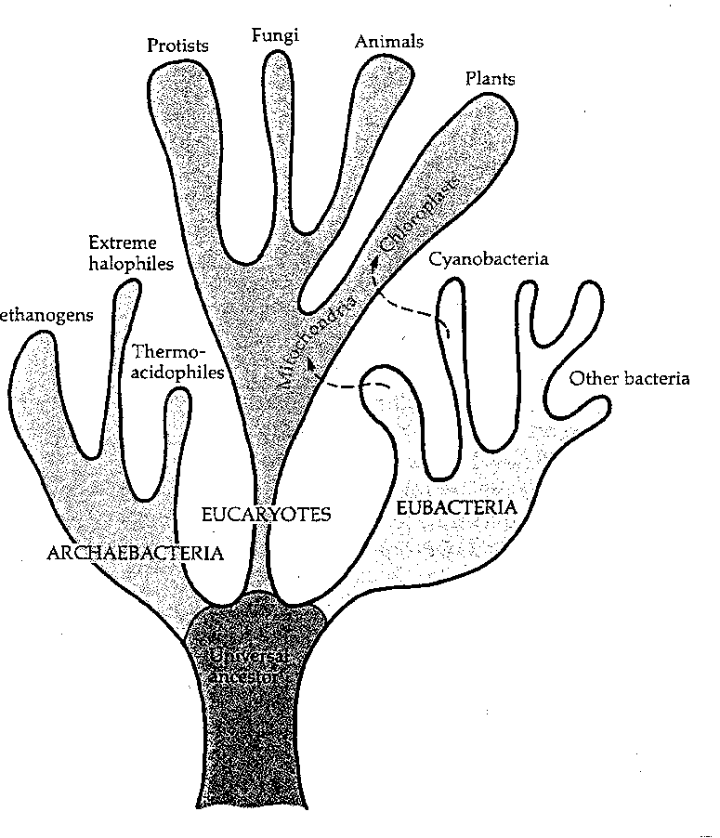

Figure 2 The 3 Superkingdom classification of living organisms

Classification According To Nutritional Requirements

Organisms can also be classified according to their nutritional requirements. This form of classification is most appropriate to wastewater treatment as it describes the opportunities for application of these organisms. It also describes, in general terms, the conditions to be designed for if a certain organism is to be put to use. Classification according to nutritional requirements is shown in Table 1.

Microorganism metabolism (principally a process of energy conversion) is sustained by redox reactions, providing the ultimate source of energy. The three major classes of these energy-yielding processes are:

- Respiration (aerobic), constituting the class of biological oxidation processes in which molecular oxygen is the electron acceptor;
- Respiration (anaerobic), constitutes the class of biological oxidation processes in which inorganic compounds other than oxygen are electron acceptors;
- Fermentation, constituting the class of energy yielding biologica redox reactions in which organic compounds serve as the final electron acceptors .

Table 1 Classification of microorganisms according to nutritional needs

CLASS NUTRITIONAL REQUIREMENTS

Autotrophic The organisms depend entirely on inorganic
compounds for energy. These are divided into:

Phototrophic Use radiant energy for growth.

Chemotrophic Use oxidation of inorganic compounds as energy
source. e.g. nitrifying bacteria.

Heterotrophic Organic compounds are required as nutrient.

Lithotrophic Use inorganic electron donors (e.g. hydrogen
gas, ammonium ions, hydrogen suIphate and
sulphur) .

Organotrophic Require organic compounds as electron donors.

Strictly Aerobic Cannot grow without molecular oxygen, which is
used as oxidant.

Strictly Anaerobic Use compounds other than oxygen for chemical
oxidation. Sensitive to the presence of traces of
molecular oxygen.

Facultative Anaerobic Can grow either in the presence or absence of
oxygen. Can use nitrate or sulfate as electron
acceptor.

The presence or absence of oxygen in water influences the products likely to be present and is of considerable importance as it limits the type of microorganism that can be active.

Most biological systems used to treat organic waste, depend upon heterotrophic organisms, which utilize organic carbon as their energy source. Heterotrophic bacteria also play a role in water treatment and distribution. Chemotrophic bacteria are important in nitrogen removal and in corrosion processes during water distribution.

Classification According To Identifiable Characteristics

Microbiologists like to classify organisms according to characteristics identifiable under a microscope, according to chemical reactions they may cause and/or their reaction to certain stains. All of these make routine identification easier to accomplish. Bergey’s Manual is the authoritative guide on this.

Another very important group of organisms in the field of water and wastewater treatment are the pathogens. Pathogens are parasitic organisms that cause disease and include viruses, bacteria, yeasts, fungi, protozoa and even animalia, such as worms. Many of these are water-borne or involve vectors, such as mosquitoes, that breed in water.

MICROBIOLOGICAL ASPECTS OF WATER POLLUTION CONTROL

Biological processes are used extensively to treat municipal and industrial wastewater. In advanced countries, the requirement of industry to implement biological treatment (secondary treatment) was the result of governmental regulations enacted over 30 years ago. Prior to that time, many industries used only sedimentation (primary treatment), which removes solids but is rather ineffective in removing dissolved organic substances. In the 1970s, the primary treatment facilities were supplemented with biological systems such as activated sludge and trickling filters. These processes have become sophisticated as a result of advances in process control and microbiology and are capable of removing over 90% of the dissolved organics from the primary effluent.

Microorganisms with the capability of degrading a wide variety of chemical compounds have been isolated and used in novel treatment applications. Recently, there has been interest in developing biological processes for the removal of polychlorinated biphenyls (PCBs), chlorinated solvents such as trichloroethylene (TCE) and perchloroethylene (PCE), and heavy metals from water. The processes that have been tested consist of biological reactors where the microorganisms are grown either suspended in liquid or as an attached biolayer on a solid support. An additional new technology is bioremediation, which involves either the inoculation of contaminated environments with microorganisms that are active in degrading the pollutants, or the stimulation of the activities of indigenous organisms by the addition of nutrients. Bioremediaton has been used effectively for treatment of contaminated land.

Microorganisms http://www.onsiteconsortium.org/files/atu_module.PDF

Both procaryotic, or unicellular organisms that lack a true nucleus, and eucaryotic, multicellular organisms that have a membrane enclosed nucleus, are active in biological treatment systems. The bacteria are procaryotes. They are typically 0.5 μm wide and 1 μm long and exist as coccus, rod, and spiral shapes. Fungi are filamentous eucaryotes that have rigid cell walls that, unlike eucaryotic algae, lack chlorophyll.

Microorganisms require both a carbon and energy source for growth. The pollutant serves as both the carbon and energy source for heterotrophic microorganisms. Autotrophic organisms use either light (photoautotrophs) or an inorganic compound (chemautotrophs) as the energy source and CO2 as the carbon source. Examples of the former are the algae and of the latter are the nitrifying bacteria that convert ammonia to nitrate:

2 NH₄⁺ + 3 O₂ ➔ 2 NO₂⁻ + 4 H⁺ + 2 H₂O
2 NO₂⁻+ O₂ ➔ 2 NO₃⁻
The bacteria converting ammonia to nitrite are usually Nitrosomonas.
Nitrobacter further oxidizes the nitrite to nitrate.

Temperature and pH are important parameters influencing growth rate. Each organism has a minimum, optimum, and a maximum temperature for growth. The three temperatures are referred to as cardinal temperatures. Psychrophilic organisms grow at low temperatures (0-20oC), mesophiles at higher (15 -45oC), and thermophiles at the highest temperatures (40-70oC). Most microorganisms grow best at pH near neutrality (pH 7) but some are acid tolerant or acidophiles. Thiobacillus thiooxidans, a sulfur-oxidizing bacterium, is capable of growth at a pH of 1.

Microorganisms require nutrients for cell synthesis. The cellular composition of bacteria consists of 50% carbon, 8-15% nitrogen, 2-6% phosphorus, 0.1-1% sulfur, and trace amounts of Na, K, and Ca. Empirical cell formulas for the organic portion of bacterial protoplasm, C5H7O2N and C60H87O23N12P, are used to calculate nutrient requirements. If the wastewater to be treated is deficient in one or more essential nutrients biological treatment is generally not possible. It is not uncommon for wastewater to be supplemented with ammonia and/or phosphoric acid prior to treatment.

The presence of nitrogen in the environment is not always an essential requirement for the biodegradation of pollutants. Heterocyclic nitrogen compounds such as pyridine contain enough nitrogen to satisfy the N growth requirements of the microorganisms. There are also bacteria that are capable of utilizing the nitrogen in the atmosphere to satisfy their N requirements. The process, nitrogen fixation, is very energy intensive because the triple bond of N2 must first be broken before N can be incorporated into biomass. The requirement for nutrients in the environment is less for cyanobacteria, which have the ability to fix both CO₂ and N₂ to satisfy their carbon and nitrogen needs.

Aerobic microorganisms grow in the presence of oxygen. They oxidize the pollutants, or electron donors, to CO2 producing adenosine triphosphate (ATP), the cellular form of stored energy used to drive the biosynthetic or anabolic reactions. The oxidation reactions that capture ATP are catabolic reactions. Under aerobic conditions, the electron acceptor is oxygen. In the absence of oxygen, under anaerobic conditions, facultative organisms use an alternative electron acceptor such as nitrate or sulfate. Unfortunately, not all pollutants are oxidized to CO₂, or mineralized, under aerobic conditions.

In anaerobic environments byproduct formation is common. Incomplete dechlorination of pesticides has been found to occur both in the laboratory and in the natural environment. However, some chemicals, such as 3-chlorobenzoic acid, are capable of being completely mineralized to methane under anaerobic conditions.

Biotransformation or incomplete mineralization occurs under both aerobic and anaerobic conditions. The microorganisms form chemical products, which persist in the growth medium. If growth occurs, the cell yield will be lower because less carbon is available for cell synthesis. Table 1 shows data on the bacterial metabolism of phenanthrene, a polyaromatic hydrocarbon. Several different genera utilize phenanthrene for growth but produce 1-hydroxy-2-naphthoic acid (1H2N). The cell yields are low compared with yields on other hydrocarbons, which may exceed 0.7 g cells/g hydrocarbon. Biotransformation is less desirable because the products formed may be as harmful or of greater harm than the pollutants. However, the products may be biodegradable by other organisms and therefore not persist in the environment.

Table 1 Phenanthrene-Degrading Isolates From: Edgehill, R.U. 1993. Biofilm treatment of polyaromatic hydrocarbons. Institution of Engineers Australia. Environmental Engineering Conference.
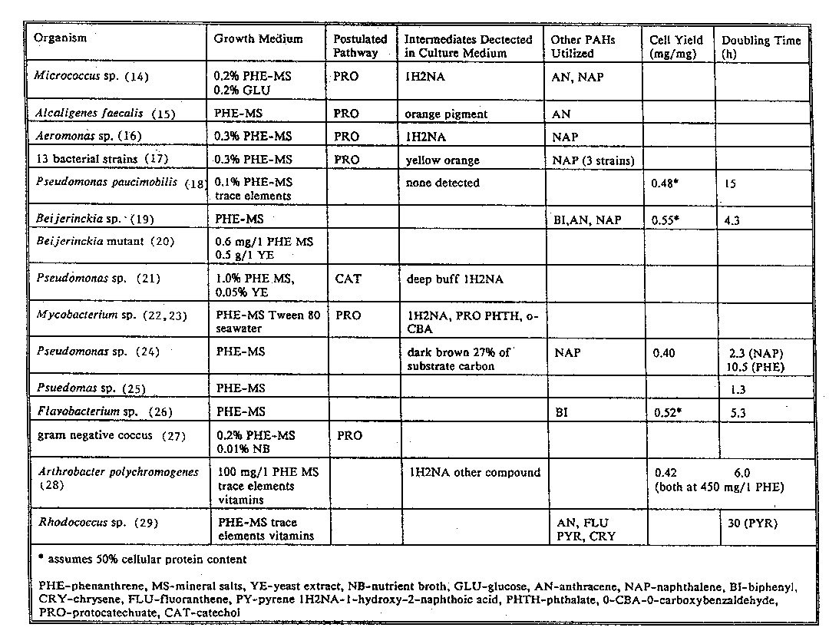

Co-metabolism results when an organism grows on a primary chemical and oxidizes a second chemical that is also present. The second chemical cannot be utilized for growth by the organism. The enzymes used to break down the first chemical may be nonspecific, having activity also on the second chemical. A large amount of research activity has been directed toward examining the potential of co-metabolism for the degradation of chlorinated solvents such as trichloroethylene (TCE) in underground aquifers. Phenol or methane-oxidizing bacteria (methanotrophs) use phenol or methane as electron donors and the TCE as the electron acceptor. The enzyme methane monooxygenase (MMO) is active on TCE and is produced during growth on methane. Co-metabolic degradation of polychlorinated biphenyls (PCBs) using co-substrate enrichment has been examined. Growth on biphenyl as a primary substrate allows the microorganisms to also degrade PCB.

Two additional reactions that may occur in the environment are accumulation and polymerization. Accumulation results in active uptake or adsorption of the pollutants. Both live and dead bacteria are capable of adsorbing organic compounds and metals, so-called biosorption. Polymerization of pollutants in soil has been shown to occur. The pollutants become bound to the soil after reacting with humus constituents. Fungal enzymes may mediate the reactions. The pollutants are clearly less mobile in bound form reducing their threat to the surroundings. However, a key question is whether they remain permanently bound to the soil because if they are slowly released, the polymerization represents only a temporary defusing reaction.

The kinetics of the growth of microorganisms strongly influences how fast pollutants will be removed. The specific growth rate is defined as

μ = 1 dX (1)
X dt
where μ is the specific growth rate, h-1, X is the biomass concentration, mg dry mass/L, and t is the time, h.

During the exponential phase, the organisms grow at their maximum rate. Because μ is constant during exponential growth, Equation 1 may be integrated and μ calculated from the slope of a plot of the log of the biomass concentration against time:

ln X₁/X₀ = μ(t₁ - t₀)

where X₁ is the biomass concentration at t₁ and X₀ is the biomass concentration at t₀. The doubling time (td) corresponds to:

X₁ = 2X₀ or t_{d} = 0.693/μ.

During the stationary phase of growth, the food source is being depleted which decreases the specific growth rate. With exhaustion of the food source, the death phase follows.

The Monod equation describes the effect of pollutant concentration on specific growth rate at low concentration:

μ = μ_{max} S/(Ks + S)

where μ_{max} = maximum specific growth rate, h⁻¹, μ is the specific growth rate, h⁻¹, Ks is the Monod saturation constant, mg/L, and S is the pollutant concentration, mg/L. At higher concentrations growth may be inhibited and the equation is no longer valid. The major assumption of the Monod equation is that a finite growth rate exists at all substrate concentrations. The plot of the Monod equation is shown in Figure 1. The Ks constant in the Monod equation is the pollutant concentration at 1/2 maximum growth rate and is a measure of the scavenging ability of the microorganism. A small Ks indicates that the organism is capable of high growth rate at low levels of pollutant and therefore efficiently removes the pollutant.

The effect of growth rate inhibition at substrate concentrations exceeding a toxicity threshold is shown in Figure 2. Such behavior has been observed with growth of bacteria on dichloromethane and pentachlorophenol (PCP), for instance.
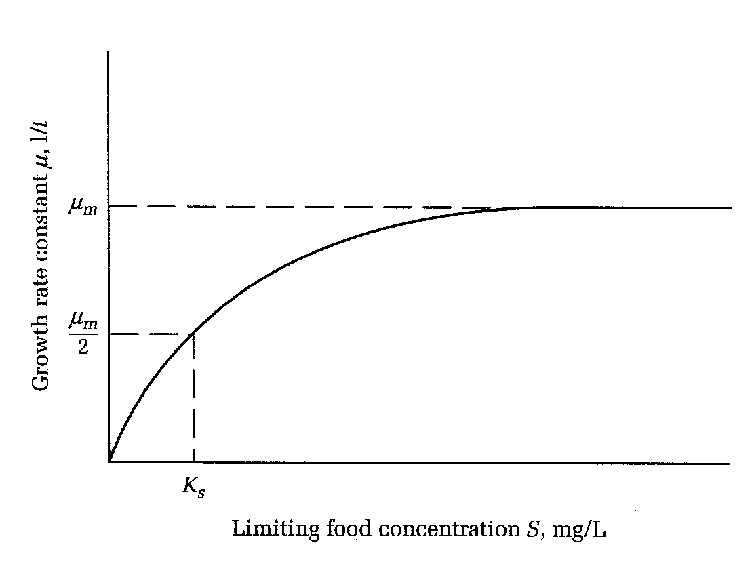

Figure 1 Monod Equation

From: Davis, M.I. and Cornwell, D.A. 1985 Introduction to Environmental Engineering. 2nd ed. McGraw-Hill Fig 5-6 p.323

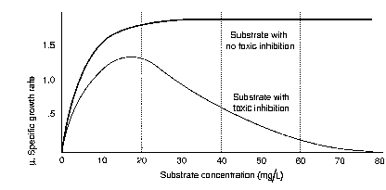

Figure 2 Growth Rate Inhibition From: La Grega, MD., Buckingham, P.L., and Evans, J.C. 1994. Hazardous Waste Management. McGraw-Hill, Inc. Fig 10-13 p.578

Upsets or shock loads that result in abrupt increases in pollutant feed concentration commonly occur in industrial wastewater treatment. During such episodes, the increase in pollutant concentration in the biological treatment tank may result in growth rate inhibition and a further increase in concentration. When this occurs, flow to the system must be stopped until residual pollutant concentrations have decreased to below toxic levels. Reseeding of the system with microorganisms may also be necessary.

The cell yield is the mass of microorganisms formed per nutrient, usually organics:
dX/dt = -YdS/dt

where Y is the cell yield, mg dry wt. cells/ mg pollutant and S is the substrate (pollutant) concentration. Values of the cell yield depend upon the specific type of organism, oxygen status of the environment, and carbon content of the pollutant. Under anaerobic conditions, less ATP is produced than under aerobic conditions resulting in a lower cell yield. Aerobic growth on compounds containing a relatively small fraction of carbon, such as pentachlorophenol, results in the production of fewer cells. The cell yield for PCP-degrading bacteria has been reported to be 0.15 mg dry wt/ mg PCB. By contrast, highly carbonaceous materials are metabolized with the production of high cell numbers. The growth yield on naphthalene is 0.7 mg dry wt/mg naphthalene.

Pollutant biodegradability

The public health threat associated with pollutants entering the environment will be greater if they are persistent. The half-life or time required for 50% disappearance of a chemical, is an indicator of susceptibility of the chemical to biodegradation. Half-lives may range from one day to several months depending on the environment and pollutant. Compounds that resist biodegradation are refractory or recalcitrant. Examples of recalcitrant compounds include DDT and PCBs.

The factors that influence persistence are related to the indigenous microbiology of the environment and chemical structures of the pollutants. The following chemical structural parameters are normally involved:

1. number of substituents
2. type of substituents
3. position of substituents
4. degree of branching
5. low solubility in water
6. atomic charge difference

Chlorine is a common substituent, which imparts both toxicity and persistence. The incorporation of chlorine into an organic compound increases its longevity. In the examples given below the compound on the right is more persistent than the one on the left.

less persistent more persistent
propionic acid 3-chloropropionic acid
monochloroacetic acid dichloroacetic acid
phenol mono-, di-, tri-, and pentachlorophenol
benzoic acid 3-chlorobenzoic acid
monochlorobiphenyl polychlorinated biphenyls (PCBs)

The type of substituent will influence pollutant residence time in the environment. Di-substituted benzenes with a carboxyl or hydroxyl replaced with nitro, sulfonate, or chlorine degrade more slowly. The position of the substituent also influences half-life of the compound in the environment as illustrated below.

less persistent more persistent
o,p-chlorophenol m-chlorophenol
o,p-chlorophenoxyacetic acid m-chlorophenoxyacetic acid
o,p-amino,nitro,methoxybenzoic acid m-amino,nitro,methoxybenzoic acid
m-nitrophenol p-nitrophenol
p-methylaniline o-methylaniline

Highly branched compounds are more resistant to biodegradation than straight chain compounds. The branched aliphatic acid, β-methylbutyric acid, is degraded more slowly than butyric acid.

Water solubility may affect the rate at which pollutants are degraded. Many microorganisms, which grow on compounds of low solubility, utilize only the dissolved form of the pollutant. The growth rate then becomes controlled by the rate of dissolution of the pollutant. Crushing crystals of naphthalene, for instance, results in an enhanced growth rate of microorganisms, due to the higher available surface area at which naphthalene dissolves, making the naphthalene more available as substrate.

NUTRIENT REQUIREMENTS FOR AEROBIC GROWTH

Hazardous waste sites are often contaminated in the subsurface with petroleum hydrocarbons. Such contamination arises from petroleum spills on the surface or from underground tank leaks. Effective biological treatment of the contamination (bioremediation) requires the presence of oxygen. The oxygen requirements for degradation of an organic compound may be determined if assumptions are made regarding cellular composition and the fraction of organic compound oxidized for energy. Consider the oxidation of a branched alkene C₇H₁₂. The complete oxidation reaction is:

C₇H₁₂ + 10 O₂ → 7 CO₂ + 6H₂O

If 1 mg alkene reacts, the O₂ required is:

10(2 x 16)/[(7+12) + (12 x1)] = 3.33 mg O₂/mg alkene

Oxygen will also be required for the production of biomass

C₇H₁₂ + 5O₂ + NH₃ → C₅H₇O₂N + 2CO₂ + 4 H₂O

5(2 x 16)/((7x12)+(12 x1)) = 1.67 mg O₂/mg alkene

We assume that 50% of the hydrocarbon is oxidized and the remainder is converted into cell mass, thus

1 mg alkene requires (0.5)(3.33 mg O2) + (0.5)(1.67 mg O2) = 2.5 mg O₂

The nitrogen required to produce cells:

0.5 mg alkene x (1 mmol cells/mmol alkene)(14 mg N/mmol cells)
96 mg/mmol)
= 0.073 mg N/ mg alkene

The cell yield is:

(0.5 mg) x (5x12+7x1+2x16+1x14) = 0.59 mg cells/mg
(7x12 + 12x1alkene)

The cell formula containing P, C₆₀H₈₇O₂₃N₁₂P, is used to obtain the phosphorus requirement:

(0.59 mg cells /mg alkene)x31 mg P = 0.0133 mg P/mg alkene
(60x12+87+23x16+12x14+31 mg cells)

The yield on oxygen Y_{xo} of the mass of microorganisms produced per mass oxygen consumed:

Yx/o = 0.59/2.5 = 0.24 mg cells/mg O2

AEROBIC TREATMENT

The main objective of conventional treatment is to remove the dissolved and colloidal degradable organic matter that remains after primary treatment, so that the effluent can be rendered suitable for discharge. In many cases, reduction of the BOD to below 20 mg/L and SS to below 30mg/L is sufficient, and conventional secondary treatment can achieve this quality. Very often in industrial systems the objective is to pretreat the wastewater before sewer discharge to reduce municipal charges or to meet disposal restrictions.

A second objective in some cases is the reduction of ammonia toxicity and nitrification oxygen demand in the receiving water body. This is achieved by oxidation of most of the ammonia to nitrate during treatment (nitrification). Nitrification is possible with aerobic biological processes if they are operated at long retention times - hence the units must be larger than those that would be required for oxidation of carbonaceous matter alone.

These bacterial processes are commonly carried out on either aerated lagoons or in activated sludge plants. The design approach is similar, except that activated sludge plants incorporate a sludge recycle, which allows independent control of the solids retention time or sludge age. The mean cell residence time in aerated lagoons is therefore equal to the hydraulic detention time. To prevent washout of active bacteria, the detention time should not be too short - two to five days' detention is the general order of the size of aerated lagoons. Activated sludge processes are commonly used industrial treatment systems and their design requires a closer study.

Activated sludge processes are now the most widely used in newly installed municipal treatment systems and their design requires a closer study. Disadvantage of this approach is that the other product, which is formed out of the organic substrate, is bacterial biomass, with virtually no reuse value other than as a fertilizer and soil conditioner as the bacterial protein is not of particularly good quality.

Design of activated sludge systems

The activated sludge process design involves details of sizing and operation of the following main elements:

a aeration tank (reactor) - capacity and dimensions
b aeration system - oxygen requirements and oxygen transfer system
c final sedimentation tank (clarifier)
d return activated sludge system
e excess activated sludge withdrawal system and subsequent treatment and disposal of the waste sludge.

Since the whole process takes place in a liquid medium, the hydraulic regime, especially in the aeration tank and the final sedimentation tank, needs to be carefully considered. The main system elements are discussed below.

The aeration tank

The aeration tank serves as a reactor in which the processes of biological growth and biodegradation take place. Therefore, conditions in the tank must satisfy the requirements for biological growth. Hence, both capacity, as determined by process loading, and configuration, as dictated by hydraulic requirements, must be considered.

Aeration tank capacity is often determined simply on the basis of empirical values of food-to-micro-organism ratio, irrespective of the hydraulic regime provided. For this purpose, F/M ratio (F) can be expressed as
F = Mass of BOD entering the aeration tanks / day = kg BOD / day (3) Total mass of MLVSS under aeration kg MLVSS

(Strictly speaking, the total MLVSS in the aeration tanks and final settling tanks should be used. Many design loading parameters, however, are quoted in terms of MLVSS in the aeration tank only.)

In terms of normal design variables,

F = QLi = Li (4)
VXv tXv

where Q is the sewage flow rate (m3/d); V is the aeration tank volume (m3);
V/Q = t, retention time of water; Li is the BOD concentration (mg/L); and
Xv is the MLVSS concentration (mg/L); and the aeration tank volume is given by

V = QL_{i} (5)
FX_{v}

In Equation 5, Q and L_{i}, or their product, are usually given, while values of F and X^{v} must be chosen according to the required effluent quality and operating characteristics of the system. For the conventional activated sludge process, values of F are usually in the range of 0.20 to 0.50 kg BOD/kg MLVSS.d and Xv 1500 to 3000 mg/L.
Performance of activated sludge processes is affected not only by the biological reactions in the aeration tanks but also by the hydraulic flow pattern through the tanks. At one extreme, flow may approximate ideal plug flow, where little intermixing of fluid entering the aeration tank takes place. At the other extreme, flow may be completely mixed.

Plug flow systems are characterized by conditions that vary along the length of the reactor. At the inlet end, substrate concentration is at its highest and reaction rate and rate of oxygen use are at a maximum. At the effluent end of the tank, substrate concentration is reduced to a very low value and sludge activity is therefore at its lowest, the oxygen use being due mainly to respiration of sludge organisms.

Completely mixed systems are characterized by uniform concentrations of substrate and activated sludge solids as well as by a constant rate of oxygen use throughout the mixed liquor. Hence the concentration of substrate and sludge solids in the effluent from the aeration tank is the same as that in the mixed liquor. Shock loads of toxic materials or organics are handled well since the whole of the aeration tank volume is available to dilute the sudden input. The actual practical flow pattern is usually somewhere between the two ideal patterns. The completely mixed condition is generally simplest to achieve. The completely mixed activated sludge process has been selected for closer study as it is the most common.

The completely mixed activated sludge process.

A definition sketch for the completely mixed activated sludge (CMAS) process is shown in Figure 5. For the CMAS system, it is possible to develop a number of useful correlations between food-to-micro-organism ratio and other design parameters. For these correlations, however, it is necessary to use a modified form of food-to-micro-organism ratio, U, defined in terms of the BOD removed by the process, rather than the BOD applied.

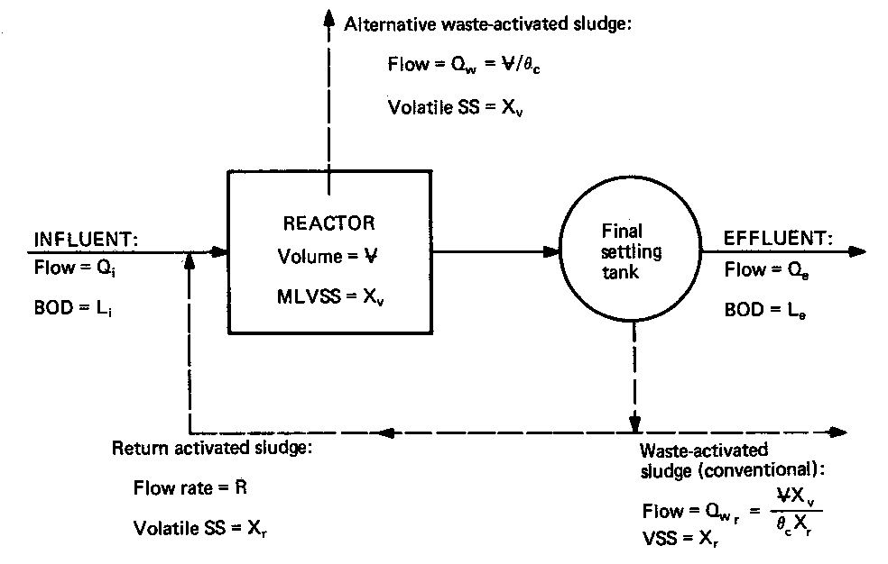

Figure 5 Completely mixed activated sludge process - definition sketch

Biomass production

U = Mass of BOD removed each day = L _{r} = Q ( L _{i} - L _{e} ) (6)
Total mass MLVSS under aeration X_{T} V X_{v}

where L_{e} is the effluent BOD concentration (mg/L).

Q is assumed to remain constant although there is some loss (c. 2 - 5 % ) in the waste sludge stream.

Biomass production per unit mass of biomass solids in the system, ΔX/X_{T} , can be correlated with U, as shown in Figure 6.

The term ΔX/X_{T} is the inverse of the mean cell residence time (MCRT) - also known as the sludge age, θ_{c}. The correlation between θ_{c} and U is expressed as

ΔX/X_{T} = 1/θ = YU - k_{d} (7)

where k_{d} is the decay rate (d⁻¹), signifying endogenous respiration, ie natural die-off and predation.

For estimation of biomass production, Eq 8 may be rearranged to give

ΔX = Y L_{r} - k_{d} X_{T} (8)

where L_{r} is the total mass of BOD removed each day and the second term represents the oxygen requirement of the biomass just for respiration Y is the yield coefficient and k_{d} the decay constant.

A better approach to understanding sludge production is to say that the excess biomass production is the biomass production - loss through predation and die-off:

Y x BOD_{removed} x throughput - k_{d} x MLVSS x volume of activated sludge unit. (9)

In practice, there will also be a contribution due to the capture of non- or slowly degradable solids from the incoming wastewater to the sludge production (see Example 4).

Effluent BOD, L_{e}, can be correlated with U, as represented in Figure 6. The first-order reaction Equation 11, shown in Figure 6 and below, can be derived from this. It should be noted that the value of L_{e} given by these relationships is the BOD, which remains dissolved in the effluent. Effluent from practical wastewater treatment plants always contains a small amount of fine activated sludge solids. In such cases, the total effluent BOD will be represented by the sum of the soluble BOD, L_{e}, and the BOD of escaping sludge solids.

$\frac{L_{e}}{L_{i}}=\frac{1}{1+{\text{kX}}_{v}t}$ (10)

Oxygen requirement

Oxygen requirements for carbonaceous oxidation, expressed as the oxygen required per unit mass of activated sludge, [O₂]_{T} / [X_{v}]_{T}, can be correlated with U, whence the total oxygen consumption in carbonaceous oxidation can be estimated from

[O₂]_{T} = aL_{r} + bX_{T} (11)

Another method of expressing Equation 11 would be to say that
Oxygen requirements are a fraction of the BOD removed + the oxygen required by all of the biomass = a x BOD x throughput plus b x MLVSS x volume of activated sludge plant. To understand and implement this approach in calculations is much preferred to using formulae.

At very low values of U, as in extended aeration plants, the linear correlation expressed by equations 8 and 9 does not apply. It is then expressed in terms of an observed yield coefficient Y_{obs} :

ΔX = Y_{obs}U (12)
X_{T}
Y_{obs} is a non-linear function of θ_{c}, and, which needs to be determined from laboratory or pilot scale studies.

An alternative expression is [O₂]_{T} = aL _{ur} - 1.42ΔX (13)

where L_{ur} is the total mass of ultimate BOD removed each day (≅ 1.46L_{r}) for domestic sewage) and the second term represents the approximate oxygen requirement to oxidize the biomass formed. The latter term is subtracted as it represents a savings in oxygen requirements as part of the BOD is converted to biomass.

The oxygen demand for nitrification must be estimated separately. In general, 4.6 kg of oxygen are required for each kilogram of ammonia (or for organic) nitrogen oxidized as predicted by NH₃ + 2O₂ + OH⁻ → NO₃⁻ + 2H₂O or simply from the fact that the change in oxidation state of NH₃ - N from (- III) to (+ V) in NO₃⁻ - N ( H remains + I ), requiring four O atoms to accept the eight electrons.

The aeration system should have sufficient oxygenation capacity to transfer the oxygen needed to satisfy the total oxygen demand for the required degree of carbonaceous and nitrogenous oxidation, while maintaining the DO concentration in the mixed liquor at, or above, the minimum acceptable value. At least 1mg/L of DO is required to ensure that organism activity is not inhibited and to prevent the growth of filamentous organisms.

In the design of the aeration system, it is important to consider not only the average but also the peak hourly rate of oxygen demand; this may be 50 to 100 per cent or more above the average rate of oxygen demand.

The values of the process coefficients, Y, Y_{obs}, k_{d}, k, a and b, depend on many factors, such as the biodegradability and oxidation-reduction state of the organic carbon and the predominant microorganism species. These values, therefore, tend to be specific to the type of waste being treated. Wherever possible, they should be evaluated by laboratory or pilot scale tests. Some typical values which have been reported for domestic wastewater systems are: Y = 0.5 to 0.7 kg VSS/kg BOD removed; k_{d} = 0.04 to 0.07 per day; k = specific substrate utilization rate constant; k = 0.025 L/mg.d; a = 0.57 kg O₂ /kg BOD removed; and b = 0.1 kg O₂ / kg MLVSS.day.

The parameter θ_{c} can be used as a simple control parameter by the withdrawal of 1 / θ_{c} of the aeration tank contents each day. The liquor so withdrawn should be thickened, and then supernatant returned to the aeration tank.

Example 4 Industrial wastewater at a flow rate of 5 ML / d with 200 mg /L BOD and 100 mg / LSS is to be treated in a completely mixed activated sludge plant to produce an effluent with not more than 10 mg / L BOD. Kinetic coefficients are k=0.03L/mg⁻¹.d⁻¹, Y = 0.65kg VSS/kg BOD_{r}, k_{d} = 0.07d⁻¹, a = 0.55 kg O₂ / kg BOD_{r} and b = 0.10 kg O₂ / kg MLVSS.

Calculate

a. The aeration tank volume and dimensions, assuming two tanks square in plan with MLVSS concentration of 2000 mg/L.
b. The mass of excess activated sludge produced each day, assuming that sludge is wasted from the return sludge system at 99 per cent moisture content.
c. The operating values of θ_{c} and F / M ratio
d. The daily oxygen requirements for oxidation of carbonaceous matter

Solution

a. Aeration tanks
The average wastewater detention time is given by Equation 11

Substitution from the data gives

or t = 0.32 d

Volume, V = Qt = 5 ML/d x 0.32 d = 1.6 ML = 1600 m³
For two tanks, and an assumed depth of 5 m, the side length is

=12.6m, say 13 m square to allow for corner fillets.

b. Sludge production

Daily production of volatile solids is given by Equation 9

Δ X = Y L_{r} - k_{d} X_{T} = 0.65[(200-10)5] - 0.07[1.6 x 2000] = 394 kgVSS/d

Non-volatile solids capture in the biomass, ΔX_{nv}, can be estimated from the amount of nonvolatile solids present in the wastewater. The amount captured and not degraded could vary from 20 - 50 % of the SS, say 25%. In practice, this would need to be determined by experimentation, but never be overlooked.

ΔX_{nv} = (25/100) x (100 x 5) = 125kgNVSS / d

Therefore, total excess sludge solids = ΔX_{nv} + Δ X = 394 + 125 = 519 kg/d

The percentage of VSS in activated sludge solids is 394 /519 x 100 = 76 %.

c. Loading factors
Mean cell residence time is X_{T}/Δ X = θ_{c} = (1.6 x 2000)/393 = 8.14 d
F / M ratio is = 0 31 kg BOD / kg MLVSS.d

Note that for a high degree of BOD removal, as in this case,

= 0.30 ~ F

It may be seen, therefore, that the size could have been calculated by the use of a conventional loading factor of F = 0.30.

d. Oxygen requirements for oxidation of carbonaceous matter

[0₂]_{T} = aL_{r} + bX_{T} = 0.55[(200 - 10)5] + 0.10[1.6 x 2000] = 843 kg O₂/d

= 35.1 kg O₂ /h = 22gO₂/m³.h

Note that the oxygenation equipment would be required to have the capacity to transfer oxygen at a rate sufficient to meet the peak flow demand. This could be twice as high.

If, for example, there had been 30 mg/L of organic N in the wastewater, the oxygen requirements for nitrification would have been 4.6 x 30 x 5 kg/d = 690 kg/d = 28.75 kg/h. Generally, this demand would not be influenced much by the peak flow as the nitrifcation reactions proceed slowly. If the peak flow was indeed double the mean flow, the aeration requirement would thus be calculated as 2x 35.1 kg/h + 28.75 kg/h, say 100 kg/h.

AERATION SYSTEMS

If all other factors are the same - type of waste, power input, system of aeration, temperature and impurities - the rate of oxygen transfer is proportional to the difference between the saturation concentration and the actual concentration.

If the concentration of oxygen is lowered, more oxygen can be transferred for the same expenditure of power on the same equipment. Therefore, it is desirable, from this point of view, to operate with a low oxygen concentration. However, too great a reduction of the oxygen concentration affects the efficient operation of the biological process. A suitable design target value, with air at atmosphere pressure as an oxygen source, is 2 mg/L. For oxygen gas, with its much higher partial pressure and a saturation concentration of about 40 mg/L or more, a higher target concentration may be used to advantage.

Aeration devices commonly used in activated sludge systems include mechanical surface aerators (horizontal or vertical shaft), diffused air systems (with porous or nonporous diffusers) and turbine aerators.

An aerator should be chosen on the basis of maximum efficiency. This should not be measured merely as kg/kWh, but as the cost per kilogram of oxygen transferred, $O₂.

$O₂ = $kWh + $ amortization + $ maintenance + $ ancillaries

The efficiency of oxygen transfer depends to a large extent on physical factors such as gas solubility and transfer rates.

Gas solubility and equilibrium

Where there is an interface between a gas and a liquid, gas molecules from the gaseous side of the gas-liquid interface hit it and dissolve in the liquid; the number of these is proportional to the partial pressure of the particular gas and other minor factors. At the same time, molecules of dissolved gases escape from the liquid; the number of these proportional to the concentration of the dissolved gas in the liquid, the surface area and dependent on the temperature of the water, the composition and concentration of impurities and the nature of the gas.

The net transfer of a gas from the gas phase to the liquid phase is the difference between these two sets of migrating molecules. When the two opposing streams of molecules are equal, the system is said to be in equilibrium and the solution would be saturated.

Henry's law provides that, at low concentrations, the saturation concentration of a gas is proportional to the partial pressure of that gas at the liquid-gas interface.

This can be expressed by the formula

C_{si} = kp_{i} (13)

where C_{si} is the saturation concentration of gas 'i'; k is the Henry's law constant; and P_{i} is the partial pressure of gas 'i' (absolute).
The proportionality constant in Henry's law is a function of the kind of gas, the temperature, the liquid and the impurities in the liquid.

The solubility of oxygen is of particular interest in studies of the biological treatment of wastes and of river quality. The effect of temperature between 5° and 25°C and salinity on its solubility in clean water from air at sea level (total pressure = 101.325 kPa, or oxygen partial pressure = 21.24 kPa) is given by the following approximate empirical equation

$C_{\text{sT}}=\frac{\text{482}\text{.}5−S[0\text{.}\text{003}−(2\text{.}6T×{\text{10}}^{−5})]}{[\text{32}\text{.}6+T]}$ (14)

where C_{sT} is the saturation concentration of oxygen (mg/L); S is the salinity (mg/L); and T is the temperature (°C).

The effect of salinity is minor at concentrations below 10 g/L. The solubility of oxygen in sewage is about 95 per cent of that in pure water. In some industrial wastes, it may be less. The total pressure used in this equation is approximately that at sea level and a correlation must be made for altitude. The saturation concentration should be reduced by one per cent for every 88 metres of elevation:

C_{sh} = C_{sT}(0.99)^{h/88} (15)

where C_{sT} is the saturation concentration at sea level and C_{sh} is the saturation concentration at an elevation of h meters. At an elevation of 1400 m, the saturation concentration is reduced by about 15 per cent.

The solubility of oxygen in sewage, as a function of all of the above factors, can be expressed to be:

C_{s} = α (0.99)^{h/88} x (16)

where α is the ratio of solubility of oxygen in sewage to that in pure water, c. 0.95.

Rate of gas transfer

The transfer rate of a gas, per unit area of surface, is proportional to the difference between the actual concentration of that gas at the liquid surface and its saturation concentration. This relationship holds because (a) the rate at which molecules leave the water is proportional to the actual concentration at the surface, and (b) the rate at which they enter is proportional to the partial pressure and that, in turn, is proportional to the saturation concentration. The net number of migrating molecules being dissolved is given by the difference between the numbers of those entering and those leaving the surface.

The coefficient of proportionality for this relationship depends on the microscopic conditions occurring at the gas-liquid interface. Gases arrive at, and leave, the interface by diffusion. On the gas side, where molecules are in rapid motion with reasonably long free paths between collisions, diffusion is rapid, but on the liquid side of the interface, it is very slow.

A stationary body of water will dissolve oxygen only very slowly, because the surface layer becomes practically saturated rapidly, and the uptake of oxygen from the air slows down. At that stage, the rate of solution of oxygen depends on the rate of diffusion away from the surface in the liquid. Molecular diffusion in liquids is very slow.

In an aerator, the space in the vicinity of the surface may be considered as consisting of four main regions. These are: the turbulent gas region, the laminar gas region in the boundary layer on the gas side of the interface, the laminar liquid region in the boundary layer on the liquid side of the interface, and the turbulent liquid region.

The main resistance to gas transfer occurs on the liquid side of the interface, where there are two stages:

- molecular diffusion through the 'boundary layer', and
- eddy diffusion by turbulence once the boundary layer is passed.

The molecular diffusion stage is the main limiting feature. An increase in general turbulence will decrease the thickness of the boundary layer and, hence, less resistance will be offered to the passage of gas.

Some surface active impurities (such as detergents) can affect the properties of the boundary layer, generally reducing the rate of gas transfer. Films of grease and oils can also interfere with the transfer of gases by creating an extra interface through which they have to pass.

A variation in temperature can affect the transfer rate. Increased temperature speeds up molecular motion, transfer rates being increased by about 2 per cent for each degree Celsius increase. The saturation concentration, however, is generally reduced by a temperature increase, thus causing a decrease in solution rates but an increase in dissolution rates.

The rate of transfer of a gas, and its effect on concentration, can be expressed generally by

(17)
and
(18)

where K_{l} is the transfer coefficient for unit area (kg / h.m²);
A is the area of air-water interface (m²);
dm/dt is the rate of gas transfer (kg/s);
∀ is the volume of water (m³);
C_{s} is the saturation concentration of the gas (mg/L);
C_{l} is the actual concentration of the gas in the water (mg/L); and
dC_{l}/dt is the rate of change of concentration (mgL⁻¹s⁻¹).

In a practical case, neither K_{l} nor A can be measured, but the value of the composite transfer coefficient K_{l} A can be inferred from the behavior of equipment (by test). The value then applies only to the particular aeration system in which the measurements were made.

The objective of aerator design is therefore an increase in the value of K_{l} and/or A, usually both. K_{l} can be affected by the turbulence in the vicinity of the air-water interface as an increase in turbulence reduces the thickness of the laminar boundary layer and thus increases K_{l}. Methods of increasing the surface area are:

- bubbling air through water,
- creating droplets of water in air,
- spreading the water in a film over a large solid surface, or
- cascading.

The value of (C_{s} - C_{l}) can be increased by increasing C_{s}. Increasing oxygen concentration to increase the oxygen partial pressure, or increasing the total pressure, or both can accomplish this. The value of C_{l} is kept as low as practicable, just to meet process requirements.

In all cases of engineered aeration, the establishment and maintenance of both turbulence and a high surface area requires energy. The energy consumption required to provide a desired degree of treatment, is a measure of the efficiency of the process.

Comparison of wastewater aerators

There is no standard basis for comparison of oxygen transfer equipment. Many approaches to expressing oxygen transfer efficiency are encountered in the literature, including:

a percentage transfer of oxygen (from diffusers)
b power consumption per volume of aerator capacity
c power consumption per kg of BOD removed
d kilograms of oxygen per kilowatt-hour under various base conditions.

The rate of oxygen transfer for a particular transfer system is

W = K_{l20}A(C_{s}-C_{l})θ^{(T-20)}β (19)

where W is the rate of oxygen transfer (kg/h);
K_{l20} is the transfer coefficient at 20°C in clean water (kg/h.m²);
A is the interface area (m²);
C_{s}, C_{l} the saturation, actual concentration of oxygen in sewage (mg/L);
T is the sewage temperature (°C);
β is the ratio of transfer coefficient in the sewage to transfer coefficient in clean water to allow for effects of surface impurities (about 0.9 to 0.95); and
θ is the temperature coefficient. A typical value of θ is 1.02, but it may vary from about 1.017 to about 1.024, depending on the type of gas and the type of aerator.

Therefore, any basis used for evaluating the capacity of aeration equipment should include:

a the power consumption per unit of oxygen transferred
b the liquid to which the oxygen is being transferred during the test
c the difference between C_{s} and C_{l} (called the 'driving force') during the test.

With this information, it is possible to estimate the value of K_{l}A for a particular piece of equipment. The method used by some manufacturers is to quote kilograms of oxygen transferred per kilowatt-hour (typically about 2kg/kWh) to clean water (or tap water) devoid of oxygen at a given temperature, under a pressure of one standard atmosphere (101.325 kPa). Some manufacturers use 20°C as the standard temperature; others, with parent companies in colder Europe, use 10°C.

Example 5 An aerator for use at an industrial wastewater treatment installation is tested at sea level with clean water devoid of oxygen at 15°C. It is found to be possible to transfer 10 kg of oxygen an hour under these conditions.

It will be installed at an elevation of l500m above sea level, to oxygenate waste water at 10°C. Estimate the oxygen transfer, if the wastewater saturation concentration is only 90 per cent of that of water at the same temperature, and the operating oxygen concentration is 3 mg/L.

Solution

To find the saturation concentrations for clean water under the two conditions, use Equations 14 and 15.

For clean water at sea level and 15°C

C_{s} = 482.5 = 482.5 = 10.14mg/L
32.6 +T 47.6

For clean water at 1500m and 10°C

C_{s} = 482.5 (0.99)^{(1500/88)} = 9.54mg/L
42.6
For waste water under these conditions, C_{s} = 9.54 x 0.9 = 8.59 mg/L

To find K_{l15}A for test conditions (Eq 17)
.
10 = K_{l15}A(C_{s}-C_{l}) = K_{l15}A x 10.14

Therefore, K_{l15}A = 10/10.14 = 0.99

For operating conditions (from Eq 19)

W = 0.99(8.59-3)(1.02)⁽¹⁰⁻¹⁵⁾ x 0.95 = 4.76 kg/h

Note the difference between test performance and the transfer rate under operating conditions.

AERATION EQUIPMENT

Porous diffusers

These must be operated continuously, with an airflow less than that which could damage the diffuser but always more than the minimum recommended flow, so that clogging will not occur too rapidly. This requires the provision of standby air compressors, and diesel motors. Most diffused air systems require a supply of air at a pressure of 50 to 80 kPa. Porous diffusers have a theoretical oxygen transfer rate of about 2.8 kg/kWh.

Porous diffusers may be made of ceramic material, and they are available in the shape of plates, domes or tubes. They may also be made of plastic material, either fabric or moulded. Fabric diffusers are generally lightweight and they can be readily cleaned.

Extensive air filtering before porous diffusers is required to prevent clogging of diffusers. Baghouse systems, sometimes 2 or 3 consecutive filters, make the pre-treatment an expensive part of the system.

Non-porous diffusers

These have been developed with the objectives of

a. Elimination of diffuser clogging problems
b. Reduction of equipment capital cost (loss in efficiency compared with fine bubble porous diffusers).

Many types of jet, valued orifice and turbulence disc are now available. A system which uses slotted pipes with a shallow immersion of about 0.9 m and a large volume of air at low pressure has been developed. Under these conditions, compressors can be replaced by blowers and the holes in the pipes are so large that they seldom block. Power efficiency is in the range of 1.0 to 2.0 kg/kWh.

Vertical shaft mechanical aerators

These have a rotor at the surface of the water, where the oxygen transfer takes place through surface turbulence, splashing and air bubble entrainment. The oxygen transfer capacity depends on the design of the equipment, the depth of immersion, the shape and size of the aeration tank, the energy input per unit volume of tank and the rate of rotation; some of these factors are interrelated. The oxygen transfer rates under average operation conditions are of the order of 2 to 3 kg/kWh.

Horizontal shaft surface aerators

Various types of brush and cage rotor have been designed. They provide not only aeration but also a horizontal pumping effect to maintain circulation and mixing. They may be used in tanks of moderate depth to provide a rolling circulation, but the most common use is in oxidation ditches and for supplementing oxygen supply in maturation ponds or oxidation ponds.

A typical cage rotor of 700 mm diameter could be operated at a speed of 75 rev / min, to give oxygen transfer of 2.9 to 3.5 kg/kWh, depending on depth of immersion. These rotors may be mounted on floats that slide in guide-boxes at each end.

U-tube aeration

In U-tube aeration, the partial pressure of the oxygen can be doubled or trebled by passing the water, with diffused bubbles entrained, through a U-tube with its lower portion 10 to 20 meters or more below the hydraulic gradeline. This increases the partial pressure 2 or 3x and hence the instantaneous saturation concentration, and speeds up the transfer of oxygen. For ease of construction, the downward tube may be inside the upward flow tube. Further increase of partial pressure of oxygen can be obtained by using pure oxygen.

Turbine aerators

These are submerged turbines with air released from spargers immediately below them. They have been used where the required oxygen input per unit of volume is greater than can be obtained with diffused air. Their oxygen transfer capacity is in the range of 1.5 to 2.0 kg/ kWh. There are also submerged self-aspirating aerators that draw the air through a hollow drive shaft (Kerag aerators).

Oxygen enriched systems

Molecular oxygen can be used instead of air to increase greatly the partial pressure of the oxygen. If the atmosphere in contact with the sewage under treatment is oxygen, the partial pressure of the oxygen is 5x as large as in air and creates a much greater driving force to transfer it into the liquid. In this way, the saturation concentration at atmospheric pressure changes from 8 - 10 mg/L up to 40 or 50 mg/L. This makes it practicable to maintain higher concentrations of DO in the liquor.

Where 'pure' oxygen is used for wastewater treatment, it has to be obtained from such a source as cylinders, bulk tankers or reticulated oxygen from suppliers, a cryogenic oxygen distillation plant at the works, or enriching air with ‘molecular sieves’.

