Introduction to
Electric Systems Expansion Planning

- Planning horizons

Electric power systems consist of power generation stations, transmission and distribution circuits, substations, and associated transformers, voltage control equipment, and protection equipment, together with equipment that facilitates monitoring, communication, and information processing to enable decision and control.

The process to plan and build such facilities takes many years. The length of time between the planning analysis and the initial start-up of the equipment is referred to as the planning horizon. For example, many regulatory bodies require that electric utilities have a 10-20 year planning horizon for generation facilities as indicated by the survey results at []. The North American Electric Reliability Corporation (NERC) requires in Planning Standard TPL-005-0 [] that “each Regional Reliability Organization shall annually conduct reliability assessments of its respective existing and planned Regional Bulk Electric System (generation and transmission facilities) for,”
- The current year (winter and summer),
- Near-term planning horizons (years one through five), &
- Longer-term planning horizons (years six through ten).

There are a number of reasons for this long decision horizon, all of which emphasize the importance of planning as an essential function, as follows:
- Financing: The equipment is capital-intensive, i.e., expensive, requiring careful analysis and decision to minimize financial risk exposure on the part of the equipment owners.
- Multiple organizations: The equipment will be interconnected within an overall system that is owned and operated by many different organizations, and so each affected organization must have access to information necessary to consider the impacts of the new equipment on their operations.
- Land: The power generation stations, the transmission and distribution circuits, and the substations require significant land areas necessitating engagement in what can be extremely complex land acquisition processes.
- Environmental impacts: Many facilities have environmental effects, for example
  - Power plant impacts, including impact of fossil fired plants on water usage and emissions, ability to store wastes from nuclear plants, impact of hydroelectric facilities on fish-kill and recreational activities, and wind turbine noise and wind turbine impact on birds.
  - Affects of overhead transmission lines including visual aesthetics, corona-induced audible noise, communications interference (particular AM radio), and induced currents in underlying objects from high electric field levels.
- Cost of energy: The cost of electric energy, which is heavily determined by planning decisions, directly affects all of us via our own residential use of it. In addition, we are all indirectly affected by the cost of electric energy in two ways:
  - Through our dependence on industrial and commercial organizations that pass on their cost of electric energy to us through the products and services that we purchase from them.
  - Through our ability to compete in international markets (including those within our own country) and the related impact that has on job growth and gross domestic product (GDP).
- Reliability: Decisions on which equipment to build and when, together with the rate of load growth and the retirements of old equipment, directly impact the reliability levels of the interconnected grids. These reliability levels, or conversely, the extent to which customers see interruptions and/or transmission unavailability causes generation owners to use higher-priced energy, also affect the cost of energy.

A final reason why planning and building new facilities takes so long is because such decisions affect all persons within our society, and therefore we as a society have concluded that it is appropriate to impose regulatory oversight in this process. Regulatory oversight generally occurs at two levels:
- Federal level: The Federal Energy Regulatory Commission (FERC) [] regulates the interstate transmission of electricity, natural gas, and oil. In regards to electric systems, FERC
  - licenses and inspects private, municipal, and state hydroelectric projects,
  - ensures the reliability of high voltage interstate transmission system,
  - monitors and investigates energy markets,
  - uses civil penalties and other means against energy organizations and individuals who violate FERC rules in the energy markets, and
  - oversees environmental matters related to natural gas and hydroelectricity projects and major electricity policy initiatives
FERC does not
  - regulate retail electricity and natural gas sales to consumers, or approve the physical construction of electric generation, transmission, or distribution facilities (done by the state regulator),
  - regulate activities of the municipal power systems, federal power marketing agencies (like Tennessee Valley Authority), and most rural electric cooperatives, or
  - regulate nuclear power plants (this is done by the Nuclear Regulatory Commission).
- State level: A list of state regulatory bodies for utilities may be found at []. The authority for these bodies varies somewhat, but the following statements from the web page of the Iowa Utilities Board (IUB) [] are typical:
“The Board regulates the rates and services of electric, natural gas, communications, and water utilities and generally supervises all pipelines and the transmission, sale, and distribution of electrical current….Also included in the Board’s jurisdiction is certification of electric power generators (476A), granting of franchises for electric transmission lines (478),…”

- Growth rates in load and generation

One of the most important stimuli for planning is growth rates. Load growth requires complementary growth in generation. Generation growth requires complementary growth in transmission. Although the “complements” might be delayed, as we shall see, they must occur eventually.

In this discussion, we will draw on various data. Although we provide references for each dataset, it must be mentioned here that the DOE Energy Information Administration (EIA) [] maintains a public website with useful data for characterizing US energy systems.

Historical US load growth rates are shown in Fig. 1 in terms of percent per year of noncoincident peak. Between 1960 and 1970, it was over 7% per year, and between 1970 and 1980, it was over 4% per year. Since 1980, however, it has varied between about 1% and 3% per year. These data were obtained by combining 1965-1989 data from [] and 1986-2007 data from Table 8.12 of [].
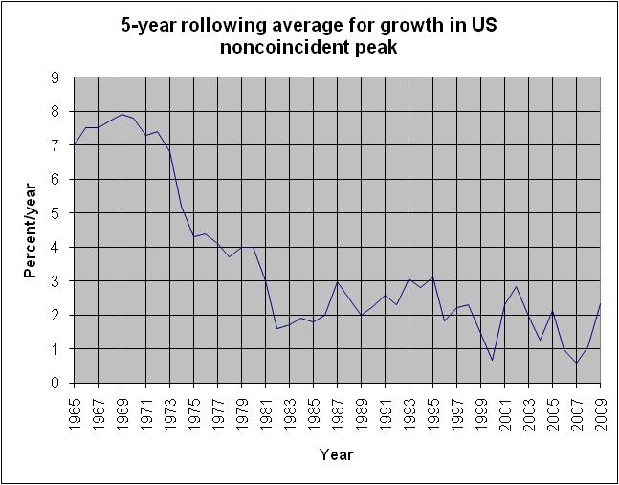
Fig. 1: Load growth in percent per year
The percentage growth in Fig. 1 is a 5-year forward rolling-average. The last five years t = ’05, ’06, ’07, ’08, ‘09 were computed assuming a 2% load growth for year t+5, and so these later five years are increasingly approximate (and probably a little high).

The growth in noncoincident peak, in GW, since 1986, is shown in Fig. 2 [Error: Reference source not found].

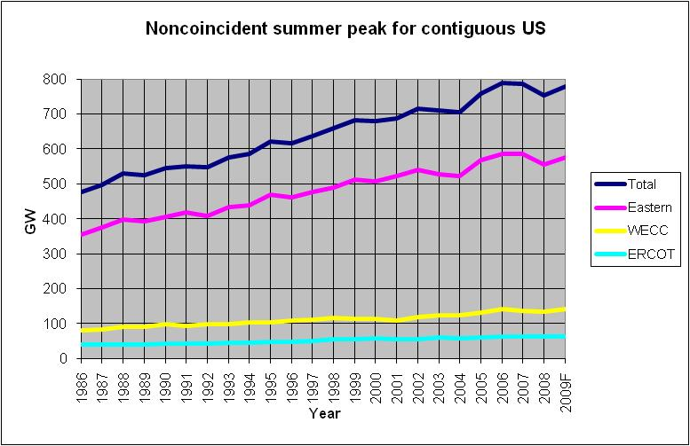
Fig. 2: Load growth in GW

There are two interesting features to note in Fig. 2:
- Load growth appears to be significantly higher in the east than in the west, and it is a bit higher in the west than in Texas (ERCOT).
- There was a significant increase in load growth between 2004 and 2006. Although most pronounced in the east, it is recognizable in the west as well. This may have been due to the facts that 2004 [] and 2006 [] were warmer than normal years, and 2005 [], was warmer in the east where the majority of the US load is served.
It is interesting to observe how this load growth has been matched by generation. Figure 3a, which comes from Table 8.11a of [Error: Reference source not found], shows a relatively steep increase in capacity during the period 1950-1973, which matches the higher load growth rate observed in Fig. 1. This capacity growth rate decreased from 1973-1987, ramped briefly for one year in 1989 (possibly due to growth in nonutility generation stimulated by the 1978 PURPA legislation), and then slowed to a record low rate between 1990 and 1999. This slow-down in capacity growth was due to the uncertainty created by the early years of deregulation.
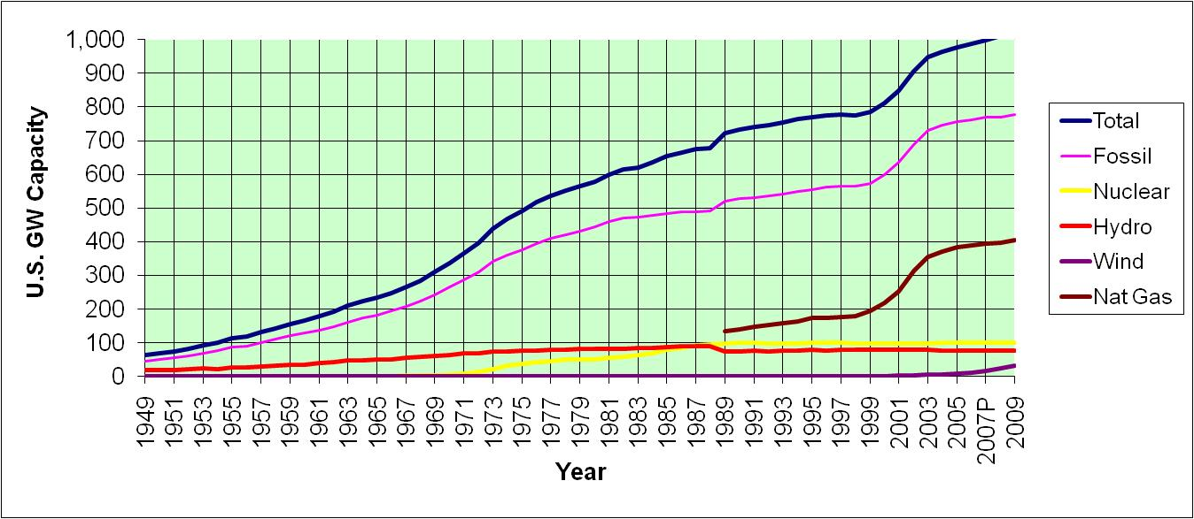
Fig. 3a: Growth in US Generation Capacity: Cumulative
The increased growth rate observed from 1999-2003 was due to the need, almost everywhere in the country, to catch up with load growth, and it was implemented using mainly generation technologies fueled by natural gas. The emphasis on natural gas resulted from the fact that natural gas was inexpensive during the 1990’s when most of these plants were planned (observed in Table 1 [], indicated by the rectangular shape around these prices), and combined cycle plants, which used natural gas, were highly efficient.

Table 1: Receipts, Average Cost, and Quality of Fossil Fuels for the Electric Power Industry, 1992 through 2006
Table 4.5. Receipts, Average Cost, and Quality of Fossil Fuels for the Electric Power Industry, 1992 through 2008
Period | Coal [1] |  |  |  | Petroleum [2] |  |  |  | Natural Gas [3] |  | All Fossil Fuels
Period | Receipts (Billion BTU) | Average Cost |  | Avg. Sulfur Percent by Weight | Receipts (billion BTU) | Average Cost |  | Avg. Sulfur Percent by Weight | Receipts (Billion BTUs) | Average Cost (cents/ 10 6 Btu) | Average Cost (cents/ 10 6 Btu)
Period | Receipts (Billion BTU) | ($ per 10 6 Btu) | (dollars/  ton) | Avg. Sulfur Percent by Weight | Receipts (billion BTU) | ($ per 10 6 Btu) | (dollars/ barrel)
1992 |  | 1.41 | 29.36 | 1.29 |  |  |  |  |  | 2.32 | 1.5
1993 |  | 1.38 | 28.58 | 1.18 |  |  |  |  |  | 2.56 | 1.59
1994 |  | 1.35 | 28.03 | 1.17 |  |  |  |  |  | 2.23 | 1.52
1995 | 16,946,807 | 1.32 | 27.01 | 1.08 | 532,564 | 2.68 | 16.93 | 0.9 | 3,081,506 | 1.98 | 1.45
1996 | 17,707,127 | 1.29 | 26.45 | 1.10 | 673,845 | 3.16 | 19.95 | 1 | 2,649,028 | 2.64 | 1.52
1997 | 18,095,870 | 1.27 | 26.16 | 1.11 | 748,634 | 2.88 | 18.3 | 1.1 | 2,817,639 | 2.76 | 1.52
1998 | 19,036,478 | 1.25 | 25.64 | 1.06 | 1,048,098 | 2.14 | 13.55 | 1.1 | 2,985,866 | 2.38 | 1.44
1999 | 18,460,617 | 1.22 | 24.72 | 1.01 | 833,706 | 2.53 | 16.03 | 1.1 | 2,862,084 | 2.57 | 1.44
2000 | 15,987,811 | 1.2 | 24.28 | 0.93 | 633,609 | 4.45 | 28.24 | 1 | 2,681,659 | 4.3 | 1.74
2001 | 15,285,607 | 1.23 | 24.68 | 0.89 | 726,135 | 3.92 | 24.86 | 1.1 | 2,209,089 | 4.49 | 1.73
2002[4] | 17,981,987 | 1.25 | 25.52 | 0.94 | 623,354 | 3.87 | 24.45 | 0.9 | 5,749,844 | 3.56 | 1.86
2003[5] | 19,989,772 | 1.28 | 25.91 | 0.94 | 980,983 | 4.94 | 31.02 | 0.8 | 5,663,023 | 5.39 | 2.28
2004 | 20,188,633 | 1.36 | 27.42 | 0.97 | 958,046 | 5 | 31.58 | 0.9 | 5,890,750 | 5.96 | 2.48
2005 | 20,647,307 | 1.54 | 31.20] | 0.98 | 986,258 | 7.59 | 47.61 | 0.8 | 6,356,868 | 8.21 | 3.25
2006 | 21,735,101 | 1.69 | 34.09 | 0.97 | 406,869 | 8.68 | 54.35 | 0.7 | 6,855,680 | 6.94 | 3.02
2007 | 21,152,358 | 1.77 | 35.48 | 1.0 | 375,260 | 9.59 | 59.93 | 0.7 | 7,396,233 | 7.11 | 3.23
2008 | 21,356,514 | 2.07 | 41.24 | 1.0 | 410,802 | 15.56 | 95.94 | 0.6 | 8,036,838 | 9.02 | 4.11
2009 | 19,278,265 | 2.21 | 43.79 | 1.0 | 306,084 | 9.95 | 60.67 | 0.5 | 8,297,586 | 4.7 | 3.03
[1] Anthracite, bituminous coal, subbituminous coal, lignite, waste coal, and synthetic coal.
[2] Distillate fuel oil (all diesel and No. 1, No. 2, and No. 4 fuel oils), residual fuel oil (No. 5 and No. 6 fuel oils and bunker C fuel oil), jet fuel, kerosene, petroleum coke (converted to liquid petroleum, see Technical Notes for conversion methodology), and waste oil.
[3] Natural gas, including a small amount of supplemental gaseous fuels that cannot be identified separately. Natural gas values for 2001 forward do not include blast furnace gas or other gas.
[4] Beginning in 2002, data from the Form EIA-423, "Monthly Cost and Quality of Fuels for Electric Plants Report" for independent power producers and combined heat and power producers are included in this data dissemination. Prior to 2002, these data were not collected; the data for 2001 and previous years include only data collected from electric utilities via the FERC Form 423.
[5] For 2003 only, estimates were developed for missing or incomplete data from some facilities reporting on the FERC Form 423. This was not done for earlier years. Therefore, 2003 data cannot be directly compared to previous years' data. Additional information regarding the estimation procedures that were used is provided in the Technical Notes.
R = Revised.
Notes: Totals may not equal sum of components because of independent rounding. Receipts data for regulated utilities are compiled by EIA from data collected by the Federal Energy Regulatory Commission (FERC) on the FERC Form 423. These data are collected by FERC for regulatory rather than statistical and publication purposes. The FERC Form 423 data published by EIA have been reviewed for consistency between volumes and prices and for their consistency over time. Nonutility data include fuel delivered to electric generating plants with a total fossil-fueled nameplate generating capacity of 50 or more megawatts; utility data include fuel delivered to plants whose total fossil-fueled steam turbine electric generating capacity and/or combined-cycle (gas turbine with associated steam turbine) generating capacity is 50 or more megawatts. Mcf = thousand cubic feet. Monetary values are expressed in nominal terms.
Sources: Energy Information Administration, Form EIA-423, "Monthly Cost and Quality of Fuels for Electric Plants Report;" Federal Energy Regulatory Commission, FERC Form 423, "Monthly Report of Cost and Quality of Fuels for Electric Plants."

An alternative view of US generation capacity growth is provided in Fig. 3b, which shows capacity addition (rather than cumulative) and also conveniently separates coal growth from natural gas growth. This picture was obtained from slides off the internet [], and there was no indication of the data source for this picture.
Fig. 3b: Growth in US Generation Capacity: Incremental
Finally, Table 2, from NERC’s 2009 Long-Term Planning Report [], compares the US generation capacity in 2009 with a 10 year projection, by fuel-type. These projections are based on what individual companies reported to NERC. Some interesting observations from Table 2 include:
- Total capacity increased by 409 GW (1044 to 1453 GW)
- Every type of generation increases, but wind increases the most (228.5 GW) with gas a distant second (106.8GW). By percentage, wind is the only resource that increases (2.7 to 17.6%), as highlighted by Fig. 3c.
Table 2: Capacity Comparison by Fuel Type

Fig. 3c: Change in capacity distribution among technologies
- But the projected on-peak capacity, i.e., the capacity from each resource that can be expected during the peak hour of the year, is quite different. Here, wind increases only 0.4 to 3.1%. Nothing else changes much, with exception of coal and gas, which compensate each other (coal 30.5 to 26.8%, gas 27.8 to 31.8%).
- The dramatic increase in wind capacity (2.7 to 17.6%) but small increase in on-peak capacity (0.4 to 3.1%) is due to the low wind capacity credit.
The capacity credit is the percentage of the capacity that can be expected to be available during the peak hour.

A rough approximation of the capacity credit is shown in the last two columns of Table 2, where we see that wind has a capacity credit of 15.6% in 2009 and 14.7% in 2018. Capacity credit for conventional plants (e.g., coal and gas) should account for the fact that they could be unavailable at the peak time as well. A capacity credit for conventional plants is sometimes assigned equal to the plant’s availability, which is the percentage of time the plant is not on forced outage during the year.

Capacity credit for wind can be computed probabilistically, as in [].

The distribution of technologies contributing to on-peak capacity is shown in Fig. 3d, where on observes that the total projected increase in on-peak capacity between 2009 and 2018 is only 196 GW, in contrast to the increase in nameplate capacity of 409 GW.
Fig. 3d: Change in capacity distribution among fuel types

COMMENT: (Also, see http://windfarmrealities.org/ for more “Wind Criticisms.”)
How to operate the fossil fired segment of the generation portfolio definitely affects the overall emissions. But the cause is still the fossil-fired generation, not wind. Cycling coal-plants does increase their emissions relative to base-loading them, and is fundamentally not a good idea for plants not designed to do it. And generation portfolios comprised only of such plants and high wind penetrations will see least emission benefit per MW-hr of wind energy generated. But….
- There is always some emissions benefit, and for areas capable of avoiding all, or most, coal-plant cycling, the benefit is large, consistent with expectation.
- The problem is a transitional one;
  - Ultimately we want to modify the overall generation portfolio so that it contains a large non-CO₂-emitting component, and in this case, the cycling plants will change from the old coal plants to new (fast) coal plants geothermal, clean-coal, nuclear, and/or storage facilities, and natural gas will be there as well.
The energy production from wind, under this scenario, will be extremely important because it is the least-cost non-CO₂ producing source of all.
  - The variability problem of wind for which the author speaks will be solved (is being solved) using regulation of wind itself, load control, storage, and introduction of increased amount of fast-ramping resources.
- Transmission growth

Without significant generation growth, the motivation for transmission growth declines. In addition, the disaggregation of generation, transmission, and distribution into multiple organizations makes it difficult to identify who benefits from transmission improvements, and thus, who pays. Thus, cost recovery for transmission investments has been complicated, and as a result, the investment in transmission slowed dramatically during the 1990’s and early 2000’s, as indicated in Fig. 4 [], which compares U.S. annual average growth rates of transmission and load during three periods of time from 1982 to 2012, and Fig. 5 [], which compares U.S. investment trends in distribution, transmission, and generation from 1925 to 2020. The figures show transmission growth and investment at its lowest point during the period 1992-2002. These two figures were made in 2003, and the data shown beyond about 2003 are projections and should not be considered accurate.
Fig. 4: Annual avg. growth rates of transmission, load [Error: Reference source not found]
Fig. 5: Capital investment as percentage of revenues [Error: Reference source not found]

An operational indication that transmission investment was not keeping pace with load and generation growth rates is observed in Fig. 6a [], which indicates, “The TLR (Transmission Loading Relief) Procedure is an Eastern Interconnection-wide process that allows reliability coordinators to mitigate potential or actual operating security limit violations while respecting transmission service reservation priorities. Over-scheduling transactions on Firm Point-to-Point Transmission Service paths is an indication of increased congestion. Trends towards increasing number of TLR Level 5 or higher may provide an early warning signal that ability of the system to reliably supply electricity during times of peak period is declining.”

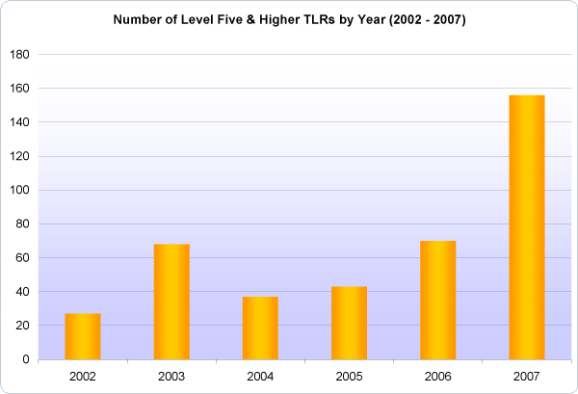
Fig. 6a: Number of Level 5 and Higher TLR’s in Eastern Interconnection [Error: Reference source not found]

Figure 6b [Error: Reference source not found] shows the number of TLR Level 5a incidents (as opposed to Level 5 and higher as in Fig. 6) in the Eastern Interconnection from 2006 to 2008, which also indicates such events are increasing in number. Comparing 2006 and 2007 data in the two plots, we observe:
- in Fig. 6a that the number of TLR5 and higher events is 70 and 155 in 2006 and 2007, respectively, and
- in Fig. 6b that the number of TLR5a events 35 and 63 in 2006 and 2007, respectively.
This suggests that the numbers from the two plots are consistent.
Fig. 6b: Number of Level 5b TLR’s in Eastern Interconnection [Error: Reference source not found]
A map which illustrates the regional reliability councils of the contiguous US is provided in Fig. 7 []. The Eastern Interconnection is everything except WECC and ERCOT.
Fig. 7: NERC Regional Reliability Councils

Reference [Error: Reference source not found] provides a view of transmission expansion, which shows that total circuit miles is expected to significantly increase in 2009 and beyond, where we observe the projected transmission plans for 5-year rolling averages are expected to increase from about 6000 circuit-miles in the 1990 to 2004 time period to about 16,000 circuit miles in the 2009-2013 time period.

- CO₂ Emissions - overview

There is increased acceptance worldwide that global warming is caused by emission of greenhouse gasses into the atmosphere. These greenhouse gases are (in order of their contribution to the greenhouse effect on Earth) []:
- Water vapor: causes 36-70% of the effect
- Carbon dioxide (CO₂): causes 9-26% of the effect
- Methane (CH₄): causes 4-9% of the effect
- Nitrous oxide (N₂O):
- Ozone (O₃): causes 3-7% of the effect
- Chlorofluorocarbons (CFCs) are compounds containing chlorine, fluorine, and carbon, (no H₂). CFCs are commonly used as refrigerants (e.g., Freon).
The DOE EIA publishes an excellent annual report on annual greenhouse gas emissions in the US, for example, the one published in November 2007 (for 2006) is [], and the one published in December 2009 (for 2008) is []. All such reports, since 1995, may be found at []. One figure from the report for 2006 is provided below as Figure 9a. The information that is of most interest to us in this table is in the center, which is summarized in Table 3a.

Note that each greenhouse gas is quantified by “million metric tons of carbon dioxide equivalents,” or MMTCO₂e. Carbon dioxide equivalents are the amount of carbon dioxide by weight emitted into the atmosphere that would produce the same estimated radiative forcing as a given weight of another radiatively active gas [Error: Reference source not found].
Fig. 9a: Summary of US Greenhouse Gas Emissions, 2006

Table 3a: Greenhouse Gas Total, 2006
Sectors | MMTCO₂e | % total CO₂ | % total GHG
From Power Sector | 2344 | 39.1 | 32.8**
*From DFU-transp | 1885 | 31.4 | 26.4**
*From DFU-other | 1661 | 27.7 | 23.3**
From ind. processes | 109 | 1.8 | 1.5**
Total CO₂ | 5999 | 100 | 84.0
Non-CO₂ GHG | 1141 |  | 16.0
Total GHG | 7140 |  | 100.
*The direct fuel use (DFU) sector includes transportation, industrial process heat, space heating, and cooking fueled by petroleum, natural gas, or coal. The DFU-transportation CO₂ emissions of 1885 MMT was obtained from the lower right-hand-side of Fig. 9a. The DFU-other CO₂ emissions of 1661 MMT was obtained as the difference between total DFU emissions of 3546 MMT (given at top-middle of Fig. 9a) and the DFU-transportation emissions of 1885 MMT.
** The “% total GHG” for the 4 sectors (power, DFU-transp, DFU-other, and ind processes) do not include the Non-CO₂ GHG emitted from these four sectors, which are lumped into the single row “Non-CO2 GHG.” If we assume that each sector emits the same percentage of Non-CO2 GHG as CO₂, then the numbers under “% total CO₂” are representative of each sector’s aggregate contribution to CO₂ emissions. The only sector we can check this for is transportation, where we know Non-CO₂ emissions are 126MMT, which is only 11% of the 1141 MMT total non-CO₂, significantly less than the % of total CO₂ for transportation, which is 31.4%.
Figure 9b [Error: Reference source not found] is the same picture as Fig. 9a except it is for the year 2008; the information is summarized in Table 3b.
Fig. 9b: Summary of US Greenhouse Gas Emissions, 2008

Table 3b: Greenhouse Gas Total, 2008
Sectors | MMTCO₂e | % total CO₂ | % total GHG
From Power Sector | 2359 | 39.8 | 33.18**
*From DFU-transp | 1819 | 30.8 | 25.5**
*From DFU-other | 1636 | 27.6 | 22.9**
From ind. processes | 104 | 1.8 | 1.5**
Total CO₂ | 5918 | 100 | 83.0
Non-CO₂ GHG | 1213 |  | 17.0
Total GHG | 7131 |  | 100.
*The direct fuel use (DFU) sector includes transportation, industrial process heat, space heating, and cooking fueled by petroleum, natural gas, or coal. The DFU-transportation CO₂ emissions of 1819 MMT was obtained from the lower right-hand-side of Fig. 9b. The DFU-other CO₂ emissions of 1636 MMT was obtained as the difference between total DFU emissions of 3555 MMT (given at top-middle of Fig. 9b) and the DFU-transportation emissions of 1819 MMT.
** The “% total GHG” for the 4 sectors (power, DFU-transp, DFU-other, and ind processes) do not include the Non-CO₂ GHG emitted from these four sectors, which are lumped into the single row “Non-CO2 GHG.” If we assume that each sector emits the same percentage of Non-CO2 GHG as CO₂, then the numbers under “% total CO₂” are representative of each sector’s aggregate contribution to CO₂ emissions. The only sector we can check this for is transportation, where we know Non-CO₂ emissions are 127MMT, which is only 10.5% of the 1213 MMT total non-CO₂, significantly less than the % of total CO₂ for transportation, which is 30.8%.
Some numbers to remember from Tables 3a and 3b are
- Total US GHG emissions are about 7100 MMT/year.
- Of these, about 83-84% are CO₂.
- Percentage of GHG emissions from power sector is about 40% (see ** note for Tables 3a and 3b).
- Percentage of GHG emissions from transportation sector is about 31% (see ** note for Tables 3a and 3b).
- Total Power Sector + Transportation Sector emissions is about 71% (see ** note for Tables 3a and 3b).

- CO₂ Emissions – power sector
Figure 10a [Error: Reference source not found] shows that electric sector CO₂ emissions from the electric power sector have been generally rising from 1990 to 2008, but the fact that they are rising more slowly than power sector sales indicates that emissions per unit of energy consumed is decreasing. Note that the emissions values given in Fig. 10a have been normalized by the value in the year 2000, which was 2293.5 MMT.
Fig. 10a: Electric power sector CO₂ emissions by year

Table 4 [Error: Reference source not found] shows the year-by-year breakdown of electric power sector CO₂ emissions by fuel. We see the dominant contributor is coal, with natural gas a distant second.
Table 4:Yearly breakdown of electric sector CO₂ emissions

Table 4 is for CO₂ emissions only – it does not include Non-CO₂ emissions.

Note that coal is the largest contributor to CO₂ emissions. For example, in year 2008, it contributed 1945.9 MMT, 82.5% of the total power sector CO₂ emissions. The next highest contributor was natural gas, at 362 MMT, which is 15.3% of the total. The two combined account for 97.8% of power sector CO₂ emissions.

CO₂ emissions from gas are only 18.6% of CO₂ emissions from coal. This does NOT imply that
- CO₂ emissions per MW from a natural gas power plant are 18.6% of the
- CO₂ emissions per MW from a coal-fired power plant!!!

The fact that coal is the largest contributor to GHG emissions is due to (a) it is used to produce over 50% of US electricity, and (b) it has the highest emissions/energy content ratio, as indicated by Table 5 below [].

Table 5: Emission Coefficients for Different Fuels
One possible misleading indication from Table 5 is that the pounds CO₂/MBTU is based on energy content of the fuel. What is of more interest is the CO₂/MWhr obtained from the fuel together with a particular generation technology. To get this, we need efficiencies of the generation technologies. Fig. 10b provides such efficiencies; the resource from which it came [] provides a good overview of various factors affecting generation efficiencies.

Fig. 10b: Generation efficiencies
Table 5 and Fig. 10b provide the ability to compare different technologies in terms of CO₂/MWhr. For example, let’s compare a natural gas combined cycle (NGCC) plant (η=.58), a gas turbine (η=.39), and a coal-fired power plant (η=.39), where the CO₂ content of the natural gas is 117.08 lbs/MBTU and the CO₂ content of the coal, assuming it uses (Powder River Basin) sub-bituminous coal is 212.7 lbs/MBTU. (Note: coal has a different energy & CO₂ content, depending on type) [].
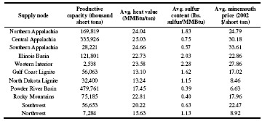

NGCC: $\text{117}\text{.}\text{08}\frac{\text{lbs}}{{\text{MBTU}}_{\text{IN}}}×\frac{1{\text{MBTU}}_{\text{IN}}}{\text{.}\text{58}{\text{MBTU}}_{\text{OUT}}}=\text{201}\text{.}9\frac{\text{lbs}}{{\text{MBTU}}_{\text{OUT}}}×\frac{3\text{.}\text{41}\text{MBTU}}{\text{MWhr}}=\text{688}\text{.}5{\text{lbs}}/{\text{MWhr}}$
Gas turbine:
$$\text{117}\text{.}\text{08}\frac{\text{lbs}}{{\text{MBTU}}_{\text{IN}}}×\frac{1{\text{MBTU}}_{\text{IN}}}{\text{.}\text{39}{\text{MBTU}}_{\text{OUT}}}=\text{300}\text{.}2\frac{\text{lbs}}{{\text{MBTU}}_{\text{OUT}}}×\frac{3\text{.}\text{41}\text{MBTU}}{\text{MWhr}}=\text{1023}\text{.}7{\text{lbs}}/{\text{MWhr}}$$
Coal-fired plant:
$$\text{212}\text{.}7\frac{\text{lbs}}{{\text{MBTU}}_{\text{IN}}}×\frac{1{\text{MBTU}}_{\text{IN}}}{\text{.}\text{39}{\text{MBTU}}_{\text{OUT}}}=\text{545}\text{.}4\frac{\text{lbs}}{{\text{MBTU}}_{\text{OUT}}}×\frac{3\text{.}\text{41}\text{MBTU}}{\text{MWhr}}=\text{1859}\text{.}8{\text{lbs}}/{\text{MWhr}}$$
The below table, from [], indicates similar numbers for a pulverized coal (PC) plant, a circulating fluidized bed (CFB) plant, an integrated gasification combined cycle (IGCC) plant, and a combined cycle plant. Note that the fuels for the first three of these are all coal, and they have similar emissions/MWhr ratios. The combined cycle plant has a bit higher ratio (810 instead of 688.5) because it assumed a lower efficiency (49.3% instead of 58%).
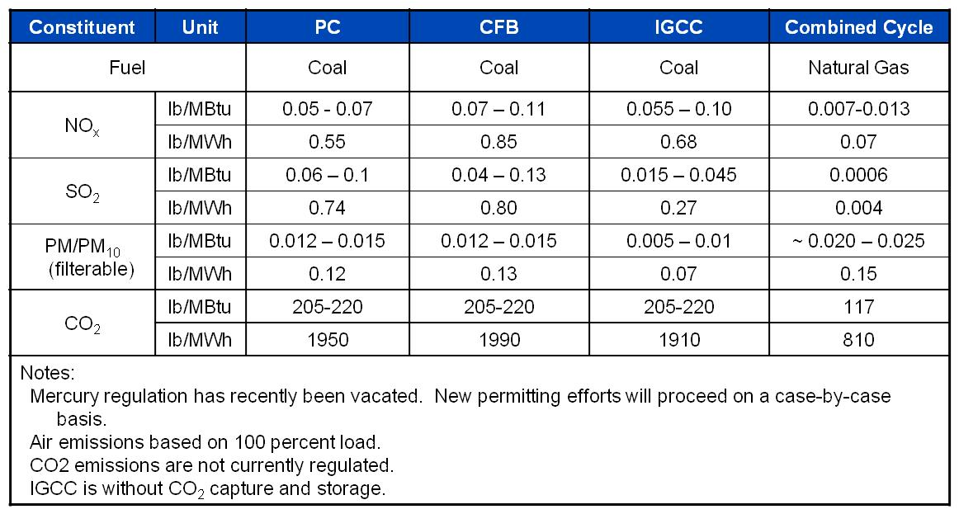

In the calculations at the top of the previous page, one can recognize that the 3.41/η factor in each equation is just the unit heat rate in MBTU/MWhr. This means the same calculation can be done by multiplying the lbs/MBTU_{IN} factor from Table 5 by the average heat rate for the plant.

Note that one needs to use an average heat rate (or 1/efficiency) since heat rate varies with plant loading. The average heat rate will depend on how the power plant is operating:
- It will be lower (more efficient) if the power plant is operated close to the rating most of the time;
- It will be higher (less efficient) if the power plant is cycling frequently.
Representative heat rate curves (average and incremental) are provided on the next page. Although additional information is provided for these curves, the point to be made is that heat rate (and efficiency) is a function of output.
Reference [] provides some actual heat rate data for units in California. The one below is one of the most efficient gas-fired units in the PG&E system. On the coast about 100 miles south of San Francisco, it is called Moss Landing Unit 7.
➔Note that the initial point for both incremental and average, at 50 MW, is very high (at 20 MBTU/MWhr). This is actually an erroneous point due to the fact that it assumes the unit has 0 MW input for 0 MW output, which cannot happen.
➔Also note that the Moss Landing unit 7 full-load average heat rate is 8.917 MBTU/MWhr, which gives an efficiency of 3.41/8.917=38.2%. This natural gas-fired plant is not a combined cycle plant and therefore has efficiency close to a coal plant.
Returning to our emissions example, we could also convert the above to Metric tons/MWhr by dividing by 2204 lbs/Metric ton, to get the following figures:
NGCC: 0.464 MT/MWhr
Gas turbine: 0.312 MT/MWhr
Coal-fired plant: 0.844 MT/MWhr.

It is interesting to compare these values with the emission coefficients given by region/state at []. A sample of some of these coefficients are provided below (this is 2002 data):
New York: 0.389
Vermont: 0.013
Penn: 0.574
Ohio: 0.817
Iowa: 0.854
N. Dakota: 1.017
Georgia: 0.619
Kentucky: 0.911
Texas: 0.664
California: 0.275
Washington: 0.111
US Average: 0.606
Vermont is so low because it has only one small fossil-fired unit (a diesel unit), and it is a peaker and so does not often run []. Almost 75% of Vermont’s electric energy comes from a large nuclear facility (Vermont Yankee) and most of the rest comes from outside the state via the ISO-NE market. Iowa was, in 2002, heavily dependent on coal. Today, with Iowa’s wind growth, it is less so, but still, coal is by far the dominant part of Iowa’s generation portfolio.

- CO₂ Emissions - transportation

Fig. 9a indicates that 2010 MMTCO₂e is attributed to the transportation sector in 2006, and Fig. 9b indicates 1946 MMTCO₂e in 2008. Figure 11 [Error: Reference source not found] shows the increase in transportation sector CO₂ emissions since 1990. Notice that the plot is normalized by the emissions value occurring in the year 1990, which was 1586.9 MMT.
Fig. 11: Transportation sector CO₂ emissions by year

Figure 11 [Error: Reference source not found] shows that transportation sector CO₂ emissions have been rising from 1990 to 2006, but the fact that they are rising more slowly than vehicle miles traveled indicates that emissions per driven mile is decreasing. This is mainly due to a general trend in using more efficient vehicles as gasoline prices have increased. Increased use of ethanol has a secondary effect.

The significant downturn in 2008 in transportation emissions is due to the above reasons (higher gasoline prices and ethanol use), and, of most influence, the slow economic growth in 2008.

Table 6 [Error: Reference source not found] shows that the year-by-year breakdown of transportation sector CO₂ emissions by fuel. It is clear that the dominant contributor is motor gasoline, with distillate fuels second and jet fuels third. (From [], “Distillate fuels are the lighter fuel oils distilled-off during refining, including heating oils, fuels, and fuel oils. The major uses of distillate fuel oils include heating, fuel for on- and off-highway diesel engines, marine diesel engines, and railroad diesel fuel.”)

Table 6: Yearly breakdown of transportation sector CO₂ emissions

There are two proposed solutions for reducing carbon emissions: carbon tax and carbon cap and trade. The carbon tax would tax owners of all carbon producing technologies by a certain $/MMTCO₂e figure. This approach is touted for its simplicity and its ability to be implemented quickly.

A carbon cap and trade program would set a national limit on total carbon emissions, and owners of carbon producing technologies would get “tickets” to emit carbon. It would be possible for ticket owners to sell or buy more tickets, thus establishing a market on carbon emissions. This approach is considered to be a “market-oriented solution,” and it is attractive because it offers some flexibility of choice to affected organizations. There is a related success story in that SO₂ and NO_{X} emitted by power plants are already addressed in this way.

A third possibility is the cap and tax, which is a combination of both approaches.

There has been no convergence on which one to choose, and likely there will not be until the next president is elected. There is a great deal of reading on the politics involved, for example [].

- Growth in new generation technologies
New generation must be continuously planned and built to keep pace with load growth and the retirement of old facilities. However, the concern over greenhouse gases has motivated an extremely strong public interest in finding ways to reduce CO₂ emissions, and electric utilities are responding to this interest in various ways. There are a number of technologies that are promising in this regard, and we will mention them in this section. Before doing so, however, it is of interest to identify what is the current state of electric generation portfolio in the US, as shown in Fig. 12a [] for 2006 and 12b [] for 2008.

Fig. 12a: 2006 Electric Energy Production by Fuel Source
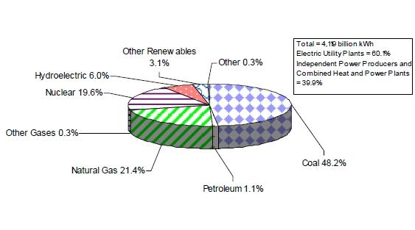
Fig. 12b: 2006 Electric Energy Production by Fuel Source

Future generation technologies which are promising in regards to carbon emissions are summarized below:
- Nuclear
- Wind
- Integrated gasification combined cycle (IGCC) with carbon capture and sequestration (CCS)
- Natural gas combined cycle (NGCC) with CCS
- Pulverized coal (PC) with carbon CCS
- Geothermal
- Photovoltaic solar
- Concentrated solar
- Electric or hybrid-electric vehicles

One of the very important issues in regards to each of these technologies is the overall cost, which depends on the investment cost and the operational cost. A recent presentation made to the FERC commissioners gave a good overview of investment costs for some of these technologies [] and is worth reading, as it provides understanding regarding the uncertainties such as fuel costs, construction costs (labor and materials), and carbon costs, associated with costing future generation technologies. The main thrust of this presentation is captured by Fig. 13 [Error: Reference source not found].

All of these costs that we are considering here are “overnight costs” or “all-in” costs, which is defined as []:
“Overnight cost is the cost of a construction project if no interest was incurred during construction, as if the project was completed ‘overnight.’ An alternate definition is: the present value cost that would have to be paid as a lump sum up front to completely pay for a construction project.”

Fig. 13: Costs of new generation (does not include cost of carbon capture & sequestration)

From Fig. 13, we may draw the following conclusions about new construction costs of different generation technologies:
- Nuclear is expensive & uncertain: ($4500/kw-$8000/kw)
- Gas-fired plants (combustion turbines and combined cycle plants) are relatively inexpensive: $700/kw-$1000/kw for CTs, $900/kw-$1500/kw for CC)
- The rest are somewhere in between, with
  - Wind on the low-end: $1400/kw-$2700/kw
  - Concentrated solar on the high-end: $3000/kw-$5000/kw
  - Geothermal in the middle: $2600/kw-$3500/kw
  - Conventional coal in the middle: $1800/kw-$4000/kw
  - IGCC is very uncertain: $2900/kw-$5500/kw
An EPRI report [] published in 2008 made projections for 2015 of investment costs associated with power generation technologies, and a summary table is provided in Table 7 below, which is fairly consistent with the above information. The exception is Nuclear, which EPRI indicates would be $3980/kW, much lower than the FERC estimate.
Table 7: Cost data from 2008 EPRI Report

The DOE EIA provides more comprehensive data, given as Table 8 below. The data for this table was published in a 2008 report, obtained from [].

A more recent DOE EIA report provides the same data but with updated estimates, given in Table 9 below. The data for this table was published in a 2010 report, obtained from [].
Table 8: Cost and performance characteristics of new generation technologies

Table 9: Cost and performance characteristics of new generation technologies

A useful document on costs of new fossil-fired generation technologies, developed using the modeling software Aspen [], and published in 2007, can be found at []. A summary table from this document is given below as Table 8.
Table 8: Cost, Performance, and Environmental Summary

A more visual representation of these data is seen in Fig. 14. Here, TS&M costs represents the transport, storage, and monitoring cost of the carbon sequestration process, and the vertical axis units, mills/kWhr, (where a mill=$0.001), is the same as $/MWhr.
Fig. 14: Levelized Cost of Electricity

Generation cost data used by the Midwest ISO in 2008 is given in Fig. 15 [].
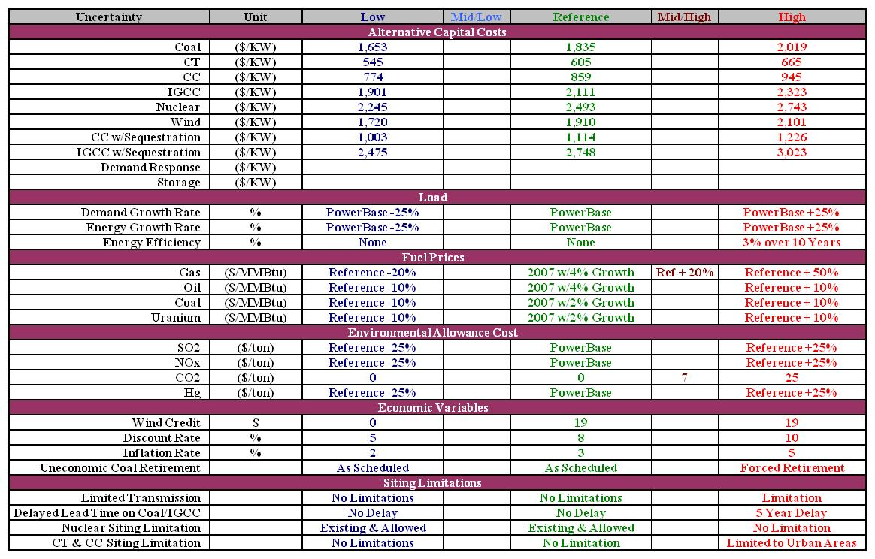
Fig. 15: The Midwest ISO “Uncertainty Matrix” from 2008
Finally, I present a fairly comprehensive compilation of generation cost data that an ME graduate student has compiled. The numbers are a little difficult to see in this table during the lecture, but I would like to draw your attention to the following column headers of this table.

In addition, observe that each attribute is given with an expected value and a “low” value and “high” value.

The “Technological readiness (yr)” is intended to be an indication of when the technology will be available.

The FOR is the “forced outage rate” and gives the percentage of time the unit could be in-service during a year that the unit is unavailable due to a “forced outage,” which is an unforeseen, unplanned outage.

This table is under copyright, 2010, by Josh Gifford. May be used for educational purposes within ISU Course EE 552 only.

References:

[?] Web page for “The regulatory assistance project,” www.raponline.org/Feature.asp?select=14#IRP%20Survey
[?] NERC Planning Standard TPL-005-0, available at http://www.nerc.com/files/TPL-005-0.pdf.
[?] Web page for FERC: http://www.ferc.gov/about/ferc-does.asp
[?] Web page for National Association for Regulatory Utility Commissioners: www.naruc.org/commissions.cfm
[?] Web page for Iowa Utility Board: www.state.ia.us/government/com/util/about_iub/jurisdiction.html
[?] Department of Energy (DOE) Energy Information Administration (EIA) website, www.eia.doe.gov/emeu/aer/elect.html.
[?] H. Stoll, “Least-cost electric utility planning,” John Wiley, 1989.
[?] DOE EIA Annual Energy Review: http://www.eia.doe.gov/emeu/aer/elect.html.
[?] Website for the NOAA National Climate Data Center, year 2004, www.ncdc.noaa.gov/oa/climate/research/2004/ann/ann04.html
[?] Website for the NOAA National Climate Data Center, year 2006, www.ncdc.noaa.gov/oa/climate/research/2006/ann/ann06.html
[?] Website for the NOAA National Climate Data Center, year 2005, www.ncdc.noaa.gov/oa/climate/research/2005/ann/ann05.html
[?] U.S. Department of Energy, Energy Information Administration website, located at http://www.eia.doe.gov/cneaf/electricity/epm/table4_1.html
[?] R. Cowart, “Resource choices in a carbon-constrained world,” Nov. 12, 2007, presentation at the NARUC Annual Meeting, available at www.narucmeetings.org/Presentations/Monday%201%20(2)%20Cowart.ppt.
[?] NERC 2009 Long-Term Reliability Assessment, October 2008, www.nerc.com/files/2009_LTRA.pdf.
[?] L. Ferreira and P. Carvalho, “Capacity credit for renewable energy resources,” Proceedings of the 1999 IEEE Power Engineering Society Winter Meeting, 1999, pp. 471 – 475.
[?] E. Hirst, “U.S. Transmission Capacity: Present Status and Future Prospects,” 2004, at www.ee.iastate.edu/~jdm/ee458/TransmissionCapacityFinal_Herst.pdf.
[?] M. Shahidehpour, “Investing in expansion: the many issues that cloud transmission planning,” IEEE Power and Energy Magazine, Jan/Feb. 2004, pp. 1-18.
[?] NERC Leading Indicators, http://www.nerc.com/page.php?cid=4|37|257|272
[?] NERC 2007 Long-Term Reliability Assessment, http://www.nerc.com/files/LTRA2007.pdf
[?] Wikipedia page on “Greenhouse gas”: http://en.wikipedia.org/wiki/Carbon_emissions
[?] US Department of Energy, Energy Information Administration, “Emissions of Greenhouse Gases in the United States 2006,” November 2007, available at http://www.eia.doe.gov/oiaf/1605/ggrpt/index.html.
[?] US Department of Energy, Energy Information Administration, “Emissions of Greenhouse Gases in the United States 2008,” December 2009, available at http://www.eia.doe.gov/oiaf/1605/ggrpt/index.html.
[?] www.eia.doe.gov/oiaf/1605/1605aold.html.
[?] DOE EIA, Data from Voluntary Reporting of Greenhouse Gasses Program, available at http://www.eia.doe.gov/oiaf/1605/coefficients.html.
[?] F. Van Aart, “Energy efficiency in power plants,” October 21, Vienna, available from Dr. McCalley (see “New Generation” folder), but you must make request.
[?] EPA report, www.epa.gov/airmarkt/progsregs/epa-ipm/docs/chapter8-v2_1-update.pdf.
[?] Black & Veatch, “Planning for Growing Electric Generation Demands,” slides from a presentation to Kansas Energy Council – Electric Subcommittee, March 12, 2008, available at http://www.google.com/search?hl=en&source=hp&q=%22Planning+for+Growing+Electric+Generation+Demands%22&btnG=Google+Search&aq=f&aqi=&aql=&oq=&gs_rfai=C5Ekv4uV7TP7ECIzmNJHV_MIEAAAAqgQFT9Dr5Lw.
[?] J. Klein, “The Use of Heat Rates in Production Cost Modeling and Market Modeling,” California Energy Commission Report, 1998.
[?] DOE EIA Website for US locations emission coefficients, http://www.eia.doe.gov/oiaf/1605/ee-factors.html.
[?] www.rutlandherald.com/apps/pbcs.dll/article?AID=/20080706/NEWS04/807060457/1024/NEWS04
[?] From the Code of Federal Regulations, Title 10, Volume 3, Chapter II, Section 436.101, available at http://a257.g.akamaitech.net/7/257/2422/14mar20010800/edocket.access.gpo.gov/cfr_2003/10CFR436.101.htm.
[?] New York Times article by T. Redburn, “The Real Climate Debate: To Cap or to Tax?,” Nov. 2, 2007, available at www.nytimes.com/2007/11/02/us/politics/04web-redburn.html?_r=1&adxnnl=1&oref=slogin&adxnnlx=1219660159-92FYUmFIXqECCSMCDhfJ7Q.
[?] DOE EIA Net Generation by Energy Source by Type of Producer, available at http://www.eia.doe.gov/cneaf/electricity/epa/epat1p1.html.
[?] http://www.eia.doe.gov/cneaf/electricity/epa/epa_sum.html
[?] FERC staff report on costs of electric generation, June 19, 2008, available at www.ferc.gov/legal/staff-reports/06-19-08-cost-electric.pdf.
[?] Wikipedia page, http://en.wikipedia.org/wiki/Overnight_cost.
[?] Electric Power Research Institute Report 1018329, “Program on Technology Innovation: Integrated Generation Technology Options,” November 2008.
[?] DOE EIA Report #:DOE/EIA-0554, June 2008 on “Generation Technologies Cost,” available from www.eia.doe.gov/fuelelectric.html, or www.eia.doe.gov/oiaf/aeo/assumption/pdf/electricity.pdf#page=3.
[?] DOE EIA Report #:DOE/EIA-0554, April 2010 on “Generation Technologies Cost,” available from http://www.eia.doe.gov/oiaf/aeo/assumption/pdf/electricity.pdf#page=3.
[?] Home page for Aspen Technologies, http://www.aspentech.com/.
[?] “Cost and Performance Baseline for Fossil Energy Plants,” Volume 1: Bituminous Coal and Natural Gas to Electricity Final Report, DOE/NETL-2007/1281, August 2007, available at www.netl.doe.gov/energy-analyses/pubs/Bituminous%20Baseline_Final%20Report.pdf.
[?] J. Lawhorn, “Discussion of Economic Planning Process: Transmission Development Application,” presentation to EE 590, Iowa State University, September 2008.

