Grid Operation and Coordination with Wind - 6
- Introduction
There are two more topics that I would like to present to you in my description of MW-frequency grid-coordination issues related to wind energy. These issues are
- Wind power forecasting and
- Capacity credit
It is possible to write books on both of these issues, and so clearly we cannot do more than expose the major issues in the single class that remains to us.
- Wind power forecasting
There are a growing number of efforts around the globe to enhance the ability to predict the output of wind turbines. Figure 1 [] represents one such effort, and may be representative of the general components necessary.
Fig. 1 [Error: Reference source not found]
Figure 2 [] represents another such effort.
Fig. 2 [Error: Reference source not found]
Both of these approaches utilize four basic components:
- Physical models
- Statistical models
- Plant output models
- Forecast delivery system
2.1 Physical models
Physical weather models may be divided into three classes []:
- Numerical weather models, 1000 km down to 10 km
- Meso-scale models: 10 km down to 1 km. Meso means “middle.”
- Micro-scale models: several 100 m down to ground
The meso-scale models [] “start with meteorological observations and measurements all over the globe, carried out by meteorologists, weather stations, satellites, etc. All available data are used as input to compute a global NWP model, which models the atmosphere of the planet. The NWP model calculates the future state of the atmosphere from the physical laws.”
These laws are captured as second-order time-dependent non-linear differential equations that are solved as an initial-value/boundary-value problem on a 3-D grid over the domain of interest []. These equations include the Navier-Stokes equations (conservation of momentum), together with four others, as indicated in Fig. 3 [Error: Reference source not found] below.
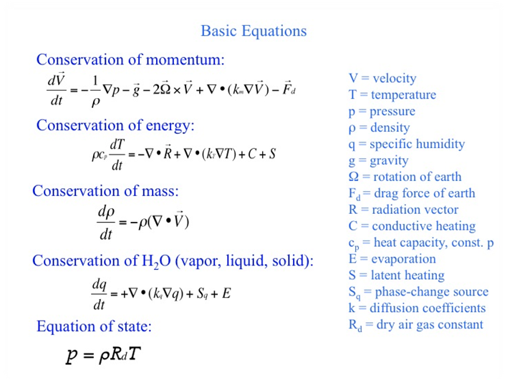
Fig. 3
Some various meso-scale weather models include MM5, GESIMA, KLIMM, RAMS, Fitnah, and the Eta Model. References for each of these models are provided in [Error: Reference source not found], pg. 19. Some other Meso-scale weather models include WRF, FOREWIND, COAMPS and OMEGA [Error: Reference source not found]. The MM5 model is perhaps one of the most widely-used meso-scale models. It is a public-domain model and has been widely verified. The WRF model is considered to be a next-generation model that offers improved numerical techniques and data assimilation options, but it has not yet undergone the depth of testing and use for which MM5 is known. Here, we provide some information about MM5 adapted from [].
Overview
Nesting is where a high-resolution model is used only in areas of special interest to cover atmospheric effects on a smaller scale that cannot be resolved by a coarser model. Most meso-scale models used3-4 nesting operations.
MM5 is a limited-area, nonhydrostatic, terrain-following sigma-coordinate model designed to simulate or predict mesoscale atmospheric circulation. The model is supported by several pre- and post-processing programs, which are referred to collectively as the MM5 modeling system. The MM5 modeling system software is mostly written in Fortran. Its features include (i) a multiple-nest capability, (ii) nonhydrostatic dynamics, which allows the model to be used at a few-kilometer scale, (iii) multitasking capability on shared- and distributed-memory machines, (iv) a four-dimensional data-assimilation capability, and (v) several physics options.
Since MM5 is a regional model, it requires an initial condition as well as lateral boundary condition to run. To produce lateral boundary condition for a model run, gridded data to cover the entire time period that the model is integrated are required. Meteorology and topography data are needed.
Resolution
The horizontal resolution is reported to be 1 km - 90 km.
The vertical resolution is reported to be ~20 m below 100 m, ~100 - 500 m above 100 m

Boundary conditions
Derived from Global forecasting models MRF and AVN from http://dss.ucar.edu/datasets.
MRF: 6-hourly, 1.5x1.5 degree resolution (~150 km)
AVN: 6-hourly, 1x1 degree resolution (~100 km)
The AVN and MRF models are similar apart from the fact that a later input data cutoff time is used for the AVN data. The PBL scheme is the same as the corresponding MM5 MRF PBL scheme, based on the Troen and Mahrt parameterisations. AVN also tends to perform better in certain weather situations, such as for a strong low pressure area, also better coverage due to higher resolution. For higher resolution domains the maps produced using MRF data contained missing information for wind speeds and temperature.
Meteorology (initial conditions)
Gridded atmospheric data that have at least these variables: sea-level pressure, wind, temperature, relative humidity and geopotential height; and at these pressure levels: surface, 1000, 850, 700, 500, 400, 300, 250, 200, 150, 100 mb; Observation data that contains soundings and surface reports (optional).
Topography
Terrain elevation, and vegetation (land-water mask,land use/vegetation categories) are required. Also, if the land-surface model (LSM) will be used in the MM5 model, additional fields such as soil types, vegetation fraction, and annual deep soil temperature will also be generated. The model has the option of three sets of land-use categorizations that are assigned along with elevation in the TERRAIN program from archived data. These have 13, 16, or 24 categories (type of vegetation, desert, urban, water, ice, etc.). Each grid cell of the model is assigned one of the categories, and this determines surface properties such as albedo, roughness length, longwave emissivity, heat capacity and moisture availability. Additionally, if a snow cover dataset is available, the surface properties may be modified accordingly. The values in the table are also variable according to summer or winter season (for the northern hemisphere). However, these values are climatological and may not be optimal for a particular case, especially moisture availability. USGS is the main source of topography data.
Output information
3D forecast fields include:U-wind (m/s)V-wind (m/s)Temperature (K)Water vapor mixing ratio (kg/kg)Turbulent k.e. (J/kg) Vertical velocity (m/s)
2D forecast fields include:Ground temperature (K)PBL height (m)Surface sensible heat flux (W/m2)Surface latent heat flux (W/m2)Frictional velocity (m/s)2 m temperature (K)10 m u component of wind (m/sec)10 m v component of wind (m/sec)Monin-Obukov length (m)
Figure 4 [Error: Reference source not found] provides a visual indication of what physical weather models provide.
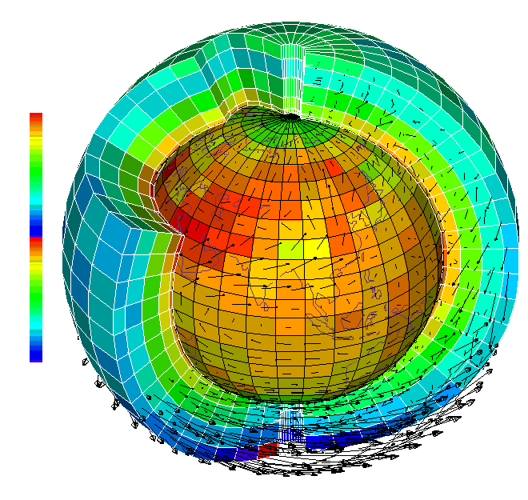
Fig. 4 [Error: Reference source not found]

It is stated in [] that
“…do not provide perfect predictions due to the fact that the atmosphere is a highly non-linear chaotic system [15]. It was shown in several investigations, e.g., that the accuracy of the NWP input has a major impact on the accuracy of the power prediction. The reason for this is quite clear: if, for example, the NWP predicts a storm front with a time delay of 2 hrs, the wind power prediction system cannot compensate for this type of error.”
Two approaches to address this inaccuracy include [Error: Reference source not found]
• Ensemble predictions: Here, one numerical model calculates a number of different predictions by using slightly different initial conditions.
• Combination of NWP models: Here, the output of several different NWP models with different physical and numerical implementations is used.
Ensemble predictions seem to be heavily used by wind power forecasting experts and result in a series of forecasts, as illustrated in Fig. 5 [Error: Reference source not found], from which a probability distribution may be extracted.
Fig. 5 [Error: Reference source not found]
Reference [Error: Reference source not found] provides data showing improved wind farm prediction when using combinations of weather models, as shown in Fig. 6 [Error: Reference source not found].
Fig. 6 [Error: Reference source not found]
To provide more accurate weather forecasts, local area models (LAMs) are used, which cover only a small part of the Earth, but can be run with a much higher resolution (see Figure 3, right). These models use as input the forecasts of the global model and calculate a weather forecast taking into account the local characteristics of the terrain.
So-called micro-scale models include AIOLOS, WIEN, NOABL, MesoMap, Winds, and Phoenics [Error: Reference source not found]. Figure 7 [Error: Reference source not found] illustrates the level at which these models operate.
Fig. 7 [Error: Reference source not found]
2.2 Statistical and learning models
There has been significant effort in developing stand-along statistical or learning approaches for predicting wind power output. Some of these are described in [Error: Reference source not found].
It is recognized today that statistical and learning methods should play a role in wind power prediction, but that role should be to tune the output of the physical model. From [Error: Reference source not found],
“Adaptive statistical models use a set of empirical relationships between the output of the physics-based atmospheric models and specific parameters to be forecasted for a particular location. In this application, the specific parameters are the wind speed and direction and air density at the location of the wind plants. The role of the statistical model is to adjust the output of the physics-based model to account for sub-grid scale and other processes that cannot be resolved or otherwise adequately simulated by the physical models.”
The idea is that historical data for each wind turbine, is collected on a continuous basis. This data would consist of minimally the date, time, wind speed, and the wind power outputs. In addition, the entire output of the wind farm should be stored. Air temperature and pressure, to obtain density, is also useful. Then time series, Bayesian, and/or neural network models can be created to provide predictive capability of wind farm output.
2.3 Plant output models
One very good application of statistical and learning models is in characterizing the power output model of a wind farm. The so-called power curve is provided by the manufacturer at purchase, but the characteristic is for one turbine, it may differ due to local effects, it may change over time, and it rarely represents the entire farm. Figure 8[Error: Reference source not found] illustrates a plot of historical data for a wind farm in Spain.
Fig. 8 [Error: Reference source not found]
Reference [Error: Reference source not found] describes 5 different methods for characterizing the wind farm power curve. These are
Model 1: Global power curve referred to meteorological mast. This model relates directly the global wind farm power to the normalized wind speed measured at the met mast. A “meteorological mast” or “met mast” or “met tower” are towers with measuring equipment, typically at the height of the wind farm Nacelles (80-100 m for a new wind farm today). Figure 9 [] illustrates.
Fig. 9 [Error: Reference source not found]
Model 2: Global power curve referred to nacelle anemometers. This model uses wind speed measured at the nacelle anemometers assuming this is a more representative measurement around the area
Model 3: Cluster analysis to determine subsets of wind turbines. Cluster power curves referred was used to group turbines to different power curves.
Model 4: Turbine power curves referred to nacelle anemometers. An extreme case derived from model 3 consists of obtaining different power curves for every turbine instead of making groups.
Model 5: Fuzzy logic power curves referred to nacelle anemometers. Here, fuzzy logic statistical tools were used to define input variables (normalised wind speed, wind direction and optionally other variables like air pressure and air temperature) and an output variable (wind farm power) by means of membership functions and transfer functions relating them. This was done at the wind-farm level and at the wind-turbine level.
The 5 different models were compared in terms of root-mean-square error, as shown in Fig. 10 [Error: Reference source not found] below.
Fig. 10 [Error: Reference source not found]
2.4 Forecast delivery system
I have not had time to investigate this issue, but I am aware through informal discussions with a number of companies that there is an increasingly higher level of sophistication in the communication systems being deployed to bring the data into the control room. The wind-farm data is often mixed with the physical model results off-site, and then just the forecast is provided to the control center. The company WindLogics has adopted this approach. Some utilities are taking a do-it-yourself approach in which case they telemeter the wind farm data directly to their control center after which they operate on it using their forecasting tools.
- Wind forecast error
Some indications of typical wind forecast error are given below.
From [Error: Reference source not found], Fig. 11 shows wind forecast error distribution from a German system.
Fig. 11 [Error: Reference source not found]
Figure 12 [] shows data characterizing wind forecast error in Denmark as a function of forecast horizon.
Fig. 12 [Error: Reference source not found]
- Capacity credit
This is a topic that I would like to spend at least three classes discussing. It is extremely important in the whole debate about what technologies we should be investing in for the future, in order to address the emissions, costs, and reliability issues. The reason is that the cost of wind is mainly due to the investment cost, which is on a basis of MW capacity, e.g., $1100/kW (equivalent to $1.1 million/MW). But we know that 1 MW of wind capacity is not capable of producing 1 MWx8760 hrs=8760MW-hrs per year. If it did, we would say that it has a capacity factor of 100%. In fact, it typically has only a capacity factor of about 30%, implying a 1 MW turbine can only be expected to produce 8760MW-hrs*0.3=2628MW-hrs.
The capacity factor provides one indication in regards to the inability of the wind to deliver its capacity all the time. There is another issue. When will the wind be unable to deliver its capacity? And what capacity will it be able to deliver?
This part of the issue is also in conventional generation, in that conventional generation may be out of service. And so we know how to handle it. There are essentially two methods, one is called probabilistic and the other is called chronological. These methods are covered for conventional generation in another course I teach – see http://www.ee.iastate.edu/~jdm/ee653/ee653schedule.htm.
However, there is a difference in order of magnitude for wind. Whereas outage percentage (called the forced outage rate) for conventional generation is on the order of 2%, the outage percentage for wind would be on the order of 70%.
In planning investment decisions for generation, it is vitally important to identify the amount of “credit” to give to wind in regards to how much capacity we will be able to count on.
Some good references on this topic include [, , ], but there are others.

[?] Electric Power Research Institute (EPRI), Final Report, January 2003, California Wind Energy Forecasting System Development and Testing Phase 1: Initial Testing
[?] Daniel Cabezon, Ignacio Marti, Mª Jesus San Isidro, Imanol Perez, “Comparison Of Methods For Power Curve Modeling,” Proc. of GLOBAL WINDPOWER, March 2004.
[?] M. Lange and U. Focken, “Physical approach to Short-term wind power prediction,” Springer, 2005.
[?] Bernhard Ernst, Brett Oakleaf, Mark L. Ahlstrom, Matthias Lange, Corinna Moehrlen, Bernhard Lange, Ulrich Focken, and Kurt Rohrig, “Predicting the Wind,” IEEE power & energy magazine, November/December 2007.
[?] E. Takle, “Contributions of climate science to the electric power industry: forecasting with lead times of hours to decades,” presentation slides, Power Systems Engineering Research Center, March 3, 2009.
[?] European Topic Centre on Air and Climate Change, Description of MM5, available at http://pandora.meng.auth.gr/mds/showlong.php?id=148&MTG_Session=7cceb5af296d222e62221397202a43c7.
[?] Matthias Lange, Ulrich Focken, “New Developments in Wind Energy Forecasting,” 2008.
[?] New York State Energy Research and Development Authority, “METEOROLOGICALMasts and Towers,” 2005, available at www.powernaturally.org.
[?] Hannele Holttinen, “Handling of wind power forecast errors in the Nordic power market,” 9th International Conference on Probabilistic Methods Applied to Power Systems KTH, Stockholm, Sweden - June 11-15, 2006.
[?] C. Ensslin, M. Milligan, H. Holttinen, M. O’Malley, A. Keane, “Current methods to calculate capacity credit of wind power, IEA collaboration,”
[?] L. Soder and M. Amelin, “A review of different methodologies used for calculation of wind power capacity credit,” Proc. of the 2008 IEEE PES General Meeting, July 2008.
[?] M. Milligan, “Wind Capacity Credit in the United States,” 2008.

