Grid Operation and Coordination with Wind - 3
- Introduction
We have, in previous notes, addressed the two topics of transient frequency control and regulation. In these notes we desire to address the topics of load following and dispatch/scheduling.
We begin by reminding you that we stated previously []:
“The key distinction between load following and regulation is the time period over which these fluctuations occur. Regulation responds to rapid load fluctuations (on the order of one minute) and load following responds to slower changes (on the order of five to thirty minutes).”
We also identified mechanisms by which the four different MW-Hz issues are addressed are:
- Transient response: Inertia and governor
- Regulation: Governor and AGC
- Load following: AGC and economic dispatch
- Scheduling: Economic dispatch and unit commitment

To focus our discussion, we desire to clearly distinguish the regulation and load following. Here are definitions, from BPA [], NERC [], Kafka [], Cal []:
Regulation:
- BPA: Correcting minute-by-minute deviations between load and generation.
- NERC: The ability of a Balancing Authority to help the Interconnection maintain Scheduled Frequency. This assistance can include both turbine governor response and AGC.
- Kafka: the provision of generation and load response capability that responds to automatic control signals issued by the control area operator.
- Cal: Regulation is the use of online generating units that are equipped with AGC and that can change output quickly (MW/minute) to track moment-to-moment fluctuations in customer loads and to correct for unintended fluctuations in generation.
Load-following:
- BPA: Correcting difference between load and generation over increments of 10 minutes between hourly scheduling adjustments.
- Kafka: The provision of generation and load response capability, including capacity, energy, and maneuverability, that is dispatched within a scheduling period by the control area operator. In traditional utility operations, it is the normal rate of response constrained economic dispatch of units while meeting NERC control performance standards. It is similar to the Regulation service, but does not need to be as fast responding and can be anticipated to move in one direction over sustained periods of time. It must be recognized that a responsive unit willing to respond to sustained load changes is supplying a different service than a base-load unit. It must report to the system operator it load following capabilities and follow the dispatch instructions of the system operator subject to the agreed upon capabilities of the resource.
- Cal: Load following is the use of online generation equipment to track intra-/inter-hour changes in customer loads. Load following & regulation differ in 3 ways.
  - It occurs over longer time intervals than does regulation, 10 minutes or more rather than minute-to-minute.
  - Load-following patterns of individual customers can be highly correlated with each other, whereas the regulation patterns are largely uncorrelated.
  - Load-following changes are often predictable (e.g., because of the weather dependence of many loads) and have similar day-to-day patterns.

BPA [Error: Reference source not found] provides a nice picture to distinguish between regulation and load following, given in Fig. 1 below.
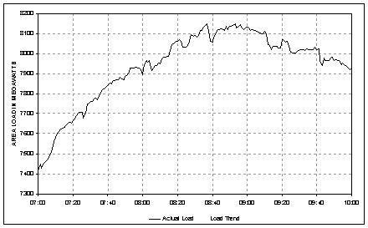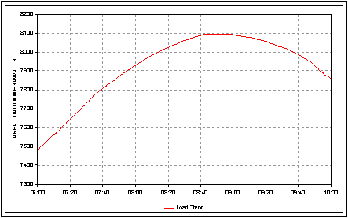
=
+
Load Following
Regulation
Fig. 1

BPA [] also provides some strong motivation for being concerned about how wind will affect regulation/load following, via Fig. 2, which shows how both load following requirements and regulation requirements will increase as wind grows in their area. In that same reference, BPA states,
“By 2010, wind capacity is expected to equal 30 percent of peak load and 50 percent of average load in BPA’s balancing authority.” … “Large changes in wind output are appearing about two hours before they’re scheduled. Wind over-generated 730 MW in a single hour in 2008 and under-generated by 625 MW in one hour. This generation imbalance requires BPA to make equally large shifts in hydro generation in real time. Twice in 2008, BPA operated outside WECC reliability standards due to wind generation imbalance.”
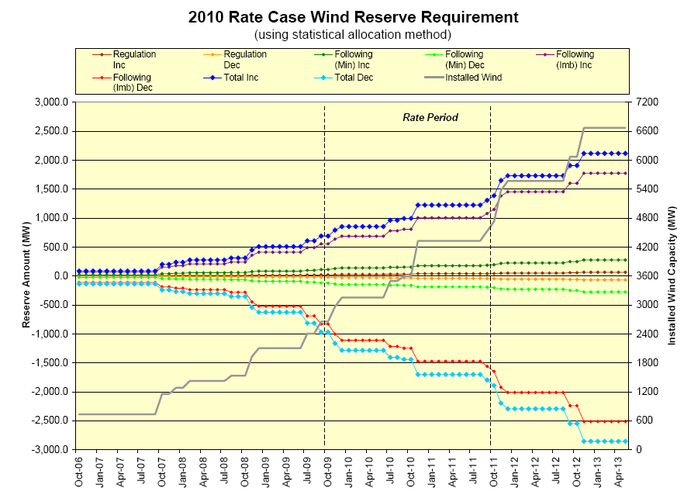
Fig. 2
BPA continues,
… “With the expected growth of wind in the BPA balancing area, there may not always be enough water or flexibility in the FCRPS to provide enough integration services while also meeting power loads and non-power obligations. Under 2008 wind generation forecasting and schedule practices and accuracy, we think we are only able to provide integration services for approximately 3,000 – 3,500 MW of installed wind generation.”
(Notice from Fig. 2 that they are expecting 6600 MW installed wind generation by 2013).

- Provision vs. allocation
We have seen that wind turbines are capable of providing inertial response to support transient frequency performance of the power system. We have also seen that wind turbines are capable of providing regulation.

The question arises of the extent to which wind turbines are capable of providing load following. If we think of an active load following provision where the turbines are blade pitching, it is unclear how one would avoid large amounts of wind spillage since the wind turbine would need to control output over a wide range for sustained amounts of time.

Let’s move away from thinking of load following as an active control problem. In contrast, let’s ask the question: To what extent does a given wind farm increase or decrease the need for load following? Answering this question is useful because it provides a basis on which to allocate the service of load following, which is a service that costs money.

Although wind turbines can provide regulation, in most cases today, they do not. Therefore it is of value to consider regulation in the same sense as load following. That is, to what extent does a given wind farm increase or decrease the need for regulation? Answering this question is useful because it provides a basis on which to allocate the service of regulation, which is a service that costs money.

We will look at approaches for allocating load following and regulation.

- ORNL Method – allocation of regulation
The basic concept of this method stems from the following:
- If a wind farm’s natural diurnal cycle is positively-correlated with the 24 hour load cycle, then the wind will ramp with the load, and therefore there will be less need for load following.
- If a wind farm’s natural diurnal cycle is negatively-correlated with the 24 hour load cycle, then the wind will ramp against the load, and therefore there will be more need for load following.

There are three statistics that are necessary in this method: moving average, variance, and correlation coefficient.

3.1 Moving average to get regulation component

The problem at hand requires separate of the regulation component from the load following component. To do this, define L_{k}, LF_{k}, and LR_{k} as the load, load following component, and regulation component respectively, at time k∆t.
We assume that the load, L_{k}, is given for k=1,…,N.

The load-following component is given by a moving average of length 2T time intervals, i.e.,
${\text{LF}}_{k}=\frac{1}{2T+1}\sum_{i=k−T}^{k+T}{L_{i}}=\frac{L_{k−T}+L_{k−T+1}+\text{.}\text{.}\text{.}+L_{k}+\text{.}\text{.}\text{.}+L_{k+T−1}+L_{k+T}}{2T+1}$ (1)
For example, in [], the authors obtained load data taken at ∆t=2 minute intervals, and then choose to compute LF_{k} based on a 28 minute rolling average, and so T was chosen as 7, resulting in
${\text{LF}}_{k}=\frac{L_{k−7}+L_{k−6}+\text{.}\text{.}\text{.}+L_{k}+\text{.}\text{.}\text{.}+L_{k+6}+L_{k+7}}{\text{15}}$ (2)
When k=20 (the 20th time point), then
${\text{LF}}_{\text{20}}=\frac{L_{\text{13}}+L_{\text{14}}+\text{.}\text{.}\text{.}+L_{\text{20}}+\text{.}\text{.}\text{.}+L_{\text{26}}+L_{\text{27}}}{\text{15}}$ (3)
and given that each time point corresponded to a ∆t=2 minute interval, in terms of minutes, we would have
${\text{LF}}_{t}={\text{LF}}_{\text{40}}=\frac{L_{\text{26}}+L_{\text{28}}+\text{.}\text{.}\text{.}+L_{\text{40}}+\text{.}\text{.}\text{.}+L_{\text{52}}+L_{\text{54}}}{\text{15}}$ (4)
Figure 3 [] illustrates a result of this computation, where it is clear that the moving average tends to smooth the function.
Fig. 3 [Error: Reference source not found]
Once the load following component is obtained, then the regulation component can be computed from
${\text{LR}}_{k}=L_{k}−{\text{LF}}_{k}$ (5)
Because the regulation component varies about the mean, its distribution tends to be normal, as confirmed by Fig. 4 [Error: Reference source not found] which was obtained from application of (5) to the data of Fig. 3.

Fig. 4

3.2 Variance as a measure of regulation burden

Consider X to represent a random variable. Where the expected value, or first moment, of a random variable provides the “centroid” or “balance point”, there is another widely used value that is also derived from the definition of moments.
The second moment, or variance, of a random variable is indicative of the “spread” or “dispersion” of a random variable. In other words, the variance tells how concentrated about the expected value the distribution is. A lower (closer to zero) variance means the distribution is concentrated tightly around the expected value. A higher (further form zero) variance means the distribution is concentrated loosely around the expected value.

Variance is denoted by the symbol σ_{x}². Variance, the average of the square of the deviation of X from its own mean, is given by
$σ_{x}^{2}=\sum_{i=1}^{n}{p_{i}(x_{i}−μ_{x})^{2}}$ (6)
where p_{i}, from the probability mass function of X, is the probability of occurrence of x_{i}. If each x_{i} is equally probable,
$σ_{x}^{2}=\frac{1}{n}\sum_{i=1}^{n}{(x_{i}−μ_{x})^{2}}$ (7)
The positive square root, σ_{x}, of the variance is called the standard deviation of a random variable and is a useful measure. If a distribution is approximately normal, then approximately 68% of the values are within 1 standard deviation of the mean, approximately 95% of the values are within two standard deviations, and approximately 99.7% of the values are within 3 standard deviations, as illustrated in Fig. 5.
Fig. 5
In designing engineering systems, it is often reasonable to assume that if the design accounts for all situations within 3σ of the mean, then the design is acceptably robust, since in such a case, the design will account for 99.7% of all possible situations.

We use 3σ to quantify regulation needs of a particular load or resource. That is, we assume that the generation reserve available to provide regulation for a particular variable resource or load is 3σ, where σ² is the variance of the variable resource or load.

We shall refer to 3σ as the regulation burden of the resource or load.

3.3 Correlation coefficient

Recall the correlation coefficient is given by
$r_{\text{xy}}=\frac{\sum_{i=1}^{N}{\left(x_{i}−μ_{x}\right)\left(y_{i}−μ_{y}\right)}}{N\sqrt{\sum_{i=1}^{N}{{\left(x_{i}−μ_{x}\right)}^{2}}}\sqrt{\sum_{i=1}^{N}{{\left(y_{i}−μ_{y}\right)}^{2}}}}=\frac{\sum_{i=1}^{N}{\left(x_{i}−μ_{x}\right)\left(y_{i}−μ_{y}\right)}}{{Nσ}_{x}σ_{y}}$ (8)
where N is the number of points in the time series, and μ_{x}, μ_{y} and σ_{x}, σ_{y} are the means and standard deviations, respectively, of the two time series.
The correlation coefficient measures strength and direction of a linear relationship between two random variables. It indicates how well two time series, x and y in this case, follow each other. It will be near 1.0 if the two time series follow each other very well, it will be 0 if they do not follow each other at all, and it will be near -1 if increases in one occur with decreases in another.
The relation between correlation and independence should be understood.
- If two variables are independent, then they are uncorrelated and r_{xy}=0.
- If r_{xy}=0, then the two variables are uncorrelated but not necessarily independent, because r_{xy} detects only linear dependence between variables.
- A special case exists if x and y are both normally distributed, then r_{xy}=0 implies independence. This will be the case for our regulation data since it is comprised of variations.
- If r_{xy}=1 or if r_{xy}=-1, then x and y are dependent.
- For values of r_{xy} such that 0<|r_{xy}|<1, the correlation coefficient reflects the degree of dependence between the two variables, or conversely, the departure of the two random variables from independence.

3.4 Using σ² and r_{xy} to measure regulation coincidence
In sections 3.1-3.3, we have developed three useful ideas:
- The regulation component of load is normal.
- σ² (or 3σ) can be used to measure regulation burden.
- For normally distributed random variables, r_{xy} can be used to measure independence.
We recall that if two random variables are independent, then the variance of their sum (or their difference) is
$σ_{z}^{2}=σ_{x}^{2}+σ_{y}^{2}$ (9)
This relationship can be represented using vectors according to Figure 6.
σ_{x}
σ_{y}
σ_{z}
Fig. 6
Let us now consider the situation where the two time series are perfectly correlated, i.e., r_{xy}=1. This would be the case if x and y are following each other perfectly. In this case, the two standard deviations should directly add, as illustrated in Fig. 7.
σ_{x}
σ_{y}
σ_{z}
Fig. 7
Finally, we now consider the situation where the two time series are perfectly anti-correlated, i.e., r_{xy}=-1. This would be the case if x and y are in perfect anti-phase such that when x increases, y decreases, and vice-versa. In this case, the two standard deviations should directly subtract, as illustrated in Fig. 8.
σ_{y}
σ_{x}
σ_{z}
Fig. 8

We can characterize the general case (where 0<|r_{xy}|<1) by defining an angle θ according to
$θ=\frac{π}{2}(1−r_{\text{xy}})$ (10)
We observe from (10) that when r_{xy} ranges from -1 to 0 to 1, θ ranges from π to π/2 to 0, corresponding to the three cases illustrated above, as summarized in Table 1.

Table 1
Correlation | r_{xy} | θ | Figure
Perfect | 1 | 0 | 7
Uncorrelated | 0 | π/2 | 6
Anti-correlated | -1 | π | 8

Figure 9 illustrates the situation for an angle θ, in this case corresponding to a value r_{xy} such that 0<r_{xy}<1.
σ_{x}
σ_{y}
σ_{z}
θ
Fig. 9
The problem that we want to solve is this. Given the load has a standard deviation of σ_{L} and the wind generation has a standard deviation of σ_{w}, and the composite of the two has a standard deviation of σ_{T}, then what component of σ_{T} can we attribute to the wind generation? To solve this problem, we redraw Fig. 9, where the only change we have made is to re-label according to the nomenclature of this newly-stated problem.
σ_{L}
σ_{w}
σ_{T}
θ
Fig. 10
The contribution of σ_{w} to σ_{T} will be the projection of the σ_{w} vector onto the σ_{T} vector, i.e., it will be the component of σ_{w} in the σ_{T} direction. In Fig. 11, we have denoted this component as X, and we have also enhanced the figure to facilitate analytic development.
σ_{L}
σ_{w}
σ_{T}
θ
X
Y
σ_{T} - X
Fig. 11
From Fig. 11, the smaller right-triangle to the right provides:
$σ_{w}^{2}=Y^{2}+X^{2}$ (11)
The larger right-triangle to the left provides:
$σ_{L}^{2}=Y^{2}+(σ_{T}−X)^{2}$ (12)
Subtracting (12) from (11) results in
$σ_{w}^{2}−σ_{L}^{2}=X^{2}−(σ_{T}−X)^{2}$ (13)
Expanding the right-hand-side of (13) results in
$σ_{w}^{2}−σ_{L}^{2}=X^{2}−(σ_{T}^{2}−2σ_{T}X+X^{2})$ (14)
which simplifies to
$σ_{w}^{2}−σ_{L}^{2}=−σ_{T}^{2}+2σ_{T}X$ (15)
Solving for X results in
$X=\frac{σ_{w}^{2}−σ_{L}^{2}+σ_{T}^{2}}{2σ_{T}}$ (16)

In [Error: Reference source not found], the above is called the “regulation share” of the “generator of interest.” It was applied there to different kinds of resources, including wind and solar. It can also be applied to different kinds of loads.

Homework:
Chapter 4 of reference [Error: Reference source not found] applies the above described method, but it indicates
“An alternative regulation analysis methodology (Method 2) was developed by Yuri Makarov at the CaISO during the course of the Phase I study. A preliminary discussion of Method 2 is presented in Section 4.4. The Method 2 Phase I results will be compared with the Method 1 results in the future.”
Table 4.10 of this same chapter provides a preliminary comparison of the two methods.
Method 2 was clearly just under development during the time that the study of [Error: Reference source not found] was completed. Since that time, Dr. Makarov has published a number of papers, including [, , , ]. Your assignment is to identify and describe the significant differences between the two methods.

The correlation ratio may be used to detect nonlinear dependence, but here, the correlation coefficient is satisfactory because the data is assumed to be normally distributed.
[?] E. Hirst and B. Kirby, “Separating and measuring the regulation and load-following ancillary services,” Utilities Policy 8, 1999, pp. 75–81.
[?] Steve Enyeart, “Large Wind Integration Challenges for Operations / System Reliability,” presentation by Bonneville Power Administration, Feb 12, 2008, available at http://cialab.ee.washington.edu/nwess/2008/presentations/stephen.ppt.
[?] North American Electric Reliability Corporation (NERC), “Glossary of Terms Used in Reliability Standards,” Feb., 2008, available at http://www.nerc.com/files/Glossary_12Feb08.pdf.
[?] R. Kafka, “Ancillary Services and Reliability,” available at http://ieeexplore.ieee.org/stamp/stamp.jsp?arnumber=00917066.
[?] B. Kirby, M. Milligan, Y. Makarov, D. Hawkins, K. Jackson, H. Shiu “California Renewables Portfolio Standard Renewable Generation Integration Cost Analysis, Phase I: One Year Analysis Of Existing Resources, Results And Recommendations, Final Report,” Dec. 10, 2003, available at http://www.consultkirby.com/files/RPS_Int_Cost_PhaseI_Final.pdf.
[?] “BPA Presentation, “Large Wind Integration Balancing Act: BPA Grid Responds to Wind Power Boom,” Nov. 2008, available at http://www.bpa.gov/corporate/About_BPA/wind/docs/presentation-BalancingActforWind.ppt.
[?] B. Kirby and E. Hirst, “Customer-Specific Metrics for The Regulation and Load-Following Ancillary Services,” Report ORNL/CON-474, Oak Ridge National Laboratories, Energy Division, January 2000.
[?] R. Hudson, B. Kirby, and Y. Wan, “Regulation Requirements for Wind Generation Facilities,” available at http://www.consultkirby.com/files/AWEA_Wind_Regulation.pdf.
[?]Yuri V. Makarov1, Shuai Lu1, Bart McManus 2, John Pease, “The Future Impact of Wind on BPA Power System Load Following and Regulation Requirements,” 2008.
[?]Yuri V. Makarov, Senior Member, IEEE, Clyde Loutan, Senior Member, IEEE, Jian Ma, Student Member, IEEE, Phillip de Mello, Student Member, IEEE, Shuai Lu, Member, IEEE, “Impacts of Wind Generation on Regulation and Load Following Requirements in the California System,” 2008.
[?]Yuri V. Makarov1, Clyde Loutan 2, Jian Ma1,3, Phillip de Mello2,4, Shuai Lu1, “Impacts of Integration of Wind Generation on Regulation and Load Following Requirements of California Power Systems, 2008.
[?]Yuri V. Makarov, Senior Member, IEEE, Clyde Loutan, Senior Member, IEEE, Jian Ma, Member, IEEE, and Phillip de Mello, Student Member, IEEE, “Operational Impacts of Wind Generation on California Power Systems,” to appear in IEEE Transactions on Power Systems.

