Grid Operation and Coordination with Wind
- Introduction
Wind turbines have different operational characteristics relative to the traditional forms of generating electric energy. This is due to the fact that the primary energy source, wind, is not controllable. This fact alone results in wind plants being viewed as non-dispatchable, implying it is not possible to a-priori specify what the power output of a wind plant should be.
This decrease in plant controllability is a key motivator behind use of technologies other than standard synchronous machines, since torque and rotational speed cannot be simultaneously maintained constant. In addition, it creates issues regarding system power control that must be addressed for high levels of wind penetration. We will focus on these MW-control issues in this document.
However, you should be aware that there are other interconnection and control issues. We begin this document by providing an overview of these issues in Section 2.0.
- Overview of interconnection & control issues
A list of interconnection and control issues related to wind plant operation within grids is as follows []:
- MW-frequency control:
  - Transient frequency disturbances
  - Regulation
  - Load following
  - Scheduling
- Reactive control and voltage issues:
  - Transient voltage response & low-voltage ride-through
  - Voltage regulation
- Protection issues:
  - Disconnection for faults
  - Coordination with reclosing
- Power quality
  - DC injection
  - Flicker
  - Harmonics
- Other issues:
  - Grounding requirements
  - Synchronization
  - Islanded operation

Many of these issues are addressed by standards and codes, such as those specified by IEEE 1547, the National Electric Code, Underwriters Laboratory [Error: Reference source not found], the North American Electric Reliability Corporation, and requirements specified by regional transmission organizations and individual companies.
Of these, MW-frequency control and MVAR-voltage control issues have been challenging. Since the MVAR-voltage control issue was addressed previously in this course, we will focus on the MW-frequency control issue at this time. We begin our discussion by looking at transient frequency response.
- Time-frames for MW-frequency control
As indicated in the last section, the MW-frequency control issue can be divided into
  - Transient frequency disturbances
  - Regulation (or load-frequency control)
  - Load following
  - Scheduling
Figure 1 provides a picture of a transient frequency response to a disturbance. Figure 2 illustrates the time-frames of regulation, load following, and scheduling.
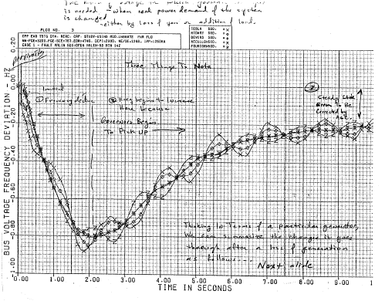
Fig. 1: Illustration of transient frequency response
Fig. 2: Illustration of regulation, load following, scheduling
We note that the transient frequency response in Fig. 1 is in the time frame of about 10 seconds, regulation and load following is in the time frame of seconds to minutes, and scheduling in the time frame of 1 day to 1 week.
Reference [] provides a good overview differentiating between regulation and load following. It states
“The key distinction between load following and regulation is the time period over which these fluctuations occur. Regulation responds to rapid load fluctuations (on the order of one minute) and load following responds to slower changes (on the order of five to thirty minutes).”
Mechanisms by which these issues are addressed are:
- Transient response: Inertia and governor
- Regulation: Governor and AGC
- Load following: AGC and economic dispatch
- Scheduling: Economic dispatch and unit commitment

- Transient frequency response
One should note three things about Fig. 1.
- The frequency declines from t=0 to about t=2 seconds. This frequency decline is due to the fact that the loss of generation has caused a generation deficit, and so generators decelerate, utilizing some of their inertial energy to compensate for the generation deficit.
- The frequency recovers during the time period from about t=2 seconds to about t=9 seconds. This recovery is primarily due to the effect of governor control (also, underfrequency load shedding also plays a role).
- At the end of the simulation period, the frequency has reached a steady-state, but it is not back to 60 Hz. This steady-state frequency deviation is intentional on the part of the governor control and ensures that different governors do not constantly make adjustments against each other. The resulting steady-state error will be zeroed by the actions of the automatic generation control (AGC).
We address regulation in the next section. Here, we desire to explore the significance of transient frequency dip, the nadir (lowest point), occurring at t=2 seconds.

We are concerned about a low frequency nadir for two reasons []. The first reason is under-frequency load shedding (UFLS), and the second is due to frequency relays that protect generators and certain kinds of loads. The significance of these problems depends on the size of the system, as we shall see in Sections 4.3-4.4.

  - Underfrequency load shedding (UFLS)
UFLS is used by utilities to protect against severe under-frequency conditions. For a particular frequency nadir, after a contingency, an operational scheme is designed to shed the appropriate load in order to prevent aggravating the frequency drop. The North American Electric Reliability Corporation (NERC) has published the PRC-006 requirement: “Each Regional Reliability Organization shall develop, coordinate, and document an UFLS program”. The MRO (Midwest Reliability Organization) has performed an under-frequency load shedding study related to this requirement. Table 1 shows the load to be shed at different frequency set points []. If the frequency falls below 59.3 Hz, 6% of the initial load will be shed. The next setting point is 59.1 Hz and so on.

Table 1

However, some systems have higher thresholds. For example, the WECC system in the western US interrupts some load at 59.75 Hz (called “interruptible load”). Allthough this is allowable under disturbance conditions, it is undesirable. The WECC threshold frequency, below which is unacceptable for credible disturbances, is 59.6 Hz [].

  - Underfrequency effects on generators []
Synchronous generators subjected to prolonged periods of underfrequency operation pose a serious threat to the turbines and other auxiliaries along with the generator. Of all turbines, steam turbines are most adversely affected by underfrequency operation.
Damage due to blade resonance is of primary concern. Resonance occurs when the frequency of the vibratory stimuli and the natural frequency of a blade coincides or are close to each other. The steam flow path is not homogeneous due to physical irregularities in the flow path and this produces cyclical force to the blades. At resonance the cyclical forces increases the stress and the damage to the blades is accumulated and may appear as a crack of some parts in the assembly. Although these cracks may not be catastrophic, they can alter the blade tuning such that resonance could occur near rated speed.
Every turbine blade has numerous natural resonance modes, namely tangential, axial, and torsional. Each mode has a natural frequency that varies with the physical dimensions of the blade. Short blades in the high-pressure and intermediate pressure stages of the turbine can be designed to withstand a resonant condition. However the longer turbine blades associated with the low pressure turbine are prone to damage by prolonged abnormal frequency operation. These blades are protected by tuning their natural resonant frequencies away from rated speed. These blades generally determine the turbine’s vulnerability to under frequency operation.
Standards do not specify short time limits for over-or underfrequency operation. The manufacturer of the specific turbine must provide this data. Reference [] lists the following limitations for one manufacturer’s turbines as:
- 1% change, 59.4–60.6Hz, no adverse effect on blade life
- 2% change, 58.8-61.2Hz, potential damage, ~ 90 mins
- 3% change, 58.2-61.8Hz, potential damage, ~10–15 mins
- 4% change, 57.6–62.4Hz, potential damage, ~1 min
Reference [] states that with a 5% frequency deviation, damage could occur within a few seconds.
Limits vary dramatically among manufacturers, as in Fig. 3, which includes limitation curves from four manufacturers. The shaded regions of Fig. 3 include
- White: Safe for continuous operation
- Light shade: Restricted time operation
- Dark shade: Prohibited operation
A “safe” approach would seem to be to ensure frequency remains in the band 59.5→60.05 Hz.
Fig. 3
Protective settings should be such as to coordinate with the automatic load shedding on the system and at the same time provides protection for each band of the manufacturer’s withstand characteristics.
The backup protection employs a multilevel underfrequency tripping scheme. A separate time delayed underfrequency function is required for each band on the manufacturer’s limit curve. The timers are set near the maximum allowable time for the band they protect. This strategy aims at maximizing the availability of large units during system disturbances, thus enhancing the power system’s ability to ride through such disturbances.
  - Inertial effects on transient frequency response
Reference [] (see section 3.6.3) provides a basis for understanding the effects of a generation-load imbalance on a power system comprised of synchronous machines. Consider that the power system experiences a load increase (or equivalently, a generation decrease) of ∆P_{L} at t=0, located at bus k. Then, at t=0⁺, each generator i will compensate according to its proximity to the change, as captured by the synchronizing power coefficient P_{Sik} between units i and k, according to
${ΔP}_{\text{ei}}=\frac{\left(−P_{\text{Sik}}\right)\left(−{ΔP}_{L}\right)}{\sum_{j=1}^{n}{P_{\text{Skj}}}}=\frac{P_{\text{Sik}}}{\sum_{j=1}^{n}{P_{\text{Skj}}}}{ΔP}_{L}$ (1)
where $P_{\text{Sik}}=\frac{∂P_{\text{ik}}}{∂δ_{\text{ik}}}|_{δ_{\text{ik}0}}$.
Equation (1) is derived for a multi-machine power system model where each synchronous generator is modeled with classical machine models, loads are modeled as constant impedance, the network is reduced to generator internal nodes, and mechanical power into the machine is assumed constant.
In such a case, the linearized swing equation for machine i (ignoring damping) is:
$\frac{2H_{i}}{ω_{\text{Re}}}\frac{d^{2}{Δδ}_{i}}{{\text{dt}}^{2}}=−{ΔP}_{\text{ei}}$ (2)
For a load change ΔP_{Lk}, at t=0⁺, we substitute eq. (1) into the right-hand-side of (2), we get:
$\frac{2H_{i}}{ω_{\text{Re}}}\frac{d^{2}{Δδ}_{i}}{{\text{dt}}^{2}}=−\frac{P_{\text{Sik}}}{\sum_{j=1}^{n}{P_{\text{Skj}}}}{ΔP}_{L}$ (3)
Bring H_{i} over to the right-hand-side and rearrange to get:
$\frac{2}{ω_{\text{Re}}}\frac{d^{2}{Δδ}_{i}}{{\text{dt}}^{2}}=−\left[\frac{P_{\text{Sik}}}{H_{i}}\right]\frac{{ΔP}_{L}}{\sum_{j=1}^{n}{P_{\text{Skj}}}}$ (4)
For ΔP_{L}>0, each machine will decelerate but at different rates, according to P_{Sik}/H_{i}.
Now rewrite eq. (3) with H_{i} inside the differentiation, use Δω_{i} instead of Δδ_{i}, write it for all generators 1,…,n, then add them up. All H_{i} must be given on a common base for this step.
$\begin{matrix}\frac{2}{ω_{\text{Re}}}\frac{{\text{dH}}_{1}{Δω}_{1}}{\text{dt}}=−\frac{P_{S1k}}{\sum_{j=1}^{n}{P_{\text{Skj}}}}{ΔP}_{L} \\ ⋮ \\ +\frac{2}{ω_{\text{Re}}}\frac{{\text{dH}}_{n}{Δω}_{n}}{\text{dt}}=−\frac{P_{\text{Snk}}}{\sum_{j=1}^{n}{P_{\text{Skj}}}}\end{matrix}$ (5a)
$\frac{2}{ω_{\text{Re}}}\sum_{i=1}^{n}{\frac{{\text{dH}}_{i}{Δω}_{i}}{\text{dt}}}=−\frac{\sum_{i=1}^{n}{P_{\text{Sik}}}}{\sum_{j=1}^{n}{P_{\text{Skj}}}}{ΔP}_{L}=−{ΔP}_{L}$ (5b)
Now define the “inertial center” of the system, in terms of angle and speed, as
- The weighted average of the angles:
$\overline{δ}≡\frac{\sum_{i=1}^{n}{H_{i}δ_{i}}}{\sum_{i=1}^{n}{H_{i}}}$ or $\overline{Δδ}≡\frac{\sum_{i=1}^{n}{H_{i}{Δδ}_{i}}}{\sum_{i=1}^{n}{H_{i}}}$ (6)

- The weighted average of the speeds:
$\overline{ω}≡\frac{\sum_{i=1}^{n}{H_{i}ω_{i}}}{\sum_{i=1}^{n}{H_{i}}}$ or $\overline{Δω}≡\frac{\sum_{i=1}^{n}{H_{i}{Δω}_{i}}}{\sum_{i=1}^{n}{H_{i}}}$ (7)
Differentiating $\overline{Δω}$ with respect to time, we get:
$\frac{d\overline{Δω}}{\text{dt}}≡\frac{\sum_{i=1}^{n}{\frac{d\left(H_{i}{Δω}_{i}\right)}{\text{dt}}}}{\sum_{i=1}^{n}{H_{i}}}$ (8)
Solve for the numerator on the right-hand-side, to get:
$\sum_{i=1}^{n}{\frac{d\left(H_{i}{Δω}_{i}\right)}{\text{dt}}}=\left[\sum_{i=1}^{n}{H_{i}}\right]\left[\frac{d\overline{Δω}}{\text{dt}}\right]$ (9)
Now substitute eq. (9) into eq. (5) to get:
$\frac{2}{ω_{\text{Re}}}\left[\sum_{i=1}^{n}{H_{i}}\right]\left[\frac{d\overline{Δω}}{\text{dt}}\right]=−{ΔP}_{L}$ (10)
Bringing the 2*(summation)/ω_{Re} over to the right-hand-side gives:
$\frac{d\overline{Δω}}{\text{dt}}=\frac{−{ΔP}_{L}ω_{\text{Re}}}{2\sum_{i=1}^{n}{H_{i}}}≡m_{ω}$ (11a)
Eq. (11a) gives the average deceleration of the system, m, the initial slope of the frequency deviation plot vs. time. This has also been called the rate of change of frequency (ROCOF) []. We again make the point that all H_{i} (units of seconds) must be given on a common power base for (11a) to be correct. In addition -∆P_{L} should be in per-unit, also on that same common base, so that -∆P_{L}/2 ΣH_{i} is in pu/sec, and m_{ω}=-∆P_{L} ω_{Re}/2 ΣH_{i} is in rad/sec/sec. Alternatively,
$\frac{d\overline{Δf}}{\text{dt}}=\frac{−{ΔP}_{L}f_{\text{Re}}}{2\sum_{i=1}^{n}{H_{i}}}≡m_{f}$ (11b)
provides ROCOF in units of Hz/sec.
Consider applying a load increase of ∆P_{L} at t=0. Assume:
- There is no governor action between time t=0⁺, and time t=t₁ (typically, t₁ might be about 1-2 seconds).
- The deceleration of the system is constant from t=0⁺ to t=t₁.
The frequency will decline to 60-m_{f}t₁. Figure 4 illustrates.
60
t₁
m_{f1}
m_{f2}
m_{f3}
Time (sec)→
Frequency(Hz)
60-m_{f1}t₁
60-m_{f2}t₁
60-m_{f3}t₁
Fig. 4
For a given ∆P_{L}, what operational attribute would cause the system to behave with characteristic of m_{f3}, instead of m_{f2} or m_{f1}?
Inspection of (11) indicates that the only operational parameter term is the denominator, $\sum_{i=1}^{n}{H_{i}}$. Thus, we observe that as the total system inertia decreases, the initial slope increases, and a given load change ∆P_{L} causes a greater frequency decline. This is an important concept in regards to understanding the effect of wind on transient frequency response.

  - Effect of system size
From (11b), we have seen that m_{f}, the average deceleration of the system, i.e., the rate of change of frequency (ROCOF), at the moment of the generation imbalance, depends on the total inertia for the entire interconnected system. The “larger” (more inertia) of the system, the smaller m_{f} will be, and the less severe will be the frequency dip. Small “isolated” systems such as those on islands experience very severe problems in this way.
Example 1, Crete: In 2000, the island of Crete had only 522 MW of conventional generation []. One plant has capacity of 132 MW. Let’s consider loss of this 132 MW plant when the capacity is 522 MW. Then remaining capacity is 522-132=400 MW. If we assume that all plants comprising that 400 MW have inertia constant (on their own base) of 3 seconds, then the total inertia following loss of the 132 MW plant, on a 100 MVA base, is
$$\sum_{i=1}^{n}{H_{i}}=\frac{\text{400}∗3}{\text{100}}=\text{12}$$
Then, for ∆P_{L}=132/100=1.32 pu, and assuming the nominal frequency is 50 Hz, ROCOF is given by
$$m_{f}=\frac{d\overline{Δf}}{\text{dt}}=\frac{−{ΔP}_{L}f_{\text{Re}}}{2\sum_{i=1}^{n}{H_{i}}}≡\frac{−1\text{.}\text{32}(\text{50})}{2∗\text{12}}=−2\text{.}\text{75}\text{Hz}\text{/sec}$$
If we assume t₁=2 seconds, then ∆f=-2.75*2=-5.5 Hz, so that the nadir would be 50-5.5=44.5Hz!
For a 60 Hz system, then m_{f}=-3.3Hz/sec, ∆f=-3.3*2=-6.6 Hz, so that the nadir would be 60-6.6=53.4 Hz.
Example 2, Ireland: Reference [Error: Reference source not found] reports on frequency issues for Ireland. The authors performed analysis on the 2010 Irish system for which the peak load (occurs in winter) is inferred to be about 7245 MW. The largest credible outage would result in loss of 422 MW. We assume a 15% reserve margin is required, so that the total spinning capacity is 8332 MW. Let’s consider this 422 MW outage, meaning the remaining generation would be 8332-422=7910 MW.
The inertia of the Irish generators is likely to be higher than that of the Crete units, so we will assume all remaining units have inertia of 6 seconds on their own base. Then the total inertia following loss of the 422 MW plant, on a 100 MVA base, is
$$\sum_{i=1}^{n}{H_{i}}=\frac{\text{7910}∗6}{\text{100}}=\text{475}$$
Then, for ∆P_{L}=422/100=4.32, and assuming the nominal frequency is 50 Hz, ROCOF is given by
$$m_{f}=\frac{d\overline{Δf}}{\text{dt}}=\frac{−{ΔP}_{L}f_{\text{Re}}}{2\sum_{i=1}^{n}{H_{i}}}≡\frac{−4\text{.}\text{32}(\text{50})}{2∗\text{475}}=−0\text{.}\text{227}\text{Hz}\text{/sec}$$
Assuming t₁=2.75 seconds, then ∆f=-0.227*2.75=-0.624 Hz, so that the nadir is 50-0.624=49.38Hz. Figure 5 [Error: Reference source not found] illustrates simulated response for this disturbance.
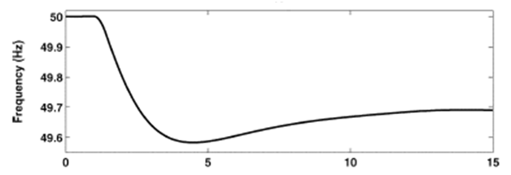
49.35
Nadir
2.75 sec
Fig. 5 [Error: Reference source not found]
The computed nadir (49.38 Hz) is almost exactly the same as the frequency dip that would be observed if the ROCOF at t=0+ were constant over the entire 2.75 sec (49.35 Hz). The fact that the actual nadir, at about 49.6 Hz is higher is due to two influences:
- Governors have some influence in the simulation that is not accounted for in the calculation.
- Some portion of the load is modeled with frequency sensitivity in the simulation, and this effect is not accounted for in the calculation.
Example 3, US Eastern Interconnection: Reference [] reports on frequency issues for the US Eastern Interconnection. The author analyzed a 2008 case for which installed capacity was 541 GW. Two outages were studied, as illustrated in Fig. 6. The large black dot in northern Florida indicates a 2.9 GW plant dropped for outage 1. All black dots represent generation totaling about 10.18 GW as below, for outage 2.
Florida: 2.9GW+1.272GW+2.390GW=6.552GW
Potomac Electric Power Co (Wash D.C.): 1.295GW
Maryland: 1.164GW
Tennessee: 1.15 0GW
The blue dot is where the frequency was monitored.
Fig. 6
Outage 1: With a 2.9 GW outage, the remaining generation is 541-2.9=538.1 GW. We assume the inertia of the generators is 6 seconds on their own base. Then the total inertia following loss of the 2.9 GW plant, on a 100 MVA base, is
$$\sum_{i=1}^{n}{H_{i}}=\frac{\text{538100}∗6}{\text{100}}=\text{32286}$$
Then, for ∆P_{L}=2900/100=29, and with nominal frequency of 60 Hz, ROCOF is given by
$$m_{f}=\frac{d\overline{Δf}}{\text{dt}}=\frac{−{ΔP}_{L}f_{\text{Re}}}{2\sum_{i=1}^{n}{H_{i}}}≡\frac{−\text{29}(\text{60})}{2∗\text{32286}}=−0\text{.}\text{0269}\text{Hz}\text{/sec}$$
Assuming t₁=2.5 seconds, then ∆f=-0.0269*2.5=-0.0673 Hz, so that the nadir is 60-0.0673=59.9327Hz. Figure 7 (pink curve) illustrates simulated response for this disturbance.
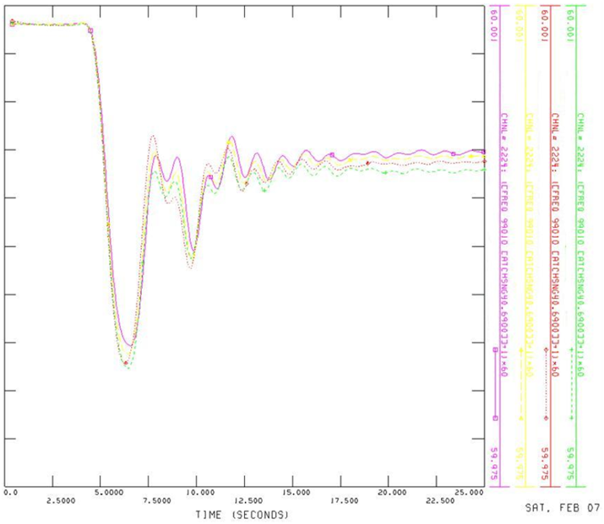
Nadir
59.9828 Hz
59.9789 Hz
Fig. 7
Outage 2: With a 10.16 GW outage, the remaining generation is 541-10.16=530.84 GW. We assume the inertia of the generators is 6 seconds on their own base. Then the total inertia following loss of the 10.16 GW generation, on a 100 MVA base, is
$$\sum_{i=1}^{n}{H_{i}}=\frac{\text{530840}∗6}{\text{100}}=\text{31850}$$
Then, for ∆P_{L}=10160/100=101.60, and with nominal frequency of 60 Hz, ROCOF is given by
$m_{f}=\frac{d\overline{Δf}}{\text{dt}}=\frac{−{ΔP}_{L}f_{\text{Re}}}{2\sum_{i=1}^{n}{H_{i}}}≡\frac{−\text{101}\text{.}\text{60}(\text{60})}{2∗\text{31850}}=−0\text{.}\text{0957}\text{Hz}\text{/sec}$Assuming t₁=2.2 seconds, then ∆f=-0.0957*2.2=-0.2105 Hz, so that the nadir is 60-0.2105=59.79Hz. Figure 8 illustrates simulated response for this disturbance.
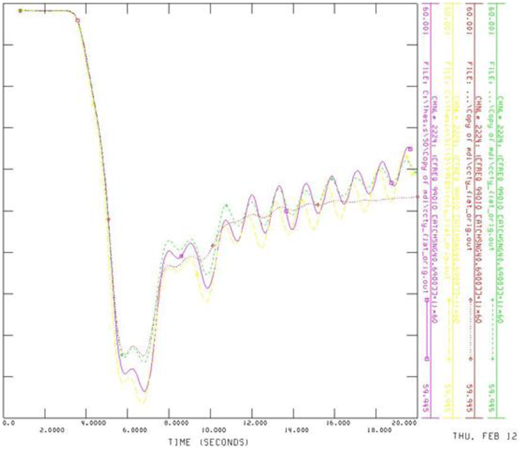
Nadir
59.978
Fig. 8
The frequency dips of Figures 7 and 8 are small and of little concern in terms of tripping underfrequency load shedding or of tripping generator protection. Yet, the amount of generation tripped is very large, and it is unlikely the eastern interconnection will see generation trips larger than 10 GW. The reason for this excellent frequency stability is the very large size of the system.
Yet, there are two reasons why frequency stability is still of concern within the eastern interconnection. The first is that during islanding conditions, the frequency stability is determined by the size of each island, not by the size of the entire interconnection. Islanding occurs very rarely, but frequency stability is of high significance when it does. During such events, the inertia of the island can be significantly lower than the entire interconnection, and generation-load imbalance can also be large, resulting in a large m_{f}, according to (11a) and (11b).
The second reason why frequency stability is still of concern within the eastern interconnection has to do with Control Performance Standards CPS1 and CPS2. These are two performance metrics associated with load frequency control. These measures depend on area control error (ACE), given for control area i as
${\text{ACE}}_{i}={ΔP}_{i}+βΔf$ (12)
${ΔP}_{i}={\text{AP}}_{i}−{\text{SP}}_{i}$ (13)
where AP_{i} and SP_{i} are actual and scheduled exports, respectively. ACE_{i} is computed on a continuous basis.
With this definition, we can define CPS1 and CPS2 as
- CPS1: It measures ACE variability, a measure of short-term error between load and generation []. It is an average of a function combining ACE and interconnection frequency error from schedule []. It measures control performance by comparing how well a control area’s ACE performs in conjunction with the frequency error of the interconnection. It is given by
$\text{CPS}1=(2−\text{CF})×\text{100}\text{\%}$ (14a)
$\text{CF}=\frac{{\text{ControlParameter}}_{\text{12}−\text{Month}}}{(ε_{1})^{2}}$ (14b)
$\text{ControlParameter}=\frac{{\text{ACE}}_{\text{min}\text{ute}}}{−\text{10}B}×{ΔF}_{\text{min}\text{ute}}$ (14c)
where
- CF is the compliance factor, the ratio of the 12 month average control parameter divided by the square of the frequency target ε₁.
- ε₁ is the maximum acceptable steady-state frequency deviation – it is 0.018 Hz=18 mHz in the eastern interconnection. It is illustrated in Fig. 9 [].
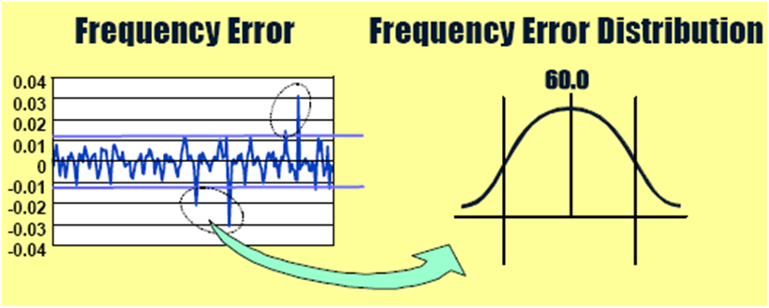
ε₁
-ε₁
60-ε₁
60+ε₁
Fig. 9 [Error: Reference source not found]
- The control parameter, a “MW-Hz,” indicates the extent to which the control area is contributing to or hindering correction of the interconnection frequency error, as illustrated in Fig. 10 [Error: Reference source not found].
Fig. 10 [Error: Reference source not found]
If ACE is positive, the control area will be increasing its generation, and if ACE is negative, the control area will be decreasing its generation. If ∆F is positive, then the overall interconnection needs to decrease its generation, and if ∆F is negative, then the overall interconnection needs to increase its generation. Therefore if the sign of the product ACE×∆F is positive, then the control area is hindering the needed frequency correction, and if the sign of the product ACE×∆F is negative, then the control area is contributing to the needed frequency correction.
  - A CPS1 score of 200% is perfect (actual measured frequency equals scheduled frequency over any 1-minute period)
  - The minimum passing long-term (12-month rolling average) score for CPS1 is 100%
- CPS2: The ten-minute average ACE.
In summary, from [], “CPS1 measures the relationship between the control area’s ACE and its interconnection frequency on a one-minute average basis. CPS1 values are recorded every minute, but the metric is evaluated and reported annually. NERC sets minimum CPS1 requirements that each control area must exceed each year. CPS2 is a monthly performance standard that sets control-area-specific limits on the maximum average ACE for every 10-minute period.” The underlying issue here is that control area operators are penalized if they do not maintain CPS. The ability to maintain these standards is decreased as inertia decreases.

  - Impact of wind on transient frequency response
There are 4 types of wind turbines deployed today.
- Type 1: The self-excited induction generator (SEIG) or squirrel cage induction generator. It is fixed speed.
- Type 2: The wound-rotor induction generator, operationally, is much like type 1, with the exception that its wound-rotor enables a limited amount of speed control via variation of a resistance in series with the rotor circuit.
- Type 3: The double-fed induction generator (DFIG) has the stator windings directly connected to the grid while the rotor windings are connected via slip rings to a converter which connects to the grid. The DFIG is a variable speed machine.
- Type 4: The direct-connected machine has its stator windings connected to a full-power converter which connects to the grid. The generator can either be a synchronous or induction machine.
Figure 11 illustrates all four types []. As far as transient frequency response is concerned, type 2 is similar to type 1. Figure 12 [] illustrates types 1, 3, and 4. Type 4 is not as commonly used as the others, so we focus further discussion on the type 1 fixed-speed machine and the type 3 variable-speed machine.
Fig. 11 [Error: Reference source not found]
Fig. 12 [Error: Reference source not found]
At this point, recall two facts:
- By (11b), transient frequency decline is reduced by contribution of each machine’s inertial energy.
$\frac{d\overline{Δf}}{\text{dt}}=\frac{−{ΔP}_{L}f_{\text{Re}}}{2\sum_{i=1}^{n}{H_{i}}}≡m_{f}$ (11b)
- By (5a), a machine contributes inertial energy if it decelerates in response to a frequency drop according to the following equation of motion:
$\frac{2}{ω_{\text{Re}}}\frac{{\text{dH}}_{i}{Δω}_{i}}{\text{dt}}=−\frac{P_{\text{Sik}}}{\sum_{j=1}^{n}{P_{\text{Sij}}}}{ΔP}_{L}$ (5a)
Therefore, a machine that decelerates in response to a frequency drop contributes inertial energy and acts to arrest frequency decline.
A machine that does not decelerate in response to a frequency drop does not contribute inertial energy and does not act to arrest frequency decline.
We will inspect the operation of type 1 (fixed speed) and type 3 (DFIG) to determine whether they contribute inertial energy to the power system or not.
    - Frequency response: fixed-speed machines
Type I turbines are simple induction machines. They operate at fixed slip for any given power level, so they can only operate over a relatively small speed range. One way to think about this is to consider the steady-state torque expression for an induction machine, given by
$T=\frac{3V_{{\text{th}}^{2}}R_{2}'}{\left({sω}_{s}\right)\left[{\left(R_{\text{th}}+\frac{R_{2}'}{s}\right)}^{2}+{\left(X_{\text{th}}+X_{2}'\right)}^{2}\right]}$ (12)
From (12), we see torque is a function of slip, s, given by
$\text{s=}\frac{\left(ω_{s}−ωm\right)}{ω_{s}}$ (13)
where ω_{s} is synchronous speed, ω_{m} is the rotor speed.
The plot of T vs. s is given in Fig. 13 []. For stable operation, the electrical torque, to counter the mechanical torque, should increase as the machine speed (driven by the wind) increases.
Figure 13 shows stable operation to be between s=0 and about s=-12%. In reality, these units operate in a tighter slip range, typically within a 2% band - almost fixed speed; as a result, they are called fixed-speed machines.
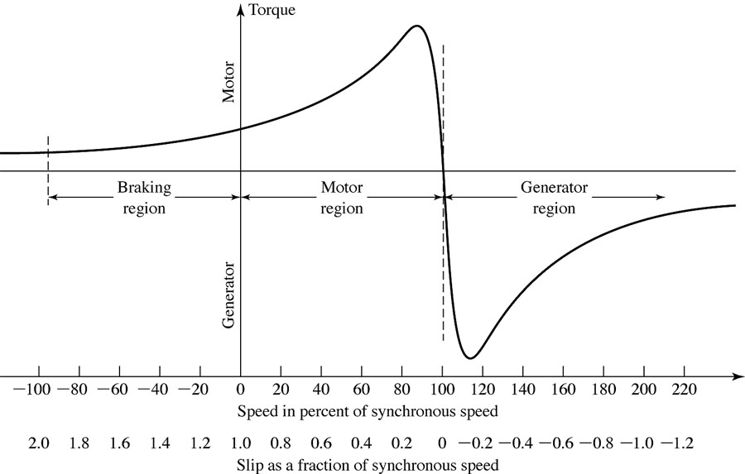
Stable region
Fig. 13
Figure 14 [] illustrates how induction generator rated or nominal slip tends to reduce with generator power rating, with the larger units being designed to operate with lower slips. This is a result of the fact that induction generator efficiency improves as slip decreases, and efficiency becomes more important for larger machines. The point is, here, that for grid-size machines, nominal slip is in the 0-2% range.
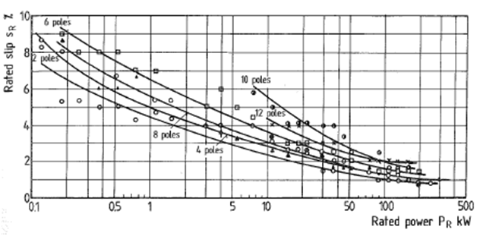
Fig. 14 [Error: Reference source not found]
So what happens with the fixed-speed machine when the wind speed changes? Because of the induction generator characteristic, per Fig. 13, the generator will resist increase in rotor speed by increasing its electromechanical torque, effectively converting the higher wind speed to a higher power output.
Because of the steepness of the speed-torque relation, fixed speed machines have the undesirable characteristic of providing power injection into the grid that is as variable as the wind speed itself; they tend to surge power into the grid during wind gusts.
Let’s now consider what happens to a fixed-speed machine when the network frequency changes due to, for example, loss of a generator somewhere in the system that causes a power imbalance.
Reconsider (12), repeated here for convenience.
$T=\frac{3V_{{\text{th}}^{2}}R_{2}'}{\left({sω}_{s}\right)\left[{\left(R_{\text{th}}+\frac{R_{2}'}{s}\right)}^{2}+{\left(X_{\text{th}}+X_{2}'\right)}^{2}\right]}$ (12)
where slip is given by (13), also repeated here for convenience.
$\text{s=}\frac{\left(ω_{s}−ω_{m}\right)}{ω_{s}}=1−\frac{ω_{m}}{ω_{s}}$ (13)
If the frequency changes from ω_{s} to kω_{s}, with 0<k<1, then the slip will also change from (13) to
$s_{\text{new}}=\frac{\left(ω_{s}−ω_{m}\right)}{ω_{s}}=1−\frac{ω_{m}}{{kω}_{s}}$ (14)
and (12) will change to
$T=\frac{3V_{{\text{th}}^{2}}R_{2}'}{\left(1−\frac{ω_{m}}{{kω}_{s}}\right){kω}_{s}\left[{\left(R_{\text{th}}+\frac{R_{2}'}{1−\frac{ω_{m}}{{kω}_{s}}}\right)}^{2}+{\left(X_{\text{th}}+X_{2}'\right)}^{2}\right]}$ (15)
where we have replaced ω_{s} by kω_{s} and s=1- ω_{m}/ω_{s} by s_{new}=1- ω_{m}/kω_{s}.
Example: [similar to , p. 189] Consider a 6-pole induction generator with line-line voltage of 220 volts, and the below data. Plot the torque-speed characteristic for f=60 Hz and for f=98% of 60Hz (58.8 Hz).
R₁=0.294 Ω X’₂=0.209 Ω
X₁=0.503 Ω R’₂=0.061 Ω
R_{C}=1000 Ω
X_{m}=13.25 Ω
Solution: First we need to obtain ω_{S}. This is given by
$$ω_{s}=2{πf}/(p/2)=2π(\text{60})/(6/2)=\text{125}\text{.}\text{664}\begin{matrix} & \end{matrix}\text{rad}\text{/sec}$$
We develop the plots using the following Matlab code.

% Set frequency factor.
k=1;
% Data.
v1= 220/sqrt(3);
r1=0.294;
x1=0.503;
rc= 1000;
xm=13.25;
xp2=0.209;
%rp2=0.1210;
rp2=0.0610;
ws=125.67;
% Compute thevenin parameters.
zb=(rc*i*xm)/(rc+i*xm);
za=r1+i*x1;
vth=abs(v1*zb/(za+zb));
zth=za*zb/(za+zb);
rth=real(zth);
xth=imag(zth);
% Mechanical speed range
wm1=[1.001*k*ws:1:1.5*k*ws];
% Torque equation components.
num=3*(vth^2)*rp2;
den1=ws*(1-wm1 /(k*ws));
den2=(rth+rp2./(1-wm1/(k*ws))).^2;
den3=(xth+xp2)^2;
% Compute torque
T1=num ./ (den1.*(den2+den3));
%
% Now do it again for a different frequency.
k=0.98;
% Mechanical speed range
wm2=[1.001*k*ws:1:1.5*k*ws];
% Torque equation components.
num=3*(vth^2)*rp2;
den1=ws*(1-wm2 /(k*ws));
den2=(rth+rp2./(1-wm2/(k*ws))).^2;
den3=(xth+xp2)^2;
% Compute torque
T2=num ./ (den1.*(den2+den3));
% Plot
x=[128.18 128.18];
y=[0 -400];
plot(wm1,T1,wm2,T2,x,y)
Plots for f=60 Hz and for f=58.8 Hz are provided in Fig. 15. We assume a -2% slip for the 60 Hz case, so that the mechanical rotor speed will be
$ω_{m}=ω_{s}(1−s)=\text{125}\text{.}\text{664}(1−−\text{.}\text{02})=\text{128}\text{.}\text{18}\begin{matrix} & \end{matrix}\text{rad}\text{/sec}$The vertical line corresponding to this mechanical speed is drawn in the plot of Fig. 15.
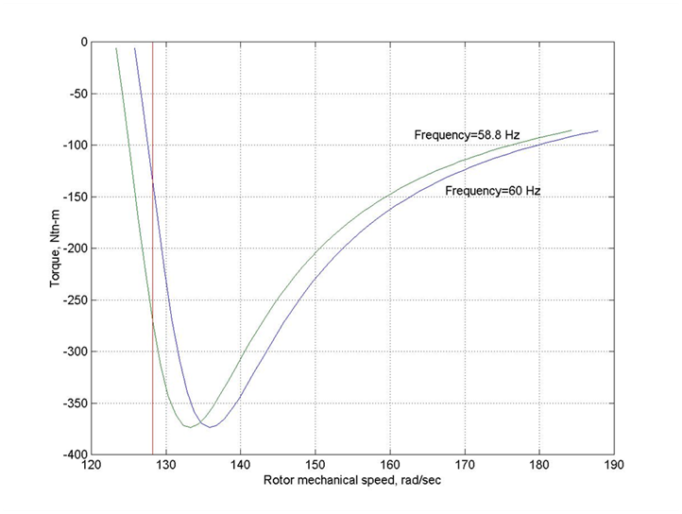Fig. 15
A
B

Assume that the wind speed does not change over the short time period (a few seconds) when the network experiences the frequency drop. Then the mechanical power into the machine also does not change during this time, and the rotor speed, driven by the turbine, will remain fairly constant.

Under these conditions, Fig. 15 indicates that the electric torque provided by the generator will increase significantly, moving from point A on the 60Hz curve to point B on the 58.8 Hz curve. The generator torque, and corresponding power, has almost doubled. With the electrical torque so much greater than the mechanical torque, the machine decelerates, releasing stored energy into the system.

The rotational inertia of the fixed speed wind turbine is effectively “seen” by the external system, although its effect is tempered by the fact that the slip does dynamically change during disturbances. Although there is no “governor” to adjust the wind turbine output in response to changes in external power system frequency, the machine will passively provide some frequency restoration due to its rotational inertia.
    - Frequency response: DFIGs
To understand transient frequency response of a DFIG, it is necessary to have some appreciation of DFIG standard control systems. There are 3 main functional systems that are controlled in a wind turbine: rotor yawing (ability to follow wind direction), speed-power control (including reactive power), and operational sequence [Error: Reference source not found]. Our interest is the speed-power control, and we will briefly review the essentials of this system. This section is adapted largely from [Error: Reference source not found].
Figure 16 compares a DFIG wind turbine to a typical steam-driven turbine-generator set (lines from “control” box indicate control capability, not feedback). The steam turbine has 3 types of control available to it: fuel input, steam valve, and generator field, with the first 2 related to speed-power control and the 3rd one related to MVAR-voltage control. In the case of the steam-turbine, the fuel supply controls the input mechanical power, and the steam-valve controls the output mechanical power.
FUEL
Steam Boiler
Generator
CONTROL SYSTEM
Steam valve control
Fuel supply control
MVAR-voltage control
Wind speed
Gear Box
Generator
CONTROL SYSTEM
MVAR-voltage control
Real power output control
STEAM-TURBINE
WIND-TURBINE
Fig. 16: Steam and Wind Turbines
The wind turbine also has three forms of control, although there are similarities, there are also significant differences. One similarity is the MVAR-voltage control capability; although this control is accomplished in a different manner, the ultimate effect is quite similar. This control capability in each machine is connected via a dashed line on the right-hand-side of Fig. 16.

The wind turbine can also control the output mechanical power applied to the generator through pitching the blades. Therefore we see that pitching the blades is analogous to steam flow control in a steam turbine. This control capability in each machine is connected via a dashed line in the middle portion of Fig. 16.
Whereas the steam turbine has the additional power control capability at the fuel input (indicated by a dark snaked arrow at the top of Fig. 16), which the wind turbine does not have, the wind turbine has power control capability at the generator output (indicated by a dark snaked arrow at the bottom of Fig. 16), which the steam turbine does not have. Control of the generator power output is performed via control of the d-axis component of the rotor current.
The ability to control mechanical power into the generator using pitch control and generator power output using rotor current control enables avoidance of mismatch between mechanical power in and electrical power out and, therefore, also avoidance of rotor deceleration under network frequency decline.
This means DFIGs contribute no inertial energy under underfrequency conditions.
As long as DFIGs are merely added to historical generation commitment schedules, this feature is not problematic. But as soon as DFIGs begin to displace conventional generators in the generation commitment schedules, the denominator of (11b) will decrease, and as a consequence, the ROCOF will increase.
$\frac{d\overline{Δf}}{\text{dt}}=\frac{−{ΔP}_{L}f_{\text{Re}}}{2\sum_{i=1}^{n}{H_{i}}}≡m_{f}$ (11b)
This results in lower transient frequency dips under large-scale generation outages, as indicated in Fig. 17 which compares, for a test system, four different DFIG:FSM splits of a 15.6% wind-turbine penetration level: 50:50, 60:40, 70:30, and 100:0 [].
Fig. 17
One can observe a similar trend for the US Eastern Interconnection in Fig. 18, where an 8% penetration level is compared under
• Pink: Base Case
• Yellow: Unit De-Commitment
• Red: Load Increasing
•Green: Generation Decreasing without De-Commitment

Fig. 18
It also results in poorer CPS1 and CPS2 performance.
Several European grid operators have imposed requirements on wind plants in regards to frequency contributions, including the Nordic countries [, ]. North American interconnections have so far not imposed requirements on wind farms in regards to frequency contributions, with the exception of Hydro-Quebec.
Hydro Quebec requires that wind farms be able to contribute to reduce large (>0.5 Hz), short-term (< 10 sec) frequency deviation []. The Hydro-Quebec requirement states [], “The frequency control system must reduce large, short-term frequency deviations at least as much as does the inertial response of a conventional generator whose inertia (H) equals 3.5 sec.”
  - Adding transient frequency control to DFIGs
At the beginning of the course, we saw that the power which can be extracted from the wind by the wind turbine rotor, P_{m}, is less than the power in the wind, P_{wind}, and that this concept is captured by the relation
$P_{m}=C_{p}P_{\text{wind}}$ (16)
where C_{p} is the power coefficient and depends on the tip speed ratio, λ. The tip speed ratio is the ratio of the rotor tip velocity and the wind speed, V_{wind}, given by []
$λ=\frac{ω_{r}R}{V_{\text{wind}}}$ (17)
where ω_{r} is the angular velocity of the rotor and R is its radius, so that the product gives the speed at the “tip.”
The dependence of C_{p} on λ is illustrated in Fig. 19, where it is clear that there is a value of λ for which C_{p} is maximum. This is the most desirable operating point. Therefore for a certain wind velocity, we desire to ensure that the tip-speed ratio is λ_{opt} in order to maximize the power extracted from the wind.
Tip speed ratio, λ →
C_{p}
λ_{opt}
Fig. 19
Figure 20a [Error: Reference source not found] illustrates this same notion, but instead of plotting C_{p} against λ, generator torque is plotted against generator speed for different wind speeds. For a given wind speed, the curve identifies optimal generator torque and speed.
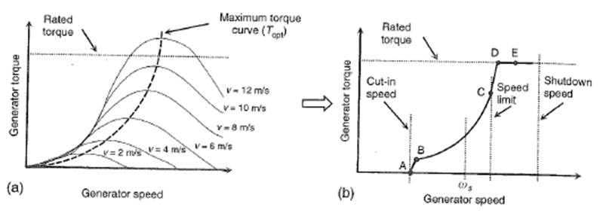
Fig. 20
In Fig. 20a, a dotted curve is drawn through the points of maximum torque. This curve is very useful for control, in that we can be sure that as long as we are operating at a point on this curve, we are guaranteed to be operating the wind turbine at maximum efficiency. Therefore this curve, redrawn in Fig. 20b, dictates how the machine should be controlled in terms of torque and speed.
A high-level view of an overall control approach for a DFIG wind turbine is shown in Fig. 21 [Error: Reference source not found]. The torque-speed control loop is shown in a bold oval.
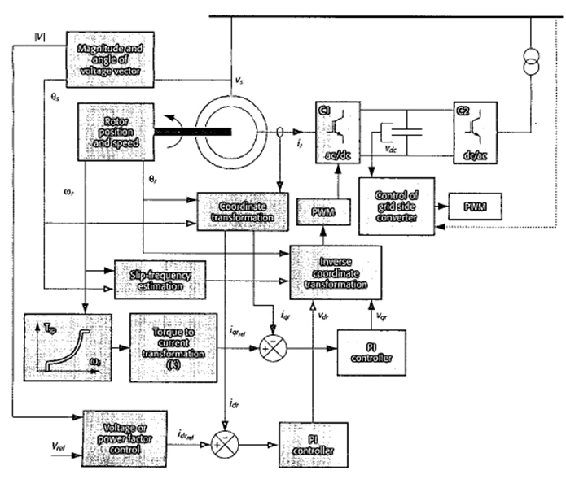
Fig. 26 [Error: Reference source not found]
The portion of Fig. 26 corresponding to the bold oval is shown in Fig. 27 [].
Fig. 27
This is how almost all DFIG’s operating today in North America were designed, and it is the primary reason why we do not obtain inertial response from DFIGs for transient frequency performance.
It is possible to provide supplementary control, however. Such control is illustrated in Fig. 28.
Fig. 28
Comparison between Fig. 27 and Fig. 28 shows that in Fig. 28 we have added a signal dω/dt scaled by 2H. This provides the control necessary to provide inertial response for transient frequency performance.

Operational sequence is addressed by the sequence controller, which, from Erich Hau’s excellent text, “receives external inputs according to the operating conditions and, above all, the wind conditions and the operator’s intentions. This information will determine the setpoint values for the control system. The sequence controller monitors operating conditions and functional sequences and makes decisions concerning the mode of operation on the basis of logical deductions. As a rule, it is implemented in a programmable process computer with an associated data acquisition system.”
[?] B. Kroposki, T. Basso, R. Deblasio, and N. Friedman, “Interconnection of Alternative Energy Sources with the Grid,” in “Integration of Alternative Sources of Energy,” edited by F. Farret and M. Simoes, Wiley-Interscience, 2006.
[?] E. Hirst and B. Kirby, “Separating and measuring the regulation and load-following ancillary services,” Utilities Policy 8, 1999, pp. 75–81.
[?] Prabha Kundur, Power System Stability and Control, McGraw-Hill Professional, January 1, 1994.
[?] Charles Lawrence, Richa Singhal, Eric Ruskamp, “MRO Under frequency Load Shedding Study”, available online: http://www.midwestreliability.org/04_standards/drafting_teams/ufls/BarryFrancisPresentation081024.pdf.
[?] WSCC Reliability Subcommittee, “Supporting Document for Reliability Criteria for Transmission System Planning,” 1994, available at www.wecc.biz/documents/library/RS/August_1994_Supporting_Document_for_Reliability_Criteria_for_Transmission_System_Planning.pdf
[?] S. Khaitan, “On-line cascading event tracking and avoidance decision support tool,” PhD Dissertation, Iowa State University, 2008.
[?] F. Baily, H. Bardwick, and R. Fenton, “Operating and maintaining steam turbine generators–Operating at off-normal conditions, Power, August 1976, The McGraw-Hill Companies.
[?] J. Berdy, P. Brown, and L. Goff, “Protection of Steam Turbine Generators During Abnormal Frequency Conditions,” General Electric Company, Schenectady, New York.
[?] P. Anderson and A. Fouad, “Power system control and stability,” Iowa State University Press, 1977.
[?] G. lalor, A. Mullane, and M. O’Malley, “Frequency control and wind turbine technologies,” IEEE Trans. On Power Systems, Vol. 20, No. 4, Nov. 2005.
[?] N. Hatziargyriou, G. Contaxis, M. Papadopoulos, B. Papadias, M. Matos, J. Pecas Lopes, E. Nogaret, G. Kariniotakis, J. Halliday, G. Dutton, P. Dokopoulos, A. Bakirtzis, A. Androutsos, J. Stefanakis, A. Gigantidou, “Operation and control of island systems-the Crete case,” IEEE Power Engineering Society Winter Meeting, Volume 2, 23-27 Jan. 2000, pp. 1053 -1056.
[?] S. Zhang, “Two Approaches to Study Wind Integration: Transient Simulation and Statistical Method,” MS Thesis, Iowa State University, 2009.
[?] M. Shahidehpour, Hatim Yamin, and Zuyi Li, “Market Operations in Electric Power Systems,” Wiley, 200?.
[?] N. Jaleeli and L. VanSlyck, “NERC’s New Control Performance Standards,” IEEE Transactions on Power Systems, Vol. 14, No. 3, August 1999.
[?] M. Terbrueggen, “Control Performance Standards,” a NERC Operators Training Document.”
[?] B. Kirby, M. Milligan, Y. Makarov, D. Hawkins, K. Jackson, H. Shiu “California Renewables Portfolio Standard Renewable Generation Integration Cost Analysis, Phase I: One Year Analysis Of Existing Resources, Results And Recommendations, Final Report,” Dec. 10, 2003, available at http://www.consultkirby.com/files/RPS_Int_Cost_PhaseI_Final.pdf.
[?] T. Thiringer, A. Petersson and T. Petru, “Grid Disturbance Response of Wind Turbines Equipped with Induction Generator and Doubly-Fed Induction Generator,” 2003.
[?] A. Mullane and M. O’Malley, “Modifying the Inertial Response of Power-Converter Based Wind Turbine Generators,” Power Electronics, Machines and Drives, 2006. The 3rd IET International Conference on Mar. 2006 Page(s):121 - 126
[?] E. Muljadi, presentation notes, Spring 2007, University of Colorado.
[?] E. Hau, “Wind Turbines: Fundamentals, Technologies, Application, Economics,” 2nd edition, Springer, 2006.
[?] B. Fox, D. Flynn, L. Bryans, N. Jenkins, D. Milborrow, M. O’Malley, R> Watson, and O. Anaya-Lara, “Wind Power Integration: Connection and system operational aspects,” Institution of engineering and technology, 2007.
[?] E. Vittal, A. Keane, and M. O’Malley, “Varying Penetration Ratios of Wind Turbine Technologies for Voltage and Frequency Stability,” ?, 2008.
[?] “Wind Turbines Connected to Grids with Voltages above 100 kV – Technical Regulation for the Properties and the Regulation of Wind Turbines, Elkraft System and Eltra Regulation, Draft version TF 3.2.5, Dec., 2004.
[?] “Nordic Grid Code 2007 (Nordic Collection of Rules), Nordel. Tech. Rep., Jan 2004, updated 2007.
[?] N. Ullah, T. Thiringer, and D. Karlsson, “Temporary Primary Frequency Control Support by Variable Speed Wind Turbines – Potential and Applications,” IEEE Transactions on Power Systems, Vol. 23, No. 2, May 2008.
[?] “Technical Requirements for the Connection of Generation Facilities to the Hydro-Quebec Transmission System: Supplementary Requirements for Wind Generation,” Hydro=Quebec, Tech. Rep., May 2003, revised 2005.
[?] J. Ekanayake, L. Holdsworth, and N. Jenkins, “Control of DFIG Wind Turbines,” Proc. Instl Electr. Eng., Power Eng., vol. 17, no. 1, pp. 28-32, Feb 2003.
[?] Janaka Ekanayake and Nick Jenkins, “Comparison of the Response of Doubly Fed and Fixed-Speed Induction Generator Wind Turbines to Changes in Network Frequency,” ieee Transactions on Energy Conversion, Vol. 19, No. 4, Dec. 2004.

