Wind Energy Development Process
Table of Contents
1. Introduction and Timeline 2
a. Project Scale and Economic Goals 2
i. Small Scale Wind 2
ii. Community Wind Projects 3
iii. Utility-Owned Projects 3
iv. Independent Power Producers 4
b. Timeline 4
2. Feasibility 5
a. Permissions: 5
b. FAA Restrictions and Military Interests: 5
c. Available Land : 5
d. Environmental Restrictions: 5
e. Local Acceptance: 5
f. Grid Connection: 6
g. Economic Viability: 6
3. Siting Wind Energy Projects 6
a. Locating Wind Resources 6
b. Energy from Wind 9
4. Financial Feasibility 14
a. Quantifying Costs 15
b. Quantifying Revenue 16
c. Present Value Analysis 18
5. Community Outreach 24
6. Land Acquisition 25
7. Interconnection Studies 26
8. Environmental Studies 27
9. Engineering Design 28
10. Permitting Process 29
a. Permitting Considerations for Schools in Ames, IA 30
11. Construction 31
12. Maintenance and Operation 31
13. End of Life 32

- Introduction and Timeline
This document outlines the process of acquiring a wind turbine. The overview includes issues pertinent to both large and small-scale projects. Ames High School plans to construct a small (< 100kW) turbine, but the curriculum goal is to teach about wind energy in general, most of which is built on the large scale.
There are two types of wind turbine generators which may be considered for this project. Most people are familiar with Horizontal Access Wind Turbines (“HAWTs”). These turbines have rotors which rotate on an axis which is on a horizontal plane. The other type of wind turbine is a Vertical Axis Wind Turbine, which rotates on an axis which is perpendicular to the ground. Figure 1 shows examples of the two types.

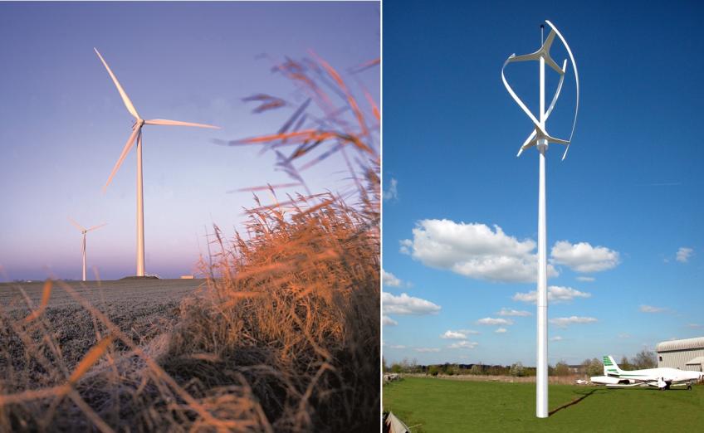
Figure 2: HAWT (Left) and VAWT (Right)
HAWTs are more common and more recognizable. Nearly all commercial wind turbines of greater than 10 kW are HAWTs. The technology for this style turbine is the most mature and the most prevalent. When we mention commercial or utility-size wind projects, these are almost all HAWTs. Where necessary, we will distinguish between the two form factors.
VAWTs in the 5-10 kW range are becoming common. They can easily be placed on rooftops or existing structures such as light-poles. Some 50-100 kW VAWTs exist, but they tend to take up a very large area, since they require guywires or frames for stability.
In this report, we will use the term “wind energy project” to refer to any proposed project intended to harvest the power of wind to produce electricity. It may refer to a single wind turbine or a wind farm. Where necessary, we will distinguish between single turbines and entire wind farms.

- Project Scale and Economic Goals
Wind energy projects are built at a variety of scales, and for a variety of reasons. The process by which these projects are approached will vary based on the size of the project and the financial goals of the developing party.
- Small Scale Wind
Small-scale wind developments are specified as those with a total capacity under 100kW. These projects are typically undertaken by individuals or businesses who seek to cut down their private energy bills or to take responsibility of their private energy use. Wind turbines are often built on land that is already owned, and are scaled to the entity which they serve. A homeowner may seek to offset a specified portion of his annual electrical usage, for instance. Alternately, he may specify a spending limit, then maximize his energy savings within that limit. Individuals may design and implement these generators on their own, or they may pay a company to do this work.
Small wind turbines have a significantly higher price per kW capacity, compared to larger megawatt-scale turbines. Experts in small wind project development estimate project costs between $3000 and $5000 per kW,, compared to the $1000-$2500/kW costs seen in large wind farms. Small turbines are not as common and not as widely manufactured, so they do not benefit from the economies of scale seen with larger turbines. However, small wind turbines often serve local loads, may not require significant upgrades in transmission systems, and benefit their owners more directly through net-metering agreements.
Construction and interconnection of private electrical generation equipment is protected under the Public Utility Regulatory Policies Act (PURPA) of 1978. In many states, individual projects may be eligible for net-metering, which significantly increases the value of the energy they generate.There may be state and federal incentives developed specifically for small-scale renewable energy installations. Utility companies may also provide cash incentives for private installations of energy systems.

- Community Wind Projects
Community wind projects are projects involving larger turbines, owned in part by towns, schools, commercial customers, or farmers. These projects are built to serve local power needs or to save on local energy costs. Projects will be initiated by individuals or groups of individuals from a community, and developed with the input of the community. Projects are again scaled to local energy needs or to investor contributions.
Community projects may be financed by pooling the capital of several individuals, by passing a bond order, or by taking out a conventional loan. Owners of community wind projects often incorporate as Limited Liability Corporations (LLCs). Community projects built by specific entities may be built on land that is already owned (like school property or city land). Projects pursued by groups of individuals (such as LLCs) will formally buy or lease the land to be used.

- Utility-Owned Projects
Utility companies approach wind projects with a broader perspective. Individual or community projects are developed to deliver localized energy savings, or to bring some financial gain. In contrast, utilities invest in generation in order to meet a wider range of concerns. Utilities must guarantee that they have enough capacity to meet future demand. They must also maintain network reliability, according to standards set by the federal, state, and local governments. Finally, they must provide energy at low cost.
Utility companies benefit from owning wind installations in various ways. First, wind projects are a source of energy that, once built, is very cheap to operate. Because of this, it can be used to mitigate the risk of other energy sources, like natural gas, which rely on fuel which may fluctuate rapidly in price. Second, by owning wind projects themselves, utilities have greater control over the operation of the plants, and do not depend on outside companies who would otherwise set the price of these resources. Third, utility companies will earn a regulated return on project ownership that they would not receive if they simply purchased power. Fourth, wind projects can also contribute towards public policy goals, such as Renewable Portfolio StandardsError: Reference source not found.
Most utility companies are rate regulated, so the cost of new generation must be kept below a set (project-specific) cost, or must be justified in terms of how much it will add to the cost of providing service to customers. Plants are primarily built in areas with the best wind source and nearest grid connection. Utility-owned wind plants do not necessarily serve specific loads, and may not be located proximal to a centralized load.

- Independent Power Producers
IPPs seek out regions that have strong wind resources and nearby grid connections. Their interest is in earning a strong return on investment. Independent power producers either finance projects independently (Project Financing), or through in-company capital funds (Corporate Financing). IPPs sell their energy through either a power-purchase agreement or on an energy market, Power purchase agreements of 20-25 years are typical, and are set near the market wholesale price of $20-40/kWhError: Reference source not found. On top of that price, they can earn tax credits, sell shares on one of the emerging “green” markets for projects that offset Carbon emissions, and they may be able to participate in select ancillary services markets.
- Timeline
Many of the steps to acquiring a wind turbine overlap. The topics in the document outline are roughly in chronological order, but for the sake of clarity, a basic timeline is laid out here. The timescales listed are derived mostly from the timescale of building a commercial wind farm.
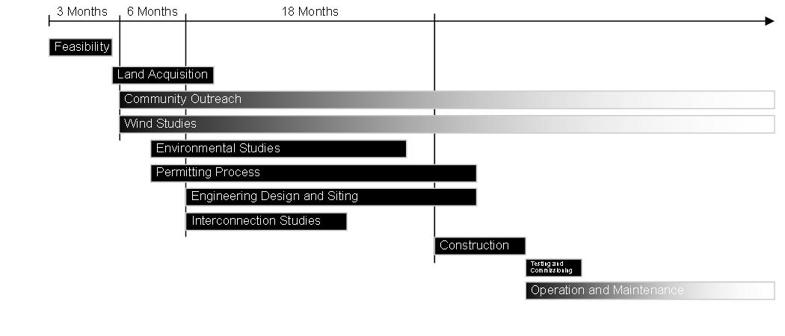
Figure 1: Process Timeline

Project developers begin by searching out locations with strong winds. When a promising location has been identified, it will be analyzed for feasibility. Once developers have identified feasible locations, they will visit the communities surrounding feasible locations, and investigate whether the locals will be willing to lease land, and whether they will be receptive to a wind energy installation.
If a locale is shown to be receptive, developers will seek out funding sources, and will take out options to lease enough land to adequately site the project, and will begin collecting wind data. If the wind data confirms that the location is strong, they will begin to pursue the legal requirements necessary to build – applying for zoning and construction permits, as well as conducting environmental studies.
Engineering design will be based on the site information gleaned from wind studies, land options, environmental studies, and local construction restrictions. Engineers will also submit information to the appropriate planning authorities, who will execute interconnection studies.
When all of the above steps have been completed, construction can begin. Once completed, the plant will be tested, then commissioned. It will run for many years, with periodic maintenance. After it has served its economic life, it will be retired.

- Feasibility
Before investing time and energy in this project, we must know if it is feasible. This will be qualified in terms of site conditions, finances, and local permitting.

- Permissions:
Local and state regulations must allow for the construction of structures such as wind turbines in the given region. Construction and zoning laws will specify size, distance, and location restrictions. Aesthetic and sound restrictions may also be specified. If no local code addresses the construction of wind turbines or similar structures, there must be a good chance of passing a viable ordinance or special construction permits and easements to accommodate construction of a wind farm.
- FAA Restrictions and Military Interests:
Wind turbines can become flight obstacles and can interfere with radar and radio communication links. The FAA specifies the minimum distance from an airport at which an obstacle of a given height may be constructed. Similarly, military installations may have differing levels of restriction as to where turbines may be constructed.
- Available Land :
Wind farms are often spread out over an area of 25 square miles or more. The owners of the land on which a project is to be built must be willing to sell or lease their land for wind construction. The land itself must also be appropriately free of obstacles such as trees, structures, or sharp ridges. Turbines must be set back a significant distance from any residences, so a high population density may make siting a project more difficult.
- Environmental Restrictions:
Areas of natural preservation such as National Parks, State Parks, nature conservatories, and sensitive ecosystems should be avoided. Construction on or near environments with protected status or with sensitive ecologies will be very difficult, and can cause projects to become infeasible. Similarly, lands with historic preservation status should also be avoided.
- Local Acceptance:
Many wind projects will require easements and special building permits, which require the approval of local citizens. Community members should be informed early in the planning process about the nature of proposed construction. If citizens are not fully informed about a turbine installation, its potential sound emission levels and impact on the local skyline, they may create a difficult political environment in which to try to build – jeopardizing not just one project, but also future wind projects.
- Grid Connection:
The viability of a wind plant can depend heavily on the ability to connect it to the larger electrical grid. Transmission lines can be expensive, and can meet a great deal of social opposition, so it is desirable to site a wind plant a short distance from its point of interconnection. Local transmission infrastructure must also support either the consumption of wind energy as load or the long-distance delivery of energy. Connection to a weak grid can either limit the capacity of the plant or add significant costs to its interconnection. A weak local grid, or a long distance to the point of interconnection can severely hinder a wind energy project.
- Economic Viability:
A project must have a reasonable probability of fulfilling some specified financial goals. Commercial projects must pay for themselves in a finite time period. Investor-owned utilities and publically-owned utilities must pay for projects with a limited increase in cost to the consumer. Independent power producers must be able to attain some minimum rate of return on their investment. Costs can be estimated based on limited knowledge of the local wind regime, estimation of installation and construction costs, and estimations of operation and maintenance costs. As the project becomes better defined, these costs will be clarified, and a financial plan will be solidified, but feasibility must be guaranteed before a company can commit to a project.

As with any engineering project, planning phases may overlap, and concerns may be addressed in several stages. The above considerations are just minimal considerations before a project can be undertaken. Most of them will be considered more thoroughly later, in one of the succeeding steps.
- Siting Wind Energy Projects
Wind is an abundant resource. Its effects can be observed all over the globe. It is tempting to believe that a wind turbine can be built nearly anywhere. But, wind energy technology can be expensive. So, before beginning a project, we must know how much wind energy is available at our site, and whether that is enough to justify the cost of a wind energy project.
The most important attribute of a wind energy project site is its wind resource. Wind is considered a resource in the same way that water, coal, and natural gas – it can be harvested and put to a good use. The amount of wind that can be efficiently harvested (or, in this case, converted into electricity) is greater in some areas than in others. In order to quantify the wind energy available at a site, we must know two things: how fast and how often the wind blows, and how much power can be extracted from that wind.

- Locating Wind Resources
Project developers begin by locating areas with strong wind resources. The most basic way to quantify the quality of a wind resource is to identify the average wind speed in that area. Higher velocity winds will produce more power, on average. The relationship between wind speed and power is covered in more detail in Section 3 b, and in the “Wind Energy Basics” Module. Wind speed data can come from several sources. Wind developers first look at wind maps, to find areas with high average wind speed. From this larger group of promising sites, they will narrow their focus, looking for sites with geography that will be conducive to wind development. When specific sites have been located, the developers will acquire the rights to use some local land, then erect met towers which will be used to collect several years worth of meteorological data, in order to verify that the wind in that location is indeed strong.
Maps showing average monthly and annual wind speed are available from the National Renewable Energy Lab, from state-level energy agencies, and from many commercial consulting companies. An example wind speed map is shown as Figure 1. Developers will use these maps to gauge where winds are strong. The Iowa Energy Center (IEC) website also contains some maps and a wind calculator, through which the wind-speed distribution of a particular region can be obtained. Figure 2 shows an estimated wind speed distribution for an 80 meter tall tower near Ames, IA, which was generated by the Wind Calculator from the IEC. Wind speed distributions describe how often the wind is expected to blow at a particular speed at a given location. The information from these resources is based on the results of computer models of wind, and has been verified by comparisons with anemometers that are located at airports and schools across the state. This information is accurate over the space of a few square miles, but will not be very precise, since the behavior of wind is highly dependent on localized geography.
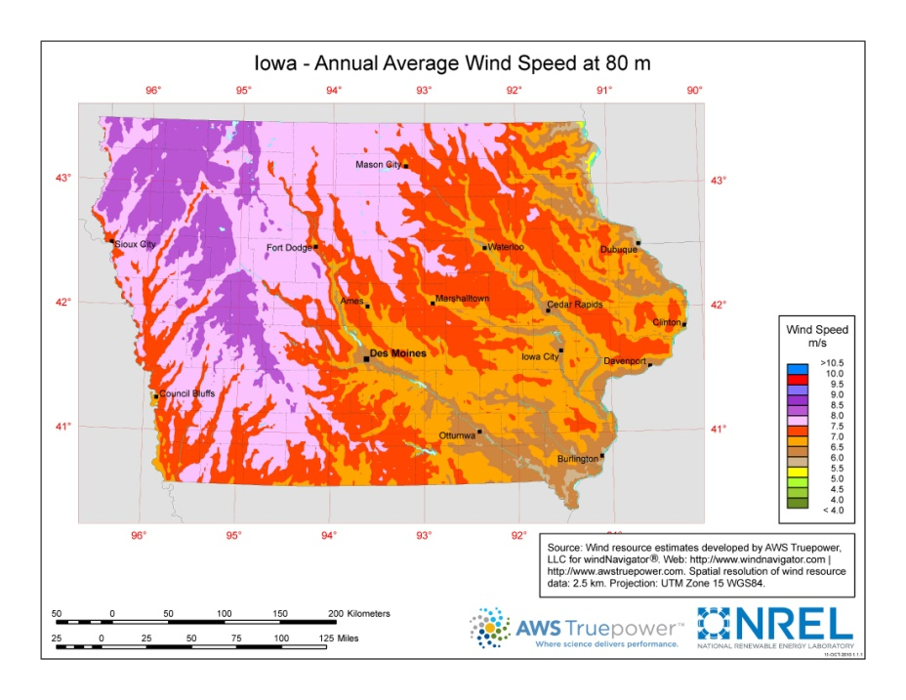
Figure 1: NREL Wind Speed Map for Iowa

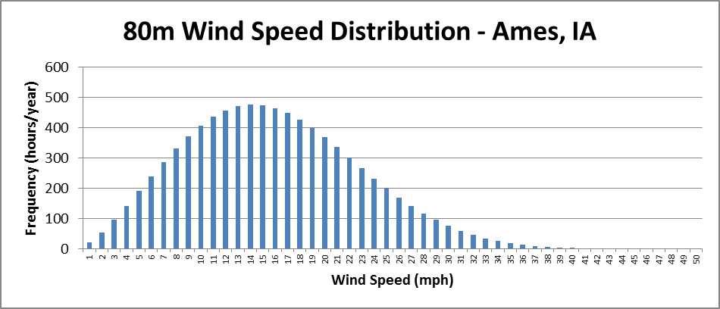
Figure 2: Wind Speed Distribution for Ames, IA, from the IEC Wind Calculator

Sites with good wind resources will be analyzed for their overall feasibility, based on the concerns mentioned in Section 2. From the set of feasible sites, the best sites will then be pursued for development.
Once a developer has selected a site in which to locate his project, he will use several tools to quantify the energy that is available from that site. The first major tool is local meteorological data. Developers will install several tall meteorological towers (‘met towers’) at key points in the properties where they intend to build. These towers will collect precise information about the wind available on their site, including wind speed distributions and directional distributions (called ‘wind roses’) at several heights. Towers may also record temperature, humidity, and air density. Ideally, this data will be collected over the course of several years, to confirm the true potential of the wind resources in the area, and to judge the year-to-year variability of the wind resource.
Project developers also utilize computer simulation to investigate the wind properties of these specific sites. The geography of these sites can be measured and entered into a precise physical model of the terrain. The data from wind maps and met towers is entered into Computational Fluid Dynamics (CFD) models, which estimate the way that wind will flow across the terrain. These models can be used to estimate the energy yield available in particular locations, and to show the best locations to place turbines.
The process of placing individual turbines to maximize their annual energy yield is called ‘micro-siting.’ Methods of placing turbines may vary with geography, but usually follow some basic patterns. Most wind farms are arranged as strings of turbines. These strings are often placed parallel to each other, and spaced so that the wakes of each row will have a minimum impact on the row behind it. In other arrangements, strings of turbines may be placed along gentle geographic ridges, or just in one long line. Other farms do not follow any apparent geometric structure. Several different arrangement examples were shown in the NREL land-use survey cited previously, and are shown in Figure 3Error: Reference source not found.
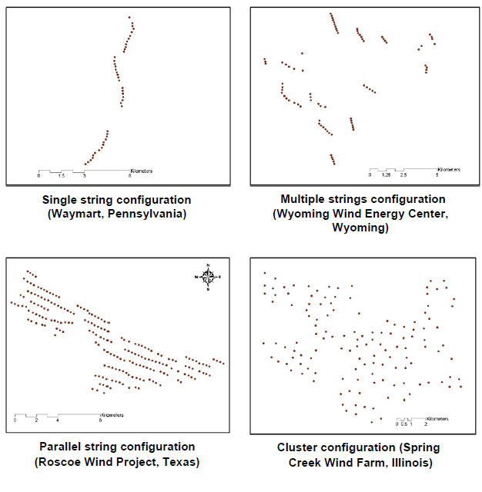
Figure 3: Common Arrangements of Wind Farms

- Energy from Wind
Wind is moving air, which has kinetic energy. For a wind turbine with blades that sweep through a circular area , with an unperturbed wind-speed and air-density , the maximum mechanical power transferred to the blades of the wind turbine is
where is Betz’ Limit (derived in the “Wind Energy Basics” Module). From this, we can see that power increases with the third power of wind speed , so a moderate increase in average wind speed can produce a significant increase in average power output. A 10% increase in wind speed can produce up to a 33% increase in power output.
Real wind turbines do not attain Betz’ Limit. Their operation is limited by the properties of the machines themselves. The following describes the operation of a modern DFIG or PMSG generator. At low speeds, they require quite a bit of reactive power and lose a lot of energy in the copper windings of the generator and in its power electronic converter. So, at these speeds (speeds below the ‘cut-in speed’), the turbine will furl its blades and not generate any power. At moderate wind speeds, the turbine will track wind speed and match its rotational speed to maximize output power. The output in this range is proportional to the wind speed cubed, but less than the Betz’ Limit. This occurs between the ‘cut-in wind speed’ and the ‘rated wind speed’. At wind speeds greater than ‘rated wind speed’, the generator and electronics will limit the amount of power that can be produced, so they will modulate the rotor speed in order to produce the rated amount of power.
This operation is described by a ‘Power Curve’ which relates upwind wind speed to the electrical power that a turbine will produces at that wind speed. These curves can be found in the spec. sheets for any wind turbine model. Figure 4 shows the power curve of a Vestas V90 wind turbine, which has a 90m rotor diameter, and which has a maximum power output of 1800 kW.
Figure 4: Power Output Curve for Vestas V90 Wind Turbine

Modern wind turbines have blades mounted at a height of 80m or more off the ground. Increasing the height of a turbine will expose it to faster winds. The surface of the earth tends to slow down the air near the ground, so air further off the ground will have a greater speed. This effect is called ‘wind shear’. Wind shear can is often approximated by the function:
,
where is the wind speed at 10m off the ground, is the wind speed at the desired height, and is a constant between 0.14 (smooth ground with few trees) and 0.17 (rough hilly ground, perhaps with a few trees). This formula is only applicable for heights of greater than 4m. Figure 5 demonstrates this relationship for a location with average wind speeds of 7 m/s at a height of 80m, and moderately rough terrain (represented by ). You can see that increasing the hub height will increase the average wind speed. More details on the effect of hub height and ground-level obstacles are covered in “Wind Energy Basics”.
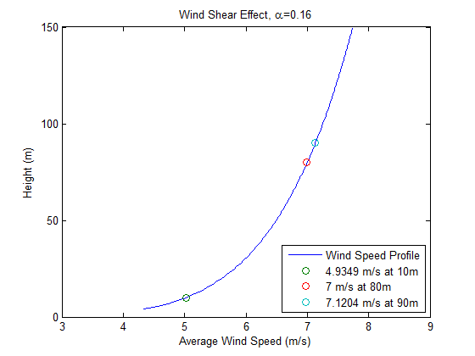
Figure 5: Wind Shear Changes Average Wind Speed
Wind does not blow at just one speed. Some days, there may be no wind, while other days the wind may be very strong. The variety of wind speeds seen in a region can be described by a statistical probability function called the probability distribution. Wind speed is often described using a specific form of probability distribution called the ‘Weibull distribution’. A typical wind speed distribution is shown in Figure 6. The meaning of this is as follows: out of the 8760 hours in a year, about 8760 x 0.108 = 946 hours will have average wind speeds of between 5 and 6 m/s.
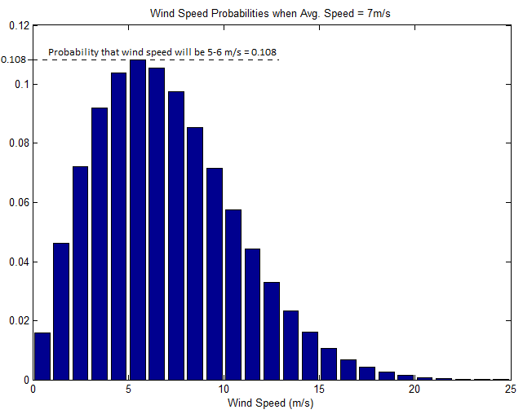
Figure 6: Hourly Wind Speed Probability Distribution for an Avg. Speed of 7 m/s
This wind speed distribution can be used to estimate the annual energy output of a wind turbine. Multiplying the power curve of a wind turbine by the wind distribution for produces a function which relates wind speed to the number of kWh of energy available from the wind at that speed over the course of a year. This relationship is visualized in Figure 7. Summing over all those wind speeds gives the total amount of energy that could be extracted from the wind at that location by the specified wind turbine in one year. This is the process that the IEC wind calculator uses to estimate wind production.
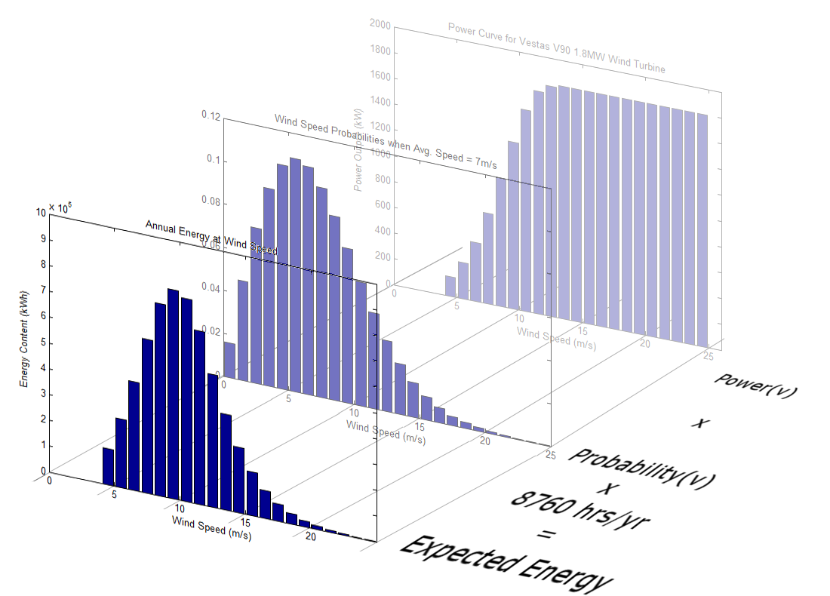
Figure 7: Expected energy to be produced at each wind speed, over the course of a year.
The IEC wind calculator was used to estimate annual energy production for a Clipper Liberty 2.5MW wind turbine with a hub height of 80m at several locations in Iowa. The results listed in Table 1. The first two large wind farms in Iowa were built near Storm Lake and Riceville.

 | Average Annual Wind Speed (m/s) | Capacity Factor | Annual Energy  MWh/yr
Ames, IA | 7.08 | 34.91 | 7,612,773
Storm Lake, IA | 7.74 | 40.76 | 9,029,220
Riceville, IA | 7.76 | 41.44 | 9,067,218
Table 1: IEC Wind Calculator Estimates of Annual Energy Production
The third column of Table 1 lists the ‘Capacity Factor’s of the wind turbine at each location. A ‘capacity factor’ is equal to the total amount of energy a source produces in a year divided by the maximum amount of energy it could produce in a year. A high capacity factor indicates that a generator produces more energy on average over the course of a year. Wind turbines in areas with strong winds will have higher capacity factors, produce more energy, and thus be more profitable. A capacity factor can be calculated as follows:
,
where is the amount of energy produced by the turbine in a year, 8760 is the number of hours in a year, and is the maximum power output of the turbine.
The statistical method described above is valid for estimating wind energy production for a single turbine in an open space free of obstacles. In a wind farm, there will be a variety of geographic features, man-made obstacles, and other wind turbines which will change the way that wind flows. To quantify these effects, many project developers will use their sophisticated computer models to estimate total energy production in a wind farm.
A key aspect of siting a wind farm is spacing wind turbines appropriately. A survey by NREL in 2009 has shown that most existing wind farms in the US have capacity densities of 1-6 MW/km². New wind projects tend to be spaced more closely, and tend towards higher capacity densities. Spacing turbines closer together reduces land use, which decreases cost and makes it easier to acquire sufficient land for the project. But, it is not always be in the best interest of developers to space turbines close to each other. When a turbine converts the kinetic energy of wind into electrical energy, that energy is removed from the airstream which passes that turbine. The air on the downstream side of the turbine will be at a lower energy level. A low-energy column of air, called a wake or a shadow, will extend downstream from the turbine. This stream dissipates with length, as low-speed air at high pressure expands outward until it reaches a uniform speed and pressure. If another turbine is operating in that wake, the energy that it can produce will be decreased.
Similarly, ground-level obstacles interrupt the smooth flow of wind. They create wakes at ground level, but also create turbulence as wind spills around their edges. This turbulence may extend past to twice the height of the obstacle, and may still be observable 500 feet past the obstacle.
Alternately, turbines placed on high ridges with moderate slopes may benefit from increased wind speeds. Gentle slopes do not perturb the wind, but can expose turbines to wind at higher elevations.
Owners of small wind turbines will use the expected annual energy production to quantify their cost savings. Commercial owners use this total annual energy information to estimate their financial outcomes. They will also use this information when drafting Power Purchase Agreements (PPAs) with other utilities which buy their power. Because utilities have contracted agreements with a variety of entities including other utilities and federal grid regulators, they have all the more incentive to collect accurate data and understand the quantity of their wind resource.

- Financial Feasibility
The project must be justified financially. If the investment is purely financially motivated, then it must pay itself off in a specified length of time. For a small private project like that of AHS, energy costs displaced over time must be compared to the cost of construction, operation and maintenance, and end-of-life disposal costs. Some tax incentives will also impact the perceived costs of the system. For larger for-profit projects, more costs and studies are involved, and net profit over time may be compared to a desired capital return rate. Some people invest in renewable energy out of principle. In this case, costs must still be quantified to check for feasibility, even if the goal is not just to save money in the long run.
A simple financial assessment would include equipment and construction costs, expected repair or replacement costs, maintenance costs, and connection fees. These would be compared against the annual cost savings and possible tax credit from self-generation of energy. Given the fixed costs and annual cost-savings, a simple payback period would be calculated.

- Quantifying Costs
Installation costs are the one-time costs of designing, installing, and commissioning a project. Installation costs for new wind turbines can be estimated based on the size of a wind energy project. Small wind turbines are turbines that have a peak output of 100 kW or less. These are often bought by individuals and installed on their property. Experts in small wind turbines estimate total project costs at between $3000/kW and $5000/kW. So, a 10 kW turbine can be expected to cost $30,000 to $50,000. This cost includes the components of the turbine (the blades, the nacelle, and the tower), the labor and materials needed to install the device, the cost of connecting it to the power grid, and the cost of circuit breakers and other protective equipment.
Per-megawatt installation costs for larger turbines are much lower, estimated at around $1000-$2500 /kW. Large turbines are more common, and their technology is more mature. Generally, larger multi-turbine projects will also benefit from economies of scale, decreasing in cost-per-unit for large orderError: Reference source not found. The installation cost of a typical multi-turbine wind farms is broken down in Table 2 Error: Reference source not found. The turbines themselves account for the majority of costs, but other significant costs include the acquisition of land, the cost of connecting to the electrical grid, and the construction costs of turbine foundations, access roads, and collector circuits. All of these costs can vary from one project to another, depending on the distance between the project and the electrical grid, the cost of labor, the cost of land, and many other factors.

Installation Costs by Category
 | Percent of Installation Cost | 100MW Wind Farm, $2000/kW
Turbine | 80% | $160M
Grid Connection | 9% | $18M
Foundations | 4% | $8M
Electrical Installation | 2% | $4M
Land | 2% | $4M
Access Roads | 1% | $2M
Consulting/Engineering Fees | 1% | $2M
Financial Costs | 1% | $2M
TOTAL | 100% | $200M
Table 2: Breakdown of Installation Costs for a Typical Wind Farm
Installation costs will be paid when a project is first constructed. Every year after that, the project owner will pay for regular maintenance of the machinery. Once or twice a year, a technician will have to check every turbine to verify that it is still in good operating condition. If any parts are worn or give out, they will be replaced. The cost of labor for maintenance personnel will not be very high. But, the cost for servicing or replacing worn parts is not well known. Most wind turbines in the US are less than 10 years old, so it is not yet clear what parts will be prone to failure, or what those failures will cost.
Operational costs include insurance costs, costs for communication equipment, and administrative costsError: Reference source not found. These costs will be paid every year, regardless of how much energy the project produces.
Experts estimate that together, operational and maintenance (O & M) costs for large projects are generally on the order of 2% of installation costs per year, starting low and increasing over the life of the machines as they age and parts develop wear. The Department of Energy, in 2010, estimated that first-year maintenance costs are now around $10/MWh or less. Costs for individual plants appeared to increase over time at a rate of 10-20%/yearError: Reference source not found. O & M costs for new plants decreased steadily over the past 30 years, and have remained steady for the past 3 years, on average. Table 3 shows the expected cost of operations and maintenance for an 100 MW wind farm, over the course of a 20-year lifespan. This farm is assumed to have a capacity factor of 0.35, so out of an 8760 hour hear, it would produce about 0.35*8760h*100MW = 306,600 MWh of energy. This is only an estimate, as an example. Since O&M costs vary widely, a prudent financial analysis should consider the possibility that these costs may be significantly higher or lower.

Year | O&M $/MWh | OM Costs
1 | 10.0 | $3.07 M
2 | 11.5 | $3.53 M
3 | 13.0 | $3.99 M
4 | 14.5 | $4.45 M
5 | 16.0 | $4.91 M
6 | 17.5 | $5.37 M
7 | 19.0 | $5.83 M
8 | 20.5 | $6.29 M
9 | 22.0 | $6.75 M
10 | 23.5 | $7.21 M
11 | 25.0 | $7.67 M
12 | 26.5 | $8.12 M
13 | 28.0 | $8.58 M
14 | 29.5 | $9.04 M
15 | 31.0 | $9.50 M
16 | 32.5 | $9.96 M
17 | 34.0 | $10.42 M
18 | 35.5 | $10.88 M
19 | 37.0 | $11.34 M
20 | 38.5 | $11.80 M
Table 3: Estimated Annual Operations and Maintenance Costs for 100MW Wind Farm
When a turbine is no longer profitable to operate, it will be decommissioned and dismantled. The project owner must pay for the labor of deconstruction and the cost of disposing of or recycling the material. This will be a one-time cost at the end of the turbine’s economic life.

- Quantifying Revenue
So far, only costs have been mentioned. Potential benefits must also be quantified for a project. The primary benefit of an energy project (in this case, a wind energy project) is the revenue from selling electricity. Electricity is sold in units of kilowatt hours (kWh) or megawatt hours (MWh). The energy that a plant will produce must be estimated from the wind that is available at the site where a project is to be built. This estimation was covered in Section 2.a. From that quantity, the value of several different revenue streams can be estimated.
Owners of small wind turbines will typically not produce enough power to sell back to their utility. These private owners will often operate under net-metering agreements, wherein every kWh of energy that they produce will simply be subtracted from their monthly utility bill. Their electrical meter will literally turn backwards at times. At the end of the month, the customer pays for the net energy consumed. If the net consumption is positive (that is, more energy was consumed than was produced), then the value of that energy to the consumer is equal to the amount of energy produced times the cost of energy to the consumer. If the owner of a small wind turbine uses 1000 kWh/month at $0.11/kWh, a wind turbine that produces 700 kWh/month will lower his bill to 300 kWh/month, saving him 700 x $0.11 = $77/month.
If a customer happens to produce more energy than he can consume over the course of a month, that extra energy will be transferred forward as a credit towards the next month’s bill. If they maintain this positive balance for more than a year, the utility company may cancel their extra credit or pay them at the “avoided cost of energy.” The avoided cost is the cost to an energy producer to produce one more MWh. This is basically the cost of fuel, not the retail price of energy.
Most wind farms sell their energy to specific entities in long-term contracts, called Power Purchase Agreements. These agreements will specify the rate at which the power plant will be reimbursed for its energy. This will typically be a single price-per-MWh, which will remain the same for as long as the contract is in place. In 2009, the average price paid for new wind-energy contracts was $53/MWh. The contracted price for wind energy tends to be lower in areas with strong winds and lower for projects that have low installation costs. Between 2006 and 2009, wind energy prices in the Heartland ranged from $25-60/MWhError: Reference source not found. During that same period, the price of wholesale electrical energy from all sources ranged from $30-80/MWhError: Reference source not found.
Because wind energy is a renewable resource, the US government provides a variety of financial incentives for wind energy projects, usually in the form of tax credits. In 1992, the federal government first established the Production Tax Credit, which provided a 1.5ȼ/kWh tax credit to qualifying renewable-energy projects for the first 10 years in which they were in operation. The credit was originally only provided for a few years, but has been renewed several times since then. The reimbursement rate increased with inflation, so the current value of the PTC is 2.2ȼ/kWh (or, $22/MWh).
Instead of the PTC, wind project owners may opt for an Investment Tax Credit (ITC) of 30% of the cost of a project. This would be a one-time tax credit earned as soon as the farm went into service. This may be a more valuable option, depending on the structure of the company owning the wind plant, and depending on the amount of energy expected to be produced by the farm.
The PTC was last renewed with the American Recovery and Reinvestment Act (ARRA) of 2009, and is available until at least December 31, 2012. Also in the ARRA, the ITC was expanded, so that those who qualified for the ITC could instead apply for a one-time cash grant of the same value. A cash grant is valuable to those who do not generally owe much for taxes, or those who cannot secure loans or other sources of funding.
Individual states also provide tax incentives for renewable energy. The state of Iowa has a Production Tax Credit of its own. Depending on the size of the facility, project owners may receive 1.0 ȼ/kWh or 1.5 ȼ /kWh in state tax credit. This credit is only available for facilities larger than 2.5MW but smaller than 30MW, and there are some restrictions on who may own these facilities. The Iowa PTC appears to be available for projects that also receive federal tax incentives.
Wind energy can also be sold on “Green Markets” such as the Chicago Climate Exchange, or the Regional Green Generation Initiative. These markets are forms of voluntary cap-and-trade, where participants agree to reduce the amount of CO₂ that they produce. Participants in these markets can buy shares in CO₂-reducing projects such as wind farms in order to pay for extra CO₂ that they may produce. On the Chicago Climate Exchange, one MWh of renewable energy is worth the amount of CO₂ that generators in its region of the country would typically produce. For instance, Iowa has an eGRID Carbon Emission rating (the amount of CO₂-equivalent produced by regional generation) is around 1820 lb/MWh, which is 0.826 metric tons. In 2010, the value of a metric ton of CO₂-equivalent on the Chicago Climate Exchange was $3.26. So, the value of selling wind energy from Iowa on the Chicago Climate Exchange would be close to $3.26/ton x 0.826 tons/MWh = $2.69/MWh, or around 0.27ȼ/kWh.

- Present Value Analysis
Borrowing money over time has a cost. That cost is referred to as the “time-value” of money. Funding for a project (or, “Capital”) is composed of two parts – equity and liability. Equity is real wealth which is owned by an investor. He gives that money to a project developer, and he expects to be paid in return for the use of that money. Liability is a form of debt – that is, money which is borrowed to the developer and must be returned with interest. The cost of equity is the rate at which stockholders expect to be repaid. The cost of debt is the interest rate. The total rate of repayment for all sources of capital is the “Weighted Average Cost of Capital” (WACC).
Equation (1) gives an example calculation of the WACC, for a project that is financed with 60% bond (debt) and 40% stock (equity). The investors expect an annual repayment of 11% on their investment. The bank who holds your bonds expects 7% interest. The WACC, then, is 8.6%.
To find out whether a project is financially viable, you must take all of these factors into account: Investment Costs, Operations and Maintenance Costs, Revenue, and the cost of capital. One method by which these are all taken into consideration is the “Present Value” method. The “Present Value” of a purchase that you will make a year from now is equal to the amount of money you would have to save today in order to make that purchase. If you expect that you will buy a car a year from now, you will save up money now so that by the time you want to buy the car next year, your money will have gained interest. That is, increased in value. Saving a dollar today, with an annual interest rate of 5%, will provide you with $1.00 x 1.05 = $1.05 a year from now. The rate at which your money increases in value will be known as the “discount rate”. For these examples, a discount rate will be equal to the Weighted Average Cost of Capital.
To “discount” a future cost to its present value, the formula is:
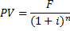
where PV is the present value, F is the future cost, i is the discount rate, and n is the year in which a transaction will be made. The present value of the energy produced under contract in year two would be calculated:
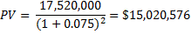
If the same cost is accrued every year, the value a series of annual payments, or “annuities” can be calculated with a single equation:
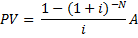
where N is the number of years in which the payment will be made and A is the payment that will be made. Every year, we expect to earn $17,520,000 from energy sales under the power purchase agreement. So, the present value of all contracted energy, over the course of 25 years is:
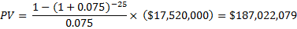

Let’s visualize an example wind project in terms of its annual costs and benefits. Table 4 shows the annual costs for a wind farm project with the following features:

Wind Farm Size = 100 MW
Investment Cost = $1800/kW
Weighted Average Cost of Capital = 7.5%
Capacity Factor = 0.40
Operations and Maintenance Costs (O&M) = ($10 + $1.5/yr)/MWh
Power Purchase Agreement (PPA) Price = $50/MWh
Production Tax Credit (PTC) = $22/MWh
Value on Chicago Climate Exchange (CCX) = $2.70/MWh

From these values, we can calculate annual costs and revenues:

Total Investment Cost = 100 MW x $1800/kW x 1000 kW/MW = $180,000,000
Annual Energy Production = 100 MW x 8760 hr/yr x 0.40 = 350,400 MWh
Annual PPA Revenue = $50/MWh x 350,400 MWh = $17,520,000
Annual PTC (first 10 years) = $22/MWh x 350,400 MWh = $7,708,800
Annual CCX Revenue = $2.70/MWh x 350,400 MWh = $946,134

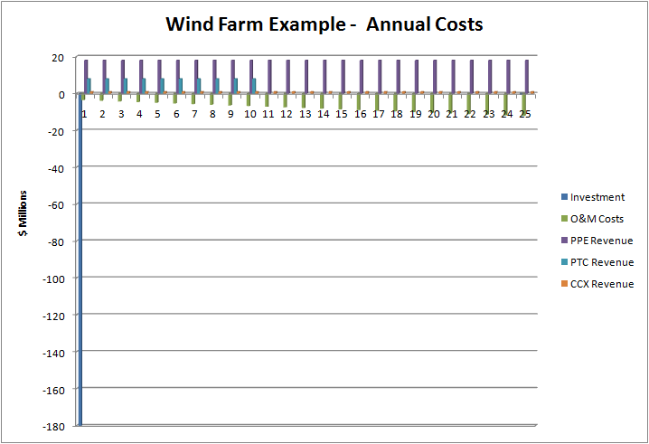
Table 4: Wind Farm Annual Costs

A “payback period” is defined to be the time it takes a project to pay for itself. The present value of a project at the end of its payback period is 0. This will be demonstrated in Table 5 below. In this table, costs and revenues for a single year are calculated in the 4th-7th columns. O&M costs are calculated from the annual energy produced (column 3) and the estimated cost of Operations and Maintenance. The three sources of revenue are constant, assuming that the same amount of energy is produced every year. These values were calculated in the setup for Table 4.
Here, all the annual costs and revenues are calculated, then converted to their present value. Negative values are marked in red, and indicate an amount that is owed. Positive values, in black, indicate an amount which was earned – a positive cash flow. The second to last column is the sum of all cash flows in a year, discounted to the present. The last column is the total present value of the project at the end of the year. At year 21, the total PV finally becomes positive, meaning that it has paid for itself. Therefore, the payback period for this project is 21 years.

Year | Investment  $M | MWh Produced | O&M Costs  $M | PPA  Revenue  $M | PTC  Revenue  $M | CCX Revenue  $M | PV for Year  $M | Total PV  $M
1 | -$180.00 | 350400 | -$3.50 | $17.52 | $7.71 | $0.95 | -$158.91 | -$158.91
2 |  | 350400 | -$3.85 | $17.52 | $7.71 | $0.95 | $19.31 | -$139.60
3 |  | 350400 | -$4.20 | $17.52 | $7.71 | $0.95 | $17.69 | -$121.91
4 |  | 350400 | -$4.56 | $17.52 | $7.71 | $0.95 | $16.19 | -$105.72
5 |  | 350400 | -$4.91 | $17.52 | $7.71 | $0.95 | $14.82 | -$90.91
6 |  | 350400 | -$5.26 | $17.52 | $7.71 | $0.95 | $13.55 | -$77.35
7 |  | 350400 | -$5.61 | $17.52 | $7.71 | $0.95 | $12.40 | -$64.95
8 |  | 350400 | -$5.96 | $17.52 | $7.71 | $0.95 | $11.34 | -$53.62
9 |  | 350400 | -$6.31 | $17.52 | $7.71 | $0.95 | $10.36 | -$43.26
10 |  | 350400 | -$6.66 | $17.52 | $7.71 | $0.95 | $9.47 | -$33.79
11 |  | 350400 | -$7.01 | $17.52 |  | $0.95 | $5.17 | -$28.61
12 |  | 350400 | -$7.36 | $17.52 |  | $0.95 | $4.66 | -$23.95
13 |  | 350400 | -$7.71 | $17.52 |  | $0.95 | $4.20 | -$19.75
14 |  | 350400 | -$8.06 | $17.52 |  | $0.95 | $3.78 | -$15.97
15 |  | 350400 | -$8.41 | $17.52 |  | $0.95 | $3.40 | -$12.57
16 |  | 350400 | -$8.76 | $17.52 |  | $0.95 | $3.05 | -$9.52
17 |  | 350400 | -$9.11 | $17.52 |  | $0.95 | $2.74 | -$6.78
18 |  | 350400 | -$9.46 | $17.52 |  | $0.95 | $2.45 | -$4.33
19 |  | 350400 | -$9.81 | $17.52 |  | $0.95 | $2.19 | -$2.14
20 |  | 350400 | -$10.16 | $17.52 |  | $0.95 | $1.95 | -$0.19
21 |  | 350400 | -$10.51 | $17.52 |  | $0.95 | $1.74 | $1.56
22 |  | 350400 | -$10.86 | $17.52 |  | $0.95 | $1.55 | $3.10
23 |  | 350400 | -$11.21 | $17.52 |  | $0.95 | $1.37 | $4.48
24 |  | 350400 | -$11.56 | $17.52 |  | $0.95 | $1.22 | $5.70
25 | -$0.80 | 350400 | -$11.91 | $17.52 |  | $0.95 | $0.93 | $6.63
Table 5: Present Value Analysis of Example Wind Project
There are a lot of assumptions built into the financial plan outlined above. If any of those assumptions is wrong, such as the amount of energy that will be generated annually, a plan like this could become unprofitable or infeasible. Financial analysts will recompute these financial plans with various assumptions, in order to show that this project is feasible for a wide range of conditions. This process is known as ‘sensitivity analysis.’
Figure 8 shows the sensitivity of this plan to a lower- or higher-than-expected annual energy production, by computing the present value over time for several capacity factors. This test presumes that the estimate of wind energy production may be off by a few percent, and shows how that would affect the payback period for this plan.
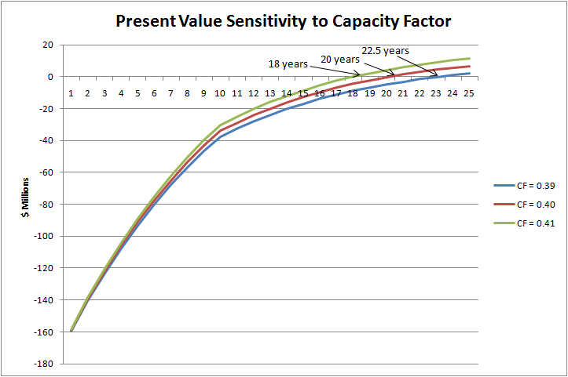
Figure 8: Sensitivity to Annual Energy Production
Figure 9 shows the sensitivity to the Weighted Average Cost of Capitol. This represents the possibility that the project developer may not be able to secure capital at low cost. You can see that while the variations in funding may not be very large, the payback period can change significantly, depending on the assumptions of your financial plan.

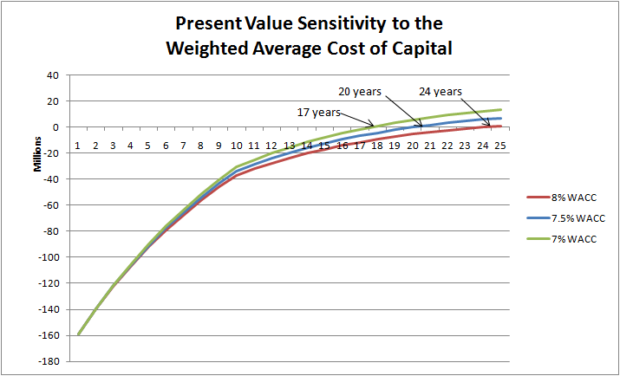
Figure 9: Sensitivity to the Cost of Capital
The present value method can also be used to investigate whether one form of government subsidy may be better than another. Currently in the United States, renewable energy products can apply for one of a few benefits – a Production Tax Credit for every MWh produced, an Investment Tax Credit towards the cost of investment, or a cash grant worth the same as the Investment Tax Credit. Using the present value method, we can compare the value of these benefits.
The current PTC rate is $22/MWh. This benefit will be applied over the course of 10 years. As previously established, the estimated annual energy produced by the example wind farm will be 350,400 MWh. Using the formula for annuities, the value of the PTC for this project is estimated:
The ITC is 30% of investment costs. From the assumptions above, investment costs totaled $180 Million. The ITC is granted at the beginning of the project, so it does not need to be discounted. Its value is calculated:

In this case, the ITC appears to be worth more, than the PTC. If the ITC is used in the present-value analysis, the payback period will be shorter, and may be less dependent on the amount of energy produced. Figure 10 shows a sensitivity analysis utilizing the ITC instead of the PTC.
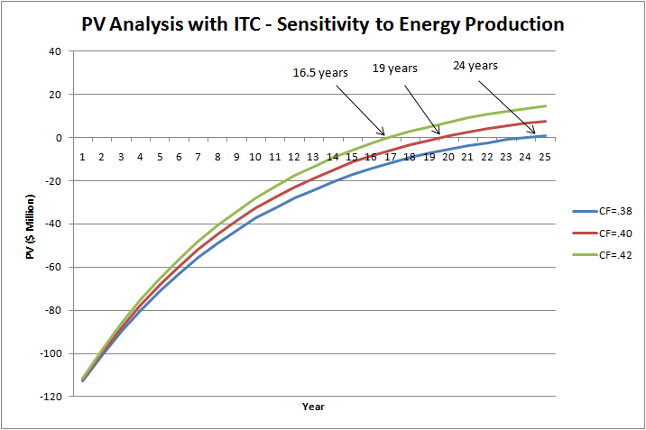
Figure 10: Sensitivity to Energy Production
- Community Outreach
If a project does not have the support of the surrounding community, it may have a hard time obtaining enough land, and it will be difficult to obtain the permits necessary for construction and operation. Project developers seek to meet with communities as early as possible in the development process. Individuals who seek to install their own turbines should also follow this practice. The community concerns related to wind farms are nearly identical to the concerns related to single turbines, and addressing those concerns proactively will enjoin greater community support, both in the planning and construction stages, and during the operating life of the project.
Neighbors and community members can have a wide variety of concerns relating to wind turbines and wind energy development. Some concerns are related to the structures themselves. Wind turbines may be perceived as noisy – they emit an electrical hum, as well as mechanical and aerodynamic noise. They cast shadows, which flicker with the spinning blades. Some people worry that a turbine will intrude on a more natural landscape. Farmers who consider leasing property to developers will want to know how turbines will affect their ability to raise crops, and may be concerned about damage caused during installation.
Other concerns may be related to the financial and business aspects of the project. Some folks question whether wind energy is affordable, and whether it will drive up local energy prices. Others may see an outside business as exploitive, benefiting communities or individuals far away while exploiting their local resources.
Developers should have clear tangible answers to all of these questions. Questions about turbine structure and appearance can most easily be explained with pictures and maps. Developers may be able to point to previous projects as examples. Many concerns raised by members of a community are concerns that the developer is already considering. City and county ordinances frequently place restrictions on the placement of turbines and other equipment to prevent them from aurally or visually intruding on the public. For this reason, engineering design will already be required to show that turbines stay below noise limitations, that turbines should not cast shadows over existing buildings, and that they be located far from existing structures. There may also be restrictions on the appearance of turbines.
Wind farms bring in temporary jobs, providing some boost in local business. They also bring in tax revenue for the community, through energy sales. These are two positive aspects of the business associated with wind development.
Most wind farm developers, after choosing a region in which to develop, will call announce a public information session, in which they will lay out their plans, in as much detail as possible. Members of the community will be invited to attend and voice their input. Depending on the input at that meeting, more meetings may be held in the future. Many developers will create websites describing their projects for the public. Some companies will maintain a phone-in hotline for community members to direct their questions or comments. Community outreach will be an ongoing task. Community members may raise concerns even after the permits have been signed, perhaps especially once the turbine is in construction or in operation.
It is in a project owner’s best interest to maintain good relationships with the communities in which they build. Members of the local community can alert owners to problems with their equipment that may not be obvious from the sensors that are visible to grid operators. And, in general, interacting graciously with locals can engender positive feelings about wind energy within the community, so that other projects in the area are not met with public resistance.
In early May 2010, the Ames city zoning board held a public forum to learn the concerns and objections that members of the Ames community had about wind power. Community concerns about wind turbines included but are not limited to noise pollution, shadow flicker from rapidly moving turbine blades, danger to birds and bats, visual aesthetic, and falling ice / debris. The Zoning Bill sought to address many of these concerns by limiting the types of wind equipment to be installed. For visual reasons, only monopole towers are allowed outside of industrial plots, since their slender shape is thought to be more natural and graceful than that of lattice structures. Noise levels are established such that generators may not be audible outside of developed properties. Placement of turbines is limited in such a way that shadow flicker may not be projected onto any residential building.
The Ames community, as expressed by the city planning and zoning board, does not yet have a great deal of exposure to the kinds of wind turbines that may be installed in town, so their questions may range from curious to furious. If one goal of this project is to increase student and community interest in the study of electric power and energy, then it would be in our interest to make significant effort to closely engage students and community in advance of, during, and after installation of the wind turbine.

- Land Acquisition
Land acquisition begins before met towers are installed, and very soon after preliminary feasibility studies have been done. Developers will begin talking to local land owners and seeking options on their land. They will describe their intentions, and seek to acquire options to lease or buy enough land for their project. Some landowners may be opposed to the placement of wind turbines on their property. This opposition is described in the “Community Outreach” section of this document. If developers cannot acquire enough land rights, their project may have to be scaled back, or may become infeasible. If this occurs, then developers will decline their option on the land, and scrap the project. If they acquire plenty of land, and the wind resource is found to be strong, then the project can move forward. Once some land has been optioned and the perceptions of the community have been measured, developers will be able to apply for permits and erect several met towers, so they can begin to collect wind data.
Wind projects take up space. All turbines will be mounted on a foundation. They require space for electrical connection and protective equipment. Wind farms require access roads for maintenance crews, and require extra space for construction and delivery equipment when they are being installed. Wind farms also require a central substation, where the power from the whole wind farm is connected to a transmission line.
Small wind projects are typically built on private property which is already owned. Most landowners will not need to acquire any land rights, but they may need to negotiate with their neighbors if the turbine is to be placed near the edge of their property.
Projects that are not privately owned will need to acquire land rights from the individuals who own the land. It is typical for a land owner to lease their entire property, even if the project will only utilize part of that property. A survey by National Renewable Energy Laboratory indicated that most wind projects only use 2-5% of the land that they are located onError: Reference source not found. That area includes the land for turbines, access roads, distribution cables, and substations. The remaining land can still be used for its original purpose – often, as farmland. The project developer must pay the rights to use all of this land, and will typically reimburse farmers for temporary damage caused by construction as well.
Land use contracts can take several forms. Some contracts simply lease the farmer’s land. Others will pay landowners a share of the wind-park’s revenue. Some parcels of land may be bought outright. Land leases are often signed for 30-50 years. In the past, landowners have earned $3000-$5000 per year, per turbine located on their land.

- Interconnection Studies
Energy produced by a wind farm has to be delivered to its corresponding load. For small projects, that load will be on the same piece of property, and the connection will be very short. For community wind projects that serve a local load, this may be a distribution line between the wind farm and a local substation. For large wind farms which serve decentralized loads, this will likely be accomplished by connecting a transmission line from the plant substation to the nearest transmission line.
Electrical utility companies must guarantee that they can deliver power reliably and economically. Adding a new piece of equipment to the power grid can change the way that power flows on a day-to-day basis. So, before a new generator can be connected to the grid, the grid operators must verify that it will not cause undue disruptions to their system.
For utility-grade wind farms, interconnection studies will be performed by the organization that owns and operates the local transmission lines. In the Midwest, this would be performed by Midwest Independent System Operator (MISO). They will certify that the planned generation does not exceed the carrying capabilities of the transmission grid. Excess current causes transmission line conductors to heat, expand, and subsequently sag. This can cause lines to violate above-ground clearances, and risk causing faults. High current flow may also cause reactive power consumption and consequent voltage depression, necessitating deployment of voltage control devices. Transformers, circuit breakers, and other protective equipment have operational limits, and may have to be upgraded to handle the new load.
If a proposed project does exceed local transmission limitations, the developer will need to front some of the costs of new transmission equipment, or share that cost with other generators with similar interests. Interconnection studies through MISO have significant costs, and interested parties must show commitment to projects through timely purchase of parts, statements of financial commitment, or through construction. If an enterprise entered MISO’s queue today, it would take 6-months to 2 years to complete their interconnection study, depending on the size of their project and its location relative to congested transmission lines.
The turbine proposed at Ames High School would be connected to the utility’s distribution system – the same lines that feed power to Ames High. The proposed turbine would be very small compared to the load that is already served by the distribution line. Peak load at AHS has been estimated to be greater than 1 MW, while the wind energy system would be limited to less than 100 kW. The utility company will do an interconnection study, but this project is not likely to change the requirements of the distribution circuit that is already in place.

- Environmental Studies
Wind turbines present new obstructions for avian creatures. This is often listed as the primary environmental concern related to wind farms. However, there are a variety of other significant concerns caused by the large scale of these structures and the wide area in which they are often installed. Most of these are of larger concern to commercial wind-farm developers because their projects cover more land, the land they build on may not be familiar to developers, and because their projects are typically located in less urban areas where wildlife and natural habitat are more abundant. These other concerns include the possible disruption of known historical sites, the level of noise produced by a turbine, and some aesthetic effects imposed by the structure onto its surroundings.
Birds and bats can be killed by wind turbines. The average wind turbine has been shown to kill around 2 birds every year. This number is not large, but its effects may be significant. Some wind farms have been built in migratory paths or close to nesting grounds. For these plants, the bird kill may be much higher. Typical wind farm installations now involve surveys of bird, bat, and other local populations by the Department of Fish and Wildlife.
Wind turbines can be very destructive to bat populations. Bat lungs are very sensitive to the pressure drops that occur in the wake of turbine blades, and many more bats than birds are seen killed at wind turbine sites. Low-pressure wakes are not detectable by bats, but they cause the bats’ lung sacs to overexpand and burst. One proposed solution to this problem is to halt turbine blades at low wind speeds, when bats would more likely be flying and turbines are not producing much power. States are beginning to demand conservation studies by the DNR and Fish and Wildlife Service before construction of large-scale wind facilities, especially in places with indigenous local bird and bat populations. For small wind turbine installation, it may be helpful to observe the proposed building site for bat migrations, and to place it further away from trees, where bats tend to roost.
A typical wind farm will require 35 hectares of developed land per MW of capacity, and will span an area of 1/6 to 1 mi²/MW Error: Reference source not found. Developers are careful to avoid natural habitats like wetlands and native prairie. The US Natural Resource Conservation Service performs wetland delineations for most sites. Developers also seek to avoid destruction of sites of archeological or historical significance. State Archeological boards are often engaged in order to avoid the destruction of historical landmarks or other archeological sites.
When turbines are installed in town, a variety of other concerns are often brought to light. Citizens are concerned that a turbine will cause significant noise pollution. Turbines will cause an electric hum, but this tends to dissipate quickly with distance. Turbine blades produce noise and can cause flickering shadows. These and other concerns are discussed in the “Community Outreach” section of this document, but may also be considered relevant environmental concerns.
The Zoning Bill specifies that no machine with an inherent volume of 55 dB should be allowed, and no noise over ambient noise should be observable from non-wind-zoned properties. Spinning blades can cause a flickering shadow over some part of the adjacent property. The Ames zoning ordinance would require that no flicker should be seen on or in any residential structure. Property owners may be concerned about the visual aesthetic of the turbine itself. They may also be concerned that the construction process will bring in noisy, destructive equipment. The Ames zoning code is designed to mitigate many of these concerns. Because VAWTs are often installed on existing structures and can be simpler to install, they may cause less of these environmental disturbances.

- Engineering Design
Once feasibility has been concluded, land has been acquired, and wind data has been collected, an engineered design can be developed. This design will include selecting the turbines themselves, specifying their precise locations, and specifying its interconnection scheme. For wind farms, this will also include substation design.
Wind farms span large patches of land. Within that land, there may be some locations where the wind is stronger and more consistent than others. These spots will be located using specialized software, as described in Section 2a.
When the locations of all turbines are specified, engineers will begin designing collection circuits to deliver the energy produced by each turbine to the substation.
For systems under 10 kW, most of the necessary equipment may come prepackaged, including the turbine, tower, and inverter. Interconnection of these turbines will be local – either through a home circuit-breaker, or at a local transformer. Turbines must be placed in such a way that they respect the local building code. Engineering documents will include a one-line diagram outlining the connection between the turbine and the bus it is connected to, a map detailing its location in reference to property lines, and an artistic rendering of the turbine in its specified location. These documents will be required to obtain building and interconnection permits from the local zoning board and the utility company respectively.
The Ames Zoning Bill lists a wide variety of physical and locational requirements for free-standing monopole wind turbines. Many of these requirements are also requirements of the utility interconnection agreements. The Zoning Bill does not require all projects to be approved by a licensed engineer, but it specifies that such a requirement may be applied to any project at the discretion of the Zoning Board.
Ames Electric Service requires that an Iowa Licensed Professional Engineer must sign off on any electrical design that is submitted for proposed interconnection. Said system must comply with all applicable IEEE standards for flicker, frequency, and harmonics, operate at a power factor of > 0.90, de-energize under islanding conditions, must be capable of arresting its maximum fault current, and must provide a lockable disconnect for use by the utility company.
Since this system is intended as an educational tool, the design of the system ought to reflect this goal. The ability to observe individual components within the turbine would be preferable. A set of sensors and meters should be utilized to visually demonstrate the system’s internal operation.

- Permitting Process
Wind turbines are large structures which can impact a community environmentally, sonically, aesthetically, and financially. Several types of permits are required for the construction and operation of a wind farm, in order to ensure that it does not impose on existing members of the community.
A special use permit is required for installing a wind system in most areas. Some counties have specific ordinances relating to acceptable wind energy systems. These ordinances dictate minimum spacing between turbines, between turbines and other buildings, between turbines and property lines, and between turbines and other infrastructural elements such as transmission lines and highways. They often indicate a maximum allowable noise level at a given distance from any turbine. Many ordinances will require that shadows cast by turbines should not be projected upon buildings in the area. Ordinances may also specify aesthetic details, including the type of tower structure, the color of the structure, and whether it may be branded with any logos.
Other communities may not have specific zoning rules, but will likely require a special use permit before construction.
To obtain either of these permits, the project developer will need structural engineering documents, maps of the locations of every turbine, and may be required to show a conceptual visual rendering of the final project. A professional engineer will be required to sign off on these plans, and the zoning board may require evidence that the developer is working with the electrical utilities, to show good faith.
A service agreement will be required before the turbine can be electrically connected. Small projects will not receive heavy scrutiny, but they will require an agreement with the utility company. This is often written up as a net-metering agreement. The utility company will want to know the rated power of the turbine they install. They have to assure that it will not degrade the local distribution system. They will also require an appropriate level of protective equipment. In particular, many utilities require an accessible disconnect switch, so that when they service the distribution level, they can be assured that the lines are de-energized.
Wind farms will require more formal contracts known as Interconnection Agreements. These will be signed with a transmission owner, once the Interconnection study has been completed. This agreement may be contingent on some transmission system upgrades, as described in the previous section. An Interconnection Agreement will require a full set of engineering documents for the electrical design of the interconnection, as well as a building permit. Under the interconnection agreement, a system must be tested by a certified testing agent, and written approval must be given by the utility before it may be connected to the grid.
In order to connect the generator, an Interconnection Agreement (“IC”) must be signed. The IC requires a full set of engineering documents for the electrical design of the interconnection, as well as an electrical permit and building permit. Under the interconnection agreement, a system must be tested by a certified testing agent, and written approval must be given by the utility before it may be connected to the grid.
The FAA requires that an FAA 7460 notification be filed for every proposed structure above a specified height. The response from the FAA will be either approval or denial of the proposed construction. Ames High School is just under 15000 ft. from the nearest runway, so any construction there would be limited to 15000/100 = 150 ft. tall. Any turbine built at AHS would be under 120 ft. tall and would likely not draw any ire from the FAA.

- Permitting Considerations for Schools in Ames, IA
The city of Ames passed a Small Wind Energy System Zoning Permit bill (“Zoning Bill”), which would augment its local building codes to allow construction of wind turbines on commercial or industrial property. A conversation with Sam Perry of the city zoning commission suggests that it may be possible to pass a similar zoning change for school zones, but construction of a wind turbine on school property is not explicitly legal under the current code, nor under the new bill. He suggests writing a formal letter to the city as soon as it would be appropriate, indicating the interest of residential and School-zone properties in wind energy. The current Zoning Bill has been in process for the past 18 months.
The Zoning Bill does not require a Special Use Permit for a wind system, but there was some discussion that if the bill was extended to residential zones, a Special Use Permit might allow the placement of a turbine closer to existing property lines, with the consent of the residents of adjacent properties.
Several permits and agreements are required for the construction and interconnection of a wind energy system. The city zoning board requires two permits. First, a Small Wind Energy System Zoning Permit (“SWESZP”) must be obtained. This requires a rough engineering design, in that device specifications of wind turbine components are required, as are elevation drawings of the proposed system’s layout.
Once a SEWSZP has been acquired, a separate building permit must be acquired prior to construction. A building permit for a grid-connected project does not require an interconnection agreement with Ames Electric Services, but it does require written authorization from the utility.
Were a zoning bill to be passed which allowed the same class of wind turbine in school zones as approved in the Zoning Bill, free-standing HAWTs would be limited to 120 ft. total height for 7+ acre properties and 100 ft. for 3-7 acre properties. A review of production models of turbines shows that a few turbines rated at 100 kW could be built under 120 ft tall, but a limit of 100 ft would probably allow only 65 kW turbines or smaller. City code requires monopole (non-lattice) towers without guy wires. Freestanding turbines must be placed 1.1x their total height away from all property lines. This is done to prevent damage to nearby structures in the unfortunate event of collapse. The bill allows a maximum of 2 freestanding HAWTs per acre to be installed on a property, but any number of building-mounted units is allowed. Building-mounted turbines must not project more than 10 ft. above the roofline of the structures they are attached to, and not more than 40 ft. into the air total.
Utility companies will also place restrictions on the types of generators that may be built and connected to the local grid. These are technical restrictions that can often be settled by installing proper protective equipment. Still, these restrictions may limit the scale of a project, or may delay its construction if not addressed at the outset. City zoning policy may also limit the types of generation to be built. The Zoning Bill limits turbines to 100 kW. The utilities’ standard interconnection agreement only accommodates generation sources up to 10 kW. The utilities are in the process of researching protection schemes that are necessary for larger generation sources. A professional engineer must sign off on any design, certifying its compliance with UL, NEC, IEEE, and NFPA guidelines, and with local requirements.
In terms of feasibility, an interested party must understand the restrictions of the building code and verify that their project can be built within those guidelines, while maintaining financial viability. If, for instance, the code prohibits larger more efficient turbines, then the energy produced by a smaller turbine may not be enough to offset its cost.
In order to get the most energy production out of a turbine, NREL suggest placing turbines at least 300 ft. from any structure that is less than 30 feet shorter than it. This will reduce the turbulence caused by structures. In general, turbines will be built as tall as city code or economics allows, since wind speed increases with height above ground. The Zoning Bill, and any subsequent bill like it, limit the location of wind turbines relative to trees, power lines, and underground cables.

- Construction
A 50-100kW turbine will be large enough that the installation should be handled by professionals, but the construction process is rather straightforward. First, the groundwork is done where the foundation is set for the tower, and a path is trenched for the electrical connection to the utility. Next, the tower and the rotor are assembled, the tower is erected, and the turbine and rotor are installed. Finally, the controls are connected. After the system is assembled, a trained professional must test the electronics to verify that the protection systems are installed correctly, and that the machine will operate properly when connected to the grid. An inspector from the local utility may observe this test process.
Construction of wind parks follows the same process, but on a much larger scale. Because of all the large moving pieces, construction is as much a logistical problem as a physical problem. Large pieces must be transported from multiple states, arriving on site within a few days of each other. A utility-size turbine and tower can be installed on a foundation in 12 hours, if all the necessary parts have arrived. Construction cranes for large towers are increasingly hard to come by – some cranes in the state of Iowa have 6-month waiting lists. The cost of renting a crane can be very expensive, so the construction process is arranged in such a way as to minimize construction time.

- Maintenance and Operation
Wind turbine manufacturers suggest performing a regular maintenance evaluation on every turbine, twice a year. Maintenance evaluations may include visual inspection of the blades and external structure, testing and inspection of the lubricants in the drive system, and inspection of exposed parts for wear. Testing will also show if the control system is operating correctly. In some cases, damaged or worn parts may have to be replaced. Lightening can do great damage to a turbine’s blades and its electronics, which can be expensive to repair.
Once connected to the grid and properly configured, a turbine should run on its own with little interruption. Because wind energy is variable, it cannot be dispatched the way that other energy sources would be. For this reason, wind is treated like a negative load, and generators throughout the grid compensate for rises and falls in its output. Wind can be predicted, a day ahead of time, with limited accuracy, so grid operators usually have some idea of what to expect.
Operating a turbine is not truly free, even though it requires no fuel. Administrative work is required to show that wind energy producers are following federal regulations, and that the plant is operating within federal guidelines. Communication lines are required to control turbines and transmit operating data. These have service costs.
Most turbines have a listed lifespan of 20-30 years, but modern turbines have not been around long enough for us to truly know whether that figure is accurate. Smaller, less complex turbines have a longer history. No one part has been identified as the Achilles heel of all wind turbine, but some wind-hobbyist sites suggest that you plan for replacement of the gearbox after 5-10 years. The best plan is to conduct periodic evaluations and maintenance. The manual to a turbine will have a specified maintenance regimen. This is often a semi-annual inspection done by a trained professional. If a turbine with a good warrantee is selected, then as long as you perform regular maintenance, it should be insured against component failure. Some cities require a minimum level of insurance on a power-machine, though Ames does not.
If one chooses to install a data-logging system, then simple tracking of its performance over time can be done, and the results can be used to quantify the wind resource and financial savings. Investigation to date indicates that datasets of wind speed above 10m in Ames is not available. A collection of wind speed data could be a great resource for Ames residents in the future.

- End of Life
At some point in the future, the turbine will become too expensive to repair or keep up. This can be considered the end of its life. Once a turbine reaches the end of its life, it must be disposed of. This is required by the city SWES zoning code. Steel towers can be recycled, as can much of the composition of the nacelle, but turbine blades are made of composites – fibers and epoxy – and have very few identified uses. Hopefully, in the future, there will be more ways to dispose of these.

References

http://www.quietrevolution.co.uk/downloads/images/QR_ground_mounted_01.jpg
V90-3.0 MW, Bockingharde,Germany, http://www.vestas.com/en/media/images.aspx
Stimmel, Ron. AWEA 2010 Small Wind Turbine Global Market Study. American Wind Energy Assocition, 2010. http://www.awea.org/learnabout/smallwind/upload/2010_AWEA_Small_Wind_Turbine_Global_Market_Study.pdf
http://www.windustry.org/how-much-do-wind-turbines-cost
Bolinger & Wiser. 2009 Wind Technologies Market Report. United States Department of Energy. August 2010.
Database of State Incentives for Renewables and Efficiency. United States Department of Energy. http://www.dsireusa.org/summarytables/finre.cfm
Wilhelm, John. Presentation to IWEA 2010 Annual Conference. John Deere. 7 April 2010.
Denholm, Hand, Jackson, & Ong. Land-Use Requirements of Modern Wind Power Plants in the United States. National Renewable Energy Laboratory. http://www.nrel.gov/docs/fy09osti/45834.pdf
Wind Powering America. http://www.windpoweringamerica.gov
Wind Assessment Study and Calculator. Iowa Energy Center. http://energy.iastate.edu/Renewable/wind/windstudy-index.htm
Wind Powering America. Iowa Wind Map and Resource Potential. http://www.windpoweringamerica.gov/wind_resource_maps.asp?stateab=ia
Heier, Siegfried. Grid Integration of Wind Energy Conversion Systems. West Sussex, England: Wiley, 2006.
Wizelius, Tore. Developing Wind Power Projects. London, England: Earthscan, 2007.
http://www.energy.gov/additionaltaxbreaks.htm
http://www.chicagoclimatex.com/about/pdf/10-21-10_CCX_Fact_Sheet.pdf
http://www.rsenergysolutions.com/wind-energy-solutions
Rubina, Joseph T. Environmental Considerations During Windfarm Siting. Stanley Consulting. For IWEA Annual Conference, 2 April 2009
https://oeaaa.faa.gov/oeaaa/external/portal.jsp , http://edocket.access.gpo.gov/cfr_2004/janqtr/14cfr77.13.htm
Ames Interconnect Agreement _3-26-2010.pdf
Small Wind Energy Systems: A US Consumers’ Guide. United States Department of Energy, office of Energy Efficiency and Renewable Energy. http://www.nrel.gov/docs/fy07osti/42005.pdf

