Module G1

Solution to problem 1
(a)
$$\begin{aligned}V_{t}=\frac{\text{30}\text{kV}}{\sqrt{3}}=\text{17}\text{.}\text{32}\text{kV} \\ P=\text{50}\text{MW} \\ \text{pf}=0\text{.}8=\text{cos}θ \\ ⇒θ=\text{36}\text{.}\text{87}° \\ P=3\left|V_{t}\right|\left|I_{a}\right|\text{cos}θ⇒\frac{P}{3⋅\left|V_{t}\right|\text{cos}θ}=\frac{\text{50}×{\text{10}}^{6}}{3\left(\text{17}\text{.}\text{32}×{\text{10}}^{3}\right)⋅\left(0\text{.}8\right)}=\left|I_{a}\right|=\text{1202}\text{.}8A \\ ⇒I_{a}=\text{1202}\text{.}8∠−\text{36}\text{.}\text{87}°A \\ E_{f}=V_{t}+I_{a}\left({\text{jX}}_{s}\right)=\text{17}\text{.}\text{32}×{\text{10}}^{3}∠0\text{°+}\left(\text{1202}\text{.}8∠−\text{36}\text{.}\text{87}°\right)⋅\left(j0\text{.}9\right) \\ \text{17970}\text{.}0+j\text{866}V \\ \text{17991}∠2\text{.}\text{759}°V \\ Q_{\text{out}}=\frac{3\left|V_{t}\right|⋅\left|E_{f}\right|}{X_{s}}\text{cos}δ−\frac{3{\left|V_{t}\right|}^{2}}{X_{s}}=\text{37}\text{.}5\text{MVar}\end{aligned}$$

(b)
$$\begin{aligned}P_{\text{out}}=\text{25}\text{MW} \\ ⇒P_{\text{out}}=\text{25}M=\frac{3\left(\text{17}\text{.}\text{32}×{\text{10}}^{3}\right)\left(\text{17990}\right)}{0\text{.}9}\text{sin}δ \\ ⇒δ={\text{sin}}^{−1}\left(0\text{.}\text{0241}\right)=1\text{.}\text{38}° \\ Q_{\text{out}}=\frac{3\left(\text{17}\text{.}\text{32}×{\text{10}}^{3}\right)\left(\text{17}\text{.}\text{99}×{\text{10}}^{3}\right)}{0\text{.}9}\text{cos}\left(1\text{.}\text{38}°\right)−\frac{3(\text{17}\text{.}\text{32}×{\text{10}}^{3})^{2}}{0\text{.}9}=\text{38}\text{.}\text{38}\text{MVar}\end{aligned}$$

(c)
With |E_{f}|=14,248.8volts, we need to find new angle
$\begin{aligned}P=\frac{3\left|V_{t}\right|\left|E_{f}\right|}{X_{s}}\text{sin}δ⇒\frac{\left(\text{50}×{\text{10}}^{6}\right)⋅0\text{.}9}{3\left(\text{17}\text{.}\text{32}×{\text{10}}^{3}\right)\left(\text{14248}\right)}=0\text{.}\text{060}⇒δ=3\text{.}\text{48}° \\ Q_{\text{out}}=\frac{3⋅\left(\text{17}\text{.}\text{32}×{\text{10}}^{3}\right)⋅\left(\text{14},\text{248}\right)}{0\text{.}9}\text{cos}\left(3\text{.}\text{48}\right)−\frac{3{\left(\text{17}\text{.}\text{32}×{\text{10}}^{3}\right)}^{2}}{0\text{.}9}=−\text{178}\text{.}\text{867}\text{MVar}\end{aligned}$

Solution to problem 4
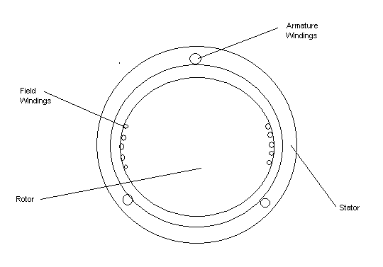

Solution to problem 8
$P=\frac{3⋅\left|Vt\right|⋅\left|Ef\right|}{2}⋅\text{sin}\left(δ\right)=\frac{3⋅\left|\text{127}\text{.}\text{02}\right|⋅\left|\text{132}\text{.}\text{98}\right|}{2}⋅\text{sin}\left(\text{10}\text{.}\text{23}°\right)=\text{4499}\text{.}8$a)

$Q=\frac{3⋅\left|Vt\right|⋅\left|Ef\right|}{2}⋅\text{cos}\left(δ\right)−\frac{3⋅{\left|Vt\right|}^{2}}{2}=\frac{3⋅\left|\text{127}\text{.}\text{02}\right|⋅\left|\text{132}\text{.}\text{98}\right|}{2}⋅\text{cos}\left(\text{10}\text{.}\text{23}°\right)−\frac{3⋅{\left|\text{127}\text{.}\text{02}\right|}^{2}}{0\text{.}\text{95}}=\text{732}\text{.}8\text{var}$b)

$Ia=\frac{Ef−Vt}{\text{jX}s}=\frac{\left(\text{132}\text{.}\text{98}∠\text{10}\text{.}\text{23}°\right)−\left(\text{127}\text{.}\text{02}∠0°\right)}{2∠\text{90}°}=\text{11}\text{.}\text{96}∠−9\text{.}\text{25}°$c)

d)
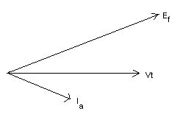e) lagging

f)
$Q=\frac{3⋅\left|Vt\right|⋅\left|Ef\right|}{2}⋅\text{cos}\left(δ\right)−\frac{3⋅{\left|Vt\right|}^{2}}{2}=\frac{3⋅\left|\text{127}\text{.}\text{02}\right|⋅\left|\text{132}\text{.}\text{98}\right|}{2}⋅\text{cos}\left(δ\right)−\frac{3⋅{\left|\text{127}\text{.}\text{02}\right|}^{2}}{0\text{.}\text{95}}=0$$\left(\text{25336}\text{.}7\right)\text{cos}\left(δ\right)−\left(\text{24201}\text{.}1\right)=0$$δ=\text{17}\text{.}\text{22}°$

Solution to problem 9
a)
$$Q=3\left(\frac{E_{f}V_{t}}{X_{s}}\text{cos}δ−\frac{{\left|V_{t}\right|}^{2}}{X_{s}}\right)=3\left(\frac{\text{132}\text{.}\text{98}×\frac{\text{220}}{\sqrt{3}}}{2}\text{cos}\left(\text{10}\text{.}\text{23}\right)−\frac{{\left(\frac{\text{220}}{\sqrt{3}}\right)}^{2}}{2}\right)=\text{733}\text{.}\text{319}\text{Var}$$

b)$\begin{aligned}I_{p}^{}=\frac{\text{1000}+j\text{200}}{\frac{\text{220}}{\sqrt{3}}∠0°}=7\text{.}\text{873}+j1\text{.}\text{575}=8\text{.}\text{0289}∠\text{11}\text{.}\text{31}° \\ \\ E_{f}=\frac{\text{220}}{\sqrt{3}}∠0\text{°+}I_{p}⋅j2=\frac{\text{220}}{\sqrt{3}}∠0\text{°+}\left(7\text{.}\text{873}−j1\text{.}\text{575}\right)⋅j2=\text{130}\text{.}\text{166}+j\text{15}\text{.}\text{75} \\ \text{131}\text{.}\text{115}∠6\text{.}\text{897}°V\end{aligned}$

Solution to problem 10

a)
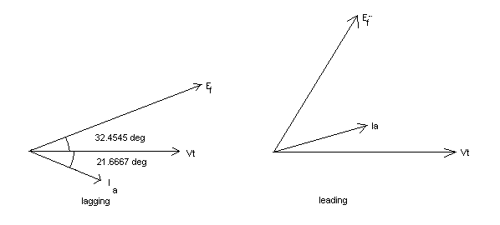
b) To get the below answers in MW and MVAR, multiply by the 3-phase power base, which is specified in the problem to be 100 MVA.

$P=\frac{\left|V1\right|\left|Eg\right|}{Xg}\text{sin}\left(δ\right)=\frac{\left|1\text{.}0\right|\left|1\text{.}\text{5136}\right|}{0\text{.}\text{95}}\text{sin}\left(\text{30}\text{.}\text{4545}\right)=0\text{.}\text{8076}$

$Q=\frac{\left|V1\right|\left|Eg\right|}{Xg}\text{cos}\left(δ\right)−\frac{{\left|V1\right|}^{2}}{Xg}=\frac{\left|1\text{.}0\right|\left|1\text{.}\text{5136}\right|}{0\text{.}\text{95}}\text{cos}\left(\text{30}\text{.}\text{4545}\right)−\frac{{\left|1\text{.}0\right|}^{2}}{0\text{.}\text{95}}=0\text{.}\text{3208}$
$S3,2=\text{VI}∗\left(0\text{.}\text{9713}∠−4\text{.}\text{7692}\right)\left(0\text{.}\text{8689}∠−\text{21}\text{.}\text{6667}\right)=0\text{.}\text{8075}+j0\text{.}\text{2453}$c)

d) P is the same because the transformer has no ‘R’ to cause real power loss. Q is not the same due to the losses in X_{x}.

$\begin{aligned}V_{t}=\frac{\text{13}\text{.}8\text{kV}}{\sqrt{3}}=\text{7967}\text{.}4\text{Volts} \\ E_{f}=V_{t}+j⋅X_{s}⋅I_{a}=\text{7967}\text{.}4V+(j⋅3)⋅\left(\text{400}∠−\text{30}°\right)=\text{7967}\text{.}4V+\text{1200}∠\text{60}° \\ E_{f}=\text{8630}\text{.}2∠6\text{.}\text{92}°\end{aligned}$Solution to problem 11
(a)

(b) At Q = 0,
$\left|E_{f}\right|⋅\text{cos}δ=V_{t}⇒\left|E_{f}\right|=\frac{\left|V_{t}\right|}{\text{cos}δ}=\frac{\text{7967}\text{.}4V}{\text{cos}6\text{.}\text{92}°}=\text{8025}\text{.}9\text{Volts}$

