Quiz 9, EE 303, Fall 2017, Dr. McCalley, Closed notes, book, calculator
Name:_________________________________________________________________
A. (50 pts) A single-phase distribution system is modeled using the circuit below.
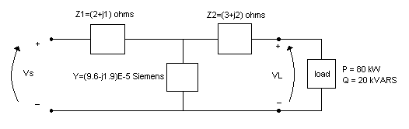1. Compute the voltage at the source to hold a voltage of 4kV at the load bus.
2. Compute the voltage regulation for this condition.
Solution:
1.
2. VR=(4116.008-4000)/4116.008=0.0282➔VR=2.82%.
B. (50 pts) The circuit in problem (A) requires two iterations of the circuit analysis process we learned in class (each iteration is essentially: (i) compute current to the load; (ii) compute current in the line; (iii) compute voltage at the preceding bus). We worked another distribution feeder problem in class; that feeder could be represented by the circuit below. If we applied our standard iterative procedure to the below distribution feeder problem, how many iterations would it require? Give a basic description of each iteration.
Solution: It would require five iterations:
Iteration 1: Compute I₅, computeV₄;
Iteration 2: Compute I_{Z4}, compute I₄, compute V₃;
Iteration 3: Compute I_{S3}, compute I₃, compute V_{2;}
Iteration 4: Compute I_{s2}, compute I₂, compute V₁
Iteration 5: Compute I_{s1}, compute I₁, compute Vsrc

