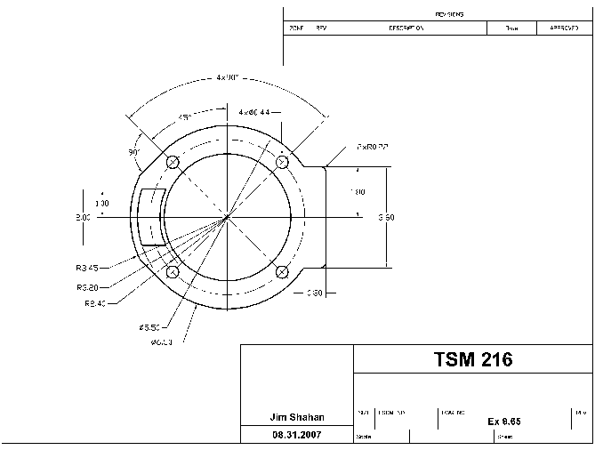 | 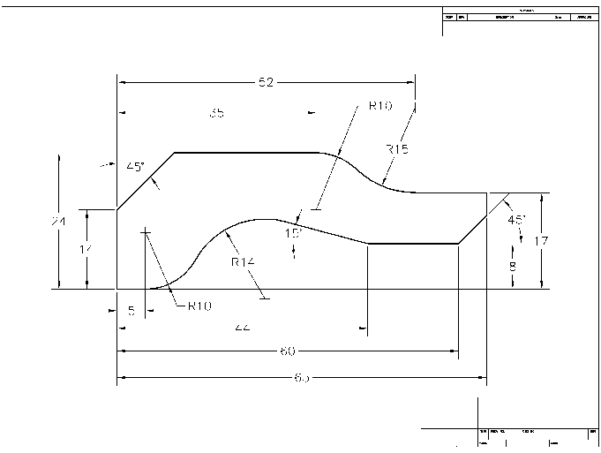
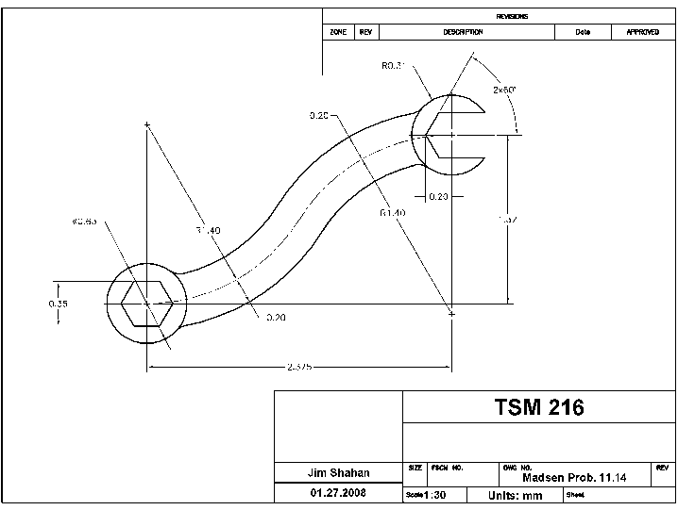 | 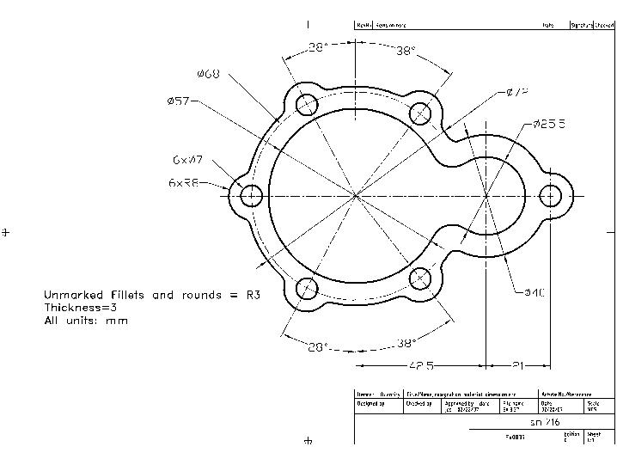
AutoCAD 2D: Single View Drawings (Re. Engineering Drawing and Design, by David A. Madsen, etal) Page 1

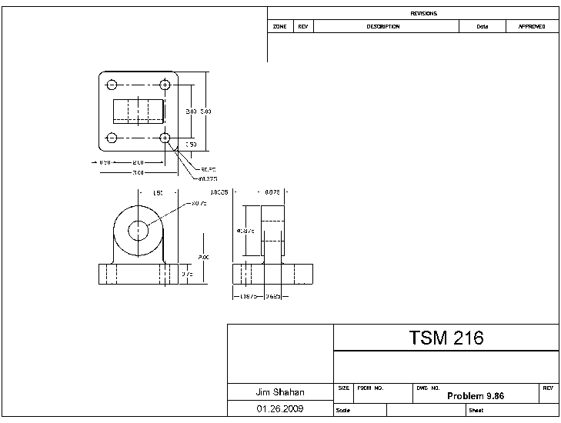 | 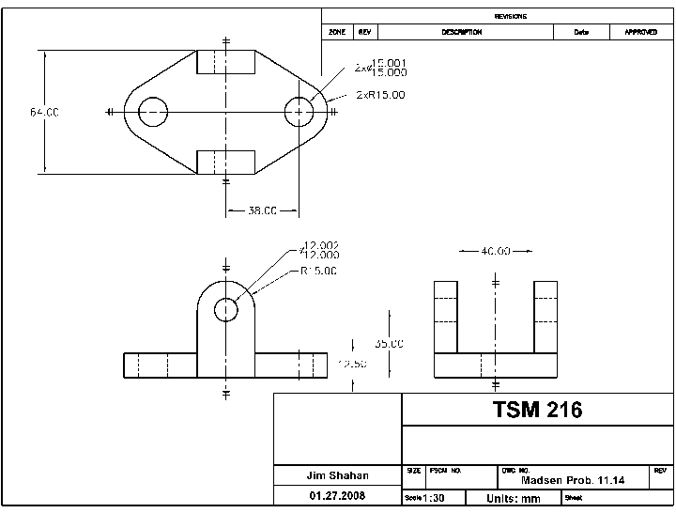
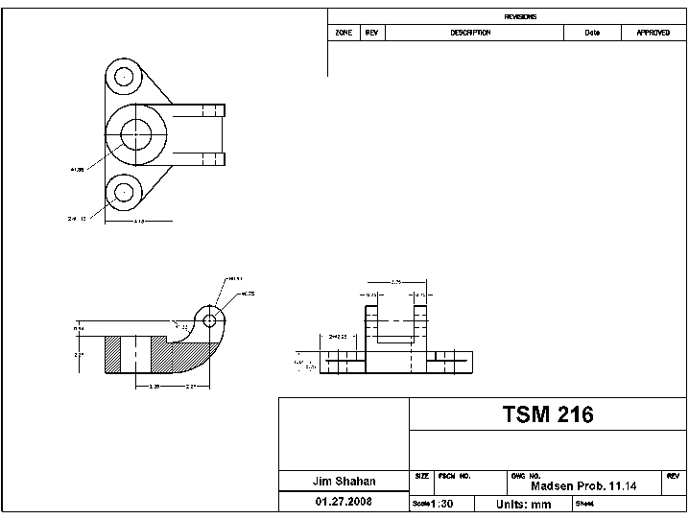 | 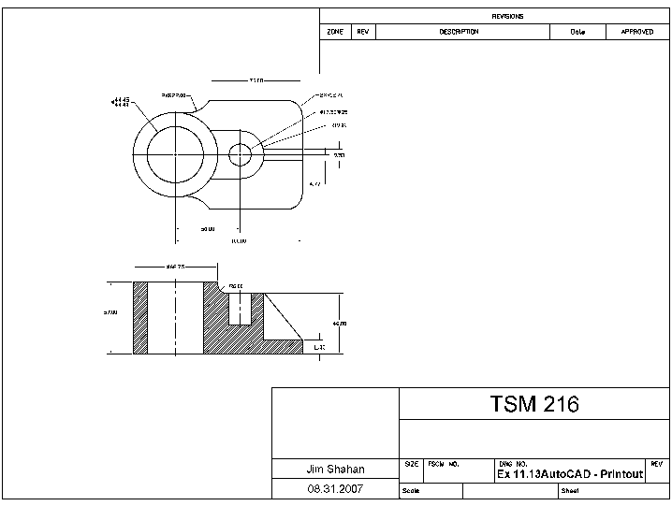
AutoCAD 2D: Multi-View Drawings (Re. Engineering Drawing and Design, by David A. Madsen, etal) Page 2

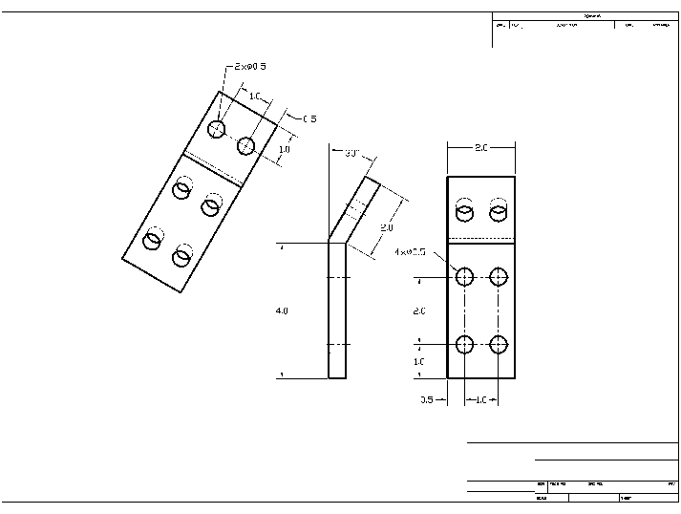 | 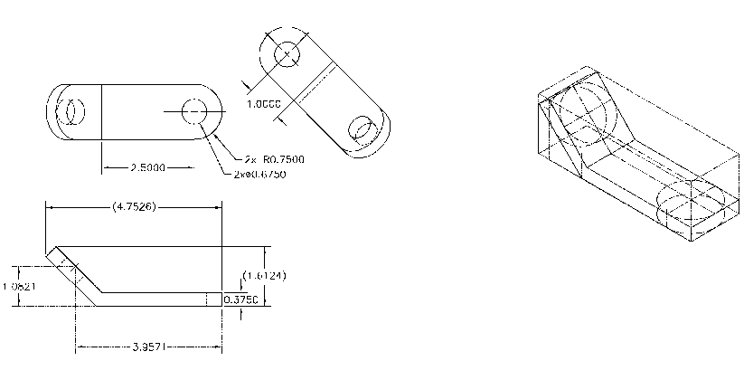  Isometric Construction Demo
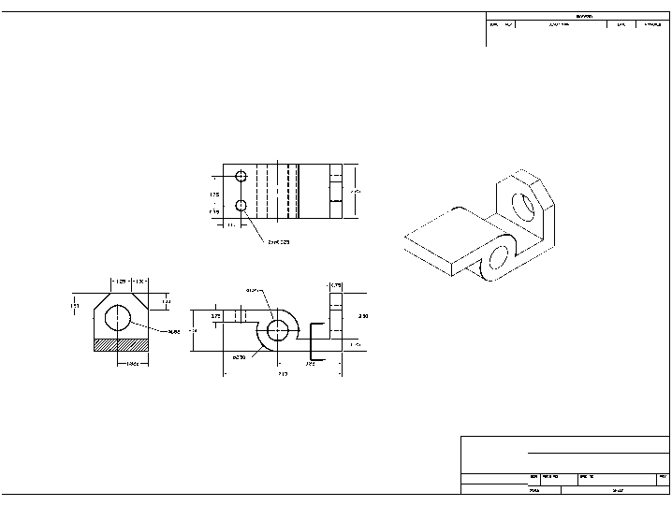

AutoCAD 2D: Auxiliary and Isometric Views (Re. Engineering Drawing and Design, by David A. Madsen, etal) Page 3

