Name & Std. No.:_________________________________________ Lab Section:____

Date:_________________

Submission Instructions:

Prelab:
- Complete the prelab
- Submit this report with the prelab completed to Canvas before your lab starts

Lab:
- Complete the lab according to the instructions
- Take screenshots of your ModelSim waveform (note: to receive points your NetID has to be present in the screenshot) and insert them into this document.
- Include screenshots of any related block design files or Verilog files in the report
- Complete this report and reupload it to Canvas

PRELAB:
Complete the prelab and make sure you have your designs and circuit diagrams ready before the lab session. You may refer to your text book, Chapter 6.

Q1. Design a simple counting device (Section 2.0).

Number of States: __________
Number of State Variables: ________

State Table: State-Assigned Table:
Present State | Next State |  | Output |  | Present State | Next State |  | Output
 | w=0 | w=1 |  |  |  | w=0 | w=1
A | A | B |  |  | 000 | 000 | 001 | 000
B | B | C
C | C | D
D | D | E
E | E | F
F | F | A

Canonical SOP Expressions for Next State Logic:

Simplified Next State Logic Expressions:

Circuit Diagram:

Q2. Design a simple counter (Section 3.0).

Number of States: __________
Number of State Variables: ________

State Table: State-Assigned Table:
Present State | Next State |  | Output
 | w=0 | w=1
A | A | B | 0
B | B | C | 2
C | C | D | 4
D | D | A | 5
Present State | Next State |  | Output
 | w=0 | w=1
Canonical SOP Expressions for Next State Logic:

Simplified Logic Expressions:

Next State Logic Verilog Code:

module circuit_nsl(w, Q1, Q0, Y1, Y0);

<<< insert code here >>>

endmodule

Output Logic Verilog Code:

module circuit_ol(Q1, Q0, Z2, Z1, Z0);

<<< insert code here >>>

endmodule

LAB:

2.0 A Simple Counting Device
Screenshots:
<<<Insert a screenshot of your module-6 counter BDF here>>>

<<< Insert a screenshot of your waveform for your modulo-6 counter here>>>
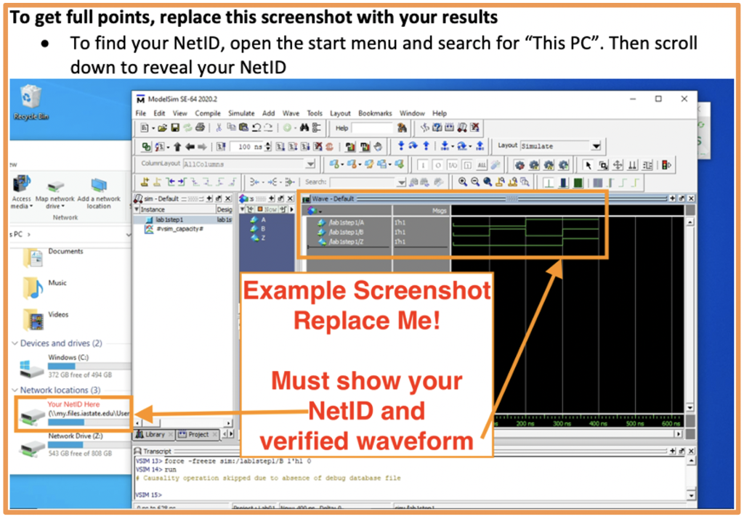
3.0 A Simple Counter
Screenshots:
<<<Insert a screenshot of your simple counter here>>>

<<<Insert a screenshot of your next state logic here>>>

<<<Insert a screenshot of your output logic here>>>

<<< Insert a screenshot of your waveform for your simple counter here>>>

