Name & Std No.:________________________________________ Lab Section:_____

Date:_________________

Submission Instructions:

Prelab:
- Complete the prelab
- Submit this report with the prelab completed to Canvas before your lab starts

Lab:
- Complete the lab according to the instructions
- Take screenshots of your ModelSim waveform (note: to receive points your NetID has to be present in the screenshot) and insert them into this document.
- Include screenshots of any related block design files or Verilog files in the report
- Complete this report and reupload it to Canvas

PRELAB:

Refer to Chapter 5 in your textbook and the lab instructions to complete your pre-lab. Please read all the material and complete the circuit diagrams before you come to the lab.

Q1. Draw the circuit diagram for the 4-bit Shift Register using D flip-flops in the space below.

Q2. Draw the circuit diagram for the 4-bit Synchronous Up-Counter using D flip-flops in the space below.

Q3. Draw the circuit diagram for the 4-bit Synchronous Up-Counter using T flip-flops in the space below.

Q4. Draw the circuit diagram for the 4-bit Asynchronous Up-Counter using T flip-flops in the space below.

Q5. Draw the circuit diagram for the 4-bit Asynchronous Down-Counter using T flip-flops in the space below.

LAB:

2.0 Fill in the sequence table below. Watch out for switch bouncing!

In | Q1 | Q2 | Q3 | Q4
t0 = 1 | ---- | ---- | ---- | ----
t1 = 0 |  | ---- | ---- | ----
t2 = 1 |  |  | ---- | ----
t3 = 1 |  |  |  | ----
t4 = 1
t5 = 0
t6 = 0
t7 = 0

<<<Insert a screenshot of shift register here>>>

<<< Insert a screenshot of your waveform for shift register here>>>
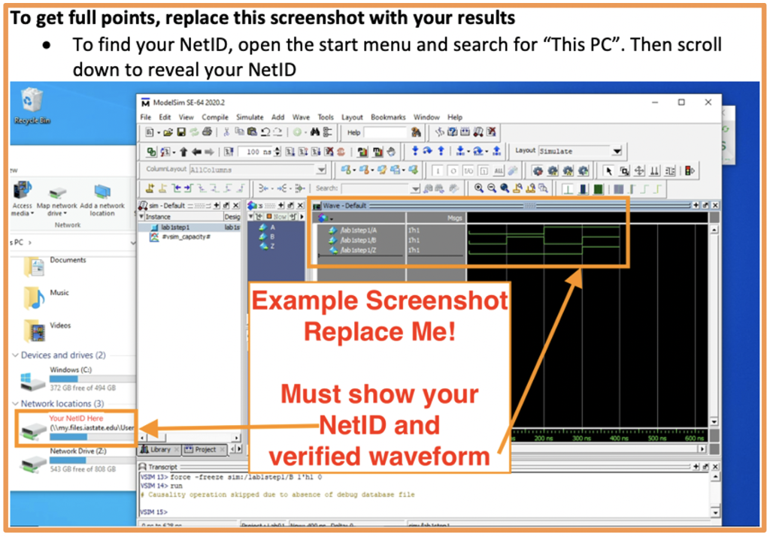

Synchronous counters:
<<<Insert a screenshot of SYNC UP counter DFF>>>

<<< Insert a screenshot of your waveform for SYNC UP counter DFF here>>>
<<<Insert a screenshot of SYNC UP counter TFF>>>

<<< Insert a screenshot of your waveform for SYNC UP counter TFF here>>>
Asynchronous counters:
<<<Insert a screenshot of ASYNC UP counter>>>

<<< Insert a screenshot of your waveform for ASYNC UP counter here>>>
<<<Insert a screenshot of ASYNC Down counter>>>

<<< Insert a screenshot of your waveform for ASYNC Down counter here>>>

