Name and Std No.:________________________________________ Lab Section:____

Date:_________________

Submission Instructions:

Prelab:
- Complete the prelab
- Submit this report with the prelab completed to Canvas before your lab starts

Lab:
- Complete the lab according to the instructions
- Take screenshots of your ModelSim waveform (note: to receive points your NetID has to be present in the screenshot) and insert them into this document.
- Include screenshots of any related block design files or Verilog files in the report
- Complete this report and reupload it to Canvas

PRELAB:

Refer to Chapter 5 in your textbook and the lab instructions to complete your pre-lab. Please read all the material and complete the circuit diagrams before you come to the lab.
Q1. Draw the circuit diagram for the SR Latch using NOR Gates for Section 2.0 in the space below.

Q2. Draw the circuit diagram for the SR Latch using NAND Gates for Section 2.0 in the space below.

Q3. Draw the circuit diagram for the D Latch using NAND Gates and a NOT gate for Section 3.0 in the space below.

Q4. Draw the circuit diagram for the Master-Slave D Flip-Flop for Section 4.0 using the D latches you built in the previous step in the space below. The flip-flop should be triggered by the negative edge of the clock.

Q5. Draw the circuit diagram for the Positive-Edge-Triggered D Flip-Flop using NAND gates for Section 4.0 in the space below.

LAB:
2.0 Complete the characteristic table for both versions of the SR latch. Do both versions function properly as a latch?

SR NOR Latch |  |  | SR NAND Latch
S R | Action |  | S R | Action
0 0 | Keep State |  | 0 0
0 1 | Q = |  | 0 1 | Q =
1 0 | Q = |  | 1 0 | Q =
1 1 | Restricted Combination |  | 1 1

NOR Screenshots:
<<<Insert a screenshot of your SR NOR latch here>>>

<<< Insert a screenshot of your waveform for your SR NOR latch here>>>
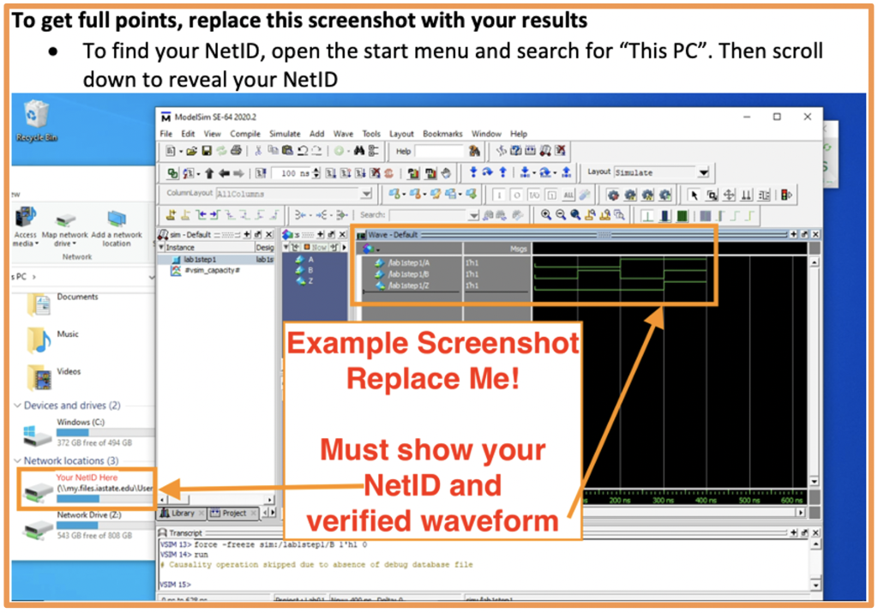

NAND screenshots:
<<<Insert a screenshot of your SR NAND latch here>>>

<<< Insert a screenshot of your waveform for your SR NAND latch here>>>

3.0 Complete the timing diagram below for your Gated D Latch. What is the difference between this gated latch and the previous basic latches?

Clk
D
Q

D Latch Screenshots:
<<<Insert a screenshot of your D latch here>>>

<<< Insert a screenshot of your waveform for your D latch here>>>

4.0 Complete the timing diagram below for your Negative-Edge-Triggered D Flip-Flop.

Clk
D
Q
~Q
Negative Edge D Flip-Flop Screenshots:
<<<Insert a screenshot of your Neg. Edge DFF here>>>

<<< Insert a screenshot of your Neg. Edge DFF waveform here>>>
Complete the timing diagram below for your Positive-Edge-Triggered D Flip-Flop.

Clk
D
Q
~Q
Positive Edge D Flip-Flop Screenshots:
<<<Insert a screenshot of your Pos. Edge DFF here>>>

<<< Insert a screenshot of your Pos. Edge DFF waveform here>>>

