Dividers in ModelSim
Dividers are useful for understanding waves in ModelSim. Dividers make it easier to see groups of outputs in waves that have many outputs. In lab5step1, dividers can separate the inputs/outputs for each of the seven-segment decoders.

Create a Divider
To create a divider, add the variables to the wave. IMPORTANT: make sure that all of your variables are in order. You can drag the inputs into the correct order. Right click on a variable that you want the divider to be above. See the image below:

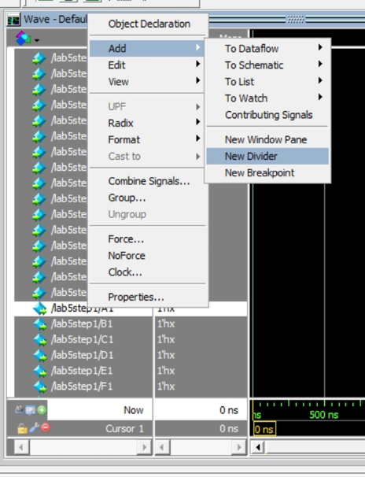
Fig. 1: Adding a New Divider from the Right Click Menu

In the menu that pops up, give the divider a name. In this case, it will be named seg1. See the image below:
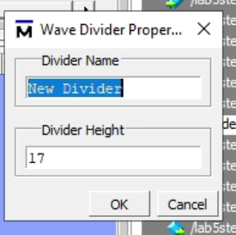
Fig. 2: Giving Dividers a Name

The final output should look like this:
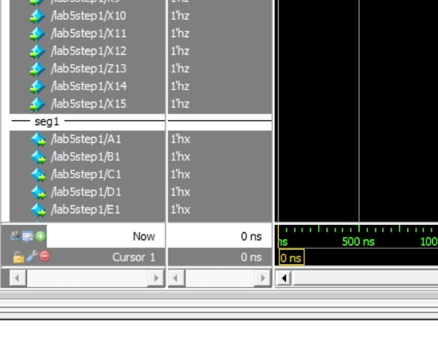
Fig.3: ModelSim with a Divider

