Name and Student ID:________________________________________ Lab Section:__

Date:_________________

Submission Instructions:

Prelab:
- Complete the prelab (questions Q1 and Q2 and Q3)
- Submit this report with the prelab completed to Canvas before your lab starts

Lab:
- Complete the lab according to the instructions
- Take screenshots of your ModelSim waveform (note: to receive points your NetID has to be present in the screenshot) and insert them into this document.
Complete this report and reupload it to Canvas.

PRELAB:

Q1. Consider the Verilog code in section 3.0. Briefly explain how the always @ structure works.

Q2. Write the Verilog code for lab4step1. Use the example code given in Section 3.0 and make the necessary changes.

Q3. Read Section 4.0 and fill in the Truth Table for lab4step2.

Inputs |  |  |  | Outputs
M | T | H | P | E | F | AC
0 | 0 | 0 | 0
0 | 0 | 0 | 1
0 | 0 | 1 | 0
0 | 0 | 1 | 1
0 | 1 | 0 | 0
0 | 1 | 0 | 1
0 | 1 | 1 | 0
0 | 1 | 1 | 1
1 | 0 | 0 | 0
1 | 0 | 0 | 1
1 | 0 | 1 | 0
1 | 0 | 1 | 1
1 | 1 | 0 | 0
1 | 1 | 0 | 1
1 | 1 | 1 | 0
1 | 1 | 1 | 1

LAB:
3.0 Use the hardware results to fill in the truth table for lab4step1.

Farmer | Cabbage | Goat | Wolf | Alarm
0 | 0 | 0 | 0
0 | 0 | 0 | 1
0 | 0 | 1 | 0
0 | 0 | 1 | 1
0 | 1 | 0 | 0
0 | 1 | 0 | 1
0 | 1 | 1 | 0
0 | 1 | 1 | 1
1 | 0 | 0 | 0
1 | 0 | 0 | 1
1 | 0 | 1 | 0
1 | 0 | 1 | 1
1 | 1 | 0 | 0
1 | 1 | 0 | 1
1 | 1 | 1 | 0
1 | 1 | 1 | 1

Screenshots:
<<<Copy and paste your Verilog code here>>>

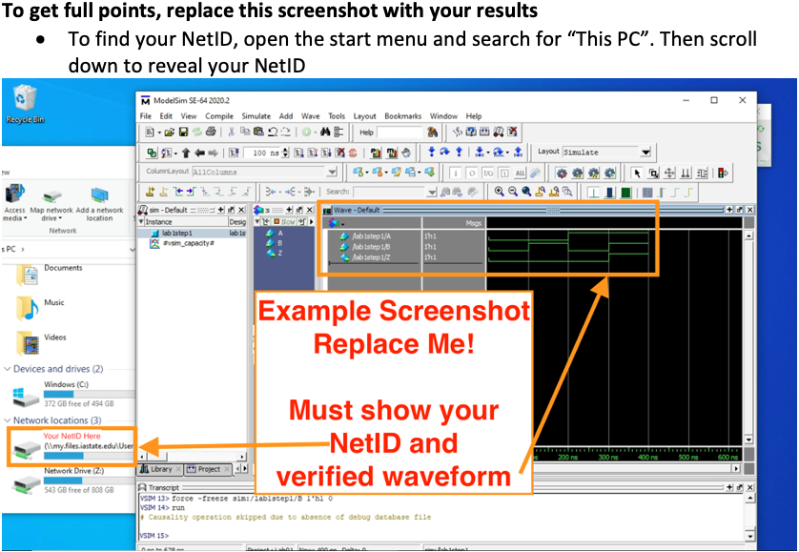

4.0 Demonstrate hardware results for correct code.

<<<Insert a screen shot of your lab4step2 BDF file>>>

Design result:

