Using DO files in ModelSim

What are DO files?
DO files are an automation tool in ModelSim. This tool allows ModelSim to automatically assign values to inputs in a simulation, run or restart the simulation, or even automatically verify circuits. This document explains how to use DO files to automatically assign inputs and run the simulation in ModelSim.

How DO files Work
DO files are essentially a very basic scripting language for ModelSim. In essence, DO files contain a list of commands that are run in the ModelSim command prompt. In previous labs, you may have used some of these commands to force inputs to a particular value or run the simulation. For more info on these commands see Forcing Inputs in ModelSim from lab2.

Lab 3 Example
Lab3step0 asks you to create a simple circuit for the “farmer problem.” That circuit has three inputs and one output. It is advisable to give your inputs and outputs names that you understand. In this example, let C, G, W, and A stand for cabbage, goat, wolf, and alarm respectively. To create a DO file, we first need to find what statements to run to simulate our project. Secondly, we need to create a DO file in the same folder as your ModelSim project.

Manual Simulation
To manually test lab3step0, we first need to force inputs to automatically vary over time (See Forcing Inputs in ModelSim from lab2). We will need 3 statements for lab3step0 to create a waveform that shows every input possible for C, G, and W.
- force C 0 0, 1 200 -repeat 400
- force G 0 0, 1 100 -repeat 200
- force W 0 0, 1 50 -repeat 100

Once we have told ModelSim how to vary the inputs, we need to tell it how long to simulate for. For the commands above, the simulation will need to run for 400ns. This time is due to input C taking 400ns to repeat which is the longest of any of the inputs. The command to run the simulation in ModelSim is:
- run 400

To manual simulate lab3step0, you will have to run these four commands:
- force C 0 0, 1 200 -repeat 400
- force G 0 0, 1 100 -repeat 200
- force W 0 0, 1 50 -repeat 100
- run 400

Creating a DO file
DO files allow you to automatically run a list of ModelSim commands. This means that we can create a DO file using the manual commands we found above to simulate lab3step0. This will greatly reduce the amount of time you will have to spend typing out these commands for each time you want to simulate lab3step0.

To create a DO file in ModelSim, go to File -> New -> Source -> Do. In the text editor that pops up, write the four commands from the previous section. Your DO file should look like this:

force C 0 0, 1 200 -repeat 400
force G 0 0, 1 100 -repeat 200
force W 0 0, 1 50 -repeat 100

run 400
Save the file to your lab3 base folder. Go to File -> Save As and save it as basic-alarm.do in U:\CPRE281\Lab03.

Running the DO file for lab3step0
To run the DO file we just created, start simulating lab3step0. Once the simulation has started, type “do basic-alarm.do” to run the DO file. If you use the same variable names for your Verilog files in lab3step1 and lab3step0, you can reuse this DO file for these steps.
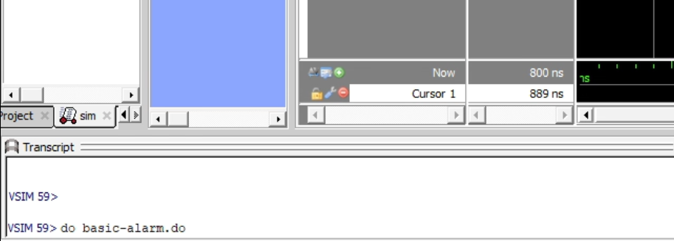
Fig 1. Running a DO file in the ModelSim Console

Extending the DO file for the Second Design (lab3step3)
Lab3step3 add an additional input for the farmer. You can extend the basic-alarm DO file for this step as well. To do this, you will need create a new DO file and copy and paste the commands we used earlier. Then, you will need to add an additional command to force the farmer’s input over time. The DO file for lab3step3 should look something like this:
force F 0 0, 1 400 -repeat 800
force C 0 0, 1 200 -repeat 400
force G 0 0, 1 100 -repeat 200
force W 0 0, 1 50 -repeat 100

run 800

Notice how we run the simulation for 800ns. This is because the most significant input is now the farmer which will repeat after 800ns.

