Name and Student ID:________________________________________ Lab Section:__

Date:_________________

Submission Instructions:

Prelab:
- Complete the prelab (questions Q1 and Q2)
- Submit this report with the prelab completed to Canvas before your lab starts

Lab:
- Complete the lab according to the instructions
- Take screenshots of your ModelSim waveform (note: to receive points your NetID has to be present in the screenshot) and insert them into this document.
- Complete this report and reupload it to Canvas
PRELAB:

Q1. Read section 3.0 and fill in the truth table below for Design 1 (the farmer’s problem). Then use it to construct the POS expression.

Cabbage | Goat | Wolf | Alarm
0 | 0 | 0
0 | 0 | 1
0 | 1 | 0
0 | 1 | 1
1 | 0 | 0
1 | 0 | 1
1 | 1 | 0
1 | 1 | 1

POS Logic Expression: _______________________________________

Q2. Read section 4.0 and fill in the truth table below for Design 2 (adding the farmer). Then use it to construct the SOP expressions.

Farmer | Cabbage | Goat | Wolf | Alarm
0 | 0 | 0 | 0
0 | 0 | 0 | 1
0 | 0 | 1 | 0
0 | 0 | 1 | 1
0 | 1 | 0 | 0
0 | 1 | 0 | 1
0 | 1 | 1 | 0
0 | 1 | 1 | 1
1 | 0 | 0 | 0
1 | 0 | 0 | 1
1 | 0 | 1 | 0
1 | 0 | 1 | 1
1 | 1 | 0 | 0
1 | 1 | 0 | 1
1 | 1 | 1 | 0
1 | 1 | 1 | 1

Canonical SOP Logic Expression: _______________________________________

Simplified SOP Logic Expression: ________________________________________

LAB:

3.1 Schematic Capture with Quartus Block Design Files (lab3step0)
Schematic screenshot:

<<<Insert a screen shot of your lab3step0 BDF file>>>

Schematic results:
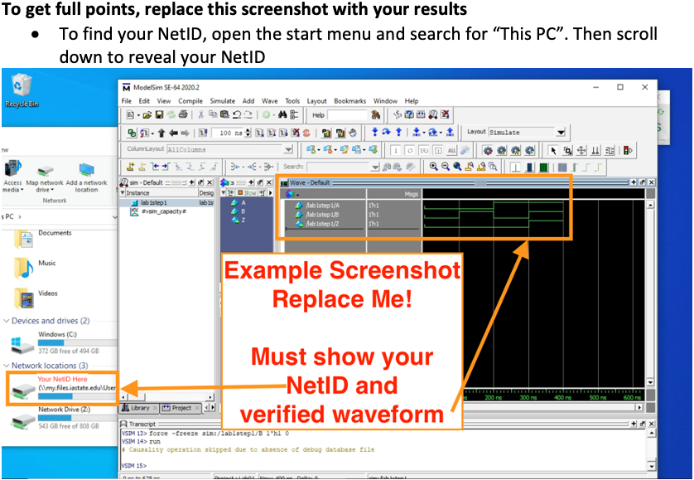

3.2 Structural Verilog (lab3step1)
Structural Code:

<<<Copy and paste your Structural Verilog code here>>>

Structural Results:

3.3 Behavioral Verilog (lab3step2)
Behavioral Code:

<<<Copy and paste your Behavioral Verilog code here>>>

Behavioral Results:

4.0 Design 2 (lab3step3)
Design 2 Code:

<<<Copy and paste your Behavioral Verilog code here>>>

Design 2 Results:

