Module PE.PAS.U22.5

Composite system reliability

U22.1 Introduction
We briefly introduced composite system reliability in module U17, (also known as HL-II or G&T adequacy analysis), where we identified two attributes that characterize most of the approaches developed to date. These attributes are:
- Method of representing stochastic nature of the operating conditions: By “operating conditions,” we are referring to the basecase network configuration (topology and unit commitment) together with the loading and dispatch. The methods include nonsequential and sequential enumeration.
- Method of representing stochastic nature of contingencies: The methods include contingency enumeration and Monte Carlo.
These methods are summarized in Table U22.1.
Table U22.1: HL-II Evaluation approaches
Contingency selection | Operating Conditions
Contingency selection | Non-sequential | Sequential
Enumeration | Non-sequential, with contingency enumeration | Sequential, with contingency enumeration
Monte-Carlo | Non-sequential, with Monte-Carlo contingency selection | Sequential, with Monte-Carlo contingency selection
We also provided a generic algorithm for composite system reliability analysis that applies independent of the particular approach taken. We repeat this algorithm here, in Fig. U22.1.

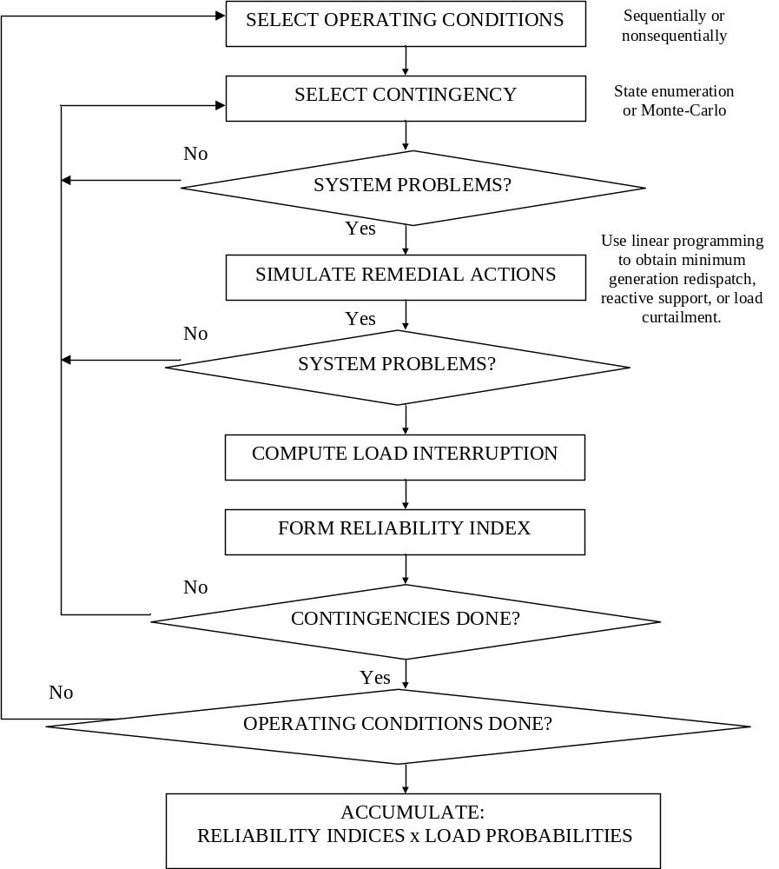
Fig. U22.1: Generic HL-II Evaluation Algorithm
In this module, we begin in Section U22.2 by introducing linear sensitivities which are useful in decreasing computations for composite reliability analysis. In Section U22.3, we summarize the common contingency enumeration approaches. In Section U22.4, we describe a remedial action algorithm for simulating operator action for overload relief. Section U22.5 describes how to determine bounds on the reliability indices.
The approaches are applicable independent of whether the operating conditions are represented sequentially or nonsequentially. All of the developments in this module focus on line overload problems. Similar algorithms may be developed for low voltage and voltage instability.

U22.2 Linear sensitivities
There are 2 basic linear sensitivities that we will use. Generation shift factors provide us with a fast method of computing changes to circuit flows for changes in real power bus injection. Line outage distribution factors provide a fast method of computing changes to circuit flows when circuits are removed from service.

U22.2.1 DC power flow
The so-called DC power flow is an approximation of the standard AC power flow equations based on the assumptions that circuit resistance is negligible, all bus voltages have magnitudes of 1.0 pu, and the angular separation across a circuit is small enough so that cosδ_{jk}≈1, sinδ_{jk}≈δ_{jk} when δ_{jk} is measured in radians. With these approximations, it is possible to show that P=B’θ where P is the vector of real power injections at ever bus, θ is the vector of angles at N-1 buses, and B’ is the “B-prime” version of the bus admittance matrix for the network being analyzed. Thus, given the network topology (enabling formation of B’) and the bus injections (enabling formation of P), it is possible to compute the bus angles θ from one application of LU decomposition to the linear set of equations represented by P=B’θ.

The B’ matrix may be formed from the Y-bus in the following fashion. Note: For an inductive circuit, the susceptance b is positive based on a defined admittance expression of y=g-jb.
- Take the imaginary part of all elements in the Y-bus, i.e., for each element, set the real part to 0 and remove the “j” from the imaginary part.
- Replace diagonal element B’_{kk} with the sum of the non-diagonal elements in row k. Alternatively, subtract b_{k} (the shunt term) from B_{kk}, and multiply by -1.
- Multiply all off-diagonals by -1.
- Remove row k and column k for any k.

For example, below is the Y-bus and the B’ matrix for a network having no resistance.
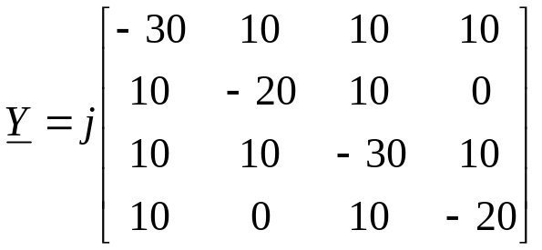
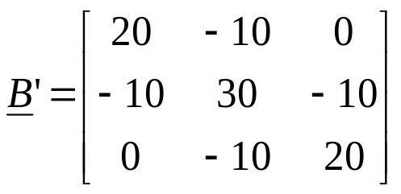
Although eq. the DC power flow equation provides the ability to compute the angles, it does not directly provide the line flows. A systematic method of computing the line flows is:
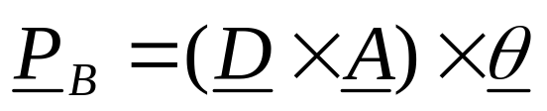
where:
- P_{B} is the vector of branch flows. It has dimension of M x 1. Branches are ordered arbitrarily, but whatever order is chosen must also be used in D and A.
- θ is (as before) the vector of nodal phase angles for buses 2,…N
- D is an M x M matrix having non-diagonal elements of zeros; the diagonal element in position row k, column k contains the negative of the susceptance of the k^{th} branch.
- A is the M x N-1 node-arc incidence matrix. It is also called the adjacency matrix, or the connection matrix. Its development requires a few comments.

Development of the node-arc incidence matrix:

This matrix is well known in any discipline that has reason to structure its problems using a network of nodes and “arcs” (or branches or edges). Any type of transportation engineering is typical of such a discipline.

The node-arc incidence matrix contains a number of rows equal to the number of arcs and a number of columns equal to the number of nodes.

Element (k,j) of A is 1 if the k^{th} branch begins at node j, -1 if the k^{th} branch terminates at node j, and 0 otherwise.

A branch is said to “begin” at node j if the power flowing across branch k is defined positive for a direction from node j to the other node.

A branch is said to “terminate” at node j if the power flowing across branch k is defined positive for a direction to node j from the other node.

Note that matrix A is of dimension M x N-1, i.e., it has only N-1 columns. This is because we do not form a column with the reference bus, in order to conform to the vector θ, which is of dimension (N-1) x 1. This works because the angle being excluded, θ₁, is zero.

U22.2.2 Generation shift factors
The generation shift factor C_{k,j} provides the change in flow on circuit k for a unit change in injection at bus j, i.e.,
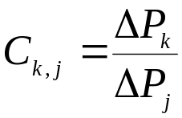 (U22.1)
It is assumed that the change in injection at bus j is compensated for an equal and opposite change in injection at a designated swing bus.

U22.2.3 Line outage distribution factors
The line outage distribution factor d_{k,j}, provides the change in flow on circuit k, denoted by Δf_{k}, due to outage of circuit j having flow 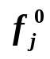, and is given by
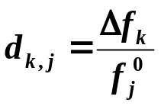 (U22.2)
The development of the generation shift factor and the line outage distribution factor are based on the DC power flow approximation and are given in [1].
Reference [5] shows how to include ramp rates into the above sensitivity factors.

U22.3 Contingency enumeration
The simplest approach to contingency selection is to assess all contingencies; in this approach, one needs only to develop an appropriate scheme to enumerate them so that none are missed. This approach is, however, computationally expensive.
A second approach is to simply limit the contingencies. Here, one can think of the following methods:
- Use a list: Provide a contingency list that prescribes exactly the contingencies of interest. This approach has merit in some cases where study objectives so dictate.
- Limit the order: For example, we may require analysis for all N-1 contingencies, or we may go one deeper and require analysis for all N-1 and N-2 contingencies. The problem with this approach is that it may spend a great deal of computation on contingencies that have little effect on the resulting indices, or, on the other hand, it may miss some higher-order contingencies that do significantly contribute to the reliability indices.
- Limit the probability: Here, one analyzes all contingencies for which their probability exceeds a certain threshold. This is slightly more refined than limiting the order, and it is subject to the same problems.
- Based on severity: The principle here is to avoid analyzing contingencies that do not result in a problem. Some type of screening approach is normally involved, using either the DC load flow or the linear sensitivities. It is convenient to also associate with each contingency k screened a performance index PI_{k} given by:
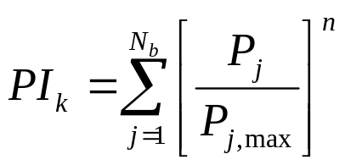 (U22.3)
where n is positive and relatively large (e.g., n=10). This means that any individual term in the summation of (U22.3), [P_{j}/P_{j,max}]^{n}, will be very small if P_{j}<P_{j,max} and very large if P_{j}>P_{j,max}. Thus, PI_{k} is guaranteed to be at least 1.0 if there is even one overload following contingency k. More important, PI_{k} is a very good metric for comparing the severity of one contingency against another.
The so-called wind-chime scheme [2,3] combines one of the first three approaches with the last approach. In the wind-chime scheme, two sets of contingencies are selected – the primary set and the secondary set. These two sets need not be different and in fact, most often, they are the same. For purposes of generality, however, we will assume in our analysis that they are different. Any of the first three contingency selection methods may be used to make these selections.
Then, each set of contingencies is screened, and the performance indicator PI_{k} is computed for each contingency in each set. Then the contingencies are ranked from most severe to least severe.
- Denote the primary contingencies as P1, P2, …, with P1 more severe than P2.
- Denote the secondary contingencies as S1, S2, …, with S1 more severe than S2.
Then N-2 contingencies (P1, S) S=S1, …, are analyzed until we find three consecutive contingencies with no violation.
Then N-2 contingencies (P2, S), S=S1, …, are analyzed until we find three consecutive contingencies with no violation.
And we continue analyzing each set of N-2 contingencies (P,S), with primary contingency P and secondary contingency S=S1,…, until we have three consecutive sets of contingencies (PN,S), (PN+1,S), (PN+2,S), S=S1, S2, S3, with no violation. The algorithm stops at this point. Fig. U22.2 illustrates the windchime algorithm [4].

It seems quite reasonable to use this algorithm for purposes of N-k contingency screening in on-line security assessment. This can be effectively combined with the approach of N-k contingency selection based on probability, given in [6].
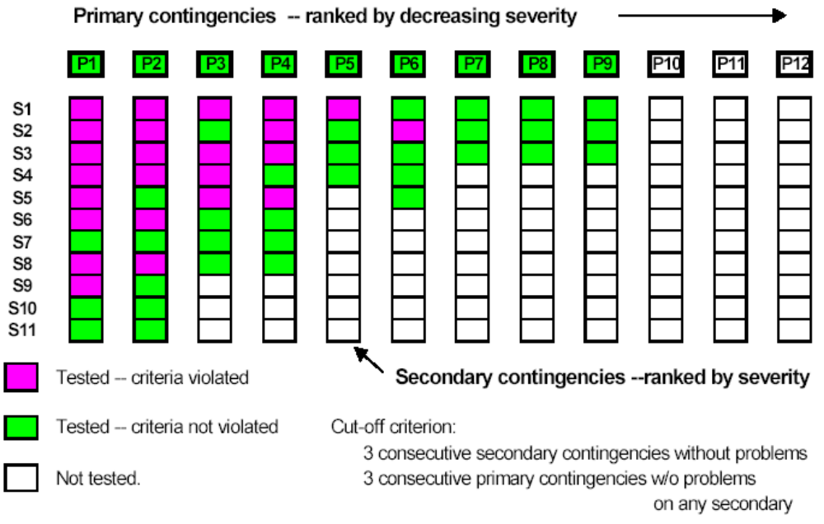Fig. U22.2: Illustration of the windchime algorithm [4]

U22.4 Remedial actions
Corrective or remedial actions performed automatically should be built into the simulation of the contingency. Examples of such actions include direct or automatic load tripping, generation rejection, and turbine-governor response to load imbalance. For these actions, it is generally known what action will take place, for what conditions, and at what time.
Corrective or remedial actions performed by the operator are quite uncertain, as they depend on human decision-making and responsiveness. We can, however, make certain assumptions regarding operator action, and based on these assumptions, develop appropriate simulation algorithms.
The fundamental assumptions we make in regards to operator action are that the operator will make the minimum control effort in order to alleviate any overloads. (One may also formulate based on the assumption that the operator will make the least-cost control adjustments in order to alleviate any overloads; such an assumption can be accommodated rather easily in the formulation to follow.)
The most comprehensive algorithm available for implementing remedial actions is the optimal power flow (OPF). The advantage of the OPF is that it provides the ability to simulate operator action for overload, low voltage, and voltage instability. However, it is computationally expensive, although computing power today via combination of high-end and parallel processing makes it quite practical, even for large systems. We provide a simpler approach which only allows remedial actions for overloads. One may consider it to be an approximation to the OPF.
Define 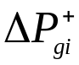 and 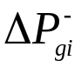 to be an increase or decrease, respectively, in the generation at bus i, and 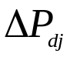 to be the load curtailment at bus j, where all three variables are always nonnegative.
Also define K_{i} and K_{j} to be weights associated with the bus i generation change and the bus j load curtailment, respectively.
- The bus i generation change weight K_{i} should be chosen based on dispatchability (0 if not dispatchable) and ramp rates (the higher the ramp rate, the larger the K_{i}) for each plant.
- The bus j load curtailment weight K_{j} should be chosen based on whatever contracts are in place with the loads. It is typical that K_{j}>>K_{i} indicating that load curtailment is typically much less desirable than generation redispatch.

We can then write a linear program as follows:
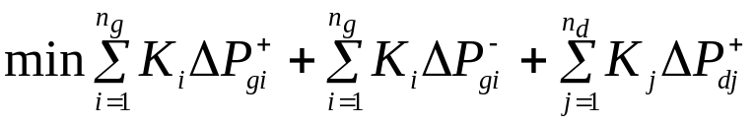 (U22.4a)
subject to:
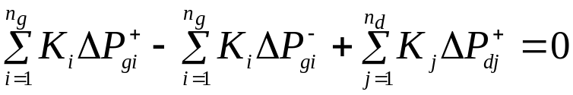 (U22.4b)
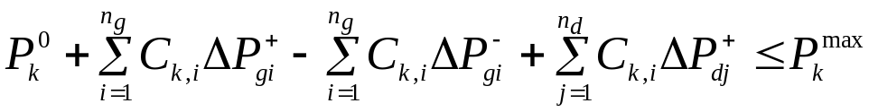 (U22.4c)
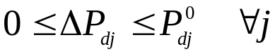 (U22.4d)
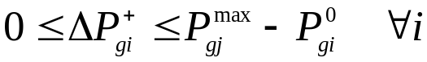 (U22.4e)
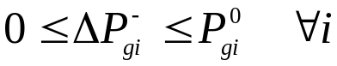 (U22.4f)
where 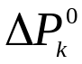 is the flow on circuit k after the contingency, and 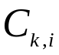 is the generation shift factor giving the sensitivity of the circuit k flow to the bus j injection. Algorithms for solving linear programs are very fast and, coded versions are easily obtained. For example, Matlab has a linear programming function called “linprog” which uses a variation of the simplex method for medium-scale problems and an interior point method for large scale problems.
We should note that the above LP alleviates only one overload. But it is easy to accommodate multiple overloads by simply adding more equations of the form (U22.4c). But what is not easy to accommodate in the above formulation is the enforcement of line flow constraints while alleviating one or more overloads.
The above formulation may be very satisfactory for many operational engineers who, based on experience, believe it highly unlikely that a redispatch to off-load one corridor will result in overload of another.
The formulation to identify a dispatch that will definitely not create additional overloads is basically an OPF. An approach is provided in the appendix that implements an LP-OPF. This approach minimizes redispatch cost rather than control effort.

U22.5 Bounding the failure probability
Given that we are capable of performing the contingency selection and then analyzing each contingency selected to determine whether it is a failure state or not, the remaining issue is to determine the reliability indices. Specifically, we desire to compute the LOLP.
However, we face the basic problem that we know whether a state is a failure state or not for only the states that we have analyzed. Based on the windchime contingency selection approach described previously, this consists of, all N-1 and N-2 contingency states. (Actually, we only analyze a subset of N-2 contingency states, but the windchime approach enables one to conclude with high confidence that all unanalyzed N-2 contingency states are success states (i.e., no loss of load).
However, we still must consider the N-k states for k>2. Although the probability of most of these states is quite small, the fact that there are so many of them suggests that they may comprise a significant percentage of the desired LOLP index.
We may determine how close our LOLP estimate is to the actual LOLP by using a bounding approach. In this approach, we will determine a lower bound together with an upper bound on the failure probability. The width of the bounded interval provides an indication of how close our LOLP estimate is.

U22.5.1 The binary tree
We illustrate the method based on understanding of a binary tree. We motivate the concept of a binary tree using a simple example. Consider the 3-component system of Fig. U22.3.
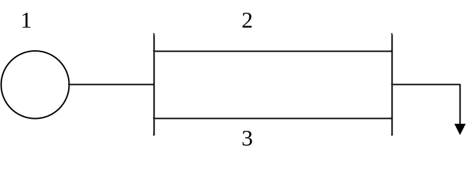
Fig. U22.3: 3 component system for illustrating bounding approach

We denote the availability and the failure probability (FOR) of each component as p_{j} and q_{j}, respectively. Thus the total number of states of this system is 2³=8. These states are summarized in Table U22.2.

Table U22.2: Summary of states for example system
State  s | Component In (1) or Out (0) |  |  | Pr[s]
State  s | 1 | 2 | 3 | Pr[s]
1 | 1 | 1 | 1 | p₁p₂p₃
2 | 1 | 1 | 0 | p₁p₂q₃
3 | 1 | 0 | 1 | p₁q₂p₃
4 | 1 | 0 | 0 | p₁q₂p₃
5 | 0 | 1 | 1 | q₁p₂p₃
6 | 0 | 1 | 0 | q₁p₂q₃
7 | 0 | 0 | 1 | q₁q₂p₃
8 | 0 | 0 | 0 | q₁q₂q₃
The binary tree for this system represents the different states of Table U22.2, and is illustrated in Fig. U22.3.
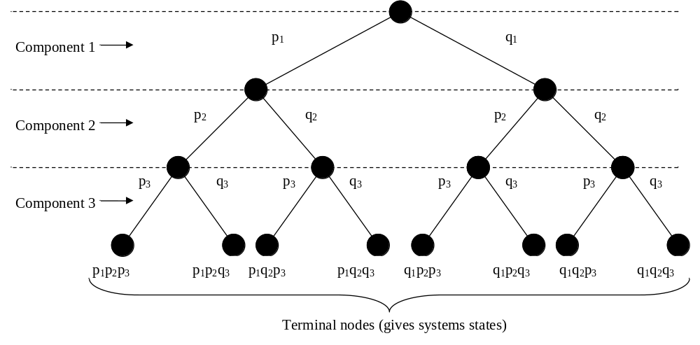Fig. U22.3: Binary tree for illustrating system states
Our goal is to identify which terminal nodes correspond to the failed states. If we can do that, then the LOLP is computed very simply as:
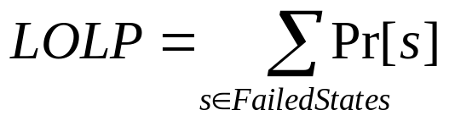 (U22.5)
The problem is, of course, that the tree can become very large. For example, if we have just 100 components, which would of course be a very small system, we would have 2¹⁰⁰=1.27×10²⁰ terminal nodes (or states).

U22.5.2 Obtaining a lower bound
We turn now to a general case corresponding to a system with N components, but we assume that each one is modeled with only 2 states.
We define ΔPr_{j}[F] as the additional failure probability due to knowledge that contingency j fails. Note that contingency j does not simply indicate that “component j fails,” i.e., contingency j simply indicates the jth contingency, which may or may not be comprised of multiple component failures.
Let’s assume that contingency j corresponds to loss of circuit k and that we know it is a failed contingency.
The state corresponding to all other circuits in (besides circuit k) is the most probable state of those which stem from the node corresponding to q_{k}. The significance of this fact is that we may write that:
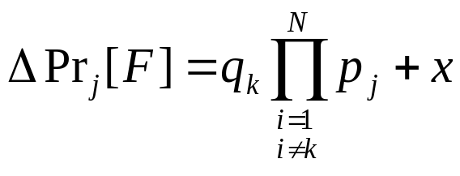 (U22.6)
where x is the probability of all other states. Since each state probability in x will have at least 2 terms in q, x should be rather small.
Now represent circuit k at the top of the tree, as shown in Fig. U22.4.
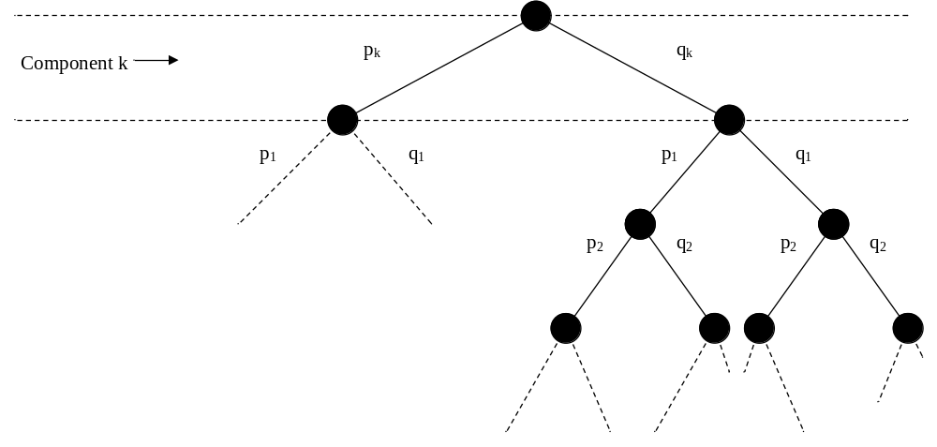Fig. U22.4: Binary tree for illustrating system states with circuit k at the tree-top
Now let’s assume that all terminal nodes stemming from q_{k} are failed states. Under this assumption, we have that:
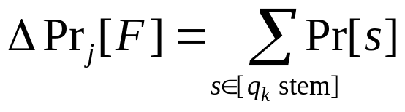 (U22.7)
Then it must be true that
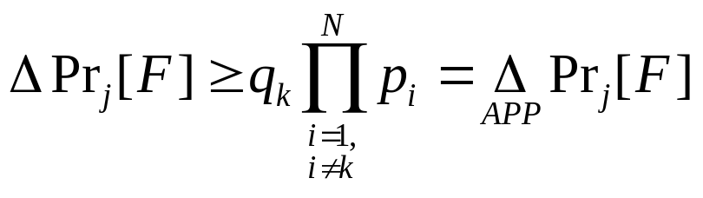 (U22.8)
is a lower bound on the actual 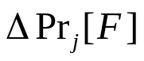.
If we compute (U22.8) for all failed states, then we may obtain a lower bound on the LOLP according to:
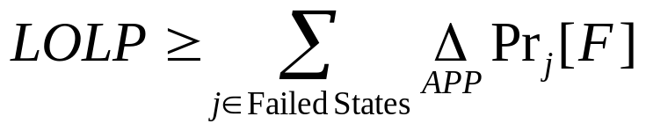 (U22.9)

U22.5.3 Obtaining an upper bound
Obtaining a lower bound does us little good unless we can also obtain an upper bound. To do this, consider that we are able to identify contingency j, corresponding to loss of circuit k, is a success, i.e., no loss of load. We again represent circuit k at the top of the tree, as in Fig. U22.4.
However, this time, we cannot assume that all terminal nodes stemming from q_{k} are successes since all but one of these terminal nodes will represent outage of additional components as well.
But we do know that at least one of the terminal nodes will be a success – the one with all components in except for circuit k. Therefore we may write that:
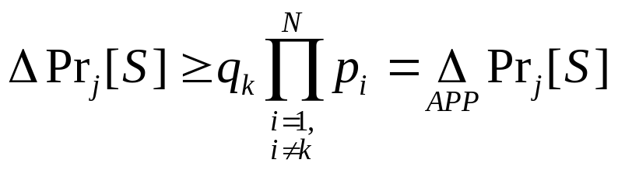 (U22.10)
This provides us with a lower bound on the probability of not losing load, in contrast to the lower bound on the probability of losing load which we obtained in (U22.8).
Multiplying both sides of (U22.10) by -1 (and reversing the sense of the inequality) and then adding 1 to both sides results in:
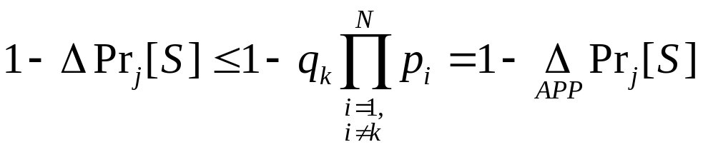(U22.11)
Now consider that 1-ΔPr_{j}[S] is actually the probability of failure. Thus, we see that (U22.11) provides a lower bound on the probability of failure for all contingency states stemming from q_{k}. Thus, we have that
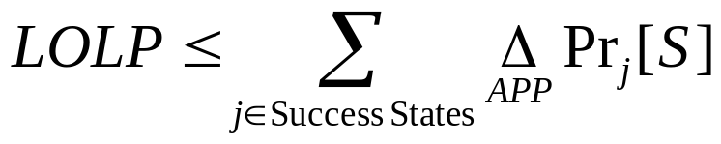 (U22.12)

U22.5.4 Algorithm for computing lower and upper LOLP bounds
The following is an algorithm for computing the lower and upper bounds on LOLP for a given system.
- ΔPr[F]=0, ΔPr[S]=0
- For j=1, (N₁+N₂)
  - If j=failed, then
    - Compute failure probability approximation
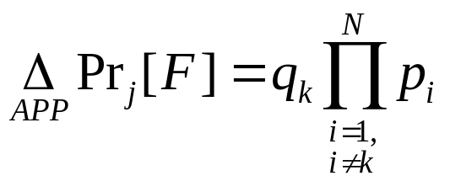
    - Sum to total failure probability approximation:
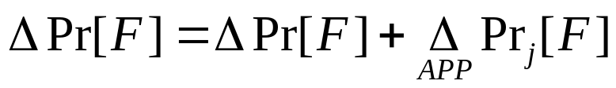
  - ElseIf j=success, then
    - Compute success probability approximation
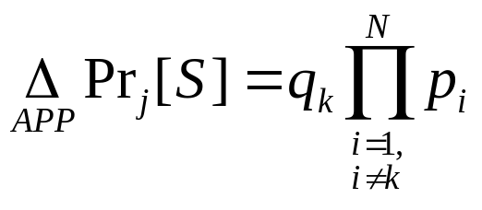
    - Sum to total failure probability approximation:
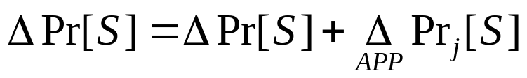
Then we have that the actual LOLP is bounded as illustrated in Fig. U22.5.
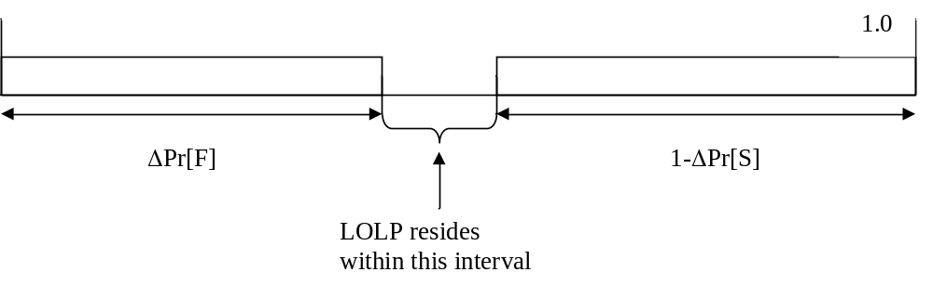Fig. U22.5: Illustration of bounds on LOLP

Appendix
This appendix provides an LP-OPF formulation which minimizes a linearized cost function subject to a set of equality constraints (DC load flow equations and line flow equations) and a set of inequality constraints (on generation limits and on branch flows).

min 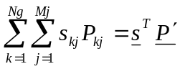

s.t.

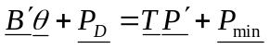 DC Power Flow Equation

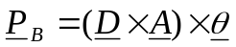 Line Flow Equation

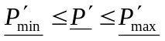 Generator Constraints

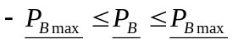 Line Flow Constraints

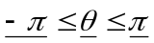 Bus Angle Constraints

D is an MxM matrix that will have its diagonal as the admittances of the lines.
M = number of branches
A is an M x (N-1) node-arc incidence matrix that describe the flow from bus i to bus j.
N= number of busses
B’ is the DC power flow matrix of dimension (N-1)x(N-1), where N is the number of buses in the network, obtained as follows:
  - Replace diagonal element B’_{kk} with the sum of the non-diagonal elements in row k. Alternatively, subtract b_{k} (the shunt term) from B_{kk}, and multiply by -1.
  - Multiply all off-diagonals by -1.
θ is the vector of nodal phase angles for buses 2,…N
P_{D} is the Power demanded at each bus.

We formulate the above into the following:
A_{eq}x=b_{eq} is the equation that will be used to do this.

Aeq matrix – The number of columns is the sum of the number of generators, lines, and buses. The number of rows is the sum of the number of lines and buses.
Example:

This is the basic system that will be used for the example.
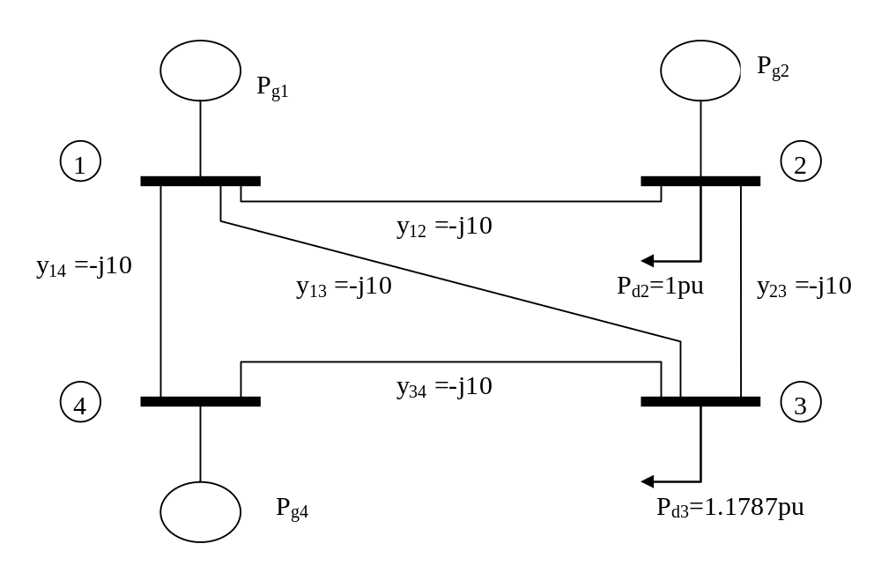
This graph gives the basic representation of the cost curves division for a generator
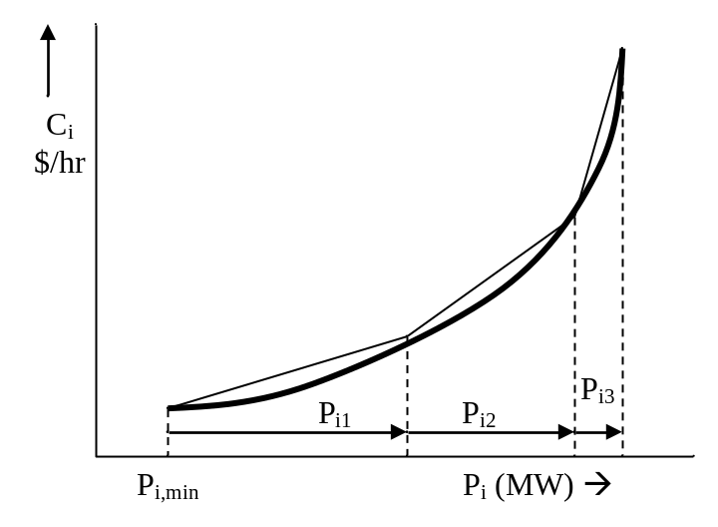
We will use linearized representation, but to begin with, we assume quadratic representation for the three cost curves of the example.

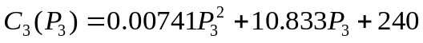
In the project implementation, we expect to receive the curves in the form of break points.

Break points for PW linear approximation of cost curves given as MW, Cost

Unit | BP#1  (unit min) | BP#2 | BP#3 | BP#4  (unit max)
1 | 50.0, 809.9 | 100, 1433 | 160, 2217 | 200, 2760
2 | 37.5, 5325 | 70, 9699 | 130, 1693 | 150, 1950
3 | 45.0, 742.5 | 90, 1275 | 140, 1902 | 180, 2430

The slope is then computed for each of the segments (1-2), (2-3), and (3-4) for each curve. This is done by the following equation:

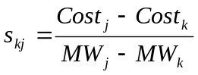 and substituting numbers: 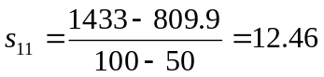

This process is done for each section and each generator. The slopes of the piecewise linear approximations of the cost curves are shown below:

Unit, i | s_{i1} | s_{i2} | s_{i3}
1 | 12.46 | 13.07 | 13.58
2 | 11.29 | 12.11 | 12.82
3 | 11.83 | 12.54 | 13.20

The limits on generation for each section must be calculated. This is given by:

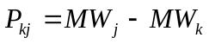, for example: 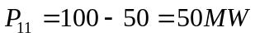

This process is done for each section of the curve for each generator. Representing the vector of piecewise linear generation values as P’, we have:
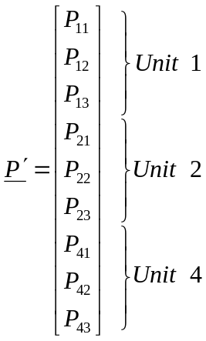 → 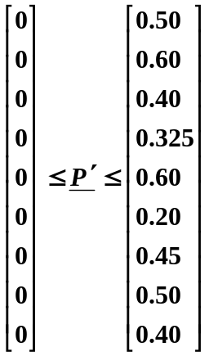

In the above, the generation is represented in per-unit on 100 MVA base.

Next, the T matrix must be built. This is a matrix that operates on the piecewise linear generation vector P’ to obtain generation injections, i.e., it sums the generation variables for each unit to obtain the total generation at that unit. For this case, T will be 4 rows high, and 9 columns long.

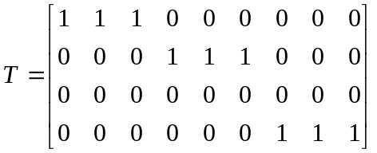
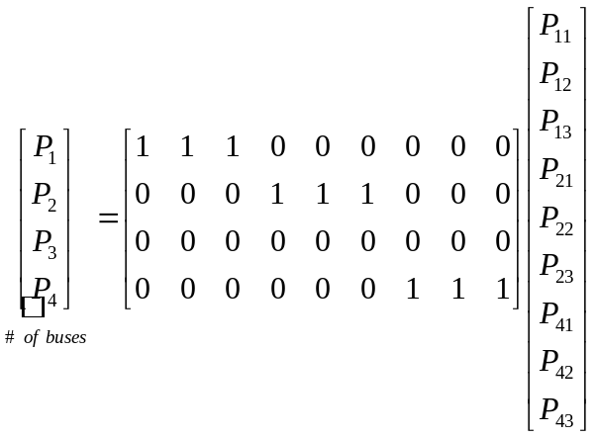

The next step is to get the respective parts for the DC Power Flow (). We first obtain the B’ matrix.

Neglecting resistance, the Y-bus is:

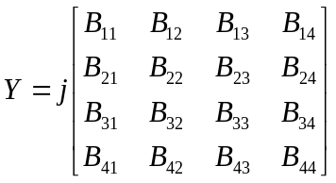

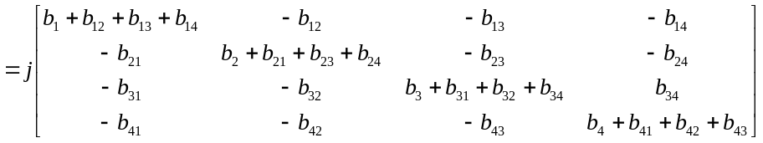

From the above, we obtain the B’ matrix from the Y-bus, as follows:
- Remove the “j” from the Y-bus.
- Replace diagonal element B’_{kk} with the sum of the non-diagonal elements in row k. Alternatively, subtract b_{k} (the shunt term) from B_{kk}, and multiply by -1.
- Multiply all off-diagonals by -1.
Comparison of the numerical values of the Y-bus with the numerical values of the B’ matrix for our example will confirm the above procedure:

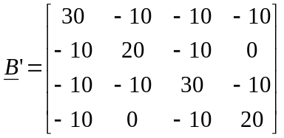

Another way to remember the B’ matrix is to observe that since its non-diagonal elements are the negative of the Y-bus matrix, the B’ non-diagonal elements are susceptances..

Limits on bus angles are:

P_{D} is the vector of load values, in per unit: 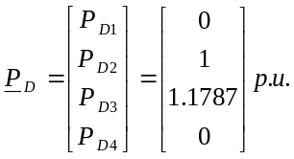

P_{min} is the minimum amount of power that each generator can produce.
P_{max} is the maximum amount of power that each generator can produce.

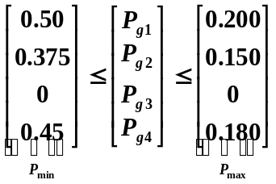
We account for the lower limit in the DC power flow equation through P_{min}.
Expressing the DC Power Flow Equation ().

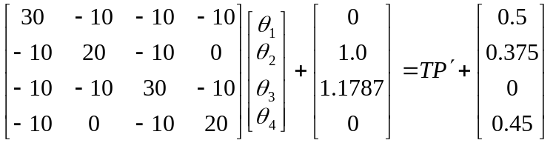

The Line Flow Equations are represented next.

The D-matrix is formed by placing the admittances of each branch along the diagonal of an M x M matrix, where M=5.

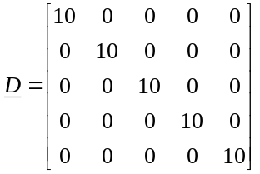

The node-arc incidence matrix is found by first defining a direction of power flow in the system.
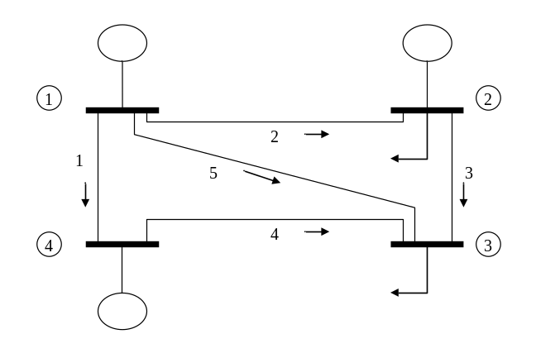
A branch is said to “begin” at node j if the power flowing across branch k is defined positive for a direction from node j to the other node.

A branch is said to “terminate” at node j if the power flowing across branch k is defined positive for a direction to node j from the other node.

With this definition, we can express the node-arc-incidence matrix as:

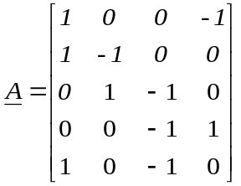 (Has four columns because there are four bus angles)

We will next find DxA.

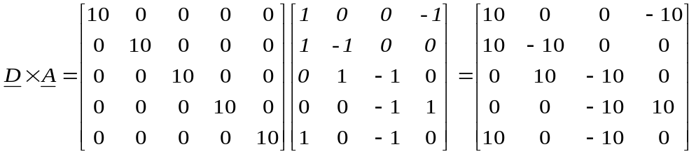

Next, the line flow constraints will be stated. (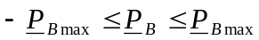)

To begin with, we will represent unconstrained transmission using very large limits.
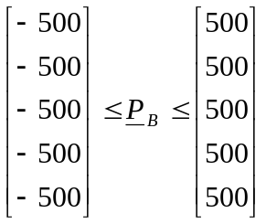 per-unit.

Bus angle (theta) constraints are – to (360 degrees)

The A_{eq} matrix will now be exampled and built.

In this example, we have 4 buses, 5 branches, and 9 generation sections. So that sums up to 18, so that is the number of columns in the Aeq matrix. For the number of rows, we have 5 branches and 4 buses, which sums up to 9 and is the number of rows in this matrix.
- The last 4 columns on the first 5 rows is the DxA matrix.
- The first 14 columns on the first 5 rows are the elements in the line flow equations that multiply the variables P₁₁, P₁₂, P₁₃, P₂₁, P₂₂, P₂₃, P₄₁, P₄₂, P_{43,} P_{B1}, P_{B2}, P_{B3}, P_{B4}, and P_{B5}. P₁₁, P₁₂, P₁₃, P₂₁, P₂₂, P₂₃, P₄₁, P₄₂, P₄₃ are set to zero because they are the generations not the line flow. P_{B1}, P_{B2}, P_{B3}, P_{B4}, and P_{B5} are set to -1 to say that there is a branch in a specific location.
- The first 9 columns of the last 4 rows multiply with the generation variables P₁₁, P₁₂, P₁₃, P₂₁, P₂₂, P₂₃, P₄₁, P₄₂, P₄₃,. The demand (P_{D}) will be given to us in the b matrix and P_{gk}-P_{dk} is in the b matrix.
- The 10-14 columns of the last 4 rows correspond to the line flow variables, but these are zeros because they are not the DC power flow equation.
- The last 4 columns of the last 4 rows correspond to the DC power flows that include all the angles.

We can see that these elements will occupy the upper right hand corner of A_{eq}. So that will take care of the last 4 columns in the first 5 rows.

What about the first 14 columns? These elements are the equations that are multiplied by the variables P₁₁, P₁₂, P₁₃, P₂₁, P₂₂, P₂₃, P₄₁, P₄₂, P₄₃, P_{B1}, P_{B2}, P_{B3}, P_{B4}, and P_{B5}. Since we do not use the generation variables within the line flow equations, the first 9 columns of these top 5 rows will be zeros. The last 5 columns in these top 5 rows will also be zeros, except the one element in each of these rows that multiply the corresponding line flow variable, and that element will be -1.

The right hand side equations will be set to zero

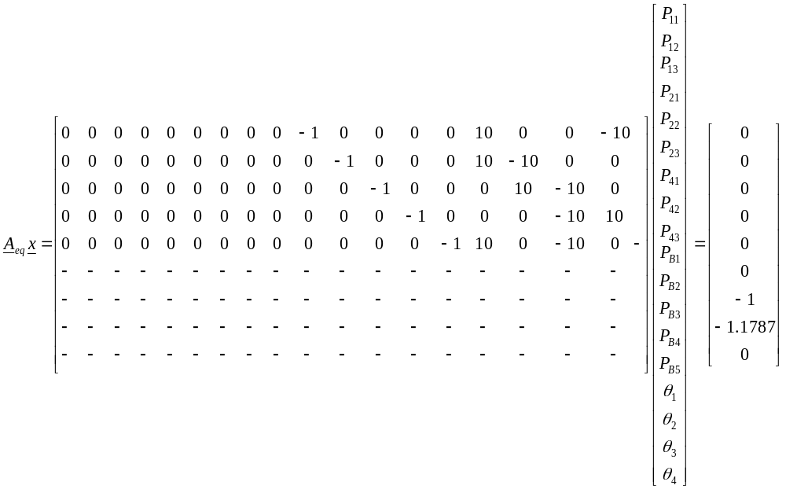

The B’ matrix deal with the bus angles. This is inserted into the last 4 columns and the bottom 4 rows. The resulting matrix appears as:
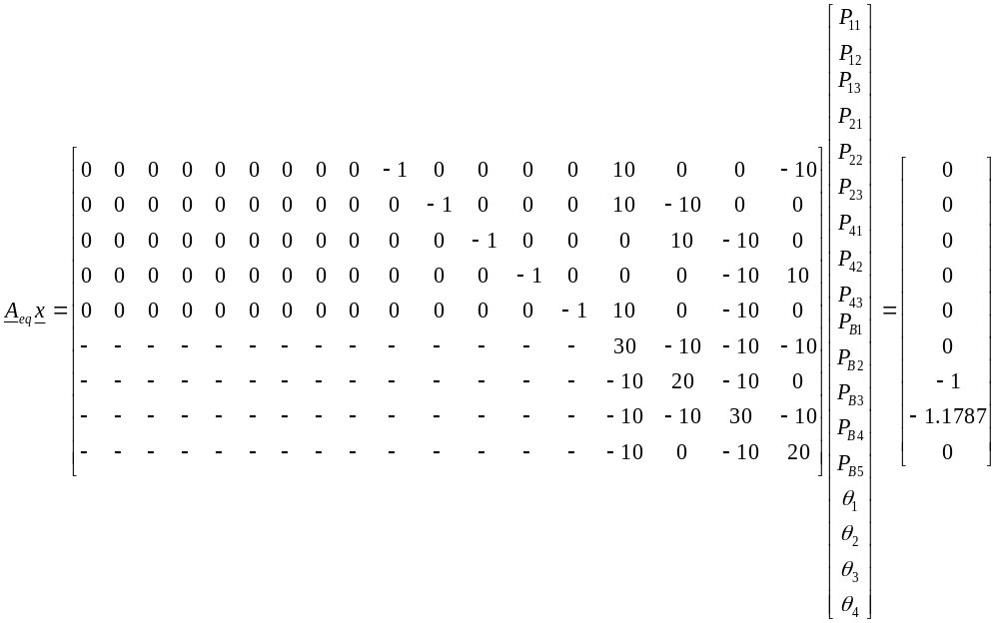

Once again, we need to consider the first eight columns. Columns 4-8 correspond to the line flow variables, which do not appear in the DC power flow equations, so these will be zero.

Given that the demand for Generator 2 = 1.0 per unit and Generator 3 = 1.178 per unit
P_{d1}=0, P_{d2}=1.0, P_{d3}=1.1787, P_{d4}=0, P_{g3}=0
Since these are constants, they can go to the right-hand side. This means on the left-hand side, the injection, which is defined as P_{gk}-P_{Dk} should be negative. That is, we should see on the left-hand-side –P_{gk}+P_{Dk}. But now we will take the load term onto the right-hand-side by subtracting it from both sides.

Thus, we see that the load term should show up on the right-hand-side as a negative number

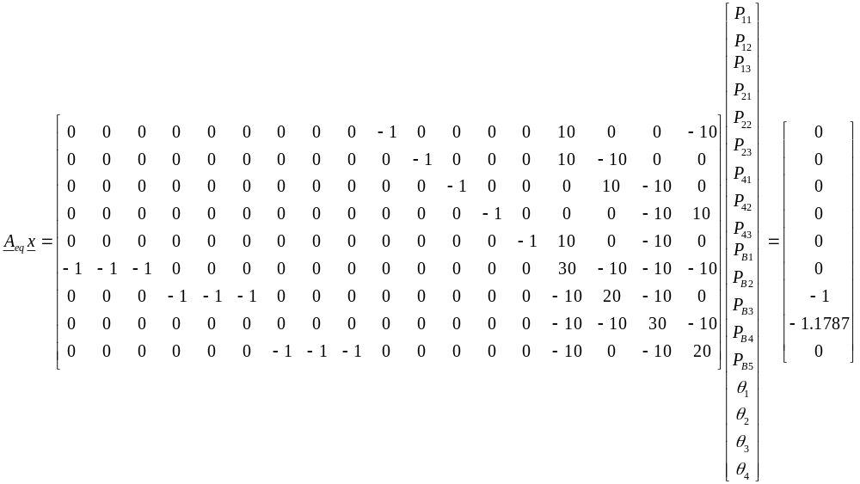
Putting all of the constraints together, and converting the generator constraints to per unit, the following vector of constraints is given.

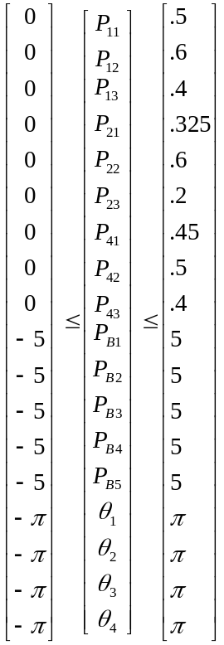

We then solve for these in Matlab using linear programming:

%Load is system load plus losses
Load=2.1787;

%Build objective function vector.
c=[1246 1307 1358 1129 1211 1282 1183 1254 1320 0 0 0 0 0 0 0 0 0]';

%Build A matrix for inequality constraints Ax<b.
A=[];
%Build b, the right-hand-side of inequality constraints.
b=[];

%Build Aeq matrix for equality constraints.
Aeq=[0 0 0 0 0 0 0 0 0 -1 0 0 0 0 10 0 0 -10;
0 0 0 0 0 0 0 0 0 0 -1 0 0 0 10 -10 0 0;
0 0 0 0 0 0 0 0 0 0 0 -1 0 0 0 10 -10 0;
0 0 0 0 0 0 0 0 0 0 0 0 -1 0 0 0 -10 10;
0 0 0 0 0 0 0 0 0 0 0 0 0 -1 10 0 -10 0;
-1 -1 -1 0 0 0 0 0 0 0 0 0 0 0 30 -10 -10 -10;
0 0 0 -1 -1 -1 0 0 0 0 0 0 0 0 -10 20 -10 0;
0 0 0 0 0 0 0 0 0 0 0 0 0 0 -10 -10 30 -10;
0 0 0 0 0 0 -1 -1 -1 0 0 0 0 0 -10 0 -10 20;];

%Build right-hand side of equality constraint.
beq=zeros(9,1);
beq(7)=-1;
beq(8)=-1.1787;

%Build upper and lower bounds on decision variables.
LB=[0 0 0 0 0 0 0 0 0 -5 -5 -5 -5 -5 -pi -pi -pi -pi]';
UB=[.5 .5 .4 .325 .6 .2 .45 .5 .4 5 5 5 5 5 pi pi pi pi]';
[X,FVAL,EXITFLAG,OUTPUT,LAMBDA]=LINPROG(c,A,b,Aeq,beq,LB,UB);

The solution is then:

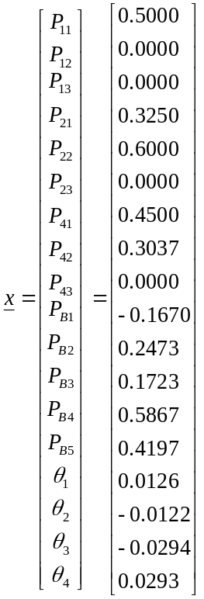

With the objective function of :
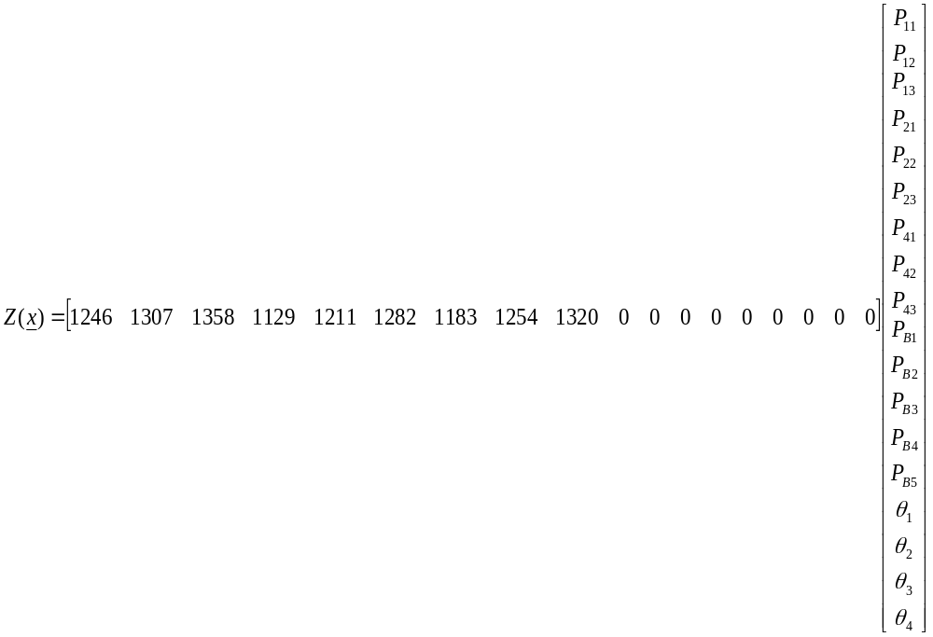

We find that Z = 2629.7$/hr
But we need to add to this solution for the following for each unit:
∆C_{k}=C(P_{gk,min})-s_{k}P_{gk,min}
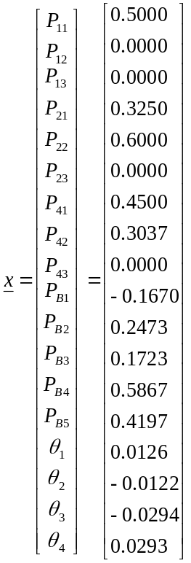

So the true objective function is:
2629.7+186.88+143.36+185.39=3145.33 $/hr

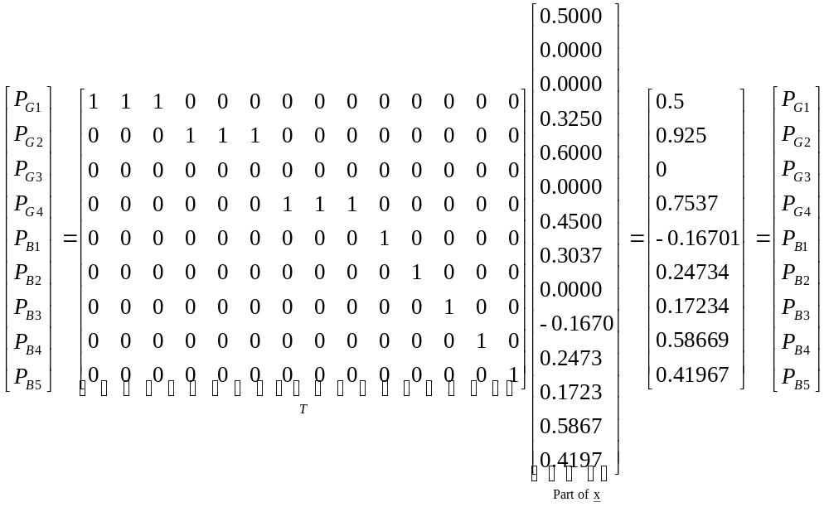

Second case, there is a constraint on P_{B2} of 15 MW.
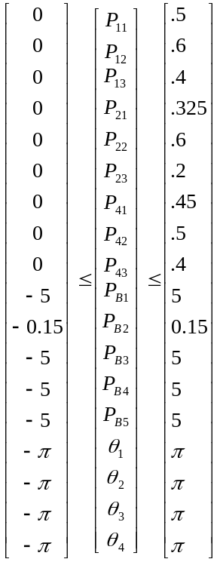

We then solve for these in Matlab using linear programming:

%Load is system load plus losses
Load=2.1787;

%Build objective function vector.
c=[1246 1307 1358 1129 1211 1282 1183 1254 1320 0 0 0 0 0 0 0 0 0]';

%Build A matrix for inequality constraints Ax<b.
A=[];
%Build b, the right-hand-side of inequality constraints.
b=[];

%Build Aeq matrix for equality constraints.
Aeq=[0 0 0 0 0 0 0 0 0 -1 0 0 0 0 10 0 0 -10;
0 0 0 0 0 0 0 0 0 0 -1 0 0 0 10 -10 0 0;
0 0 0 0 0 0 0 0 0 0 0 -1 0 0 0 10 -10 0;
0 0 0 0 0 0 0 0 0 0 0 0 -1 0 0 0 -10 10;
0 0 0 0 0 0 0 0 0 0 0 0 0 -1 10 0 -10 0;
-1 -1 -1 0 0 0 0 0 0 0 0 0 0 0 30 -10 -10 -10;
0 0 0 -1 -1 -1 0 0 0 0 0 0 0 0 -10 20 -10 0;
0 0 0 0 0 0 0 0 0 0 0 0 0 0 -10 -10 30 -10;
0 0 0 0 0 0 -1 -1 -1 0 0 0 0 0 -10 0 -10 20;];

%Build right-hand side of equality constraint.
beq=zeros(9,1);
beq(7)=-1;
beq(8)=-1.1787;

%Build upper and lower bounds on decision variables.
LB=[0 0 0 0 0 0 0 0 0 -5 -0.15 -5 -5 -5 -pi -pi -pi -pi]';
UB=[.5 .5 .4 .325 .6 .2 .45 .5 .4 5 0.15 5 5 5 pi pi pi pi]';
[X,FVAL,EXITFLAG,OUTPUT,LAMBDA]=LINPROG(c,A,b,Aeq,beq,LB,UB);

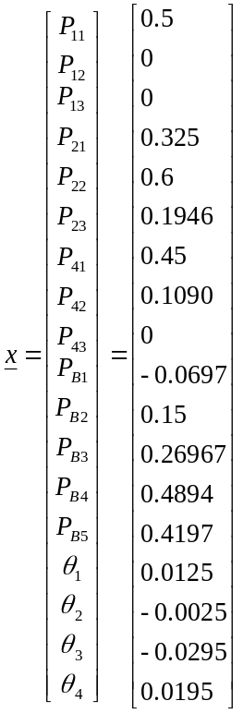

We find that Z = 2635.2

So the true objective function is:
2635.2+186.88+235.06+199.68=3256.82 $/hr

The most noticeable change in the system is how the generation shifted at each generator to account for the constraint on Bus 2.

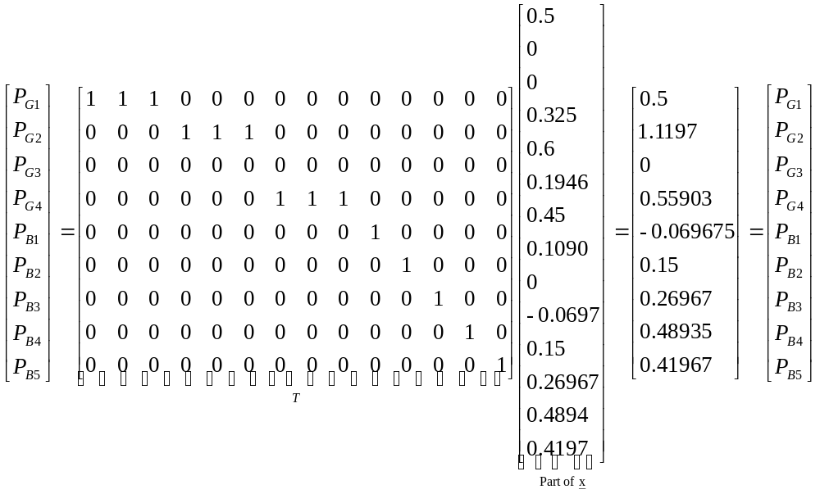

The Change in the P vector that was solved for is:

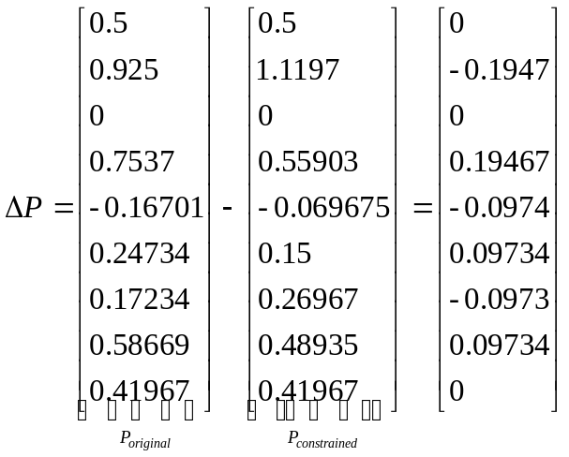

Summary algorithm for the steps above
Using the above steps we determine the necessary variables to enter into a linear programming equation that produces the solution vector. The variables required by the equation are:
- Objective function vector
- A matrix
- RHS of inequality constraints
- A equivalent matrix
- RHS equality constraints
- Lower bounds
- Upper bounds

We find the objective function, lower bounds, and the upper bounds from the cost curve data. The A matrix, RHS of inequality constraints, RHS of equality constraints, and the A equivalent matrix are found using MatLab code using data from PSSE.

References
- A. Wood and B. Wollenberg, “Power generation, operation, and control,” Second edition, John Wiley & Sons, 1996.
- “Transmission system reliability methods,” project 1530-1, prepared by Power Technologies Incorporated (PTI), EPRI report EL-2526, 1982.
- Feng Xia; Meliopoulos, A.P.S, “A methodology for probabilistic simultaneous transfer capability analysis”.;
Power Systems, IEEE Transactions on, Volume 11, Issue 3, Aug. 1996 Page(s):1269 – 1278.
- N. Dag Reppen, presentation slides given at EPRI Workshop on Reliability Analysis, San Diego, California, Feb 27, 2001.
- R. A. Leon Candela, “Sensor network design for a secure electric energy infrastructure,” M.S., thesis, Iowa State University, April 2005.
- Q. Chen and J. McCalley, “Identifying High-Risk N-k Contingencies for On-line Security Assessment,” to appear in IEEE Transactions on Power Systems.

