Module PE.PAS.U18.5

Data and models for power system reliability analysis

NOTE! See pp 6.26-6.30 of EPRI EL-5290 for more info on data.

U18.1 Introduction
Module 17 provided an overview of power systems reliability evaluation, and we saw there that it can be broken down into three broad types of analysis: HL-I (generation), HL-II (generation and transmission), and distribution system reliability analysis.
A fundamental issue regarding any of these analyses is, however, that all of the application software that performs the analyses requires input data in order to compute the desired indices. In this module, we address the issue of obtaining this input data.
Reliability data is often quoted in the literature. For example, in a recent talk, an engineer gave the following information:

Generator Force Outaged Rate Average Outage
Duration (hours)
Hydro Unit 0.04 50
Thermal Unit 0.10 50

Lines Frequency Average Outage
(occ./km/year) Duration (hours)
230 kV Line 0.01 100
115 kV Line 0.01 7
69 kV Line 0.07 7

Transformers 0.10 3

This kind of data is essential to performing HL-I and HL-II reliability analyses. How do we obtain such data and how can we be sure that it is consistent?
This is the topic of this module.

U18.2 Reliability data – generators
There are two organizations that have been coordinating long-term comprehensive generator data gathering efforts in effect at the time of this writing:
- North American Electric Reliability Council (NERC)
- Canadian Electricity Association (CEA)
We describe these in what follows, and then discuss models.

U18.2.1 North American Electric Reliability Council (NERC)
There exists a NERC subcommittee that serves to coordinate issues related to reliability data. This subcommittee is called the “Reliability Data, Methods, and Modeling Subcommittee (RDMMS). One of the key functions of RDMMS is to maintain the Generator Availability Data System (GADS). This database was created in the mid-1960’s by the Edison Electric Institute (EEI), and then came under NERC management in 1979 [1]. The GADS mission is to collect, record, and retrieve operating information for improving the performance of electric generating equipment. Today, 182 generating facility operators in the United States and Canada voluntarily participate in GADS, representing almost 3700 electric generating units [1]. Detailed information on GADS can be found at the NERC web site [2].
The information gathered, their definitions, and their relationships are based on IEEE Standard 762, "Definitions for Use in Reporting Electric Generating Unit Reliability, Availability, and Productivity" [3].
GADS provides functionality for collection of data corresponding to generator events, generator performance, and generator design, for all types of bulk transmission system generation facilities (nuclear, hydro, pumped storage, gas turbine, jet engine, diesel, combined cycle, cogeneration, fluidized bed combustion).
The event data is comprised of information related to event identification (e.g., outages, deratings, reserve shutdowns, and noncurtailing events), event magnitude (e.g., start of event, event transitions, end of event, gross and net available capacity as a result of event), and primary cause/additional cause of event. Causes are specified by selecting from detailed cause codes provided for each type of generation facility and each major system comprising that facility. Figure U18.1 provides a hierarchical illustration of different generator event types. The level of detail required by GADS is characterized by the two-letter codes in the fourth level in the bottom half of the diagram.
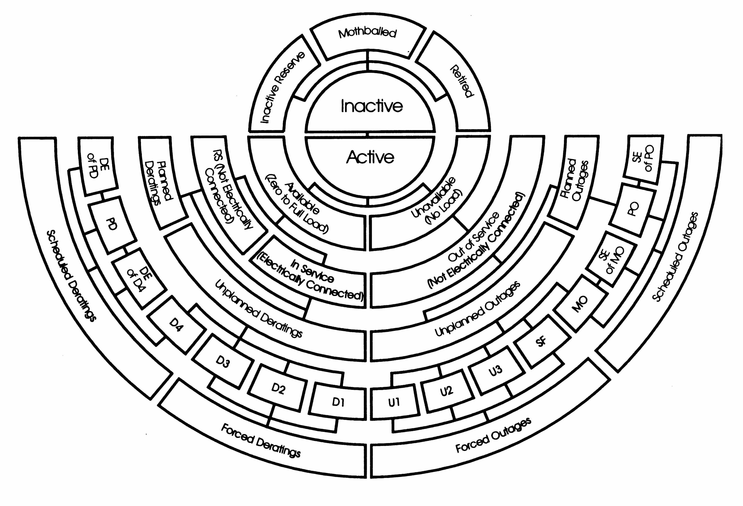
Fig. U18.1: Hierarchy of Generator Events

The performance data is comprised of information related to unit capacity (e.g., gross and net maximum, dependable, and actual capacities), unit starting characteristics (e.g., attempted and actual unit starts), unit time information (e.g., unit service hours, reserve shutdown hours, available hours, planned shutdown hours, forced outage hours, maintenance outage hours, unavailable hours, etc.), and primary/secondary fuel data (e.g., quantity burned, average heat content, etc.).
The design data is comprised of information related to unit type, manufacturer, fuel type, in-service dates, intended operational mode, fuel handling systems, auxiliary systems, etc.
U18.2.2 Canadian Electricity Association (CEA)
The CEA maintains a database called the Equipment Reliability Information System (ERIS) which contains data on generation, transmission, and distribution equipment [4].
ERIS reports on the continuous status of generating units from idle to fully operational, including shut downs or failures. The database contains events since 1977. There are now 16 Canadian utilities that submit over 150,000 events recorded per year. The information comprising the database covers 850 generating units and over 7000 generation-related components. The generating units covered are: hydraulic, thermal, combustion turbine, diesel and nuclear. Details such as fuel type, size, and manufacturer, age and design information are collected for each unit.
Annual and five year cumulative data published yearly by CEA and are available at [5] for a nominal fee. Some of the major indicators published in the resulting "Generation Equipment Status Annual Report" are failure rate, maintenance outage factor, planned outage factor, number of outages (forced, deratings, etc), forced outage rate, and the derating adjusted forced outage rate.

U18.2.3 Using data for models
There is much information available in the two databases described above, and a great deal of characterizing information about each unit or different classes of units may be derived from it. Reference [6] summarizes four different Markov models that had been suggested up until that time, 3 of which were variations on the 2-state model. This model is illustrated in Fig. U18.2, with the two states being “up” (U) and “down” (D), and MTTF=m, MTTR=r.
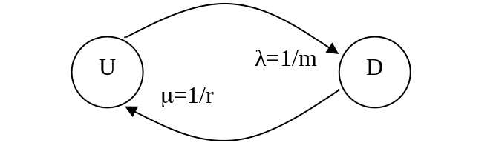
Fig. U18.2: Two-State Model
It can be shown that the availability, A, and unavailability, U, which gives the probabilities that the unit is in states U and D, respectively, are given by [7]:
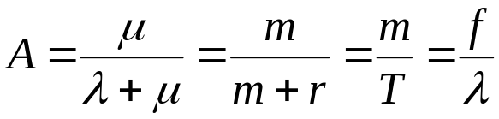 (U18.1)
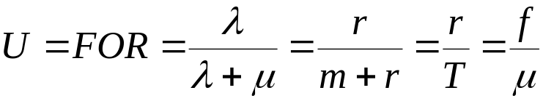 (U18.2)
(Module U16, Section U16.4, covers this case in more depth).
In (U18.2), the FOR is the force outage rate. One should be careful to note that the FOR is not a rate at all but rather an estimator for a probability. Reference [3] indicates that that is computed as:
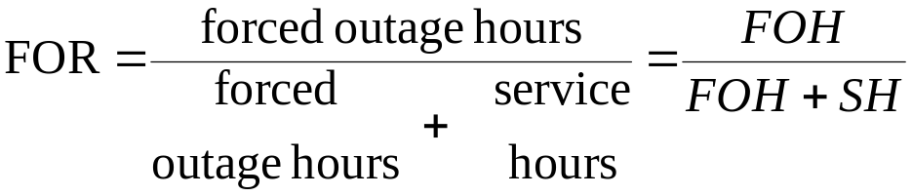 (U18.3)
where [3]:
- Forced outage hours (FOH) is the number of hours a unit was in a class 0, 1, 2, or 3 unplanned outage state; the classes are:
  - Class 0 (starting failure): an outage that results from the unsuccessful attempt to place the unit in service
  - Class 1 (immediate): an outage that requires immediate removal from the existing state.
  - Class 2 (delayed): an outage that does not require immediate removal from the in-service state but requires removal within 6 hours.
  - Class 3 (postponed): an outage that can be postponed beyond 6 hours but requires that a unit be removed from the in-service state before the end of the next weekend.
- Service hours (SH) is the number of hours a unit was in the in-service state. It does not include reserve shutdown hours.
We may also compute an estimator for the availability as
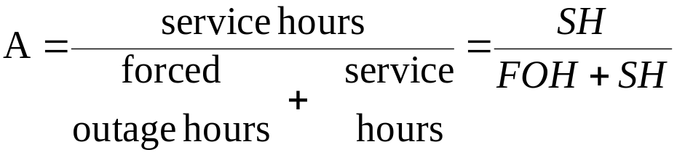 (U18.4)
where we see that A=1-U=1-FOR.
Once U and A are obtained from the appropriate database information, it is a simple matter to use (U18.1) and (U18.2) to obtain any of the other parameters that might be desired.
This model would only apply, of course, when the unit was in service or forced out of service when it was desired to be in service. The model would not apply for times when the unit is intentionally out of service. For most large base loaded units, the only time the unit is intentionally out of service is when it is on maintenance, in which case the model should not be used.
So we conclude that the 2-state model provides a good estimate of the risk of base loaded units not being available at any time during a span between successive periods of scheduled maintenance.
There are two basic problems with the 2-state model. The first is that it does not account for derated states, i.e., states in which it is still operating but at reduced capacity due to, for example, the outages of auxiliary equipment such as pulverizers, water pumps, fans, or environmental constraints.
The second is that the 2-state model does not allow for a unit to be on reserve, i.e., intentionally out of service on a frequent basis, which is a very real possibility for peaking units.
Approach 1: Equivalent forced outage rate.
An obvious approach to handling derated states is to increase the number of states in our Markov model by a number equal to the number of derated capacities for which the unit might operate, and this approach can be appropriate in some circumstances where increased accuracy is required, e.g., in short-term operating reserve studies. But generally, for capacity planning studies, the 2-state model is acceptable for base-loaded plants if we increase the forced outage hours in the numerator of the FOR by an “equivalent” forced derated hours (which will be less than the actual derated hours since partial capacity is there during these hours).
The equivalent forced outage rate (EFOR) is given by
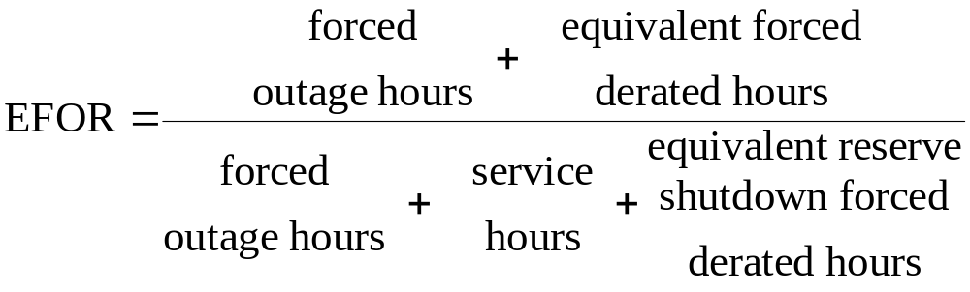
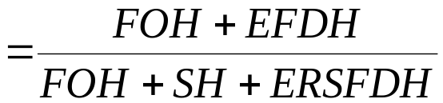 (U18.5)
where FOH and SH are defined in the same way as in (U18.3) (note that SH includes derated hours as well), and the other terms are:
- Equivalent forced derated hours (EFDH) is the equivalent available hours during which a class 1, 2, or 3 unplanned derating was in effect (where the derating classes are defined similarly to the outage classes given above). Note two items with respect to this term:
  - “Available hours” is the number of hours a unit could be in-service, which includes the number of hours the unit is in-service (SH) plus the number of hours the unit is in reserve shutdown.
  - The word “equivalent” implies the number of hours a unit is derated expressed as equivalent hours of full outage at maximum capacity. We account for the derating by decreasing each actual forced derated hour in proportion to the derating fraction, i.e.,
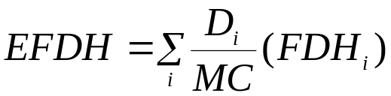 (U18.6)
where
  - D_{i} is the difference between the maximum capacity and the available capacity for the i^{th} derated state,
  - FDH_{i} is the number of hours in that derated state, and
  - MC is the unit maximum capacity.
We see that D_{i} / MC, which is the ratio of the unit’s decreased capacity in the i^{th} derated state to the unit’s maximum capacity, is the derating factor.
- Equivalent reserve shutdown forced derated hours (ERSFDH) is the equivalent reserve shutdown hours during which a class 1, 2, or 3 unplanned derating was in effect. The word equivalent, again, implies:
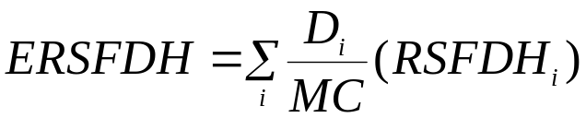 (U18.7)
where D_{i} and MC are as before and RSFDH_{i} is the number of hours, while in reserve shutdown, that the unit is in the i^{th} derated state.
The basis for (U18.5) may be understood by examining Fig. U18.3 where we see that (U18.5) is comprised of
- The numerator, which is the double line comprising FOH and EFDH. This is the total equivalent forced outage hours.
- The denominator, which is the single thick line comprising SH, ERSFDH, and FOH. This is the total equivalent hours that the unit is in demand.
Note that IFDH is the in-service forced derated hours, EIFDH is the equivalent IFDH, and RSH is the reserve shutdown hours.
Observe that the number of hours where the unit is in reserve shutdown, but either fully available or equivalently fully available, RSH-ERSFDH, is not included in the numerator or denominator, i.e., it is ignored in the calculation. This is a result of the perspective that the unit, while in reserve, has a much different failure rate (typically, much lower) than it does when it is in service, and we do not want to capture this failure rate.
On the other hand, ERSFDH is included in the denominator, and EFDH is included in the numerator because, for these times, the unit is (equivalently) fully failed; we assume these failures occurred from the in-service state, not from the reserve state.
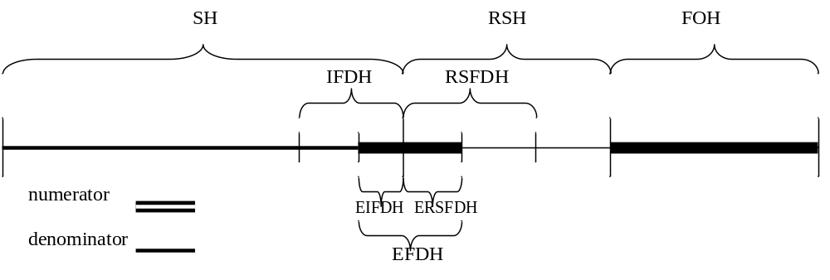Fig. U18.3: Illustration of FOH computation
Approach 2:
A second approach which effectively deals with the reserve issue (but not the derated issue) is to use a 4 state model. This model, which is attractive for modeling peaking units in operating reserve studies, is shown in Fig. U18.4 [6].

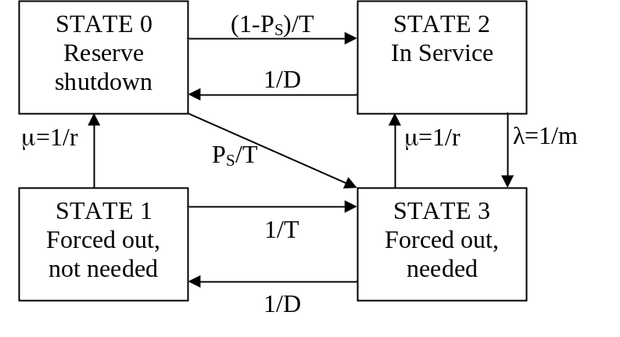
Fig. U18.4: 4-state model [6]
Some comments to help in understanding this model follow:
- The states of our previous 2-state model are on the right-hand-side, represented by states 2 and 3.
- The new states are on the left-hand-side, states 0 and 1, and represent the reserved shutdown states.
- The top two states, 0 and 2, represent states where the unit is available.
- The bottom two states, 1 and 3, represent states where the unit has been forced out and therefore is unavailable.
- Using the term “demand” to indicate the unit is needed, notationally, we have:
  - T is the average reserve shutdown time between periods of need, exclusive of periods for maintenance or other planned unavailability (hrs)
  - D is the average in-service time per occasion of demand (hrs)
  - m is the MTTF, i.e., the average in-service time between occasions of forced outage (hrs)
  - r is the MTTR, i.e., the average repair time per forced outage occurrence (hrs)
  - P_{S} is the probability of a starting failure resulting in inability to serve load during all or part of a demand period. Repeated attempts to start during one demand period are not interpreted as more than one failure to start.
- The transition from state 0 to state 3 accounts for the occasion when a unit is needed but cannot start. This is a very desirable feature of this model because, relatively, starting is well-known to be a high-probability failure step.
The differential equation for this model, denoted in module U16 as equation (U16.10), is given by:
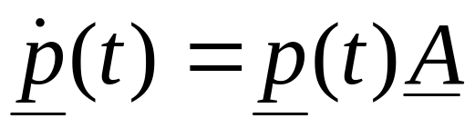
or in terms of the model notation,
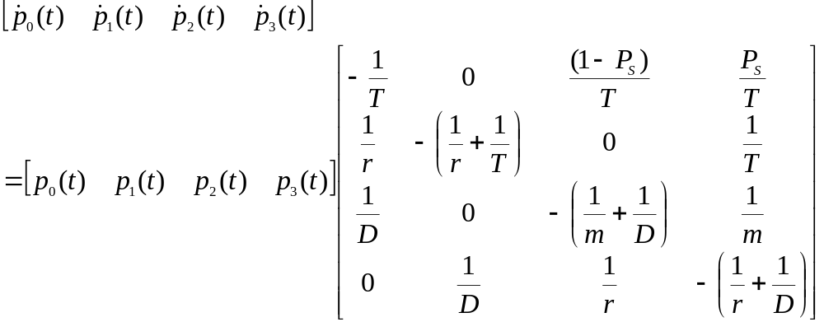(U18.8)
As we have done several times before, we may find the long-run probabilities as the steady-state solution to the above set of differential equations, using
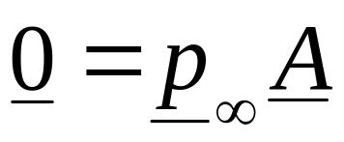
together with p₀+p₁+p₂+p₃=1. We will not solve this here but simply depend on the relations in [6], which are given as:
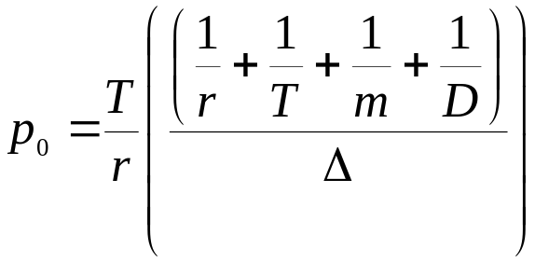 (U18.9)
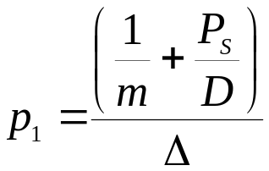 (U18.10)
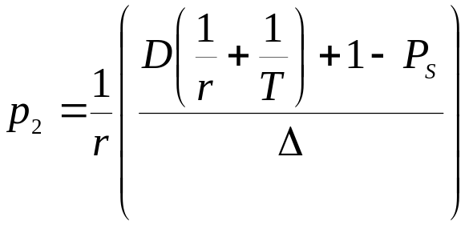 (U18.11)
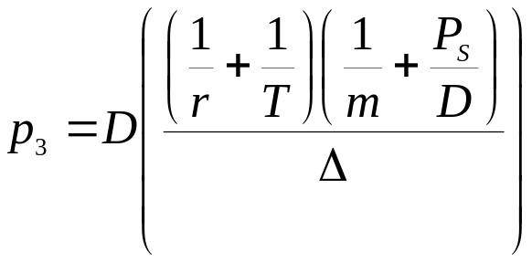 (U18.12)
where
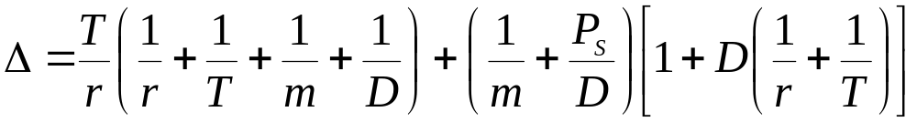
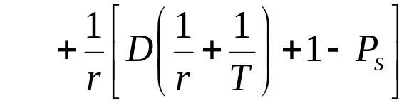 (U18.13)
Now we can obtain from this model several probabilities of interest:
- P(the unit is not in service) =p₀+p₁+p₃; yet this includes p₁, the probability that the unit is not in service but not needed.
- P(the unit is not available)=p₁+p₃; yet this excludes the component of state 0 where the unit receives a demand but cannot start.
So neither of these terms are very attractive. The alternative suggested in [6] is to use:
The probability of being unavailable GIVEN the unit is in demand.
This is obviously a conditional probability.
So the desired probability is:
P[being unavailable|the unit is in demand]
Recalling P[A|B]=P[A∩B]/P[B], the desired probability can be expressed as:
P[(being unavailable) | (the unit is in demand)]
=P[(being unavailable) AND (in demand)] / P[in demand]
Referring back to the individual states in our model of Fig. U18.3, we find that the numerator is given by
P[(being unavailable) AND (in demand)]=p₃
and the denominator is given by
P[in demand]=p₂+p₃
Our desired probability, which we will use in place of the FOR, is
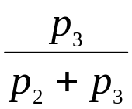 (U18.14)
It is of interest to note that we can identify the “old” concept of FOR from our new model by simply ignoring the reserve shutdown state, state 0, since the “old” concept of FOR was predicated on the idea that it is not possible for the unit to be working but unavailable. Recalling that FOR is the ratio of the number of hours in the outaged state (states 1 and 3) to the number of total hours (states 1, 2 and 3, ignoring state 0), we have that
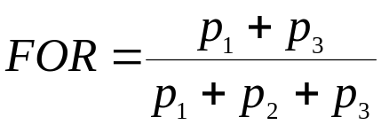 (U18.15)
It is consoling that the FOR approaches the new desired probability of (U18.14) as p₁ approaches zero.
Reference [6] has a nice numerical example illustrating different aspects of this model.
Also, reference [7] illustrates variation in EFOR with unit size.
Final comment: Some recent developments for statistically improving estimators for generator unit outage and availability data, based on so-called data pooling, is given in [8]. This work is based on the idea that estimator variance reduces as the sample size increases.

U18.3 Reliability data – overhead transmission
Database resources for overhead transmission reliability are perhaps not as well-developed as that of generation, partly because generation reliability (HL-I) was developed before composite reliability (HL-II) and partly because transmission data is more complex. For example, the mission for the NERC Reliability Data, Methods, and Modeling Subcommittee reads “Maintain and manage the data collection and system modeling (including steady-state and dynamic) efforts necessary for reliability simulations and assessments.” Yet, although their scope of activities includes maintenance of GADS, there is no statement referring to maintenance of transmission reliability data.
Some early efforts resulted in a 1973 IEEE standard that provided definitions for reporting and analyzing outages of electrical transmission and distribution facilities [9]. The Electric Power Research Institute (EPRI) also sponsored some projects to identify component outage data analysis methods [10] and create a corresponding database [11]. There have been several efforts on the part of NERC regional councils [12, 13] as well as individual utilities [14] to address the complexities of transmission reliability data. In addition, the IEEE PES Subcommittee on Applications of Probability Methods have made efforts to address this issue [15], ultimately resulting in a revised IEEE standard [16]. An IEEE Working Group published a 1993 paper summarizing a survey of US and Canadian overhead high voltage transmission outages [17], with 78 US utilities responding plus a single consolidated response from the Canadian Electricity Association (CEA) representing Canadian utilities.
One notable exception to the lack of long-term collection efforts with established centralized database for transmission reliability data is that maintained by CEA [3]. Similar to the CEA Electric Reliability Information System (ERIS) on generation, the ERIS transmission database contains data for all major transmission equipment components, and reports forced outage statistics on a national scale (for Canada). The major components covered are: lines, cables, circuit breakers, transformers, shunt reactor banks, shunt capacitor banks, series capacitor banks, and synchronous and static compensators.
The CEA database contains design information for all components and details on all forced outages that has occurred on the various components, including outage causes, with voltage classification as low as 60 kV. CEA has been collecting transmission reliability data since 1978, and at the time of this writing, has 14 contributing utilities, reporting over 20,000 events per year.
CEA published an annual report titled "Forced Outage Performance of Transmission Equipment Report,” which includes number of outages, outage frequency, total outage time, mean duration, and unavailabilities. This information is provided for each subcomponent (such as busses, surge arresters, windings, conductors, etc) of the major components, as well as primary causes, voltage classifications, failure modes, interrupting mediums, supporting structures and tank arrangements.

U18.4.1 Data collection: a case study
One utility’s report of such an exercise is provided in [12], where they performed an extensive examination of bulk transmission system component outages. The results of this effort illustrate some of the intricacies of transmission reliability data collection. A brief summary follows.

A. Line outages:
500 kV 230kV 115kV .
# of lines 61 149 181
outage rate/yr 1.31 0.87 0.73
Duration (hr) 4.93 6.79 4.62

They also suggest normalizing the outage rates by line length, in which case we get, for example, on the 500kV lines, .0127 outages/year.

B. Unit outages:

Single unit outages:
4.25 times/year for average duration of 109 hours/event

Two unit outages (at the same plant):
0.33 times/year for average duration of 50 hours/event

C. Forced transformer outages:
- Xfmr failures restoration times are long.
  - Replace 115/13.8 kV bank replacement with a spare: 1 wk
  - Replace 500/230 kV bank replacement with a spare: 1 mo
- Repair times for winding failures may involve factory-time.
- No analysis of non-catastrophic events (xfmr relay operations)
- Wear-out begins at 8-10 years, MTTF=27 years, failure rate=0.037/yr

D. Multiple contingencies:
  - Independent: two outages occur independently (multiple outages during storms are modeled as independent events having increased failure rates).
  - Common mode (common cause): a single initiating event forces two or more components out of service simultaneously (perhaps due to airplane flying into double circuit tower)
  - Dependent: outage of an element leads to a 2nd outage due to
    - overload on second circuit in parallel to an outaged circuit
    - stuck breaker
    - relay misoperation
    - bus faults

In a 6 year data base, they observed 10 N-2 (sustained) outages.

Sustained (N-2) multiple line outages
Dependent events: 0.088/year
Independent events: 0.0026/year
Duration (both components) 4 hours

E. Weather effects (lightning & cold):
- Outages for all lines show a peak in July and August, but it is not so pronounced for lines in the mountains. Due to lightning!
- Outages for all lines show a peak in December and January due to abnormal cold weather effects causing:
  - low gas pressure in breakers
  - frozen switches
- The cold weather effect was particularly pronounced
  - in the mountains
  - when temperatures are between 17 degrees and 35 degrees F
- Authors doubled line outage rates during cold weather
- Outage duration was not affected
- Transformer outage rates were not affected

U18.7.2 Standard approach
This section is adapted from [7]. This resource divides the different types of outages along lines similar to the division of the last section, except that it also divides the dependent outages into two classes. So the outage classes are:
- Single component outages
- Independent multiple outages
- Dependent multiple outages
- Common mode or common cause multiple outages
- Station originated multiple outages
Single component outages:
These are the easiest to deal with as they involve only a two state model for each component. The transition rate from the up-state to the down-state is given by the failure rate, λ, typically estimated based on 1/MTTF, excluding the influence of maintenance outages.
The transition rate from the down state to the up-state is the repair rate, μ, and heavily depends on how the restoration takes place, with possibilities including high or low-speed automatic reclosing, without repair, and with repair. It is common to assume a single repair rate in most composite reliability assessment efforts based on the assumption that the effects of momentary outages (automatic recluse) are negligible, implying the repair rate is a function of restorations with and without repair.
Independent multiple outages:
Independent multiple outages are referred to as overlapping or simultaneous independent outages. They are simple to deal with in that they involve two 2-state models such that the probability being in an N-outage state is the product of the probabilities of each individual outage state. A Markov model accounting for 2 independent outages is given in Fig. U18.5.

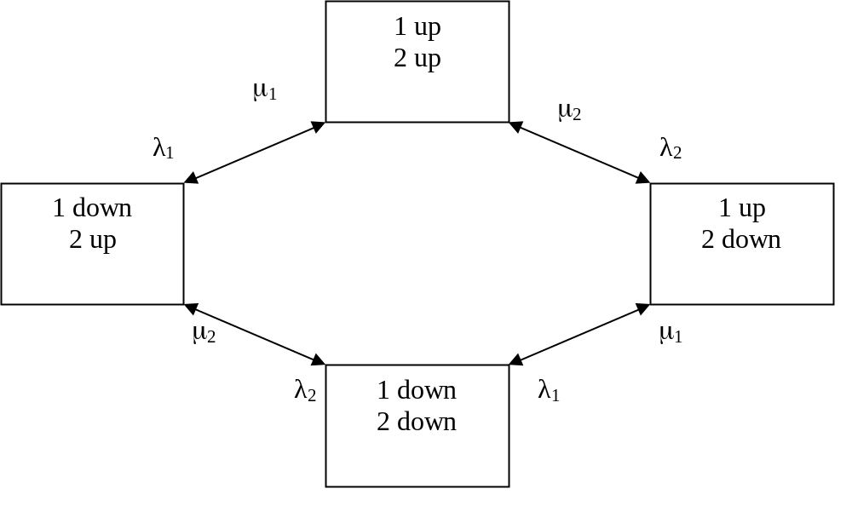
Fig. U18.5: 2 component model accounting for independent multiple outages
Dependent multiple outages:
Reference [7] argues that the dependent multiple outage category should consist of only the case where outage of one component creates system conditions which cause another component to outage. Such a case is typical if one assumes a certain loading level on a transmission circuit beyond which the operator will trip it. Therefore, such a case is not modeled stochastically but rather must be built into the analysis program. One should note that substation-oriented failures may also result in dependent outages, properly classified as such. We will, however, treat these separately, because of repair rate differences, as we shall see.
Whereas the probability of two independent outages is the product of their individual probabilities, the probability of an outage resulting in a subsequent dependent outage is, when the conditions result in a secondary dependent outage, equal to the probability of the first outage. Clearly, under such conditions, the probability of multiple outages resulting from dependent events can be much higher than the probability of two independent events!
Common mode multiple outages:
A common cause event is an event having an external cause with multiple failure effects where the effects are not consequences of each other [18]. Outage causes are classified as follows:
- Natural events:
  - Fire in the right-of-way
  - Foundation or anchor failure due to flood, landslide, or ground subsidence
  - Severe environmental conditions (hurricane, tornado, or icing)
- Interference:
  - Interference with other circuits, e.g., HV crossing of lower voltage circuits
  - Aircraft interference
  - Rail, road, or boat vehicle interference
Reference [18] suggests a common mode outage model for two transmission lines on the same right of way or on the same transmission tower. This model, shown in Fig. U18.6, is similar to that shown in Fig. U18.5 except for the direct transition rate λ_{C} from the top state to the bottom state.

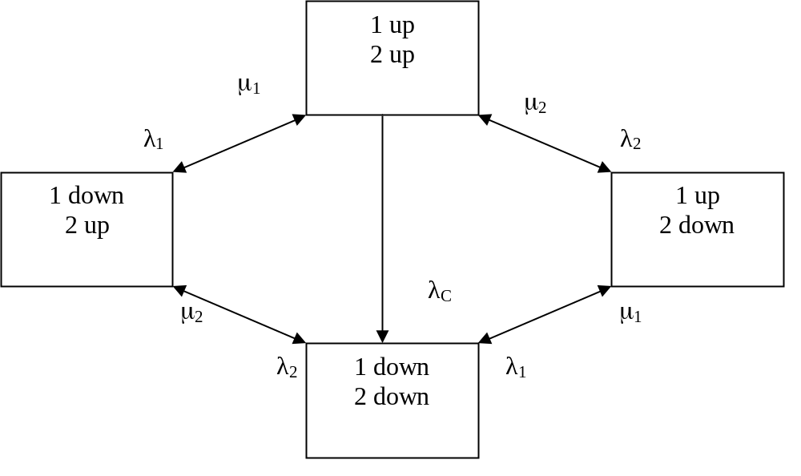
Fig. U18.6: Common mode outage model for two components [18]

Note that the model of Fig. U18.6 assumes that, following a common mode outage, the lines are repaired sequentially.
Station originated outages:
Reference [19] identifies station originated outages as a type of dependent outage, but one that needs special treatment. This is quite important in some cases, as indicated by the fact that one utility (Commonwealth Edison of Chicago) identified this type of outage as comprising over half of their multiple 345 kV transmission outages [20].
Station originated outages can occur due to a ground fault on a breaker, a stuck breaker condition, a bus fault, or a combination of these, resulting in outage of 2 or more transmission elements.
Many references account for such outages in the line and/or generator outage rates by combining these outages with independent or common mode outage rates, but this approach neglects the fact that repair times for station-oriented outages can vary significantly from repair times associated with independent or common mode outages. This point is discussed further in relation to Fig. U18.7.
Fig. U18.7 illustrates a model which includes common mode outages and also station originated outages [7, 19].

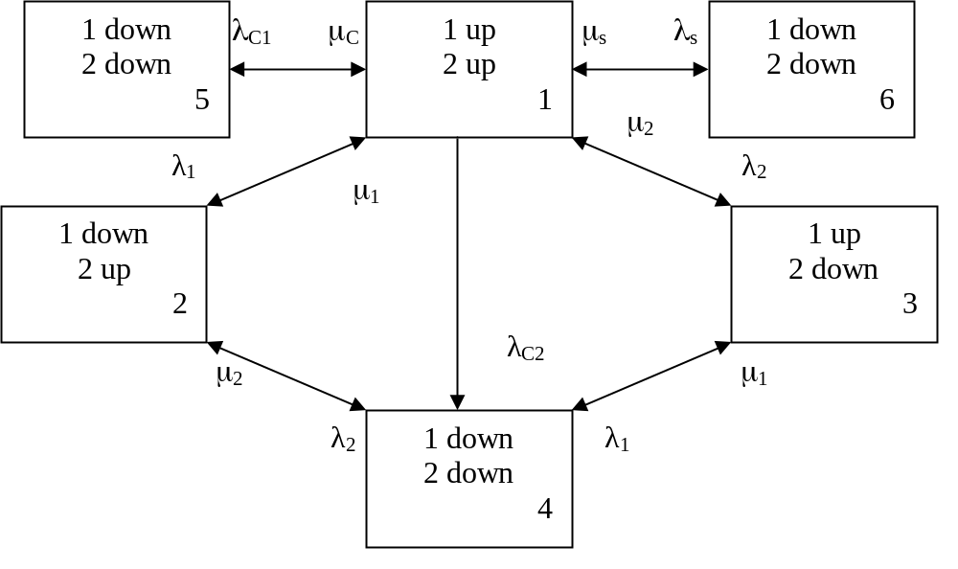
Fig. U18.7: Model with common mode, station originated outages
Transitions from state 1 to states 2, 3, and 4 are as in Fig. U18.6. The new states, 5 and 6, are described as follows:
- State 5: This state represents a common mode event, but it differs from that of state 4 in that, for state 4, the lines are repaired and brought back into service sequentially (so that the total repair time is the sum of the two individual repair times), whereas in state 5, the 2 lines are repaired and brought back in service simultaneously. We could say that the state 5 repair process is a common mode repair process. The transition rate μ_{C} should therefore be significantly larger than either μ₁ or μ₂. Examples:
  - Common mode to state 4: Both circuits are blown from their tower by a strong wind and are repaired sequentially.
  - Common mode to state 5: Both circuits fail from a common short circuit cleared from both simultaneously, e.g., another (stray) conductor falls across both, everything is deenergized, and the stray conductor is removed.
- State 6: This state represents the station originated failure where a failure occurs at a circuit terminal that results in the removal of two or more circuits. Most high voltage substations are protected so that, under normal conditions, this will only occur if a breaker fails, implying that the λ_{S} transition rate is relatively small under such conditions. On the other hand, during conditions of substation maintenance, the substation configuration can change resulting in a significant increase in λ_{S}. Figure U18.8 illustrate such a situation, where we see that, on the right-hand-side, a maintenance task on busbar 1 results in a topology where an N-2 outage can occur as a result of a single fault on busbar 2. In fact, this is a particularly risky situation since a fault on either line will also result in an N-2 outage. Any such failure could, however, be quickly rectified by an appropriate switching action.
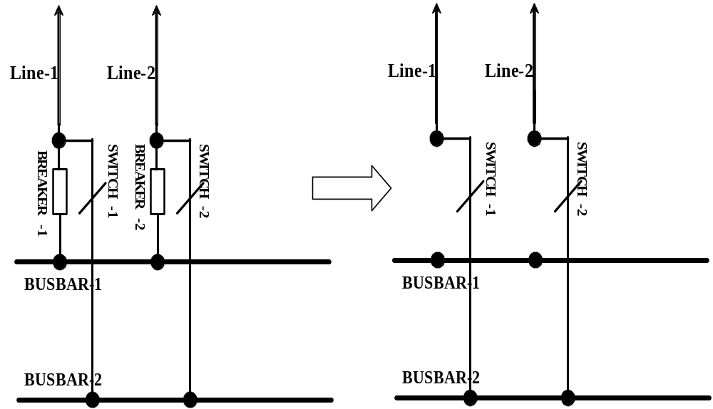
Fig. U18.9: Double bus, double breaker configuration (L) undergoing maintenance (R)

U18.7.3. Component and Unit approaches
We first define some terms. Most of these definitions come from [16] but several come from [14]. The individual intending to participate in transmission outage data collection is encouraged to obtain [16] as it contains a complete set of definitions for appropriate terminology. Below we have identified only those terms which we deem to be central to discussing the approach identified in [14].
- Component [16]: A device which performs a major operating function and which is regarded as an entity for purposes of recording and analyzing data on outage occurrences. Some examples of components are: line sections, transformers, ac/dc converters, series capacitors or reactors, shunt capacitors, circuit breakers, line protection systems, and bus sections.
- Unit [16]: A group of components which are functionally related and are regarded as an entity for purposes of recording and analyzing data on outage occurrences. A unit can be identified in a number of ways. We will use the following: a group of components which constitute an operating entity bounded by automatic fault interrupting devices (e.g., circuit breakers) that isolate it from other such entities for faults on any component within the group. All components within a unit are deenergized together. A unit may be single-terminal, two-terminal, or multi-terminal.
- Outage event [16]: An event involving the outage occurrence of one or more units or components.
- Single outage event [16]: An outage event involving only one component or one unit.
- Multiple outage event [16]: An outage event involving two or more components, or two or more units.
- Related multiple outage event [16]: A multiple outage event in which one outage occurrence is the consequence of another outage occurrence, or in which multiple outage occurrences were initiated by a single incident, or both. Each outage occurrence in a related multiple outage event is classified as either a primary outage or a secondary outage depending on the relationship between that outage occurrence and its initiating incident:
- Primary outage: An outage occurrence within a related multiple outage event which occurs as a direct consequence of the initiating incident and is not dependent on any other outage occurrence. A primary outage of a component or a unit may be caused by a fault on equipment within the unit or component or repair of a component within the unit.
- Secondary outage: An outage occurrence which is the result of another outage occurrence.
Secondary outages of components or units may be caused by repair of other components or units requiring physical clearance, failure of a circuit breaker to clear a fault, or a protective relay system operating incorrectly and overreaching into the normal tripping zone of another unit. Some secondary outages are solely the result of system configuration (e.g, two components connected in series will always go out of service together). These secondary outages may be given special treatment when compiling outage data. Primary outages have been referred to in the industry as independent outage occurrences, and secondary outages as dependent or related outage occurrences.
- Common mode outage event: A related multiple outage event consisting of two or more primary outage occurrences initiated by a single incident or underlying cause where the outage occurrences are not consequences of each other.
- Failure [16]: The inability of a component to perform its required function.
- Failure of continuously required function [16] : (This was called “active failure” in [14].) The inability of a component to perform a function which is continuously required. Continuously required functions include carrying current, providing electrical isolation, and abstaining from tripping in the absence of a signal. Examples include component short circuit, component open circuit, switching equipment opening without proper command or closing without proper command.
- Failure of response function [16]: (This was called “passive failure” in [14].) The inability of a component to perform a function which is required as a response to system conditions or to a manually or automatically initiated command. Response functions include responding to fault conditions (protective systems), to command (circuit breakers), and to manual operation (disconnect switches). Inabilities to perform a response function do not cause an immediate interruption of power flow as they can be disclosed by subsequent inspection or by failure to respond to conditions as intended. This type of failure has been referred to as dormant failure, latent failure, unrevealed failure, and hidden failure. Examples are switching equipment failing to open on command (stuck breaker), switching equipment failing to close on command, and protection system tripped incorrectly (over-reach during fault).
- Reference unit [14]: a unit whose performance is being studied.
- Related unit [14]: a unit in proximity to the reference unit such that common mode and/or dependent outage events can occur
- Interfacing unit [14]: a type of common terminal where the reference unit is exposed to a related unit due to a common breaker interfacing between the two. The reference unit is exposed to complete deenergization if an interfacing unit experiences a forced outage and the common breaker experiences a failure of response function.
Figure U18.8 [14] illustrates several interfacing units.
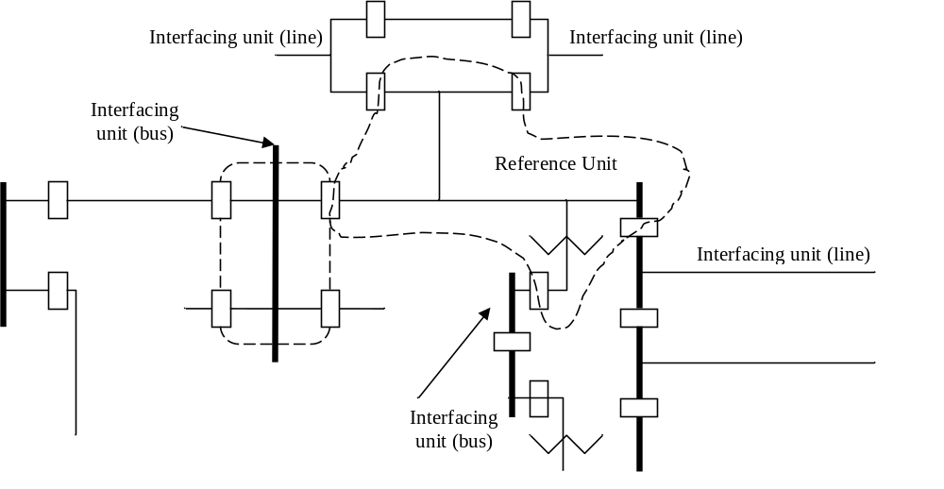

Fig. U18.8: Illustration of interfacing units [14]

Transmission outage performance prediction is performed in three steps:
- Markov model: Develop the Markov model characterizing the different states of interest to the transmission outage performance prediction.
- Transition rates: Develop the basic component and/or unit outage statistics (transition rates) such as outage rate, restoration rate, and passive failure probability.
- Compute: Use the Markov model to predict the state probability, outage frequency, and duration of the failure states.

Step 1 (Markov model):

The model of Fig. U18.6 is usually sufficient for most purposes, as long as weather effects on transition rates are not to be considered. Reference [22] provides 1 and 2 component Markov models that also represent 2 weather conditions. Fig. U18.9 nicely illustrates a 2 unit, 2 weather model [14]. Note that all transitions from one weather state to the corresponding state in the other weather condition would have the same transition intensity.

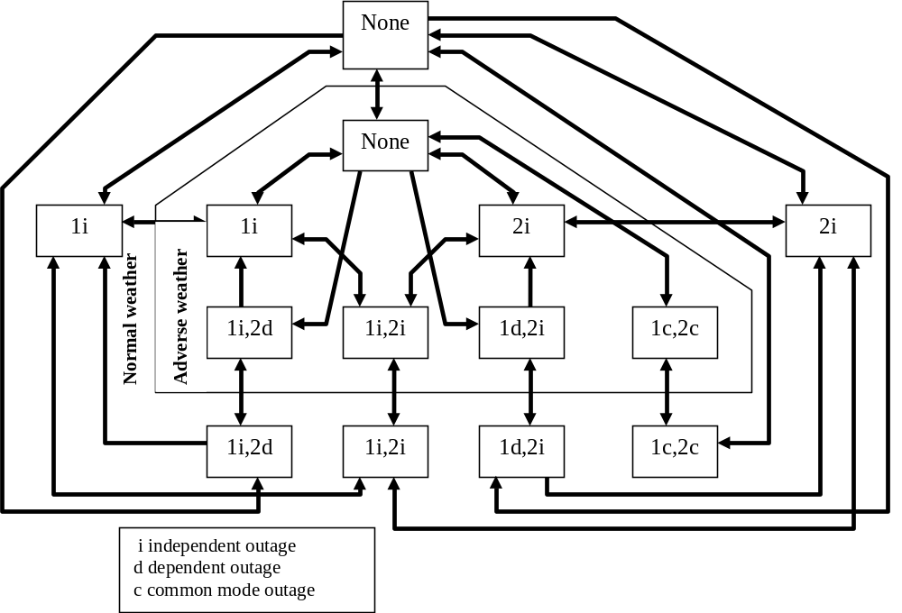
Fig. U18.9: 2 unit, 2 weather model [14]

It is interesting to compare only one weather state for the model of U18.9 (either normal or adverse as they are identical) to the model of Fig. U18.7. The following observations can be made:
- Model U18.9 has only one common mode state whereas Model U18.7 has two. Thus, Model U18.9 assumes that all common mode outages have common mode repairs, whereas Model U18.7 permits a common mode failure with sequential repair.
- Model U18.9 distinguishes between two types of dependent failures:
  - 1i, 2d occurs from a first failure of 1 and a consequential (dependent) failure of 2.
  - 1d, 2i occurs from a first failure of 2 and a consequential (dependent) failure of 1.
These failures generally correspond to the station oriented outages represented in Model U18.7 by state 6.

Step 2 (transition rates):

This step is the data collection and synthesis step. There are two fundamentally different approaches to take in this step. One is the component approach and the other is the unit approach. Central to both approaches is the underlying assumption that our Markov model represents the states of two units, not two components, since the unit represents the smallest entity that can be modeled distinctly within a Markov mode. (Whenever we say a Markov model represents different component states, it should be implicitly understood that all components are assumed to be distinct units.)

In a component approach to data collection, all data collected is by component (bus, circuit, breaker), without any reference to the unit of which the data is a part. There are two characterizing features to this approach:
- Breaker failure data: It is essential to collect data characterizing breaker failure to respond (called “passive failures” in [14]).
- Synthesis: Substation topology must be used together with the component outage data to compute the necessary transition rates. This is a tedious and difficult process, as illustrated by Fig. U18.10.
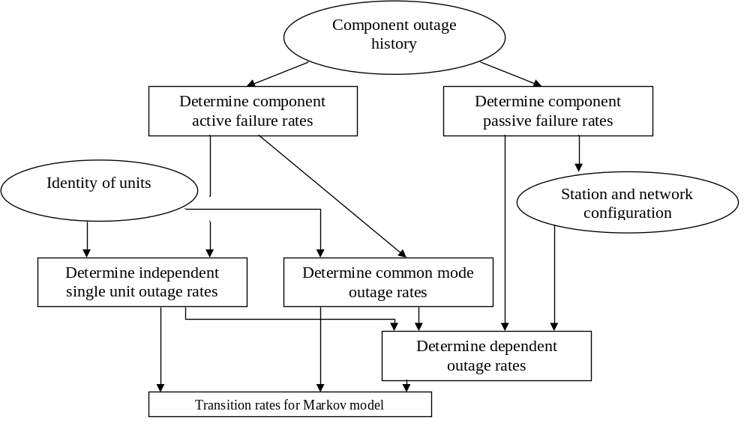Fig. U18.10: Transition Rates from Component Data [14]

In a unit approach to data collection, there is no synthesis required as the events (single unit outage, common mode unit outage, dependent event unit outage) themselves are observed so that the transition rates can be computed directly from the data. It should be recognized that the reduction in synthesis effort (and likely improvement in accuracy) is generally at the expense of greater attention within the data collection effort.

U18.4 Typical data
A review of the literature results in the following typical data. We do not intend to be exhaustive in this summary, only representative. All information is for forced, sustained outages.
From [14], typical data for the Commonwealth Edison Company (Chicago) is:
- Single circuit (unit) outage: 0.0279 outages per mile-year.
- Bus unit: 0.0196 outages per year
- Transformers:
  - 345/138 kV: 0.225 outages/year
  - 765/345 kV: 0.390 outages/year
- Common tower:
  - Early design: 0.00114 outages/mile-year
  - Late design: 0.00074 outages/mile-year
- Common right-of-way: 0.00059 outages/mile-year
From reference [12], typical data for the MAPP system (Midwest US) is divided by “line-related outages” and “terminal-related outages” where the first are caused by faults on the line and the second by faults at the terminal (substation). Note that these are distinguished according to the initiating failure. Therefore, a secondary outage due to a breaker failure resulting from an initiating line outage would be a “line-related” secondary outage. A secondary outage due to a breaker failure resulting from an initiating terminal failure would be a “terminal-related” secondary outage.
Line-related:
- 230 kV lines (primary): 0.018 outages/mile-year, 0.384 hrs average duration per mile-year, 21.6 hrs average duration per outage
- 345 kV lines (primary): 0.025 outages/mile-year, 0.806 hrs average duration per mile-year, 32.8 hrs average duration per outage
- 230 kV lines (secondary/dependent): 0.004 outages/mile-year, 0.017 hrs average duration per mile-year, 4.3 hrs average duration per outage
- 345 kV lines (secondary/dependent): 0.001 outages/mile-year, 0 hrs average duration per mile-year, 0.4 hrs average duration per outage.
Terminal-related:
- 230 kV terminals (primary): 0.2 outages/terminal-year, 0.6 hrs average duration per terminal-year, 3.5 hrs average duration per occurrence
- 345 kV terminals (primary): 0.2 outages/terminal-year, 2.4 hrs average duration per terminal-year, 9.7 hrs average duration per occurrence
- 230 kV terminals (secondary/dependent): 0 outages/terminal-year, 0.1 hrs average duration per terminal-year, 2.3 hrs average duration per occurrence
- 345 kV terminals (secondary/dependent): 0.1 outages/terminals-year, 0.1 hrs average duration per terminal-year, 1.5 hrs average duration per occurrence.
Reference [17] provides the following as averages over all of the US and Canadian utilities that were surveyed.
Line-related:
- 230 kV lines (primary): 0.01287 outages/mile-year
- 345 kV lines (primary): 0.0752 outages/mile-year
- 500 kV lines (primary): 0.00527 outages/mile-year
- 765 kV lines (primary): 0.00536 outages/mile-year
Terminal-related:
- 230 kV lines (primary): 0.062 outages/mile-year
- 345 kV lines (primary): 0.151 outages/mile-year
- 500 kV lines (primary): 0.097 outages/mile-year
- 765 kV lines (primary): 0.302 outages/mile-year
From [23] ….

Reference [24] is a source which shows how some of the IEEE RTS probability data was computed.

References
- D. Logan, P. Barber, R. Billinton, G. Curley, J. Fisher, H. Outhred, and K. Staschus, “Reliability Information in a Competitive Market,” Proc. of the IEEE PES 2000 Summer Meeting, Seattle, July 17, 2000.
- North American Electric Reliability Council web site: http://www.nerc.com
- ANSI/IEEE Standard 762-1987, “IEEE Standard Definitions for Use in Reporting Electric Generating Unit Reliability, Availability, and Productivity,” May,1987.
- Canadian Electricity Association home page: http://www.canelect.ca.
- Canadian Electricity Association Documents page: http://www.canelect.ca/english/aboutcea_documents_reports_benchmarking.html.
- A. Calsetta (chair), P. Albrecht, V. Cook, R. Ringlee, and J. Whooley, “A Four-State Model for Estimation of Outage Risk for Units in Peaking Service,” a report of the IEEE Task Group on Models for Peaking Service Units, Application of Probability Methods Subcommittee, IEEE Transactions on Power Apparatus and Systems, vol. PAS-91, no. 2. pp. 618-627, Mar./Apr. 1972.
- R. Billinton and R. Allan, “Reliability Evaluation of Power Systems, 2nd edition, Plenum Press, 1996.
- A. Breipohl, P. Albrecht, R. Allan, S. Asgarpoor, M. Bhavaraju, R. Billinton, M. Curley, C. Heising, M. Mazumdar, M. McCoy, R. Niebo, A. Patton, N. Rau, R. Ringlee, A. Schneider, C. Singh, L. Wang, M. Warren, P. Wong, “Pooling Generator Unit Data for Improved Estimates of Performance Indices,” Task Force on Generator Pooling Data of the Application of Probability Methods Subcommittee, IEEE Transactions on Power Systems, Vol. 10, no. 4, November, 1995.
- IEEE Standard 346-1973, IEEE Standard Definitions in Power Operations Terminology including Terms for Reporting and Analyzing Outages of Electrical Transmission and Distribution Facilities and Interruptions to Customer Service, November 2, 1973.
- EPRI Project 1468-1, EL-1980, “Component Outage Data Analysis Methods,” Volumes 1 and 2, August, 1981.
- EPRI Project 1283, EL-1797, “Bulk Transmission System Component Outage Data Base,” April, 1981.
- M Lauby, R. Polesky, R. Vandello, J. Doudna, P. Lehman, and D. Klempel, “MAPP Bulk Transmission Outage Data Collection and Analysis,” IEEE Transactions on Power Apparatus and Systems, Vol. PAS-103, no. 1, pp 213-221, Jan., 1984.
- B. Silverstein and D. Porter, “Contingency Ranking for Bulk System Reliability Criteria,” paper 91 SM-442-4 PWRS.
- G. Landgren, A. Schneider, M. Bhavaraju, and N. Balu, “Transmission Outage Performance Prediction: Unit or Component Approach,” IEEE Trans. on Power Systems, Vol PWRS-1, No. 2, May, 1986, pp. 54-61.
- D. Forrest, P. Albrecht, R. Allan, M. Bhavarahu, R. Billinton, G. Landgren, M. McCoy, and N. Reppen, “Proposed Terms for Reporting and Analyzing Outages of Electrical Transmission and Distribution Facilities,” IEEE Transactions on Power Apparatus and Systems, Vol. PAS-104, no. 2, pp. 337-348, Feb. 1985.
- IEEE Standard 859-1987, “IEEE Standard Terms for Reporting and Analyzing Outage Occurrences and Outage States of Electrical Transmission Facilities,” June, 1987.
- R. Adler, S. Daniel, C. Heising, M. Lauby, R. Ludorf, and T. White, “An IEEE survey of US and Canadian Overhead Transmission Outages at 230 kV and Above,” paper 93 WM 054-7 PWRD, presented at the IEEE/PES 1993 Winter Meeting, Columbus, Ohio, January, 1993.
- H. Saddock (chair), M. Bhavaraju, R. Billinton, C. DeSieno, J. Endrenyi, G. Horgensen, A. Patton, D. Piede, R. Ringlee, and J. Stratton, “Common Mode Forced Outages of Overhead Transmission Lines,” Task Force on Common Mode Outages of Bulk Power Supply Facilities of the IEEE PES Application of Probability Methods Subcommittee, IEEE Transactions on Power Apparatus and Systems, Vol. PAS-95, No. 3, pp. 859-863, May/June 1976.
- R. Billinton and T. Medicheria, “Station originated multiple outages in the reliability analysis of a composite generation and transmission system,” IEEE Trans. Power Apparatus and Systems, vol. PAS-100, no. 8, pp3870-3878.
- G. Landgren, S. Anderson, and A. Schneider, discussion to reference [19].
- ANSI/IEEE C57-117-1986, “IEEE Guide for Reporting Failure Data for Power Transformers and Shunt Reactors on Electric Utility Power Systems,” June, 1986.
- R. Billinton and K. Bollinger, “Transmission System Reliability Evaluation Using Markov Processes,” IEEE Transactions on Power Apparatus and Systems, vol. PAS-87, no. 2, pp. 538-547, Feb., 1968.
- M. Lauby, J. Doudna, R> Polesky, P. Lehman, and D. Klempel, “The procedure used in the probabilistic transfer capability analysis of the MAPP region bulk transmission system,” IEEE Transactions on Power Apparatus and Systems, Vol. PAS-104, No. 11, November, 1985.
- B. Adler, chair, The PJM Transmission Reliability Task Force, “Bulk Power Area Reliability Evaluation Considering Probabilistic Transfer Capability,” IEEE Transaction on Power Apparatus and Systems, Vol. PAS-101, No. 9, Sept, 1982.

