Module PE.PAS.U15.5

Analysis of non-series/parallel systems comprised
of non-repairable components

U15.1 Introduction
It is often the case that a logic diagram modeling a system of non-repairable components is neither parallel nor series, and as a result, cannot be analyzed using the techniques developed in module U14. Different techniques must be used as a result. To motivate the idea, consider the configuration illustrated in Fig. U15.1 [1], two substations connected by two lines.
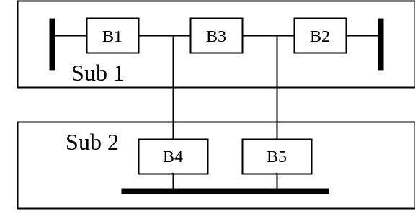
Fig. 15.1: Substation Configuration
Substation 1 has three breakers protecting two circuits and as a result, is referred to as a “breaker and a half scheme.” From a reliability point of view, let’s consider that this system “works” if power is delivered through the lines to at least one of the buses and the scheme “fails” if power cannot be delivered to either bus. The components that may fail are breakers B1-B5. For each breaker, the failure mode of interest is its inadvertent opening.
We want to construct the logic diagram for this system. One observes that the following constitute failure modes for this system: (B1,B2), (B4,B5), (B4,B2,B3), (B5,B1,B3). We may represent these failure modes using the following logic diagram.
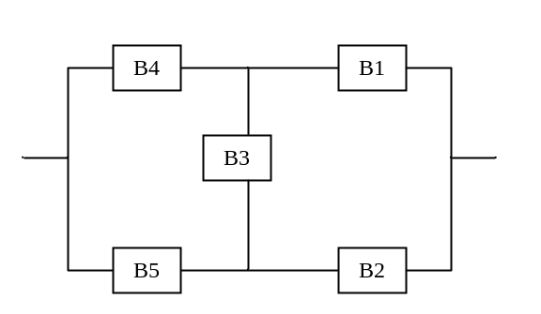
Fig. U15.2a: Substation Logic Diagram
The logic diagram of U15.2a is referred to as a bridge diagram and, as one observes, is in a configuration that is not directly amenable to our approach for reducing networks comprised of series/parallel subsystems.
Therefore, we resort to different methods, with the intent essentially being to decompose such non-series/parallel systems into series/parallel systems so that we may then apply our familiar techniques. These methods are as follows:
- Decomposition
- Delta-star transformation
- Cut set method
- Tie set method
- Connection matrix method
- Event trees
- Fault trees

U15.2 Decomposition
The decomposition approach is also called the conditional probability approach [2] and the factoring algorithm [3]. In this approach, we reduce the logic diagram sequentially into sub-structures that are connected in series/parallel and then recombine these substructures using conditional probability.

We can apply this to the diagram of Fig. U15.2a. The basic idea stems from the recognition that:
Or, in terms of Fig. U15.2:
Denoting, as usual, R_{S} as the probability that the system works, we can write this as
R_{S}=R_{S}(given B3 works)R_{B3} +R_{S}(given B3 fails)Q_{B3}
The reliabilities of the system, given that B3 works, and given that B3 fails, can be observed from inspecting Fig U15.2, so that the system reliability is:
R_{S}={(1-Q_{B4}Q_{B5})(1-Q_{B1}Q_{B2})}R_{B3}+{1-(1-R_{B4}R_{B1})(1-R_{B5}R_{B2})}Q_{B3}

U15.3 Delta-Star Transformation
Logic diagrams that have “delta” configurations may be transformed to logic diagrams containing “star” or “Y” configurations, often resulting in a simpler configuration that is amenable to series/parallel analysis [4]. This same idea is often used in basic circuit analysis, but one should be aware that the equations used to make the transformation are quite different.
To derive the equations for transforming a logical “delta” into a logical “star,” we take a terminal perspective of the two diagrams, as indicated in Fig. U15.3, so that the reliability between any two terminals of the delta configuration must be equal to the reliability between any two identical terminals of the star configuration. Application of this principle leads to the equivalencies shown in Fig. U15.4.

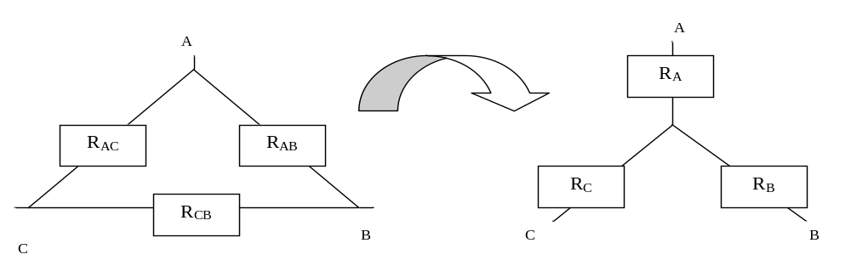Fig. U15.3: Delta-Star Transformation
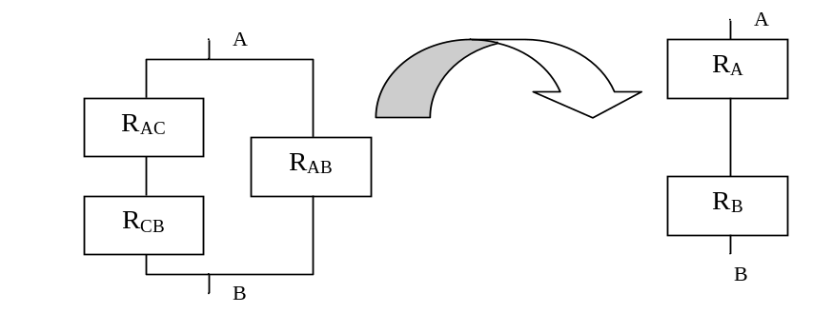
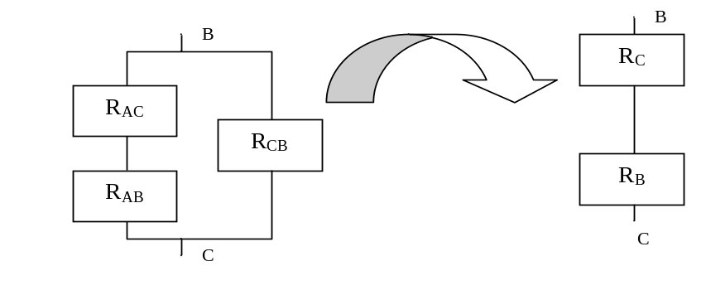
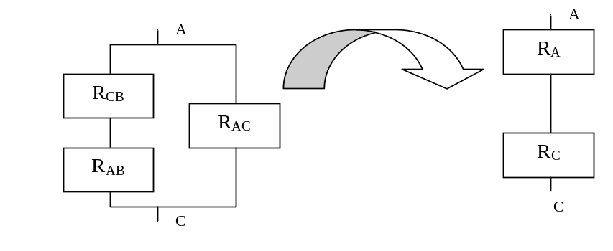
Fig. U15.4: Delta-Star Equivalencies

Equating the reliabilities of each pair of diagrams in Fig. U15.4 results in three equations that can then be solved for R_{A}, R_{B}, and R_{C}. The result of this effort is [4]:
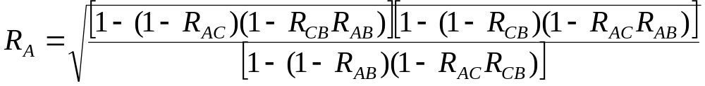
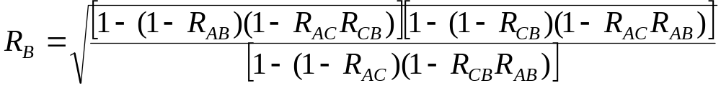
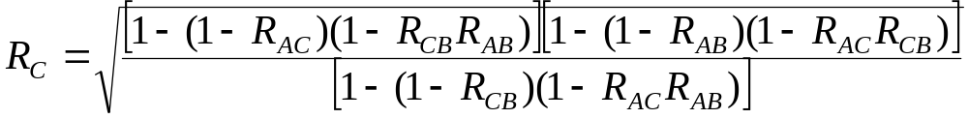
In Fig. U15.2b, we see, for example, how the system of Fig. U15.2a can be transformed.
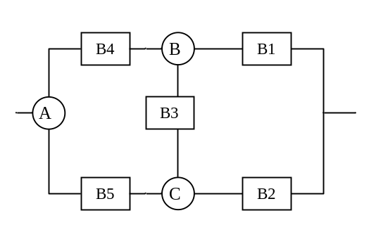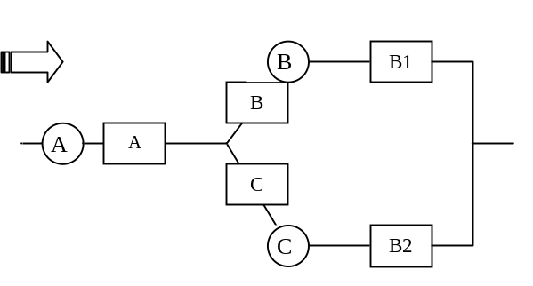
Fig. U15.2b: Use of Delta-Star Transformation

U15.4 Cutset method
The basic idea of the cutset method is stated loosely as follows.
- Identify all failure modes in terms of component sets such that,
- for any one component set, there is no extra component in the set (meaning that the set no longer causes a failure if any one of the components does not fail), then
- we compute the system failure probability as the probability of the union of all of the sets.
Note that item 3 indicates that we compute the system failure probability. This would be Q_{S}. The direct computation of R_{S} is not appropriate in the cutset method, for reasons that we will see.
Definition: A cutset K is a set of components whose failure results in system failure. The removal of the corresponding set of blocks in the logic diagram interrupts the continuity between the input and output of the diagram [1]. Removal of all components in any cutset “disconnects” the “input” from the “output” in the logical diagram.
Definition: A minimal cutset C is a cutset where the set remaining after a removal of any of its elements is no longer a cutset. This definition means that all components of a minimal cutset must be failed to cause system failure.
Example: Find all cutsets K and minimal cutsets C for Fig. U15.5.
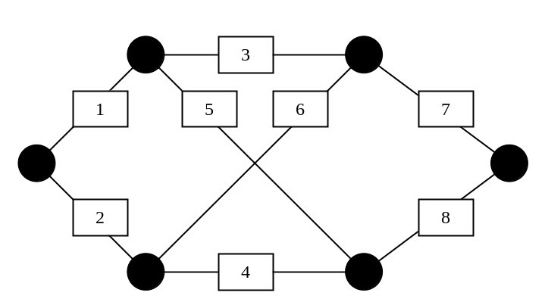
Fig. U15.5: Logic Diagram for Illustrating Cutset Identification
(1,2), (1,2,3), (1,2,4), (1,2,5), (1,2,6), (1,2,7), (1,2,8), (1,2,3,4), (1,2,3,5), (1,2,3,6), (1,2,3,7), (1,2,3,8), (1,2,4,5), (1,2,4,6), (1,2,4,7), (1,2,4,8), (1,2,5,6), (1,2,5,7), (1,2,5,8), (1,2,6,7), (1,2,6,8), (1,2,7,8), (1,2,3,4,5), (1,2,3,4,6), (1,2,3,4,7), (1,2,3,4,8), (1,2,3,5,6), (1,2,3,5,7), (1,2,3,5,8), (1,2,3,6,8), (1,2,3,7,8), (1,2,4,5,6), (1,2,4,5,7), (1,2,4,5,8), (1,2,4,6,7), (1,2,4,6,8), (1,2,4,7,8), (1,2,5,6,7), (1,2,5,6,8), (1,2,5,7,8), (1,2,6,7,8),
(7,8), (1,7,8), (2,7,8), (3,7,8), (4,7,8), (5,7,8), (6,7,8), (1,3,7,8), (1,4,7,8), (1,5,7,8), (1,6,7,8), (2,3,7,8), (2,4,7,8), (2,5,7,8), (2,6,7,8), (3,4,7,8), (3,5,7,8), (3,6,7,8), (4,5,7,8), (4,6,7,8), (5,6,7,8), (1,3,4,7,8), (1,3,5,7,8), (1,3,6,7,8), (1,4,5,7,8), (1,4,6,7,8), (1,5,6,7,8), (2,3,4,7,8), (2,3,5,7,8), (2,3,6,7,8), (2,4,5,7,8), (2,4,6,7,8), (2,5,6,7,8), (3,4,5,7,8), (3,4,6,7,8), (3,5,6,7,8), (4,5,6,7,8),
(2,3,5), (2,3,4,5), (2,3,5,6), (2,3,5,7), (2,3,5,8), (2,3,4,5,6), (2,3,4,5,7), (2,3,4,5,8), (2,3,5,6,7), (2,3,5,6,8),
(1,4,6), (1,3,4,6), (1,4,5,6), (1,4,6,7), (1,4,6,8), (1,3,4,5,6), (1,3,4,6,7), (1,3,4,6,8), (1,3,4,5,6), (1,4,5,6,7), (1,4,5,6,8), (1,3,4,6,7), (1,4,5,6,7), (1,3,4,6,8), (1,4,5,6,8),
(4,5,7), (1,4,5,7), (2,4,5,7), (3,4,5,7), (4,5,6,7), (1,3,4,5,7), (1,4,5,6,7), (2,4,5,6,7), (1,3,4,5,7), (3,4,5,6,7), (1,4,5,6,7), (3,4,5,6,7), (1,4,5,6,7), (2,4,5,6,7), (3,4,5,6,7),
(3,6,8), (1,3,6,8), (2,3,6,8), (3,4,6,8), (3,5,6,8), (1,3,4,6,8), (1,3,5,6,8), (2,3,4,6,8), (2,3,4,6,8), (3,4,5,6,8), (10)
(1,5,6,8), (1,3,5,6,8)
(3,4,5,6), (3,4,5,6,8)
(2,5,6,7)
plus all combinations of 6 elements, 8!/[6!(8-6)!]=28 combinations
plus all combinations of 7 elements, 8!/[7!(8-7)!]=8 combinations
(1,2,3,4,5,6,7,8)
There are 169 cutsets.
Cutset identification algorithm:
- Identify the minimum number of branches which would be a cutset independent of the identity of the branches. This is N_{C}=6.
- Identify the minimal cutsets C, which are the ones above that are bold faced.
➔An informal way to think about how we did this is that a minimal cutset is any set of branches “cut” by a monotonically increasing or decreasing curve from left to right that completely breaks all paths from “input” to “output.”
- For each minimal cutset, enumerate every set containing the minimal cutset that does not contain a cutset already enumerated, up to cardinality N_{C}-1 (no need to enumerate cutsets of 6 or more).
- Enumerate every set of cardinality N_{C}, N_{C}+1, …, N (these will all be cutsets)
Well, why are we interested in cutsets? We are not, really.
But we are interested in minimal cutsets. These would be, for our example, C₁=(1,2), C₂=(7,8), C₃=(2,3,5), C₄=(1,4,6), C₅=(4,5,7), C₆=(3,6,8), C₇=(1,5,6,8), C₈=(3,4,5,6), C₉=(2,5,6,7).
Why are we interested in minimal cutsets?
Because the probability of system failure is given by the probability that at least one minimal cut fails, which is the probability that C₁ fails or C₂ fails or C₃ fails or C₄ fails or C₅ fails or C₆ fails or C₇ fails or C₈ fails or C₉ fails, i.e.,
Q_{sys}=P(F_{sys})=P(F_{C1}∪F_{C2}∪F_{C3}∪F_{C4}∪F_{C5}∪F_{C6}∪F_{C7}∪F_{C8}∪F_{C9})
Note that evaluation of Q_{sys} excludes all non-minimal cutsets. Why is this? Recall C₁=(1,2), so (1,2,3) is a non-minimal cutset.
System failure occurs if 1 and 2 fail; the state of component 3 makes no difference. So
P(system failure due to failure of (1,2,3))=P(1 and 2 failing)
So getting just the probabilities of the minimal cutsets is sufficient.
We can develop a logical model for our system as in Fig. U15.6:
Fig. U15.6: Equivalent Cutset Logic Diagram
Now one is tempted here to evaluate the system reliability as:
R_{sys}=R_{C1}R_{C2}R_{C3}R_{C4}R_{C5}R_{C6}R_{C7}R_{C8}R_{C9}
However, this does not work! Why not?

To find out why evaluation of system reliability R_{sys} does not work for a series connection of cutsets, let’s expand the series connection of cutsets so that it models the individual components.
To start with, look closely at a single cutset, say C₁=(1,2).
How does failure of C₁ occur? It occurs on failure of component 1 AND component 2, i.e., P(C₁)=P(F₁∩F₂). This can be modeled logically as a parallel combination of components 1 and 2.
In fact, all cutset blocks can be modeled logically as a parallel combination of their constituent components. So we can expand the logic diagram of Fig. U15.6 to that of Fig. U15.7.
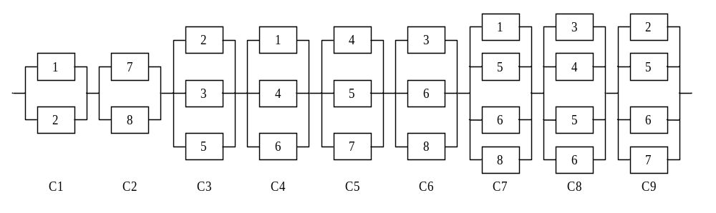Fig. U15.7: Expanded Logic Diagram
One immediately observes repeated blocks, indicating dependencies between them, i.e., each block does not work or fail independently. This is the reason why we should not evaluate the reliability of this logic diagram using 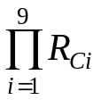since it is based on probability evaluation of joint events, P(S_{C1}∩S_{C2}∩S_{C3}∩S_{C4}∩S_{C5}∩S_{C6}∩S_{C7}∩S_{C8}∩S_{C9}), and therefore only applies if each block works or fails independently.

But what if we want to obtain the unreliability, Q_{S}?
Then, as we have said, we must evaluate the probability of the union of the events:
Q_{sys}=P(F_{sys})=P(F_{C1}∪F_{C2}∪F_{C3}∪F_{C4}∪F_{C5}∪F_{C6}∪F_{C7}∪F_{C8}∪F_{C9})
Do dependencies cause problems here?
To answer this question, let’s do a simpler case of evaluating just P(F_{C1}∪F_{C2}∪F_{C3}), as illustrated in Fig. U15.8:
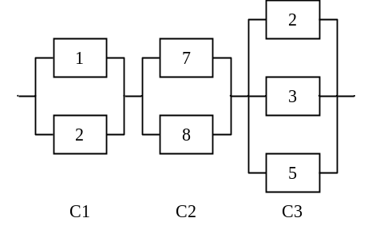
Fig. U15.8
Generalizing the rule for the union of two events, which is P(A∪B)=P(A)+P(B)-P(A∩B), we have for three events:
P(F_{C1}∪F_{C2}∪F_{C3})
=P(F_{C1})+P(F_{C2})+P(F_{C3}) LINE 1
-{P(F_{C1}∩F_{C2})+P(F_{C2}∩F_{C3})+P(F_{C1}∩F_{C3})} LINE 2
+P(F_{C1}∩F_{C2}∩F_{C3}) LINE 3
In terms of components failure probabilities, this would be:
P(F_{C1}∪F_{C2}∪F_{C3})
=Q₁Q₂+Q₇Q₈+Q₂Q₃Q₅ LINE 1
-{Q₁Q₂Q₇Q₈+Q₇Q₈Q₂Q₃Q₅+Q₁Q₂Q₃Q₅} LINE 2
+Q₁Q₂Q₇Q₈Q₃Q₅ LINE 3
Note:
- The last term in LINE 2, Q₁Q₂Q₃Q₅, came from:
P(F_{C1}∩F_{C3})=P(F_{C1})×P(F_{C3}| F_{C1})=Q₁Q₂×Q₃Q₅
- The term in LINE 3, Q₁Q₂Q₇Q₈Q₃Q₅, came from:
P(F_{C1}∩F_{C2}∩F_{C3})=P((F_{C1}∩F_{C2})∩F_{C3})=P(F_{C1}∩F_{C2})×P(F_{C3}|(F_{C1}∩F_{C2}))
=Q₁Q₂Q₇Q₈×Q₃Q₅
Clearly, we still have trouble with dependencies, although we were able to effectively deal with them.
We could analyze the entire C₁-C₉ logic diagram this way, with the help of the general formula for the union of multiple events [5]:
P(F_{C1}∪F_{C2}∪F_{C3}…∪F_{Cn})=
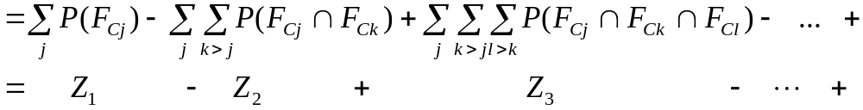where Z_{r} is the r^{th} summation in this sequence of summations, i.e.,
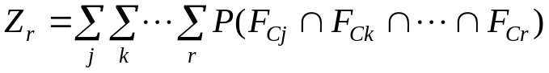 such that
P(F_{C1}∪F_{C2}∪F_{C3}…∪F_{Cn})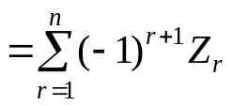
But this would become rather tedious, since we would have to deal with each of the joint probabilities very carefully so as to appropriately screen the dependencies.
Instead, make 3 observations in reference to the above calculation.
- The magnitudes of the quantities in the LINEs get smaller, i.e.,
    - |LINE 1|>>|LINE 2|, i.e., Z₁>>Z₂
    - |LINE 2|>>|LINE 3|, i.e., Z₂>>Z₃
and we can generalize to say that |LINE I|>>|LINE J| when J>I, i.e., Z_{i}>>Z_{j} when j>i.
- Evaluation of P(F_{C1}∪F_{C2}∪F_{C3}) using only LINE 1 (Z₁) is a good approximation, as long as Q_{i}’s are reasonably small. Therefore,
P(F_{C1}∪F_{C2}∪F_{C3}…∪F_{Cn})≈P(F_{C1})+P(F_{C2})+…+P(F_{Cn})=Z₁
This approximation is exact if cutset failures are mutually exclusive (occurrence of one cutset failure prohibits occurrence of other cutset failures), rarely the case in engineering systems.
- |LINE 2|>>|LINE I| for any I=3,…n. Since LINE 2>0, and since it is subtracted from LINE 1 (which is also >0), it must be the case that LINE 1> P(F_{C1}∪F_{C2}∪F_{C3}…∪F_{Cn}). Therefore, our approximation P(F_{C1}∪F_{C2}∪F_{C3}…∪F_{Cn}) is an UPPER BOUND to the actual probability.
In fact, observation 3 can be carried a little further. In [5], it is stated (with proof given in the references to [5]), that
P(F_{C1}∪F_{C2}∪F_{C3}…∪F_{Cn})≤Z₁
P(F_{C1}∪F_{C2}∪F_{C3}…∪F_{Cn})≥Z₁-Z₂
P(F_{C1}∪F_{C2}∪F_{C3}…∪F_{Cn}) ≤ Z₁-Z₂+Z₃
and so on. Fig. U15.9 illustrates this phenomenon.
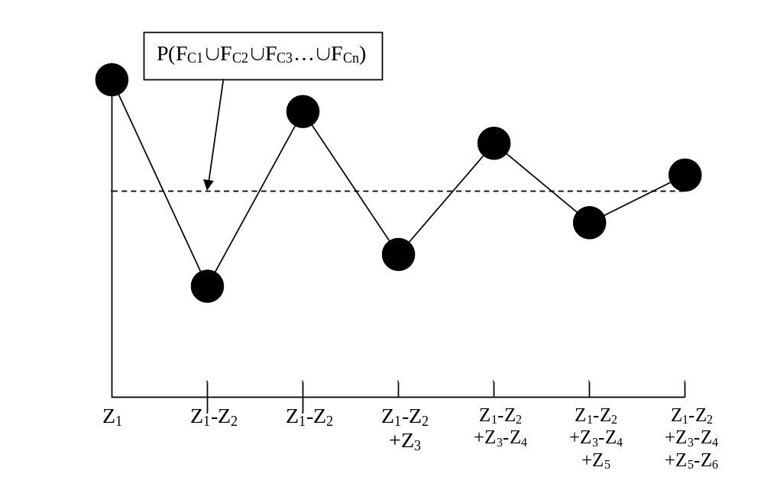
Fig. U15.9: Impact of Additional Terms on
Failure Probability Estimation
One thought that comes to mind in studying Fig. U15.9 is that evaluation of Z₁ and Z₁-Z₂ provides an upper and lower bound, respectively, on the failure probability P(F_{C1}∪F_{C2}∪F_{C3}…∪F_{Cn}). However, as we have observed, evaluation of Z₂ requires that we address the issue of dependencies between cutsets. This is no fun. Besides, there is a better way.

U15.5 Tieset method
The basic idea of the tieset method is stated loosely as follows.
- Identify all success modes in terms of component sets such that,
- for any one component set, there is no extra component in the set (meaning that the set no longer causes a success if any one of the components fails), then
- compute the system success probability as the probability of the union of all of the tiesets.
Note that item 3 indicates that we compute the system success probability. This would be R_{S}. The direct computation of Q_{S} is not appropriate in the tieset method, for reasons that we will see.
Definition: A tieset V is a set of components whose success results in system success. The presence of the corresponding set of blocks in the logic diagram ensures the continuity between the “input” and “output” of the diagram, i.e., the presence of all components in any tieset “connects” the “input” to the “output” in the logical diagram.
Definition: A minimal tieset T is a tieset where the set remaining after a removal of any of its elements is no longer a tieset. This definition means that all components of a minimal tieset must succeed to cause system success.
Example: Find all tiesets V and minimal tiesets T for Fig. U15.5.
Fig. U15.5: Logic Diagram for Illustrating Tieset Identification
(1,3,7), (1,2,3,7),(1,3,4,7),(1,3,5,7),(1,3,6,7),(1,3,7,8),…
(1,5,8),(1,2,5,8),(1,3,5,8),(1,4,5,8),(1,5,6,8),(1,5,7,8),…
(2,4,8),(1,2,4,8),(2,3,4,8),(2,4,5,8),(2,4,6,8),(2,4,7,8),…
(2,6,7), (1,2,6,7),(2,3,6,7),(2,4,6,7),(2,5,6,7),(2,6,7,8),…
(1,3,4,6,8), (1,2,3,4,6,8),(1,3,4,5,6,8),(1,3,4,6,7,8) …
(2,3,4,5,7),(1,2,3,4,5,7)
(1,4,5,6,7),(1,2,4,5,6,7)
(2,3,5,6,8)
Again, we are not really interested in the tiesets but rather in the minimal tiesets. These would be, for our example, T₁=(1,3,7), T₂=(1,5,8), T₃=(2,4,8), T₄=(2,6,7), T₅=(1,3,4,6,8), T₆=(2,3,4,5,7), T₇=(1,4,5,6,7), T₈=(2,3,5,6,8).
Why are we interested in minimal tiesets?
Because the probability of system success is given by the probability that at least one minimal tieset succeeds, which is the probability that T₁ succeeds or T₂ succeeds or T₃ succeeds or T₄ succeeds or T₅ succeeds or T₆ succeeds or T₇ succeeds or T₈ succeeds, i.e.,
R_{sys}=P(S_{sys})=P(S_{T1}∪S_{T2}∪S_{T3}∪S_{T4}∪S_{T5}∪S_{T6}∪S_{T7}∪S_{T8}∪S_{T9})
Note that evaluation of R_{sys} excludes all non-minimal tiesets. Why is this? Recall T₁=(1,3,7), so (1,2,3,7) is a non-minimal tieset.
System success occurs if 1, 3, and 7 succeed; the state of component 2 makes no difference. So
P(system success due to success of (1,2,3,7))=P(1 and 3 and 7 succeeding)
So getting just the probabilities of the minimal tiesets is sufficient to evaluate to probability of system success.
We can develop a logical model for our system as in Fig. U15.6:
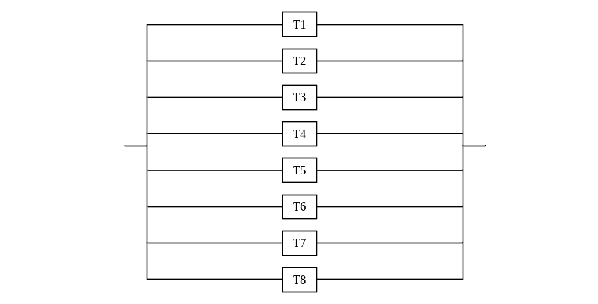Fig. U15.10: Equivalent Tieset Logic Diagram
Now one is tempted here to evaluate the system unreliability as:
Q_{sys}=Q_{T1}Q_{T2}Q_{T3}Q_{T4}Q_{T5}Q_{T6}Q_{T7}Q_{T8}
However, this does not work! Why not?

To find out why evaluation of system unreliability Q_{sys} does not work for a parallel connection of tiesets, let’s expand the series connection of tiesets so that it models the individual components.
To start with, look closely at a single tieset, say T₁=(1,3,7).
How does success of T₁ occur? It occurs on success of component 1 AND component 3, AND component 7, i.e., P(T₁)=P(S₁∩S₃∩S₇). This can be modeled logically as a series combination of components 1, 3, and 7.
In fact, all tieset blocks can be modeled logically as a series combination of their constituent components. So we can expand the logic diagram of Fig. U15.10 to that of Fig. U15.11.
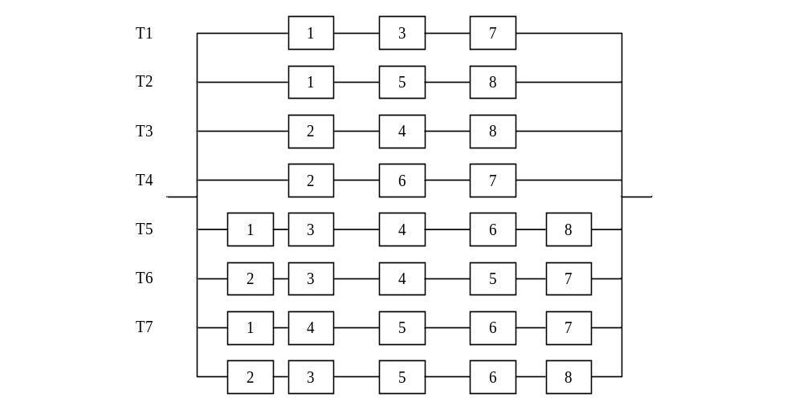Fig. U15.11: Expanded Logic Diagram
One immediately observes repeated blocks, indicating dependencies between them, i.e., each block does not work or fail independently. This is the reason why we should not evaluate the unreliability of this logic diagram using 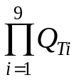since it is based on probability evaluation of joint events, P(F_{T1}∩F_{T2}∩F_{T3}∩F_{T4}∩F_{T5}∩F_{T6}∩F_{T7}∩F_{T8}), and therefore only applies if each block works or fails independently.

But what if we want to obtain the reliability, R_{sys}?
Then, as we have said, we must evaluate the probability of the union of the events:
R_{sys}=P(S_{sys})=P(S_{T1}∪S_{T2}∪S_{T3}∪S_{T4}∪S_{T5}∪S_{T6}∪S_{T7}∪S_{T8})
Do dependencies cause problems here?
To answer this question, let’s do a simpler case of evaluating just P(S_{T1}∪S_{T2}), as illustrated in Fig. U15.12:
Fig. U15.12
Using the rule for the union of two events, which is P(A∪B)=P(A)+P(B)-P(A∩B), we have for two events:
P(S_{T1}∪S_{T2})
=P(S_{T1})+P(S_{T2}) LINE 1
-{P(S_{T1}∩S_{T2})} LINE 2
In terms of component success probabilities, this would be:
P(S_{T1}∪S_{T2})
=R₁R₃R₇+R₁R₅R₈ LINE 1
-R₁R₃R₇R₅R₈ LINE 2

Note:
➔The last term in LINE 2, R₁R₃R₇R₅R₈, came from:
P(S_{T1}∩S_{T2})=P(S_{T1})×P(S_{T2}| S_{T1})=R₁R₃R₇×R₅R₈
Clearly, we still have trouble with dependencies, although we were able to effectively deal with them.
We could analyze the entire T₁-T₈ logic diagram this way, with the help of the general formula for the union of multiple events [5]:
P(S_{T1}∪S_{T2}∪S_{T3}…∪S_{Tn})=
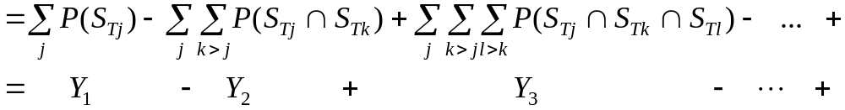where Y_{r} is the r^{th} summation in this sequence of summations, i.e.,
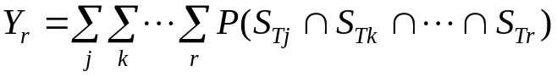 such that
P(S_{T1}∪S_{T2}∪S_{T3}…∪S_{Tn})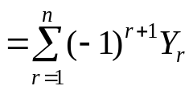
But this would become rather tedious, since we would have to deal with each of the joint probabilities very carefully so as to appropriately screen the dependencies.
Instead, make 3 observations in reference to the above calculation.
- The magnitudes of the quantities in the LINEs get smaller, i.e.,
  - |LINE 1|>>|LINE 2|, i.e., Y₁>>Y₂
and we can generalize to say that |LINE I|>>|LINE J| when J>I, i.e., Y_{i}>>Y_{j} when j>i.
- Evaluation of P(S_{T1}∪S_{T2}) using only LINE 1 (Y₁) is a good approximation, as long as R_{i}’s are reasonably small. Therefore,
P(S_{T1}∪S_{T2}∪S_{T3}…∪S_{Tn})≈P(S_{T1})+P(S_{T2})+…+P(S_{Tn})=Y₁
However, this is normally not the case, as it was with the cutset analysis (which dealt with Q’s instead of R’s).
This approximation becomes exact if tieset successes are mutually exclusive, which is never the case in engineering systems (it would mean one set of components T1 working prevents all other sets of components from working!).
- |LINE 2|>>|LINE I| for any I=3,…n. Since LINE 2>0, and since it is subtracted from LINE 1 (which is also >0), it must be the case that LINE 1>P(S_{T1}∪S_{T2}∪S_{T3}…∪S_{Tn}). Therefore, our approximation P(S_{T1}∪S_{T2}∪S_{T3}…∪S_{Tn}) is an UPPER BOUND to the actual probability.
In fact, observation 3 can be carried a little further. In [5], it is stated (with proof given in the references to [5]), that
P(S_{T1}∪S_{T2}∪S_{T3}…∪S_{Tn})≤Y₁
P(S_{T1}∪S_{T2}∪S_{T3}…∪S_{Tn})≥Y₁-Y₂
P(S_{T1}∪S_{T2}∪S_{T3}…∪F_{Cn}) ≤ Y₁-Y₂+Y₃
and so on. Fig. U15.13 illustrates this phenomenon.
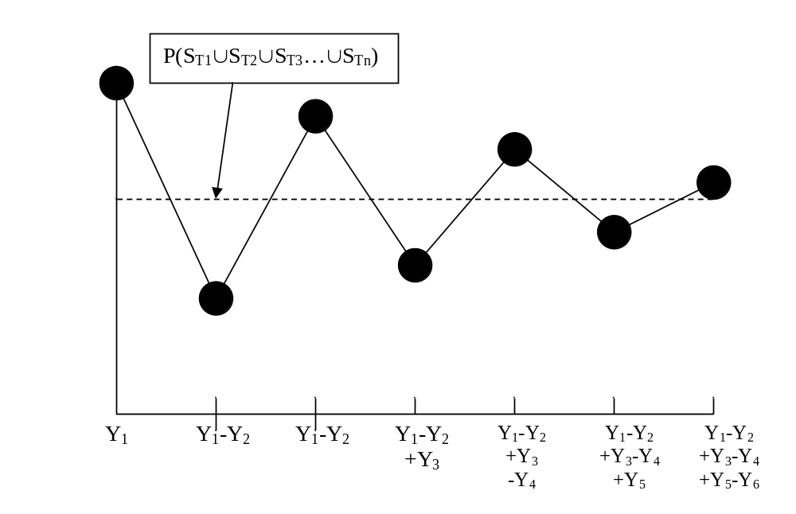
Fig. U15.13: Impact of Additional Terms on
Success Probability Estimation
One thought that comes to mind in studying Fig. U15.13 is that evaluation of Y₁ and Y₁-Y₂ provides an upper and lower bound, respectively, on the success probability P(S_{T1}∪S_{T2}∪S_{T3}…∪S_{Tn}). However, as we have observed, evaluation of Y₂ requires that we address the issue of dependencies between tiesets.
But if Y₁ is an upper bound on the success probability, then 1-Y₁ is a lower bound on the failure probability. This is good news indeed, since cutset analysis gives an upper bound on failure probability.

So our strategy is as follows:
- Find all minimal cutsets and tiesets
- Evaluate:
  - Z₁=P(F_{C1})+P(F_{C2})+…+P(F_{Cn})
  - 1-Y₁=1-{P(S_{T1})+P(S_{T2})+…+P(S_{Tn})}
- It will be the case that 1-Y₁<Q_{sys}<Z₁
For most systems, Q_{sys} will be much closer to Z₁ than to 1-Y₁ because the approximations used depend on the component Q’s and R’s being small. Obviously, we cannot have both, and it is more typical to have small component Q than to have small component R. Fig. U15.14, from [5], illustrates the point.
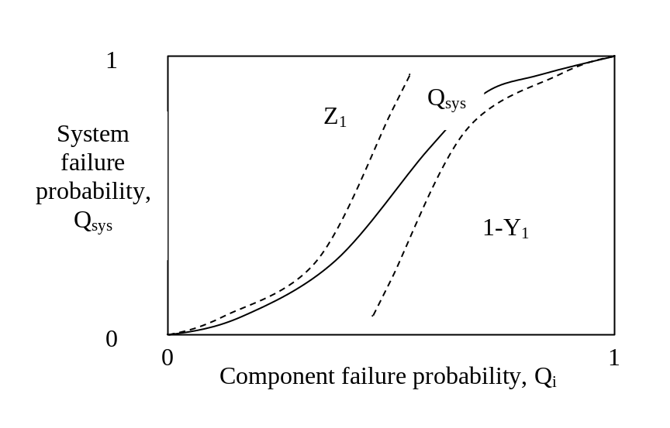
Fig. U15.14: Relation between approximations and Q_{sys}
A key step in the cutset-tieset approach is the ability to identify the cutsets and tiesets from the logic diagram. We have done this in a “manual” fashion by simple visual recognition. However, cutset and tieset identification may be done algorithmically and then programmed so that a computer can do the job. Various algorithms are available for this. Billinton [2] describes two of these and Endrenyi [5] refers to another. But these algorithms are dated, and before coding anything, it is recommended that a literature search be done, particularly in the more recent reliability literature (not the power system reliability literature).

U15.6 Fault trees
The material in this section is adapted from [4,6,7,8,9] and is intended to compliment the corresponding material in [2].
Fault trees are effectively used at providing a systematic way to view logical sequences of events that can lead to failure of complex systems. Fault trees are useful in reliability analysis of power system protection, nuclear power plants, and process control systems.
A key term in the literature on fault trees is the top event, which is an event that is postulated before the analysis so that it effectively drives the analysis. Then branches are developed leading from fault events to the top event, and these lower events are in turn connected through lower branches to more detailed fault events. The fault events at the bottom of the tree are the basic failures attributed to components.
The building blocks of fault trees are:
- Gate symbols: the connectors between events. A gate can have 2 or more input events but only 1 output event. The most heavily used gates are the AND gate and the OR gate, but others are available for more complex situations (exclusive OR, priority AND, m/n gate, inhibit gate, etc.)
- Event symbols: indicating the nature of events. Event symbols may be further classified according to:
  - Primary events:
    - basic event: an event requiring no further development.
    - undeveloped event: an event which is not further developed either because it is of insufficient consequence or because information is unavailable.
    - Trigger (house) event: A fault event which is expected to occur.
  - Intermediate events: an event that occurs because of one or more antecedent causes acting through logic gates.
- Transfer symbols:
  - Transfer in: Indicates that the tree is developed further on another page.
  - Transfer out: Indicates that this portion of the tree must be attached to another tree at this point.
Billinton [2] summarizes some of these symbols in Fig. 5.16 of his book. Another summary is given in Table U15.1 below [6].
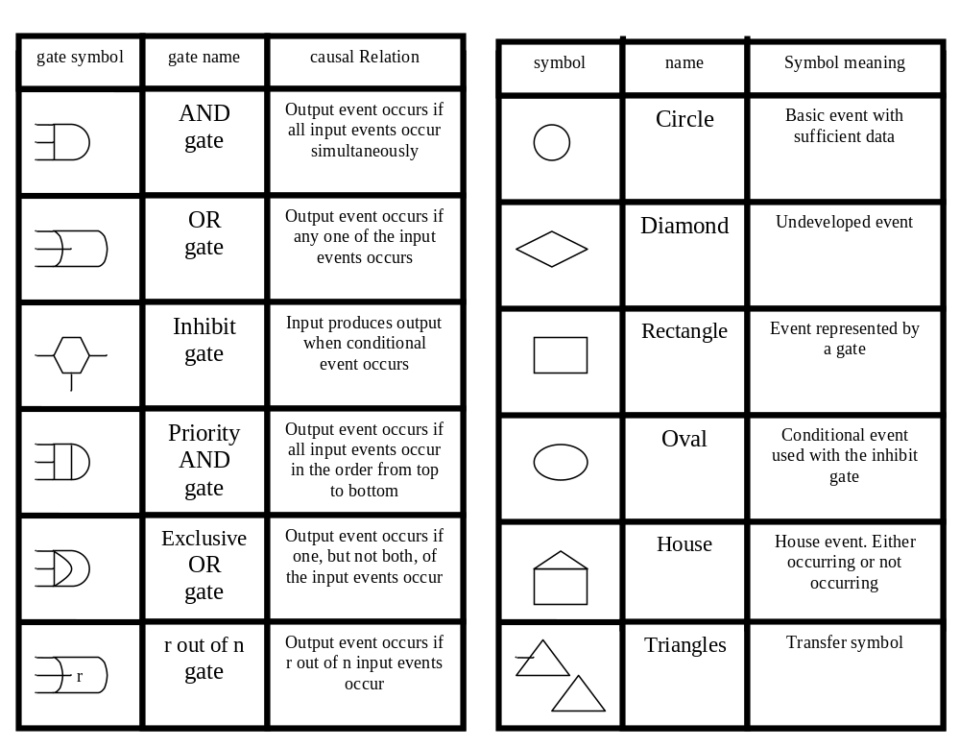Table U15.1: Fault Tree Gate and Event Symbols
Three important characteristic of fault trees are:
- Fault tree analysis is generally a “top-down” analysis using “backwards logic” where the top-event is specified first. This is in contrast to event trees.
- A fault tree does not necessarily contain all possible failure modes of the components of the system. Only those failure modes which contribute to the occurrence of the top event are modeled.
- A fault tree is an expression of Boolean logic. Thus, when using them as a modeling tool, we must assume that the top event and all basic events are binary, that is, either true or false.
There are 4 basic steps to fault tree analysis, as follows:
- System definition
- Fault tree construction
- Qualitative evaluation
- Quantitative evaluation
We will outline these steps in what follows.

System definition
The most important step in all of the analysis is to identify the top event. This is the event that IS system failure. But what is the system?
A system is composed of components that are arranged to permit the achievement of a particular objective. Thus, in defining the system, it is key to identify all of the components that constitute it. This may often be done through the inspection of functional diagrams.
The system may also require materials, information, and/or personnel for its proper functioning, all of which may also be classified as “components.” All of these components should be classified according to whether they are active or passive.
- Active component: a component that takes action. Moving parts are typical of active components.
- Passive component: a component that passively contributes to the system operation. Storage facilities (e.g. batteries) are a good example of passive components.
The above delineation is important because active components almost always have failure rates that are at least an order of magnitude greater than passive components.
One helpful mechanism in defining the system is to establish boundaries in terms of:
- External boundaries: What factors could be of influence in the top event and how important are these factors?
- Internal boundaries: In how much detail should we study the system?
- Temporal boundaries: Specify not only the components but also their states, since the states of many components may change over time.
Perhaps the most fundamental step in the system definition process is to identify and classify the types of faults that may occur. There are two basic classification approaches, taxonomies, both of which should be considered in any fault tree analysis. These are:
- Primary, secondary, and command faults:
  - A primary fault occurs when a component fails in a task for which it was designed. One might say that such faults are ones for which the component should be “held accountable.” Aging or random environmental stress is often the cause of a primary failure. For example, a switching surge causes a dirty insulator to flashover on a transmission line.
  - A secondary fault occurs when a component fails in a situation for which it was not designed. One might say that such a fault is one for which the component should not be “held accountable.” For example, a power transformer has voltage ratings that are calculated to provide long life, but excessive overvoltage causes insulation failure due to operation outside of the apparatus rating.
  - A command fault occurs when the component operates in the correct way but at the wrong time or in the wrong place or when it does not get the command to operate when it was supposed to operate. Command faults are usually corrected by control or operator action to return the component to a working state. For example, an operator causes power to an important load to be lost because the wrong breaker is opened during routine switching for repair of a neighboring circuit. Service is restored by correcting the switching error.
- Causes, mechanisms, modes, effects:
  - Causes: The causes identify the causes of the failure, i.e., the reasons why a component fails. These causes should include both immediate (local) causes as well as the root causes.
  - Mechanisms: The mechanisms describe the actual physical processes leading to a failure. For example, the cause of failure might be “leak in the oil lines” and the mechanism of failure might be jamming of a piston.
  - Modes: The modes describe the way in which the component fails, usually from a functional or sub-functional point of view (e.g., fails to open, fails to close, fail to start, fail to run).
  - Effects: These are the consequences of the failure in relation to other components of the system. Sometimes the effect of a failure depends on the mode.
An approach called “failure modes and effects analysis” is well documented in the literature and offers a systematic way of classifying faults according to the above taxonomy.
Figure U15.15 offers a convenient illustration that connects the two classification methods described above [8].
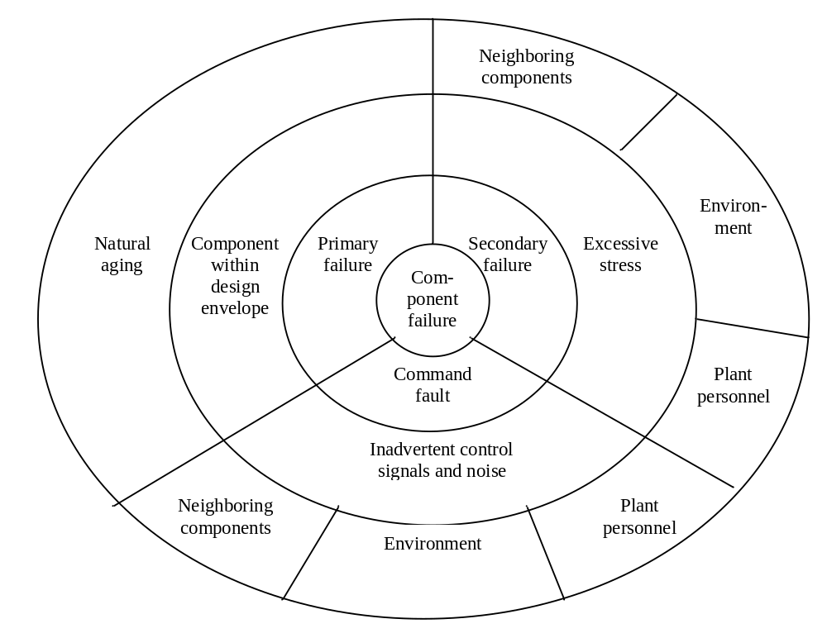
Fig. U15.15: Component Failure Characteristics [8]
Anderson, in [6], provides a statement that is particularly important within the arena of power system engineering, in that it clarifies the relationship between faults, as used above, faults in the typical power system sense, and failures.
“A term that is widely used in fault tree analysis is the term “fault.” The events pictured in the fault tree are often referred to as “faults.” A distinction must be made between a fault and a failure. A failure is a basic abnormal occurrence for a component. It is an inoperable state, in which a component is not able to perform its intended function. A fault is the immediate cause of failure. It is a general type of occurrence, which may not refer to the complete loss of an item, but just an improper action or operation of that item. For example, a relay may close without command, due to physical or seismic shock, but this does not imply failure of the relay, since the component is not damaged by the action, although the event may be unwanted. Thus, we say that all failures are faults, but not all faults are failures. This distinction is important to observe in analyzing power system protection, where it is common to refer to short circuits or other events requiring protective action as “faults.” More precisely, a temporary short circuit should be termed a fault, but a permanent short circuit is a failure. The general usage of the term fault will usually be clear from the context.”

Fault tree construction
Fault tree construction begins with writing down the top event. Then there are two principle steps from there:
- Level 1 construction: Identify and draw with proper logic and event symbols the necessary and sufficient causes for the top event, i.e., the immediate causes, and not the basic or root causes. These events should be faults and should be clearly described in terms of what has happened and when it happened.
- Step 2, Level n fault construction: Identify and draw with proper logic and event symbols the necessary and sufficient causes for the lowest existing level of events in the fault tree. The first time through, n=2, after which n=n+1 as we repeat this step until all terminal events are basic.
References [6, 8, 9] all provide the following general guidelines for fault tree construction:
  - Replace an abstract event by a less abstract event.
  - Classify an event into more elementary events.
  - Identify distinct causes for an event.
  - Couple trigger events with “no protective actions.”
  - Find cooperative causes for an event.
  - Pinpoint a component failure event.
  - Develop a component failure event in terms of primary failures, command failures, and secondary failures.
Three more general rules are often quoted in the literature. These are:
- No miracles: If the normal functioning of a component propagates a fault sequence, then assume that the component functions normally.
- Complete the gate: Fully describe all inputs to a particular gate before developing any of the inputs further.
- No gate-to-gate connections: The input to a gate should always be a properly defined fault event and not another gate.
Of these rules, the first helps to make fault trees coherent (meaning that component failure should not enhance the system reliability). The second two rules are “good practice” rules that enable the tree to be easily checked.
Example: Consider the power system illustrated in Fig. U15.16 [5].
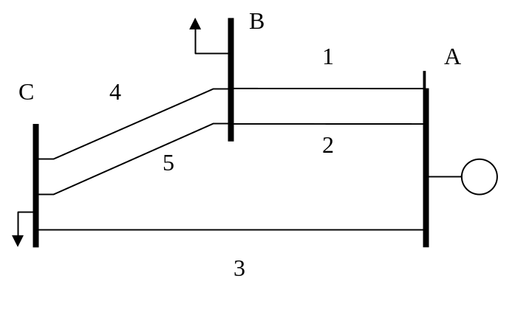
Fig. U15.16: System for Fault Tree Example
The generator at station A represents power inflow that can be perfectly reliable for purposes of this example. Define “system failure” to be
- Station B is isolated or
- Station C is isolated or
- The combined load of stations B and C are carried by a single circuit.
Draw a fault tree for this system (note the answer is not unique).
The top event is “system failure” as defined in the problem statement. Based on this definition, we may immediately draw the first level of a tree, as shown in Fig. U15.17.
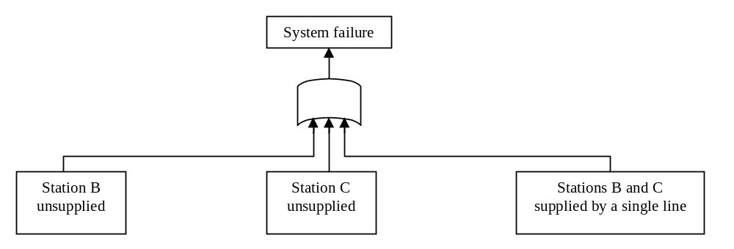
Fig. U15.17: First Level

Now one proceeds by analyzing each of the three ways that system failure may occur.
- Occurrence of the first event on the left of Fig. U15.17 requires three events:
  - loss of circuit 1 (basic event),
  - loss of circuit 2 (basic event), and
  - loss of supply from Station C (intermediate event)
Because this failure mode requires all of these three events to occur, we flow them through an AND gate.
- Occurrence of the event in the middle of Fig. U15.17 requires two events:
  - loss of circuit 3 (basic event), and
  - loss of supply from Station B (intermediate event)
Because this failure mode requires both of these two events to occur, we flow them through an AND gate.
- Occurrence of the event one the right of Fig. U15.17 may occur in any of three different ways:
  - supply from circuit 1 only (intermediate event),
  - supply from circuit 2 only (intermediate event), or
  - supply from circuit 3 only (intermediate event).
Because this failure mode occurs if any of these three events occur, we flow them through an OR gate.
The second level of the tree is shown in Fig. U15.18.
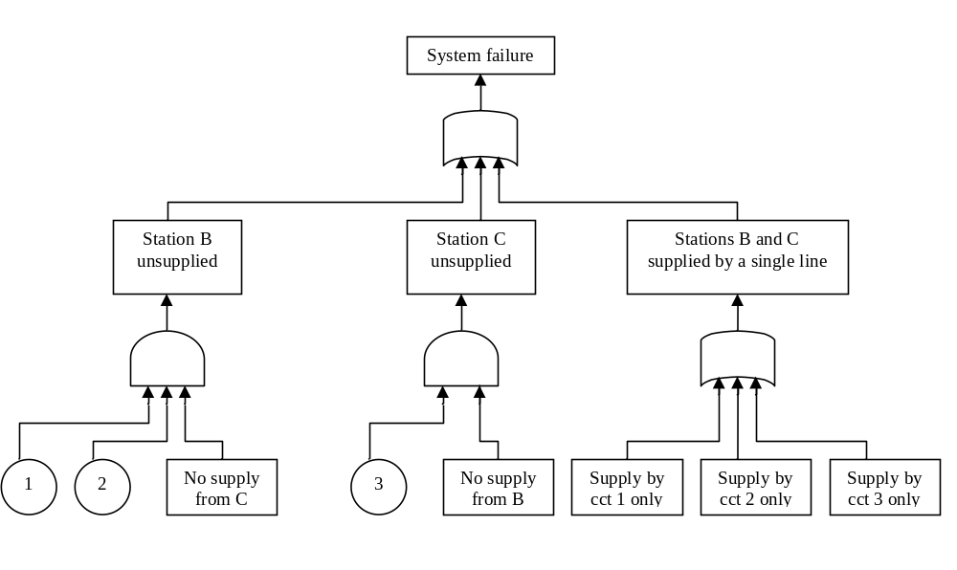Fig. U15.18: Second Level

Each of the five unexpanded intermediate events (rectangles at the second level) in Fig. U15.18 must now be expanded. Consider the first intermediate event on the left of the tree: no supply from C (to Station B). Referring back to Fig. U15.16, we observe that this may happen in one of two ways:
- Circuit 3 is lost (basic event) or
- The tie from C to B is lost (intermediate event)
The fact that the upper level event occurs on occurrence of either one of these implies use of an OR gate. Of course, the loss of CB tie is obviously decomposed into the basic events of loss of circuit 4 and loss of circuit 5, using an AND gate.
Similar analysis of the other 4 second level intermediate events results in the final fault tree of Fig. U15.19.
Remark: Use of fault trees for analysis of power systems, as illustrated in the above example, is not the most fruitful application area for fault trees. It works well in the above example because of the simplicity of the power system. They are more typically used within the power field for more containable subsystems such as protection systems. We elect to use the above example, however, because of the ease with which one may understand the system, its defined failure (top) event, and the relation between events from one level to another, and thus allow the reader to concentrate entirely on the method of fault tree construction.

Determination of cutsets
A fault tree is, like the reliability block diagram, a logic tree, and from it, it should be possible to extract the minimal cutsets of events that result in system failure (the top event). Given identification of the minimal cutsets, we may proceed to compute the probability of the top event in exactly the same way that we did in Section U15.4 above.
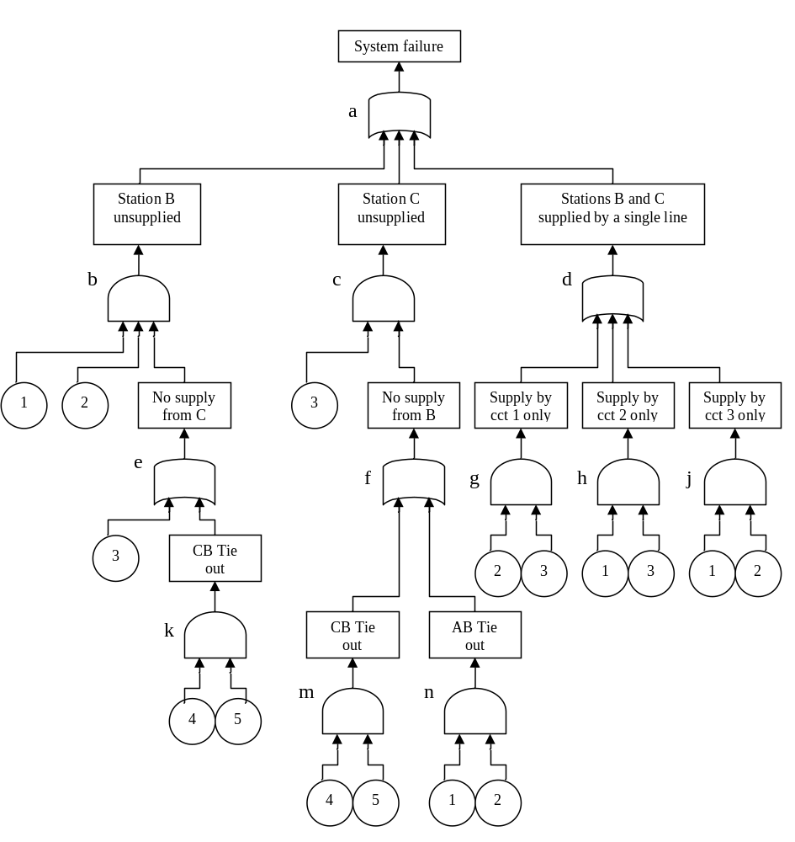
Fig. U15.19: Full Tree

Our approach to identifying the minimal cutsets from a fault tree assumes that we will make the identification by analyzing the fault tree from the top to the bottom. In doing so, we make two important observations:
- As we proceed down the tree from the top event, whenever we pass through an AND-gate, it means that all of the inputs to the gate must occur in order for the output to occur; as a result, the cutset of interest increases in cardinality by adding the events corresponding to the AND-gate inputs.
- As we proceed down the tree from the top event, whenever we pass through an OR-gate, it means that any of the inputs to the gate must occur in order for the output to occur; as a result, the number of cutsets increases by adding additional cutsets corresponding to the original cutset plus one of the OR-gate input events.

The following cutset identification algorithm follows from these two observations [6].
- Alphabetize the gates.
- Number each basic failure event.
- Locate the uppermost gate in the first row and first column of a matrix.
- Iterate either of the fundamental permutations (a) or (b) in a top-down fashion.
  - Replace AND gates by a horizontal arrangement of the input to the gates, and enlarge the size of the cutsets.
  - Replace OR gates by a vertical arrangement of the input to the gates, and increase the cutsets.
- When all gates are replaced by basic events, obtain the minimal cutsets by removing supersets. A superset is a cutset that includes some other cutset or cutsets.
This algorithm is illustrated on Fig. U15.19, as follows:
We begin with the top event, which comes from gate a.
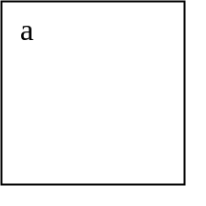
The gate below a is an OR gate, so we replace a with a vertical arrangement of the inputs to gate a, resulting in:
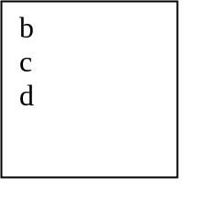
Gates b and c are both AND gates, with inputs {1, 2, e}, and {3, f}, respectively, so replace b and c with these horizontal expansions. Gate d is an OR gate, with inputs {g, h, j}, so we replace d with this vertical expansion. These changes result in:
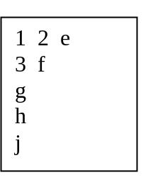
Gates e and f are OR gates, with inputs {3, k} and {m, n}, respectively, so replace e and f with these vertical expansions. Gates g, h, and j are AND gates with inputs {2, 3}, {1,3}, and {1,2}, respectively, so replace g, h, and j with these horizontal expansions.
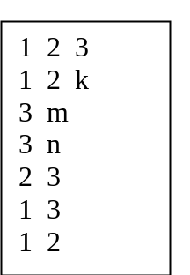
Gates k, m, and n, are all AND gates with inputs {4, 5}, {4, 5}, and {1, 2}, respectively, so replace k, m, and n with these horizontal expansions.
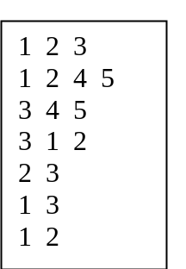
The above contains 3 supersets: {1, 2, 3}, {1, 2, 4, 5}, {3, 1, 2}, and these can be eliminated. We have remaining the minimal cutsets of {3, 4, 5}, {2, 3}, {1, 3}, and {1, 2}. There are no other minimal cutsets because a properly constructed fault tree must produce all cutsets. In this example, we may verify the list by observing its significance with respect to Fig. U15.16.
Computer programs are available implementing this procedure (or one like it) that allow automated identification of minimal cutsets for fault trees. Some of these include [8, 10, 11].

15.6.4 Quantitative Evaluation
Each cutset may be modeled as a parallel combination of its constituent components, with the various cutsets in series. Dependencies show up as duplicate elements from one parallel combination to another, and, when dependencies are present, the top event probability must be approximated by the method of Section U15.4.

15.6.5 Qualitative Evaluation
It may at times be the case that a qualitative assessment of the top event likelihood may be sufficient for purposes of decision-making. We assume that the minimal cutsets are available. There are two qualitative assessments that can be done which typically yield a great deal of information. These are:
- Order of magnitude estimation: List the cutsets in order based on cardinality, with cutsets having minimum cardinality first. Estimate the order of magnitude of each individual event comprising the cutsets, e.g, 10⁻¹, 10⁻², or, in general, 10^{-k}. Then the cutsets of cardinality 1 (a single component) will have probability order equal to k (meaning they will have probability approximated by 10^{-k}), that of a single component. Cutsets of cardinality 2 will have probability order equal to 2k (meaning they will have probability approximated by the probability of two independent events, each of which have probability order k).
- Common Mode Failure Analysis: Careful consideration of the minimal cutsets may often result in identification of situations that may result in the occurrence of more than one of the cutsets. For example, a catastrophic event at Station A of Fig. U15.16 would result in 3 out of the 4 cutsets: {2, 3}, {1, 3}, and {1, 2}. Of course, in this example, this common cause event is obvious, but in more complex fault trees, they may not be. Such common mode, or common cause events may raise awareness and motivate particular attention.
15.6.6 Final Comment Related to Fault Trees
One may wonder whether to use reliability block diagrams or fault trees for a given application, as both incur the same fundamental limitation that all system components must be two-state [5].
The decision is most typically based on the complexity of the system to be analyzed. Simple systems are typically amenable to development of a block diagram, and in such cases, this approach is most efficient. However, for more complex systems, the systematic approach underlying fault tree construction and analysis can be quite advantageous. Particular benefits associated with fault tree analysis are [12]:
- It directs the analysis to ferret out failures.
- It points out the aspects of the system that are important to the failure of interest.
- It provides a graphical aid by giving visibility to those in systems management who are removed from design changes.
- It provides options for qualitative and quantitative systems reliability analysis.
- It allows the analyst to concentrate on one particular system failure at a time.
- It provides additional insight into system behavior.
We note that, in addition to [2, 4-12] a number of good references [13-19] on fault trees should be reviewed if one desires further exploration of this topic.
15.7 Final comments on failure analysis
It has been recommended by a number of authors that fault tree analysis should be used in parallel with other approaches, some of which are briefly described in what follows.
Hazard and Operability (HAZOP): Here, a team of engineers performs a structured examination of a design. A leader drives the procedure by presenting each part of the system in connection with several guide words. Every applied condition or failure mode is considered for its feasibility, how it could arise, the possible consequences, and how it could be avoided.
Failure Modes and Effects Analysis (FMEA): This is a bottom-up method that starts with a detailed list of all components in the system. An entire system can be analyzed one component at a time. Alternatively, the system can be hierarchically divided into subsystems and modules as required. The FMEA technique is generally poor at identifying combinations of failures that cause critical problems but good at identifying multiple problems that can be caused by a common failure. Since each component is reviewed individually, failures due to combination of components are not addressed. Common cause failures are rarely identified since they require more than one component failure. An extension of this method, called Failure Modes, Effects, and Criticality Analysis (FMECA), results in a criticality ranking of all components.
Event Tree Analysis: This method is a bottom-up approach. It begins with the determination of a bottom event, which is a basic or initiating event and aims to determine the possible consequences of the event. Possible consequences of this event are described in a tree fashion using logical operators. Intermediate consequences are similarly analyzed, and so on, until a terminal event is reached. A terminal event is one that has no other immediate consequences.
Cause-Consequence Analysis: This technique can be regarded as a combination of fault tree and event tree analysis. Starting from a critical event, a cause consequence graph is traced backwards using fault tree construction techniques and forwards using event tree construction techniques.
Recognizing that HAZOP, FMEA, and event tree are inductive methods (begin with root failures and induce the effects and so it is from specific to general), and fault tree is a deductive method (begin with an effect and deduce the failures and so it is from general to specific), it is often effective to use at least one of each to gain complementary benefits.
Layer of Protection Analysis (LOPA): Reference [20], which describes this method, represents the culmination of work by reliability and process control engineers that occurred following the 1984 Union Carbide Plant chemical spill in Bhopal, India, when the gas methyl isocyanate (MIC) was leaked. The LOPA approach is very effective for systems having the following characteristics:
- Failures can be extremely high consequence.
- System has, or should have, multiple layers of protection against failures.
- System is complex.
The approach is applied following a HAZOP or FMEA that results in identification of specific scenarios consisting of initiating event and top event. Blackouts could be perceived this way.

References
- G. Anders, “Probability Concepts in Electric Power Systems,” John Wiley, New York, 1990.
- R. Billinton and R. Allan, “Reliability Evaluation of Engineering Systems: Concepts and Techniques,” Second edition, Plenum Press, New York, 1992.
- E. Elsayed, “Reliability Engineering,” Addison Wesley Longman, 1996.
- B. Dhillon and C. Singh, “Engineering Reliability, New Techniques and Applications,” John Wiley, New York, 1981.
- J. Endrenyi, “Reliability Modeling in Electric Power Systems,” John Wiley, New York, 1978.
- P. Anderson, “Power system protection,” volume III.
- M. Modarres, M. Kaminskiy, and V. Krivsov, “Reliability Engineering and Risk Analysis, A Practical Guide,” Marcel Dekker, Inc. New York, 1999.
- E. Henley and H. Kumamoto, “Probabilistic Risk Assessment,” IEEE Press, 1992, New York.
- T. Bedford and R. Cooke, “Probabilistic Risk Analysis, Foundations and Methods,” Cambridge University Press, 2001.
- S. Mason, “Feedback Theory – Further Properties of Signal Flow Graphs,” Proceedings of the IRE, v. 44, n. 7, July 1956, p 920-926.
- J. Fussell, E. Henry, and N. Marshall, “Mocus – A Computer Program to Obtain Minimal Cut Sets from Fault Trees,” Aerojet Nuclear Company, ANCR-1166, Idaho Falls, ID., 1974.
- W. Blischke and D. Murthy, “Reliability: Modeling, Prediction, and Optimization,” John Wiley, New York, 2000.
- C. Berge, “The Theory of Graphs,” Methuen, London, 1962.
- “Reliability and Fault Tree Analysis,” Edited by R. Barlow, H. Fussell, and N. Singpurwalla, Society for Industrial and Applied Mathematics, Philadelphia, Pa., 1975.
- W. Vesely, W. Goldberg, N. Roberts, and D. Haasl, “Fault Tree Handbook,” NUREG-0492, U.S>, Nuclear Regulatory Commission, Washington, D.C., 1981.
- The Instrument Society of America (ISA), Application of Safety Instrumented Systems for the Process Industries, ISA S84.01, February, 1996.
- The Instrument Society of America (ISA), Electrical/Electronic/Programmable Electronic Systems for Use in Safety Applications – Safety Integrity Evaluation Techniques, ISA-dTR84.02 (draft), September, 1997.
- The International Electrotechnical Commission, Functional Safety of Electrical/Electronic/Programmable Electronic Safety-Related Systems, IEC-61508, Parts 1-7, April, 1998.
- The International Electrotechnical Commission, Functional Safety Instrumented Systems for the Process Industry Sector, IEC-61511, Parts 1-3, June, 1999.
- “Layer of Protection Analysis: Simplifed process risk assessment,” Center for Chemical Process Safety, New York, 2001.

