Module T1


Electric Power Transmission

Primary Author: James D. McCalley, Iowa State University
Email Address: jdm@.iastate.edu
Co-author: None
Last Update: 7/30/98
Prerequisite Competencies: 1. Steady State analysis of circuits using phasors.
2. Three-phase circuit analysis and three-phase power relationships, found in module B3
3. Per-unit analysis, found in module B4
Module Objectives: 1. Relate the electrical characteristics of an overhead transmission line conductor, including resistance.
2. Use the pi-equivalent model of a transmission line to make power flow calculations.
3. Identify the influence of angular difference and voltage magnitude on real and reactive power flow across a transmission line.
4. Identify limitations of power flow across a transmission line.
5. Identify different types of thyristor controlled transmission equipment.

T1.0 Introduction
This chapter begins our study of the components comprising the AC transmission system. The basic purpose of the transmission system is to interconnect generation with load. Therefore we may think of the transmission system as providing the medium of transportation for electric energy, but one must realize that this transportation system is unlike most in that the transportation takes place almost instantaneously. In addition, the transmission system is a highly integrated system; that is, a change in the status of any one component can significantly affect the operation of the entire system. In this chapter, we will focus on transmission lines; substation equipment such as transformers, relays, and circuit breakers, although critical and interesting, will not be addressed in this module.

By transmission system, we are generally referring to the substation equipment and transmission lines at nominal voltage levels ranging from 34.5 kV to 765 kV (nominal voltage levels are always given line to line). These voltage levels are much higher than those used for generation or distribution in order to enable long distance power transfer at lower current levels and therefore minimize 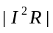 losses.

The transmission system may be subdivided into the bulk transmission system and the subtransmission system. The bulk transmission system includes the portion of the transmission system operating at voltage levels of 138, 161, 230, 345, 500, and 765 kV, although not every geographical region will contain transmission at all of these voltage levels. The functions of the bulk transmission system are to interconnect generators, to interconnect various areas of the network, and to transfer electrical energy from the generators to the major load centers. This portion of the system is called “bulk’ because it delivers energy only to so-called bulk loads such as the distribution system of a town, city, or large industrial plant. The sub-transmission system includes the portion of the transmission system operating at voltage levels of 34.5, 46, 69, and 115 kV although portions of the system at the lower voltage levels are sometimes classified as part of the distribution system, depending on usage. The function of the subtransmission system is to interconnect the bulk power system with the distribution system.
All materials are under copyright of PowerLearn project
copyright © 2000, all rights reserved

Transmission circuits may be built either underground or overhead. Underground cables are used predominantly in urban areas where acquisition of overhead rights of way are costly or not possible, and they are often used for transmission under rivers, lakes, and bays. Overhead transmission is used otherwise because, for a given voltage level, overhead conductors are much less expensive than underground cables. All of the discussion in this chapter will pertain to overhead transmission.

T1.1 Transmission Line Components
The basic components of a transmission line are the supports (towers), insulators, and the conductors. Operation of a transmission line is also dependent on fault detection equipment, voltage control equipment, and the bus arrangement at the terminals. In this chapter, we will focus on conductor characteristics.

A single transmission circuit is comprised of three phases. Each phase may consist of a single conductor, or each phase may be bundled in that it consists of two or more conductors suspended from the same insulator string. The latter design is more common, particularly at the high voltage levels, because it minimizes power loss due to corona. Conductors are always bare in order to allow maximum heat dissipation. In addition to the phase conductors, one or two grounded shield wires are also strung along the top of the tower in order to protect the phase conductors from lightning strokes.

Today, almost all conductors utilize aluminum in their construction because aluminum is plentiful, relatively inexpensive, and lightweight. The most common types of conductors are commonly referred to by the following acronyms: AAC (all-aluminum conductor), AAAC (all-aluminum-alloy conductor), ACSR (aluminum conductor, steel-reinforced), and ACAR (aluminum conductor, alloy-reinforced).

T1.2 Conductor Characteristics
There are three main characteristics of a conductor that are of concern to us. These are the resistance, inductance, and the shunt capacitance. We will discuss some of the influencing effects regarding these characteristics. Because we consider only balanced three-phase operation, discussion is limited to positive sequence quantities only.

T1.2.1 Conductor Resistance
Conductors of any material have resistance. Although conductor resistance is small enough so that it does not appreciably contribute to voltage drop, it is of considerable interest in systems analysis because it causes 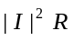 losses. The conductor resistance to direct current is given by 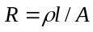, where is the resistivity, 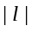 is the length, and 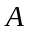 is the cross-sectional area of the conductor. However, there are two other important considerations regarding the DC resistance.

- Values of resistivity are given for a specified temperature (e.g. 20 degrees C), and resistivity increases approximately linearly with temperature.
- Because conductors are actually made with strands of material that are spiraled around a central core, the length used to compute resistance should be greater than the length of the conductor itself.
In addition, resistance to AC is usually higher than the resistance to DC because AC causes current distribution in the conductor to be non-uniform; typically, more current tends to flow at the surface of the conductor than in the interior. This is known as the skin effect, and its influence may be studied rigorously using a mathematical model derived directly from Maxwell’s equations.

T1.2.2 Conductor Inductance
Current flowing in a single conductor generates a magnetic field surrounding the conductor. Let us assume that the return path is located very far away from this conductor. If the current is alternating, then we may denote it as 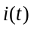because it varies with time; consequently, so will the magnetic field. We characterize this magnetic field with magnetic flux 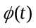 in Webers. The amount of flux which links this conductor is the flux linkage 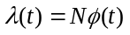 in Weber-turns, where 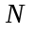 is the number of turns linked. In the case of a single conductor, 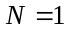. We assume here that 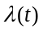 is given on a per unit length basis. According to Faraday’s Law, this time varying magnetic field will induce a voltage in the conductor, and by Lenz’s Law, it will be in a direction that opposes the change in current which produced it. The magnitude of this induced voltage will be

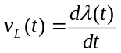 (T1.1)

in units of induced volts per unit length of conductor. If the magnetic field is set up in a medium of constant
permeability, then

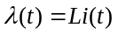 (T1.2)

where is a constant. Substitution of eqn.(T1.2) into eqn.(T1.1) yields

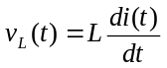 (T1.3)

The constant is defined as the inductance of the conductor, and it relates the voltage induced by the changing magnetic field to the rate of change of current:

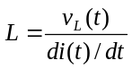 (T1.4)

Here, is given in units of henries per unit length. If we consider sinusoidal steady-state quantities, eqn. (T1.3) becomes

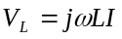 (T1.5)

where the quantity 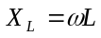 is defined as the inductive reactance per unit length of the conductor, and 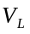 represents the voltage drop per unit length across the conductor carrying current I. For a power transmission line, the inductive reactance is higher than the resistance by a factor of about 2 to 3 for lower voltage transmission lines, increasing to a factor of about 20 to 30 for the highest voltage transmission line. Consequently, inductive reactance is the dominant factor in computing voltage drop and power flow across a line.

As previously mentioned, power transmission circuits are comprised of three phases, with each phase consisting of a bundle of conductors, and each conductor consisting of several conductor strands. Therefore, the mutual coupling (i.e., the effect of flux from one conductor on the induced voltage of another conductor) between strands in a conductor, between conductors in a bundle, and between phases in the circuit must be analyzed, and the effects included in a composite value of inductance per phase for the circuit. If the three phases are equilaterally spaced, then the inductances for the three phases are the same. However, construction costs are lower for other configurations such as the vertical or horizontal configurations. For these configurations, the mutual couplings between phases are not identical, and for balanced current loadings, the phases will incur unbalanced voltage drops. To avoid this problem, circuits with non-equilateral spacing among phases are normally strung in a transposed fashion, i.e., each phase occupies the position of the other two phases over an equal distance. In addition, transposition can also help to mitigate induced voltages in communication channels suspended from the same structures. Phase transposition is usually done at switching stations.

Example T 1.1

An ACSR 100 mile 230 kV transmission line has a resistance of 0.1 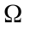/mile/phase and an inductive reactance of 0.777 /mile/phase. The voltage at the sending end of this line is 231 kV and the current through the line is 125 amperes, lagging the sending end voltage by 20 degrees. Assume that there is no capacitance associated with this line. Also, assume that the series impedance can be modeled as a single, lumped impedance.(a) Compute the receiving end voltage and the voltage drop across the line caused by the resistance and that caused by the reactance. (b) Compute the real power flowing into the line, the real losses, and the real power flowing out of the line. (c) Compute the reactive power flowing into the line, the reactive losses, and the reactive power flowing out of the line.

Solution

We must first obtain the series impedance for the line.

(a) The phase to neutral voltage magnitude at the sending end is 231 kV/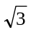=133.4 kV. With 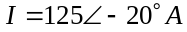, the receiving end phase to neutral voltage is

The drop across the resistance is 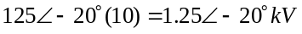, and the drop across the inductance is

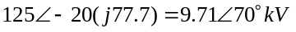

(b) The real power flowing into the line is

The losses are

and the real power flowing out of the line is

(c) The reactive power flowing into the line is

The reactive losses are

and the reactive power flowing out of the line is

T1.2.3 Conductor Shunt Capacitance
Let us consider again a single conductor such that the return path is located far away from this conductor, that there is a charge on the peripheral of the conductor that is uniformly distributed throughout its length, and that an equal and opposite charge is distributed along the earth below the conductor. This charge generates an electric field emanating from the conductor directed towards the ground. If the conductor voltage is alternating, then we may denote it as 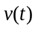 because it varies with time; consequently, so will the electric field. We characterize the electric field with the charge 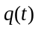 in coulombs per unit length of conductor. The flow of charge per unit length caused by the changing voltage is current, given by

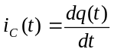 (T1.6)

If the electric field is set up in a medium of constant permittivity, then

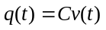 (T1.7)
where 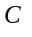 is a constant. Substitution of eqn. T1.7 into eqn. T1.6 yields

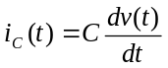 (T1.8)
The constant is defined as the capacitance per unit length of the conductor, and it relates the current resulting from the changing electric field to the rate of change of voltage:

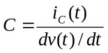 (T1.9)

If we consider sinusoidal steady-state quantities, then eqn. T1.8 can be written as

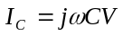 (T1.10)

where the quantity 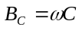 is the capacitive susceptance per unit length of the conductor to ground. For three phase transmission lines, the capacitance between the phases is normally much larger than the capacitance to ground.

Note the in eqn. T1.10 causes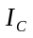 to lead by 90 degrees. Therefore line capacitance, also called line charging, contributes leading current. In a power system, when the loads are heavy, currents of high magnitude in the lines result in heavy reactive losses (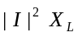). The current in this case is lagging (since 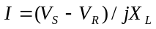), and the effect of the leading current from the line capacitance is to bring the total current angle closer to zero degrees. This effect is desirable since the same real power flow can be obtained for a smaller current magnitude: 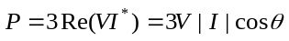, where is the angle between the current and voltage phasors; if decreases, then 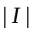 can decrease for constant , assuming that remains approximately constant. Reducing current magnitude will decrease both real losses(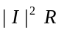) and reactive losses (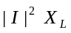).

Another equally valid way to think about this is that the line inductance absorbs reactive power (-MVAR) whereas the line capacitance produces reactive power (+MVAR). For a power transmission line under about 40 miles in length, the amount of reactive power produced by the line capacitance is very small, and the line capacitance is usually not modeled.

We have concentrated entirely on the capacitive susceptance of the line’s shunt admittance. There is also a real part, the conductance, caused mainly by insulator leakage. However, this component is usually very small and negligible. It is rarely modeled in power system studies.

T1.2.4 Use of Tables
Analytical expressions for transmission line resistance, inductance, and capacitance, developed from Maxwell’s equations, are available in most senior level power systems analysis textbooks. Generally, these expressions are dependent on the configuration of the phases and distances between them, the bundling of conductors per phase, the distance between each conductor in a bundle, and the material and size of each conductor. Tables can also be used to obtain the series impedance and the shunt admittance parameters for a given line. Such tables are available in, for example, reference [6].

T1.3 Lumped Parameter Model
The pi-equivalent lumped parameter model is used for most power flow analysis applications. This model represents the distributed effects of the series resistance and inductance and the shunt capacitance with composite or lumped values. Figure T1.1 illustrates the model.

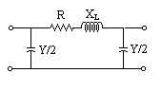

Figure T1.1 Pi-Equivalent Model of a Transmission Line

For transmission lines less than about 150 miles in length, the lumped parameters are computed as simply the product of the per-unit length parameter and the line length. For lines that exceed 150 miles, the model is still used but one needs to more rigorously derive appropriate expressions based on equivalent terminal characteristics. It should be noted as well that often, for lines less than about 50 miles in length, the charging capacitance is negligible, and the equivalent pi-model becomes a simple series impedance.

T1.4 Power Flow Through a Line
In this section, we will develop equations for computing real and reactive power flow in a transmission line. These equations are fundamental to a power systems engineer. We consider a transmission line that interconnects two buses p and q. Therefore we may denote the series impedance as 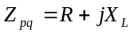 and the shunt admittance at each end of the line as 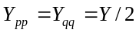 where is the total line charging given by 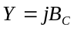. In addition, we may represent the series impedance as admittance; thus we have 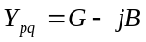 (note the use of the negative sign in front of the susceptance so that for an inductive reactance, the number will be positive). We will investigate the power flow into the transmission line from bus p in terms of two components: the flow into the p-side shunt capacitance, and the flow into the p to q series impedance. The total flow into the line from the p bus will then be the sum of these two components. Similar analysis will apply for the flow from bus q into the transmission line (which is just the negative of the flow from the transmission line into the q bus).

Using phasor notation, we denote the per unit voltages at the p and q buses as 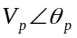 and 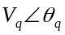, respectively.

T1.4.1 Flow Into Charging Capacitance
Let the current flowing into the p-side charging capacitance be 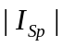. This current is given by

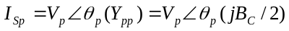 (T1.11)

The per phase complex power flowing into the p-side charging capacitance is then given by

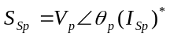 (T1.12)

where the asterisk indicates complex conjugation. Substitution of eqn. T1.11 into equation T1.12 yields

(T1.13)

Therefore the power flow into the charging capacitance is purely reactive, and the negative sign indicates that vars are being supplied to the network, not absorbed from it.

T1.4.2 Flow Into Series Impedance
The per phase complex power flowing into the series impedance from the p bus is given by

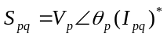 (T1.14)

where 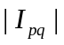 is the current flowing into the series impedance, computed as

(T1.15)

However, from eqn. T1.14, we see that 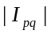 must be conjugated. Recall that if 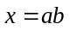 where and are two complex numbers, then 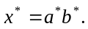 Applying this relation to eqn. T1.15, we have that

Substitution into eqn. T1.14 yields

Recalling that , we may rewrite the last expression as

Carrying out the indicated multiplication, and then collecting real and imaginary parts, we have that

(T1.16)

The real and reactive power flow from bus p to bus q, measured at bus p, are then given by

(T1.17)
(T1.18)

These equations are appropriate for computing real and reactive power flow across a transmission line. If voltages are given as phase to neutral, in volts, and impedances as per phase, in ohms, then the computed power quantities are per phase, in watts and vars. These equations can also be used if voltages and impedance values are given in per unit; in this case, the computed power quantities are also per unit, and multiplication by the system 3-phase base gives the three phase power flowing across the transmission line.

For quick, but approximate power flow calculations, we make use of the fact that normally, 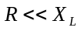. Because

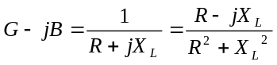 (T1.19)

we see that the assumption 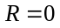 implies 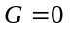; then eqns. T1.17 and T1.18 become

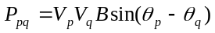 (T1.20)
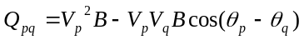 (T1.21)

These equations are used by most practicing power system engineers to gain insight into how certain flows are affected by design or operational actions that might be under consideration.

We may gain considerable insight into transmission line power flow if we make use of one additional simplification. In order to avoid system stability problems (see Section T1.6.3), the angular difference 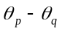 across a transmission line is rarely allowed to exceed about 40 degrees; typically, angle differences are less than 20 to 30 degrees. This means that the arguments of the trigonometric functions in eqns. T1.20 and T1.21 are small angles. For small angles these trigonometric functions may be approximated with 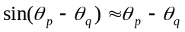 and 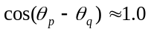, causing eqns. T1.20 and T1.21 to simplify to

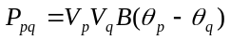 (T1.22)
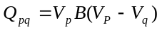 (T1.23)

where here we require that all angles be given in radians. From these two equations, we see that real and reactive flows are heavily influenced by the series susceptance (i.e., the series reactance). In addition, we may also ascertain two fundamental concepts to understanding power flow in a transmission system

- Real power flow is closely related to differences between bus angles; this is especially apparent if we realize that normally, bus voltage magnitudes do not deviate substantially from 1.0 per unit.
- Reactive power flow is closely related to differences in bus voltage magnitudes.

These two concepts are fundamental to understanding control of real and reactive power flow in a transmission system.

Example T 1.2
Consider the following data characterizing two interconnected buses p and q.

 | 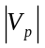 | 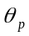 | 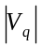 | 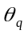
Case 1 | 1.03 | 30 | 1.03 | 10
Case 2 | 1.06 | 30 | 1.03 | 10
Case 3 | 1.03 | 50 | 1.03 | 10

The transmission line, which interconnects, buses p and q has resistance 0.004 pu and reactance 0.04 pu with no charging capacitance. For all three cases, we will compute the real and reactive power flow on the line using the three different power flow equations, which we have developed.

Solution

We first compute G-jB=2.475-j24.75 per-unit. We show the calculations only for Case 1, as they are similar for the other two cases.

Use full equations (eqs. T1.17 and T1.18):

Use equations based on zero line resistance (eqs. T1.20 and T1.21):

Use equations based on zero line resistance and small angle approximation (eqs. T1.22 and T1.23):

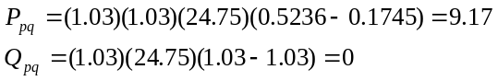

where the angles have been converted to radians. The following table summarizes the results for all three cases:

 | Eqns. T1.17 and T1.18 |  | Eqns. T1.20 and T1.21 |  | Eqns. T1.22 and T1.23
 | 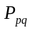 | 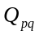
Case 1 | 9.139 | 0.685 | 8.98 | 1.58 | 9.17 | 0
Case 2 | 9.48 | 1.49 | 9.24 | 2.42 | 9.43 | 0.79
Case 3 | 17.49 | 4.46 | 16.87 | 6.14 | 18.33 | 0

Inspection of the first two columns (using the “exact” equations, Eqns. T1.17 and T1.18) indicate that
- Cases 1 and 2 have almost the same but different . This illustrates the effect of changing voltage magnitude.
- Case 3 has a dramatic change in due to the fact that the voltage angle was changed.

Comparison between the three sets of columns for the three cases indicates that the approximate equations appear fairly accurate for real power flow but not so accurate for reactive power flow.

T1.5 Surge Impedance Loading
Recall that power transmission lines typically have 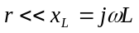; therefore it is reasonable to consider the lossless transmission line (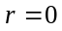). In this case, we may define the characteristic impedance as

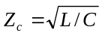 (T1.24)

where L and C are the inductance and capacitance per unit length of the conductor, respectively. 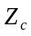 is also sometimes called the surge impedance. Note the units of are henries/farads which are the dimensions of a pure resistance. An interesting case occurs when a lossless transmission line supplies a load equal to its surge impedance 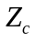. In the language of the power system engineer, we say that when the effective load of a transmission line is , then the line is carrying its surge impedance loading (SIL). The SIL of a transmission line is given by

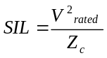 (T1.25)

where 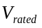 is the rated line to line voltage and SIL is the three phase real power delivered to the load. For a lossless transmission line loaded to its SIL, the reactive power absorbed by the inductance for each incremental length of the line is equal to the reactive power produced by the capacitance. Therefore the line is operating at 1.0 power factor, i.e., it is neither absorbing nor supplying vars.

We will see in Section T1.6 that the SIL is a good reference quantity for quantifying its power carrying capability.

T1.6 Power Flow Limitations
There are three possible causes for power flow limitations to a transmission line or transmission corridor. These causes are (1) thermal overload, (2) voltage instability, and (3) rotor angle instability.

T1.6.1 Thermal Overload
Thermal overload is caused by excessive current flow in a circuit causing overheating due to I-squared-R effect and subsequent conductor sag due to thermal expansion and loss of conductor life through a process known as annealing. In the worst case, the conductor can sag and short to a tree of some other high object, or the loss of life can be so substantial that the conductor must be replaced. Usually, at least two current limits are specified for a conductor: the normal rating and the emergency rating. The normal rating specifies how much current may flow in the circuit on a continuous basis, whereas the emergency rating specifies how much current can flow under emergency conditions (such as outage of a parallel circuit) for a specified amount of time, e.g., 30 minutes. Often, different ratings are specified for different seasons of the year, e.g., summer and winter ratings are typical. These ratings are based on a number of influencing factors, among which are

- conductor construction: outside diameter, strand diameter, core strand diameter, number of conductor strands, and number of core strands
- conductor AC resistance
- conductor surface condition: solar absorptivity, emissivity
- line location: latitude and longitude, conductor inclination, conductor azimuth, and elevation above sea level
- weather: incident solar flux, air temperature, wind speed, and wind direction

For highly variable factors such as those associated with weather, ratings are usually computed using conservative estimates. For example, a 40 degree C air temperature and a 1.5 mph wind velocity might be used when it is known that mean temperature and wind velocity are actually 27 degree C and 5 mph, respectively. Another approach to computing conductor ratings is to use probabilistic descriptions of the wind speed and the air temperature.

There has been considerable interest recently in so-called “dynamic thermal ratings” (DTR), motivated by the desire to increase transmission capacity without actually constructing new facilities. Here, measurements are made for temperature, wind speed, and solar flux, and the current rating is calculated in real time. An example [10] will help to illustrate the potential benefit of DTR. Under a “base” condition of 40 degrees C, 1.5 miles per hour, with sun, the rating for a 795 kcmil 26/7 ACSR conductor is 730 amperes. Table 3.1 illustrates the effect on the thermal rating of using various values of temperature, wind speed, and solar conditions.

DTR contributes toward allowing full utilization of transmission facilities. However, because a single circuit spans a large geographical area with high variability in the factors that influence the rating, the most limiting circuit section during one hour may not be the most limiting circuit section in the next hour. Therefore, in order to provide 100% accuracy of rating, all influencing factors must be monitored at every section of the circuit, and for most transmission owners, the associated cost of installing and monitoring the sensing devices would exceed the benefit gained from them. Another interesting approach to dealing with transmission line ratings is to use historical data to statistically assess probabilities of conductor temperature, from which one can identify ratings which would correspond to risk levels no higher than those the decision maker are willing to accept.

Table T1.1
Case | Wind Speed (mph) | Air Temp (C) | Solar Condition | Rating (amps)
Base | 1.5 | 40 | Sun | 730
1 | 0.0 | 40 | Sun | 480
2 | 3.0 | 40 | Sun | 877
3 | 1.5 | 20 | Sun | 954
4 | 1.5 | 0 | Sun | 1130
5 | 1.5 | 40 | No Sun | 835

T1.6.2 Voltage Instability
Voltage instability is said to occur when, under either normal operating conditions or those following a disturbance, the reactive power required to maintain voltages at or above acceptable levels exceeds the reactive power available at one or more buses. Voltage instability is brought on by either an increase in reactive demand or a decrease in reactive supply. Reactive demand increases may occur as a result of an increase in real power load at one or more transmission buses or as a result of a circuit outage. In the first case, the additional reactive load associated with the real power load must be supplied in addition to the increase in 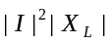 losses caused by higher currents. In the second case, the flow in the outaged circuit must be transferred to parallel circuits and the losses increase. Reactive supply decrease may occur as a result of a outage of a generator, synchronous condenser, or a shunt capacitor.

The voltage instability phenomenon may be observed via analysis of the simple system illustrated in Figure T1.2.

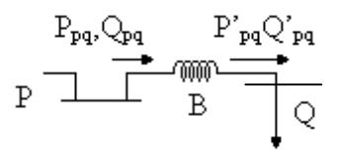

Figure T1.2

We can use our previously developed eqns. T1.20 and T1.21 to provide analytical insight into the voltage instability problem, and this is done in module T5 and also in [12]. Here, it is sufficient to simply gain a qualitative understanding of the voltage instability problem. Assume that we can hold the P-bus (left hand bus) voltage magnitude constant at 1.0 pu. As we increase the real and reactive power loading at the Q (right hand side) bus, the real and reactive flow through the transmission line will increase with a corresponding increase in current flow. This increased current flow will cause a greater voltage drop across the reactance B, and therefore the Q-bus voltage will decrease with increased current flow. At some particular loading level, the Q-bus voltage will become "unstable." In practice, exceeding this loading limit would result in uncontrollable voltage decline and subsequent loss of load. Mathematically, the relationship between the real power flow and the voltage at the Q-bus appears as in Figure T1.3. Here, we illustrate plots of vs. for various values of power factor. The important aspect of these curves is that for a given power factor, there is a maximum real power transfer to the load; if this maximum is exceeded, the system is voltage unstable. One should note that for highly leading (capacitive) loads, the voltage at which instability occurs is actually greater than the no-load voltage of 1.0. This fact implies that voltage instability can be difficult to detect by observing the voltage magnitudes alone.

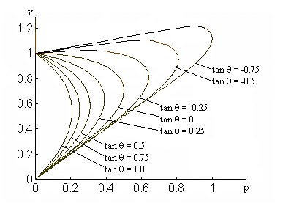

Figure T1.3 Plot of v vs. p for Various Values of Power Factor

T1.6.3 Rotor Angle Instability
Rotor angle instability is a dynamic problem that may occur following faults (short circuits) on a transmission line, at a generator station, or at a substation. During a faulted condition, generators in close proximity to the fault have decreased capability to transmit the electrical power generated. However, the mechanical power produced by the turbine remains constant during the fault, and there is consequently an imbalance between mechanical power input to the generator and electrical power output, with mechanical power being in excess. The excess mechanical power is converted into accelerating power, and the generator increases its rotational velocity. Under certain conditions, the increase can be sufficiently large so as to cause the generator to “lose synchronism” or “go out of step” with the rest of the power system, usually within two to three seconds following the fault. When this happens, the system has experienced rotor angle instability. This form of rotor angle instability is commonly known as transient instability. It is a nonlinear phenomenon, and analysis is done using time domain simulation where numerical integration is applied to the differential equations that describe the electro-mechanical dynamics of all machines in the power system.

Rotor angle instability may also occur tens of seconds after a fault due to poorly damped or undamped oscillatory response of the rotor motion. This kind of problem can be local to a single generator or it may be widespread over vast geographical regions involving multiple generator units. In either case, special control devices called power system stabilizers are usually used in conjunction with the excitation system to provide additional damping of the oscillations. Normally, this type of problem is amenable to analysis via use of linear system theory.

T1.6.4 Relation to Surge Impedance Loading
Surge impedance loading (SIL), as discussed in Section T1.5, is a useful reference for estimating the relative loading capabilities of lines of different lengths from a system perspective. Figure T1.4 gives the curve of line loadability in per unit of SIL as a function of line length. From this curve, we can draw the following general conclusions regarding power flow limits:

- Loadability decreases as length increases.
- Short lines tend to be limited by thermal overload and may be loaded at 2 or 2.5 times SIL.
- Medium length lines tend to be limited by voltage problems.
- Long lines are more limited by rotor angle instability problems and are generally limited to about 1.0 times the SIL.

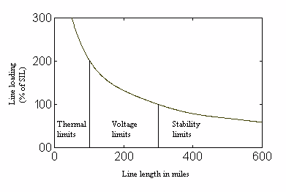

Figure T1.4 Line Loadability in Per-Unit SIL as a Function of Line Length

T1.7 Thyristor Controlled Transmission Equipment

T1.7.1 High Voltage Direct Current Transmission
Electrical energy may also be transmitted using high voltage DC (HVDC) transmission. HVDC circuits are advantageous relative to AC circuits because HVDC requires only two conductors rather than three and are therefore less expensive to build due to narrower rights of way and tower requirements. Further, HVDC allows non-synchronous interconnections; and this often offers advantages over AC interconnections due to system stability considerations. However, interconnection with the AC transmission system requires AC/DC and DC/AC conversion using high power thyristor valves. The additional expense of conversion is the main reason that HVDC is normally only used for overhead bulk transmission purposes when the transmission distance is substantial; a good rule of thumb is that HVDC can be considered as a design alternative to AC transmission when the distance is in excess of about 350 miles.

T1.7.2 Static Var Compensators and Static Condensers [14]
In electric power systems, voltage control is typically accomplished by regulation of generator terminal voltage and use of shunt capacitors and reactors with fixed impedance. However, in 1977, the first static var compensator (SVC) was installed in the Tri-State system by General Electric Company. The SVC is a shunt-connected reactive power generator or absorber (inductive) such that the output is automatically adjusted via thyristor controlled capacitors and/or reactors so as to control voltage magnitude at specific buses in the power system. Another more recent device is the static condenser (STATCON). This device is a three-phase inverter that is driven from the voltage across a DC storage capacitor and whose three output voltages are in phase with the AC system voltages. When the output voltages are higher (or lower) than the AC system voltages, the current flow is caused to lead (or lag), and the difference in the voltage amplitudes determines how much current flows. In this manner, reactive power and its polarity can be controlled by controlling the voltage. SVCs and STATCONs are also useful for alleviating oscillatory instability problems.

T1.7.3 Thyristor Controlled Series Compensation
A thyristor controlled series compensator [13] is an impedance compensator which is applied in series on an AC transmission circuit to provide smooth control of series reactance. Such a device may be capacitive or inductive. The thyristor controlled series capacitor (TCSC) contains a capacitor in series with the transmission circuit, a thyristor pair and reactor in parallel with the capacitor, and a metal oxide varistor (MOV) in parallel with the capacitor. The application of this device to electric power transmission systems can result in improved flow control, alleviation of transient instability, oscillatory instability, and voltage instability, and elimination of sub-synchronous resonance (SSR), a phenomenon that can result in high amplitude mechanical oscillations of the turbine-mass system and subsequent failure of the turbine-generator shaft.

T1.7.4 Unified Power Flow Controllers [15]
The unified power flow controller (UPFC) is intended to perform a wide range of control functions, including voltage regulation, series compensation, and angle regulation, or any combination of these simultaneously. It can therefore control both real and reactive flow in a transmission circuit and is consequently a very useful device. It makes use of two inverters gate-turn-off (GTO) thyristors, which are self-commutated thyristors, i.e., it is possible to turn them off using a pulse signal at the gate.

References

- T. Gonen, Electric Power Transmission System Engineering: Analysis and Design, John Wiley and Sons, New York, 1988.

- D. Fink and H. Beaty, editors, Standard Handbook for Electrical Engineers, 13th Edition, McGraw-Hill, New York, 1993.

- P. Kundur, Power System Stability and Control, McGraw-Hill, New York, 1994.

- Bergen, Power Systems Analysis, Prentice-Hall, New Jersey, 1986.

- V. Del Toro, Electric power Systems, Prentice-Hall, New Jersey, 1992.

- E. Kuffel and W. Zaengl, High Voltage Engineering Fundamentals, Pergamon Press, New York, 1984.

- H. Rustebakke, editor, Electric Utility Systems and Practices, John Wiley and Sons, New York, 1983.

- W. Stevenson, Elements of Power System Analysis, 4th edition, McGraw-Hill, New York, 1982.

- R Shultz and R. Smith, Introduction to Electric Power Engineering, Harper and Row, New York, 1985.

- J. Stewart, Transmission Line Loading Limits, presented at the 1994 IEEE Power Engineering Society Winter Meeting, Power System Engineering Task Force on Transmission Access and Nonutility Generation, New York.

- Technical Limits to Transmission System Operation, Electric Power Research Institute (EPRI) EL-5859, Project 5005-2, Final Report, June, 1988, L. Barthold, Principle Investigator.

- C. Taylor, Power System Voltage Stability, McGraw-Hill, New York, 1994.

- Thyristor Controlled Series Compensation, CIGRE Working Group 14.18 chaired by N. Hingorani, Draft Document, December 1996.

- N. Hingorani, Flexible AC Transmission, IEEE Spectrum, pg. 40-45, April 1993.

- E. Larsen, F. Sener, editors, FACTS Applications, IEEE PES Special Publication 96TP116-0, 1996.

P R O B L E M S

Problem 1
A 60 Hz three-phase 115kV transmission line has a series impedance of 30+j150 ohms/phase. The shunt susceptance of this line is 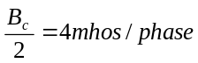. The line to neutral voltages at buses p and q are 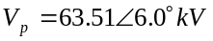 and 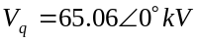, respectively. Compute 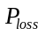, the three phase real power losses in MW for this transmission circuit.

Problem 2

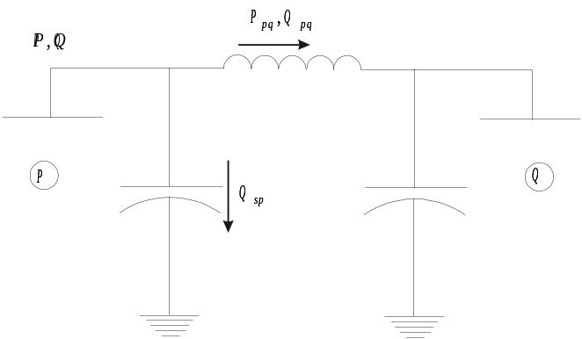

A 60 Hz three-phase 115kV transmission line has a series reactance of . Assume that the series line resistance is 0. The shunt susceptance of this line is 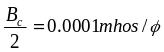. The line –to-neutral voltage at buses p and q are 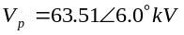 and 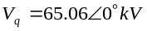, respectively. Using equations based on the small angle approximation, compute the three-phase real and reactive power flow out of the p-bus substation and into the line.

Problem 3
A transmission line having R=0.005 pu and X=0.05 pu (charging capacitance is negligible) is operating so that the voltage magnitudes and angles at its terminals are given by the data below:

Voltage Magnitude  for p-bus  (pu) | Voltage Angle  for p-bus  (deg) | Voltage Magnitude  for q-bus  (pu) | Voltage Angle  for q-bus  (deg)
1.15 | 10 | 0.95 | 0

The transmission line operates this way for 6 hours. All per unit values are given on a 100 MVA base. Compute:
- the real power flowing into and out of the line, in MW
- the real power absorbed by the transmission line impedance.
- the cost per hour ($/hr) for losses on this line, if the cost per hour ($/hr) for generating electricity is $.03/kWhr.
- the efficiency of the line

Problem 4
Answer the following questions about transmission lines. You will find the answers or at least clues in Module T1.
- What are the typical voltage levels for bulk transmission lines?
- What are the typical voltage levels for the subtransmission system?
- When are underground transmission circuits used?
- If a transmission line is bundled so that it requires a total of 9 conductors, how many conductors per phase are being used?
- What is the range for the ratio X_{L}/R for a typical conductor?
- Which is larger for a transmission circuit: capacitance between the phases or capacitance between phases and ground?
- Under heavily loaded conditions, does the capacitance of the circuit typically increase or decrease losses?
- Explain why charging capacitance increases with line length
- If a transmission line has impedance of Z = R + jX = 1 + j5, compute the admittance Y = G - jB, i.e., find G and B.
- If a transmission line has impedance of Z = R + jX = 0 + j5, compute the admittance Y = G -jB, i.e., find G and B.

Problem 5
A three-phase transmission line that connects bus 1 to bus 2 has negligible shunt capacitance. The current in the line is 400 amps, when the power flowing out of bus 1 into the line is +50 MW and +20 MVAR. Compute the real and reactive power flowing out of the line into bus 2 if the impedance is

- Z₁₂ = 5 + j50
- Z₁₂ = 0 + j50
- Z₁₂ = 5 + j0

Problem 6
A 60 Hz three-phase 115 kV transmission line has a series impedance of 30 + j150 ohms/phase. The shunt susceptance (B_{c}) of this line is assumed 0. The line to neutral voltages at buses p and q are 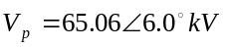 and 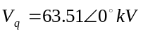, respectively.
- Compute the three phase real power in MW flowing into the series impedance from bus p. Use any one of the three power flow equations (exact, first approximation, or second approximation) to obtain your answer, but if you use an approximate equation, clearly indicate the approximation(s) on which the equation depends.
- Compute the three phase real power losses in MW for this transmission circuit.
- How does the three phase real power in MW flowing into bus q from the series elements relate to your answers in 1 and 2?

Problem 7
A synchronous generator rated 10 MVA, 13.8kV (line-to-line) is supplying a Y-connected load over a transmission line. The synchronous reactance, 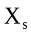, of the synchronous generator is 0.2 p.u. on its own base. The transmission line is modeled with a series impedance of 1.0+j2.0 p.u. on a base of 20MVA, 15.0kV. The impedance of the load is 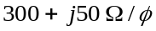. It is found that the line-to-line voltage across the load has a magnitude of 13.0kV.

- Compute the per unit values of the transmission line and load impedances, and the load voltage, on the generator MVA and kV bases.

- Determine the amount of reactive power from a shunt capacitor located at the load, in per unit, required to correct the load power factor to 1.0.

- Compute the per unit terminal voltage and the per unit excitation voltage of the generator (magnitude and angle for both).

- Compute the per unit real and reactive power flowing into the transmission line from the generator terminals. Use the "exact" power flow equations.

- Should the real power consumed by the load be higher or lower than the real power computed in part (d) ? Justify your answer.

- Use the power equations for a synchronous generator to compute the per unit real and reactive power flowing out of the generator terminals.

- Should the reactive powers computed in parts (d), (f) be the same or different? Justify your answer.

- It was noticed (in the field) that when the load was turned off (0 real power consumption) that the generator began to operate leading, yet the engineer was not able to replicate this behavior using the model described above. Explain what is deficient about this model.

Problem 8
Consider the following power system and associated data (bus voltages and series admittances given in per unit). Assume the charging capacitance of both lines is negligible. Use approximate power flow equations based on negligible resistance and small angle to:

- Compute the per unit real and reactive power flowing from bus 1 to bus 3.

- Compute the per unit real and reactive power flowing from bus 1 to bus 2.

- Compute the per unit power injected into bus 1; this is the per unit real and reactive power flowing into bus 1 from the generator.

Y₁₂=1-j5
Y₁₃=2-j10
Bus 1
Bus 2
Bus 3
V₃=0.98∠-20°
V₂=0.96∠-10°
V₁=1.0∠0°
For part (a)
For part (b)
For part (c)

Problem 9
Indicate True (T) or False (F) for the following statements:

- _____The capacitive legs of the pi-equivalent model of a transmission line model the capacitance between the conductors and the earth beneath the conductor.

- _____Short transmission lines have more capacitance than long transmission lines.

- _____Electric power is normally transmitted at high voltage levels because overhead conductor insulation material is inexpensive and effective.

- _____When all quantities are in per-unit, the per-unit complex power flowing from bus i into a transmission line connected to bus j may be computed according to S = V_{i}I_{i} where V_{i} is the voltage at bus i and I_{i} is the current flowing from bus i into the line.

- _____The reactive power flowing into a zero-resistance, short (i.e. negligible capacitance) transmission line will be the same as the reactive power flowing out of it.

- _____Transmission lines in the eastern U.S. are typically limited by voltage and thermal overload, whereas transmission lines in the western U.S. are typically limited by voltage and transient instability.

Problem 10

Consider the following power system, with all bus voltages given in per unit. The bus 1 magnitude and angle are held constant at V₁=1.0∠0° throughout this problem. The approximate power flow equations based on negligible resistance and small angle are used to compute power flows from the bus 1 side into the transmission line series impedance, and the following results are obtained:
P₁₋₃=3.419 pu, Q₁₋₃=0.2 pu, P₁₋₂=0.84 pu, Q₁₋₂=0.2 pu.
- If the line charging susceptance on the bus 1 side of the bus 1-bus 2 transmission line is B_{c}/2=0.01 pu, and the line charging in the bus 1-bus 3 transmission line is negligible, determine the total per unit reactive power supplied by the generator, assuming the given flows are accurate.

- Determine the new bus 3 voltage magnitude and angle, V₃, if the bus 1 to bus 3 real and reactive power flows into the series impedance, P₁₋₃ and Q₁₋₃, are both doubled. Use the approximate power flow equations based on negligible resistance and small angle approximation.
Bus 1
Bus 2
Bus 3
V₃=0.98∠-20°
V₂=0.96∠-10°
V₁=1.0∠0°

Corona occurs when the surface voltage gradient of a conductor gets so high, usually in excess of about 3000 kV/meter, that it causes partial dielectric breakdown in the surrounding air, and ionization occurs. Corona can be detected audibly as a hissing noise or visually, in the dark, as a bluish-white glow surrounding the conductor or reddish spots distributed along the wire. Besides causing power loss, corona can also lead to deterioration of insulation and interference in communication systems.
This effect is easy to understand in the following way. Assume that voltages do not change following a circuit outage, and that,before the outage, the circuit to be outaged carries a current and a single parallel circuit carries a current , and that both circuits have the same reactance 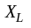. Before the outage, the reactive losses for the two circuits are 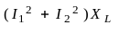; after the outage, the reactive losses on the single remaining circuit (which now carries both currents) are 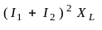. It is clear that 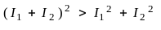.
Actually, Figure T1.3 shows plots of vs. for various values of 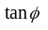, where 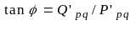. The power factor is given by 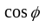.
We are describing the most common HVDC configuration, the bipolar arrangement where one conductor is at positive potential and the other at negative potential. HVDC may also be configured in the monopolar arrangement, in which case it utilizes only a single conductor with earth acting as the return. A third configuration, called the homopolar arrangement, uses two conductors at the same potential; here, again earth acts as the return. The homopolar arrangement is advantageous relative to the bipolar arrangement because when one conductor is out of service, the entire converter station is available for supplying the remaining conductor. However, any system that uses ground return may be problematic because of corrosion effects of gas and oil pipelines that are nearby.

