Overview of Electricity Markets

A good overview is contained in [1].

1.0 Origins of competitive electric energy systems [2]

Economic theory indicates that when commodity prices are equal to marginal costs, the resulting levels of production and consumption will be most efficient, and that marginal prices are induced through competition. However, for most of the 20th century, it has been generally accepted that electric energy generation, transmission, and distribution required either public or regulated private ownership because the industry constituted a natural monopoly, i.e., economies of scale dictated that least cost service was most closely captured by a single firm (a 500 MW plant is less expensive to build and operate than two 250 MW plants; it is less expensive to supply power over a single transmission or distribution system than two parallel ones) [3]. This view was first called into question in 1962 in what has become known as the Averch-Johnson (A-J) thesis [4] which states that regulation can be inefficient because the regulated companies tend to over-invest in order to expand the rate base on which their return is computed. In the ensuing years, however, a competitive electric power marketplace was not seriously considered because A-J effects were thought to be outweighed by economies of scale benefits achievable by monopolistic firms. In addition, it was felt that the coordination required in operating a power system precluded competition among its participants.
➔
➔

It was not until the 1980s that the perception of the electric power industry as a ``natural monopoly'' began to change, and competition in the industry was seriously entertained. There were three major reasons for this. First, economies of scale in generation began to point downward, i.e., smaller plants became more economically attractive because [5]:
➔
- Smaller plants can be built more quickly and their construction costs are consequently subject to less economic uncertainty.
- Smaller plants can be located more closely to load centers, an attribute that decreases system losses and tends to be advantageous for system security.
- Combined cycle units, also attractive because of their high efficiency, have to account for design complexities because of the coupling between the combustion turbines (CTs) and the heat recovery steam generators (HRSG) that are driven by waste heat from the CTs and therefore tend to be lower in rating.
- Cogeneration facilities, attractive because of their high efficiency, typically have lower ratings as a result of their interdependency with the industrial steam processes supported by them.
- Plants fueled by renewable energy sources (biomass, wind, solar, and independent hydro), attractive because of their low operating expenses and environmental appeal, also tend to have lower ratings.
Second, with the influence of “Reaganomics” in the 1980s and the breakup of the Soviet Union, public approval of government involvement in daily affairs began to decline, whether that involvement was as an industry owner and operator or only as a regulator. This public sentiment resulted in the election of administrations in many countries that strongly urged more laissez-faire economics, and industries in many countries were subsequently deregulated or privatized. Third, the late Dr. Fred Schweppe published an article in 1978 [6], giving more detail in [7] and later publications [8], that outlined a plausible method, called spot pricing, by which electric energy could be supplied and purchased in a real time fashion at marginal costs, and those costs tracked at each network node.
➔
➔

From this discussion we make two observations.
➔First, the inefficiencies of a regulated monopoly coupled with a general public disapproval of government intervention originally drove the desire to form a competitive energy marketplace.
➔Second, the increased attractiveness of smaller plants, together with an articulation of how an electric energy marketplace might operate, enabled competition in electric energy by opening the door for a multiparticipant, real-time market.

Some significant events in the US development of electricity markets are listed below:
- 1935 Public Utility Holdings Company Act (PUCHA)
  - Broke up layered interstate holding companies; required them to divest holdings that were not within a single circumscribed geographical area; reduced existing monopoly power.
➔
  - Required companies to engage only in business essential for the operation of a single integrated utility, and eliminated NUGs; didn’t want companies moving into other areas; reduced future monopoly power.
- 1965 Northeast Blackout
- 1968 National Electric Reliability Council (NERC) created.
- 1973 Energy Crisis
- 1977 Department of Energy (DOE) created.
- 1978 Public Utility Regulatory Policies Act (PURPA): utilities had to interconnect and buy at avoided cost from any qualifying facility QF (SPP using 75% renewables or Cogens).
➔
- 1987 Non-utility generation exceeds 5%
- 1992 Electric Policy Act
  - Exempt Wholesale Generators: class of unregulated gens; utilities did not have to buy their energy.
➔
  - They did have to provide transportation (wheeling), but no rules were specified regarding transmission service price.
- 1996 FERC Orders 888, 889, required IOUs to
➔
  - file nondiscriminatory transmission tariffs
  - purchase transmission service for their own new wholesale sales, purchases under open access tariffs,
  - maintain an information system that gives equal access to transmission information (OASIS)
  - functional unbundling of generation from “wires”
  - FERC order did not specify “how”
  - Can be done through divestiture or “in-house”
- 1996, 1997, 1998, 1999, 2000, Major outages
  - WSCC (’96,’97), Bay area (‘98), NY (‘99), Chicago (‘00)
- 1997: Startup of 21 OASIS nodes across US
- 1998 (April) California legislation gave consumers the right to choose electricity supplier
  - 1999 (June) 1% residential, 3% small commercial, 6% commercial, 21% large industrial, 3% agricultural have switched providers in California
  - 2000 (Jan) 13.8% of total load has switched in Cal
- 1998, 1999 Midwest price spikes: $7000, $9000/Mwhr, respectively, caused by:
  - Above-average planned, unplanned outages of gen, trans
  - Unseasonably, sustained high temperatures
  - Transmission constraints
  - Short-term price signals were inappropriate
  - Defaults in power sales
  - Inexperience in dealing with the above conditions
- FERC Order 2000 requires utilities to form regional transmission organizations (RTOs) to operate, control, possibly own transmission (ATC)
➔
- 2000-2001 California energy crisis
  - Drought, hot weather, outaged generation, natural gas shortage, transmission bottlenecks, flawed market design allowing price manipulation by some companies, problematic political forces. READ “California Crisis Explained” []
➔
- 2001, April PG&E went bankrupt
- 2001, November Enron collapse
- 2002 FERC standard market design issued.
- 2003 Major blackout in the northeast US.
- 2005, July National Energy Policy Act passed
➔
- 2006, Al Gore’s “An Inconvenient Truth” is released; greenhouse gases become high-profile in the public.

Electricity markets have been established throughout the United States and Canada and also in many countries throughout the world. For example, an electricity market was first set up in Chile in 1982, New Zealand in 1988, and England and Wales in 1990 [2]. Figure 1a illustrates chronological progression of these developments since 1990 [9]. Figure 1b provides a geographical map of the US market areas (from www.ferc.gov/market-oversight/mkt-electric/overview.asp). Of the market areas, only the northwest, southwest, and southeast do not operate short-term balancing markets.
➔
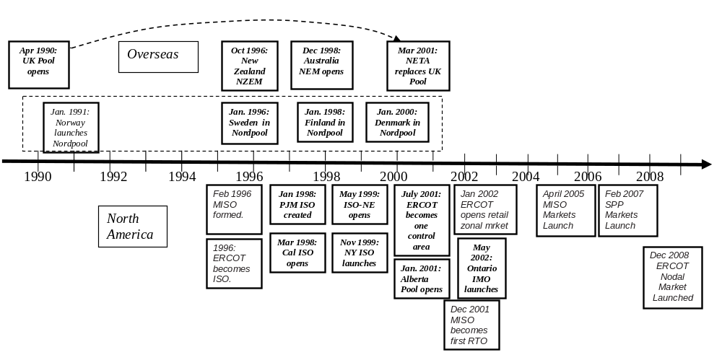Fig. 1a: Chronological Development of
➔
Electricity Markets Since 1990

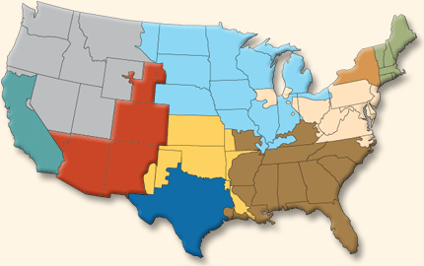
Fig. 1b: Electricity Markets in the US

2.0 Organizational structure

Organizational structure is the most important characteristic regarding electricity markets and has been the most significant change the industry has had to accommodate. Traditional industry structure centered on the vertically integrated utility, where the distribution, transmission, and generation functions were owned and operated by a single organization, a regulated monopoly. However, the vertically integrated structure, by virtue of the fact that it is a monopolistic structure, is not amendable to introduction of competition.
➔

Current industry structure generally requires separating the functions associated with selling and buying electric energy, the generation and distribution (or consumption), from transmission. The reason for this is that transmission is the means of transporting the tradable commodity, and ability to influence the use of transmission (through, for example, line maintenance schedules, line ratings, and network data) would provide a participant with a very powerful competitive advantage. Figure 2 illustrates the difference between the vertically integrated industry and the disaggregated industry.
➔
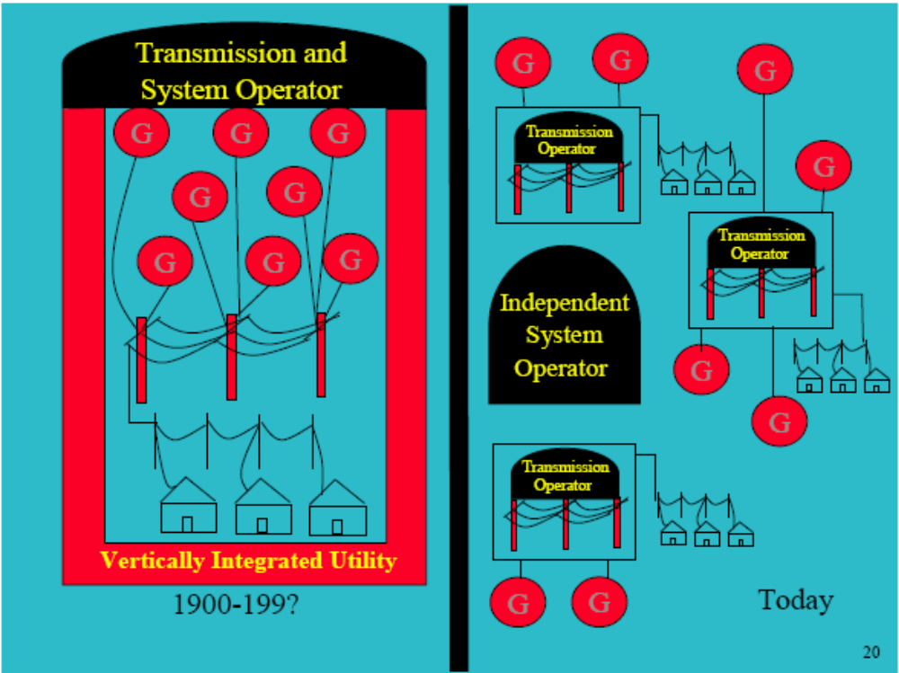
Fig. 2: Vertical Integration Vs. Disaggregated Industry

Another important function, traditionally viewed as a generation/transmission function, is system operation. In most electricity markets today, this function has evolved to the Independent System Operator (ISO), having responsibilities of coordinating maintenance schedules and performing security assessment. Usually, the ISO also has responsibility of operating the real-time market. Some system operation responsibility may also exist with the transmission owner, but primary regional responsibility lies with the ISO.
➔

Order 2000 of the Federal Energy Regulatory Commission (FERC) brought about the concept of regional transmission organizations (RTOs) [10]. An RTO is an organization, independent of all generation or transmission owners and load-serving entities, that facilitates electricity transmission on a regional basis with responsibilities for grid reliability, planning, and transmission operation. Order 2000 stated minimum characteristics of an RTO:
- independence from market participants;
➔
- appropriate scope and regional configuration;
- possession of operational authority for all transmission facilities under the RTO's control; and
- exclusive authority to maintain short-term reliability.

Order 2000 also identified minimum functions of an RTO as:
➔
- administer its own tariff and employ a transmission pricing system that will promote efficient use and expansion of transmission and generation facilities;
- create market mechanisms to manage transmission congestion;
- develop, implement procedures to address parallel path flows;
- serve as a supplier of last resort for all ancillary services required in Order No. 888 and subsequent orders;
- operate a single OASIS site for all transmission facilities under its control with responsibility for independently calculating TTC & ATC;
- monitor markets to identify design flaws and market power; and
- plan, coordinate necessary transmission additions and upgrades.
Organizations approved by FERC for approval as an RTO are shown in Fig. 3 [11]. Data to 2004 indicated that Day 1 RTOs have required an investment outlay of between $38 million-$117 million and an annual revenue requirement of between $35 million-$78 million [12].
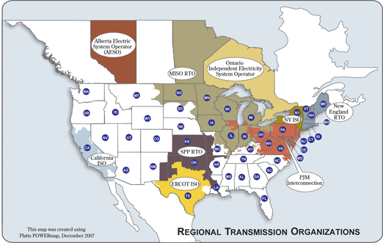
Fig. 2: Existing RTOs

3.0 Power Pools and Spot-Market Power Exchanges

An early predecessor of electricity markets was the power pool, developed in the 1970s and 1980s. The objective of the power pool was to reduce utility operating costs by sharing the least expensive resources in different regions. A central dispatcher would administer interchange between different utilities by dispatching the least-cost units throughout the pool. Thus, generation units owned by the low-cost utility would end up supplying load in a higher-cost utility’s region at a price beneficial to both, and total savings would be split between them. A key feature of these power pools was that the central dispatcher was given the generator cost curves of each company’s generation units, so the dispatch problem could be solved using a standard economic dispatch calculation [13]. Examples of such pools included the New England Power Pool and the California Power Pool.

Caution in regards to the use of the word “pool” is suggested. Some writings use it in the same way that some people use the word “Exchange.”

A spot-market power exchange, also known as a power brokerage, is similar to a power pool in that a centralized operator determines the dispatch, but a significant difference is that the exchange operator (i.e., the broker) does not know the generator cost curves. Instead, bids (to buy) and offers (to sell) are submitted to the operator, and then some algorithm is utilized to determine which ones are accepted.

4.0 Bilateral Trading

Bilateral trading, involving only two parties (buyer and seller) has occurred for as long as owners of different electric systems were interconnected, which dates back to before 1920 for North America. The essential characteristic of bilateral trading is that the price of each transaction is set via negotiation between the two parties involved.
➔

The material in these notes was adapted from [26-31].

The agricultural commodity market has existed for centuries. Today, there exist commodity markets not only for agriculture (grains, corn, soybeans, coffee, pork bellies, etc.), but also for precious metals (gold, silver, platinum, etc), base metals (aluminum, copper, nickel, zinc, etc.), and others (pulp, paper, chemicals, etc.), but also energy, including crude oil, gasoline, heating oil, natural gas, and, of courses, electricity.

There are a few important terms that are heavily used in reference to any commodity market, and specifically in reference to electricity markets. It is useful for you to become familiar with these terms.
- Bilateral Exchange: A trading arena (usually internet-based nowadays) where contracts on the commodities are exchanged. Examples include the Chicago Board of Trade (www.cbot.com), the New York Mercantile Exchange (www.nymex.com), the Chicago Mercantile Exchange (www.cme.com), (and the Minneapolis Grain Exchange (www.mgex.com). Of these, only the New York Mercantile Exchange (NYMEX) operates an exchange for energy contracts. The different trading products available that were available as of 2005 were futures and options contracts indexed to one of the following nodal price indicators:
- PJM Western Hub: A daily nodal-time average over 111 nodes in the PJM area over 16 hours/day (7am to 11pm).
- NYISO Zones A, G, J: A daily nodal-time average over nodes in the corresponding zone (A is Western NY, G is Eastern NY, and J is NYC) over 16 hours/day.
- Mid Colombia: A daily nodal-time average over nodes at the hydroelectric plants along the Columbia River in Washington State over 16 hours/day.
- Palo-Verde: A daily time average at the Palo Verde 500 kV substation in Arizona over 16 hours/day.
- Path 15 North and South: A daily nodal-time average over nodes in the corresponding region over 16 hours/day. Path 15 is a well-known highly constrained transmission path in the central valley region of California, connecting Southern California to the northern part of the state.
One of reason why these locations were chosen was due to their price volatility (and therefore their good sensitivity to market conditions). The figure below illustrates price variation for 4 locations, two of which are listed above (PJM and Palo Verde) and one of which (COB) falls almost halfway between the Path 15 area and the Mid Columbia area.
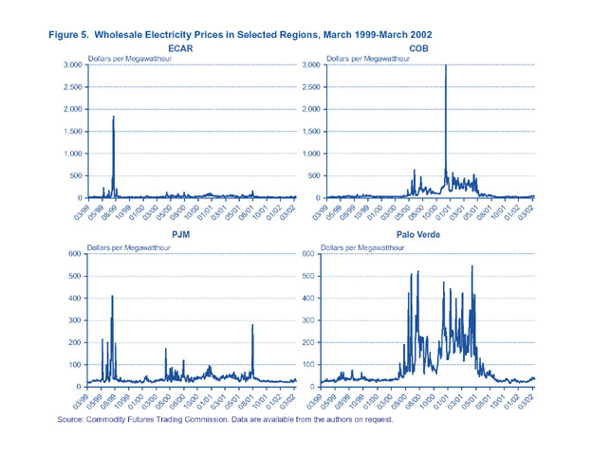
Now, as of 2008, NYMEX offers futures contracts for PJM, Western Power, New York ISO, Midwest ISO, and ISO-New England (see http://www.nymex.com/ele_oth_main.aspx). The same URL indicates the NYMEX also offers options contracts for PJM, ISO-New England, AEP-Dayton, Cinergy, and Northern Illinois.
- Derivative: A financial instrument derived from a related or underlying asset, e.g., a commodity such as electric energy or another financial instrument. Derivative trading involves the exchange of rights or obligations based on an underlying asset, but derivatives themselves do not directly transfer property. Derivatives include futures and options on futures, both of which are traded on exchanges, and forwards and other contracts traded outside of formal exchanges on over-the-counter markets.
- Over-the-counter (OTC): Customized derivative traded outside of an organized exchange.
- Reference price: The settlement price of a derivatives contract, based on a particular location, time T, and commodity. It is also sometimes called the future price. The nodal price indicators given above serve as the reference price for those electricity contracts listed on the NYMEX.
- Strike price: The specified price at which the holder can exercise his option to buy or sell the underlying asset.
- Hedge: Manage price risks associated with purchases or sales of an actual commodity.
- Arbitrage: Making profit by simultaneous purchase and sale of the same or equivalent commodity with net zero investment and without any risk. Arbitrage can occur when there exist price discrepancies between the same or equivalent commodities.

The types of contracts developed for bilateral trading include:
- Forward: An agreement between two parties to deliver a specified quantity and quality of a commodity at a specified future date at an agreed upon price (the strike price). Delivery is contemplated, but may be avoided by either party via sale of the contract. Forwards are normally created bilaterally and are not traded on an exchange.
- If at the settlement time T of the contract, the strike price exceeds the reference (spot) price, then the investor having contractual commitment to sell (a “short” position) realizes a profit and the investor having contractual commitment to buy (a “long” position) realizes a loss.
- If at the settlement time T of the contract, the strike price is lower than the reference (spot) price, then the investor having contractual commitment to sell (a “short” position) realizes a loss and the investor having contractual commitment to sell (a “long” position) realizes a profit.
- Futures and options: These are usually exchange-traded with a clearinghouse. They are financial tools to provide for delivery in the future, used primarily for shifting or assuming risk.
- Futures are standardized forward contracts, traded on organized exchanges such as NYMEX, typically not backed by physical delivery.
- Options are contracts that give the buyer the right, but not the obligation to purchase or sell the underlying asset at an agreed upon price in the future. Call options give buyers the right to buy the underlying asset from the seller at the prearranged strike price. Put options give buyers the right to sell the underlying asset at the strike price.

Participation in using these various contracts include electricity consumers & producers, and others, as indicated in Fig. 3.

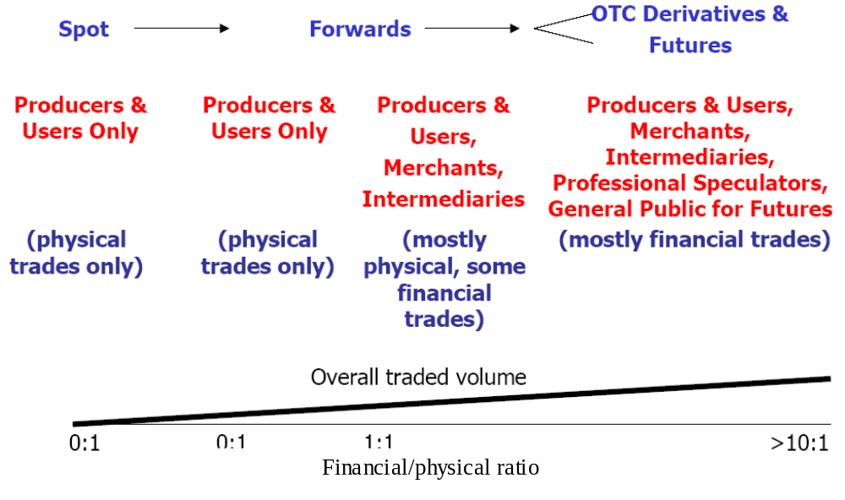Fig. 3: Participation in using different types of contracts [26]

Traders of derivatives can be classified as hedgers, speculators, or arbitrageurs.
- Hedgers are interested in reducing risk against adverse price movements.
- Speculators are engaged in a betting game pursuing profits from price movements.
- Arbitrageurs seek a riskless profit by trading simultaneously in different markets.
Although all three types of traders exist in electricity markets, we will focus on the use of financial derivatives for hedging because this type is most closely related to the familiar (at least to engineers) of adequacy.

Adequacy, as defined by the North American Electric Reliability Council (NERC) is “is the ability of the electric systems to supply the aggregate electrical demand and energy requirements of their customers at all times, taking into account scheduled and reasonably expected unscheduled outage of system elements.”

Note that this definition does not include the ability to respond to disturbances, which embedded in the notion of security. One distinguishing difference between these two is that adequacy is primarily a steady-state attribute: given a certain network configuration (topology and unit commitment),
- Is there enough generation to supply the demand?
- Is transmission capacity sufficient to supply the demand?
In contrast, security is related to the ability of the system to continue operations, in a shorter-term sense, following disturbances, without damaging equipment, inadvertently tripping load, or causing cascading sequences and/or uncontrolled islanding.

In traditional utility operation, it was the vertically integrated utility that shouldered the entire “obligation to serve,” i.e., to ensure adequacy, while supplying energy at specified prices. In return for accepting this obligation, utilities were guaranteed, by the regulatory bodies, a certain level of return on reasonable investments in the electric system infrastructure, and energy prices were set accordingly.

Under market-based electric transmission operation, this obligation is certainly weakened if not eliminated altogether, at least at the wholesale level. The new paradigm requires obligation, on the part of buyers or sellers, only insofar as contracts dictate.

Outside of the prices agreed to within the contracts, buyers and sellers are subject to the price variation of the spot market, and this price variation can in some instances be quite volatile. As a result, buyers and sellers seek to protect themselves against undesirable spot market prices through the utilization of forwards, futures, and options.

Therefore, forwards, futures, and options are financial contracts serving electric power market participants as risk management tools. Producers and consumers actively utilize these financial instruments to hedge against price volatility.

Fig. 4 illustrates the interaction of the various markets.
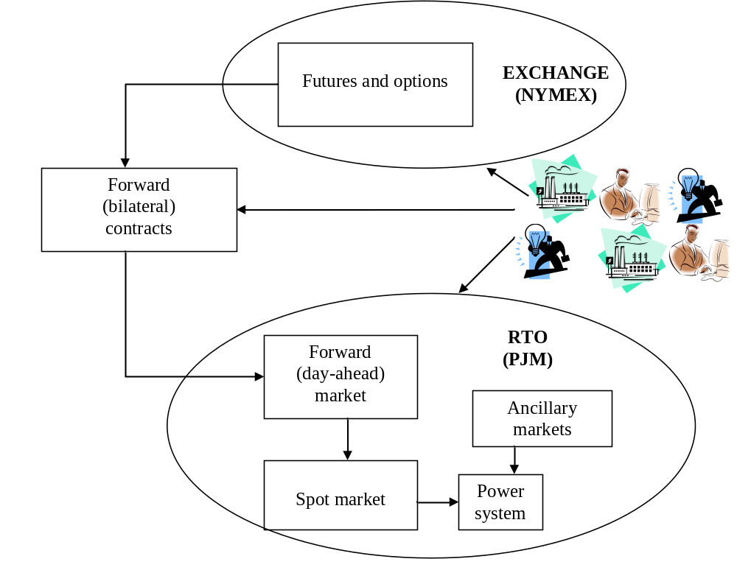
Fig. 4: Interaction of Markets

5.0 Attributes of electricity markets

The information in this section is adapted from [14-16].

There are a number of different attributes for electricity markets. Here, we are identifying the attributes that distinguish between specific types of electricity markets. We are not listing the different possible overall market architectures from which a market designer may choose. Such architectures are addressed in Sections 6.0-7.0 and are identified based on the particular selection of the attributes.

The main market attributes are given below:
- Time until delivery: Trading for power delivery may begin years in advance and continue through a sequence of overlapping markets right up to the moment the electricity is actually generated and delivered to the load. The typical spectrum of electricity markets include:
➔
  - Forward markets: These markets operate years, months, weeks, and days ahead of actual delivery. We use the term here to designate markets where forward, future, or option contracts are bought and sold.
  - Day-ahead and hour-ahead: These markets operate, obviously, one day and one hour ahead, respectively.
  - Real-time: Power must be delivered according to the conclusion of the real-time market. This market is where supplemental energy is quickly bought or sold every 10-15 minutes to accommodate energy use just moments before it occurs. It is also sometimes called a balancing market.
- Financial vs. physical: In financial markets, the delivery of power is optional and the seller’s only obligation is financial. Financial markets deal only with the transfer of money and financial risk; they do not affect the actual delivery and use of electricity. A physical market results in actual delivery for cash payment. Real-time markets are clearly physical. Markets for financial transmission rights (FTRs), capacity, and reserve markets are financial.
- Type of commodity traded: Electricity markets are considered to be markets where energy is the tradable commodity. But there are other commodities, or services, that are required to operate the power system. We list the main ones below, most of which generally fall under the heading of “ancillary services.” Depending on the particular ISO, these may be traded within a market framework, or they may just be provided on a cost-basis. Ancillary services include [17]:
➔
  - Load following and frequency regulation: This is provided by generation that is synchronized with the grid, has an active speed-governing system, and responds to automatic generator control (AGC) and can therefore respond continuously to maintain power balance between supply and consumption. This type of control also regulates frequency since power imbalance is the reason for frequency deviation. It is sometimes called “regulation.”
  - Reserve capacity: There are three traditional definitions of different types of reserve capacity, as follows (but some ISOs may identify them in other terms):
    - Spinning Reserves: Generation that is running, with additional capacity that can be dispatched within 3-4 minutes.
    - Non-Spinning Reserves: Generation that is not running, but can be brought up to speed within a short amount of time, e.g., 10 minutes.
    - Replacement Reserves: Generation that can begin contributing to the grid within an hour.
  - Voltage regulation: Voltage regulation, which is primarily done at generator terminals via the automatic voltage regulator (AVR) by injecting more or less reactive power into the network, is normally not considered a commodity to be traded but rather a service to be purchased. Generators are required to have an AVR and to respond to the system operator’s request in establishing set-point voltage levels within a certain power factor band (e.g., 0.90 lag to 0.95 lead). If the system operator requests operation such that the MW output is limited, then the generation owner is usually compensated appropriately.
  - Black-start capability: If a portion of the interconnection experiences blackout, all equipment in that region will be de-energized. Before re-synchronizing the network, it is important to bring some generation back on-line in the blacked-out region. The ability of a generator to provide self-re-energization is called black-start capability. Black-start capability requires having on-site generation that can start the thermal or mechanical processes necessary to initiate operation of the larger steam turbine or gas turbine units. Generation owners providing this capability are compensated for it as an ancillary service.
One other that you will find in some of the market architectures is
- Presence of Transmission Hedges: So-called financial transmission rights (FTRs), defined between any two nodes in a network, entitle their holder to a revenue equal to the product of the amount of transmission rights bought (in MW) and the price differential between the two nodes (in $/MW). FTRs isolate their holders from the risk associated with congestion in the transmission network.
➔
- Wholesale vs. retail: Markets may be restricted to wholesale trade only, i.e., trading electric energy for resale. Retail markets involve electric energy sale directly to the end-users. Most markets are wholesale with exception for large industrial users.
➔
- Determination of price: Price is determined via negotiation or some kind of matching algorithm in most types of bilateral trading, but it may also be determined via calculation. Algorithms for computing price include Economic Dispatch, Security Constrained Economic Dispatch, Optimal Power Flow, and Security Constrained Optimal Power Flow. These three algorithms are successively increasing in complexity and rigor. The latter three may be used to obtain locational marginal prices (LMPs), which are energy prices given on a per bus (i.e., per node) basis. Other names for LMPs include nodal prices and spot prices. We will later see how to use linear programming to compute LMPs. One market (ERCOT) has been using zonal prices rather than nodal but will soon be switching to nodal.
➔
- Market Rules: The market rules (tariffs, procedures) provide governance to how participants engage in the market. For example, the market rules of one real-time electricity market [18] “govern the relationship between the system operator, transmitters and market participants within the context of the operation of the integrated electricity system and in respect of the provision of ancillary services and contracts for the supply of electricity. The Market Rules also govern the manner in which the system operator will administer the Transmission Tariff, including with respect to the manner in which and the persons by whom the grid may be used and the manner in which reliability of the grid will be maintained.” Two important market rules which must be in place for any real-time electricity market are described below:
➔
  - Gate closure (See section 3.5.2 of [1]): The energy trading must stop sometime in advance of real-time to provide operators time to achieve a final balance between load and generation. So gate closure represents the final point before delivery at which traders can adjust their contracts. For example, the amount of time between gate closure and real-time in the UK model was 3.5 hours and now is 1 hour. System operators usually prefer longer gate closures to give them more time to respond to potential network problems caused by the trading. Traders, on the other hand, usually prefer shorter gate closures to give them more time to respond to expected changes in market prices.
➔
  - Market settlements (see section 3.6 of [1]): The percentage of energy traded bilaterally is usually much greater than the percentage traded on the spot market. Following a designated time period, buyers and sellers report their metered energy supplied or consumed. In almost all cases, the metered energy does not precisely equal the contracted energy. The difference, either positive or negative, for each market participant, is then compensated according to the amount of energy and the spot price at the bus where the participant is located.
➔

6.0 Standard Market Design

On July 31, 2002 the Federal Energy Regulatory Commission (FERC) issued a “Notice of Proposed Rulemaking” (NOPR) on a specific “Standard Market Design” (SMD) for electricity markets. This document states [19]:
- The objective of standard market design for wholesale electric markets is to establish a common market framework that promotes economic efficiency and lower delivered energy costs, maintains power system reliability, mitigates significant market power and increases the choices offered to wholesale market participants. All customers should benefit from an efficient competitive wholesale energy market, whether or not they are in states that have elected to adopt retail access.
➔
- Market rules and market operation must be fair, well defined and understandable to all market participants.
➔
- Imbalance markets and transmission systems must be operated by entities that are independent of the market participants they serve.
- Energy and transmission markets must accommodate and expand customer choices. Buyers and sellers should have options which include self-supply, long-term and short-term energy and transmission acquisitions, financial hedging opportunities, and supply or demand options.
➔
- Market rules must be technology- and fuel-neutral. They must not unduly bias the choice between demand or supply sources nor provide competitive advantages or disadvantages to large or small demand or supply sources. Demand resources and intermittent supply resources should be able to participate fully in energy, ancillary services and capacity markets.
- Standard market design should create price signals that reflect the time and locational value of electricity. The price signal – here, created by LMP – should encourage short-term efficiency in the provision of wholesale energy and long-term efficiency by locating generation, demand response and/or transmission at the proper locations and times. But while price signals should support efficient decisions about consumption and new investment, they are not full substitutes for a transmission planning and expansion process that identifies and causes the construction of needed transmission and generation facilities or demand response.
➔
- Demand response is essential in competitive markets to assure the efficient interaction of supply and demand, as a check on supplier and locational market power, and as an opportunity for choice by wholesale and end-use customers.
- Transmission owners will continue to have the opportunity to recover the embedded and new costs of their transmission systems. Consistent with current policy, merchant transmission capacity would be built without regulatory assurance of cost recovery.
➔
- Customers under existing contracts (real or implicit) should continue to receive the same level and quality of service under standard market design. However, transmission capacity not currently used and paid for by these customers must be made available to others.
- Standard market design must not be static. It must not inhibit adaptation of the market design to regional requirements nor hinder innovation.
Under the stated goal of Standardized Market Design (SMD), “To enhance competition in wholesale electric markets and broaden the benefits and cost savings to all wholesale and retail customers,” the electricity wholesale market should meet the following requirements [20]:
- Each Regional Transmission Operator (RTO) should develop a day-ahead energy market, a real-time spot energy market, a financial transmission rights market, and simultaneously allow for bilateral contracts.
➔
- Market-clearing prices should be derived through bid-based, security-constrained dispatch and be linked to the physical dispatch of the system through locational marginal pricing.
- Each RTO should seek to implement an energy market that, to the extent feasible, imposes the least amount of additional cost to the public.
- Each RTO should develop transparent rules and procedures that integrate and coordinate system operation with market administration functions for energy, ancillary services, and congestion management.
- RTOs should acknowledge the role of state utility commissions and the regional reliability authority in ensuring long-term supply adequacy and should coordinate with these entities in implementing a market approach.
- Load-serving entities should ensure that sufficient operating reserves and capacity are committed to meet the adequacy obligation established by the regional reliability authority or state commissions.
- Each RTO, in coordination with transmission owners or Independent Transmission Coordinators (ITCs) within the RTO, should manage or coordinate the operation of the transmission system.
- Limits may be necessary on bidding flexibility to mitigate market power. For example, suppliers may be required to submit a start-up bid which would remain in place for a period of several months (rather than re-bid every day). As more demand response becomes available in a regional market, limits on supplier bidding flexibility can be relaxed.
- The demand side must be able to participate in the energy market. The demand side can participate as buyers or sellers (e.g., offering to sell operating reserves). As a buyer, an entity must be able to submit bids that indicate it is willing to vary the quantities it purchases based on the prices that it may be charged.
In late 2002 and early 2003, FERC’s SMD faced fierce opposition, mainly from utilities in the lower-energy-cost southeast and Pacific northwest, because the SMD intended there would be no exceptions, a “one-size-fits-all” design; therefore [22, 23], (a) all regions would have to institute LMPs and other SMD requirements, and (b) no region would be able to prioritize transmission service except by willingness to pay and therefore so-called “native load” customers would have no priority over wheeling customers. Although this opposition was enough to prevent SMD from becoming law (the Energy Policy Act of 2005 did not implement it, and it was officially terminated as a FERC proceeding on July 19, 2005), it had great influence among more receptive regions of the country between 2002 and 2005, and many of the market architectures in place today reflect most of the SMD’s requirements.
➔

7.0 PJM: An Illustrative Market Architecture

Much of the following material was lifted from [9], with permission.
The Pennsylvania-New Jersey-Maryland (PJM) Interconnection serves about 9.6 million customers with installed capacity of 59,000 MW. In the year 2000, PJM served 262,081 GWh of energy, which represents about 7% of U.S. electric energy. PJM’s generation fleet has a fuel mix of 31% coal, 27% oil, 22% nuclear, 6% natural gas, and 5% hydroelectric. PJM allows physical bilateral scheduling that enables it to leverage its long-standing pool and its emerging bilateral markets.

PJM operates a day-ahead energy market, a real-time energy market, a daily capacity market, monthly and multi-monthly capacity markets, a regulation market, and the monthly Financial Transmission Rights (FTRs) auction market. PJM introduced nodal energy pricing with market-clearing prices in April 1998 and nodal market-clearing prices based on competitive offers in April 1999. PJM implemented a competitive auction-based FTR market in May 1999. Daily capacity markets were introduced in January 1999 and were broadened to include monthly and multi-monthly markets in mid-1999. PJM implemented the day-ahead energy market and the regulation market June 2000.
➔

PJM calculates and posts LMPs for more than 1,750 buses located in PJM control area and an additional 600 buses located outside PJM control area (see www.pjm.com/markets/jsp/lmp.jsp). LMPs are computed for aggregate load buses and the PJM eastern and western hubs. Fig. 5 shows average LMP, load-average LMP, and system load for PJM’s system over the year 2003. Load average LMP weight each buses LMP by the load, and then divide by total load. The fact that load averaged LMP is higher than the average LMPs indicates that LMP tends to be higher at buses with high load.
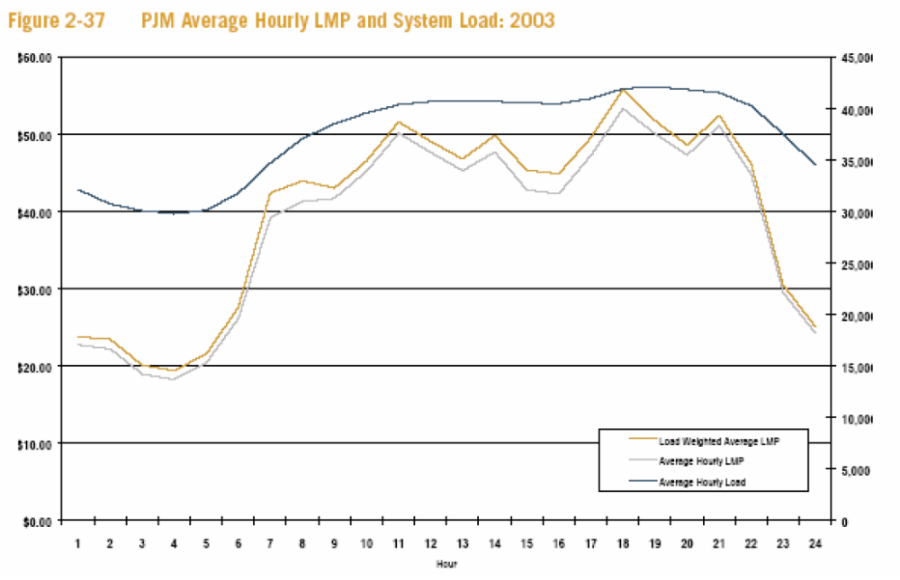
Fig. 5: PJM Hourly-avg LMPs, Load-avg LMPs, system load, ‘03

PJM’s two-settlement system consists of two markets – a day-ahead market and a real-time balancing market. Separate accounting settlements are performed for each market. For the year 2001, real-time spot market activity averaged 6,563 MW during peak periods and 6,395 MW during off-peak periods, or 21% of average loads. In the day-ahead market, spot market activity averaged 4,794 MW on-peak and 4,877 MW off-peak, or 15% of average loads.
➔

The day-ahead market is a financial market and thus may be used to provide a hedge against price fluctuations in the real-time spot market. This means that day-ahead prices for awarded bids and offers will hold; energy traded outside of those day-ahead prices (and without bilateral contracts) must be bought and sold at the real-time spot price. Also, for any generator that is scheduled in the day-ahead market, the offer data submitted into the day-ahead market (before 12 noon) will automatically carry over into the real-time market.
➔

Distinction between the two markets:
• The day-ahead market settlement is based on scheduled hourly quantities and day-ahead hourly LMPs;
➔
• The real-time or balancing market settlement is based on actual hourly quantity deviations from day-ahead schedule hourly quantities priced at real-time LMPs.

The real-time market is essential in order to provide final balancing.

The day-ahead market is also necessary in order to provide market participants with one way to handle price uncertainty by allowing them to do the following:
- commit & obtain commitments to energy prices & transmission congestion charges in advance of real-time dispatch (forward energy prices)
➔
- submit price sensitive demand bids (demands coupled with a reservation price above which bidder wishes to be removed from day-ahead schedule)
- submit increment offers & decrement bids (more on this later)
In addition, the day-ahead market allows market participants to submit either internal (originating and terminating within PJM service area) or external (either originating or terminating outside of PJM service area) bilateral transactions. Only internal transactions are allowed in the real-time market. In either case (internal or external), transactions must have transmission service reserved via OASIS. In addition, transaction participants are allowed to inform PJM of maximum congestion charges they are willing to pay using “up-to” congestion bids.

More on the Day-ahead Market
The day-ahead market is a forward market in which clearing prices are calculated for each hour of the next operating day based on generation offers, demand bids, bilateral transaction schedules, and incremental and decremental bids, which are purely financial bids to supply and demand energy in the day-ahead market. The day-ahead market uses exactly the same underlying system model as the real time market.
➔

The day-ahead market does two things:
- develops day-ahead schedule using least-cost security constrained unit commitment and security constrained economic dispatch programs;
➔
- calculates hourly LMPs for next Operating Day using generation offers, demand bids, and bilateral transaction schedules.
The day-ahead market timeline is shown in Fig. 6. Note that an “operating day” begins at midnight.

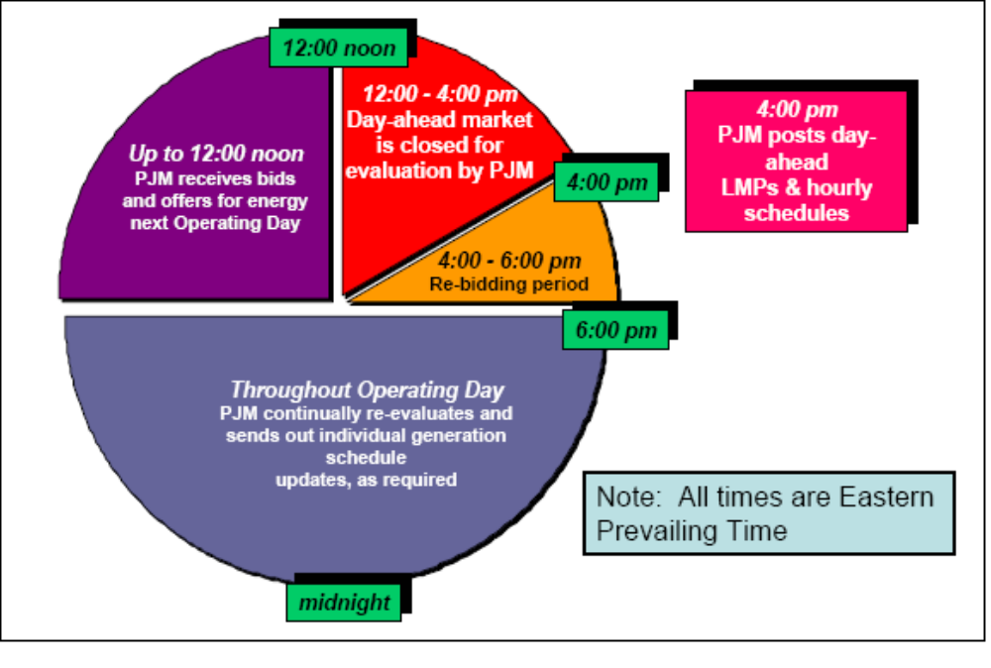
Fig. 6: Day-Ahead Market Timeline [24]

PJM’s day-ahead market enables market participants to purchase and sell energy at binding day-ahead prices. It further permits customers to schedule bilateral transactions at binding day-ahead congestion charges based on the differences in the LMP between a transaction’s source and sink locations. In the day-ahead market, Load Serving Entities (LSEs) will submit hourly demand schedules, including any price sensitive demand bids, for the amount of demand that they wish to lock-in at day-ahead prices.
➔
The day-ahead market data flow is illustrated in Fig. 7 [25]. Notice the data flow from left to right at the top of (a) market data, (b) network data, (c) forecast data, and (d) transaction (for bilaterals) data.
➔

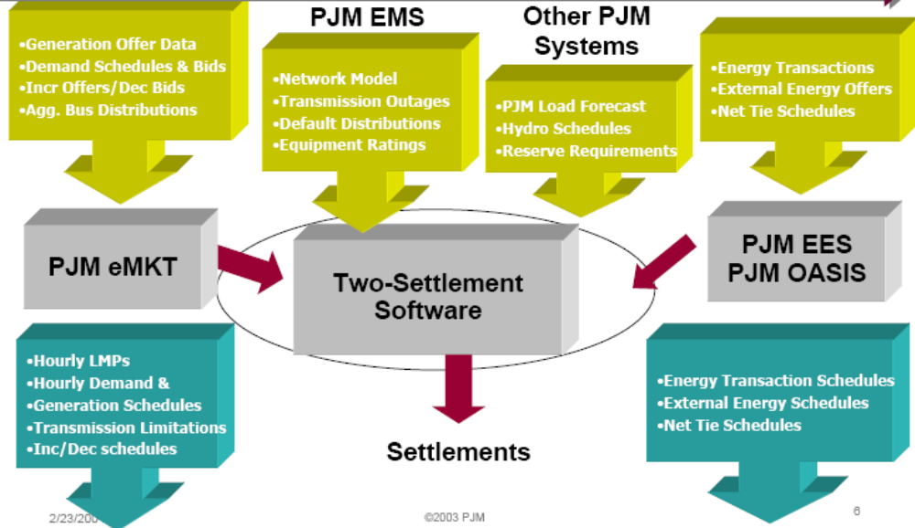
Fig. 7: Day-ahead market flow [25]

Resources must submit an offer schedule into the day-ahead market unless they are self-scheduled or unavailable due to outage. Non-capacity resources have the option to make offers into the day-ahead market, but are not required to do so. Transmission customers may submit fixed or dispatchable bilateral transaction schedules into the day-ahead market and may specify the maximum amount of congestion charges they are willing to pay between the transaction sources and sink if congestion occurs in the day-ahead schedule. FTRs are available to hedge congestion in the day-ahead market.

Price sensitive demand bids are offered by entities with actual physical demand such as LSEs. These bids allow a customer to place a bid to purchase a certain quantity of energy at a certain location if the day-ahead price is at or below a certain price.

Decremental bids are similar to price-sensitive demand bids. They allow a marketer or other similar entity without physical demand to place a bid to purchase a certain quantity of energy at a certain location if the day-ahead price is at or below a certain price. Incremental offers are essentially the flip side of decremental bids. The PJM day-ahead market allows all market participants to use incremental offering and decremental bidding as financial hedging tools to provide additional price certainty in a variety of situations.

Figures 8 and 9 illustrate the meaning of increment offers and decrement bids [24]. A main reason for using increment offers and decrement bids is to hedge (reduce risk) associated with real-time market. But there are other reasons – see slide 29 in [24].
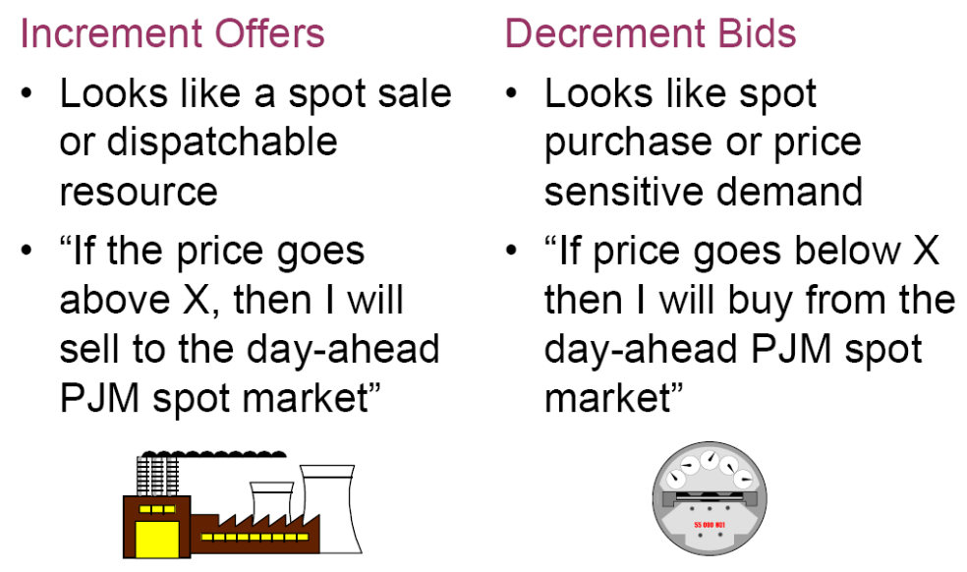
Fig. 8: Increment offers vs. Decrement Bids [24]

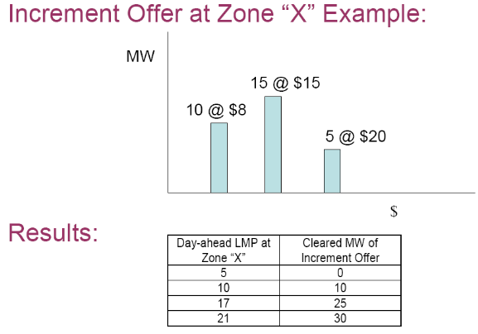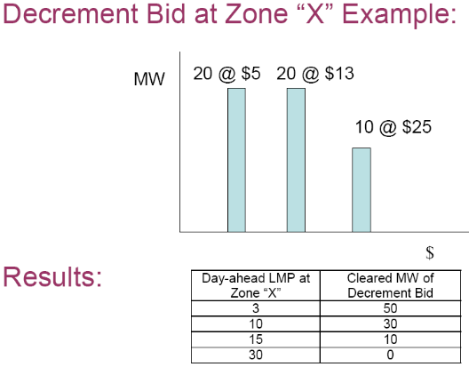
Fig. 9: Increment Offers and Decrement Bids [24]

“Up-to” congestion bids permit transmission customers (those having bilateral transactions) to specify how much they are willing to pay for congestion by bidding a certain maximum amount for congestion between the transaction source and sink. The “up to” bid for the transmission customer is analogous to the decrement bid for the energy customer. If the congestion charges are less than the amount specified in the bid, then the transaction will be reflected in the day-ahead schedule. The up-to bids protect transmission customers from paying uncertain congestion charges by guaranteeing that they will pay no more than the amount reflected in their bids. Transmission customers also may use an incremental and decremental bid pair to accomplish the same type of hedging strategy, which further enhances their price certainty options.

All spot purchases and sales in the day-ahead market are settled at the day-ahead prices. PJM allows virtual bidding so market participants can submit bids that are purely financial in order to arbitrage between the day ahead and real time market prices. Such bids are treated in the unit commitment process as if they were physical. PJM calculates the day-ahead final schedule based on the bids, offers, and schedules submitted. Day-ahead bids are of three types: energy bids by generators that self-commit, virtual bids, and multidimensional bids including cost and operating parameters by generators that want to be committed by PJM’s central unit commitment algorithm. Generators that are committed by PJM are made whole on a 24-hour basis (i.e., PJM guarantees cost recovery). All self-committed and centrally committed units are scheduled for each hour in the day-ahead market through a security constrained bid-based dispatch, and the corresponding hourly LMPs are calculated. The day-ahead scheduling process will incorporate PJM reliability requirements and reserve obligations into the analysis. The resulting hourly schedules and LMPs represent binding financial commitments to market participants.

More on the Real-time Market
The real-time balancing market is based on actual real-time operations. As in the day-ahead market, generators that are Capacity Resources must participate in the real-time balancing market or may self-schedule. However, Capacity Resources that are available but were not selected in the day-ahead scheduling may alter their bids for use in the balancing market. If a generator chooses not to alter its bid, its original bid in the day-ahead market remains in effect.

Real-time prices are recalculated at 5 minute intervals using real-time data from the EMS.
➔

The balancing market is the real-time energy market in which clearing prices are determined by the actual bid-based, least-cost, security constrained unit commitment dispatch.
➔
➔

LSEs will pay balancing prices (real-time LMP) for any demand that exceeds their day-ahead scheduled amounts but will receive revenue (real-time LMP) for demand deviations below their day-ahead scheduled amounts. Similarly, generators are paid balancing prices for any generation that exceeds their day-ahead scheduled amounts and will pay for any generation deficit below their day-ahead scheduled amounts. Transmission customers will pay congestion charges (or may receive congestion credits) for bilateral transaction quantity deviations from day-ahead schedules.

Ancillary Services Market
The PJM regulation market, introduced on June 1, 2000, supplanted an administrative and cost-based regulation procurement mechanism that had been in place for many years. Market participants can now acquire regulation in the regulation market in addition to self-scheduling their own resources or purchasing regulation bilaterally. The market for regulation permits suppliers to make offers of regulation subject to a bid cap of $100 per MW, plus opportunity costs.

PJM also offers a synchronized reserve market on an hourly basis to provide 10 minute response capability.
➔

Black start and voltage regulation are services provided by suppliers that get compensated on a fixed-price basis.

Capacity Market

An LSE has the obligation to own or acquire Capacity Resources greater than or equal to the peak load that it serves plus a reserve margin of about 18%. LSEs have the flexibility to acquire capacity in a variety of ways. Capacity can be obtained by building units, by entering into bilateral arrangements, or by participating in the capacity credit markets operated by PJM. Collectively, these arrangements are known as the Installed Capacity Market, or ICAP.
➔

The PJM capacity credit markets are intended to provide the mechanism to balance the supply of and demand for capacity not met via the bilateral market or via self-supply. Capacity credit markets were created to provide a transparent, market based mechanism for new, competitive LSEs to acquire the Capacity Resources needed to meet their capacity obligations and to sell Capacity Resources when no longer needed to serve load. PJM’s daily capacity credit markets ensure that LSEs can match Capacity Resources with changing obligations caused by daily shifts in retail load. Monthly and multi-monthly capacity credit markets provide a mechanism that matches longer-term capacity obligations with available Capacity Resources.
➔

Financial Transmission Rights
PJM introduced Financial Transmission Rights (FTRs) in its initial market design in order to provide a hedge against congestion for firm transmission service customers, who pay the costs of the transmission system. PJM introduced the monthly FTR auction market to provide increased access to FTRs and thus increased price certainty for transactions not otherwise hedged by allocated FTRs. In PJM, firm point-to-point (PTP) and network transmission service customers may request FTRs as a hedge against the congestion costs that can result from locational marginal pricing. An FTR is a financial instrument that entitles the holder to receive revenues (or charges) based on transmission congestion measured as the hourly energy locational marginal price differences in the day-ahead market across a specific path. Transmission customers are hedged against real-time congestion by matching real-time energy schedules with day-ahead energy schedules. FTRs can also provide a hedge for market participants against the basis risk associated with delivering energy from one bus or aggregate to another. An FTR holder does not need to deliver energy in order to receive congestion credits. FTRs can be purchased with no intent to deliver power on a path.
➔

Price Cap
➔
PJM’s mitigation consists of the $1,000/MWh bid cap in the PJM energy market and the $100/MW bid cap in the PJM regulation market. To mitigate local market power, PJM limits the offers of units which are dispatched out of merit order to relieve transmission constraints, to marginal cost plus 10%. PJM has a number of additional rules designed and implemented in order to limit market power. PJM is investigating other rules changes to reduce the incentives to exercise market power.

8.0 Summary of Other Market Architectures
Reference [9] provides a detailed summary of a number of market architectures as of 2003. Table 1, lifted from [9] with permission, provides an overview of this summary.

Table 1: Summary of Market Architectures

 | Market and  GROUP NUMBER | Bilateral Contract | Active Financial Market | Day-ahead Market | Hour-ahead Schedule | Real-time Market | Bilateral /Self-schedule | LMP | ICAP | FTR | Price CAP | AMP | LAAR | Retail Competition
Existing Market Designs | 1.NORD POOL | √ | √ | √ | Market | √ | 71% |  | √ | CfD |  |  | √ | √
Existing Market Designs | 2. New Zealand | √ |  |  | √ | √ | <25% | √ | √ | √ |  |  | √ | √
Existing Market Designs | 3. Australia | Financial hedge |  | Schedule |  | √ | 0 |  |  | SRA | √ | √ | √ | √
Existing Market Designs | 4. England | √ | √ | Private | √ | √ | 98% |  |  |  |  |  | √ | √
Existing Market Designs | PJM | √ |  | √ |  | √ | 64% | √ | √ | √ | √ |  | √
Existing Market Designs | 5. NYISO | √ |  | √ | √ | √ | 50% | √ | √ | √ | √ | √ | √
Existing Market Designs | 6. ISO-NE | Financial hedge 40% |  | √ |  | √ | 0 | √ | √ | √ | √ |  | √
Existing Market Designs | 7. ERCOT | √ |  | Schedule |  | √ | 97% |  |  | TCR | √ |  | √ | √
Existing Market Designs | 8. Ontario | √ |  | Financial | √ | √ | √ |  |  |  | Profit limit |  | √
Existing Market Designs | 9, 10. Alberta | √ | √ | Schedule |  | √ |  |  |  |  | √ |  | √
Proposed Market Designs | FERC SMD | √ |  | √ |  | √ |  | √ | √ | √ | √ | √ | √ | √
Proposed Market Designs | NERTO | √ |  | √ |  | √ |  | √ | √ | √ | √ | √ | √
Proposed Market Designs | 11, 12. MISO | √ |  | √ |  | √ |  | √ | √ | √ | √ | √ | √
Proposed Market Designs | 13, 14. California | √ |  | √ | Market | √ |  | √ | √ | √ | √ | √ | √

References
- D. Kirschen and G. Gtrbac, “Fundamentals of power system economics,” John Wiley and Sons, 2004.
- J. McCalley and G. Sheble, “Competitive electric energy systems, engineering issues in the great experiment,” a paper published as a tutorial of the 4th International Conference on Probabilistic Methods Applied to Power Systems, Rio de Janeiro, Brazil, 1994.
- A. Kahn, “The economics of regulation: principles and institutions,” Vol. II, John Wiley and Sons, 1971.
- H. Averch and L. Johnson, “Behavior of the firm under regulatory constraint,” American Economic Review, Vol. 52, 1962, pp. 1053-1069.
- T. Berrie, “Electricity economics and planning,” Peter Peregrinus Ltd., 1992.
- F. Schweppe, “Power Systems 2000,” IEEE Spectrum, Vol. 15, No. 7, July 1978.
- F. Schweppe, R. Tabors, J. Kirtley, H. Outhred, F. Pickel, and A. Cox, “Homeostatic Utility Control,” IEEE Trans. Pwr. App. And Sys., Vol. PAS-99, No. 3, May/June 1980.
- F. Schweppe, M. Caramanis, R. Tabors, and R. Bohn, “Spot Pricing of Electricity,” Kluwer, 1988.
- Sam Zhou, “Comparison of Market Designs,” based on Project 26376, Rulemaking Proceeding on Wholesale Market Design Issues in the Electric Reliability Council of Texas, Jan. 7, 2003, obtained and used with permission from the author.
- “Regional Transmission Organizations,” Docket No. RM99-2-000; Order 2000 of the Federal Energy Regulatory Commission (FERC), issued Dec. 20, 1999; www.ferc.gov/legal/ferc-regs/land-docs/RM99-2A.pdf.
- www.ferc.gov/industries/electric/indus-act/rto.asp
- “Staff Report on Cost Ranges for the Development and Operation of a Day One Regional Transmission Organization, Docket No. PL04-16-000,” FERC staff, Oct., 2004, www.ferc.gov/EventCalendar/Files/20041006145934-rto-cost-report.pdf.
- G. Sheble and J. McCalley, “Module E3: Economic dispatch calculation,” used in EE 303 at Iowa State University.
- S. Stoft, “Power system economics: Designing markets for electricity,” Wiley Interscience, 2002.
- A. J. Wood and B. F. Wollenberg, Power, Generation, Operation and Control, second edition, John Wiley & Sons, New York, NY, 1996.
- K. Bhattacharya, M. Bollen, J. Daalder, “Operation of Restructured Power Systems,” Kluwer, 2001.
- Federal Energy Regulatory Commission, Working Paper on Standardized Transmission Service and Wholesale Electric Market Design, May 2002, pp 6-7.
- New Brunswick Electricity Market Rules, 2004, located at http://www.gnb.ca/0085/ElectricityMarketRules/chapter1-e.pdf.
- California Independent System Operator Ancillary Services Requirements Protocol, located at www.caiso.com/docs/2004/08/23/200408231007245980.pdf.
- Federal Energy Regulatory Commission, “Working Paper on Standardized Transmission Service and Wholesale Electric Market Design,” March 15, 2002, p. 1.
- Website of the North American Energy Standards Board, http://www.naesb.org/pdf/weq_ess_oasis2_083004w1.doc.
- http://energylegalblog.com/archive/2005/07/21/59.aspx
- http://www.milbank.com/en/NewsEvents/ClientAlerts/030519_pwr.htm
- www.pjm.com/services/training/downloads/transactions-201-two-settlement.pdf
- www.pjm.com/etools/downloads/emkt/markets-training-new-emkt-vitual-workshop.pdf
- R. Shilts, Harvard U. Division of Economic Analysis Commodity Futures Trading Commission, http://www.ksg.harvard.edu/hepg/Papers/Shilts%2001-25-02.pdf.
- S. Dudley, “Risk and risk management in electricity markets: A primer,” July, 2001, http://www.eei.org/industry_issues/finance_and_accounting/finance/restoring_investor_confidence/Risk_and_Risk_Management.pdf.
- M. Shahidehpour and H. Yatin, “Markets in electric power systems,”
- G. Anders, R. Entriken, and P. Nitu, “Risk Management and Financial Management,” IEEE Power Engineering Society Tutorial TP-137-0, 1999.
- “Derivatives and Risk Management in the Petroleum, Natural Gas, and Electricity Industries,” a report developed by the Energy Information Administration of the US Department of Energy, Oct., 2002, located at http://www.eia.doe.gov/oiaf/servicerpt/derivative/appendix.html.

Information in this section is based on (1) PJM Interconnection State of the Market Report 2001 by Market Monitoring Unit, PJM Interconnection, L.L.C. June 2001; and (2) The Amended and Restated Operating Agreement of the PJM Interconnection, L.L.C. (“Operating Agreement”) setting forth procedures for a two-settlement system; Filing to Federal Energy Regulatory Commission, March 10, 2000. The section also contains information from the PJM website: www.pjm.com.
A Capacity Resource is the net capacity from owned or contracted for generating facilities which are accredited pursuant to the procedures set forth in the Reliability Assurance Agreement among Load Serving Entities in the PJM Control Area.
Self Schedules reflect a Market Participant’s intent to inject energy into the system at a given location, or to notify the Market Operator or Balancing Authority of the provision of certain ancillary services (e.g., operating reserves) from qualified generation resources or dispatchable load resources. An example of the use for self-schedules is a municipality with behind-the-meter generation that intends to run that generation to satisfy all or a portion of their forecasted load [19].
Under consideration of some capacity support mechanism
Under consideration

